
Applied Leadership and Management in the Workplace
Module Assignment Submission
Student Name: | Scott Morgan
Student Number: | 2319551
Module No: | BMSK4011
Module Title: | Continous Professional Development

Statement of Confirmation of Authenticity
By the act of making this submission, the student declares that this is the work of the student named above. The work has not, in whole or in part, been knowingly presented elsewhere for assessment, or where assessment has been built on a previous assessment, this has been identified. Where materials have been used from other sources it has been properly acknowledged. If this statement is untrue, the student acknowledges that an assessment offence has been committed.
Attention is drawn to the plagiarism and unfair practice policies of both the University and of ILM.

Table of Contents
Section 1: Know how to identify development needs 3
1.1 Identify learning styles for self and another 3
1.2 Use a simple technique for identifying development needs for self & another 4
1.3 Identify potential barriers to learning for self and another. 5
1.4 Explain how these barriers to learning can be overcome. 6
Section 2: Know how to develop self & others to achieve organisational objectives 6
2.1 Analyse learning/development options to meet needs of self & another. 6
2.2 Identify support mechanisms for the development of self & another 7
2.4 Method used to monitor the development of self & another. 9
References 11
Appendix A Curriculum Vitae 11
Appendix B Continuous Professional Development Record 13

Section 1: Know how to identify development needs
In this section, I will be analysing the learning styles of myself and another, using the Methods of Peter Honey and Alan Mumfords learning styles questionnaire and Neil Flemings VARK Method. I then move onto a SWOT Analysis and GAP analysis, before moving onto barriers of learning and how to overcome them.

Identify learning styles for self and another
There are many ways of identifying our learning styles. One that I most commonly use is the VARK method, as this is the one I am instructed to use in my career. The Vark learning style is important in my field because it shows how my learners learn best and can tailor my sessions to the style that suits them. Following the VARK questionnaire, it shows four types of learning styles, they are Visual, Auditory, Reading/writing and kinaesthetic. “Teaching through the appropriate learning style provides a higher opportunity for improving learning performance in an educational setting”- Dutsinma and Temdee (2020)
During my research, I found that I was more of a visual learner. I prefer to watch someone do it first and then have a go. However, when I am studying, I enjoy listening to music or TV in the background, which makes me a mix of an Auditory learner as well. This reflects in my VARK questionnaire as it showed to be a mix between Visual and Auditory. To put this to the test, I tried this out on my colleague, who is very much an auditory learner. My colleague enjoys listening to podcasts, listening to music whilst studying, however, I noticed that in the office he often fidgets with pens. This reflects in my colleague’s questionnaire which shows he is a mix between Auditory and Kinaesthetic.
Following Honey and Mumfords questionnaire, this uses a different approach to learning styles. Honey and Mumford uses four different styles such as Activist, Pragmatist, Reflector and Theorist. When taking this questionnaire, myself, it shows that I am a reflective and theorist learner. This rings true to me as I tend to look for the bigger picture when undertaking tasks, I like to get involved with tasks and reflect on it after, I prefer group work and discussions, I research and review my findings and I like to stand back and observe what is happening. I am a good communicator and a problem solver I think things through before I act on tasks and I need a lot of information before starting tasks and rely on facts over opinions. Some identified development needs are that I can forget important details, can be indecisive and easy going at times. “vague and sometimes contradictory guidelines about the desirable amount of data”- Marsh and Hau (1992)

1.2 Use a simple technique for identifying development needs for self & another
SWOT Person 1

STRENGTHS  - Experience of providing 5* customer service, education and social care  - Attention to detail  - Good communicator  - Seeks new skills | WEAKNESSES  - Planning my calendar sufficiently  - Timekeeping  - Admin catch up  - Procrastination
OPPORTUNITIES  - Finishing my degree  - Stable career  - Promotion in work  - Technology is ever changing in my current sector, including new software | THREATS  - More experienced colleagues  - Self-sabotage  - Currently no promotions on offer  - Standard working practices are always updating

SWOT Person 2

STRENGTHS  - Calm  - Sociable  - Knowledgeable  - Amiable | WEAKNESSES  - Not authoritative  - Don’t like confrontation  - Can be disorganised
OPPORTUNITIES  - Progression onto Masters  - Possible promotion to Head of Business | THREATS  - Standard working practices are always updating  - Caseload above maximum  - Timing to complete Masters

Gap Analysis person 1

Objective | Current Position | Deficiency | Action
What do I want to do? | What can I already do? | What am I lacking? | How do I fix this?
Complete the first year of my degree | Attend my course | 100% dedication due to full time job and family commitments | Set time aside both in work and at home  Stay up later if I need to
Progress in my career | Go on training courses  Keep up to date with roles in my company | Experience  Management skills  No promotions available | Go on training courses  Shadow colleagues
Become better at planning | Work with my manager to work on this | Planning skills | Get on the job training on planning skills  Look up articles/books on planning

Gap Analysis person 2

Objective | Current Position | Deficiency | Action
What do I want to do? | What can I already do? | What am I lacking? | How do I fix this?
Undertake my Masters | I have achieved my Bachelors Degree | Time and mental head space | Speak with my manager regarding my caseload  Ask for advice from friends, family, colleagues
Reduce my caseload | Complete learners  Speak to my manager | Time and currently a lot of pressure from my manager | Speak to my colleagues and ask for advice  Speak to my manager regarding my problems
Promotion in work | I have the experience  I have done management duties already  I have a leadership and management degree | Currently no promotion on offer | Ask for advice from my manager and let him know my interest in becoming manager after him

1.3 Identify potential barriers to learning for self and another.
For myself, one barrier is that I have a family to look after and a full-time job. My family can be a barrier for my learning because there will be times that I can’t get child care and I will need to stay at home. When it comes to having a full-time job, even though I am in charge of my own calendar, there have been times that I have had to stay out later, or I am down in the Newport/Cardiff area all day and can come back late. One of my identified weaknesses in my SWOT analysis is that I tend to procrastinate. This can be a barrier because I tend to get easily distracted and forget about the important things I have to do. Another identified weakness is that my time keeping and planning is not up to a sufficient standard. This can be a potential barrier because there may be an important task or assignment to complete but my planning hinders me and will fall into the streams of admin catch up.
With regards to my colleague, his caseload of learners is above maximum, which can lead to standards of work dropping and affecting the mental health by making him stressed. It is a question as to whether the timing is right to complete his masters. An identified weakness of my colleague is that he can be disorganised. This can be a barrier to learning because if files and documents are all spread out and not in a neat manner, this can take up a lot of time of trying to sort things into the right place and tasks will get put off in the process.

1.4 Explain how these barriers to learning can be overcome.
A way of overcoming the barrier of my family can be arranging childcare. This will give me the space and time I need to get the tasks or assignments completed or get a good bulk of them done. My job I would say is my main barrier. However, I have the liberty of being in control of my own calendar. Being in control of my own calendar allows me to set time aside in work to focus on my assignment and tasks. A way of overcoming procrastination can be to allow myself to take time out, if I feel like I am overwhelmed. I can then choose time to come back to it when I feel motivated again. I am currently working close with my manager, to overcome my poor planning. I am taking time out of my day to update my calendar regularly, which shows him where I am on a certain date and a certain time. I can tie this into my learning by utilising the skills I am learning and transfer them over to planning for my assignments and tasks.
When discussing with my colleague, about overcoming the outlined barriers, he could speak to our manager about his mental health due to the increased caseload. They could come up with a potential solution of decreasing his caseload by passing some onto me and our colleagues. This way he can dedicate more time to seeing his learners, spending more time with them to progress them quicker and potentially be in the right head space to undertake the Masters degree. If he wants to overcome his organisational skills, I gave him empty files and folders to help him on his desk and I have offered my services to help sort them by importance and categories. Another solution to this could be researching online for organising tips and even attend training courses.

Section 2: Know how to develop self & others to achieve organisational objectives
In this next section, I will be analysing the learning and development opportunities available, identifying the support mechanisms, presenting development plans and analysing the different methods we can use that will monitor the development of myself and my colleague.

2.1 Analyse learning/development options to meet needs of self & another.
A learning and development option that is available to myself and my colleague is self-directed learning. To analyse this method, you first have to understand what self-directed learning is. Self-directed learning is when the learner takes the initiative to undertake learning and development of oneself. For example, if my colleague and I want to improve our time-management skills, then we would use the resources that are available to us. These resources could be online books, laptop or phone to access the internet and we could shadow one of my colleagues who has good time keeping and ask for advice from them.
Self-directed learning has its disadvantages. As it is the learner taking the initiative, there is no curriculum t follow, it is more of a do it yourself and hope for the best sort of method. There is a way to measure your success, through asking colleagues and management regarding how you have developed, but you have to find your own ways of learning.
Another option can be through formal(Off site) training. Formal training is through use of a classroom or online, what I am doing to get through my degree. The advantage for myself and my colleague of using this method, is it is more curriculum based and will be given professional and appropriate training of what we want to learn. As both myself and my colleague wish to undertake a degree and a masters respectively, this will be a perfect way of getting the training and learning we need. Another benefit to formal training, is that it is structured and you can plan accordingly around your rota.
A drawback to formal training can be that the pressure of assignments and deadlines can contribute to stress and maybe anxiety. If you are fearful of missing deadlines, then formal training will be something to take into consideration before applying. “too much direction for students on how to do assignments restricts their innate abilities to become self-directed.” Mentz et al (2020)
Informal learning is the other method that can be used for learning and development. Informal learning is a way of learning outside of a formal setting. This style of training would be more beneficial to myself and my colleague, because this can be done through shadowing on the job, training provided by our employer or team bonding. I am currently on a learning and development course, which is to be completed on the job and this is classed as informal training.
Through my research, I found that informal training isn’t normally classed as curriculum based or associated with credits or degrees. This is a drawback because it is a sort of high effort, low reward sort of method. Another drawback is, that like self-directed learning, it is unlikely that a tutor is involved, which makes asking for feedback a bit more complicated.

2.2 Identify support mechanisms for the development of self & another
The tutor on my course is one support mechanism to contribute to my self-development. My tutor can provide me with task sheets, offer feedback on my assignments and provide support if I need help. My family can offer me support, by giving me time and space to work through my degree and my wife can offer me help if I get stuck. I have set up a WhatsApp group with my classmates, where if we get stuck on a question we can all work together to work out an answer. The library is a resource available to me, where I can access at the university or online. The library can provide me with books to help with any assignment. My manager can measure my caseload and provide support through one to ones or in the office. If I need to go on to any extra training, my manager can provide me training courses and advice. My work colleagues can both help me with my course and help with my work. One of my colleagues has gone through the same course I am on now; my other colleagues can offer support and work collaboratively.
My colleague has the same support mechanisms that I have, albeit a different tutor. Another support mechanism for my colleague is that he can go to the board of directors for advice. As he is a more experience colleague, he inevitably has more access to resources that I have which is why he has the advice and support of the board and directors.

2.3 Prepare development plans for yourself and another person
Person 1

What do I want to learn? | What do I have to do? | What support and resources will I need? | How will I measure success? | Target Date for Review
More about Applied Leadership and Management | Complete my degree, or at least my first year | Tutor, books, technology | Over the span of my degree, being consistent with assignment completion | 1st September 2023
Learning and Development | Complete my level 3 in Learning and Development | Support from my manager, resources on my work documents | Progression reports after each workshop | 11th July 2023
Timekeeping | Read up on strategies | Tutor, Family | Improved timekeeping skills meeting deadlines effectively | March 2024

Personal Objectives
Short Term Goals (next 12 months)
Complete the first year of my degree

Medium Term Goals (2-3 years)
Complete my degree

Long Term Goals (3-5 years)
Start my own business or be higher up in my company

Person 2

What do I want to learn? | What do I have to do? | What support and resources will I need? | How will I measure success? | Target Date for Review
Assertiveness | Learn ways of becoming more assertive in my role, maybe through off site training. | Support from colleagues, manager. Tech for online training. | Through completion of training. Review with manager. | April 2024
Timekeeping | Learn ways of becoming better at timekeeping. Maybe through off site training | Support from colleagues, manager. Tech for online training. | Through completion of training. Review with manager | April 2024
Organisational skills | Learn ways of becoming more organised. Maybe through off site training. | Support from colleagues, manager. Tech for online training. | Through completion of training. Review with manager | April 2024

Personal Objectives
Short Term Goals (next 12 months)
Become more organised, get better at timekeeping, gain organisational skills

Medium Term Goals (2-3 years)
Get onto my Masters

Long Term Goals (3-5 years)
Complete my masters. Become HBU(Manager)

2.4 Method used to monitor the development of self & another.
A method that both myself and my colleague can use is through reflections. Reflections are a good way to look back on what you have learnt. Dependant on what learning it was, this can be don through a variety of ways, such as a reflection log online or through pen and paper, casting your mind back on what you have learnt through your career or through a questionnaire.
One method which I use frequently with my learners is Progress Reports. When I see a learner, after each visit we will go through a progress report which talks about what activity we did in our session, what they learnt and what is the next step. It is also a chance for the learner to discuss any problems, mental health if they feel comfortable and what advice I can provide. Progress reports are what both my colleague and I find most efficient, as this is what we are used to in our careers. Therefore I would feel more inclined to use a progress report for monitoring my development.
An appraisal is another method we can use, and what we advise our learners to use, both on their Level 3 qualification in supervision and leadership and when sitting down for a one-to-one with their manager near the end of their probationary period. To monitor my development in work, an appraisal is what my manager uses most commonly. My manager will discuss our KPIs, our individual learners’ progression, any new financial targets and standardisation updates and gives myself and my colleague to bring up any topics we want to discuss. The outcome of our appraisal will be uploaded onto our HR website, we will tick whether we accept what has been addressed and we can then tick to say that our task has been complete.
If you have a knack for technology and computers, then a Gantt chart is something that can be beneficial to one’s development. A Gantt chart, usually made on excel is a spreadsheet styled monitoring system, used to assist in the planning and scheduling of tasks of all kinds. The Gantt chart is not something that I am familiar with myself, but my colleague and manager use this a lot as they go in depth into the KPIs and financial targets of the year.
I can use a few of these methods to monitor my development. If I was talking about my degree, then I would use my reflective learning, where after each assignment I will think to myself what went well, what can be improved for next time. When talking about my career, I would use both an appraisal with my manager and if doing training courses on the job then I would use progress reports.
When discussing with my colleague which one they would prefer to use to monitor his development, he said he would be more inclined to use either progress reports or an appraisal. If it was to monitor the progress of his masters, then he would sway towards reflecting, such as what went well, what didn’t go so well and what can be improved on next time. If it is to do with the development of his career, then he would use an appraisal with our manager, discussing what he has done well, what his caseload is looking like and what areas of improvement have been outlined.

References
- Van Eerde, W. et al. (2018) Overcoming procrastination? A meta-analysis of Intervention Studies, Educational Research Review. Available at: https://www.sciencedirect.com/science/article/abs/pii/S1747938X18300472
- Lehman, M. (2019) Using vark learning styles to predict instructional preferences, www.jstor.org. Available at: https://www.jstor.org/stable/26769624
- The 3 types of education: Formal, informal, non-formal: Advantages: Disadvantages (2021) Cuemath. Available at: https://www.cuemath.com/learn/3-types-of-education/
- Daniel, C. (2021) Pros and cons of Formal & Informal Learning, Tutorsource Platform. Available at: https://mytutorsource.com/blog/pros-and-cons-of-formal-informal-learning/
- Boyle, M. (2023) Why reflection encourages a better learning experience, Learning Pool. Available at: https://learningpool.com/why-reflection-encourages-a-better-learning-experience/
- Contributor, Pestle. (2022) Benefits of SWOT analysis, PESTLE Analysis. Available at: https://pestleanalysis.com/benefits-of-swot-analysis/
- Think Learning and Newham, T. (2023) 7 learning and development Kpis you need to measure, Think Learning. Available at: https://www.think-learning.com/learning-impact/learning-and-development-kpis/
- Bjerke, M.B. and Renger, R. (2017) Being smart about writing SMART objectives, Science Direct. Available at: https://www-sciencedirect-com.ezproxy.uwtsd.ac.uk/science/article/pii/S0149718916302580?via%3Dihub
- Morgan, P. (2021) The Business Student’s Guide to Study and Employability. London, England: Sage Publishing.
- Maund, A., Schriek, M. and Tinkler, P. (2017) Certificate in Higher Education: Skills for the Workplace Student Yearbook. London, England: Sage Publishing.

Appendix A Details on Learning Styles

VARK Method- If they are visual a learner then I can offer visual aids and videos. If they are an auditory learner, then I know that I can provide them with podcasts or I can talk to them about a topic through professional discussions. If a learner was a Reader/writer, then I can provide them with textbooks and theory. Finally, if my learner is a kinaesthetic learner, then I can provide my learners with workshop sessions and get them to do certain tasks which shows they are hitting the criteria. V stands for Visual, which means the learner prefers to learn with their eyes, will observe the session rather than talk and is good at memorising by looking at pictures or videos. A stands for Auditory, which means the learner enjoys to talk during the session and listen to others, doesn’t like noisy environments as this can lead to them being distracted and likes to try new things. R stands for Reading/writing, this means that the learner learns best by writing out the information or reading up about the topic, often good at spelling and likes solitary activities. K stands for Kinaesthetic, which means the learner enjoys physical activities, fidgets with various objects during study, uses their hands whilst talking and does not like reading.
Honey and Mumford- Some characteristics to look out for in an activist learner is they enjoy doing things, prefers new experiences and taking risks, concerned about how relevant it is to them, preferred way of learning is through self-discovery and doesn’t use thoughts or feelings when learning or working. Some disadvantages to look out for could be lack of planning and poor time management. Moving onto the reflective learner, some characteristics for a reflector learner could be collects data from various sources, more interested in how people behave and feel rather than structured, concerned about personal meaning and harmony and prefers to learn by listening and sharing ideas. Some disadvantages to a reflective learner could be easily distracted and frustrated by action plans. Some characteristics for a pragmatic learner, they integrate theory and practice, prefer the more ‘hands on’ approach, test ideas out to get the correct solution and have a strong need to work on practical, relevant problems. Some disadvantages to this learner are that they lack patience of other peoples suggestions and want to do things their way. Finally, a theorist learner has verbal skills, enjoy problem solving and finding the expert advice, concerned about details and quality of information received, they enjoy specialising in their field and like to think things through. Some disadvantages to consider for a theorist learner is that they need a lot of information before starting tasks and rely on logic rather than feelings.

Appendix B Curriculum Vitae

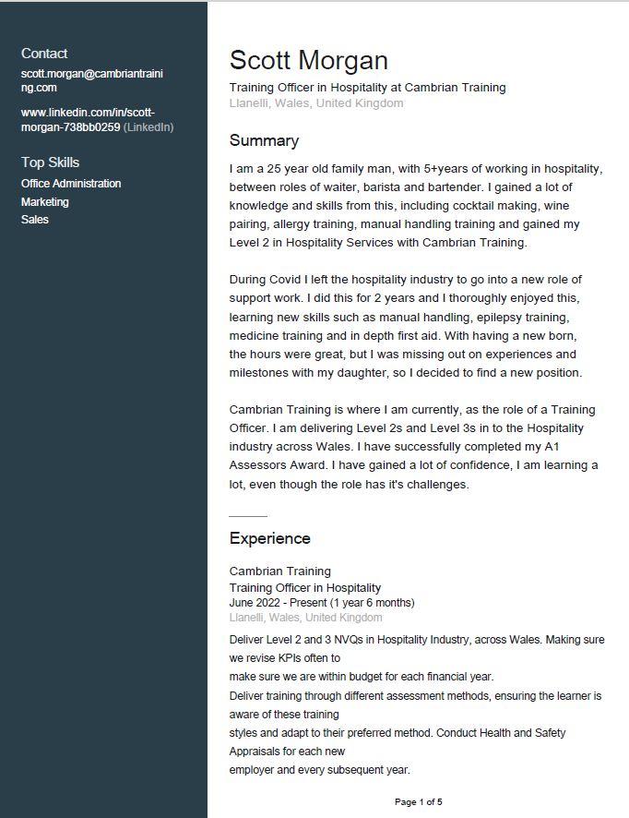

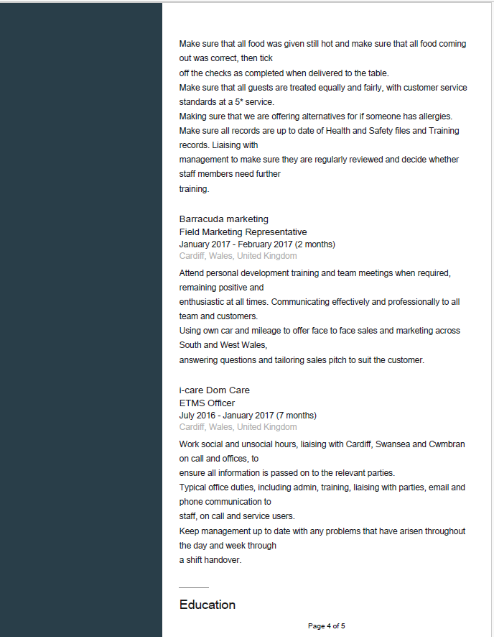
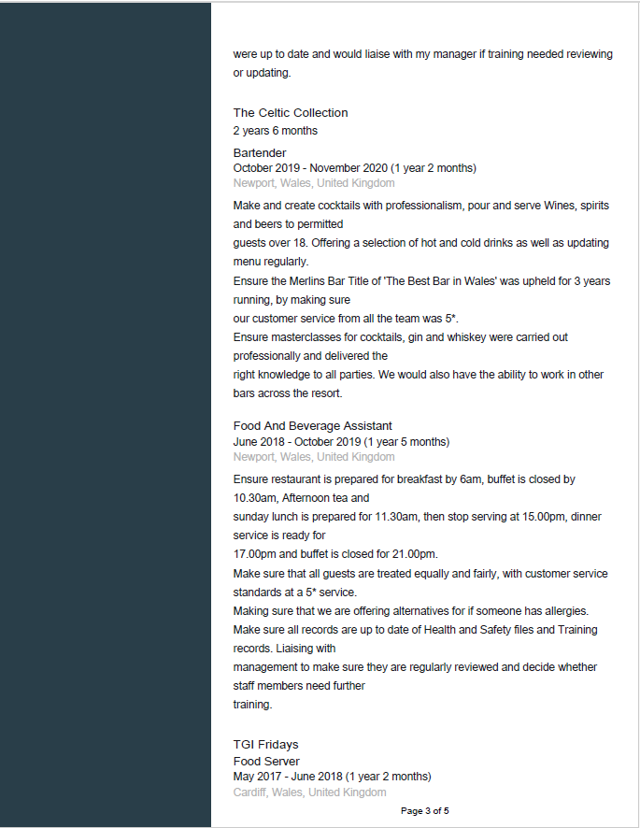

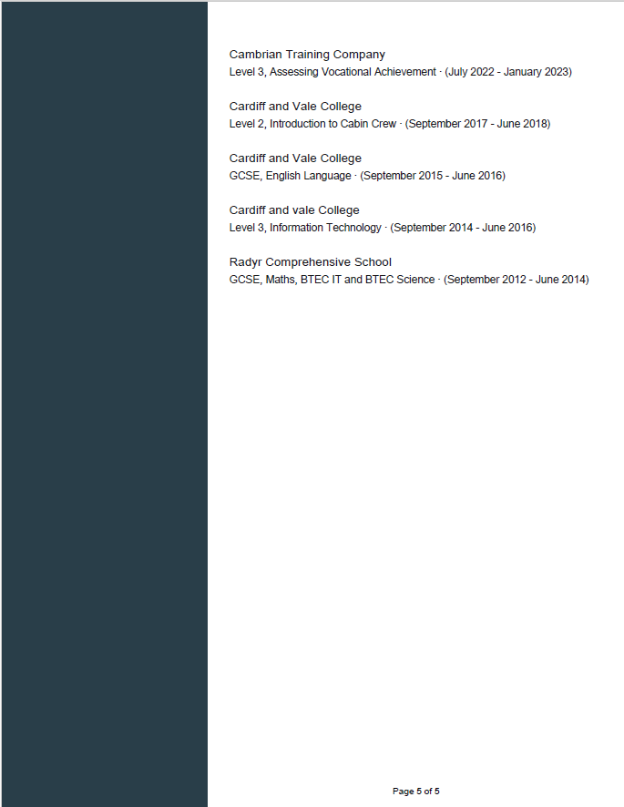

Appendix C CPD
 |  | Activity & Date | Activity & Date | Activity & Date | Activity & Date
Updating occupational expertise | Internal and external work placements | Bluestone knowledge theory sessions- 2023 | Celtic Collection- 2022, 2023, ongoing | Coffi Fach- 2023, ongoing | Coleg Y Cymoedd- 2023, ongoing
Updating occupational expertise | Work experience and shadowing | Preparing cooking and finishing Sunday lunch - Bella’s Bar Summer 2022 | BIIAB training session with IQA 2022 | BIIAB training session with IQA 2023
Updating occupational expertise | External visits to other organisations
Updating occupational expertise | Updated and new training and qualifications | Assessors award 2022 | Learning and Development Level 3- 2023
Updating occupational expertise | Training sessions to update skills | Onboarding 2022 | Shadowing 2022 | Face to face standardisation meetings, quaterly
Updating occupational expertise | Visits to educational establishments
Updating occupational expertise | Trade fairs | Autumn Fayre October 2022 | Winter Fayre 2022 | Spring Fayre 2023
Keeping up to date with sector developments and new legislation | Relevant sector websites | C&G/BIIAB/Edexcel, EWC
 | Membership of professional bodies | Culinary association of Wales 2023
 | Papers and documents on legislative change | Updates in legislations- licenced and food safety
 | Networking events
 | Seminars, conferences, workshops,
 | Membership of committees
 | Staff development days | CPD staff day June 22 | CPD insights June 2023 | CPD staff day December 2023
Standardising and best practice in assessment | Regular standardisation meetings with colleagues | Shadowing and standardisation | Hospitality team meeting – HA4 standardisation/benchmarking and resources
Standardising and best practice in assessment | Sharing best practice through internal meetings | Fortnightly team meetings
Standardising and best practice in assessment | Benchmarking with other sectors
Standardising and best practice in assessment | Attending awarding organisation meetings / seminars | Graduation event June 23

