

MBA - Master of Business Administration
University of Wales
Strategic Management
Name of Professor: Amare Desta
Student Name & Id: Dhruv Amitkumar Jha, 2318492
Module Code: LCMB7003

Table of Contents

Task 2: 4
1.0 Introduction 4
2.0 Discussion 4
2.1 Overview of Virtual Organisations and Virtual Management 4
2.2 Virtual Management in Virtual Organisations 6
2.3 Analysis of Google 7
2.4 Challenges Faced by Google in Virtual Management 8
2.5 Opportunities for Google through Virtual Management 9
2.6 Virtual Management at Google: Impact on Planning, Designing, and Leading 10
2.6.1 Impact on Planning 10
2.6.2 Impact on Designing 10
2.6.3 Impact on Leading 11
3.0 Conclusion 12
References 13
Appendix 16
Appendix 1: Presentation 16
Appendix 2: Precis 21
Appendix 3: Summary 23

Task 2:

1.0 Introduction
The concepts of virtual origination (VO) and virtual management have become vital subjects these days. As most organisations are trying to stay competitive in the ever-changing global market, they started depending on virtual management techniques progressively for operation optimisation, increased flexibility and access to an extensive talent pool. This transition has a significant implication for the organisation structure, leadership, and communication, especially for multinational companies like Google, as they are leading this transformation. It consists of regulating projects, maintaining communication, making sure about productivity, and promoting collaboration within a virtual environment.

2.0 Discussion

2.1 Overview of Virtual Organisations and Virtual Management
Virtual organisation and virtual management both represent the modern culture of the business where organisations can operate without any physical centralised office. In a virtual organisation, the employees can work remotely, they can do their job from any corner of the world. Virtual organisations rely on multiple digital tools like video conferencing, collaborative platforms, and cloud storage, to manage the project, and maintain seamless communication to maintain their productivity. In the USA during the pandemic, the percentage of remote workers increased from 33% to 61% (Graves and Karabayeva, 2020).
Virtual management is the procedure to lead and supervise the virtual organisation. Managers must adapt the conventional leadership method to fit in the digital environment. This includes coordinating with the teams who work remotely, making sure of seamless communication, promote teamwork even when employees are working remotely. The rise of virtual organisation and management fosters flexibility, it is cost-effective and can access talent from across the world. This model assists the organisation to adapt the changes in the market more effectively.
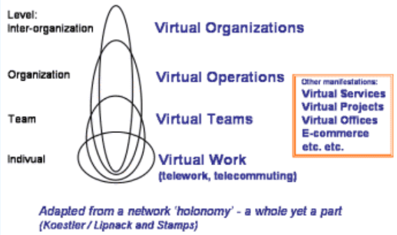
Image 1: Virtual Organisation
(Source: Skyrme, 2024)
Defining Virtual Organisations
A virtual organisation can be defined as a network of geographically scattered teams that work together to accomplish a common goal by leveraging digital technologies. Virtual organisations are flexible, they mainly rely on information and communication technology (ICT) for maintaining smooth coordination and communication and keep the focus on the project work. Key experts in this field depict the virtual organisation as a temporary partnership where organisations come together to exchange skills, core strengths and resources to respond better to the opportunities. Girish Chandra Murmu, The Controller and Auditor General of India stated that by 2030 AI will contribute $15.7 trillion to the global economy (indiaai.gov, 2023). The digital revolution has reshaped the professional outlook globally. The percentage of employees who are working remotely across the world is increasing. From 20%(2020) to 28% in 2023 (Sherif, 2024). Virtual organisation is cost-effective because it does not require the maintenance of physical space.

Theoretical Foundations of Virtual Organisations
Virtual organisations rely on multiple theoretical foundations to get a detailed understanding of how the business can work and embrace technological changes. Transaction Cost Economics (TCE) states that companies must choose a cost-effective way to maintain the transactions. Due to the ICT advancement, the costs which are associated with the transaction have reduced, and thus virtual organisation has become one of the practical options. According to the Resource View (RBV), the organisation can stay competitive by utilising resources like digital technologies and the capability to manage a scattered team. Virtual organisations (VOs) enable the business to access the global talent pool to enhance productivity. The Network theory sheds light on the significance of the organisational network in a Virtual organisation, which operates with a web of suppliers, partners and consumers. The entire network relies on common objectives and trust rather than conventional hierarchical control.

2.2 Virtual Management in Virtual Organisations
Virtual management in the virtual organisation includes supervising a team that works remotely from different parts of the world (Božić, 2023). Like conventional management where the employees have to be present in the office physically, Virtual management believes in digital technology and tools to stay connected with the team to maintain smooth communication and thus ensure productivity. According to Krapivnyk (2024), remote jobs boost employee satisfaction levels by 20%. The virtual organisation's manager utilises multiple platforms for collaboration, meetings and project management. Tools like messaging applications, video conferencing and online sharing documents assist the teammate in staying connected so that they can work effectively while they are not in the commonplace. A study says that satisfied employees can do their job 13% more effectively (Krapivnyk, 2024). The flexibility of work grabs attention and retains top-notch talent, as most of the employees demand work-life balance in their careers. By operating virtual management businesses can lower their expenses as they do not have to take any physical space for the office, and don't have to pay for the maintenance, utilities and travel. According to Silvermann (2020), 60% of employers believe that virtual management is cost-effective. According to the report, if every employee who is willing to work remotely does the same half of the time, the organisation can save approx $700 billion every year. By embracing the virtual work model organisations can save nearly $11000 per employee each year (Silvermann, 2020). Virtual management demolishes the geographic barrier, by allowing the team to work from various regions. Digital collaboration tools like Slack, Microsoft Teams, Zoom, and Dropbox enable the organisation to make seamless communication.

2.3 Analysis of Google
Google’s Virtual and Hybrid Work Structure: Integration of Virtual Management
The virtual and hybrid work structure of organisations demonstrates the commitment to developing an inclusive, flexible and efficient workplace. Through this segment Google's Virtual and hybrid work model will be described and how it combines virtual management in business operations.
Evolution of Virtual and Hybrid Work at Google
The evolution of hybrid and virtual work at Google showcases the organisation's adaption to the changing work culture and its commitment towards flexibility. Earlier Google was known for the conventional office-based model. The office campuses used to offer unique and collaborative workrooms. However, once remote work became popular and reasonable, Google started to explore hybrid and virtual work models.
After COVID-19 hit, Google shifted to the remote work model quickly which provides flexibility to work from home to ensure employee safety. By 2021, Google announced a hybrid work model where employees are required to work three days from the office and rest two days they can do remotely (Pichai, 2021). The aim of this approach is to maintain the balance of in-person collaboration with the flexibility of work. Overall these changes allow the workforce where 60% of Google employees spend a few days of every week in the office, 20% will continue their work from the new office location and the rest 20% will prefer to work from home. Google has invested a huge amount in digital tools like Google Meet, Google Drive, and Google Workplace to support the Hybrid workplace. Google has invested $300 million in AI to start Anthropic (Economictimes, 2023). Google Workplace is a popular cloud-based platform which allows collaboration from any device anywhere (Worthington, 2023).
Virtual Management Integration
Google's virtual management integration emphasises managing the global remote workforce by implementing modern digital tools. With the rise of remote and hybrid work after the pandemic hit Google embraced it by utilising its platform like Google Workplace. Other tools like Google Meet, drive, Doc, and Zoom allow to maintain smooth communication with the team though they are not present physically at the office. According to Dennison (2024), 73% of organisations will start working remotely by 2028. Google managers are well-trained to lead a remote team efficiently regardless of location. Google's virtual management integration believes in a robust organisational culture that supports teamwork.

2.4 Challenges Faced by Google in Virtual Management
Like many other organisations Google also faced challenges while implementing virtual management for remote work. One of the main challenges that Google faces is maintaining team unity and collaboration in a virtual workplace. In Spite of using digital tools like Google Workplace, promoting a robust team without personal interaction is a tough task. According to the report by Leeron Hoory (2023), 34% of remote workers feel less connected.
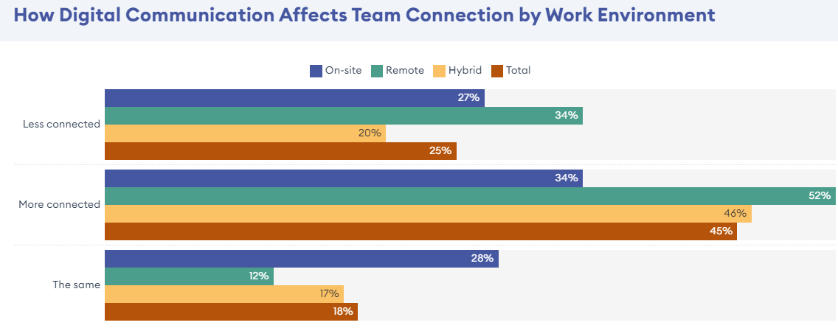
Image 2: Impact of Digital communication on team by work environment
(Source: Leeron Hoory, 2023)
Another challenge is maintaining productivity levels from different regions, as the team is spread globally. Ensuring smooth communication, and organising meetings is a difficult task. Lastly, ensuring data security is another challenge. In 2021 Google announced plans to invest over $10 billion in the next five years to develop robust cybersecurity (Walker, 2021). Emphasising these challenges sheds light on the complexity of managing a global remote work environment efficiently.

2.5 Opportunities for Google through Virtual Management
The shift towards virtual management provides notable opportunities for Google to improve global operations and grab the attention of diverse talent.
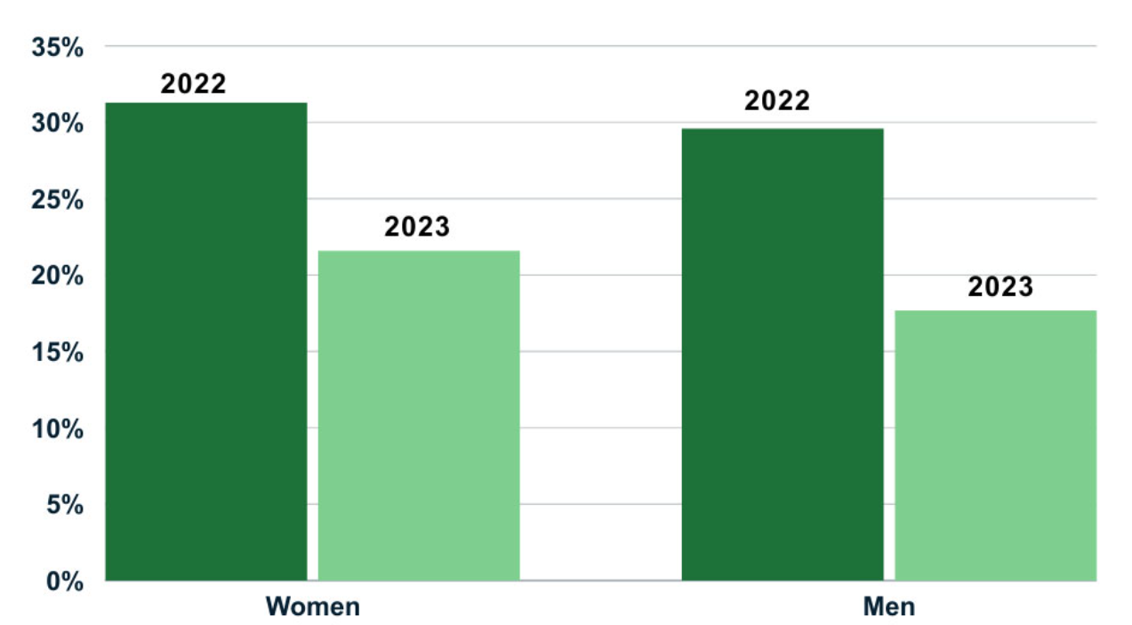
Image 3: Remote work
(Source: Carpenter, 2024)
Implementing virtual management allows the company to expand their talent pool. This will improve productivity. Virtual management helps reduce operation costs. The virtual management model supports environmental sustainability, as it rescues the Carbon footprint by rescuing commuting. According to the study conducted by Tao et al. (2021)Virtual management mitigated the carbon footprint by 94% and 90% energy use. Virtual management fosters work-life balance and improves employee retention and satisfaction.
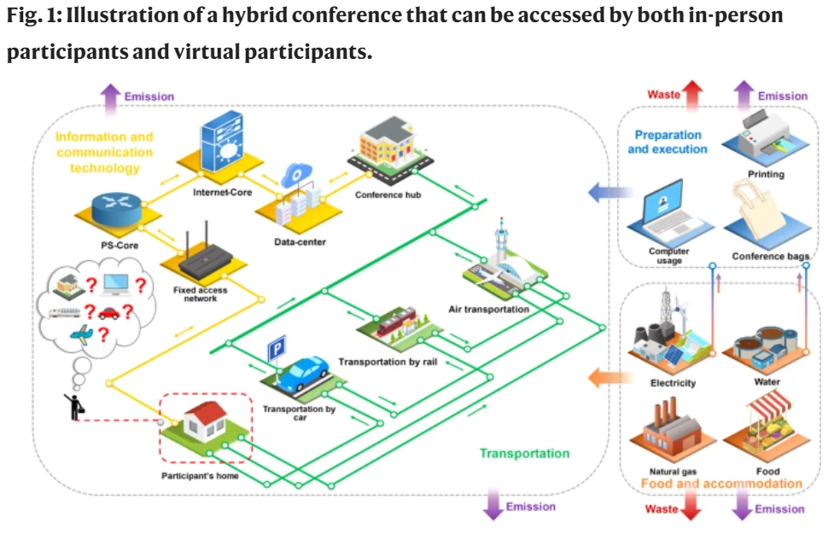
Image 4: Hybrid Conference
(Source: Tao et al., 2021)

2.6 Virtual Management at Google: Impact on Planning, Designing, and Leading

2.6.1 Impact on Planning
Virtual management has transformed the planning process of Google from conventional approaches to digital strategies. Now the company can utilise project management tools like Google Workplace to allow the team to collaborate in real time from any part of the world. This transformation has enabled Google to conduct projects more efficiently and flexibly. Nearly 91% of organisations are involved in various forms of digital initiative and 87% of senior leader says that digitalisation has become a top priorities for the companies (Quixy, 2024)
Tools like Google meet, and Drive are helpful to connect with the global team.

2.6.2 Impact on Designing
Google's design phase has transformed with virtual management. Rather than depending on in-person meetings, the company's design team can use the collaborative platform to build and refine the projects. Tools like Miro and Figma open the door for real-time feedback and visual imagination. Collaboration tools can improve the productivity of remote workers by 20-25% (Zight, 2023). By leveraging these platforms Google can promote innovation and maintain project consistency.

2.6.3 Impact on Leading
Leadership in the virtual environment demonstrates both challenges and opportunities. The leaders must prioritise maintaining engagement and provide motivation by leveraging digital communication tools. The leaders implement strategies like virtual check-in regularly and utilise data analytics to observe the team's wellbeing and performance. According to the survey conducted by Buffer approx 20% of remote employees feel that they are disconnected, which impacts their productivity and well-being overall (psico-smart.com, 2021).

3.0 Conclusion
Google has integrated virtual management successfully into the operation and fostered a hybrid and remote workplace. It provides both challenges and benefits. Transforming to a remote and hybrid work environment enables the company to become flexible and promote innovation, while other main challenges include data security, productivity and collaboration. Leveraging digital tools like Google Workplace fosters a strong organisation work culture by keeping the organisation as a leader in ever-changing digital workplace.

References
Božić, V. (2023). MANAGEMENT OF VIRTUAL ORGANIZATIONS. MANAGEMENT OF VIRTUAL ORGANIZATIONS. [online] doi:https://doi.org/10.13140/RG.2.2.25548.28804.
Carpenter, G. (2024). How Many People Work Remotely? [online] B2B Reviews. Available at: https://www.b2breviews.com/remote-work-statistics/ [Accessed 18 Aug. 2024].
Dennison, K. (2024). Tools To Enhance Communication & Efficiency Across Global Teams. [online] Forbes. Available at: https://www.forbes.com/sites/karadennison/2024/06/14/tools-to-enhance-communication--efficiency-across-global-teams/ [Accessed 18 Aug. 2024].
Economictimes (2023). Google invests $300 million in artificial intelligence startup Anthropic. The Economic Times. [online] 3 Feb. Available at: https://economictimes.indiatimes.com/tech/technology/google-invests-300mn-in-artificial-intelligence-start-up-anthropic/articleshow/97586675.cms?from=mdr [Accessed 18 Aug. 2024].
Graves, L.M. and Karabayeva, A. (2020). Managing Virtual Workers—Strategies for Success. IEEE Engineering Management Review, [online] 48(2), pp.166–172. doi:https://doi.org/10.1109/emr.2020.2990386.
indiaai.gov (2023). AI has the potential to contribute $15.7 trillion to the global economy by 2030: CAG Girish Chandra Murmu. [online] INDIAai. Available at: https://indiaai.gov.in/news/ai-has-the-potential-to-contribute-15-7-trillion-to-the-global-economy-by-2030-cag-girish-chandra-murmu [Accessed 18 Aug. 2024].
Krapivnyk, M. (2024). How To Make A Remote Worker Happier: Actionable Ideas Every Leader Can Try. [online] eLearning Industry. Available at: https://elearningindustry.com/how-to-make-a-remote-worker-happier-actionable-ideas-every-leader-can-try [Accessed 18 Aug. 2024].
Leeron Hoory (2023). The State Of Workplace Communication In 2024. Forbes. [online] 10 Mar. Available at: https://www.forbes.com/advisor/business/digital-communication-workplace/#:~:text=Remote%20workers%20were%20the%20most [Accessed 18 Aug. 2024].
Pichai, S. (2021). A hybrid approach to work. [online] Google. Available at: https://blog.google/inside-google/life-at-google/hybrid-approach-work/ [Accessed 18 Aug. 2024].
psico-smart.com (2021). How does remote work impact employee mental health, and what can organizations do to address it? [online] Psico-smart.com. Available at: https://psico-smart.com/en/blogs/blog-how-does-remote-work-impact-employee-mental-health-and-what-can-organizations-do-to-address-it-156403#:~:text=According%20to%20a%20survey%20by [Accessed 18 Aug. 2024].
Quixy (2024). Top 100 Digital Transformation Statistics & Trends To Help You Navigate it in 2024 | Quixy. [online] quixy.com. Available at: https://quixy.com/blog/top-digital-transformation-statistics-trends/#:~:text=According%20to%20Gartner%2C%2091%25%20of [Accessed 18 Aug. 2024].
Sherif, A. (2024). Work from home: remote & hybrid work - Statistics & Facts. [online] Statista. Available at: https://www.statista.com/topics/6565/work-from-home-and-remote-work/#:~:text=The%20share%20of%20employees%20working [Accessed 18 Aug. 2024].
Silvermann, B. (2020). How Working From Home Can Save Companies Money. [online] business.com. Available at: https://www.business.com/articles/working-from-home-save-money/ [Accessed 18 Aug. 2024].
Skyrme, D.J. (2024). K-Briefing: The Virtual Organization. [online] Skyrme.com. Available at: https://www.skyrme.com/kmbriefings/2virtorg.htm [Accessed 18 Aug. 2024].
Tao, Y., Steckel, D., Klemeš, J.J. and You, F. (2021). Trend towards virtual and hybrid conferences may be an effective climate change mitigation strategy. Nature Communications, [online] 12(1). doi:https://doi.org/10.1038/s41467-021-27251-2.
Walker, K. (2021). Why we’re committing $10 billion to advance cybersecurity. [online] Google. Available at: https://blog.google/technology/safety-security/why-were-committing-10-billion-to-advance-cybersecurity/ [Accessed 18 Aug. 2024].
Worthington, D. (2023). What is Google Workspace and Why Do People Love it? [online] JumpCloud. Available at: https://jumpcloud.com/blog/what-is-google-workspace [Accessed 18 Aug. 2024].
Zight (2023). 40 Workplace Collaboration Statistics: The Power of Teamwork. [online] Zight. Available at: https://zight.com/blog/collaboration-statistics/ [Accessed 18 Aug. 2024].

Appendix

Appendix 1: Presentation
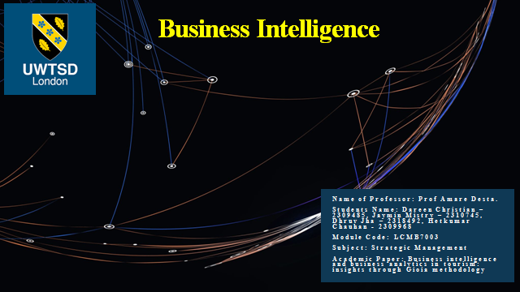

Appendix 2: Precis

Precis
This precis is done to assess the ways the implementation of business intelligence and business analytics influence the tourism industry. The journal focuses on exploring the ways both tools help to improve the tourism sector with the help of a data-focused approach.
The adoption of Business Intelligence and Business Analytics is done to deal with the operational challenge and improve customer engagement. The use of the BI and BA is influential to ensure that the future use of the resource is done to improve the data collection to assess the tourism trend.The main difference between BI and BA is that BI have an emphasis ondescriptive analysis, and BA have a specific emphasis on prescriptive analysis. BI is stated to have a diverse definition and a consensual definition that has not been established. The use of BI is done with the integration of different tools, technologies, and software that are designed to automate data analysis and gain knowledge. The BI system helps to have a data-driven decision support system that favours gaining business advantage by making data-driven decisions rather than decisions taken out of intuition. Some of the major components of BI consist of OLAP (Online analytical processing) which helps in advancedanalytics, and focuses on corporate performance with the help of Real-time BI and Data Warehouse (Jiménez-Partearroyoet al., 2024). The use of a data warehouse and different business methods are essential to yield tangible insight into tourism destinations. The use of BI is also essential to develop computational intelligence and neuroscience that helps to explore the tourism demand. The use of tourism destination competitive productivity (TDPC) is also done by nations like Thailand to advance tourism competitiveness. The integrative approach is also essential to contribute to the knowledge management that aids tourism capacity towards comprehensive growth.
Some of the major components of the BA system are Data Mining, Text Mining, Forecasting, Predictive Analytics, Optimization, and Visualization. Data mining is used to create models that help to explore unknown trends. The use of text mining is used to extract useful patterns and relationships. The use of forecasting is also done to make analysis and predict time-based processes. The use of predictive analysis is used for developing a predicting scoring process. The use of optimization is also done to simulate methods to identify the challenge. There is also a need to visualize the data exploration that ensures interactive statistics to employ statistical methods. The main benefit of these facilities is that theyhelp to adopt a more personalized approach to customer engagement. The use of BA is the influential catalyst to act as a personalized engagement to improve decision-making. Enhanced engagement and informed decision-making are influential in driving innovation in the tourism sector.
While considering the analysis of the methods, there is use of the dual methodology approach to analyze the qualitative analysis. The use of qualitative and quantitative methods is done to collect information about the trend analysis. The complex structure of the tourism industry is a key reason as it involves the restaurant, food and transport sectors.
Reference
Jiménez-Partearroyo, M., Medina-López, A. and Rana, S., 2024. Business intelligence and business analytics in tourism: insights through Gioia methodology. International Entrepreneurship and Management Journal, pp.1-35.

Appendix 3: Summary
c. Summary of the Results of Each Experiment
Summary of Tables
Research papers that investigate the application of business intelligence (BI) in the travel and tourism industry are compiled in Table 4 below. In every record, the title of the article along with its authors, the name of the journal it is published in and a summary of the key findings and recommendations of the study are provided. The papers include a description of the variety of BI approaches, including case studies using BI implementation in organizations, competitive productivity and sustainability frameworks, neural networks for demand forecasting, and BI from varying data sources. These researchers used both primary and secondary methods of data collection at the same time, the data analysis of this research was quantitative and qualitative. Secondary data were obtained from working records and databases, and primary data were from active sources like “Twitter, OpenStreetMap, TripAdvisor, and Airbnb”. Case studies and framework construction were used in qualitative strategies, while statistical results and neural network algorithms were used in quantitative research. Due to these comprehensive methods, practical recommendations regarding the potential ways of enhancing the decision-making process and competitiveness of the tourist industry were identified by researchers.
Table 5 provides the authors’ empirical findings of the number of papers on tourism and hospitality management in various publications. Two to three related papers are provided for each of the journals, which are “Tourism and Hospitality Management-Croatia,” “Information Technology & Tourism,” “Tourism Management Perspectives,” “Hotelnictvi, Turismus a Vzdelavani,” “International Journal of Contemporary Hospitality Management,” and “Journal of Destination Marketing & Management.” The approach to data collection seems secondary, because, instead of getting novel information from the primary sources. This means that because the method focuses on the total document frequency in any journal, they are quantitative. In days of identifying focus areas of these journals and the extent of the research works that appear in these journals, this type of analysis helps in evaluating the distribution of the contribution of the research in the different journals in the niche.
Regarding the specific papers associated with a given sample of tourist research articles, the ten most cited papers are presented in Table 6. It contains information about significant works within the discussed topic in terms of authors of the article, citations, and title (Jiménez-Partearroyoet al., 2024). Perhaps, the sources to obtain such statistics were bibliometric databases in terms of citations of academic publications, for instance, Scopus or Web of Science. Given the fact that it involves numerical counts of citations, the data type identified is quantitative. These citations determine the influence and its relevance in the academic community for any given publication. Researchers interested in this kind of citation data are in a position to identify key themes, seminal works, and influential authors of tourist studies. Through this chart, one can see how business intelligence, big data analytics, and sustainability are related to the field of tourist studies and how scholars can improve their understanding of its development and focal areas. The collection of data is extremely important for further research proposals and also for the enhanced understanding of critical issues that are of significant concern in tourist research.
Summary of Figures
Figure 1 is a graphical representation that indicates the number of keywords common to two sub-periods in a certain research study in the form of an overlap. The statistical data were collected out of the bibliographic data obtained from “Web of Science Core Collection (WoS)”. Since the researchers themselves did not collect this data but have used it for their study, it forms a Secondary data source. The overlaps of each sub-period are presented by the size of the arrows which indicates the number of keywords. Description of these facets appear in the text as well when deciphering the many components of the graphic. For instance, the first period of the GPS data is characterized by the beginning number of keywords as the number 37, whereas the second period is characterized by the number of keywords as the number 23. The fact that both in the first and in the second half of the period, 20 keywords are common for both approaches, is depicted by the “20” arrow. These are represented by the stability index which now moves into the post-crisis era representing the degree of overlap which has an average of 0. 87 as a fraction. The image helps constituent the two sub-periods when it comes to the continuity of the study subjects. This means that the emphasis of the study was primarily steady since it was observed that a large number of keywords remained constant between the two time periods in question.
As demonstrated in Figure 7, in two periods, there is a change in the focus from information technology and big data to business management utilizing BI and decision support systems. This information is statistically examined to investigate the characteristics, dynamics and peculiarities of adaptation and innovation of the tourist sector. It was probably obtained from secondary sources by bibliometric or content analysis methods.Figure 8 below illustrates the data structure that is generated when the Gioia technique is applied to the business intelligence of the tourist industry: The created prominence of BI relating to operations, strategic tactics and planning implications expresses the underpinning fundamental reasoning behind its application in the tourist industry. The data for this figure was collected from secondary sources only, however, data collection tools included content analysis, case studies & in-depth interviews. This type of approach helps in understanding all the direct and indirect implications that BI has on the travel and tourist business.
Thus, the study reveals that BI is an indispensable factor that positively contributes to the refinement of forecasts for enhancing the demand for tourism and the maintenance of changes in the decision-making process. BI enriches the whole process of a tourism event through the improvement of the operations and consideration of the importance of client needs. Furthermore, BI enhances the organization’s capabilities to integrate the data, which helps the travel and tourism sector adopt more ethical and sustainable approaches. Summing up the qualitative results one can state that BI has significant value in the operation and management optimization, strategies anticipation, and stability and is pivotal for the tourist sector development in general. The information presented in this chart helps analyse how BI techniques could contribute to the management of tourists.

Reference
Jiménez-Partearroyo, M., Medina-López, A. and Rana, S., 2024. Business intelligence and business analytics in tourism: insights through Gioia methodology. International Entrepreneurship and Management Journal, pp.1-35.

