Research proposal
An investigation into the marketing of successful festivals and ticket sales – a case study of Glastonbury Festival
Contents page

- Introduction…………………………………………………………….Page 2
- What is research?..........................................................................Page 2
- Aim and objectives……………………………………..…….……….Page 2
  - Aim……………………………..……………………….………Page 2
  - Objectives…………………..…………………………….……Page 2
- Rationale………………………………………………………….……Page 2
- Glastonbury Festival as a mega event………………………….…..Page 3
- History and background of Glastonbury Festival……………….....Page 3
- The theory……………………………………………........................Page 4
- Sampling………………………………………………………….……Page 5
- Why non probability sampling is more effective for this research proposal.........................................................................................Page 6
- Review of primary and secondary research………………………..Page 7
- What research will be carried out?................................................Page 7
- Primary research………………………………..………………..…...Page 7
  - Qualitative research…………………………………………..Page 8
  - Quantitative research…………………………………………Page 8
- Methodology………………………………………………………..….Page 9
- Reliability and validity………………………………………………….Page 10
- Gantt Chart……………………………………………………………..Page 10
- Appendices…………………………………..…………………………Page 11
- References……………………………………………………….….…Page 12

1.Introduction
Throughout this research proposal it will be of the investigators intention to research, display and exploit various methods of how successful festivals are still marketed despite a high volume of ticket sales. A case study of Glastonbury festival shall be used for the purpose of this research proposal.
2.What is research?
Research can be defined as an investigation into a particular study that aims to reach a new conclusion or provide additional information to an ongoing case study. Research can be carried out through primary research as well as quantitative and qualitive research. The investigator throughout this proposal will demonstrate various ways of research methods and as to why successful festivals i.e. Glastonbury festival, are still marketed despite a high volume of ticket sales and the respectable reputation the event has.
3. Aim and objectives
3.1. Aim
- To gain a clear understanding from the present investigation of why successful events such as festivals are still marketed given that tickets sell out in minutes – based on a case study of Glastonbury festival.
3.2 Objectives
- Carry out several interviews to gain extra perspective from a past event attendee
- To make recommendations of whether future mega events need to marketed
- Establish whether mega events require the need for continual marketing
- To conclude whether marketing for mega events influences the audience
4. Rationale
Whilst it is important to gain understanding of the success of Glastonbury festival, it is just as important to understand how and why they are as successful as they are compared to other festivals that are held within the U.K. the evolution of Glastonbury festival and correct market segmentation has been hugely vital to the developing growth and success of the event.
“Festivals are themed, public celebrations” (D. Getz, 2012. P51). Festivals are most commonly known to be celebrate music and arts, however, more commonly food and beverage festivals are now held. It can be underpinned that there is a wide diversity to the term ‘festival’.
It is evident to identify that festivals are evolving and are very popular with a wide range of audiences. “They have become a commonplace and no longer refer exclusively to cultural celebrations.” (D. Getz, 2012. P53). Whilst Getz states that festivals are no longer just to celebrate cultural events, this can be displayed through the growth of live music and festivals market. The live music and festival market has a value of more than £2bn and is estimated to be worth around £3.5bn by 2020. (www.telegraph.co.uk).
5. Glastonbury festival as a mega event
Glastonbury festival is classed as a mega event for several factors including: the size and scale of the event and the attendees, the economic impacts and revenue that is generated and the high amount of global media attention it attracts each year. It has been reported that BBC Music’s Glastonbury 2017 coverage attracted an audience of nearly 21 million, which is a 16% increase to BBC Music’s Glastonbury coverage from 2016. (http://www.bbc.co.uk/mediacentre/latestnews/2017/glastonbury-record-audience).
There are plenty of economic impacts that Glastonbury festival creates from using local companies based within 25 miles of the event venue, attracting tourism (national and international), generating profit for local shops and hotels and exceeds economic profits of up to nearly £80m each year. (http://www.glastonburyfestivals.co.uk/worthy-causes/local-benefits/).
6. History and background of Glastonbury Festival
Glastonbury festival is a globally known event which is furthermore categorised as a mega event. However, the event organisers continue to market for the mega event each year it is held– but do they really need to?
The 48 year old festival first began in 1970 with as little as 1500 people attending, with tickets available to purchase for a small fortune of £1. A year later in 1971, the event organisers of Glastonbury festival felt that all other festivals that were taking place were to “commercialised” and wanted to offer a USP to the market and audience. During the early 2000’s, the popularity of the festival began to soar, seeing numbers of up to 150,000 people attending. More commonly now the festival is known to be spread out over 900 acres with over 100 stages, over 2000 artists and performers with record number of festival goers attending the 5 day event.
With hundreds of thousands of hopeful attendees wishing to purchase a ticket, more are unsuccessful than successful nowadays. All ticket types for 2017’s Glastonbury festival sold out in an astonishing 50 minutes. “We are blown away by the incredible number of people from around the planet who hoped to come, with demand significantly outstripping supply.” (www.glastonburyfestivals.co.uk ) Glastonbury peaked in 2015 with the highest recorded number of festival goers whilst celebrating its 45th birthday with 253,000 attendees- making it the world’s largest greenfield festival (www.glastonburyfestivals.co.uk) . Excessive marketing can be displayed through the growth of the event and how the first Glastonbury festival only attracted as little as 1,500 event attendees. (www.mirror.co.uk/tv/tv-news/glastonbury-numbers).
7. The theory
The success of Glastonbury festival may not depend on the overall attraction of the event but on how well the marketing takes advantage of certain factors of the event including; location, competition weather, cost and entertainment. Whilst various types of research will be displayed by the investigator, relevant theories are to be applied displaying the need for marketing of already successful festivals.
“The use of marketing allows a framework for decision making, innovation and creativity” (J. Allen et al, 2002. P163). Whilst Allen et al states that correct marketing leads to innovation and creativity this can be linked with Kotler’s theory of marketing. “Marketing can be defined as the art of finding and keeping customers.” (P. Kotler, 2001. P121). Whilst Glastonbury festival has a correct structured framework of marketing in place this has led to evident innovation, creativity and the increasing numbers of event attendees. From Glastonbury festival selecting the target market this has enabled the event to keep returning customers whilst attracting new ones. “As the organisation deepens its knowledge of what the customer wants, how and why it wants it, then the organisation can deliver.” (P. Kotler, 2001. P123.)
Whilst Glastonbury festival have correct marketing techniques and framework in place this can be displayed by the success of their sell out tickets and global interest in the event. “Marketing for events requires not only working with the media and sponsors but realising what resources are required.” (L.H. Hoyle et al, 2002. P158). Glastonbury festival exploit what they have to offer via several resources including; social media, radio and their website. Whilst social media plays a huge part of the marketing for the festival, celebrity involvement massively boosts global interest and the marketing. “Using celebrities at festival can boost success , credibility and enhance the image.” (L.H. Hoyle et al 2002. P163).
With Glastonbury festival hosting some of the most in demand and successful music artists on the planet, this influences ticket sales massively. In 2016, Adele broke records and drew the biggest audience as a headliner that Glastonbury festival has ever seen. Over 150,000 event attendees stood in awe throughout the performance (www.telegraph.co.uk ). “By having celebrities you must maximise their uses and do advanced media coverage before the event.” (L.H. Hoyle et al 2002. P163). Fundamentally, ticket sales are influenced by the entertainment that the event is offering to the market.
8. Sampling
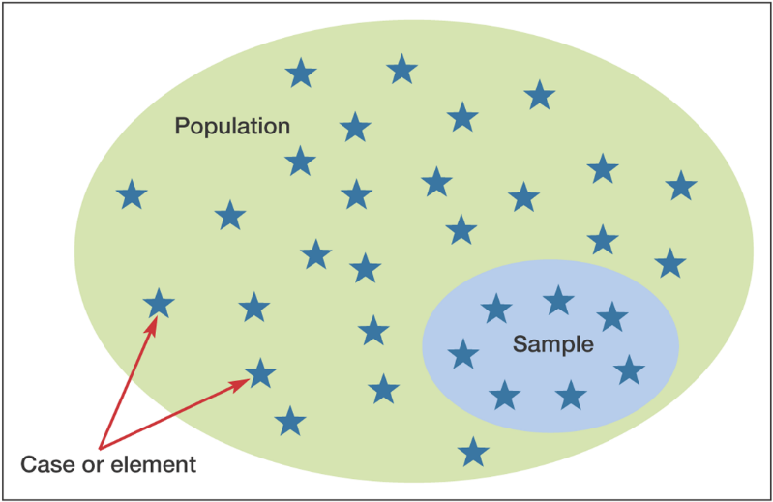
“It would be impracticable to collect data from the whole population, a sample is to be selected.” (Saunders, et al. 2007. P206). The researcher is to undertake a sampling method in order to gain additional research and data as to why Glastonbury festival still continues to be marketed. Sampling is the process of selecting a method that is able to represent the population but on a much smaller scale (Figure 1).
Figure 1. Saunders, Lewis and Thornhill (2007).
Sampling is a practical and useful method for when the researcher is collecting data as to why the mega event Glastonbury festival still uses marketing. Saunders et al theory states that there is a significant need for sampling when collecting data and choosing the correct sample method is nearly as important as carrying out the sampling. Saunders et al furthermore states that once the data is collected from the selected sample population it is key to use and calculate the data correctly otherwise this can result in impractical and wasteful data.
The researcher for the proposal will select the most effective sampling method in order to carry out and complete data collection which has the most useful result.
When using sampling in research there are two variations – probability and non-probability (Figure 2). For the basis of the researcher, non-probability sampling with quota sampling characteristics shall be carried out to result in specific, accurate and reliable data.
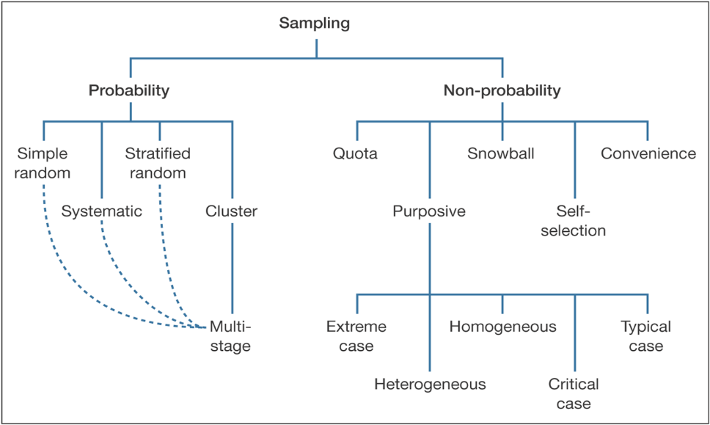
Figure 2.

9. Why non-probability sampling is more effective for this research proposal
From using the non-probability method of sampling this allows the researcher to use a specific group of the population with categories of which relate to the proposed research. The population of who will be used for data collection for the researcher are those who have attended Glastonbury festival and are most relevant to the topic.
Similarly, quota sampling method will also be used by the researcher, although it is non-random like non-probability sampling, it has the most common use for interviews and surveys- which are due to be carried out by the researcher.
Non- probability sampling can be seen as the most effective method to use when resourcing data as to why Glastonbury festival needs to be marketed. The method is easy and practical to use by the researcher on the sampling group.
10. Review of primary and secondary research
Primary research is created and carried out by the investigator to meet the unique and specific needs of the data needed. Primary research can be collected in various forms such as; interviews, surveys and observations. Differently, secondary research is when the researcher uses already collected data and applies it to the research case.
11.What research will be carried out?
Part of the research that will displayed throughout the proposal is to be collected by the investigator via primary research. A collection of primary research is to be gathered by the investigator including several in depth interviews and 100 completed questionnaires from past event attendees. From collecting this primary research it allows the researchers to gain an understanding of how Glastonbury’s marketing may have persuaded the past event attendees to definitely attend the event. Light research of how Glastonbury use social media platforms to market the mega event will also be exploited throughout the proposal.
12. Primary research
By collecting data via questionnaires and interviews this allows the investigator to resource information which is important for the final conclusion of the overall proposal. (appendix 1). Primary research can collected by qualitative and quantitative methods. Quantitative data is primarily going to be used by the investigator through the use of 100 completed questionnaires and several interviews.

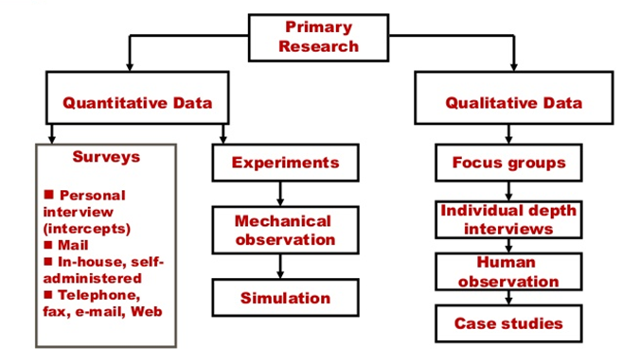
Figure 3.
From collecting primary research via quantitative and qualitative data, the researcher will be able to find advantages and disadvantages of collecting data with this method.
12.1. Qualitive research
When collecting primary research this can be split down into quantitative and qualitative data, both of which have advantages and disadvantages of using them. Qualitive data is used by a researcher to gain an in-depth understanding of information and focuses more on a specific attribute such as gender. In contrast, quantitative research is used by determined behaviours, opinions and experiences (Figure 3).
Advantages
  - Accurate information as it is based on real experiences/observations
  - Non biased data
  - Easy to produce data collection methods e.g. survey or questionnaire
  - Smaller amount of individuals used to collect the research
Disadvantages
  - Cannot be converted into a numerical form of data
  - Can often be time consuming
  - Often difficult to present the collected data
  - Not statistically based
12.2 Quantitative research
Similarly, when the investigator uses quantitative research to collect data there are advantages and disadvantages of this method which include –
Advantages
  - The researcher is able to measure and analyse the data easily
  - Easy to test against the hypothesis due to the ability to measure the data from the statistics collected
  - Enables a variation of methods used to collect the data
Disadvantages
  - a larger section of the population must be studied for more research to be collected in order for the statistics to be as accurate as they can be
  - individuals asked for the quantitative data may not be completely honest or may over exaggerate.
  - May be seen to be time consuming – waiting for questionnaires and interviews to be completed
13. Methodology
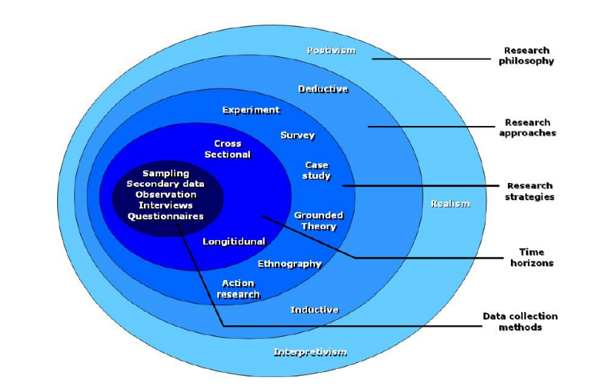
Figure 1. The research onion, Saunders (2007).
When gathering research there are various methods and pathways that can be taken in order to complete this.
The purpose of collecting data for the research proposal is to obtain, record, use and to make a conclusion from the gathered data.
Within this research proposal, the investigator is to use a mix method approach in order to complete the investigation.
Saunders et al (2009) uses the ‘research onion’ to breakdown the effective progression of research, subsequently from this a research methodology can be designed from it by the investigator. Each outer circle represents an individual stage which is more in-depth and a critical review of the data collected for the research proposal. Figure 1 of Saunders et al theory (2009) can be applied for the investigator to determine whether mega events need to be marketed still.
By using a mix method approach within the research proposal it enables the researcher to gather all research and information that is relevant to the research proposal. In addition, by using a mix method approach this also allows the researcher to use qualitive and quantitative research to its best advantage.
14. Reliability and validity
“The use of reliability and validity are most common in quantitative research and is also considered in qualitative research” (N. Golafshani, 2003. P596). By using the primary research method to collect the quantitative data needed for the research proposal, this results in the research are to be reliable and valid due to the data being the most relevant and reliant as the research is collected straight from the specific group. Reliability and validity is used as an extra approach and method in collecting the quantitative data needed for the research proposal.
15.Gantt chart
From the Gantt chart that has been produced (appendix 1), this allows the timeline frame of what tasks need to be completed for the research proposal over a dissertation period time frame and when they should be completed by. The Gantt chart allows the investigator to breakdown the overall proposal into small and manageable sections (appendix 1).

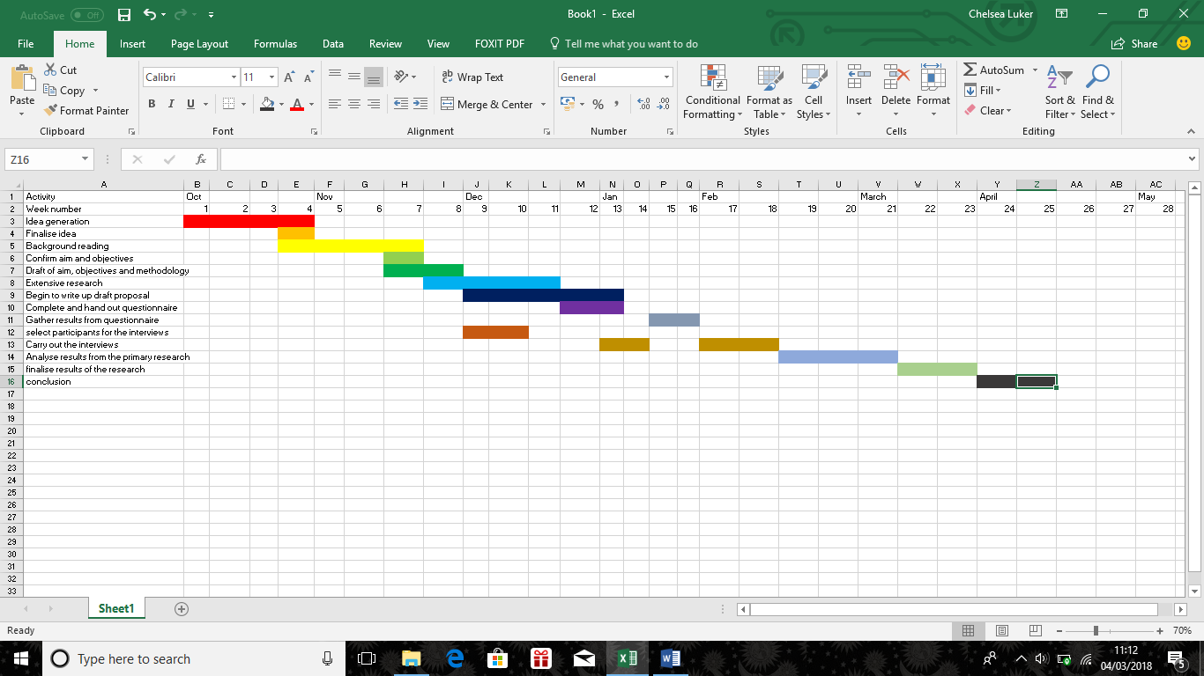
Appendices (1)

References
Books
Donald Getz (2012). Event Studies. 2nd ed. Abingdon: Routledge. P51, P53.
J. Allen, et al (2002). Festival and special event management. 2nd ed. Australia: John Wiley and Sons. P163.
L.H. Hoyle, Jr., CAE, CMP (2002). Event Marketing. Canada: unknown. P158, P163.
M. Saunders, P. Lewis, A. Thornhill (2007). Research Methods for Business Students. 4th ed. England: Pearson Education Limited. P206
P. Kotler (2001). Kotler on Marketing. Great Britain: A Viacom company. P121, P123.

Article
N. Golafshani. (2003). Understanding Reliability and Validity in Qualitative Research. The Qualitative Report. 2 (6), P596.

Websites
Bob Shennan. (2017). BBC Music’s Glastonbury 2017 coverage attracts record audience of almost 21 million. Available: http://www.bbc.co.uk/mediacentre/latestnews/2017/glastonbury-record-audience. Last accessed 23/02/2018.
Carl Greenwood. (2015). Glastonbury by numbers. Available: https://www.mirror.co.uk/tv/tv-news/glastonbury-numbers-153000-325-million-5913132. Last accessed 20/02/2018
Glastonbury Festival. (2018). History. Available: http://www.glastonburyfestivals.co.uk/history/2015-2/. Last accessed 21/02/2018
Glastonbury Festival. (2018). Local benefits. Available: http://www.glastonburyfestivals.co.uk/worthy-causes/local-benefits/. Last accessed 23/02/2018.
Sam Dean. (2016). Do the number of music festivals actually make any money?. Available: http://www.telegraph.co.uk/business/2016/07/02/do-the-growing-number-of-music-festivals-actually-make-any-money/. Last accessed 21/02/2018.

