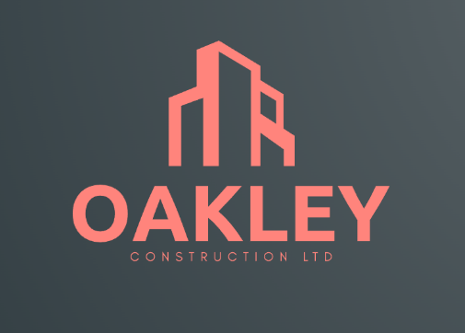
Oakley Construction Ltd
Unit 2 Llanelli Industrial Estate
Woodville Road
LLANELLI
SA15 4FG
20th March 2022
Mr. David Richards
Swansea City and County Council
Civic Centre
Oystermouth Rd
Maritime Quarter
SWANSEA
SA1 3SN

Dear Mr. David Richards
RE: Ysgol Bae Abertawe and BIM level 2 compliance
As Oakley Construction Ltd are the lead consultant appointed to carry out this scheme, we will be overseeing the project from the original brief to the operation in use. We understand the requirement of the Ysgol Bae Abertawe project achieving BIM Level 2 and this is done by adhering to the necessary processes in ISO 19650. Every stage of the project will have key BIM tasks to implement, and each tasks needs to be carried out in accordance with ISO 19650. We understand that on the surface BIM seems confusing, and the benefits can be difficult to see especially from the client’s point of view. Therefore, I am writing to you today to explain how greater efficiencies can be realized when BIM level 2 is adopted.
BIM level 2 requires information to be shared, coordinated, and managed in a collaborative manner. It also dictates “what, when and how this information should be created, shared and managed” (Autodesk, 2016). In a nutshell, by receiving your EIR’s (employers information requirements) we will collaborate with our designers and specialist contractors and produce individually authored models. By utilising a common classification of data and information exchange methods a federated model will be created, which will serve as the communal basis for which the project is built on.
At the briefing stage of the project a CDE (common data environment) will be established. As outlined in ISO 19650 this is a agreed source of information for the project and it will serve to collect, manage and disseminate each information container through a managed process (ISO, 2018). This will take the form of a file-based retrieval system (McPartland, 2016), similar to the server that Swansea Council undoubtably use on a day-to-day basis. This single source of information will contain graphical data such as architects and engineers’ drawings, as well as non-graphical data such as schedules and specifications. This data and information will be easily accessible due to the use of naming conventions, as set out in the ISO standards. Naming conventions are a standard format of naming which will be universally implemented and used by the project team.
Following the establishment of a CDE, full attention will be paid to the preferred design option required to fulfil your brief. A preferred design option will be chosen through analysing initial models to establish if the design meets the required outcomes. The benefit of creating this initial model is the ability to utilise early contractor involvement and benefit from expertise from different principles. At this stage BIM truly begins to come to life, with the collaborative aspect coming to fruition. From analysing the initial model, the concept design and PIM (project information model) will be progressed to a stage whereby the design can be coordinated across the various design disciplines (Scottish Futures Trust, 2022). Here clash detections can be made and resolved by undertaking model reviews and collaborative workshops. Being able to resolve these types of issues at the design stage will be much less costly than resolving these issues when they arise at the construction stage. This is one way that you as a council may save on costs by adopting this level of BIM maturity. By adhering to clause 11.2 in ISO 19650:1 standard each discipline’s designer will establish the level of information needed and then take ownership of their own work prior to issuing it to the CDE.
At this stage in the design process, we will already be able to estimate and therefore agree a first stage target price. This is because the models will portray a 3D representation containing a specification. Here the models will contain the details of space allocation, assembly and performance of the different components. Once the PIM is advanced enough that it is dimensionally correct and technical definition is established, we can then verify it’s compliance with the Building Framework for Primary School Projects, which the Welsh Government will require this project to follow. The safety of the proposed school will also be established prior to construction as the models will provide adequate information to be able to conduct a risk management plan and health and safety planning.
At the build and commission stage of the project, the time allocation from your point of view as the client will be greatly reduced. The PIM would still be under development; however, we will not have to have exchanges with yourselves. The exchanges will now be between ourselves as the lead consultant and our supply chain to replace any generic components with the components procured by the manufacturer. We will ensure to deliver ‘as constructed models which will encompass operation and maintenance data from our manufacturers. This will benefit yourselves greatly as all the components and processes that the school building will entail, will have operational and maintenance instructions to accompany them. This will save a lot of time for school care takers and other staff who will be operating in the school and allow more time to be allocated to teaching the children and providing as best of a learning experience as possible.
At the greatly anticipated handover stage, your exchange information requirements and the newly completed project information model will be collated into the AIM (asset information model) which will aid in managing, maintaining and operating the school building. The AIM will be the all-encompassing source of information relating to the operation of the school. It is vital that the AIM is maintained through a CDE and that there is a strategy for maintaining it. As the lead consultant, we will provide you with the necessary guidance and assistance needed to do this.
I hope that the complex perception of BIM has been changed for yourselves after reading this letter, and that you now understand how beneficial this level of maturity of BIM will be for Ysgol Bae Abertawe and it’s pupils.
Yours Sincerely, Nathan Davies, Oakley Construction Ltd

Project: Ysgol Bae Abertawe
Project number: 5010
Client: Swansea City Council
Lead Consultant: Oakley Construction LTD

Project | Originator | Functional  Breakdown | Spartial  Breakdown | Form | Discipline | Number | Description | Status | Revision
5010 | OCLTD | XX | XX | T | Z | 1001 | BEP | S2
BIM Execution Plan

Executive Summary
This BEP (BIM execution plan) outlines the delivery plan which will be implemented by the delivery team as a response to the received tender documentation (BSI, 2021). BIM entails the use of advanced design technologies, and this BEP will aid in the successful deployment of these technologies by helping the delivery team to focus on the important details. This comprehensive document includes things such as who will be providing information, who will be responsible for key roles, standards and procedures to adhere to and I.T solutions. By defining all this information, work and model flow can be optimised across the whole life cycle and stakeholders of the project.

Executive Summary
Contents
Executive Summary 5
1. Project Information 7
1.1 Project Details 7
1.2 Project Description 7
2. Management 8
2.1 Roles, Responsibilities and Authorities 8
2.2 Major Project Milestones 10
3. Planning and Documentation 11
3.1 Agreed project processes for collaboration and information modelling 11
3.2 Task information delivery plan (TIDP) 11
3.3 Master information delivery plan (MIDP) 11
4. Standards, Methods and Procedures 13
4.1 Federation Strategy 13
4.2 Naming Conventions 13
4.3 PIM Origin and Orientation 14
5. I.T Solutions 15
5.1 Software Versions 15

Project Information

Project Details
Employer’s Name | Swansea City Council
Project Name | Ysgol Bae Abertawe
Employer’s Project Code | 5010
Contact | Stephen.graham@swanseacouncil.co.uk
Project Address | The Slipway, Maritime Quarter, Swansea, SA1 1FZ
Project Value | £12 million
Contract Type & Delivery Method | NEC3 – Option A (Lump Sum)
Anticipated Start Date | 06/06/2023
Anticipated End Date | 05/08/2024

Project Description
The project of Ysgol Bae Abertawe is a new build primary school consisting of a one form entry infant school for 90 pupils with a 48 part time nursery pupils’ provision. The existing site contains a small building, and a wall which will be demolished prior to the construction of the primary school and associated hard landscaping.
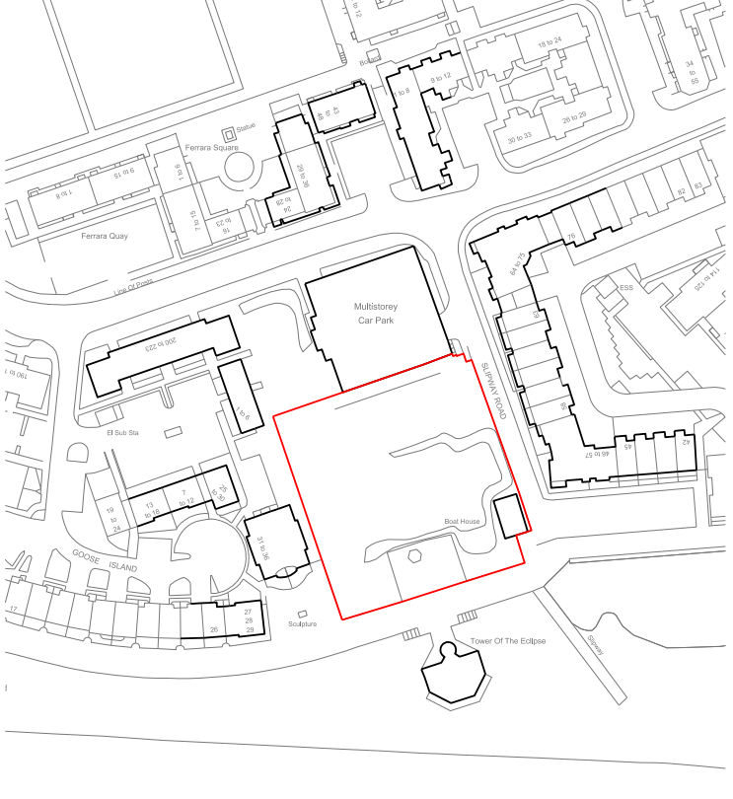
Location of the proposed and project and immediate climate.

Management

2.1 Roles, Responsibilities and Authorities
The below table details the individuals and their respective organisations undertaking the information management responsibilities, as outlined within Figure 9 of ISO 19650:2. These specialist contractors have been chosen by considering the projects information requirements as outlined in ISO 19650:1 5.1.2.
Name | Company | Role | Resources | Contract Information
Stephen Graham | Swansea City Council | Client | K1 | Stephen.graham@swanseacouncil.co.uk
Nathan Davies | Oakley Construction Ltd | Lead Consultant | LC1 | Nathan.davies@oakleyconstruction.co.uk
Rowan Lovering | Lovering Mechanical | Mechanical | M1 | Rowan@loveringmechanical.co.uk
Mike Davies | Davs Electrical | Electrical | E1 | Mike@davselectrical.co.uk
Lee Dunsford | Dunsford’s Architects | Architect | A1 | Ldunsford@dunsfordarchitects.co.uk
Adam Wilson | Wilson Associates | Engineer | S1 | Adam@wilsonassociates.co.uk

Table 1 – Individuals and Organisations
Outlined in the below table are the Employer’s Representative responsibilities that apply to each individual.
Responsibility | Resource
Capture Key Decision Points | LC1
Produce Plan Language Questions | LC1
Capture Required Standards, Methods and Procedures | LC1
Ensure the Appointment of a project Information Manager | A1
Review the Supplier Information Exchanges against the EIR | LC1
Table 2 (Rossiter, 2016) – Employers Representative responsibilities

Outlined in the below table are the Project Information Manager responsibilities that apply to each individual.
Responsibility | Resource
Enable Information Exchanges through a CDE | **
Maintain and Receive Information into the Information Model | A1
Enable Integration and Coordination of Information | A1
Configure Information for Projects Outputs | A1
Populate the Information Exchange Format | A1
Accept/Reject Information Exchanges | A1
Table 3 (Rossiter, 2016) – Project Information Manager responsibilities

Outlined in the below table are the Project Delivery Manager responsibilities that apply to each individual.
Responsibility | Resource
Assure Delivery of Information Exchanges | A1
Confirm Suppliers Ability to Deliver Information Requirements | **
Accept/Reject Information Exchanges | A1
Table 4 (Rossiter, 2016) – Project Delivery Manager responsibilities

Outlined in the below table are the Lead Designer/Contractor responsibilities that apply to each individual.
Responsibility | Resource
Coordinate Delivery of all Design Information | LC1
Manage Information Development and Information Approvals | LC1
Confirm Design Deliverables | LC1
Overall Lead for Configuration Management | LC1
Confirm Status and Approve Information for Issue | LC1
Approve Design Charges Proposed to Resolve Clashes | LC1
Table 5 (Rossiter, 2016) – Lead Designer/Contractor responsibilities

Outlined in the below table are the Task Team responsibilities that apply to each individual.
Responsibility | Resource Arch | Resource Mech | Resource Elec
Production of Design Outputs Relates to Specific Tasks | A1 | M1 | E1
Issue Approved Information | ** | ** | **
Direct the Production of Information in Compliance with SMP | A1 | M1 | E1
Direct the Production of Information Using Agreed Systems | A1 | M1 | E1
Confirmation that information is suitable for Issue | A1 | M1 | E1
Manage Spatial Coordination im behalf of the Task Team | A1 | M1 | E1
Propose Resolution to Coordination Clashes | A1 | M1 | E1
Develop Constituent Parts of the Information Model | A1 | M1 | E1
Production of Project Outputs | A1 | M1 | E1
Table 6 (Rossiter, 2016) – Task Team responsibilities

2.2 Major Project Milestones

Start Date | Design Completion | Detail Design Completion + Fabrication | Construction | As Constructed Models, Documents and Date | Handover
29/04/2022 | 15/12/2022 | 12/03/2023 | 06/06/2023 | 14/07/2024 | 14/08/2024

Planning and Documentation

Agreed project processes for collaboration and information modelling
Company | Solution | Network | Database | File based | Comments
Dunsford’s Architects | Revit | Revizto | Model | RVT
Wilson Associates | Revit | Revizto | Model | RVT
Oakley Construction | Revit | Revizto | Model | RVT
Dunsford’s Architects | Solibri | Revizto | Model | IFC | Clash Detection

Task information delivery plan (TIDP)

Each task team shall establish and maintain throughout it’s appointment a TIDP (ISO, 2018).
The TIDP must contain the following for each information container:
- Name and title
- Procedures or dependencies
- Maturity of information required
- Anticipated duration of production
- Key delivery milestones

ISO 19650:2 5.4.4 states that each task should consider the following when producing the TIDP:
- The projects information delivery milestones
- Their responsibilities detailed in the responsibility matrix
- Information requirements outlined by the lead appointed party
- Timescale of the task team in producing information

Master information delivery plan (MIDP)

The MIDP is established by the lead appointing party collating the TIDP from each task team (ISO, 2018)
ISO 19650:2 5.4.5 states that lead appointed party should consider the following when producing the MIDP:
- Responsibilities outlined in the responsibility matrix
- Information predecessors or dependencies on information between task teams
- Time needed to review and authorize the information model
- Time needed to review and accept the information model

Upon establishment of the MIDP, the lead appointing party shall baseline the deliverables and dates within the MIDP. Also they must notify each individual task team if any alterations need to be made to the TIDP. The appointing party must also be made aware of any risks or issues which could potentially impact the information delivery milestones of the project.

Standards, Methods and Procedures

4.1 Federation Strategy
A very important procedure that’s implemented within BIM is the Federation Strategy. It’s purpose is to aid in the plan production of information by each task team to the suitable level of information. It does this by outlining how the information model should be divided into multiple sets of information containers. This strategy is to be carried out when doing information planning activities.

4.2 Naming Conventions
To gain the benefits that are available by achieving a fully collaborative BIM process, common language and the standardised terms are necessary. The models being produced by each task team (both graphical and non-graphical) must be authored to a agreed industry standard.
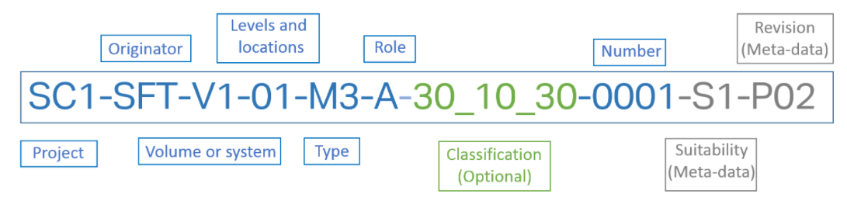

(Scottish Futures Trust, 2021) – File naming convention example under ISO 19650:1
Project: This is the project code. The code should be between two and six characters in length and can consist of letters and numbers. This code must be used across all organisations on the project.
Originator: This refers to the originator of the information. The code should be between three and six characters long.
Volume of System: Relates to the spatial sub-division of the project and can be one or two characters.
Levels and Locations: This also relates to spatial sub-division of the project and also consist of two characters. The different classes of levels and locations are levels and locations, floor levels, mezzanine levels and below ground floors.
Type: This is a standard code used to show what type of container the document is.
Role: This section of the naming convention is used to outline what role explicitly the organisation in question does.
Classification (Optional): This is an optional field that helps describe the asset represented using the chosen reference dictionary.
Number: If the container is one of a series then the number should be used. Four integer numeric digits used sequentially is the format for this field.
Suitability (Meta-data): There are four categories of statuses in this field. These are Work in Progress, Shared (Non-Contractual), WIP to Publish and Published Documents. Each category has their own sub categories and each sub category has it’s own two character code that appears in the naming convention.
Revision (Meta-data): This can be a numerical or letter code to describe what revision the information container is.

4.3 PIM Origin and Orientation
Reference | Position
Ground Floor FFL | 0 (mm)
Project Base Point | 00000N, 00000E(mm)
Building Point 1 | 192364.7N, 265976.9E (mm)

I.T Solutions

Software Versions
The software and their versions are confirmed prior to the beginning of the project. Project deliverables should only be produced using only the software outlined in the below table. No software shall be upgraded beyond the versions outlined in the table below. Doing so could cause implications due to separate teams operating on technically differing software.
Company | Purpose | Software | Versions
Autodesk | 3D Modelling | Revit | 2021
Adobe | 2D drawings and documentation | PDF | 2021

In Text Citation | Full Reference
Autodesk, 2016 | Autodesk Inc. 2016, Autodesk BIM 360, What is BIM Level 2?...Glad you asked
ISO, 2018 | BSI Standards Publication 2018, Organization and digitization of information about buildings and civil engineering works, including building information modelling (BIM) – Information management using building information modelling, Part 1: Concepts and principles
McPartland, 2016 | Richard McPartland 2016, NBS, What is the common data environment (CDE)?
Scottish Futures Trust, 2022 | Scottish Futures Trust 2022, Building Information Modelling, Welcome to BIM Level 2
BSI, 2021 | BSI 2021, Little Book of BIM
Rossiter, 2016 | Dan Rossiter 2016, There’s no BIM like home
ISO, 2018 | BSI Standards Publication 2018, Organization and digitization of information about buildings and civil engineering works, including building information modelling (BIM) – Information management using building information modelling, Part 2: Delivery phase of the asets

