Kimberley Robinson 1707907
This essay will analyse funerary evidence associated with the Iron Age site at Brisley farm in Kent. It will use the evidence to identify the differences in social status within the community by looking at the end of life rituals. The grave goods in the burials give an understanding of social status within the community in which the tombs were found. The style of the entombments will give an understanding of origin, and connection with the Hallstatt and Le Tene cultures on the continent. This shows that an Identity has an ability to migrate and be valued by new communities, by adopting new ways to live and ways to cherish the dead. The Iron Age knowledge was first publicised by a Danish archaeologist Called C.J Thomsen in 1836. But it wasn’t until the excavations at Hallstatt from 1846 until 1862 and the finds in Le Tene in 1858 that a chronological record could be made Barry Cunliff, Iron Age communities in Britain (2005 p90). Subsequently the archaeologists, P. Reinecke, J Dechelette and R. Viollier made classifications by studying types and styles of the material from these different areas creating distinctive cultures. (B, Cunliffe 2005 p90). The large settlements communities were using in the Iron Age were called oppida, oppida first started to appear in Britain in the early Iron Age (Tom Moore and Hasselgrove 2007). Tom Moore and Hasselgrove, the later Iron Age in Britain and beyond (2007 p87) state that’ “British oppida or territorial oppida are defined by imposing, embanked, discontinuous linear earthwork”. In this essay one of the religious sites in one of these communities will be discussed.
One of these communities was discovered at the excavation’s at Brisley Farm in Kent in 1989 unearthing several remains. Within the area cremation remains were also found both human and animal (Moore and Hasselgrove 2007). Within the boundary of the settlement along with the evidence of cremations was two very different graves, they date from AD 10, and around the time of the conquest AD 40–50 (Johnson 2002 p 15) these graves were a distinct feature on the landscape, it has been suggested both burials were surrounded by square ditched enclosures, the up cast from which would have formed low barrows over the burials which then became focal points in the land (Johnson 2002 P16). This act of purpose build architecture was meant to sustain a memory over the years. In Iron age Britain currently excarnation was a usual method for burial practice, opening questions as to who these two individuals were. Below is a plan of the site (Casper Johnson Archaeology International 2002)
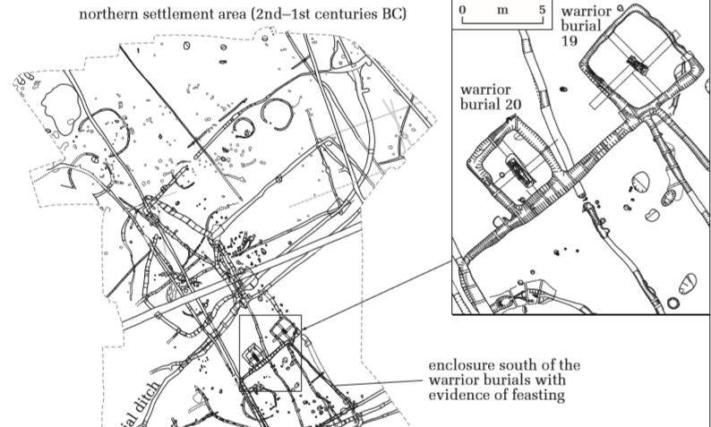
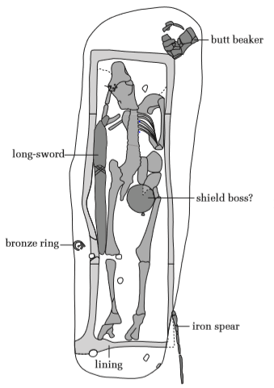
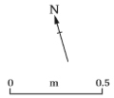
The first grave (see right) held a man of about 5ft 10 he was buried pointing north (Casper Johnson Archaeology International p16 2002) the man was laid out flat on his back. Which is rare in Iron age Britain, this tradition was derived from the continent. (Moore and Hasselgrove 2007 p91) He had the remains of weapons including a long sword shield boss, and iron spear. This evidence suggests he was an armed man when he was alive, he could have been someone that protected his community. Also discovered was a bronze ring, he was a man who thought about his appearance if it was his in life. The beaker found at the remains head was an imported beaker, being Gallo-Belgic. All other metal work from both graves was said to come from Britain (Moore and Hasselgrove 2007 p90). This man had obviously had status but what that was is hard to tell. His sword was half drawn as if readying for battle, his grave was well made a dug deep (Johnson 2002) Johnson (2002 p16) writes that this grave ‘ had Deliberately broken pottery vessels, and cremated and unburnt animal bone (mostly cattle teeth and jaws), were deposited in a ditch running along the southern side the of the boundary’ this evidence concludes that there was some sort of feasting or celebration. Adding to the importance of this man.
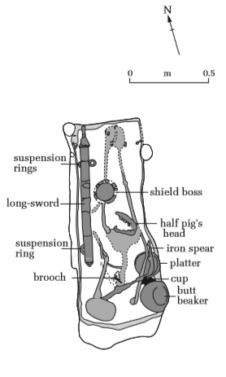
The second warrior grave (see right)(Casper Johnson 2002) was made a decade later. This young man was only 5ft 2’ tall he was buried with his head south. His weapons consisted of a long sword with suspension rings a shield boss and Iron spear (Johnson 2002 p17). For a long sword to have had to be suspended it could be possible this man was a mounted warrior, The body was twisted, with the hips pushed over towards the east wall of the grave and the feet placed centrally, but the head in the southwest corner (Johnson 2002 p17). This evidence could be the clue to his death, he could have fallen from his horse in battle or even been decapitated. his grave goods also included a Brooch, these fibulae were used to fasten clothing and this style has been found in Iron Age burials in Europe. Borislav Jovanovic (2014 p 28) confirms by saying these types of fibulae are indisputable diagnostic elements crucial for determining the relative and absolute chronology of La Tene artefacts and structures’. Also, in with the grave goods, Johnson (nd p16-17) describes: ‘there was a platter with a maker’s stamp (CANICOS-) on it and is known to have been made at Sept-Saulx in the Main area of northern France, sometime between AD 20–25 and AD 40–45.8’. Along with this was a cup and butt beaker with the same origins as the first grave. In this grave was half a pig’s jaw. Pig offerings are consistently associated with the richest burials in respect of the rite (Moore and Hasselgrove 2007 p90). The pigs head isn’t entire, just a jaw to represent the pig. This grave was dug in a hurry or with less respect as the grave is shallow, and the hilt of his sword pointing down to his feet. This could be a sign of disrespect or It is possible the death was unexpected. It is suspected that both coffins were made of a wicker material. (Johnson 2002) for someone to weave a wicker coffin either represents care and love for the person in the time spent making it. Or there could be a religious reason.
It is likely that this burial type was introduced from the continent, where it has been documented across from France to Hungary, starting in the middle of the first millennium BC and fading out with the development of the Roman Empire. By the time of the warrior burials at Brisley Farm (AD 10–50) the custom seems to have all but disappeared on the continent. These two men could have been from Europe, but they had British metal work in their graves (Johnson 2002 p17). Whatever these men’s Identity, they were thought of fondly by their community, as their burials are not like the rest of the communities as several cremation cemeteries are evident in the area. as Moore and Hasselgrove (2007 p89) point out excarnation was deeply rooted in the Iron age in southern Britain. This points out the likelihood of this area at Brisley Farm being a sacred site, with these warriors as a prominent feature as that they must have been a very important part of British history. As they are buried a decade apart and the second warrior being younger and smaller it is possible, they could have been related, perhaps farther and son.

Bibliography
Cunliffe, B, 2005. Iron Age communities in Britain. 4th ed. Oxon: Routledge.
Hasselgrove, C, and Moore T, 2007. The Later Iron Age in Britain and beyond. 1st ed. Oxford: Oxbow Books.
Johnson, C. (2002). Two Late Iron Age warrior burials discovered in Kent. Archaeology international, file:///C:/Users/Student/AppData/Local/Packages/Microsoft.MicrosoftEdge_8wekyb3d8bbwe/TempState/Downloads/121-636-1-PB%20(1).pdf (Accessed January 16th 2019).
Jovanovic, B, 2014. The Eastern Celts and their invasions of Hellenistic Greece and Asia Minor.

