Software Development Assignment -

BSc/HND Computing Portfolio, School of Applied Computing
  - Daniel Adam Carlson 2001079

Table of Contents
Introduction 2
Part A – Understanding 2
1. What is a variable and why are they important in writing programs? 2
2. Explain what an if/else statement is, how and why they are used, and give a code example of when you would use one. 3
3. Explain why loops are needed in a program and when you might use a for and a while loop. 4
For Loop 4
While Loop 4
Part B – Implementation 6
Scenario 1 – Car Details 6
Logical Steps: 6
Code with annotation: 6
Testing 7
Scenario 2 – Vegetable Bed 8
Logical Steps: 8
Code with annotation: 8
Testing 9
Scenario 3 – Store Items with Discount 10
Logical Steps 10
Code with annotation: 10
Testing 12
Scenario 4 – Treasure Hunt 13
Logical Steps 13
Code with annotation: 13
Testing 15
References 17

Introduction
For me to accurately present this report I must first understand what exactly python is. As stated by python.org:
Python is an interpreted, object-oriented, high-level programming language with dynamic semantics. Its high-level built-in data structures, combined with dynamic typing and dynamic binding, make it very attractive for Rapid Application Development, as well as for use as a scripting or glue language to connect existing components together. [1]
Within this report/assignment I will be answering some python software related questions in detail based on the general knowledge of a python programmer. I will also code and produce the solutions to the coding scenarios presented within this assignment.

Part A – Understanding
The first part of the assignment is my understanding of the python software. I have been set certain questions to answer based on the python software. Below are both the questions and my in-detail answers.

1. What is a variable and why are they important in writing programs?
To answer this question, I must understand what is a variable? There are many different definitions of what a variable is, but they all differ based on the programming language used. Within python variables have no specific command or value. Tutorials Point clearly stated that “Variables are nothing but reserved memory locations to store values. This means that when you create a variable you reserve some space in memory.” [2] In essence variables are used to help quantify certain commands and values e.g., String and Integer.
When we define the variable above it seems as though they sound useless but, the main and most important use of variables is writing programs. We can say that variables are the most important function to write a program efficiently and properly. As stated by V. Beal:
Variables play an important role in computer programming because they enable programmers to write flexible programs. Rather than entering data directly into a program, a programmer can use variables to represent the data. Then, when the program is executed, the variables are replaced with real data. This makes it possible for the same program to process different sets of data. [3]
Without variables each program would be unable to be flexible and would only be able to use constants in which are values that are unable to change and therefore there would be essentially no user input available. Each variable is set into a specific data type which shows its value within the program for example, a string would show that only letters and symbols would be allowed where if an integer would be used then any number could be used etc.

2. Explain what an if/else statement is, how and why they are used, and give a code example of when you would use one.
An If/else statement can be used in several different scenarios based on the conditions required by the user. An if/else statement are considered as one statement but are 2 blocks of code. If we needed a certain value to be true, then the if statement would be used but if then that if value changed to false then it would proceed to the else statement for further action within the program. This is stated by A. Biswal when they explain that:
The if-else statement is used to execute both the true part and the false part of a given condition. If the condition is true, the if block code is executed and if the condition is false, the else block code is executed. [4]
Therefore, the if/else statement can be a very useful and important tool within different programming software’s. When we use If/else statements within mathematics we need to use different symbols to show what we wish to do, I have shown below what different symbol commands are recognized by python when using if/else statements:
- Equals: a == b
- Not Equals: a != b
- Less than: a < b
- Less than or equal to: a <= b
- Greater than: a > b
- Greater than or equal to: a >= b [5]
I will now show a brief demonstration on how if/ else statements are used. My example will be that the user must enter their age, but it must be above 18 or they will be asked to try again:
# Here I will demonstrate how to use an if/else statement based on a age scenario where the user must enter an age of
# 18 or higher otherwise they will be asked to try again
print("Enter your age, it must 18 or more:")
userAge = int(input())
if userAge >= 18:
print("Thank You", "You are", userAge, "years old")
else:
print("Please Try Again, Remember it must be 18 or more")
userAge2 = int(input())
if userAge2 >= 18:
print("Thank You", "You are", userAge, "years old")
Above is a good example of how this is implemented within a simple program. The is/else statement is an extremely useful tool within programming.

3. Explain why loops are needed in a program and when you might use a for and a while loop.
When programming within python the use of loops is a very effective way of one reducing the amount of code within the program but also a perfect way of categorizing different functions and code within that specific program. The two main loops within python that are used are the for and while loops.

For Loop
When using a for loop it is mostly associated with lists and different strings of words. As stated by w3schools:
A for loop is used for iterating over a sequence (that is either a list, a tuple, a dictionary, a set, or a string). With the for loop, we can execute a set of statements, once for each item in a list, tuple, set etc. [6]
The for loop can be used in several different scenarios but I will demonstrate a simple for loop scenario below, in this scenario I have created a list of capital cities and will print them in 2 parts using a for loop. The code for this is displayed below:
# I will print a list of different capital cities of the world
capitalcity1 = ["Dublin", "Cardiff", "London"]
# This is the created list of capital cities
capitalcity2 = ["Paris", "Rome", "Sydney"]
# Split into 2 for ease of reading
for x in capitalcity1:
print(x)
if x == "London":
print(capitalcity2)
For loops are an easy and helpful way of easy of programming and an easy way to create and display lists such as the one shown above. Next, I will explain the final loop most used in python which Is a while loop.

While Loop
A while loops are used based on true or false inputs for example, if x were equal to 6 then the loop can continue but if it were less than or more than 6 then the loop would not continue. For a while loop to continue all the input statements must be true otherwise the loop will fail to proceed. As said by tutorials point “A while loop statement in Python programming language repeatedly executes a target statement as long as a given condition is true.” [7]

Below I will demonstrate a quick example of a simple while loop, I will create a simple mathematical question and code this in by using while loops:
# If I had a 2 litre bottle and drank 1.25 litres how much would be left?
guessTrue = int("0.75" or "750")
userInput = int(input("What is the Answer?"))
while userInput == guessTrue:
print("Well Done, you guessed Correctly")
else:
print("Incorrect, Good Luck Next Time")
By using the while loop I was able to tell python that only when the answer was correct the message of well done would be displayed otherwise it would continue onto the else statement instead. These loops are an effective way of creating different functions and scenarios in as little amount of code as possible. By using For and While loops it ensures that both the appearance and structure of the program is effective and correct.

Part B – Implementation
In this part I will be required to create solutions to certain scenarios with ranging difficulties. I will set this out as clear as possible based on the scenario given. I will start below:

Scenario 1 – Car Details
I will create a program here which will allow the user to enter certain variables based on the questions given for example car model and milage.

Logical Steps:
- Prompt user to input different values e.g., Car Make.
- Make sure it corresponds to the set variable e.g., Integer or String.
- Display that inputted variable for the user to see.

Code with annotation:
# Program to display input user variables based on Car Make, Car Model, Mileage and Number of Doors
print("Please enter the Car Make:") # Creating Car Make Input and String Variable
userMake = input()
print("Please enter the Car Model:") # Creating Car Model Input and String Variable
userModel = input()
print("Please enter the Car Mileage:") # Creating Car Mileage Input and Float Variable
userMileage = float(input())
print("Please enter the Number of Doors:") # Creating Car Door Number Input and Integer Variable
userDoorNumber = int(input())
print("Thank you, your inputted details are below:")
# Displaying All Inputted Variables by the user
print ("Car Make - ", userMake)
print ("Car Model - ", userModel)
print ("Car Mileage - ", userMileage)
print ("Door Number - ", userDoorNumber)

Testing
Normal use without errors, Variable Boundaries.

Normal Use Without Errors
Test for smooth input and display:
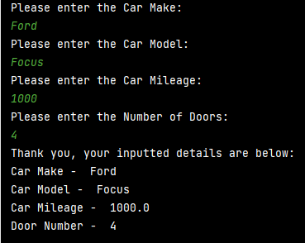
Result – Program worked as expected with no faults.

Variable Boundaries
Test on breaching Variable boundaries:
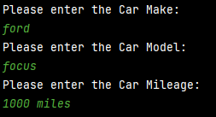
Result – As Expected, user inputted a string therefore program failed. Only float values are allowed as programmed.

Scenario 2 – Vegetable Bed
This scenario is for growing vegetables based on different dimensions. I will create a program to calculate the number of carrots grown from the specified user dimensions.

Logical Steps:
- Prompt user to input dimensions desired.
- Check that the dimensions are above 0.
- Calculate and display total dimension area.
- Calculate total number of carrots gained from calculated area.
- Display total number of Carrots for the user.

Code with annotation:
# This Program is for calculating the number of carrots gained from the specified dimensions entered by the user.
import math
# Importing the required math module in order for simplification
print("Please enter the first dimension:")
# Creating First Dimension Variable input for user
userDimension1 = float(input())
while userDimension1 < 0:
# This is to ensure that the value inputted is not less than 0
print("Sorry, It must be above 0")
print("Please Try Again:")
userDimension1 = float(input())
else:
print("Please enter the second dimension:")
# Creating Second Dimension Variable input for user
userDimension2 = float(input())
while userDimension2 < 0: # This is to ensure that the value inputted is not less that 0
print("Sorry, It must be above 0")
print("Please Try Again:")
userDimension2 = float(input())
else:
totalDimension = userDimension1 * userDimension2
# Calculating the total dimension by multiplying both together
print("The total dimensions of the vegetable bed is - ", totalDimension, "cm2")
numberCarrotsSum = totalDimension / 64
# Calculating original number of carrots (not simplified)
numberCarrotsTotal = math.floor(numberCarrotsSum)
# Simplifying Original Number of Carrots to the nearest lower number
print("The Total Number of Carrots that you can grow is", numberCarrotsTotal)
# Displaying the total number of carrots that you can grow from the inputted dimensions

Testing
Normal use without errors, Input 1 Negative Value, Input 2 Negative Value.

Normal use without errors:
Test for smooth running of program:
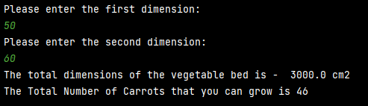
Result – Program ran as intended without any significant errors.

Input 1 Negative Value:
Test for Validation if value is below 0 on Input 1:
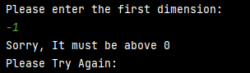
Result – As expected from the code, the program identified the negative value and asked the user to input another value above 0.

Input 2 Negative Value:
Test for Validation if value is below 0 on Input 2:
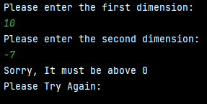
Result - As expected from the code, like input 1, the program identified the negative value and asked the user to input another value above 0.

Scenario 3 – Store Items with Discount
In this scenario, the user is required to input 5 items and their prices and then show the price on screen and the automatically apply a 15% staff discount.

Logical Steps
- Prompt user to enter the items and their prices.
- Make sure it corresponds to the selected variable (float, string, or integer)
- Input all inputted variables into 2 different lists.
- Calculate total price of all items and display for user.
- Calculate 15% staff discount on Total Price.
- Simplify price to 2 decimal points.
- Display total price for the user.

Code with annotation:
# This Scenario is to create 2 lists based on the user inputs and then calculate prices based on those inputs
print("Please enter the items and prices below starting with a number e.g. 1.") # Brief Instruction on input
item1 = input("Please enter the first item:\n") # Item Input
price1 = float(input("Please enter item 1's Price:\n"))
# Price Input
while price1 < 0:
print("The price must be higher than 0")
price1 = float(input("Please enter item 1's Price:\n"))
item2 = input("Please enter the second item:\n")
# Item Input
price2 = float(input("Please enter item 2's Price:\n"))
# Price Input
while price2 < 0:
print("The price must be higher than 0")
price2 = float(input("Please enter item 1's Price:\n"))
item3 = input("Please enter the third item:\n") # Item Input
price3 = float(input("Please enter item 3's Price:\n"))
#Price Input
while price3 < 0:
print("The price must be higher than 0")
price3 = float(input("Please enter item 1's Price:\n"))
item4 = input("Please enter the fourth item:\n") # Item Input
price4 = float(input("Please enter item 4's Price:\n"))
#Price Input
while price4 < 0:
print("The price must be higher than 0")
price4 = float(input("Please enter item 1's Price:\n"))
item5 = input("Please enter the fifth item:\n") # Item Input
price5 = float(input("Please enter item 5's Price:\n"))
# Price Input
while price5 < 0:
print("The price must be higher than 0")
price5 = float(input("Please enter item 1's Price:\n"))
item_list = [item1, item2, item3, item4, item5]
# Created list of all inputted items
price_list = [price1, price2, price3, price4, price5]
# Created list of all inputted prices
print("Below are the Items and prices inputted: ")
print("Items Prices")

for x in range(4): # Displaying Both lists side by side
print(item_list[x], price_list[x])
TotalPrice = price1 + price2 + price3 + price4 + price5
# Calculating the Total Price by adding each price together
print("Total price is", TotalPrice)
# Display total price of all items
TotalDiscountSum = TotalPrice - (TotalPrice * 0.15)
# Calculating Total with Staff Discount
TotalDiscount = "{:.2f}".format(TotalDiscountSum)
# Simplifying the answer to 2 decimal points
print("Total with Staff Discount: ", TotalDiscount)
# Displaying the Total with the Staff Discount

Testing
Normal use without errors, Variable Boundaries, Negative Input Values.

Normal Use Without Errors
Testing for smooth operation of program with no errors:
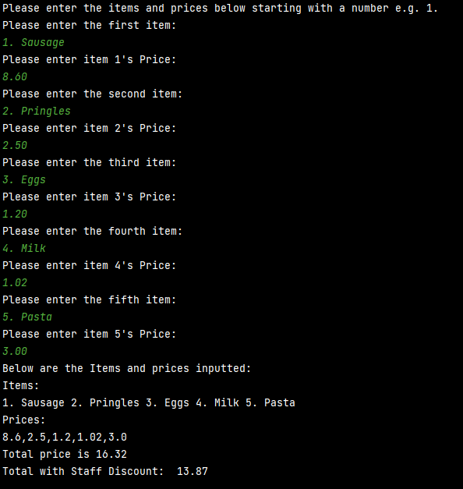
Result – Program runs smoothly and without any errors.

Variable Boundaries
Test for breach of Variable Boundaries e.g. String input in float:
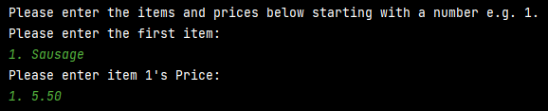
Result – When user enters a string into a float input a significant error appears as expected. Causing program to stop and requires restart.

Negative Input Values
Test for reaction in program from user negative values:
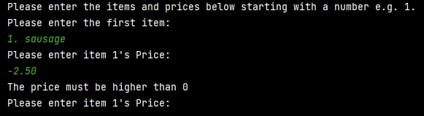
Result – As expected, When the user inputs a negative value, the program identifies it and asks the user to re-enter a value above 0.

Scenario 4 – Treasure Hunt
This scenario I am required to create a treasure hunt in python and then allow the user to select a random place and display it on the grid.

Logical Steps
- Prompt user to start or quit the game.
- Display the grid.
- Prompt user to choose a number between 0 – 15.
- Display change of that number on the grid
- Identify if user has hit the treasure.
- If unsuccessful ask again.
- Continue until user hits treasure.

Code with annotation:
# This scenario i will attempt to create a treasure hunt using a 4x4 grid.
import random # Importing random function
def print_grid(): # This creates displays the grid
for row in grid:
print(" ", row)
correctNum = random.randint(0, 16)
# This is the random number generator
grid = [0, 0, 0, 0, 0, 0, 0, 0, 0, 0, 0, 0, 0, 0, 0, 0]
# List of grid icons
print("Welcome to the Game")
# Welcome message and initial instructions
print("=-=-=-=-=-=-=-=-=-=-=-=-=-=-=-=-=")
print("Chose 1 to start and 2 to quit")
user_choice = int(input("Please enter your choice?"))
# User can input either to start or quit the game
while user_choice < 1 or user_choice > 2:
# Validates what choice the user has inputted
print("Not a valid option, please chose again")
user_choice = int(input("Please enter your choice?"))
if user_choice == 1:
# If user inputted 1 then game starts
print("Choose a number between 0 - 15")
# Asks for a number between 0-15
user_Game = int(input())
# Box for user to input their choice
grid[user_Game] = 1
# Displays that choice in the correct position on the grid
else:
quit() # If user chose 2 then game ends
while user_Game != correctNum:
# Validates if user number is the same as the random number
print("Missed! Try Again!")
# Displays message to try again
print_grid() # Displays the grid
print("Choose a number between 0 - 15")
# Asks for a number between 0-15
user_Game = int(input())
# Box for user to input their choice
grid[user_Game] = 1
# Displays that choice in the correct position on the grid
print_grid() # Displays the grid
else:
print("Congratulations you guessed correctly!")
# Displays if the guess was correct

Testing
Normal use without errors, User Choice Validation, Variable Boundary

Normal use without errors:
Test for smooth and efficient running of program without errors:
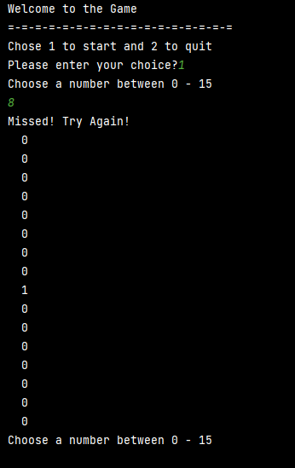
Result – The program ran smoothly without any significant errors within the code.

User Choice Validation
Test to see if user choice boundaries are broken will a message appear:
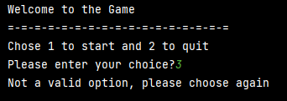
Result – As expected, when user enters a number that is not 1 or 2 then the program displays a message to try again.

Variable Boundary
Test to see if float is entered if the program will continue or not:
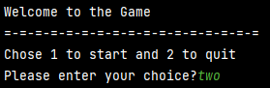
Result – As expected, when user enters a string instead of an integer the program stops with the error displayed above.

References

[1] | Python.org, “What is Python? Executive Summary,” [Online]. Available: https://www.python.org/doc/essays/blurb/. [Accessed 15 April 2021].
[2] | tutorialspoint.com, “Python - Variable Types,” [Online]. Available: https://www.tutorialspoint.com/python/python_variable_types.htm. [Accessed 15 April 2021].
[3] | V. Beal, “Variable,” [Online]. Available: https://www.webopedia.com/definitions/variable/#:~:text=Variables%20play%20an%20important%20role,variables%20to%20represent%20the%20data.&text=This%20makes%20it%20possible%20for,processdifferent%20sets%20of%20data.. [Accessed 15 April 2021].
[4] | A. Biswal, “Understanding Python If-Else Statement,” [Online]. Available: https://www.simplilearn.com/tutorials/python-tutorial/python-if-else-statement#:~:text=The%20if%2Delse%20statement%20is,else%20block%20code%20is%20executed.. [Accessed 15 April 2021].
[5] | w3schools.com, “Python If ... Else,” [Online]. Available: https://www.w3schools.com/python/python_conditions.asp. [Accessed 15 April 2021].
[6] | w3schools.com, “Python For Loops,” [Online]. Available: https://www.w3schools.com/python/python_for_loops.asp#:~:text=A%20for%20loop%20is%20used,set%2C%20or%20a%20string).&text=With%20the%20for%20loop%20we,list%2C%20tuple%2C%20set%20etc.. [Accessed 17 April 2021].
[7] | tutorialspoint.com, “Python while Loop Statements,” [Online]. Available: https://www.tutorialspoint.com/python/python_while_loop.htm. [Accessed 17 April 2021].

