Quantifying Animal Bones
Some archaeological sites contain faunal remains in the form of animal bones. Counting bones in an assemblage is integral to the identification of the potential number of specimens present and understanding what animals are found at the site. Through counting the animal bones, it’s possible to understand what bones have survived and gain a greater understanding of the relationship between the animals present and the context of the site. It is important to consider that when quantifying bones that the data collected gives an estimation on what may have been present at a site.
The bones present in an assemblage are rarely ever a full skeleton or even full intact bones. It is often the fragments of bones that make up most of all bones present within an assemblage. This is in part due to the survivability of bone or the taphonomy, that is the rate at which bones and parts of bone deteriorate after the point of death. The context that the bones in can affect the survivability of the specimens left, environment, and bone size are two of the many elements that can influence how well bones survive into the archaeological record.
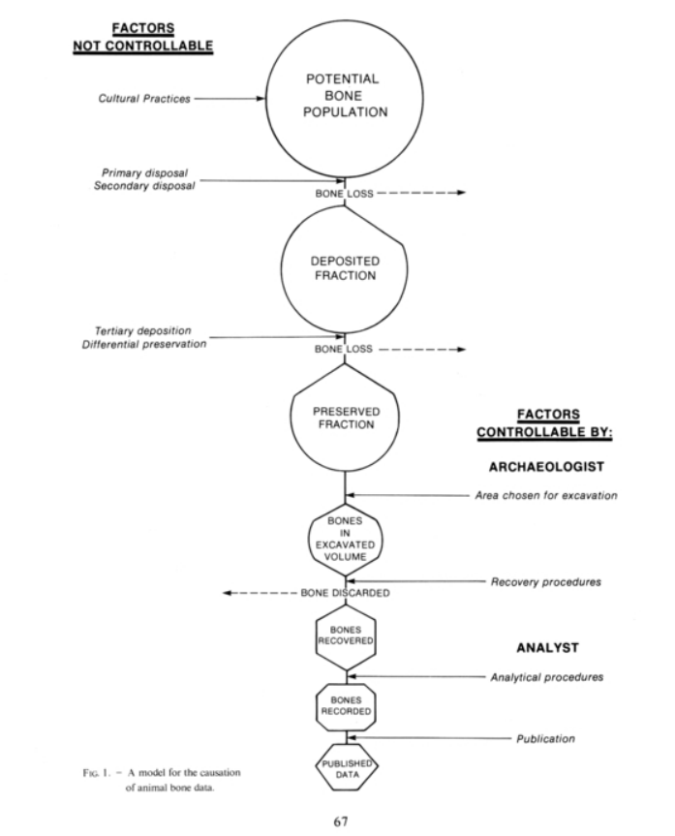
Figure 1 Meadow, R. H. (1980) Animal Bones Problems for the Archaeologist. p.67
The graph by Meadow (1980) highlights why the assemblage of bone being counted may only be a sample of the original collection and emphasises how the collected data can help to make assumptions about the history of an assemblage however does not necessarily accurately reflect the past.
When counting bone fragments the method of counting is vital for collecting the best set of data for the assemblage. Whilst there are many methods available for quantifying animal bones O’Connor stresses the importance of considering the validity and the repeatability of the collection methods (O’Connor 2000, p.54). The research question is an important aspect to consider when choosing how to count animal bones (Baker & Worley 2019). The research question not only helps in choosing the correct data collection method in terms of single site use but for comparison between sites.
Whilst there are many methods of quantification counting the minimum number of individuals (MNI) and the number of individuals present (NISP) are common ways of counting bones present in an assemblage. Bone fragments are counted individually to give NISP and for MNI the bone types are identified and then counted with the assumption that the bones belong to the same individual unless they obviously do not. It is here that understanding and categorising the bones is beneficial. Knowing if the bone is a left or right, size and age can contribute to more accurate counting of MNI.
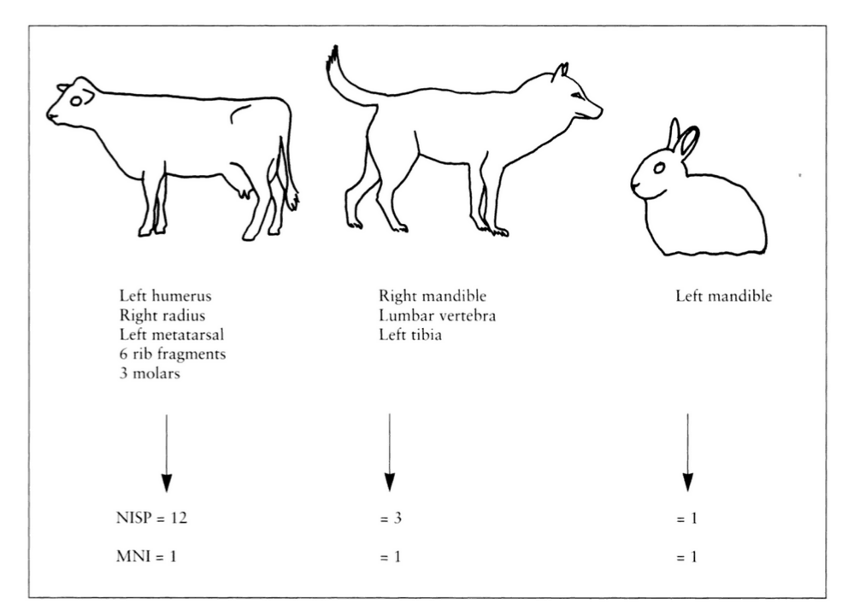
Figure 2 O'Connor, T (2000) The Archaeology of Animal Bones p. 55
There are many ways to quantify bones and most are heavily debated, including MNI and NISP. For example, NISP may result in misidentification of species when the bones are fragmented and hard to identify (O’Connor 2000, p.56). There are many other methods of quantifying the bones present at an assemblage weighing for example may be useful when the research is on specimens such as shells which may all have a similar mass with little variation between individuals (Mason Et.al 1998).
NISP and MNI can be seen to work well together to give a maximum and a minimum boundary for animal bones present in the assemblage and can give a simple overview of the overall assemblage.

Reference list
Baker, P. and Worley, F. (2019). Animal Bones and Archaeology Recovery to archive Historic England Handbooks for Archaeology. [online] Swindon: Historic England. Available at: https://historicengland.org.uk/images-books/publications/animal-bones-and-archaeology/animal-bones-archaeology-handbook/ [Accessed 19 Feb. 2023].
Mason, R.D., Peterson, M.L. and Tiffany, J.A. (1998). Weighing vs. Counting: Measurement Reliability and the California School of Midden Analysis. American Antiquity, [online] 63(2), pp.303–324. doi:https://doi.org/10.2307/2694700.
Meadow, R.H. (1980). Animal Bones : Problems for the Archaeologist together with some possible solutions. Paléorient, [online] 6(1), pp.65–77. doi:https://doi.org/10.3406/paleo.1980.4260.
O’Connor, T.P. and O’Connor, T. (2000). The Archaeology of Animal Bones. 2nd ed. [online] Google Books, Stroud: Sutton Publishing Limited, pp.54–57. Available at: https://books.google.co.uk/books?id=kzVpgrMQcJsC&printsec=frontcover#v=onepage&q&f=false [Accessed 19 Feb. 2023].
‌

