
APPENDIX GA36c

LEVEL 6 ASSESSMENT SPECIFICATION

Student name: | Georgina Jones | Student ID number: | 1702648
Programme: | Primary
Module: | Principles of Pedagogy
Module code: | M6X01438/C | Contribution to Overall Module Assessment (%): | 100%
Lecturer: | Siân Brooks | Internal Verifier: | Siân Brooks
Assignment Title: | ‘Describe a learning event which has happened during your recent school experience. Reflect upon what took place, connecting events to theories of learning and teaching. Make recommendations about how you could improve your own practice in the light of this. Produce a poster to illustrate how you would develop the elements of an effective learning environment.’ | Word count (or equivalent): | 5,000 or equivalent.
Submission deadline: | 17/10/18 (23.59) | Return date of provisional marks & written feedback: | 14/11/18
Submission method: | All written assessments, where practical and possible, must be submitted via Turnitin unless otherwise instructed by the Lecturer. (Please DO NOT put this assessment specification into Turnitin or it will match many similarities with other students’ submissions.)  Alternative submission method (if applicable):  Late submission of the assessment will result in a late penalty mark. Penalties for late submission: Up to one week late, maximum mark of 40%. Over one week late, 0%. Only the Extenuating Circumstances Panel may approve a change to submission dates.
Academic honesty / referencing: | Academic honesty is required. In the main body of your submission you must give credit to authors on whose research and ideas your work is based. Append to your submission a reference list that indicates the books, articles, etc. that you have used, cited or quoted in order to complete this assessment.

Module Learning Outcomes
(from module syllabus)
1. understand, synthesise and evaluate the main theories that underpinning learning, behaviour and assessment in the primary school
2. reflect critically on how learning theories inform the planning and provision of high quality learning environments, demonstrating a clear understanding of how theory and practice are interrelated
3. organise knowledge and learning through the use of a range of information sources, and present work appropriately.

‘Describe a learning event which has happened during your recent school experience. Reflect upon what took place, connecting events to theories of learning and teaching. Make recommendations about how you could improve your own practice in the light of this. Produce a poster to illustrate how you would develop the elements of an effective learning environment.’

Introduction
In accordance with the BERA (British Educational Research Association) guidelines, I have a responsibility to the: pupils, staff, school and community to provide an unprejudiced, ethically correct and mindful assignment based upon my observations. Following these guidelines, the: specific location, school name, teachers’ names and pupils’ names have all been redacted and replaced with a pseudonym. This has been done to protect the identity and provide anonymity. (BERA, 2018) Due to this the following children I observed will be referred to as; child A and child B. Furthermore, I supplied the school with a consent form and received written consent from the headmaster (Figure 1) allowing for the photography or recording of the learning event or anything I deemed important to the assignment. It should be noted that due to ethical concerns, any recording or photo evidence containing a reference to any of the young learners or the school will be blurred or edited to protect their identity.
For my observation, where I noted a significant learning event, I was placed in a primary school in South Wales. Said school, in the most recent Estyn report, had a population of 384 pupils with a 94.6% attendance rate. The school had an above average percentage of 33.6% for free school meals and is classed green in the support category. (Reference not added as schools identity would be compromised.)

Observation
The learning event I observed took place after lunch within the indoor environment of the classroom. The event originated from work produced in a pervious lesson. Here the teacher brought out a whiteboard filled with words and images based on the topic of electricity and it’s uses, produced by the students in a previous over to you session, shown in Figure 2. The aim of the activity was to access pervious knowledge of the topic and help them to expand their understanding of electricity and link it to the real world through: previous knowledge, group discussions, questioning and real-life applications.
After a brief refresher using the whiteboard the young learners were given the question, “What might you know about the uses of electricity?” They then went into their buzz groups. At this point I sat just on the outskirts of the groups. This was done to not cause a disturbance or make any of the young learners feel too nervous or uncomfortable in the presence of an unknown adult and leading to my observation results being affected. Here is where I focused my observation on one of the groups and their conversation with the teacher and each other. The transcription of my selected learning event is shown in Figure 3.
I recorded my learning experience using the written observation method. I personally selected this method as I felt that I could more accurately record any observations that might present themselves in the moment. I made sure these notes would make sense to me later, so I could easily reflect upon the learning event. I also used photographic recording to log my observations as shown in Figure 2. This helped me to easily recall and reflect upon one moment of the observation. However, I do see the limitations to both techniques. For instance, with the written observation method resulted in areas of my notes lacking some information, that at the time I deemed unnecessary, but later would have found useful in my reflection. The downfalls to photographic recordings were that despite having the consent (Figure 1) of the school, images had to be cropped or blurred to protect the identity of the school and its pupils. While this in itself was not an issue it did affect the quality and information the photo provided. Also, when taking the photos some of the pupils noticed and would become distracted and stare at the camera, resulting in the learning experience being missed.
Looking back I would have considered using audio recording as all discussions or learning moments would be vocally recorded and would allow me to replay them later and reflect on the experience with more clarity. (Wilson, 2009) It would have also worked very nicely with photographic recordings, as I could line up what was being said to elements in the photo, such as, facial expressions or body language.
I could have used video recording, as it would have encompassed the visual effect of the photographic method and the audio effect of the recording. (Wilson, 2009) However, I decided against this as I realised combing through all the footage would be overwhelming and believed that the camera would have caused disruption in the class and would have resulted in focus being taking away from the learning and in turn disturbing my observation. (Wilson, 2009) On top of this several of the children in the class were not allowed to be recorded on photo or video, making this recording method more problematic than the other methods.
Out of all my observations I selected this one as I felt that it was an excellent case of Constructivism, specifically, social constructivism, Vygotsky’s theory, with links to exploratory talk.
I consider this learning experience to underpin social constructivism. The constructivist theory was originally established by Jean Piaget and was the influential factor in Lev Vygotsky, social constructivism. Specifically, looking at the importance of social interactions in children’s cognitive development, rather than Piaget’s view that cognitive development should be established by the independent learner. In the learning experience I can see how child A and B discussed what their understanding is of the topic, in this case, the uses of electricity and build upon it. For example, Child B, while understanding some of the real life applications of electricity, in this case, “like in our bee bots,” has not seemed to quite grasp the full knowledge of other applications of electricity. This new piece of information didn’t fit with child B’s previous knowledge creating confusion. Child A helped child B develop their understanding and learning by using the board as a visual aid and thru exploratory talk. Child A and the teacher, the more knowledgeable individuals, guide child B, helping them create links between the new knowledge and the previous knowledge. This can be seen when Child A explains how, “miss said their were batteries in cars.” Here child A challenges child B’s thinking. This is done via recalling information using short term memory. Child A helps child B to reconstruct and reapply their concepts, in this case of uses of batteries and create understanding. The teacher also had a part by initially leading the group with a question. he question, “Who here can tell me anything they might know about electricity?” The teacher then uses questions and prompts like, “how do bee bots work?” and “batteries?” This is referred to as an Information, response and feedback exchange (IRF), a technique pioneered by Sinclair and Couthald. This where the teacher initiates conversation using a question that in turn caused a response and this response results in a form of feedback. (Mercer and Hodgkinson, 2008) This kind of exchange is useful for the teacher to gage the understanding of the learning from their pupils, without taking over the conversation entirely.

Theory
explain how consideration of these has helped you to understand what went on during this event, and how this could impact on outcomes for pupils in your future practice (approx 1500 words).

Jean Piaget, a swiss biologist, developed the theory of cognitive constructivism. His work is considered to be a significant and influential piece of research in the understanding of learning in the classroom. Piaget held the opinion that a child’s age could directly impact on their development and that a child should have a complete understanding before moving on to higher development stages. (Edwards and Mercer, 1987) Piaget produced four developmental stages as guild lines. These are referred to as the follows: the sensorimotor stage, the preoperational stage, the concrete operational stage and the formal operational stage. (Hattie, 2012) However, these four developmental stages have been heavily critiqued and as many, like, ---, believed that a child could be balanced on more than one step and age should not be factored into the child’s cognitive development.
Piaget believed that learning should not be an entirely teacher led practise, where the pupils are fact fed, but rather it should be an independent process that comes from the active learning of the young learner, in the form of open ended questions and exploration of their environment to allow for internalisation and reconstruction of their previous understanding. (Grigg, 2015)
Piaget’s work on constructivism subsequently influenced Russian psychologist Lev Vygotsky, whom pioneered Social Constructivism. While Vygotsky agreed with several arguments made by Piaget, he strongly held the perspective that children learn and develop their cognitive abilities not by independent learning, as Piaget believed, but rather through dialogue, language and social interactions. (Russel, 2015) Vygotsky believed that social interactions were the key to understanding language, signs and symbols in early years, via peers or parental guidance. He, unlike Piaget, saw that this early years speech was an attempt at communication made by the child. He determined the term, egocentric speech, first referred to by Piaget as speech spoken aloud by children, not as an attempt to socialise but more for themselves, was actually the child’s attempt at creating inner speech from outer speech. (Fosnot and Perry. 2005) This shows one of Vygotsky’s main concepts of internalisation. Here we see how children go from outer speech, where they constantly vocalise sounds in an attempt to imitate them or vocally communicate, to inner speech. Here we can see the begins of the transition to thought, done without the need to vocalise. This internalisation of speech can now be used by the child and allows for them to problem solve and make sense of the world around them.
Vygotsky saw language as a cultural tool enabling children to produce cognitive development through social interactions, such as, discussions with fellow peers and even teacher initiated talks. (Hattie, 2012) Piaget, on the other hand was against teacher involvement as it was in contradiction of his belief that children are independent individuals and learn by exploring their environment and making their own sense of what they are learning and what applications there could be in the real life world. However, Vygotsky’s theory encourages teacher engagement to further understanding and scaffold learning of their pupils.
Scaffolding was a term used by, American psychologist, Jerome Bruner, who after following Vygotsky’s work used the term to explain the support given to the learner by an adult, such as, a parent or teacher, through means of dialogue and give the support needed to understand more challenging tasks. (Smidt, 2009) The level of involvement by the adult is reduced depending on if the learner’s grasp of the topic becomes more steadfast and requires the scaffolding to be removed accordingly. This fits with Vygotsky’s opinion that the scaffolding being provided helps the learner stretch their knowledge and allows them to understand something that they would have struggled to or never been capable to sufficiently comprehend.(Mercer, 1995) This scaffolding is usually the product of dialogue.
The opinion of talk in classrooms has changed over time, from being extensively dissuaded to commonly used as a tool in children’s cognitive and social development and understanding. Talk is frequently used in: problem solving, sharing ideas, evaluating and challenging peers hypothesises. There are three types of talk: disputational, cumulative and exploratory. It should be noted that talk does not fall into one category. Disputational talk comprises of the learners forming their own opinion. Often creating a challenging and argumentative environment. Cumulative talk invokes a more positive environment where people simply agree with an opinion without challenging or assessing it. Exploratory talk is produced amongst learners who feel comfortable with each other to share concepts and thoughts, that might be wrong or vague, without feeling worried about being judged. Douglas Barnes describes exploratory talks as being “…hesitant and incomplete because it enables the speaker to try out ideas, to hear how they sound, to see what others make of them…” (Barnes and Todd, 1977, P5) Peers are critical but constructive when discussing each other’s ideas. This social technique can be useful between pupils in problem solving and promote teamwork.(Mercer and Hodgkinson, 2008) The teacher can observe or involve themselves in these talks to see if understanding is happening.
Vygotsky introduced a model that incorporated dialogue, scaffolding and social interactions between individuals to promote understanding. This model is termed as The Zone of Proximal Development (ZPD). This model is made up of a more knowledgeable other (MKO), who has full unaided mastery over the topic and a less knowledgeable other who lack the knowledge and understanding of the topic (LKO). This more knowledgeable other could be an adult or more “capable peer” (Vygotsky, 1978, p86) and provide the scaffolding and social interaction that the less knowledgeable other needs to comprehend and further their understanding. This showed Vygotsky’s understanding of the adult’s role in leading their pupils understanding, using language and social interaction. The ZPD represents three main ideas: What can be done unaided, what they can not do unaided and what with hep from a MKO could be attained. (Russel, 2015)
I believe that looking on the above theories that my learning event was best represented by Vygotsky’s theory of Social Constructivism with links tying in exploratory talk and the overall importance of Scaffolding. Looking at my learning event I can see how exploratory talk was present within the group, through a mix of teacher-peer led and peer- peer led talks, which unconsciously led to scaffolding being present to provide cognitive support for Child B, from their peer, Child A and the teacher. (The MKO’S)

Poster
Create a digital poster that exemplifies your ideal learning environment, and submit a commentary to explain and justify the pedagogical principles underpinning this provision (equivalent to 1500 words).
TIP - Ensure that you refer to your observations and research in order to justify your decisions within your ideal environment. Present your poster professionally.
Conclusion

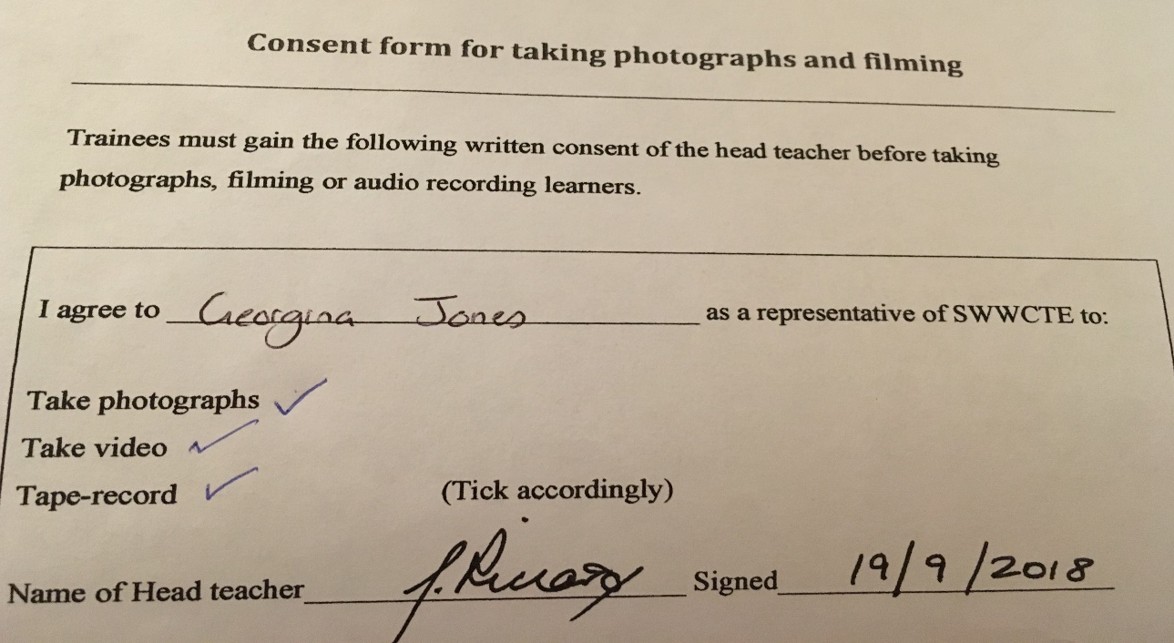
Appendix

Figure 1, shows the consent form signed by the headmaster, giving me permission to take photos and recordings of those allowed in my given class.

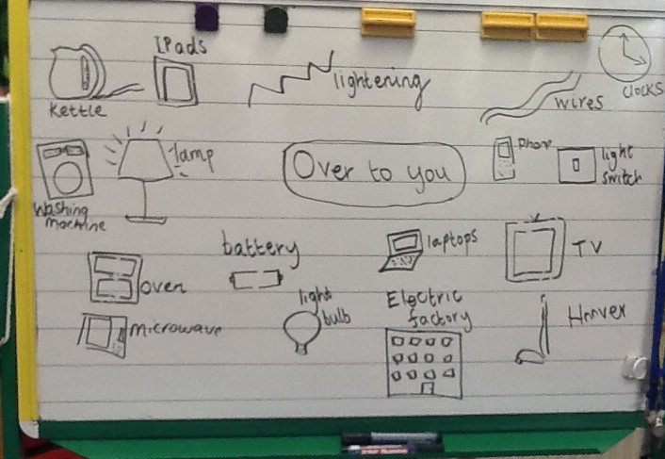
Figure 2 shows an image of the whiteboard from the previous over to you session containing the children’s ideas. This was used to help review the previous lesson.


Figure 3 is the transcript of the discussion after the over to you review session. This is where the pupils were placed into small buzz groups to discuss their

Reference

Barnes, D and Todd, F. (1997) Communicating and learning in small groups. Routledge FIND THIS BOOK

British Educational Research Association [BERA] (2018) Ethical Guidelines for Educational Research, fourth edition, London. https://www.bera.ac.uk/researchers-resources/publications/ethicalguidelines-for-educational-research-2018 (Accessed: 2nd October 2018)

Edwards, D. and Mercer, N. (1987) Common knowledge. The development of understanding In the classroom. Methuen & Co

Fosnot, C.T. (2005) Constructivism: Theory, Perspectives and Practice, second edition, Teachers Collage Press
http://faculty.arts.ubc.ca/emeyers/LIBR535/readings/Fosnot&Perry_2005.pdf (Accessed: 9th October 2018)

Grigg, R. (2015) Becoming an outstanding primary school teacher. 2nd edition. Routledge

Hattie, J. (2012) Visible learning for teachers. Routledge

Mercer, N. (1995) The Guided Construction of Knowledge. Talk amongst teachers and learners. The Cromwell Press.

Mercer, N and Hodgkinson, S. (2008) Exploring talk in school. SAGE publications.

Smidt, S. (2009) Introducing Vygotsky. Routledge

Vygotsky, L. (1978) Mind in society: The development of higher Psychological processes. Harvard University Press

Wilson, E. (2009) School based research. A guide for education students. SAGE publications

