
Bereavement

During later life, bereavement of a spouse is a common event that everybody will experience and is a significant source of psychiatric morbidity. Depression, anxiety and “complicated” grief are the most common symptoms among spousal bereavement. A study by Williams, Sawyer, Allman & Roseman (2007) revealed that over a 2.5-year period, around 70% of elderly adults suffered a bereavement. In addition, the most common form of bereavement is spousal, however, the biggest proportion of losses among elderly adults are the losses of friends or siblings. The theories mentioned throughout this briefing report are the Kubler-ross model (1969), illustrative images such as the grief wheel, the theory of attachment (Bowlby, 1961) and the dual process model (Strobe and Schut, 1999). According to Hall (2014) no theory or model to bereavement is appropriate for everyone. All therapeutic interventions must be adapted to the individual person, relationship or circumstances that that individual is experiencing at that present time.
Introduction
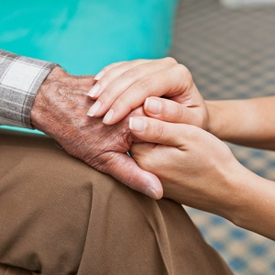
A definition of bereavement by Stroebe et al, (1993) states that bereavement is a feeling of loss which triggers a reaction known as grief that displays a collection of actions known as mourning. According to Shapiro (2001), the first ever theoretical contribution was given by Freud (1957) in his research called “Mourning and Melancholia” and he made a significant impact on professional intervention for almost half a century. Sometime later, several theorist which specialist in grief and bereavement described grief as a person going through a set of predicable set of stages (Kübler-Ross, 1969; Bowlby, 1980; Parkes & Weiss, 1983).
Elderly adults are particularly susceptible to symptoms such as depression, partially due to internal factors related to the development of ageing. During some point of an elderly person’s life, their spouse may pass away, leaving the elderly person bereaved (Rosenzweig, Prigerson, Miller & Reynolds III, 1997). The way a person deals with bereavement may be influenced by individual factors such as faith, ethnicity, personality, the association with the deceased individual or the way the person died.
Elderly adults are the most common age group to suffer from a bereavement. A study by Williams, Sawyer, Allman & Roseman (2007) discovered that in the United States of America 7 out of 10 elderly adults had already faced bereavement in a short period of only two and a half years.

Mortality Rates & Statistics
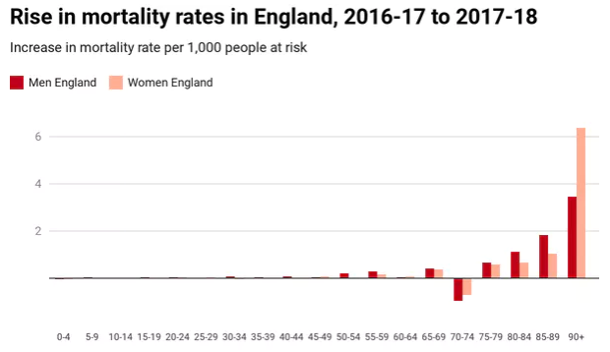
The human increase of life expectation in the United Kingdom suggests that people have a higher rate of mortality at the age of 85-90 or 90+ (Office for National Statistics, 2018).
According to these figures, elderly women only had a 2% rise in mortality rates in 2018. However, figures from earlier years have shown that it had been generally women who had died in the highest numbers. In England, women in their 90’s have been shown to have to the highest rise in mortality with an extra 2,504 dying of these old ages. This is an extra 6,358 million women at risk (Office for National Statistics, 2018).
Depression, anxiety and “complicated” grief are the most common symptoms among spousal bereavement. “Complicated” grief is a form of grief that is tenacious in which abnormal behaviour are present along with continuous longing, sorrow and fixation with feelings and recollections of the person who passed away (Monk, Pfoff, & Zarotney, 2013). Due to elderly adults experiencing greater levels of bereavement than younger people, bereavement is particularly important to study. A study by Williams, Sawyer, Allman & Roseman (2007) revealed that over a 2.5-year period, around 70% of elderly adults suffered a bereavement. In addition, the most common form of bereavement is spousal, however, the biggest proportion of losses among elderly adults are the losses of friends or siblings. According to Lindemann (1944), Kübler-Ross (1969), Parkes (1975), Bowlby (1980) & Worden (1991) Numerous models of grief have mutual themes or phases.
Theories

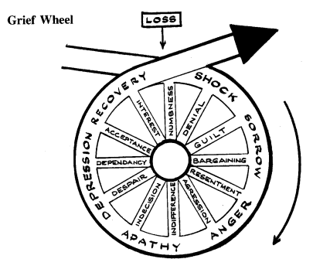
Methods such as illustrative images such as the grief wheel (Grief Education Institute, 1986) are commonly used to explain the progression and phases involved in bereavement, proposing that it is hardly a stationary process. According to Baxter & Diehl (1998), the grief wheel is flexible, and people do not experience the stages in the same order. According to Bee (2000), Corey & Corey (2006), due to elderly adults’ high exposure of bereavement, the symptoms such as anxiety and depression are highly likely to occur throughout this phase. An important intervention to help the elderly cope with their loss is group counselling support as this is vital to help the growing number of elderly in society. However, additional models, such as the ‘dual process model’ (Strobe and Schut, 1999) offer a more adaptable method to the explanation and management of grief. The dual process model explains how a person who is bereaved manages everyday life and other lifestyle changes that arise whilst trying to come to terms with their loss. According to Dunne (2004), the dual process model assumes that when individuals experience grief, the way they cope is a reciprocal process and the person moves amongst grieving and attempting to live with and understand their loss. According to Strobe & Strutt (1999), the theory of grief provides an explanation as to how a bereaved individual may experience two different types of behaviour whilst experiencing grief. These are loss-orientated and restoration-oriented. As the living partner experiences grief, they will fluctuate among these two dissimilar phases. This is the explanation as to why it is named the dual process model because two different processes are occurring.
To think about your loved one and their passing are called loss-oriented stressors, and this is called the loss-oriented stage. These stressors may include relooking at old photographs or remembering a memory. Another type of stressors are types of activities that allow the bereaved person to carry on with daily tasks and activities and provide a distraction for a while from their grief. A common daily activity may be cleaning or working.
According to Stroebe & Schut (1999) people who do use daily activities to distract themselves from grief are exhibiting normal behaviour and state that it is healthy for them following a bereavement. Stroebe & Schut (1999) also argue that without restoration-oriented behaviour a bereaved person may end up being completely unable to continue with daily life. Finally, Oscillation is best used to describe the way a person experiencing grief can alternate between the two modes of being; loss-oriented and restoration-orientation. Stroebe & Schut (1999) state that individuals who are suffering a bereavement should adopt this oscillation, as they are then able to freely move throughout the grief stage and challenge the reality of the loss one step at a time. According to Hansson, Carpenter, & Fairchild, (1993); Lund, Caserta, & Dimond, (1993) both loss-oriented coping and restoration-oriented coping and run alongside each other and expressed recurrently. But some individuals do participate in loss-oriented actions more often than others during the primary stages of bereavement and then participate in more restoration-oriented tasks after.
Another theory that tries to explain and identify bereavement and grief is called the ‘stage model’ (Kubler-Ross, 1969). Kubler-Ross proposed that stage theory consists of a series of what they call ‘likely stages’ and that a person who is experiencing grief will progress through these stages. These likely stages include denial, anger, bargaining, depression and finally acceptance. However, according to Archer (1999) the stage model lacks theoretical explanation. In addition, Bonanno and Boerner (2007) expressed their concerns by stating that the stage model provides very little information about how people come to terms with loss, why people experience different types of distress at different times and it also does not assist to recognise those at elevated risk or with difficulties in the mourning process (Bonanno and Boerner, 2007).
An evaluation of this theory was offered by Kastenbaum (1998). Kastenbaum states that the phrase “stages” suggests a set sequence of set circumstances. Kastenbaum (1998) suggests there is no proof that people who are bereaved experience the stages in their supposed correct sequence. The sequences mentioned in the stage model may not be the sequences experienced by every person and they may experience feelings that are not stated throughout the stage model. More specifically, there is no evidence that people who are suffering with bereavement complete all the stages.
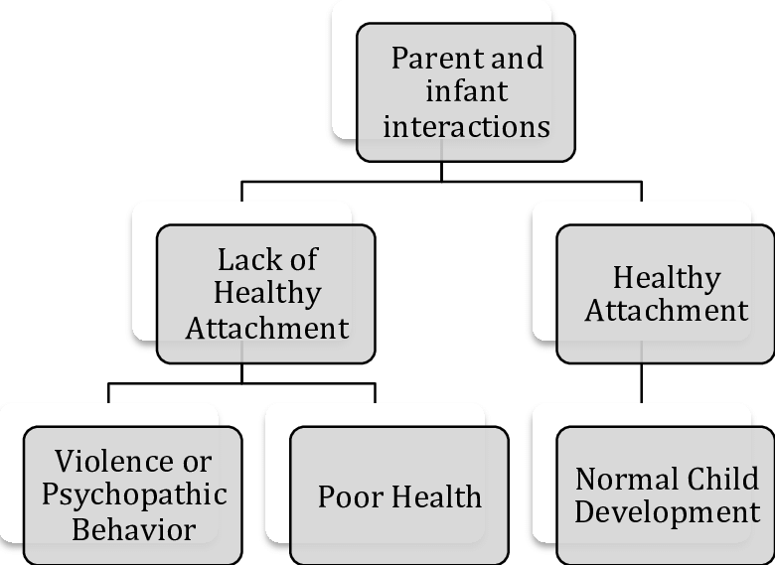
Bowlby’s (1961) theory of attachment is another theory that attempts to understand grief. Bowlby suggests that humans tend to form strong affectional relationships and that attachment is reciprocal. This happens because of long-term interactions which start in childhood between the infant and its caregivers, however, during adulthood the attachment shifts from caregivers to romantic partners. According to Ciechanowski et al., (2001, 2002) it has been previously recognised that Bowlby’s attachment theory could be used to understand the attachment behaviour in elderly adults to comprehend their behaviour whilst they are experiencing an illness e.g. dementia. Previous research has normally focused on the connection between experiences in early stage attachment and how these experiences impact behavioural responses to illness and death (Ciechanowski et al., 2001, 2002). In a study by Hazan & Shaver (1987, 1990), they discovered that even though attachment behaviour derives from the connection between infant and guardian it does continue during the lifespan.
One of the greatest recognised explanations regarding social relations on health is often called the “widow effect” (Schaefer, Quesenberry Jr, & Wi, 1995). The Widow effect provides an explanation as to the increased probability for a newly widowed individual to pass away. The Widowhood effect has been discovered to be present among both males and females of every age all over the world (Kraus & Lilienfeld, 1959; Hu & Goldman, 1990). A current longitudinal study Kraus & Lilienfeld, (1959); Hu & Goldman (1990) placed the additional death of widowhood (in comparison with marriage) amongst the elderly people between 30% and 90% in the initial three months of marriage and about 15% in the continuing months (Schaefer & Quesenberry, 1995; Martikainen & Valkonen, 1996; Jognson, Backlund, Sorlie & Loveless, 2000; Elwert & Christakis, 2006).
Elwert & Christakis et al., (2008) stated that the bereavement of a partner is commonly related with an expanded age specific likelihood of dying for the living partner comparative to wedded males or females. Becoming a widow does not only interrupt long-lasting companionship but also interrupts monetary changes and additional major lifestyle routines. Adapting to these lifestyle changes may result in weak health consequences for the living partner. According to Thierry (2000), descriptions for the theory known as the widow effect has been separated into three overall groups: selection into widowhood, the direct consequence of shock and new accommodation arrangements. Originally, the connection between widowhood and mortality risk may be false. Bowling (1987), stated that selection into widowhood may be a contributing factor to morality as these individuals who have a higher chance of becoming widows may also possess higher rates of mortality risks due to shared domestic qualities (Bowling, 1987). An example of this was provided by Bowling (1987), and this states that individuals with a lower social economic status are more prone to die compared to those who possess a higher social economic status who are of a similar age and are also more probable to be married to a partner who also has low economic status. Therefore, individuals who have low economic status are concurrently more probable to experience spousal bereavement and more likely to die themselves, independent of any widowhood effect Bowling, 1987).
Mortality rates may rise due to the direct effects of widowhood (Strobe, 1994). One probability of this could be caused by overall “wear and tear” which may be related to providing support to their dying partner, particularly if the partners death was prolonged due to a drawn-out ailment. (Pruchno, Cartwright, & Wilson-Genderson, 2009). Also, proving support for an ill partner can have serious consequences such as the increased risk of illness (Christakis & Allison, 2006; Shaw et al., 1997) and mortality (Christakis & Allison, 2006; Schulz & Beach, 1999). The overall stress of providing care for an ill partner may cause neuroendocrine changes (Kim & Jacobs, 1993) or may cause suppressed immune system functioning (Irwin & Pike, 1993). On the other hand, spousal bereavement may cause harmful changes to the individuals health which may cause an increased possibility of related mortality (Luoma & Pearson, 2002; Martikainen & Valkonen, 1996; Umberson, 1992). According to Zisook, Shuchter & Mulvihill (1990), after the death of a partner, the living partner may decide to engage in risky health choices such as smoking, taking drugs or drinking alcohol. Finally, becoming a widow forces to the living spouse to rearrange their living situation and they may not have had time to acquire other means of communal or emotional support (Smith & Zick, 1996). According to Shumaker & Hill, 1991), males may be particularly vulnerable due to not having close intimate relations other than their wives, this can be explained by role theory.
Role theory provides explanations of daily behaviour of people and how they act out roles e.g. husband and wife. The period after death of a spouse, role theory presumes that the living partner will have difficulty to adjust to the loss of both material and task support (Bowling, 1987). Couples depend on one another to complete these tasks (Becker, 1991).
Conclusion

The amount of clinical research available has enhanced researchers’ perception of the individual symptoms, risk factors and potential consequences of grief. According to Hall (2014) no theory or model to bereavement is appropriate for everyone. All therapeutic interventions must be adapted to the individual person, relationship or circumstances that that individual is experiencing at that present time (Hall, 2014).

Becker, G. S., & Murphy, K. M. (2009). Social economics: Market behaviour in a social environment. Harvard University Press.
Bonanno, G. A., & Boerner, K. (2007). The stage theory of grief. Jama, 297(24), 2692-2694.
Bowlby, J. (1961). Processes of mourning. International Journal of Psycho-Analysis, 42, 317-340.
Bowlby, J. (2012). The making and breaking of affectional bonds. Routledge.
Bowling, A. (1987). Mortality after bereavement: a review of the literature on survival periods and factors affecting survival. Social science & medicine, 24(2), 117-124.
Coleman, P., & O'Hanlon, A. (2004). Ageing and development: Theories and research. Hodder Arnold.
Danny, D. (2019, July 2). Mortality rates are still rising in the UK – and everyone is ignoring how many more people are dying. Retrieved from www.theconversation.com
Dimond, M. (1981). Bereavement and the elderly: A critical review with implications for nursing practice and research. Journal of Advanced Nursing, 6(6), 461-470.
Elwert, F., & Christakis, N. A. (2006). Widowhood and race. American Sociological Review, 71(1), 16-41.
Hansson, R. O., Carpenter, B. N., & Fairchild, S. K. (1993). Measurement issues in bereavement.
Hu, Y., & Goldman, N. (1990). Mortality differentials by marital status: an international comparison. Demography, 27(2), 233-250.
Johnson, N. J., Backlund, E., Sorlie, P. D., & Loveless, C. A. (2000). Marital status and mortality: the national longitudinal mortality study. Annals of epidemiology, 10(4), 224-238.
Kraus, A. S., & Lilienfeld, A. M. (1959). Some epidemiologic aspects of the high mortality rate in the young widowed group. Journal of Chronic Diseases, 10(3), 207-217.
Kübler-Ross, E. (1973). On death and dying. Routledge.
Lund, D. A., Caserta, M. S., & Dimond, M. F. (1986). Gender differences through two years of bereavement among the elderly. The Gerontologist, 26(3), 314-320.
Martikainen, P., & Valkonen, T. (1996). Mortality after death of spouse in relation to duration of bereavement in Finland. Journal of Epidemiology & Community Health, 50(3), 264-268.
Monk, T. H., Pfoff, M. K., & Zarotney, J. R. (2013). Depression in the spousally bereaved elderly: correlations with subjective sleep measures. Depression research and treatment, 2013.
Office for National Statistics. (2018). Estimates of the population for the UK, England and Wales, Scotland and Northern Ireland [online].
Pruchno, R., Wilson-Genderson, M., & Cartwright, F. P. (2009). Depressive symptoms and marital satisfaction in the context of chronic disease: A longitudinal dyadic analysis. Journal of Family Psychology, 23(4), 573.
Richardson, V. E., & Balaswamy, S. (2001). Coping with bereavement among elderly widowers. OMEGA-Journal of Death and Dying, 43(2), 129-144.
Rosenzweig, MD, MPH, A., Prigerson, PhD, H., Miller, MD, M. D., & Reynolds III, MD, C. F. (1997). Bereavement and late-life depression: Grief and its complications in the elderly. Annual review of medicine, 48(1), 421-428.
Schaefer, C., Quesenberry Jr, C. P., & Wi, S. (1995). Mortality following conjugal bereavement and the effects of a shared environment. American Journal of Epidemiology, 141(12), 1142-1152.
Smith, K. R., & Zick, C. D. (1996). Risk of mortality following widowhood: Age and sex differences by mode of death. Social biology, 43(1-2), 59-71.
Sullivan, A. R., & Fenelon, A. (2013). Patterns of widowhood mortality. Journals of Gerontology Series B: Psychological Sciences and Social Sciences, 69(1), 53-62.
Sullivan, A. R., & Fenelon, A. (2013). Patterns of widowhood mortality. Journals of Gerontology Series B: Psychological Sciences and Social Sciences, 69(1), 53-62.
Sullivan, A. R., & Fenelon, A. (2013). Patterns of widowhood mortality. Journals of Gerontology Series B: Psychological Sciences and Social Sciences, 69(1), 53-62.
Thierry, X. (2000). Risks of mortality and excess mortality during the first ten years of widowhood. Population: An English Selection, 81-109.
Williams, B. R., Sawyer Baker, P., Allman, R. M., & Roseman, J. M. (2007). Bereavement among African American and White older adults. Journal of aging and health, 19(2), 313-333.
Zisook, S., Shuchter, S. R., & Mulvihill, M. (1990). Alcohol, cigarette, and medication use during the first year of widowhood. Psychiatric Annals, 20(6), 318-326.


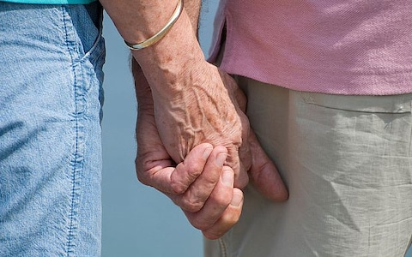
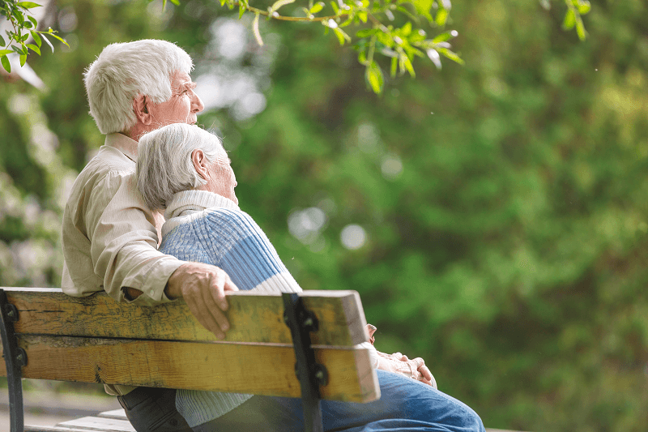
The connection between social support and health outcomes have always been linked. Elderly people who are more social normally have better physical and mental health than elderly adults who are not social (Barrera, 1986; House, Landis & Umberson, 1988; Uchino, 2009).
The findings of many studies suggest that social support has a positive effect on well-being (Wallston, Alagna & Devellis, 1983)
During a period of crisis, an elderly person who is experiencing bereavement may require social support which may be in the form of material support for example, money or food. Or they may require emotional support (e.g. personal advice, religious advice, time to socialise etc). these types of emotional support can be provided by companions, family, colleagues, neighbours, etc.
A study by Raphael (1997) discovered that widows who were at high-risk of bereavement who had undergone counselling had reported better health and adjustment a year after their grief than those widows who did not undergo counselling. An additional study by DeVerber (1996) also discovered similar findings as Raphael (1997) in that the presence of a therapist rapidly decreased the suffering displayed by widows in their primary year of bereavement.
Strategies to help cope with elderly bereavement
In addition to these types of support, elderly adults experiencing bereavement require further support to help recuperate from crisis of bereavement. According to Hobfoll et al., (1990), elderly people experiencing bereavement need to be provided with social support which has been described as an apparatus that decreases the sternness of stress by offering a chance for explanation through sources provided by others of the traumatic occasion therefore permitting the person a means of regulating or recuperating from a tough situation (Mutran, Reitzes, Mossey, & Fernandez, 1995).
During a phase where a person is experiencing bereavement, the person needs adequate support from people who can provide re-assurance regarding the normality of the grief, to explain the symptoms of bereavement, to provide reassurance that they are not going to die or to provide them with additional reassurance that the symptoms they may be experiencing such as anxiety and tension does not indicate death.
Elderly bereavement is a major concern as it could lead to mental illnesses such as depression. A large majority of people can learn to deal with their grief without the need for intervention, however, some people cannot move forward without any intervention (Stroebe & Stroebe, 2007). According to Ancher (1997), bereavement has been described as the passing of somebody with whom they had a close connection to. Therefore, bereavement is a stage after a death during which time grief is experienced and mourning arises. Bereavement is distinguished by detachment, irritation and unhappiness. Bereavement also has biological, emotional, and well-being effects. Hence, it can cause people to experience bodily responses including insomnia, lethargy and decreased appetite (BUPA, 2004).

Ancher, J. (1997). Coping with Bereavement. Cambridge Handbook of Psychology.
Barrera Jr, M. (1986). Distinctions between social support concepts, measures, and models. American journal of community psychology, 14(4), 413-445.
BUPA Health Information Services (2004). Bereavement: The process of grieving a loss. Retrieved on 18/12/2019 from http:www.repsych.ac.uk
DeVerber, A., Deut, A. and Condon, L. (1996). Bereaved children, who cares? Journal of Psychology, 69, 7, 270-271.
Gonzalez, V. M., Goeppinger, J., & Lorig, K. (1990). Four psychosocial theories and their application to patient education and clinical practice. Arthritis & Rheumatism: Official Journal of the American College of Rheumatology, 3(3), 132-143.
Hobfoll, S. E., Freedy, J., Lane, C., & Geller, P. (1990). Conservation of social resources: Social support resource theory. Journal of Social and Personal Relationships, 7(4), 465-478.
Mutran, E. J., Reitzes, D. C., Mossey, J., & Fernandez, M. E. (1995). Social support, depression, and recovery of walking ability following hip fracture surgery. The Journals of Gerontology Series B: Psychological Sciences and Social Sciences, 50(6), S354-S361.
Parkes, C. M. (1980). Bereavement counselling: does it work?. British Medical Journal, 281(6232), 3.
Raphael, B., & Minkov, C. (1999). Abnormal grief. Current Opinion in Psychiatry, 12(1), 99-102.
Stroebe, M., Schut, H., & Stroebe, W. (2007). Health outcomes of bereavement. The Lancet, 370(9603), 1960-1973.
Wallston, B. S., Alagna, S. W., DeVellis, B. M., & DeVellis, R. F. (1983). Social support and physical health. Health psychology, 2(4), 367.

