

Marketing Fundamentals
(LCBB4004)

Assignment 2 (70%)

Submitted to: Submitted by:
Tushara Balendran Desislava Nankova
1913488

Table of Contents
PROCESS AND STAGES OF MARKETING INCLUDING THE ROLE OF THE MARKETING MIX 3
Definition of marketing 3
Marketing process 3
THE MAIN STAGES IN THE MARKETING PROCESS OF NIKE 4
Mission Statements 4
Situational Analysis 5
Objectives of Nike 5
Marketing Strategies of Nike 6
Implementation and Control 6
PORTERS FIVE FORCES MODEL OF NIKE 7
SWOT ANALYSIS OF NIKE 8
Advantages and disadvantages of SWOT 10
Segmentation, Targeting and positioning 11
MARKETING MIX OF NIKE 11
Recommendations 14
Conclusion 14
STAKEHOLDER ENGAGEMENT AND THEIR IMPACT ON THE MARKETING ACTIVITIES OF AN ORGANISATION 15
How Nike communicate with its stakeholders 16
Recommendations 16
Conclusion 17
REFERENCE LIST 18

PROCESS AND STAGES OF MARKETING INCLUDING THE ROLE OF THE MARKETING MIX

Definition of marketing
In this modern world marketing includes creating process, institutions formation, delivering, communicating, and various exchanging offers of all the customers, partners, society, and clients. In the company, marketing is used for promoting the selling or buying of different products across the world. Marketing consists of selling, delivering products, and selling (Cateora et al., 2020)

Marketing process
In any company across the world, the process of marketing consists of four basic elements which includes Planning of marketing-mix, marketing control, marketing implementation, and strategies of marketing analysis. The company has done its marketing in order to gain a huge profit. The company needs to explain which and whose needs they can easily satisfy (Cateora et al., 2020).
The main stages in the marketing process

THE MAIN STAGES IN THE MARKETING PROCESS OF NIKE
In every organization, the most important aspect is its marketing process. This is the process which is used by the organization in order to engage customers towards its products. With the help of its marketing style company can engage more customers (Cateora et al., 2020). Many companies used effective marketing in order to create awareness among the people towards their customers. The bad marketing plan has also affected the sales percentage of the company, it also causes customers loss to the company. The failure in the process of marketing also affects the image of the company in the global market. The plan which affects any organization is the short marketing plan. One of the most popular companies in the world Nike follows the different procedure of marketing which are given below:
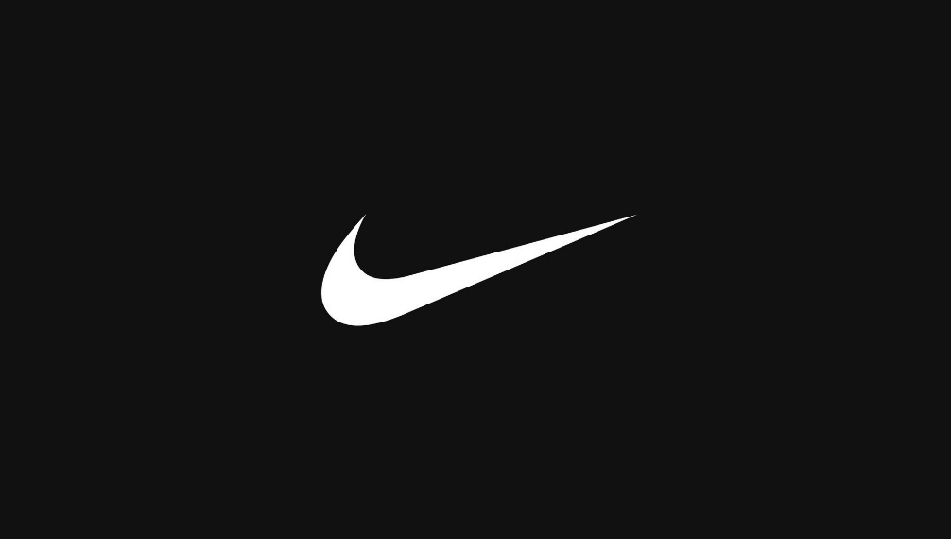

Mission Statements
The vision statements and corporate mission of Nike Inc. are to retain its good position in the worldwide market as the apparel supplier and athletic shoe brand. The corporate mission of Nike explains its fundamental objectives for better business growth (Shilbury et al., 2020)
The main aim or corporate mission of Nike Inc. is “to bring innovation and inspiration to every athlete across the world.”

Situational Analysis
In this part we discussed the situation analysis of Nike; situation analysis plays an important role in the growth of the company. With the help of situation analysis company knows if they are ahead or behind its competitors (Shilbury et al., 2020). Examples for situational analysis are PESTLE, Porters 5 forces model and SWOT.

Pestle Analysis
Pestle analysis is the tool to measure the impact of political, social, technological, economic, environmental, social, and legal factors on the internal and external environment of the business. With Pestle analysis, the business is able to determine the forces of these factors over its operations.
Porter 5 forces model
Porter 5 forces model is a framework to analyse the competitive environment of the organisation. It takes in view the power of suppliers, customers, rivals, and the threat of new entrants and substitute products on the organisation.
SWOT Analysis
SWOT analysis is a tool to gauge the internal and external factors which affects the business. The strengths and weaknesses are internal to the business and opportunities and threats are external to the business.
All the products of Nike have ultimate finish and superior quality, due to which the customers crossing in front of Nike showrooms are become attracted to the products of Nike. The showrooms of Nike are present across the world.

Objectives of Nike
The objectives of Nike are as follows:
- Increase sale by 3%
- Increase market share in Europe region by 4%
- Increase the brand awareness of Nike

Marketing Strategies of Nike
The modern strategies of marketing did not make Nike successful in the global market in its early days. It is the marketing strategy of Nike which makes them famous across the world. In the early days, Nike did not focus on applying different marketing strategies (Tuten, 2020); the main motive of Nike is to offer a quality product to its customers. That motive of Nike is the main reason behind the success story of Nike.
`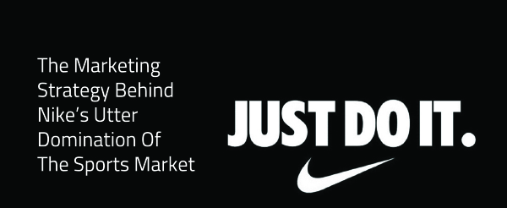
The main aim of Nike is to sell “Emotional Benefits” of its various products. In order to chase flashy and new objects, Nike has not adopted the modern platforms of communication (Tuten, 2020). Nike makes sure that its message as a brand is still displayed across the world during the content marketing in the current time. Nike focuses to make a product that provides more benefits to the customers. In the global market, the marketing strategy of Nike has still remained successful; on the other hand, many marketing strategies of various companies end into the vein.

Implementation and Control
For implementation and control, it is essential that Nike use effective methods which able to seek and foresight the happenings that can affect the business in future. For implementation, Nike must have such expert marketing executives which are experience and able to implement the plan effectively.
For control, it must have a contingency plan that can foresee the challenges and devise strategies as per the arousing challenges.
PORTERS FIVE FORCES MODEL OF NIKE
Suppliers bargaining power - Low
Supplier of Nike's have poor negotiation strength. Its own goods are made in about 620 factories worldwide in 42 countries. Although individual suppliers are limited in numbers, those are often not able to integrate forward (Schultz, 2020). This limits the prospects for the suppliers to compete. In comparison, the proportion of suppliers is higher and is they are working and distributed all around the globe. That is why Nike cannot be pressurized by any of the individual suppliers. In general, Nike monitors and periodically audits its suppliers by third-party regulatory auditors.
Buyers low to moderate bargaining power
Nike's customers have little to moderate negotiation capacity. There are many competitors for Nike in the industry. Such competitors such as Puma as well as Reebok within addition to Adidas & also Under Armor (Park, 2020). Nike also has some several other locally and internationally existing brands. Customers have found low cost of switching in Nike. The consistency and selling of Nike's goods have somewhat reduced by this force. Nike basically emphasizes towards design & performance. Therefore, it was able to establish strong loyalty about their brand and the customers are satisfied by their products.
Low to moderate threat of alternative products
Nike is moderately threatened by the replacement products. That is because multiple competitive brands manufacture goods that complement or match by the Nike's products. Many of the brands are making low-cost shoes similar to Nike throughout the local and foreign markets (Park, 2020). These products challenge Nike with lower-priced alternatives. The design & quality of Nike's products reduce the substitute products threat to a certain low degree. Overall, the challenge from the substitute goods is considered to be moderate for Nike brand.
New entrants Threat: Low
The challenge of new competitors to Nike may be regarded as low to moderate. And while the expenses to set up the company are not too high, there are also other criteria which are not possible to convince (Park, 2020). Initially, every new entrant must begin at a local or smaller level. In addition to manufacturing, marketing, logistics and management of supply chain are available which require resources, professional staff and effort. It is also challenging to create a brand name and reputation.
Competitiveness level: Strong
In the sport sector there is a high level of competitiveness. Four of Nike's fiercest competitor include Adidas, Under Armor as well as Puma. The sector has been saturated and the major companies are fighting to enhance in the market penetration as well as to grab the highest market shares (Park, 2020). Marketing, advertising and other aspects are so much concentrated by these brands. The numbers of Nike's best players as well as their direct competitors are weak, but it does intensify competitiveness. The overall competitive standard in the industry is generally high.
SWOT ANALYSIS OF NIKE
Nike’s Strengths – Internal Strategic Factors
Strong branding
The best niche of Nike is its strategy of branding. Nike performs its campaign across the world. It is a social responsibility of the company to promote its brand image worldwide. With the help of strong branding, Nike gains popularity in the global market (Shilbury et al., 2020).
Strong customer service
The company Nike has a strong network of offices in the whole world, which makes sure that the customer gets the best products. The feedback services of Nike are quite appreciable. Based on the feedback Nike contacts its various customers (Shilbury et al., 2020). Nike also tries to resolve and bad feedback and problem of a customer in a very short period of time. Additionally, Nike also offers Nike plus membership to its customers because of that the customers get various benefits or discounts.

Nike’s Weaknesses – Internal Strategic Factors
Poor labour conditions
Nike also is known for its poor environment of working across the world. It happens most of the times that Nike faced many problems which are related to the working condition. Those problems also affect the employees of Nike (Kotabe and Helsen, 2020). Because of those problems the employees of Nike are demotivated and did not feel safe working in an environment which is unhealthy.
The unequal pays
One of the weaknesses of Nike is that it still has a toxic working culture because of unfairness in the women equally and paying men (Kotabe and Helsen, 2020). In Nike, most of the working ladies are not satisfied with their working payment, most of them also raise their voice about the culture of unequal pay.
Nike’s Opportunities – External Strategic Factors
Improvement of work environments
For any organization, the biggest opportunity is to get a chance to work on its weaknesses. According to the report of the SWOT analysis of Nike, the biggest weakness of Nike is its employee's condition of poor working (Kotabe and Helsen, 2020). So, for the growth, it is important for the company to work on its weakness of poor working conditions in its every office in the whole world. Furthermore, the internal public of every organization needs to be served. So, Nike should also make its employees happy because of that the employees can perform their work with more passion or motivation and so employees can produce various products which fulfil the requirements of the customers.
Markets of developing nations
Nike marks its attendance in every country of the world which is very significant for its business growth (Kotabe and Helsen, 2020). Furthermore, Nike also makes some more offices in the expanding countries in the world like China India. If the business of Nike expands in those countries so it will be so beneficial for its growth and development.

Nike’s Threats – External Strategic Factors
The fake products
According to the report of the situation analysis of Nike, many markets across the world sell fake products of Nike. Because of those products the image Nike brand is damaged in the global market (Tuten, 2020). The quality of fake Nike products is not up to customer acceptance because of that the customer trust on the brand is also affected. At the level of competition, the quality of fake products is affecting the image of the brand.
Increasing competition
The one threat which is always very dangerous for any brand is the competition, it does not depend that the brand is well developed or still in the process of developing (Tuten, 2020). During the presence of various brands like Under Armor and Adidas, it is not easy for Nike to beat the innovation strategies of other brands every time. In order to compete with other brands, Nike has to increase the productivity, creativity, and quality of its products.

Advantages and disadvantages of SWOT
Advantages:
The biggest advantage which SWOT analysis provides to the business is that it helps the business to understand its dynamics in a better way. It enables the business to understand its weaknesses and deter the threats. It also ensures that it devise such a pathway that helps the business to capitalize on its opportunities.
With these advantages, business will be able to develop its goals and strategies for achieving the goals.
Disadvantages:
One major disadvantage of SWOT Analysis is that it does not prioritise the issues which are outlined. It just gives a general overview of the issues instead.
Another weakness is that it does not provide solutions to the problems that are outlined.

Segmentation, Targeting and positioning

Segmentation
Customers have been segmented according to demographic, geographic and psychographic variable. In demographic age and gender of customer has been bifurcated, however the income level of the customers is also a part of demographic variable. Geographic variables include various maintained stores by Nike worldwide according to the culture and norms of each country. Psychographic variables include comparison of product according to the personality of a person. The product portfolio of Nike is large so that it can satisfy the need of each customer class.
Targeting
Differentiated target market has been set by Nike, irrespective of the gender, mostly they have targeted the young generation who are involved in sports and fitness activities like regular exercise. They are offering for men, women and kids to capture the large market area. Colours variety and design attract each class of customers.
Positioning
The main competitors for Nike are Adidas and Puma, in comparison with they have to maintain a solid brand image to capture high market share, for this purpose the brand image of Nike is positioned as athlete. And their brand focuses more towards providing best shows for sports. Those customers who need relax and soothing footwear can pursue buying of Nike shoes.

MARKETING MIX OF NIKE
The process of marketing mix deals with the growth of apparel business, equipment business, athletic footwear, and profitability of Nike (Tuten, 2020). In a company like Nike, the marketing mix includes the tactics and strategies which are used to implement the marketing plan, having a focus on place, promotion, price, and products.
Nikes Products (Products Mix)
The organizational output which is used to focus on various consumers is the part of marketing mix. The above outputs are called the product mix. The product mix is one of the reasons for the growth of the Nike business (Tuten, 2020). The product mix of Nike is represented through those broad categories which are given below:
- Accessories and equipment
- Shoes
- Apparel
The most famous product of Nike is its shoes. Nike also adds some more products to its business when it starts expanding across the world. Nike also introduces some new products, for example, golf clubs, equipment, and accessories. Nike sells these products under the various companies’ brands which include Converse, Hurley, and Air Jordan. In order to complete the needs of the customers, the product mix of Nike expands. Most common branding strategy followed by Nike is the emotional marketing where they include any of sports celebrity and big names from the sports to endorse their brand and make people purchase the brand which is being supported by their favourite players.
Place/ Distribution in Nike Marketing Mix
With the help of a marketing mix, the company’s products are distributed and sold in different venues (Tuten, 2020). There are many outlets across the world through which Nike sold its apparel, sports shoes, and equipment. All of these products of Nike are offered in the popular retails stores in the world. Following are the places where Nike distributes its products:
- Online stores of Nike
- Retail stores
- Retail stores of Nike town
Most of the products of Nike are sold through retail stores. These stores are located in the common public areas in which the customers can attract towards the products of Nike. Furthermore, the retail outlet of Nike town is operated by its business (Herhausen et al., 2020). The company owned these outlets and allowed them to perform the business across the world. These outlets operate with certain marketing strategies and the emerging or new products are also offers in these outlets.
Indirect channel of distribution channel of Nike includes selling the product to the Whole sale persons in the country where they approach towards international market as well, Nike is also approaching directly to the customers by selling through their factory outlets and using the source of online sales.
Nike Inc. Promotion (Promotional Mix)
Marketing communication mix is also used as the marketing mix, with the help of marketing communication the company can easily communicate with the targeted customers. In order to make its image successful in the global market the company needs to promote its products across the world (Herhausen et al., 2020). According to the SWOT analysis to create a successful image in the global market is the strength of Nike.
With the help of promotional tactics, Nike can easily communicate with its target customers and provide them the information about its products. Nike performs various activities of promotion in which some of them are given below:
- Personal selling
- Sales promotion
- Advertising
- Direct marketing
- Public relations
The main source of Nike which is used for attracting various customers is called advertising. In order to engage customers towards the product, the company fully depends on the process of advertising. In its advertisements for products, Nike used many sports teams and professional athletes (Herhausen et al., 2020). The personal selling process is also a part of the marketing mix of Nike. In this process, companies perform direct marketing with the help of local sports, colleges, organizations, and teams in order to focus the target customers. According to the 4ps, in order to promote the products company used direct contact with different organizations. On the other hand, to gain huge profits and increase the selling percentage Nike applies some special offers discount on its products. These discounts are usually offering on any occasion as a promotional tactic.
Nikes Prices and Pricing Strategies
With the help of marketing mix company can decide the price of its products in order to gain maximum profit (Herhausen et al., 2020). To sell the product at premium prices Nike also invests its money in technology. Nike decides its product price on the basis of current situation of the market. Nike applies various pricing strategies for its business in which some of them are given below:
- The strategy of premium pricing
- The strategy based on value pricing
The strategy based on the value pricing depends on the customer's point of view on how much value he/she gave to the product. According to the marketing mix, this strategy is applied to find out the value of products in customer perception and then set the price of the product related to the perception of the customer (Herhausen et al., 2020). On the other hand, the strategy of premium pricing consists of high prices of the products. Nike set the price of some of the products at the premium level because of the high quality of the products and in order to compete with the different brand's products.

Recommendations
Following recommendations for Nike are presented below:
- Nike must capitalize on its brand name and market image.
- It must continue to focus more on the footwear segment since its Nike’s key strength.
- Nike must ensure that it follows ethical and well devised labour practices.
- Nike must cooperate with the government and follow the rules of the region in which it is handling its operations.
Various helpful techniques can be adopted from Ansoff matrix using the strategies of market development and diversification, the strategy related to product development will be crucial for Nike as they already have diversified portfolio in which well-known brands are available, but product development will help them to focus on introduction of new product.

Conclusion
To conclude, the marketing plan of Nike ensures that Nike has effective marketing strategies intact which ensures that the brand continues to build and maintain its market image and brand name in the industry.

STAKEHOLDER ENGAGEMENT AND THEIR IMPACT ON THE MARKETING ACTIVITIES OF AN ORGANISATION
Stakeholder – Definition
Stakeholders are the ones that are directly or indirectly related to the operations of the organization. These are the key persons that runs the operations of the organization directly and indirectly.
Internal Stakeholders
Internal stakeholders are the one that are internal to the business. These are the key people that carry outs the business operations directly and in person. The key internal stakeholders at Nike includes:
- Employees
- Managers
- Directors
These are the people that are closely linked with the operations of the business; hence their opinion matters a lot in the marketing decisions of the business.
Nike ensures that it employs right people for the job that is in the hand. For this the recruitment and selection process at Nike is rigorous.
The managers of Nike are experience individuals who have been a part of the company for a longer period of time. These are the people who possess people skills.
The directors are such people who are the majority of shareholders of Nike.
External Stakeholders
The external stakeholders are the ones that does not carry out business operations from the inside but are directly impacted from it. The external stakeholders in case of Nike include:
- Consumers
- Regulators
- Investors
- Suppliers
External stakeholders drive the external environment of the business that effects its marketing activities.
The consumers of Nike are mainly such people who are fond of or are professional Athletes. These consumers are usually such people of all ages that are able to pay premium price for the products.
The suppliers of Nike are its authorized vendors who are part of Nike’s supply chain network all around the world.

How Nike communicate with its stakeholders
Stakeholder Meetings
Nike conducts a three-month stakeholder meeting at its HQ. in this meeting, the internal and external stakeholders are gathered at a single point and expectations of each stakeholder is gauged and overall performance is evaluated.
Newsletters
Before finalizing a big decision, Nike ensures that it takes in view the suggestions of its stakeholders. For this, Nike uses newsletters to communicate important changes with the stakeholders.
Summary Report
Another effective way to communicate with the stakeholders is to send out a summary report that features all relevant data and statistics.
Marketing activities of Nike have influential impact on both their stakeholders and shareholders, more importantly the CSR activities increases the stake of shareholders in the activities of the business, once the effective marketing activities has been visualized by shareholders they would dare to invest more in the profitable operations of the company.

Recommendations
The following are the key recommendations for Nike:
- Adopt modern technology in its marketing campaign.
- Concentrate on a particular niche.
- Collaborate more with athletes and celebrities.
- Focus more on its footwear segment as it is one of the biggest strengths of Nike.
- Nike must address the concerns regarding labour laws.
- It must remain competitive I the market to deal with increasing competition.
- Nike must secure patent protections.

Conclusion
To conclude, it is evident that Nike has a strong marketing portfolio, which has greatly contributed to its positive market image and its success all over the world. With the marketing plan of Nike, the organization will be able to concentrate more on its specific marketing plans and will aim to adopt a rifle approach rather than a shotgun approach. This will help the organization to target on a specific niche.

REFERENCE LIST
Al-Zyoud, M. F. (2018). Social media marketing, functional branding strategy and intentional branding. Problems and Perspectives in Management, 16(3), 102-116.
Brennan, R., Canning, L., and McDowell, R. (2020) Business-to-business marketing. SAGE Publications Limited.
Cateora, P.R., Meyer, R.B.M.F., Gilly, M.C., and Graham, J.L. (2020) International marketing. McGraw-Hill Education.
Flikkema, M., Castaldi, C., de Man, A. P., & Seip, M. (2019). Trademarks’ relatedness to product and service innovation: A branding strategy approach. Research Policy, 48(6), 1340-1353.
Herhausen, D., Miočević, D., Morgan, R.E., and Kleijnen, M.H. (2020) “The digital marketing capabilities gap” Industrial Marketing Management, 90, pp.276-290.
Kotabe, M.M., and Helsen, K. (2020) Global marketing management. John Wiley & Sons.
Park, S. (2020) Marketing management (Vol. 3). Seohee Academy.
Price, L. G. (2017). U.S. Patent No. 9,646,288. Washington, DC: U.S. Patent and Trademark Office.
Ruiz-Pava, G., & Forero-Pineda, C. (2018). Internal and external search strategies of innovative firms: the role of the target market. Journal of Knowledge Management.
Schultz, D.E. (2020) “From Advertising to Integrated Marketing Communications” In A Reader in Marketing Communications (pp. 10-40). Routledge.
Shilbury, D., Quick, S., Funk, D., Westerbeek, H., and Karg, A. (2020) Strategic sport marketing. Routledge.
Tuten, T.L. (2020) Social media marketing. SAGE Publications Limited.

