HOW TO CREATE CHART IN A WORD DOCUMENT

FOLLOW THE STEPS BELOW

STEP 1: STEP 2: STEP 3: STEP 4:
PLACE YOUR CURSOR OPEN INSERT TAB CLICK CHART PICK A CHART TYPE
Go to the insert tab on the ribbon
Choose e.g, Column, Line or Pie, then ok
Select Chart in the illustration group
Click in the document where the chart should go

STEP5: STEP 6:
EDIT DATA CLOSE AND CUSTOMISE
Close the worksheet, the use Chart design or format to style it
Type your labels and numbers into the pop up Excel Worksheet
WHERE TO FIND IT  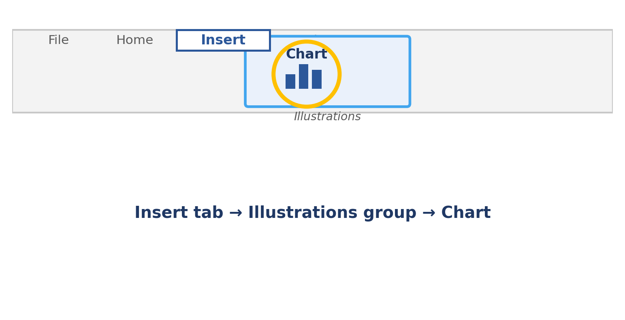 | WHAT YOU'LL GET  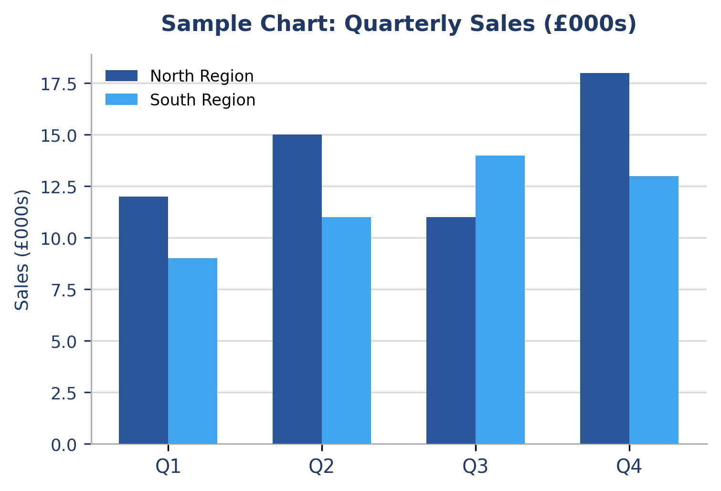

TIPS
- To update numbers later, right-click the chart and choose Edit Data.
- Use the + Chart Elements button to add titles, labels or a legend.
- Pick a Quick Layout from the Chart Design tab for an instant, tidy look.
- Keep it simple: one clear message per chart is easier to read at a glance.

