Megan Ann Lewis
Combined word count- 3353

Task 1-

- Define the term professional and explain what it means to be a ‘people professional’. (AC 1.1)

When discussing what it means to be professional, it refers to the way an individual behaves and represents themselves in a business setting. Professional behaviour can be characterised as being considerate, formal and focused and having a professional attitude can make an employee trustworthy and reliable (Herrity, 2021).

Attributes of professionalism include:

- Competency
- Reliability and accountability
- Honesty and integrity
- Self- control
- Flexibility
- Respect for others
- Professional image
(ACCA Global, 2019).

A people professional is an individual that is responsible for the wellbeing and effectiveness of the employees within their organisation. The role of a People Professional will include areas such as Recruitment, Learning & Development and Employee Relations. In addition, the people professions also work alongside the management teams to direct and influence culture, employee engagement and significant company changes (Dessler, 2019).

As a people professional it is important that a deep understanding of the human behaviour exists. It is important they have the ability to coach, advise, influence, mentor and motivate others (Indeed, 2022). Many individuals find this profession rewarding due to the ability of observing the positive impact you can have on the teams and individuals you work with.

Within the UK, there is a definite body of knowledge and training programmes, accredited by the professional body, CIPD. The CIPD acts as a governing body and it clearly determines the standards of conduct of the people profession. Having said that, unlike some other professions, it must be noted that membership of the professional body, CIPD is not compulsory (CIPD, 2021c). The CIPD have developed a comprehensive map detailing all the knowledge and skills that the people professions require at each level of their career (Taylor, Woodhams, 2022).

- Explore how the role of a people professional (either a generalist or a particular specialist) is evolving and the priorities this raises for continuing professional development (CPD) (AC 3.1)

Continuing professional development can be described as personal process that all individuals are responsible for continuously. Individuals should decide for themselves what their learning needs are and how in which they are going to achieve them (Megginson, Whitaker 2007). It is important to keep up to date with the rapidly changing role by continuing to learn, read and put it into practise (Taylor, Woodhams, 2022). This is important, if they do not stay up to date, practises or advise could be outdated and in some cases even illegal.

It is key for people professionals to stay current with trends within their specialist field to best serve their organisation. It is important for them to be adaptable and have the ability to learn new skills to keep up with the evolving workforce and to remain competitive (Brassey, J et al 2019).

Today, people professionals can be tech savvy and use technology to their advantage to implement a more coordinated approach to HRM. Technology enables the profession to automate and streamline tasks which in turn allows more time to be spent on strategic work (Dessler, 2019).

I joined my current organisation, Morrisons in July 2021 as a People Manager for one store. The role has adapted over the last 18 months and in August 2022 we entered into a consultation period with the role taking on broader accountability with a clear framework developed to ensure we’re focusing on the right priorities. This work is completely underpinned by building the capability of the line managers to a create a ‘customers first’ environment within our retail organisation.

Looking to the future, it is anticipated that the most influential trends of 2030 will be internal change, digital and technological transformation, changing demographics and diversity & inclusion strategy, diversifying employment relationships and sustainability, purpose and responsible business (Green, Peters and Young, 2020).

The use of the employee’s voice is also evolving and with an increase in remote working and workforce diversity, new opportunities and challenges are being created for the people professionals (CIPD, 2021a). The ‘four-day week’ is a big evolvement since the Covid-19 pandemic and the CIPD research discussed how the pilot had demonstrated organisations willingness to innovate and it stated it could be valuable to improve work-life balance whilst also good to retain and attract employees (CIPD, 2023).

- Discuss the concept of ‘ethical values’, and how at least three ethical values that you hold personally, impact (or could impact) on your work as a people professional. (AC 1.2)

Ethical values provide us with the moral compass by which we live our lives and make decisions (Russell, N.D). Ethics are collective codes of what is right and what is wrong. As a people professional it is important to consider interactions with others and the aim should be to respectful and considerate of every individual value. Words and actions are powerful and we should use them to create and develop positive relationships. Our behaviour, which is what is seen by others is underpinned by three factors that live within us. Our beliefs, values and attitude (Taylor, Woodhams, 2022).

As an individual, it’s important to know our own personal values as this allows us to identify when they are being compromised (Mind Tools, N.D.b). It is important to act on this situation to uphold our values. This work helps demonstrate and model the kind of behaviour you, or I as an individual would like to see in others. Living and breathing our own values helps us create a world that is more compassionate.

The three ethical values that I hold personally are honesty, kindness and belonging. I highlighted these by using the Values Wheel (Linkedin, 2016). For me, trust is the fundamental principal of honesty. Working with honesty within my organisation allows me to consider and implement the right solutions to resolve problems. This value allows me to gain stronger support from my employees and it also brings peace and success. I demonstrate the value by being clear and consistent with the message I am delivering.

Kindness for me is important inside and outside of the workplace. I have always believed that it’s important to treat everyone, no matter the age, race, gender or religion with kindness and therefore respect. In Morrisons, one of our six ways of working is ‘we care’ and I strive to demonstrate this in every interaction I have from development and performance conversations to welfare meetings and ‘Your Say’ meetings, ensuring everyone feels heard and valued within the team and organisation.

I always want to feel comfortable being my authentic self and that is why belonging is my third value. When we feel like we belong to a group, we have a sense of security and support and as individuals we feel accepted and included (Cornell University, N.D).

- Explain why it is essential for people professionals to contribute confidently to discussions, and ways of doing this that are (AC 1.3):
- informed
- clear
- engaging

For people professions to develop transparency, it is vital that internal communication is clear, consistent and regular especially when navigating change and transformations (CIPD, 2022a). Communication should be to listen and be heard and work both ways. It is key for people professionals to have and continually develop their ability to influence outcomes and have the courage to challenge decisions and actions (CIPD, 2022c). This often means doing the right thing, even if that isn’t the cheapest or quickest way. It is a key requirement of the role to communicate clearly, effectively and professionally at all times. This requires communication to gain attention by using volume and tone to deliver in a clear and engaged manner. The more they practise communicating effectively the more confident they will become which will in turn have a positive impact on their ability to influence (CIPD, 2022a).
For people professionals to contribute confidentially to discussions, it is important that they adapt the content to suit the audience and draw on rational persuasion, logistical arguments and facts & data whilst linking it to evidence. The profession is in a position in which they can have a significant impact on others. The three factors that underpin the contribution are the ability to think critically, communicate effectively and build relationships. An approach that can be used is to find common ground through shared personal values and beliefs. (Mind Tools, N.D.a).

People professionals use their insight and expertise to help their employees to see things in a new light and make well informed decisions by making evidence-based arguments (CIPD, 2021b). They can also influence positive change by inspiring others to take action. When conversations are meaningful, organisations support an innovative and collaborative culture (Gratton, Erickson, 2007). To be informed, it is important to have and use the right evidence that can be qualitive or quantitative (Taylor, Woodhams, 2022).

- Discuss when and how to raise concerns when issues such as organisational policies or leadership approaches conflict with ethical values or legislation. (AC 1.4)

It’s important for everyone feels comfortable about raising concerns within an organisation, especially the people professionals. There are multiple ways that an employee can raise a concern and this could wither be informally, formally or through a whistle blow. A whistle blow is when a worker reports certain types of wrongdoing that they have seen at work and the individual would be protected by law (GOV.UK, 2011).

People practitioners have an important role in creating a psychologically safe environment for employees to feel like they can raise issues. This environment can be created by having open and honest communication style, encouraging employees to share their ideas & concerns and by providing support when employees make mistakes (Lockwood, 2022).

When organisations have regular team time or quality circles which entails employees meeting regularly to solve problems effecting its work area (Lawler III, Mohrman, 1985) it becomes normal for employees to speak truth to power.

It is important to note that there is a difference between an ethical value and what would be breaking the law and therefore illegal. People practitioners must be seen as role models or ‘ethical stewards’ and have the ability to highlight issues within their organisation as employees then witness this. The profession has a level of perceived authority in their role to challenge organisational decisions (CIPD, 2017).

- Provide a robust argument for ethical people practice that is supported by academic theory and details both the business and human benefits of people at work feeling included, valued and fairly treated. (AC 2.1)

When employees feel valued, included and fairly treated, employee engagement is positive and there is personal motivation within teams that drive better business outcomes. A key part of being a people professional revolves around championing diversity and inclusion as well as collaborative strategies to ensure all employees feel valued (Carter-Hicks, 2015).

It is imperative that organisations recognize and embrace the interdependence of a variety of stakeholders. They must advocate management systems that benefit the business owners, staff, customers, and wider society at large. (Beer et al, 2015).
According to the Maslow’s Hierarchy of Needs theory, people are motivated to achieve certain needs, and some needs take precedence over others. Once lower-level needs are met for instance phycological needs, higher-level needs take their place. The theory believes that individuals have the desire to reach their full potential, however, Maslow states, to achieve self-actualisation, first the five basic needs must be met (CIPD, 2021d). The five needs are:
- Physiological
- Safety
- Love and belonginess
- Esteem
- Self-actualisation
When people professionals are working ethically, this helps employees feel included, valued and fairly treated. This is supported by the SCARF model broken down by:

Status
Certainty
Autonomy
Relatedness
Fairness
(Rock, 2008).

When organisations observe the five domains in their communication, trust and further attachment is built to the organisation as the interaction isn’t threatening.

- Drawing on your own or a hypothetical example of providing a people practice solution to meet a particular need or introducing a new policy or initiative, describe:
- strategies for designing the solution/initiative so that it will be inclusive
- strategies for checking that, when in practice, the solution/initiative engages and meets the needs of all those it is aimed at. (AC 2.2)

Following the restructure in October 2022 that saw the People Managers become multisite within my organisation, a critical people practice solution that would allow us to continue upskilling of our line managers capability. Training models were broken down to ‘leading myself,’ ‘leading my team’ and ‘leading the business.’ We also delivered an up-skill on ER essential skills to every line manager. This work was very important to ensure we adapted to the new way of working as efficiently as possible and we empowered the managers with the skills and knowledge required to complete their role (University of Bradford, 2019.) In recent years, the use of technology within the business has grown exponentially and therefore through completing a PESTLE analysis we identified that there were gaps to address within the employees’ skills and knowledge. Since rolling this workload out, the success of the project has been measured by the levels of absence, grievances & appeals as well as our colleagues happiness score to demonstrate that our line managers are now fully responsible for their people and organisation and own it from end-to-end (Diggin, 2021).

As we are a large organisation with many employees spread across various stores and shift patterns, the training was conducted virtually, led by People Managers specialising in their areas of expertise for the ER essentials. This allowed the managers to network and interact with their peers that they may never have met before and interact with people from diverse backgrounds (Inclusive Employers, 2022). For the bitesize leadership and development sessions, these were facilitated locally at store level in an intimate setting for the managers to have the opportunity to be real, open and honest with their closest peers. The training sessions were designed to support the inclusion within the workspace and it was aligned to our organisational values. Going forward, we continue to monitor progress and identify our opportunities for where we can continue to develop.

Task 2 –

Self-assessment (AC 2.3, 3.2)

I have completed my self-assessment against the five CIPD Profession Map core behaviours at associate level: Ethical Practise, Professional Courage and Influence, Valuing People, Working Inclusively and Passion for Learning (CIPD, 2022b).

Within ethical practise my biggest opportunity is raising concerns as this is something that is new to me and I need to be more confident in conveying challenges when I know what I am delivering. I consider the thoughts of others and how my actions will impact them and therefore by developing this skill I will be better equipped at supporting my colleagues.

I am proud to recognise and develop those within my team however I can greater develop this by being a mentor to future inspiring leaders of the business and help them on their career journey (Together, 2022).

Within my role, a key part is coaching and advising on the go. As I continue to develop my experience and be exposed to more complex situations a line manager has identified an opportunity whereby I can develop myself and my teams further by sharing my knowledge through experience with them.

My development activities (AC 3.4)

Having identified my main development needs by using the self-assessment tool via the CIPD learning hub and collating 360* feedback from my work colleagues (Peiperl, 2001). I have now reviewed the development activities I am going to place on my learning plan. My biggest opportunity lies within passion for learning and therefore I have committed to asking for feedback from those that attend on what went well and what could be even better next time. I am also going to complete the CIPD course on ethical practise to develop my skillset within this behaviour, as an informal activity this is a convenient way to keep up my learning.

Over the next year within Morrisons I will also be receiving professional development workshop that will be delivered by the ER Casework specialists as well as the Regional People Managers. This will be a great way for me to gain new knowledge on current trends and develop new skills as well as making professional connections outside of my peer group (Forbes Coaches Council, 2018). The sessions will be broken down into three behavioural sessions and eight technical & ER sessions.

Something I will also be developing is my core behaviour of Working Inclusively and I will be actively seeking more diverse views. I will seek to ask for feedback from a diverse group of stakeholders and build purposeful relationships with wider colleagues (Prossack, 2021).

CDP Reflective record (AC 3.4)

Over the last twelve months, I have enjoyed developing professionally and have personally witnessed a lot of personal growth. Below I have noted three reflective records of my learning over the last year and I have described how my 'what' has impacted my performance at work and my personal behaviour. Through the points I discuss I have been able to continue learning and staying up to date with developments in my field which have improved my skillset and professional journey (Indeed, 2023a).
Since June 2022 I have been the lead People Manager for our Community Champions within the South Wales and Somerset region of Morrisons. During this period I planned, prepared and presented a full day of engagement in order to influence the team and ensure everyone understood their role and how we were going to achieve our target of raising £10 million for our charity partner Together For Short Lives. This project has enabled me to develop the core behaviour of Professional Courage and Influence as well as Valuing People by building a sense of team spirit and purpose. From this I gained experience in holding and engaging with a room for a full day by contributing to discussion in an informed and confident way and communicating key information clearly to engage and influence the Community Champions (Mills, 2017). As I successfully delivered this day, I have the confidence to present a meeting day on a topic that I am passionate about. I also hold weekly thirty-minute virtual calls with the thirty six stores to check in on progress and to address any anticipated obstacles as everyone is in the same position. Having facilitated this team, in December 2022 I was able to take responsibility and contribute by leading the region through the stores to host our first regional event ‘Race to the North Pole,’ where we raised £25k collectively for charity.
In August 2022 we entered a consultation period as People Managers in Morrisons and were going from one store to a cluster of stores. In order to secure the role we had to present a presentation on ‘How you will successfully embed the future People Manager role’ assuming we’d be responsible for up to 4 stores. This developed my core behaviour of Passion for Learning as I proactively developed my professional knowledge, skills and experience. The project also required me to demonstrate my awareness of my own strengths and development areas (Indeed, 2023b). Having been fortunate enough to already be holding two stores for three months due to a colleague’s resignation I was in a position of knowing what I was currently doing and what I needed to work on. As part of my presentation, I considered what my short- and long-term priorities would be. I decided to present with a simple presentation that I had designed through the online graphic design tool ‘Canva.’ I really had to think about my audience here which was my Regional People Manager. Knowing she doesn’t like presentations I kept the information on screen to a minimum and used prompt card to help me deliver all the key information I needed to convey. This opportunity allowed me to gain specific knowledge and insight into the role (myfuture, 2021).
In early 2023 I was nominated to be the Mental Health ‘Train the Trainer’ for our region which entailed being trained on the work and slides I was going to deliver to our People Manager’s. From this workshop that was delivered by our Employee Relations specialist, I developed my listening and responding skills as we all had different previous experience levels and real-life stories. This project enabled me to also develop my Valuing People core behaviour whereby I had the opportunity to coach and advise others in the business and had to consider the wellbeing of others for this piece of work (NHS Employers, 2022). This project allowed me to continue working with our ER specialist as well as my peers as I support them with their Mental Health cases within their stores. I took away from the session that as People Manager’s, we are often always looking after others and how important it is for us to ensure we are looking after ourselves first to for the people that work with us to get the best version, ‘You can’t pour from an empty cup.’ During my session I shared the information I had learnt to influence and educate them on the topic of Mental Health and positive Wellbeing. This project has also allowed me to feel more confident with supporting my own line managers within my three Cardiff stores because as a business, we currently see mental ill-health as the most common cause of absence. We aren’t alone as an organisation, the Mental Health foundation released that their evidence suggested that 12.7% of all absence days in the UK were attributed to mental health conditions (2022).

Bibliography

ACCA Global (2019). What it means to be professional | ACCA Global. Accaglobal.com. Available at: https://www.accaglobal.com/an/en/student/sa/features/being-professional.html.
Beer, M., Boselie, P. and Brewster, C. (2015) Back to the future: implications for the field of HRM of the multistakeholder perspective proposed 30 years ago. Human Resource Management. Vol 54, No 3, May/June. pp427-38
Brassey, J., Christensen, L. and van Dam, N. (2019). Essential components of a learning and development strategy | McKinsey. www.mckinsey.com. Available at: https://www.mckinsey.com/capabilities/people-and-organizational-performance/our-insights/the-essential-components-of-a-successful-l-and-d-strategy.
Carter-Hicks, G. (2015). The Intersection of Diversity, Inclusion, Maslow’s Theory & Engagement. [online] www.linkedin.com. Available at: https://www.linkedin.com/pulse/intersection-diversity-inclusion-maslows-theory-gloria-carter-hicks.
CIPD (2017) Professionalism: what do we stand for? Available at: https://peopleprofession.cipd.org/Images/professional-identity-research-report-updatedPFFMay20_tcm29-17960.pdf.
CIPD (2021a) Employee Voice, CIPD: London
CIPD (2021a) Evidence-based practise for effective decision-making, CIPD: London
‌CIPD (2021c) Membership, CIPD: London
CIPD (2021) Work Motivation, CIPD: London
CIPD (2022a) Employee communication, CIPD: London
CIPD (2022b) New Profession Map, CIPD: London
CIPD (2022c) Professional courage and influence, CIPD: London
CIPD (2023) CIPD responds to 4-day week pilot results, CIPD: London
Cornell University (n.d.). Sense of Belonging | Cornell University Diversity and Inclusion. Available at: https://diversity.cornell.edu/belonging/sense-belonging.
Dessler, W. (2019). How the Role of HR Professionals Is Evolving. Cayenne Consulting. Available at: https://www.caycon.com/blog/how-the-role-of-hr-professionals-is-evolving.
Diggin, W. (2021). Council Post: Measuring Your Organization’s Happiness Quotient (HQ). Forbes. Available at: https://www.forbes.com/sites/forbestechcouncil/2021/09/03/measuring-your-organizations-happiness-quotient-hq/?sh=4333d7864d8c
Forbes Coaches Council (2018). Council Post: Network Diversification: 15 Tips For Expanding Your Professional Contacts. [online] Forbes. https://www.forbes.com/sites/forbescoachescouncil/2018/11/01/network-diversification-15-tips-for-expanding-your-professional-contacts/?sh=5e917857336b
GOV.UK (2011). Whistleblowing for Employees. GOV.UK. Available at: https://www.gov.uk/whistleblowing.
Gratton, L. and Erickson, T.J. (2007). Eight Ways to Build Collaborative Teams. [online] Harvard Business Review. Available at: https://hbr.org/2007/11/eight-ways-to-build-collaborative-teams.
Green, M, Peters, R and Young, J (2020) People Profession 2030: A collective view of future trends, London: CIPD

Herrity, J. (2021). What Does It Mean To Be Professional? Indeed Career Guide. Available at: https://www.indeed.com/career-advice/career-development/what-does-it-mean-to-be-professional.
Inclusive Employers (2022). The benefits of having a diverse network. Inclusive Employers. Available at: https://www.inclusiveemployers.co.uk/blog/the-benefits-of-having-a-diverse-network/.
Indeed (2022). Leadership as influence (Plus strategies to exert influence). Indeed. Available at: https://uk.indeed.com/career-advice/career-development/leadership-as-influence.
Indeed (2023). How To Demonstrate Your Willingness To Learn in the Workplace. [online] Indeed Career Guide. Available at: https://www.indeed.com/career-advice/interviewing/willingness-to-learn.
Indeed (2023b). Understanding Strengths in the Workplace (With Examples). Indeed Career Guide. Available at: https://uk.indeed.com/career-advice/career-development/strengths-in-the-workplace.
Lawler III, E. and Mohrman, S. (1985). Quality Circles After the Fad. Harvard Business Review. Available at: https://hbr.org/1985/01/quality-circles-after-the-fad.
Linkedin (2016) The Wheel of Values. Linkedin. Available at: https://www.linkedin.com/pulse/wheel-values-franky-redant
Lockwood, J. (2022). Why is it important for organisations to ensure they are establishing a psychologically safe environment for their staff and colleagues? [online] SEE Change Happen: The Inclusive Culture Experts. Available at: https://seechangehappen.co.uk/why-is-it-important-for-organisations-to-ensure-they-are-establishing-a-psychologically-safe-environment-for-their-staff-and-colleagues/
Megginson, D and Whitaker, V (2007) Continuing professional development, 2nd ed, London: CIPD
Mental Health Foundation (2022). Mental Health at work: Statistics. www.mentalhealth.org.uk. Available at: https://www.mentalhealth.org.uk/explore-mental-health/mental-health-statistics/mental-health-work-statistics.
Mills, G.R. (2017). Council Post: Mastering The Five C’s Of Influential Communication. [online] Forbes. Available at: https://www.forbes.com/sites/forbescoachescouncil/2017/05/05/mastering-the-five-cs-of-influential-communication/?sh=6c30766421b6
Mind Tools Content Team (N.D.a). Building Rapport. [online] www.mindtools.com. Available at: https://www.mindtools.com/a9f9kqi/building-rapport.
Mind Tools Content Team (N.D.b). What are your values. | www.mindtools.com. Available at: https://www.mindtools.com/a5eygum/what-are-your-values.
myfuture (2021). myfuture - Australia’s National Career Information Service. [online] myfuture. Available at: https://myfuture.edu.au/career-articles/details/gaining-personal-insight-and-an-edge-through-work-experience.
NHS Employers (2022). Health and wellbeing conversations | NHS Employers. [online] www.nhsemployers.org. Available at: https://www.nhsemployers.org/articles/health-and-wellbeing-conversations.
Peiperl, M. (2001). Getting 360-Degree Feedback Right. [online] Harvard Business Review. Available at: https://hbr.org/2001/01/getting-360-degree-feedback-right.
Prossack, A. (2021). 4 Ways To Build Stronger Workplace Relationships. Forbes. Available at: https://www.forbes.com/sites/ashiraprossack1/2021/03/30/4-ways-to-build-stronger-workplace-relationships/.
Rock, D (2008) SCARF: A brain-based model for collaborating with and influencing others, NeuroLeadership Journal, 1 (1) p 44
Russell, T (N.D) Ethical Practice, https://peopleproffesion.cipd.org/profession-map/core-behavious/ethical-practise
Taylor, S & Woodhams, C. (2022). Studying human resource management : a guide to the study, context and practice of HR (Taylor & C. Woodhams, Eds.; Third edition.). KoganPage.

Together (2022). What is a career mentor and do you need one? | Together Mentoring Software. Available at: https://www.togetherplatform.com/blog/career-mentoring
University Of Bradford (2019). Adaptability and flexibility - University of Bradford. [online] Bradford.ac.uk. Available at: https://www.bradford.ac.uk/careers/develop-skills/adapt-flex/.

Appendix

Self-assessment

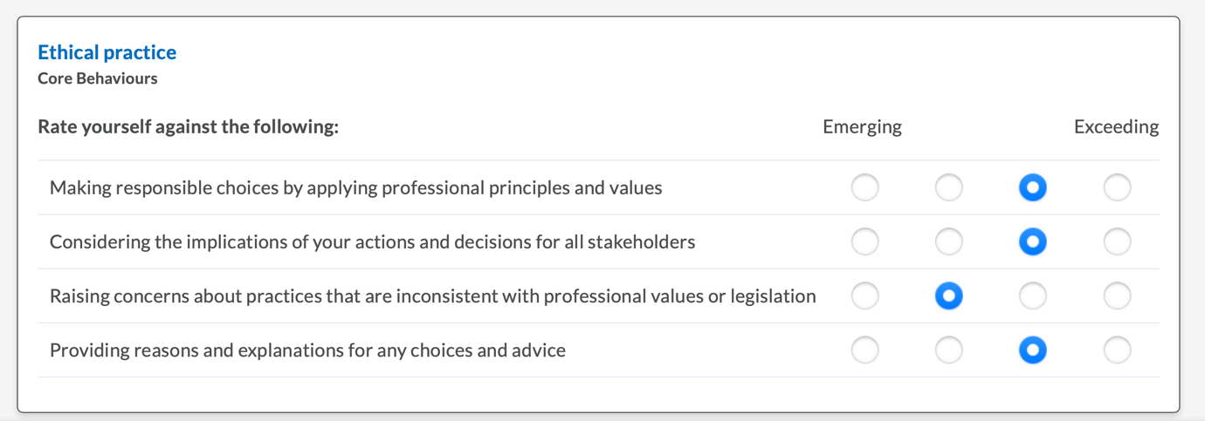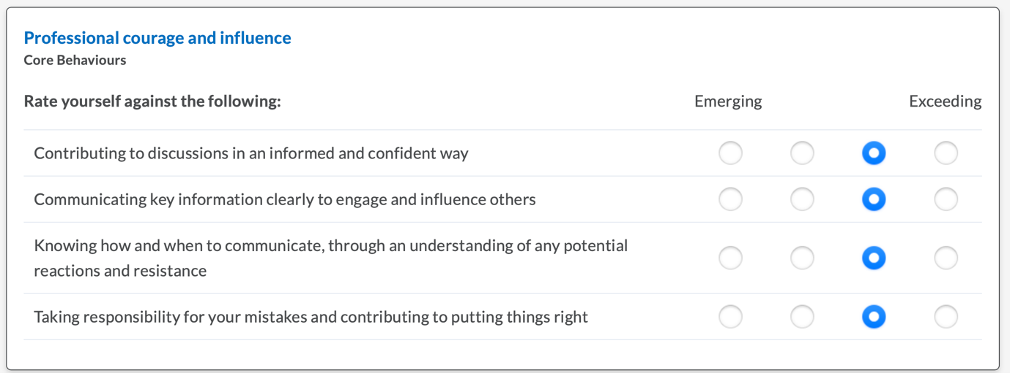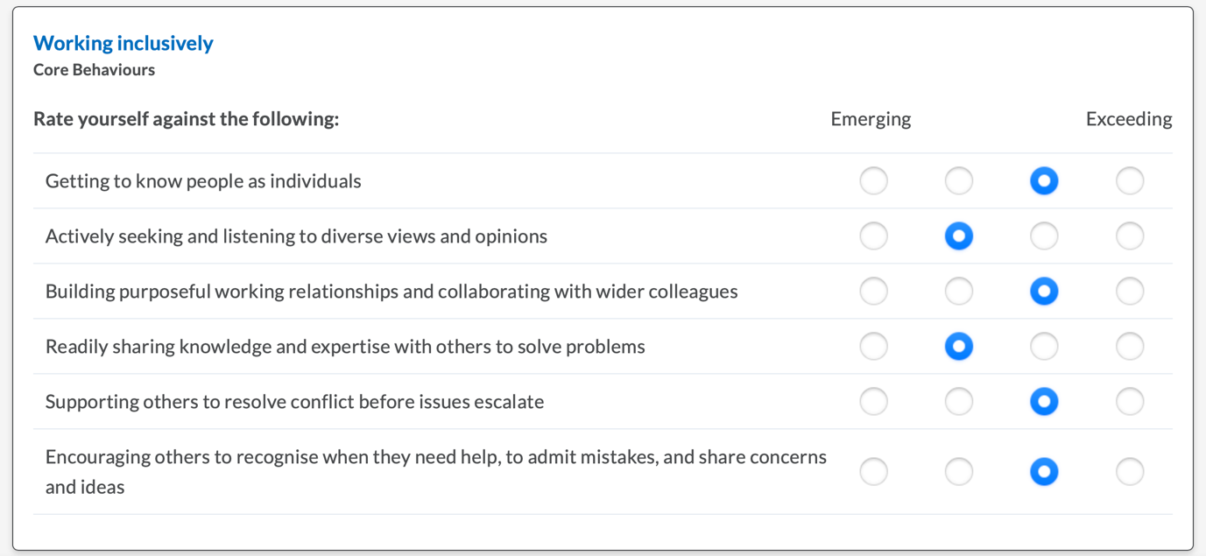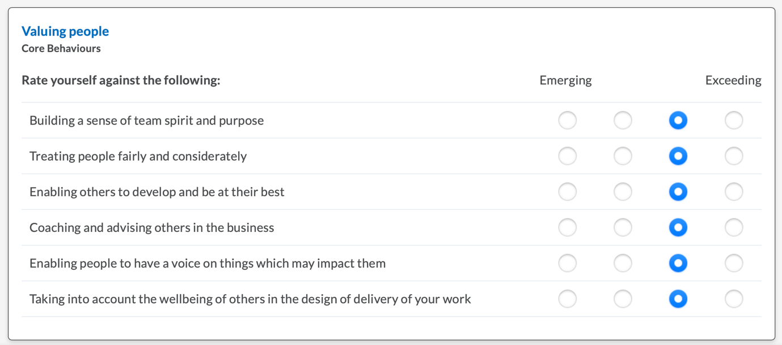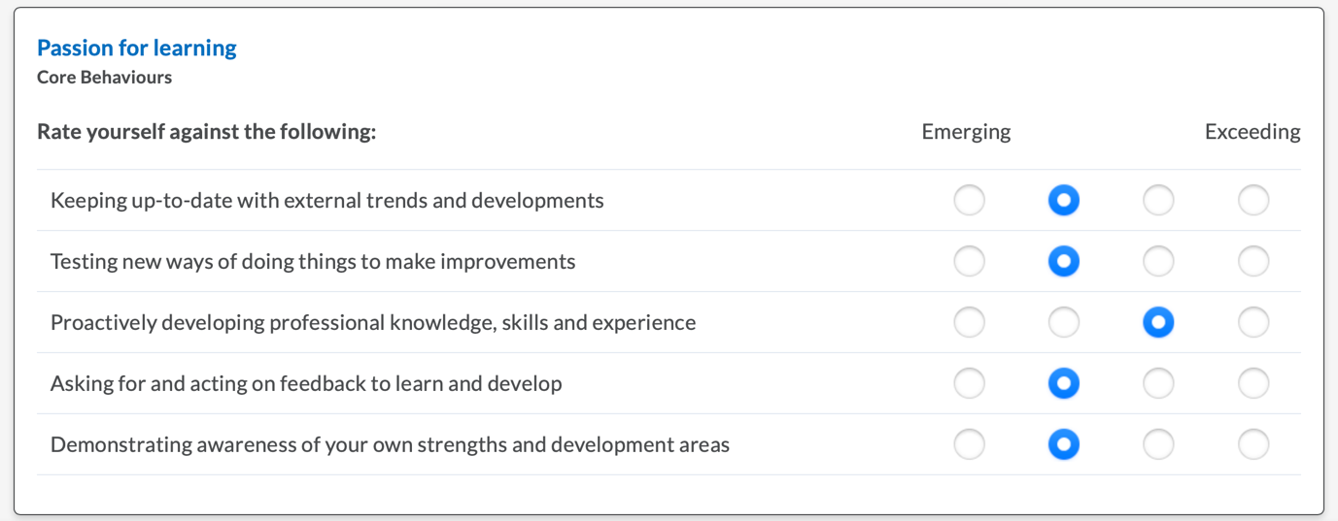

My Learning plan



