Essential Skills for Study and Employment

In today's fast evolving job market, developing a set of essential skills is crucial for academic success and professional career [1]. These skills, often referred to as transferable or soft skills, implement technical knowledge and enhance employability across different industries.
Critical thinking and problem-solving abilities are fundamental for academic and professional settings [2]. These skills help to analyse complex situations, make informed decisions, and develop innovative solutions.
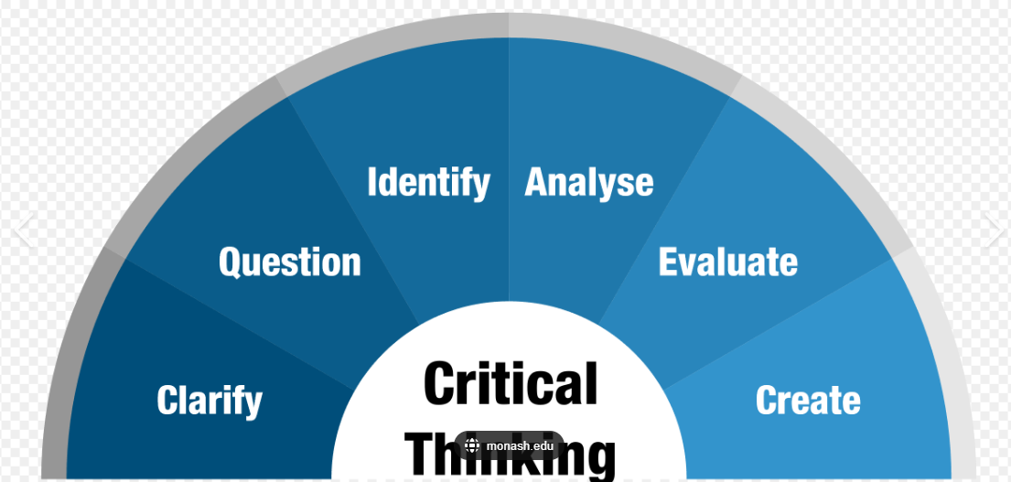
Effective communication, both written and verbal, is another vital skill set. The ability to articulate ideas clearly and precisely is essential in academic writing, presentations, and workplace interactions [3]. Therefore, digital literacy and proficiency with relevant software tools have become more important in our technology-driven world.
Time management and organizational skills are fundamental for balancing the academic workload and meeting professional deadlines. These skills help in prioritising tasks, improving productivity, and reducing stress levels [4].
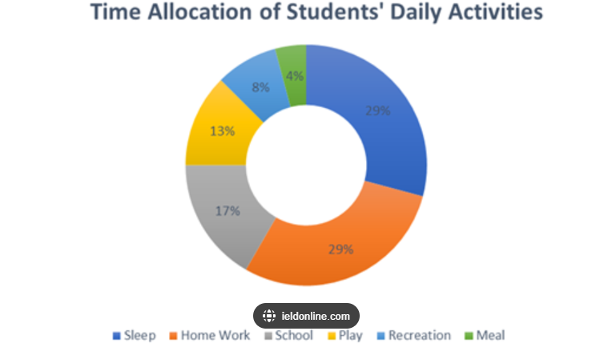
Developing these essential skills during academic years significantly supports career progression after graduation. Employers value candidates who can prove these transferable skills alongside their technical ability. Critical thinking and problem-solving abilities enable graduates to adapt to new challenges and contribute innovative ideas to their organizations. Strong communication skills help effective teamwork, client interactions, and leadership potential. Time management and organizational skills enhance overall productivity and reliability in the workplace.
By focusing on developing these essential skills, students can better prepare themselves for the demands of their chosen careers and position themselves as valuable assets in the competitive job market.

References:
[1] World Economic Forum, "The Future of Jobs Report 2020," World Economic Forum, 2020. [Online]. Available: https://www.weforum.org/reports/the-future-of-jobs-report-2020. [Accessed: 16-Jul-2024].
[2] P. Facione, Critical Thinking: What It Is and Why It Counts. Hermosa Beach, CA: Measured Reasons LLC, 2015.
[3] D. Crystal, English as a Global Language, 2nd ed. Cambridge: Cambridge University Press, 2012.
[4] T. H. Macan, "Time management: Test of a process model," Journal of Applied Psychology, vol. 79, no. 3, pp. 381-391, 1994.

