Saint Fagans Personal Reflection

As someone who has never been to Wales before, Saint Fagans was a way to immerse myself into Welsh history. Within our first module we had the opportunity to explore local locations, such as Lampeter and Strata Florida, but St Fagans was the most appealing as it presents the most about the history of Welsh culture and what makes Wales, Wales. Another reason I chose St Fagans is due to its accessibility of archaeology as it has a gallery based on What Makes Wales, which highlights historical artifacts and events which shaped Wales into what it is today. However, as someone who has never been to Wales before all the history presented seemed very glamourised, like it doesn’t show the pure roots of Wales, such as the coal mines and the other grimy parts of Welsh culture.
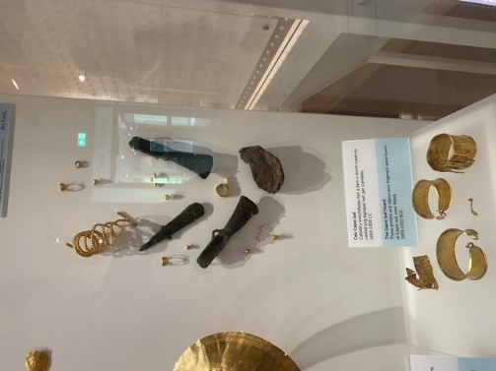
One of the first display cases you are greeted with is a case holding Welsh gold. This is a staple to Welsh history as it shows their wealth and value, signifying how gold is deeply rooted into their past. This gives the impression of Wales being this rich country with all this gold to go around, whereas the reality of it is high levels of poverty. From an outsider’s point of view, it shows that the museum is using rose tinted glasses to restrict what “tourists” see of Welsh history, like they are trying to paint a new picture to cover up the reality of what it is. When going around the displays after seeing the gold jewellery, I felt like it put a different light on everything else in the room, even though it wasn’t a huge amount of gold on display it gave the effect of everything being centred around the idea of all the items being lavish and rich, as the room never really put across the poverty and difficulties the Welsh faced.
Figure 1 - S. Green - 04/10/2024
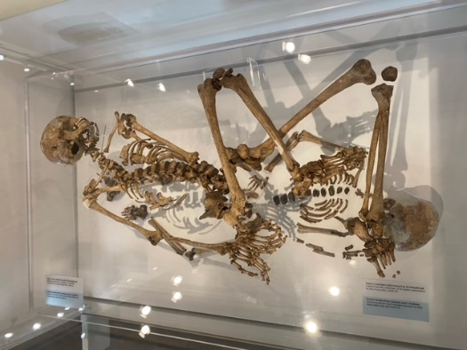
Whilst walking around the first gallery, the ethicality of having skeletons on display became apparent. Having skeletons in display cases is having people laid out on display for everyone to glance and take pictures of, as they were people with emotions and families. It brings the question of how you would feel if a family member you had laid to rest got dug up, moved away from the burial ground and was put on display for people to mindlessly spend 45 seconds looking at and maybe taking a single picture of. Next bringing up the idea of what makes one skeleton more special than another, they are all people who have a story, but it’s what story will sell more tickets, who has the most interesting death.
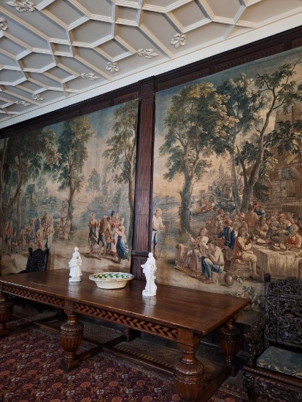
When visiting St Fagans I was told about the castle that was on the site, but I wasn’t expecting the pure beauty of it. There was nothing really “Welsh” about the castle that stood out. Since visiting the castle, I found out that the castle is built in a traditional South Wales style when it was built in 1580 with an “E” shape to it, however the last owner who furnished the castle was Lord Windsor, father of the Earl of Plymouth, this explains why there is a divide between the Welsh history and the castle which was owned most recently by Lord Windsor. The long walk gave the impression of a divide, making you go under a bridge, emphasising the feeling of walking into a new space, a whole new setting where you can’t even see the rest of the museum from castle grounds, putting together a plot of tension between the two countries from the deep-rooted history. Inside of the castle the artifacts and the decorations are mostly oriental items, lots from countries such as India and China. The first room I walked into was playing what sounded like Middle Eastern music, this was due to a previous display about colonisation, but it did highlight that lots of the decoration was from middle eastern countries.
Figure 3 - S. Green - 04/10/2024
Figure 2 - L. Jessopp - 04/10/2024
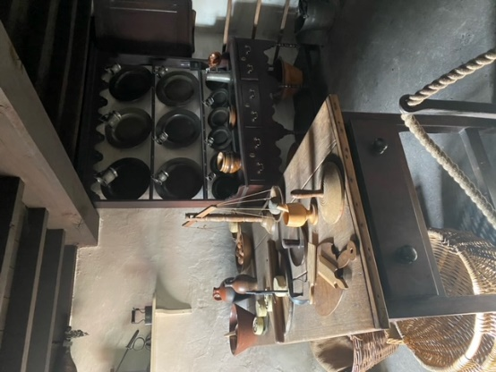
Whilst walking around St Fagans it showed that they were trying to make the museum as realistic and immersive as possible, but with the items being moved from its origin location it removes the realism from it. There is an out of place feeling to the whole museum that I felt, as the journey of the item and where it was found is part of its context, its apart of the emotions that specific artifact or building brings. However, with the buildings and items being moved it numbs some of those emotions people can feel. The reality of the of life is you would own more than one bowl or more than one basket, but the museum curators decide to only display one of the artifacts. I got the impression of the museum trying to make it as realistic and as interesting as possible, but with that they only show one historical spoon which is meant to represent all the spoons everyone owned. It’s the same argument for the houses and the recreated buildings, that they only represent the general common building for that period.
Overall, I believe that the museum on the basis of being a museum on the history of Welsh history is very informative from a person who has never been to Wales and knows nothing about Welsh history. From an archaeologist’s point of view none of the galleries have a reflection on the archaeology of the St Fagans site, in addition the argument for what makes something special enough to be put in a museum, how unique does it have to be to be deemed interesting enough for people to want to visit it. The galleries presented at St Fagan’s trying to paint Wales in a different light to what its history actually is, there is no mention of the coal mines, that them closing down took families out of jobs and thus lead to a wide spread poverty, however, it does mention the tensions between England and Wales through displays about the flooded valleys to provide Liverpool with water. The museum seems to enjoy setting a boundary between the English and the Welsh, putting a light on the conflicts they have had in the past, leaving in the dark crisis’s that happened within Wales.
Figure 4 - S. Green - 04/10/2024

Bibliography:
St Fagans castle (no date) Museum Wales. Available at: https://museum.wales/stfagans/buildings/castle/ (Accessed: 10 October 2024).

