Suzanne Pearton-Scale
Student Number - 2105981
Module Code – ECAP4003
Module Title – Psychological Approaches and Perspectives
Assessment Title – Group Presentation
Academic Year – 2021-2022

Presentation link:
https://uowtsd-my.sharepoint.com/:p:/g/personal/2100048_student_uwtsd_ac_uk/EWErLHGseCRBo3nx3P7YI_sB0z5cPjmLz5Z5XO5cWeKi1Q
Alternative link:
https://uowtsd-my.sharepoint.com/personal/2100048_student_uwtsd_ac_uk/Documents/Psychological%20Approaches.pptx?web=1
Presentation screenshots:
(No script written)

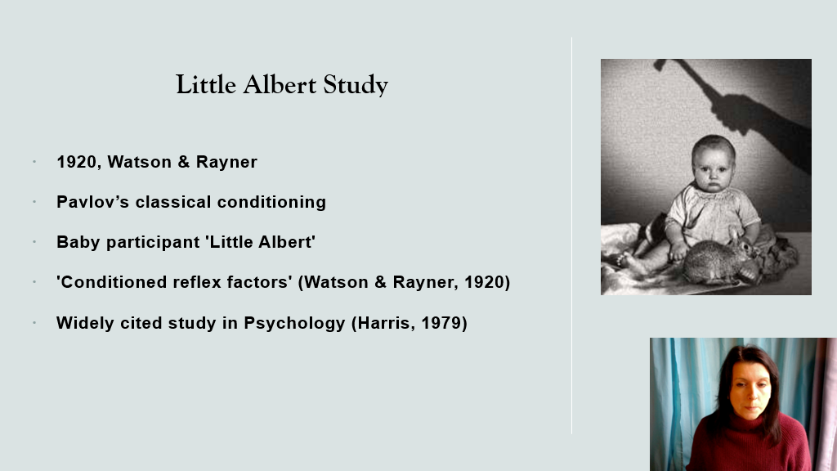

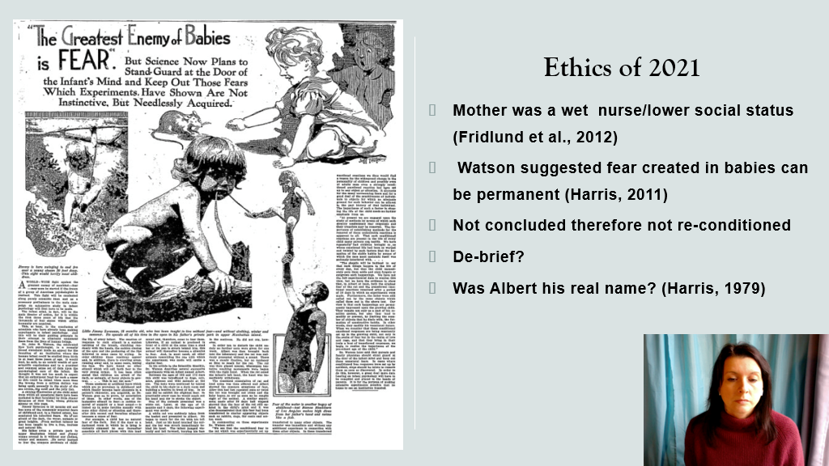
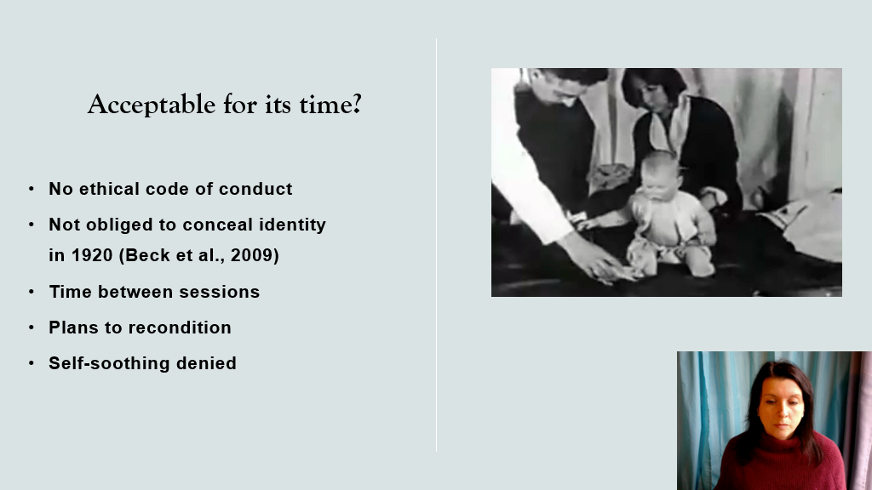

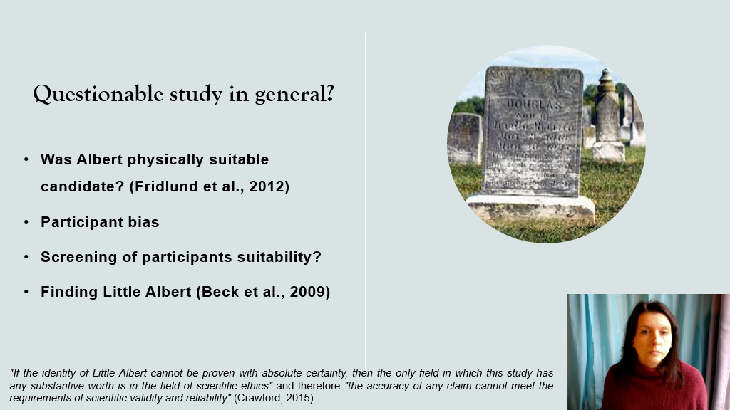

References for my slides:
Beck, H. P., Levinson, S., & Irons, G. (2009). Finding little Albert: A journey to John B. Watson’s infant laboratory. American Psychologist, 64(7), 605.​
Crawford, C. (2015). Little Albert: Ethics and Pragmatics. IU South Bend Undergraduate Research Journal, 15, 211-211.​
Fridlund, A. J., Beck, H. P., Goldie, W. D., & Irons, G. (2012). Little Albert: A neurologically impaired child. History of Psychology, 15(4), 302.​
Harris, B. (1979). Whatever happened to little Albert?. American psychologist, 34(2), 151.​
Harris, B. (2011). Letting go of Little Albert: Disciplinary memory, history, and the uses of myth. Journal of the History of the Behavioral Sciences, 47(1), 1-17.​
Watson, J. B., & Rayner, R. (1920). Conditioned emotional reactions. Journal of experimental psychology, 3(1), 1.​

