The Changing Shape of the Professions

Intro
Throughout the past few decades there has been more and more research into Artificial intelligence (AI) and the impacts it can have on business’ and society as a whole. Everyone has a different point of view on what they think of AI and some people are just unaware of what the impacts might be. As developments in technology are being made, there is a lot of research that needs to be made by people in employment and also by businesses to look at the positives and negatives of AI. From a professionals point of view they will need to look at the developments being made and also look at what AI systems can and cannot do which is what I will be looking at in this report. I will also be focusing on the potential impacts AI might have on me when finding work and look at the ways in which to stay relevant in the workplace.

Main Body
While researching into the effects AI will have in the future, the question “what is the need for change?” came up. As the years go on there are lots of things that need to be considered for example mega trends. “A ‘Megatrend’ is a word coined to describe and group a set of changes in our world that are enormous in their impact, unprecedented in their magnitude, and apparently unstoppable in their march.” (Helps, 2019)
A few examples of mega trends are Global Warming, Urbanisation, Population growth and also AI. Together, all of these trends are changing the world and also changing the future in a big way. Looking specifically at AI, a lot of employees within organisations might be worried about where they stand and whether their job might be over taken by AI but they need to look at both the positive and negative sides of the situation.
Optimistic people might realise that AI could actually create more jobs in the future. This is because when the ‘robots’ and machines are put into organisations, they will still need to be monitored and controlled by humans to make sure they are working properly. Another way in which an AI system would be good from a manufacturing point of view is because of how efficient and productive they are. A machine can work 24/7 all year round without stopping if it is told to do so. “Human beings are biological organisms and need regular maintenance, e.g. food and sleep… Robots don’t get tired or hungry, and are capable of working on the production line 24/7. This allows expansion of production capabilities, which is increasingly necessary to meet the demands of worldwide customers… They can greatly reduce turn-round times in many areas of the business operation.” (Manufacturing, 2019)
Pessimistic people will look at AI and think the usual things for example how robots are going to take over the world and they will worry about their jobs being lost. One point that employees in an organisation might think about is what they will do if they lose their job to AI. As I have said before, some people will be able to continue in their place of work as they can manage the AI systems but that will only take a small minority of people to do that. The big worry that people have is, what the rest of the workers will do. They will have specific skills tailored to doing their certain job and now they won’t be able to find anything else to do because AI will take over any similar jobs as well.

Even though AI has a lot of benefits, there are some things that these machines and technology will not be able to do. To stay relevant within the workplace, it would be wise to choose a job which requires communication skills. Some example of these kinds of skills are jobs that require critical thinking, empathy, creativity, strategy and physical skill. These areas just a few skills that AI technology and ‘robots’ will not be able to do as well as humans.
For example, if you were a patient and you had some bad news, you would want someone that is empathetic and you would want it to be personal. “While AI is being used in medical applications to do things like more accurately detect diseases on a scan, I certainly wouldn't want to get a robocall to break the news that I have cancer. Even though we are making strides towards affective computing, we are a long way away from any technology that can genuinely recognize human emotions and respond to them appropriately”. (Marr, 2019)
Another example is within physical skills. AI can do a lot of great things but one thing they have yet to master is physical skills for example within sport. This one skill that should be safe from AI for the foreseeable future as this technology would be very complex. “While robots are being created that can do increasingly tricky things, like make your morning latte, there are still a significant number of physical skills robots haven’t mastered…if you have any amazing physical skills, from crafting to sport, you’re also safe for now.” (Marr, 2019)
And lastly, AI don’t have an imagination. AI is amazing for being programmed and getting told what to do. They follow a written path and do whatever they are told to do but they cannot think by themselves and are not creative. In a business point of view they would be useless in a job role where new ideas had to be made or things had to be created because they just don’t have the technology yet to do such thing. “The way AI currently works is by taking existing data and making logical inferences based on parameters we give it. Imagination and dreaming are merely not programmable skills.” (Marr, 2019)

As someone that wants to get into a marketing role within a business in the future it got me thinking about how likely my job will be to get taken over by AI. When thinking about the role of a marketing manager or any role within marketing really I thought there would be no chance that these jobs could be taken by AI. When doing some research I found a helpful article. The article has a table which says
“The table below ranks occupations according to their probability of computerisation (from least- to most-computerisable). Those occupations used as training data are labelled as either ‘0’ (not computerisable) or ‘1’ (computerisable), respectively. There are 70 such occupations, 10 percent of the total number of occupations.”(Frey and Osborne, 2019)
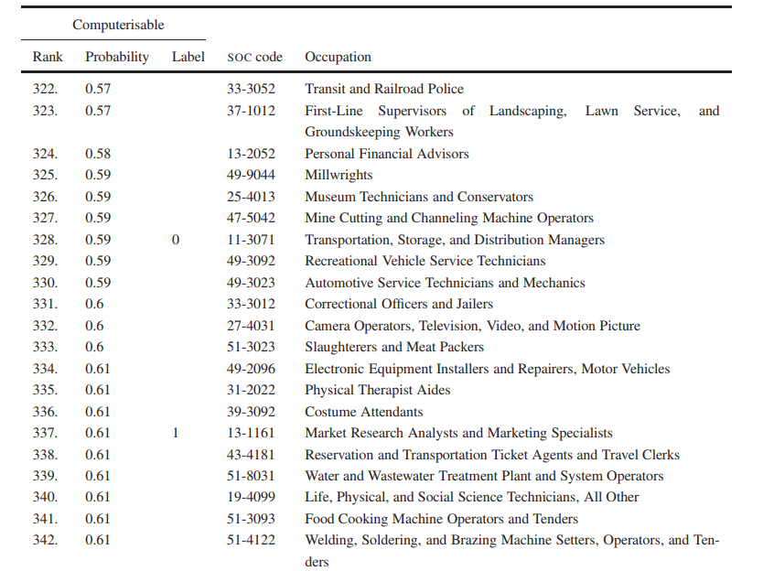

(Frey and Osborne, 2019)

When looking at the data in the table I was very surprised to see that there is a 61% chance that one day the roles of Market research analyst and Marketing Specialists will get over taken by AI. Both of these jobs require communication skills and some forms of imagination and creativity and this is why I was so surprised. In the table above it doesn’t say exactly when these jobs will be overtaken but I predict it won’t be until a long time in the future.
Conclusion
By researching the topic of how the role of the professional will be effected in the future of work I have found out a lot of things and come up with a few ideas of what I think will happen in the future.
In reality I think that it will only be certain jobs that will be effected in the next few years and for people working in the manufacturing industry there might be small changes but most jobs should be secure. For people working in jobs which require communication and physical skills they won’t need to worry for a lot longer because the advancements in technology aren’t there yet to affect these kind of jobs for example a marketing specialist or a sports performer.
Looking at it from a positive perspective, I thinking that the introduction of AI could have a lot of benefits for the professional as it will in some cases create jobs. But on the other hand, if your job gets taken to an AI system you will have skills that might not be applicable anywhere else because any job similar to the persons skill set will most likely get taken by AI in the nearby future.
Lastly, I think that even if the foreseeable future jobs do start getting more and more AI based, there still be jobs for everyone as new jobs will be created and I think that advancements in AI will bring more good than bad.

Appendix
- Helps, C (2019) What is a Megatrend, and How they will Change Everything! Charliehelps.co
Available at: https://charliehelps.co/what-is-a-megatrend/
[Accessed 07 Nov 2019]

- Manufacturing, 7 (2019) 7 Benefits of AI in Manufacturing - Industry 4.0 Trends - Rowse. Rowse.co.uk
Available at: https://www.rowse.co.uk/blog/post/7-manufacturing-ai-benefits
[Accessed 8 Nov 2019]

- Marr, B (2019) 7 Job Skills Of The Future (That AIs And Robots Can't Do Better Than Humans) Forbes.com

Available at: https://www.forbes.com/sites/bernardmarr/2018/08/06/7-job-skills-of-the-future-that-ais-and-robots-cant-do-better-than-humans/#26e98ee16c2e

[Accessed 11 Nov 2019]

- Frey, C. and Osborne, M. (2019) Oxfordmartin.ox.ac.uk

Available at: https://www.oxfordmartin.ox.ac.uk/downloads/academic/The_Future_of_Employment.pdf

[Accessed 12 Nov. 2019]

