BA Leadership and Management Skillsfor the Workplace

Assignment Title:Developing Workplace Critical Thinking- A case of SushiDog, London


Student: Faisal Yussuf 1712895
Teacher: Yajesh Kumar

Table of Contents
1 Introduction 4
2 The case study 5
3 The importance of values in the workplace 7
4 The importance of attitude in the workplace: Negativity and positivity 9
5 The importance of beliefs in the workplace 11
6 Management theories 12
6.1 Functions of a Manager 12
6.2 Scientific management theory 13
6.3 Bureaucratic Management Theory 14
6.4 Human Relations 15
6.4.1 Group Dynamics and Teamwork 16
6.5 Contingency theory 17
7 Recommendation 18
7.1 Share of best practices 19
8 Conclusion 19
9 Reference list 21

List of Figures
Figure 1: SushiDog Products 8
Figure 2: Core Values 9
Figure 3: Customer Reviews-Facebook 11
Figure 4 Functions of a manager 13
Figure 5: Elements of Group Dynamics 17

Introduction
Growth is a process; in order to bring about the change, it is essential to change the mind to bring in new changes. The skillset possessed by an individual varies from person to person; however, critical thinking abilities are most sought after skills (Dochyet al. 2012). Within the workplace, it is important to consider critical thinking that helps to solve the problems at work and enhance the ability of management to utilise knowledge in order to deal with productive work behaviour. With the help critical thinking in the workplace, the ways of accomplishing objectives are changed entirely.By considering the viewpoint of Brookfield (2011), it is examined that critical thinking helps to bring in new ideas and allow the management to focus on the effective and innovative solutions to the business problems. It is quite obvious that the overall workforce shows involvement in the critical thinking process that fosters team management and makes it tranquilto manage the work-related activities.
The theme of this assignment revolves around the application of appropriate management theory that plays an essential role in managing the workforce. With this, the implication of management theories will also help in evaluating the beliefs, attitude, and values of the organisation that gives suitable design to deal with the issues. In the view of Marcus (1988), critical thinking can be defined as the ability to analyse the given situation objectively and then make a reasoned judgment. Usually, critical thinkers within the workplace setting are quite open-minded as they are open to change. In other words, the critical thinking process is considered as an automatic thoughtprocess that examines the overall condition of the working environment, under which critical thinkers differentiates between useful and non-useful information to arrive on a decision.The development of critical thinking helpsto cover the civil and economic aspectsthat engage employees as well as manage the workforce within an organisation (Fontanaet al, 2015).The assignment is designed in a respective manner that covers the examination of a selected small enterprise located in London that isSushiDog. There is a discussion on the importance of values, attitude and behaviourwithin an organisationthat helps to investigate the issues in management. Under the examination of management theories, the most suitable recommendationsare givenwith sound concluding remarks.

The case study
SushiDog is a sushi food corner established in London that facilitates customers by creating made to order sushi that is easy to eat on the go. The company SushiDog is considered asa small and medium enterprise that operates in the fast-food industry of London, UK. The company was established by two friends namely;Nick and Greg who are known as co-founder of SushiDog (SushiDog, 2019). Initially, they started up with a small shop that offered fresh rollsfilled with customise filling. The concept of SushiDog is to offer ease to the customer so that they can savour famed Japanese Cuisine as they move around and do their daily errands. The overall set up is designed to set the mission to create SushiDogfun brand that serves the customers in an entirely new manner. The mission of SushiDog is to offer the SushiDogbowl or sushi roll, the customers are given choice to experience it as per their ease. The idea is to put all the ingredients in a roll that give convenience to food lovers (SushiDog, 2019a). For facilitating the customers, SushiDog provides the options to choose customiseSushiDog roll that is deliciously prepared by mouth-watering ingredients. This includes the avocado, sweet corn, and ahi tuna. There is an opportunity to choose signature recommendation from a customer that helps to create your own SushiDog roll.The roll is prepared in front of the customer that enhances their satisfaction and enables them to revisitSushiDogagain. The company aims is to make the fresh sushi and adopts the easy method to make SushiDog rolls(SushiDog, 2019 a).

The utmost aim of SushiDogis to revolutionise the Japanese food that helps to increase the demand inthe fast-food industry of UK. There is a variety of food that includes the sushi burritos and pokes bowls that are cherry on the top for SushiDog customers (SushiDog, 2019 b). This company is established recently that is in the year 2018; it is the privately-owned enterprise.
On examining the motive and mission of SushiDog, it is found that there is a focus on the sustainable environment that safe the environment from harm. Whether it’s about the supplier or any other fish partner, there is an utmostfocuson ensuringasafe and healthy environment. There is consideration of cleaning regimes that increase the confidence of the customer and allow SushiDog to serve customers in a healthy manner (SushiDog, 2019 c).
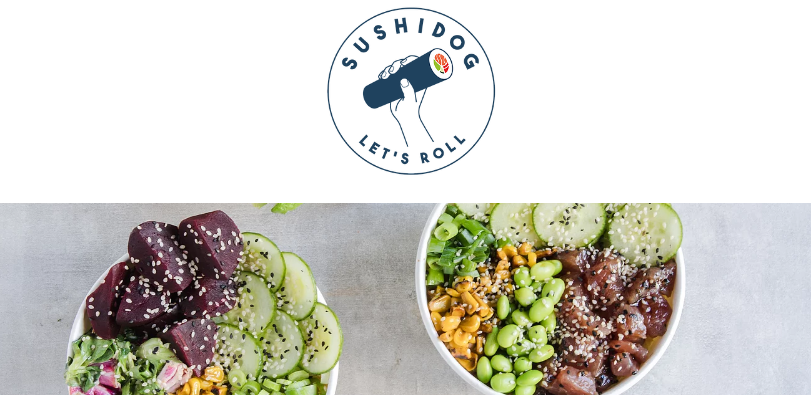
Figure 1: SushiDog Products
(Source: SushiDog, 2019 a)
As far as packing is concerned atSushiDog, it is constituted of recycled packing paper which reflects their compliance towards being environmental friendly. There is less dependency on virgin plastic as it ensures that there is minimum use of plastic bags that reduce the chances of the landfill and improve the sustainable environment (SushiDog, 2019 a). This also reflects their belief and values that how the SushiDog work and is focusing on the concept of social responsibility.

The importance of values in the workplace
By reviewing the information mentioned in course work that value is the measure of importance and worth of the person and working activity. Within the organisation, values are considered as the road map that helps the management and employees to stay directed. On considering its importance, it is found that workplace values are the principles that differentiate in between right and wrong and helps the management to makedecisions and analyse the situation, critically. Some example of workplace values includes accountability, making the difference, quality management, keeping the promise, honesty, reliability, positivity, respect, and accomplishment of objectives (Laforet, 2016). According to Willoughby et al. (2015), the success of an organisationhighly depends on the consideration towards values that what aspectsare valued by management and what are the practices that are valuable for the productive growth of the organisation. With the help of workplace values, it is easy for an organisation to accept the change and to develop the critical decisions for managing the workplace environment. In the case of SushiDog, the core values revolve around customer satisfactionandmake them feel privilegedby serving tasty sushi roll. On considering the viewpoint of Salas et al. (2015), it is observed that organisational values derive organisational culture, make the employees and customers feel valued.
It is mentioned that if workplace values are out of alignment, there is no productive outcome attained by the organisation. The values of SushiDog includes offering the products at low cost, the subtraction of cost is considered as the economic value adopted by SushiDog. The figure affixed below clearly demonstrates the values of SushiDog that differentiates it from other rivals, despite being small scale company, the values form the foundation of SushiDog:
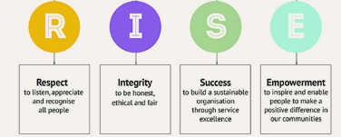
Figure 2: Core Values

The importance of attitude in the workplace: Negativity and positivity
Within an organisation, there is an importance of the attitude that reflects the expression of an individual and considers the beliefs and values towards the accomplishment of organisational objectives. There is the importance of attitude within an organisation that makes the personality of employees pleasant and injects the energy in the overall working environment (Jain, 2015). According to Willoughby et al. (2015), the attitude among employees as well as employer help to make the organisation stable where there is a positive and negative attitude that accordingly affects the performance of the organisation. To shed light on positive attitude, it is observed that a positive attitude help to deal with daily affairs in an effective manner. Added to this, the positive attitude contributes to a less stressful working environment and avoid negative thoughts to float in. It is mentioned that SushiDog back in 2018 was established by two friends as they reflect a positive attitude that results in constructive changes. This constructive change makes business activities successful. The examples of positive work behaviour and employee satisfaction can be determined by satisfied customers as figure appended below depicts reviews from customers on the official fan page of SushiDog on Facebook:
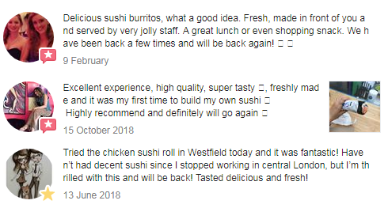
Figure 3: Customer Reviews-Facebook
(Source: SushiDog fan page-Facebook, 2019)
On the other hand, there is a negative attitude or bad attitude that affect organisational performance negatively this includes laziness, rumours, tardiness, and rudeness. It is found by the study of Lamm et al. (2015) that negative attitude lowers the morale of the employees as well as creates personal problems that affect the organisational performance. Customer retention is important and often this negative attitude turns satisfied customers into dissatisfied ones. Referring to SushiDog, till date customers are satisfied and no such negative experiences are being observed, but despite this, the management prefers clarity as evident from the initiatives taken. The staff is very cooperative, teamwork is the utmost ingredient of the SushiDog’s success. Furthermore, the negative attitude in the workplace makes the customer unhappy because there is no proper fulfillment of their orders. According to the viewpoint of Malbašić and Potočan (2015), it is shared that attitude is learned and can develop for increasing the success factor of the organisation. In this manner, SushiDogconcentrates on managing the attitude of each employee that helps to reflect the efficient services and make the customer satisfied and avoid unfavourable situations that will harm the working environment, negatively.

The importance of beliefs in the workplace
According to Willoughby et al. (2015), belief is an essential aspect of organisational development. It is shared by Malbašić and Potočan (2015) that belief is the internal feeling that brings confidence and offers the direction to accomplish any goal. It is examined that the overall organisational culture is the system based on beliefs and attitude that associate with the behaviour of an organisation. In the view of Willoughby et al. (2015), belief is known as the strong emotional state that is developed by certainty as this aspect depends on specific ideas, people and experiences. The study of Lamm et al. (2015) shared some dimensions of beliefs that help to strengthen the belief including the environment, past experiences, education, parents and lifestyle. The establishment of SushiDog highlight that there is a factor of the strong belief that help the owners to grow the business. There is an association found between creative thinking and beliefs as conception are essential to show compliance with the beliefs. It is observed that beliefs are depending on the knowledge and information that an individual has; this highlights the importance of beliefs within the workplace as there is the utilisation of knowledge and information. The importance of belief reflects in a way that belief towards the capabilities serves business growth. Added to this, there is strong support found to increase the efficiency of the organisation. Contrast to this, there is a negative belief that restricts the progress of the organisation (Bailey et al, 2019: Saoulaet al, 2018). In the context of organisational development, there is a strong correlation between belief and level of achievement which is also evident in the case of SushiDog. Within a short time frame, the firm has attained a strong customer base and is working on enhancing its customer service (SushiDog, 2019).According to Malbašić and Potočan (2015), Embracing chssange is another belief that too is found in the motto of the selected company.

Management theories

Functions of a Manager
Within the organisation, it is essential to consider the functions of a manager that help them regulate the management activities and allow them to maintain the structure of an organisation. According to Cooke and Williams (2013), there are five major functions of a manager including planning, organizing, directing, controlling and staffing. Under these functions, managers need to plan accordingly and reflect the creation of structure according to the daily task and working processes. According to Post and Preston (2012), the functions of manager direct to lead, help and manage the organisation that allows employees to engage in working condition.
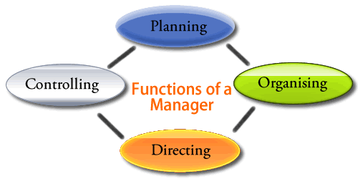
Figure 4Functions of a manager
Source: Cooke and Williams (2013)

There are various management theories that help an organisation to manage the performance as each management theory reflect different dimension.
Implications of Managerial functions to SushiDog
Planning | To consider the aspect of planning as the function of the manager, at SushiDogit is observed that there is a determination of decision and opinion that help the organisation to attain the respective goals. Planning and effective decision making has helpedSushiDogto attain enough success in just a year since its start-up.
Controlling | Controlling at SushiDog is resulted by suitable decision making; this allows owners in which there is the conversion of ideas into reality that contributes to determining the objectives and stay directed towards them.
Directing | The aspect of direction shared that it is the process that instructs the manager and makes them guide to oversee the performance of the organisation
Organisation | The aspect of organising helps the owners of SushiDog to motivate, guide and to communicate the brand message so that SushiDog can sustain its performance. The aspect of leading helps to motivate the employees and encourage them to solve the problems.

Scientific management theory
In the view of Berry et al. (2016), scientific management theory emerges with the help of the potential of science that contributes to improving the productivity level and performance of an organisation. According to Dahlgaard-Park et al. (2018), scientific management theory allowsmanaging the actions by following scientific methods. This theory is proposed by Frederick Taylor who shed light on the working conditions with the help of scientific management methods. According to this theory, there is consideration of principle objects that secure the maximum prosperity for the employee as well as the employer. The emergence of this theory is based on the concept that the industry is suffered froma great loss that highlights inefficiency in daily business activities. That is why, it is important to consider the systematic management method to investigate individual act and cooperation level (Gaugler, 1995). With the help of this management theory, it is observed that there are some important aspects like training and development that help both employee and employer to reflect high-level performance. The principles of scientific management focus onthe development of spirit that balances the cooperation between management and workers that directly improve the working criteria of an organisation (Sells et al, 2018). The discussed management theory can be explained from the perspective of SushiDog as well in a way that, the scientific management principle has helpedSushiDog to develop new ideas and focuses on innovation by launching a new way to serve the customers and offering them a chance to try out Japanese cuisine within their region. Added to this, Ford Motor follows the scientific management theory to involve creativity and innovation in its services (Ford Motor, 2008). It is examined by the case study that Ford Motor focuses on equal opportunities that highly show commitment with employees and working condition (Business Case studies, 2019).

Bureaucratic Management Theory
Under the theory of Bureaucratic Management, there is a focus on the production system by following the principle of ideal bureaucracy. It is examined that Bureaucratic Management theory is applicable for the organisation that follows the hierarchical organisational structure; it reflects a clear systematic approach that manages the employees working condition. It is highlighted that Bureaucratic Management theory is applicable to the organisation that follows a pyramidal command structure (Berry et al. 2016). This theory is proposed by Max Weber that examines the structure of the organisation with respect to its hierarchy. In added to this, there is clearly define decision-making rules considered by the organisation as the principle of Bureaucratic Management theory control the activities of individual workers. There are standardised principles, trained administration, managed rules and regulation that shared clear differences with the traditional managerial organisation. With the help of Bureaucratic Management theory, there is clear authority to show accountability and immediate implications (Dahlgaard-Park et al. 2018). The clear line of authority helps to develop effective workplace as GM, IBM and Union Pacific Railroad followed the Bureaucratic Management theory as there is an organised hierarchy adopted in mentioned organisations.

Human Relations
It is examined that the management system is becoming more human-centered that focuses on individual working capabilities and make the organisation able to act in a creative manner. There is some aspects cover under the human relation theory including management, group dynamics. Teamwork and social interaction; all dimensions are associated with human relationships. There is an emphasis on human relation theory to consider the accurate alignment of workers’ needs. It is examined that fulfilment of human’s need direct to the benefits for the organisation as this is considered as the need for organisation (Collings et al, 2018). By adopting the human relation theory, there are more chances to experience the potential capabilities of the workforce because the practices allow the organisation to give individual attention to employees (Wood and Ogbonnaya, 2018). The discussed organisationShushidog is accomplishing their goals by considering the human relation; in this context; it gives recognition to individual. Added to this, there is involvement of motivational theories that help to enhance the potential of the individual. By considering the human relation theory, there is an association obtained between productivity and relationship of employees that will contribute to enhance the communication. According to Dahlgaard-Park et al.(2018), the increased rate of attention for worker increases motivation as well as productivity; similarly, it works for SushiDog. The adoption of human relation theory is suitable for the company as it helps to guide how to manage the workforce requirement and how to organise the working condition. In line with this, instances can be drawn from the case study of Scottish Power that represents the understanding to examine the needs of its workforce as well as to evaluate the value of its people working with them (Business Case studies, 2019 a). This helps them to enhance the working performance of the business by investing in new invention and in managing the assets.

Group Dynamics and Teamwork
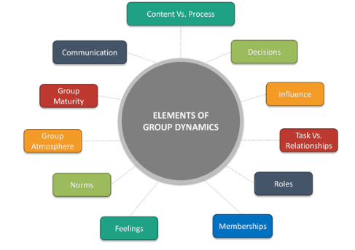
Figure 5: Elements of Group Dynamics
The figure affixed above explains the elements of group dynamics which include roles, decisions, communication, content Vs. Process etc. however, these dynamics are applicable to the case study organisation that is SushiDog. At SushiDog, there are two owners which makes it quite clear that the roles are well defined in order to maintain relationships with the customers, each individual knows what to do and how to do. In addition, the communication is quite clear as management of SushiDog prefers clarity and communicate what is necessary for the wellbeing of the business. Similarly, decisions are taken by the owners and are passed on to other team members, which gives a clear indication of a top-down approach. Task Vs. relationships concept is fully discernible from the repeat purchase behaviour of the customers, tasks objectives are attained within the given time frame as reflected by the performance since its establishment because, in just 1 year, SushiDog has hit a large base of customers. Open and clear communication, as well as well-defined goals, are the core elements that explain teamwork at SushiDog.

Contingency theory
According to Berry et al. (2016), contingency theory is a behavioural theory that helpsthe manager in decision making and highlights the importance of the strategic decision. The theme of contingency theory is to lead the organisation with the cooperation and strategically. Under the context of contingency theory, it is observed that there is an association between organisational actions and internal and external factors; the actions or practices of an organisation are highly dependent on the internal and external factors. In the view of Berry et al. (2016), some important contingency practices for the organisation include the adoption of technology, changes in suppliers and distribution, needs of the customer, competitors, consumer interest groups, and government policies. It is highlighted by Dahlgaard-Park et al. (2018) that contingency theory manages the actions that are practicing according to the current situation. Added to this, there is a contribution of contingency theory in decision making that requiresthe accurate amount of information to get a result. The reason that contingency theory is not frequently used by the majority of organisation is the lack of flexibility; this style does not match with the situation and limits the adoption of contingency theory.

Recommendation
With the aforementioned analysis, it can be suggested that there are some improvements which SushiDog needs to adapt in order to enhance its overall performance and for achieving an edge over the competitors as these changes will be helpful in increasing the growth of the business. It is observed by the current analysis that SushiDog was established last year, therefore, does not have any advanced management style with the help of which the company could perform its operations more efficiently. Therefore it is recommended that the company should focus on the management style that would help SushiDog in managing its services in a better manner. An analysis of operations at SushiDog reveals that human relation management theory forms an integral part of its functions. To achieve optimal productivity levels a number of management practices related to HRM have been deployed. However relevant pompadour in deploying the advanced management of HR and other functions is yet to be achieved. Therefore it is recommended that there is a need for improvement for the management functions and for that the company needs to consider other management theories with the help of which they can enhance their performance more efficiently. It is observed that there is a need to focus more on management regulation which will be helpful in improving the performance and will also lead to enhancing the overall working condition at SushiDog. Added to this, it is recommended that the company should focus on generating profits which can be achieved through improved management style and theories which will be helpful for SushiDog in improving their services and will result in providing impressive services.

Share of best practices
By considering the current situation of the organisation as well as by investigating the improvement, there would be the adoption of excellent ways or techniques to implement the changes. With the help of efficient practices and best techniques, the decision-making ability would be enhanced (Kerzner, 2018). For improving the management process of SushiDog, there would be the adoption of training and development sessions to the managers and employees of the discussed company as this guide the employees about the working condition. With this, the best practice would help to increase the productivity level and increase the performance level of the organisation. It is obvious that the implementation of changes and adoption of improved management practices to deal with critical decision-making process require the proper planning and procedure that manages the employee mindset. In this context, there is a need fora clear expectation that helps to measure the expected result. Within an organisation, the clear expectation helps an organisation to nurture the learning culture; added to this, there is clear identification of the knowledge gap that is considered in best practice. The shared best practices needed for SushiDog include the generation of creative or innovative ideas that boost efficiency and allow employees to accept the change. The organisation offers productive result when there is an association of employees and manager to participate in the working condition. That is why there is a need for acknowledgment from the employee regarding any change and diversification.

Conclusion
It is concluded that critical thinking and decision-making process is essential for an organisation where the organisational development requires the consideration of beliefs, attitude, and values for the success of business activities. The evaluation of selected organisationSushiDog reflects that strong belief, positive attitude, and high values are essential to proceed the business activities; there is a high contribution of organisational development aspects in managing the workplace behaviour. It can be summated that a clear difference lies amongst attitude, belief and value system within an organisation that helps it to achieve the desired objectives. Apart from these aspects, there is an important role of management functions and theories to make the organisation successful; concluded from this; it is revealed that strong and efficient management style helps an organisation to take a suitable decision and is able to analyse the performance of organisation critically. It is also concluded that SushiDog works by considering the human relation theory that allows them to involve an individual within work or performance. A constant need to grow and progress has been highlighted within the analysis.

Reference list
Bailey, B. Benson, A. J. and Bruner, M. W. (2019). Investigating the organisational culture of CrossFit. International Journal of Sport and Exercise Psychology, 17(3), pp. 197-211.
Berry, A.J., Broadbent, J. and Otley, D.T. (2016). Management control: theories, issues and practices. Macmillan International Higher Education.
Brookfield, S.D. (2011). Teaching for critical thinking: Tools and techniques to help students question their assumptions. John Wiley & Sons. (Online) San Francisco. [Accessed on 4th Aug 2019]. Available at:<https://books.google.com.pk/books?hl=en&lr=&id=r7DG2e41pZMC&oi=fnd&pg=PT11&dq=Brookfield.+S.+(2012)+Teaching+for+critical+thinking+:+tools+and+techniques+to+help+students+question+their+assumptions&ots=UWRrfga-jT&sig=cmYg_Xfge5dNH2KGjrFdxyHswT4&redir_esc=y#v=onepage&q=Brookfield.%20S.%20(2012)%20Teaching%20for%20critical%20thinking%20%3A%20tools%20and%20techniques%20to%20help%20students%20question%20their%20assumptions&f=false>
Business Case studies (2019 a). Managing workforce requirements
A ScottishPower case study. [Accessed on 4th Aug 2019]. Available at:<http://businesscasestudies.co.uk/scottish-power/managing-workforce-requirements/introduction.html>
Business Case studies (2019). People. [Accessed on 5th Aug 2019]. Available at:<http://businesscasestudies.co.uk/case-studies/by-topic/people.html>
Collings, D. G. Wood, G. T. and Szamosi, L. T. (2018). Human resource management: A critical approach. In Human Resource Management (pp. 1-23). Routledge.
Cooke, B. and Williams, P., (2013). Construction planning, programming and control. John Wiley & Sons. US.
Daddi, T., Todaro, N.M., De Giacomo, M.R. and Frey, M., (2018). A systematic review of the use of organisation and management theories in climate change studies. Business Strategy and the Environment, 27(4), pp.456-474.
Dahlgaard-Park, S.M., Reyes, L. and Chen, C.K., (2018). The evolution and convergence of total quality management and management theories. Total Quality Management & Business Excellence, 29(9-10), pp.1108-1128.
Dochy, F., Gijbels, D., Segers, M. and Van den Bossche, P., (2012). Theories of learning for the workplace: Building blocks for training and professional development programs. Routledge UK. [Accessed on 4th Aug 2019]. Available at:<https://books.google.com.pk/books?hl=en&lr=&id=7OSrAgAAQBAJ&oi=fnd&pg=PP1&dq=Dochy,+F%3B+Gijbels,+D%3B+Segers,+M%3B+Van+den+Bossche,+P.+(2011)+Theories+of+Learning+for+the+Workplace:+Building+blocks+for+training+and+professional+development+programs.+(Online)+Hoboken:+Taylor+and+Francis.++Available+from+http://www.tsd.ac.uk/en/lrc/online&ots=GUZVYhXpJd&sig=Jzsawm4fito-M3-YLrf3x3Ra4EA&redir_esc=y#v=onepage&q&f=false>
Fontana, R. P., Milligan, C., Littlejohn, A., &Margaryan, A. (2015). Measuring self‐regulated learning in the workplace. International Journal of Training and Development, 19(1), 32-52.
Ford Motor (2008). Scientific Management Theory and the Ford Motor Company. [Accessed on 3rd Aug 2019]. Available at:<https://resources.saylor.org/wwwresources/archived/site/wp-content/uploads/2013/08/Saylor.orgs-Scientific-Management-Theory-and-the-Ford-Motor-Company.pdf>
Gaugler, E., (1995). Frederick Winslow Taylor: the principles of scientific management: Ch. 2: “The Principles of Scientific Management” excerpts. [Accessed on 3rd Aug 2019]. Available at:<http://nationalhumanitiescenter.org/pds/gilded/progress/text3/taylor.pdf>
Jain, A. K. (2015). Volunteerism and organisational culture: Relationship to organisational commitment and citizenship behaviors in India. Cross Cultural Management, 22(1), 116-144
Kerzner, H. (2018). Project management best practices: Achieving global excellence. John Wiley & Sons US.
Laforet, S. (2016). Effects of organisational culture on organisational innovation performance in family firms. Journal of Small Business and Enterprise Development, 23(2), 379-407.
Lamm, ETosti-Kharas, J. and King, C. E. (2015). Empowering employee sustainability: Perceived organizational support toward the environment. Journal of Business Ethics, 128(1), pp.207-220.
Malbašić, I., Rey, C. and Potočan, V., (2015). Balanced organizational values: From theory to practice. Journal of Business Ethics, 130 (2), pp.437-446.
Marcus, E.C., (1988). Developing Critical Thinkers: Challenging Adults to Explore Alternative Ways of Thinking and Acting. p.1. San Francisco. Jossey- Bass Publishers. [Accessed on 5th Aug 2019]. Available at:<https://journals.aom.org/doi/abs/10.5465/ame.1988.4274785?journalCode=amp>
Post, J. and Preston, L.E., (2012). Private management and public policy: The principle of public responsibility. Stanford University Press.
Salas, E., Shuffler, M.L., Thayer, A.L., Bedwell, W.L. and Lazzara, E.H., (2015). Understanding and improving teamwork in organizations: A scientifically based practical guide. Human Resource Management, 54(4), pp.599-622.
Saoula, O., Johari, H. and Fareed, M. (2018). A conceptualization of the role of organisational learning culture and organisational citizenship behaviour in reducing turnover intention. Journal of Business and Retail Management Research, 12(4). Pp. 126-133.
Sells, S. N., Bassing, S. B., Barker, K. J., Forshee, S. C., Keever, A. C., Goerz, J. W. and Mitchell, M. S. (2018). Increased scientific rigor will improve reliability of research and effectiveness of management. The Journal of Wildlife Management, 82(3), pp. 485-494.
SushiDog (2019 a). Sustainable Sushi. [Accessed on 3rd Aug 2019]. Available at:<https://www.SushiDog.co.uk/responsible-sushi>
SushiDog (2019 b). Menu. [Accessed on 4th Aug 2019]. Available at:<https://www.SushiDog.co.uk/menu-1>
SushiDog (2019 c). Facebook. [Accessed on 5th Aug 2019]. Available at:<https://www.facebook.com/SushiDoguk/>
SushiDog (2019). About us. [Accessed on 3rd Aug 2019]. Available at:<https://www.SushiDog.co.uk/>
SushiDog, (2019), SushiDog- fan page-Facebook [Accessed on 8th Aug 2019]. Available at <https://www.facebook.com/pg/Sushidoguk/reviews/?referrer=page_recommendations_see_all&ref=page_internal>
Willoughby, B.J., Hall, S.S. and Luczak, H.P., (2015). Marital paradigms: A conceptual framework for marital attitudes, values, and beliefs. Journal of Family Issues, 36(2), pp.188-211.
Wood, S. and Ogbonnaya, C. (2018). High-involvement management, economic recession, well-being, and organizational performance. Journal of Management, 44(8), pp. 3070-3095.

