Nina Allen

Global tourism – BMTH4000

1102802

Word count - 2200

BHUTAN
Happiness is a place.
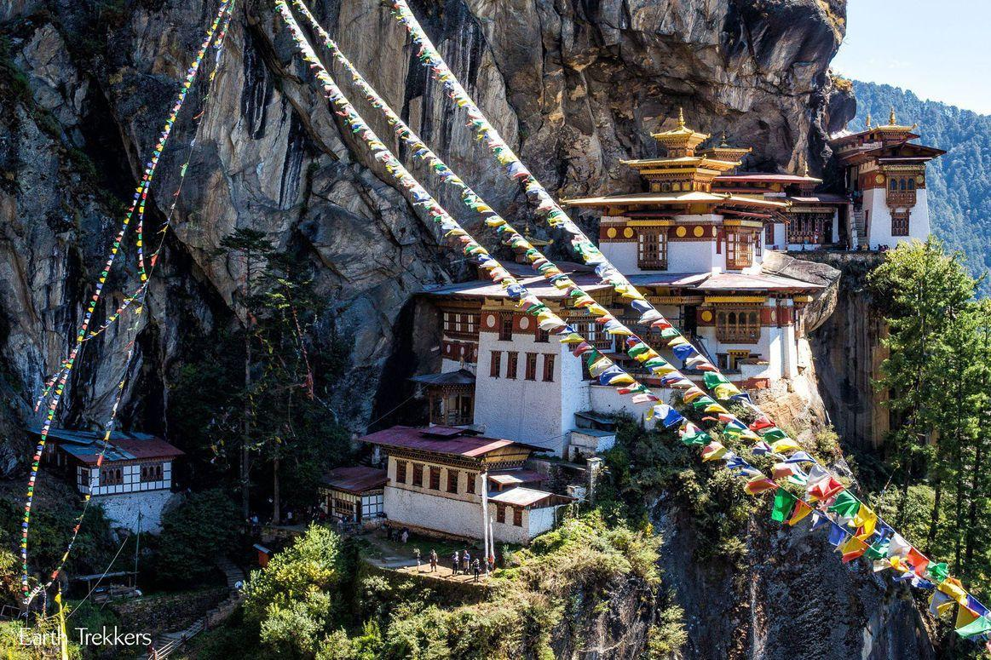
(Tigers nest monastery)
This Review identifies Bhutan as a potential country to be promoted and marketed by a particular group of travel agents. The review outlines all information needed, Infographics, Market segment, type of traveller and stage of life cycle.
Bhutan as a holiday destination would be treated as a one-off trip to really experience the rich culture and history and to determine what it really means to be Bhutanese, basically as stated by Gilbert (1990) the total experience, an amalgam of different goods and services offered as an activity experience to the tourist (Gilbert 1990: 20). Post tourists (Feifer 1985), seeking authenticity, well managed, tailored experiences that allow them to become familiar and accustomed to their chosen destination. This is not your sun, sea and sand holiday rather a cultural tourism product for culturally motivated tourists. It emulates the four realms of experience (Gibson) where travellers can truly escape, being subject to a place that is pleasing to the senses and on a cosmetic level, be educated by a different culture and can be entertained by the various festivals in Bhutan.
Bhutan should be at the top of your list of travel destinations, for the affluent traveller seeking a cultural experience and on a quest for self-esteem and self-actualisation. Bhutan is a Buddhist kingdom, situated between India and China. It is a unique, Independent and vibrant land. Famed for trekking, Temples, monks and meditation and where national dress is mandatory amongst the locals. The Bhutanese people favour wellbeing and happiness over gross national product, Stating Gross happiness as opposed to gross national product, and promote it throughout with inspirational life quotes situated throughout the journey from the airport to the capital of Bhutan.
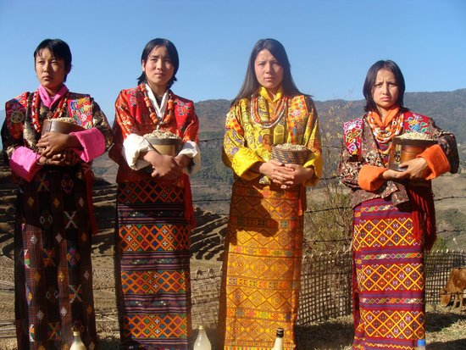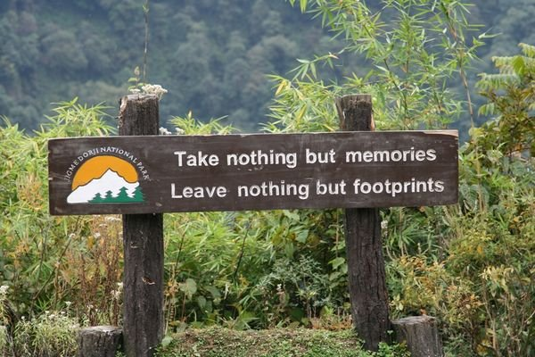
Bhutan national dress Inspirational quote at one of Bhutan’s national parks

Bhutan stakeholders
Key stakeholders that promote and regulate the industry, it’s region and allows it to thrive. Tourism development within Bhutan is to provide sustainable functionality, the organisation of the tourist service or product, the managing of available resources to produce high quality service and to observe and improve the partaking and fulfilment of leisure and tourism activities.
To provide job prosperity, increased revenue and a sense of place within society and to keep the heritage and history of Bhutan alive. Tourism has an impact on Bhutan, economically the industry has grown and has been a key source of income for Bhutan, the second largest revenue producer after hydropower, providing employment across Bhutan also, however it is important that the tourism industry and the services and products provided are sustainable for the environment and culture and traditions. It can have an extremely positive social effect, allowing the exchange of cultures and personal growth and satisfaction.

The main institutions involved in the tourism sector is;
Bhutan tourism council – Provides all tourism information for stakeholders and visitors.
Website; www.bhutantourismcouncil.co.uk
Tour operators – ABTO/ association of Bhutanese tour operators.
Website; www.abto.org.bt
Guides association of Bhutan (GAB) is a mutual benefit organisation. It holds a database of all guides stating their qualifications, contact details and experience. The association has a code of conduct which must be adhered to and they also offer workshops and training to enhance their skills and provide an optimum professionalism to all tourists. (Bhutanessence.com, 2019)
Hotels and restaurants.

Safety and security
Overall image of Bhutan via 2017 Bhutan tourism report statistics. (Bhutan, 2017)
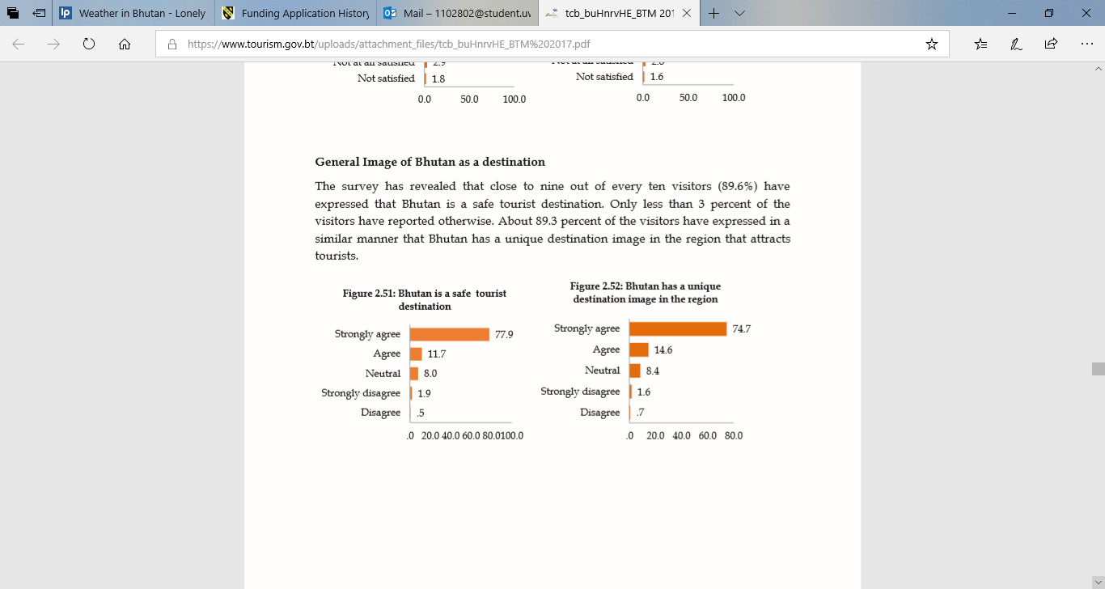
Bhutan is considered a safe destination to travel, with low crime rates and no recent history of terrorism attacks. Petty crimes are known, such as pick pocketing but on a generally low level and requires personal vigilance. As independent travel is not permitted, travellers must book through an authorised tour operator and tour guide this provides some security and guides will take visitors to established tourism destinations and will be with tour groups whilst travelling and accompany travellers on any treks that take place. Local law and custom should be taken seriously and should be respected and adhered to whilst in Bhutan. For sacred sites, an appropriate dress code should be in place. Homosexuality is banned in Bhutan and should be noted to the LGBT community before booking any tours to this destination as discretion is required. (gov.uk, 2019)

Topography
Bhutan is an extremely mountainous country of very high altitudes, making it the ideal place for trekking, ideal for the more active traveller. Terrain is diverse and can vary in very short distances, elevation increases from North to South. Bhutan remains carbon neutral, and by law at least 60% of the country must remain forested for future generations and makes environmental conservation one of its fundamental principles.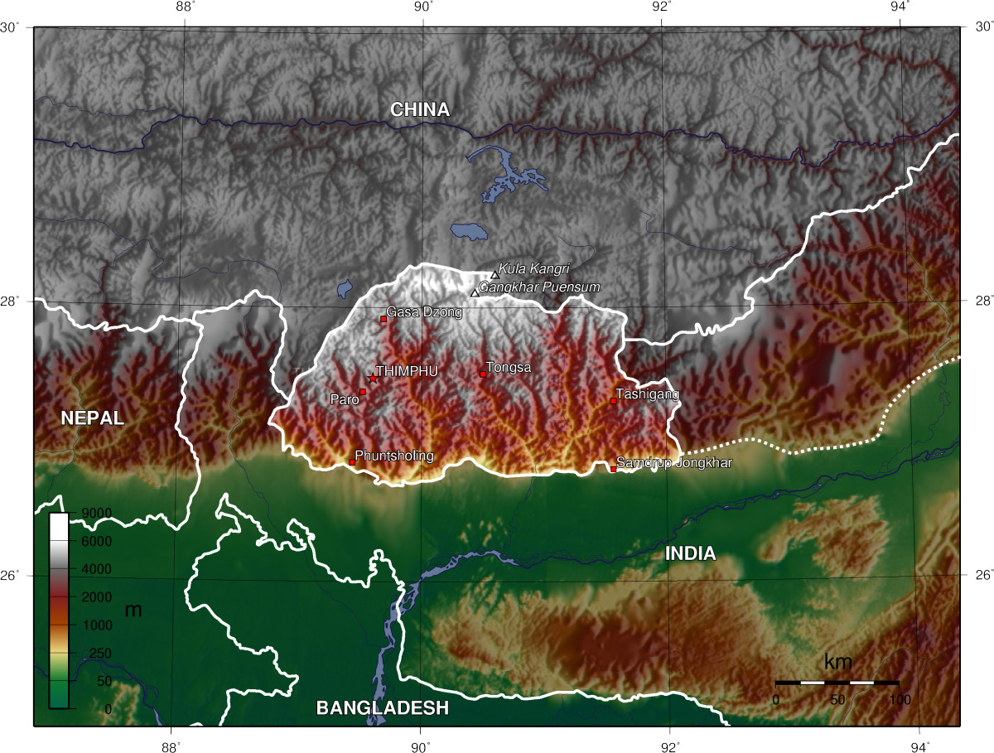

Tourism
Tourism is a fairly new concept to Bhutan, it is at the early stages of life cycle, being at the implementation stage (Butler), allowing it time allowance before reaching any kind of stagnation and therefore being a lucrative destination to market and promote. Only opening its borders to tourists from 1974, which it seen just 287 tourists in the initial year. The Bhutanese government recognised the need for tourism, as it offered benefits of increased employment, increased economic Growth. Tourism offered the ability to promote the unique culture and traditions of Bhutan to the rest of civilisation, however also being extremely conscientious in its control and managing inbound tourism through a minimum daily spend and focusing on low volume tourism with the intention of preserving the Bhutanese culture, traditions and natural environment. This may be due to noticing the detrimental effect tourism had on Nepal after mass tourism, however this works in their favour as Bhutan has control of the type of traveller it attracts and how tourism will be managed. You will not see any backpackers here, rather an organised itinerary for the culture core travellers seeking a preserved environment and deep-rooted traditions. It is a unique selling point and a lucrative destination to market due to the authenticity of the destination.
Details of Minimum daily spend
A minimum daily spend is in place for international tourists, 250 dollars per day in high season and 200 dollars per day in low season, though this may sound expensive this includes all food, accommodation, transport and official guide throughout the stay. This revenue is used for free medical care and education for Bhutanese nationals and allows a sustainable approach to tourism, which helps implement and sustain the Bhutanese ethos for preservation of culture and environmental responsibility.
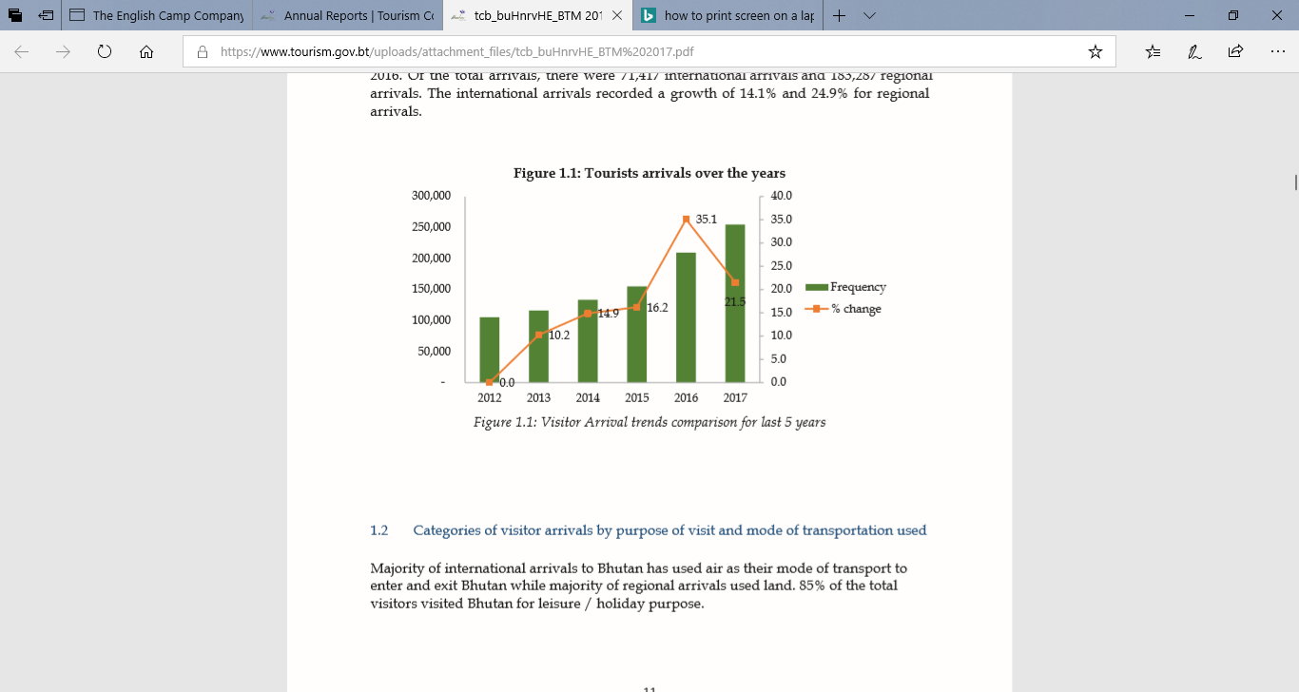
The figures state’s the increase of tourism from 2012 through to 2017. 2012 seen 100,000 tourists, this increased to 250,000 tourists in 2017.
Due to being at such an early age of the life cycle, tourism figures are expected to further increase at a healthy rate but sustainable rate due to the control the Bhutanese government and stakeholders have on tourism and how it is distributed. It will be a slow process to stagnation of mass tourism, if it ever reaches that point due to the monitoring of tourism visitors. However there has been an influx of regional tourism due to not needing the same visa requirements and minimum daily spend as international tourists, this should be monitored before reaching detrimental affects
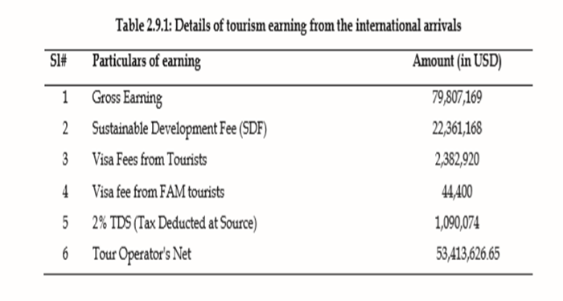
(Bhutan, 2017)
Revenue generated from tourism, including visa fee’s and sustainable development fee which contributes to low impact tourism and preservation of Bhutan’s natural habitat.

Destination management

Thimphu is the capital of Bhutan, lots of crafts antiques and a weekend market. Thimphu valley is perfect to visit monasteries and hiking trails.
Heart of culture and home to sacred sites.

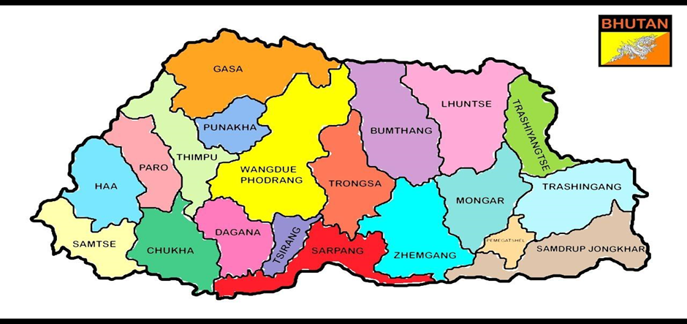
Paro. Home to the international airport. National museum is located here.
The most beautiful Dzong in Bhutan.
Paro is the most popular destination to market, it generates the most visitors and is also home to the only international airport.
Thimphu is a region near to Paro and should be marketed due to the festival in Thimphu being the most visited festival of Bhutan and Thimphu is also the capital of Bhutan. Some destinations in Bhutan are not automatically accessible by tourists and special permits are required to certain areas.
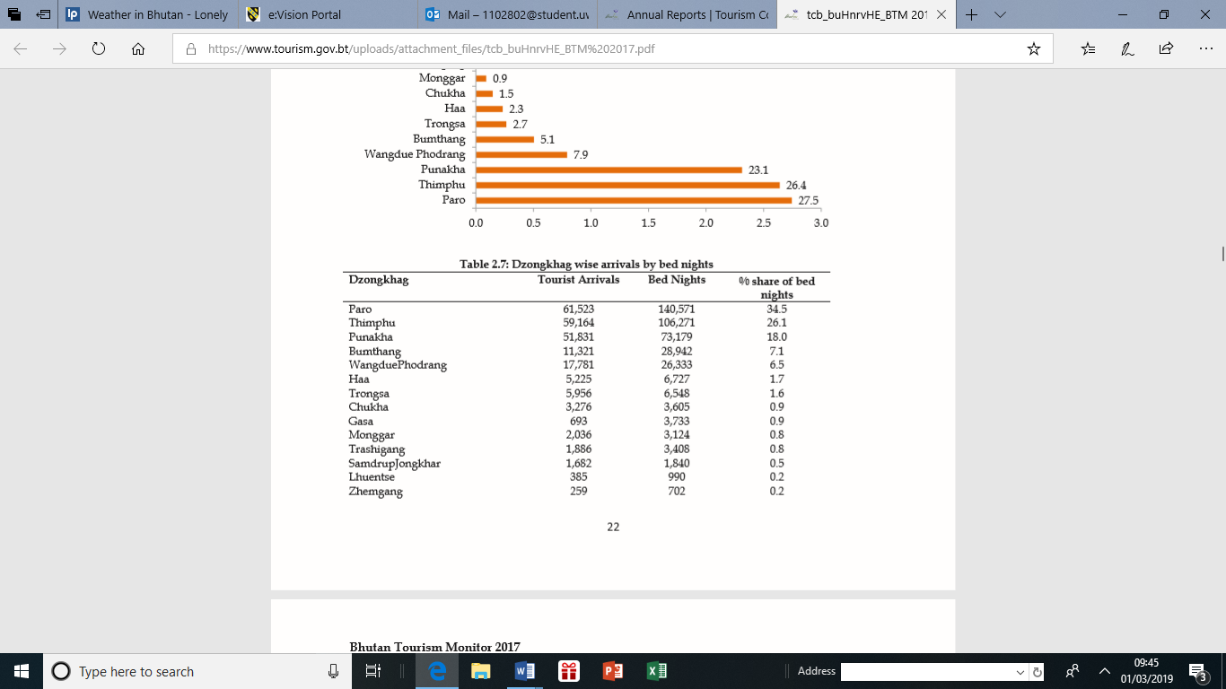
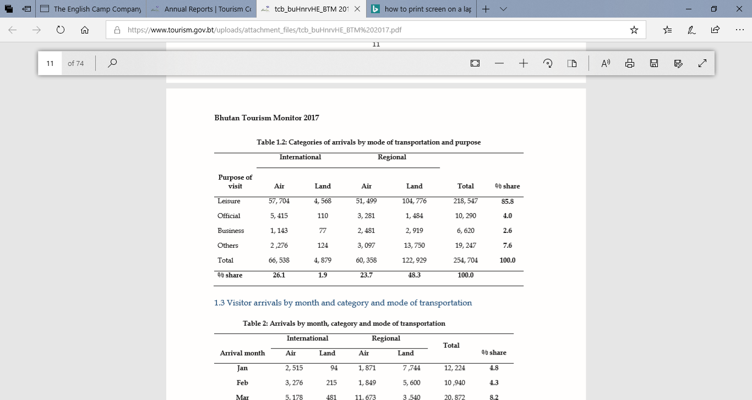
Most international travellers are travelling via air and are doing so mainly for leisure purposes. Circuit tourism is most likely generating the 4,565 international tourists travelling by land.
(Bhutan, 2017)

Visa requirements
A visa must be applied for before entering Bhutan and will only be allocated on arrival, it will be processed by a registered tour operator or foreign travel agent. Once full payment of holiday has been received prior to travel, the visa will then be processed by Bhutan tourism council. Special entry permits to access other areas of Bhutan can be obtained from Thimphu if needed and stated on itinerary.
Airports
There is only one international Airport which is Paro Airport, weather conditions can vary and flights only operate in daylight hours so some delays are to be expected. Travellers are advised to bring an essential needed in event of delays at the airport. There are three other airports that do domestic flights, and two airline companies Bhutan airlines and Druk Air.
Airports offering direct flights to Bhutan
- Bangkok
- Delhi
- Kolkata
- Kathmandu
- Mumbai
- Bagdogra
- Gaya
- Guwahati
- Dhaka
- Changi
(Limited, D, 2019), (Bhutanairlines.bt 2019)
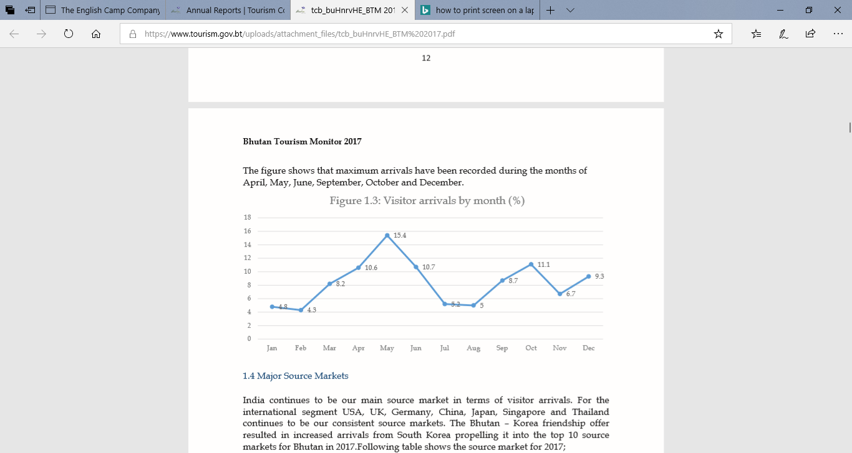
The most poplar month to visit Bhutan is in May this is due to guidance of tour guides and due to the timings of festivals and also weather conditions.
(Bhutan, 2017)

Weather in Bhutan and natural disasters.
The weather can be diverse in Bhutan depending on area visiting but generally high season is March – May and September – November, the weather is most ideal but also when the tariff is highest. Landslides are common in Monsoon season/ low season (June to August). December to February the weather can be cold but fairly nice. Bhutan is also situated on an active seismic zone, so is susceptible to earthquakes, the last recorded earthquake was in 2011, and no fatal injuries were recorded but should still be taken note of in case of event.

Regional and international tourism market.
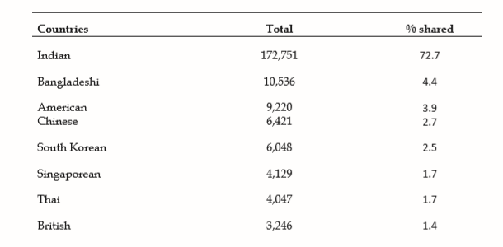
Indian, Bangladeshi and Chinese tourists are the highest volume of tourists visiting Bhutan, this is due to the close proximity to Bhutan, and they account for regional tourism. American are the highest volume of international tourists visiting Bhutan.

Reasons for visit
- Festivals
- Treks
- Visit Monasteries
- Wildlife
- Scenery
- Flora and fauna
- Experience a homestay
- Gross national happiness
- Culture
- Spiritual/ Buddhist culture
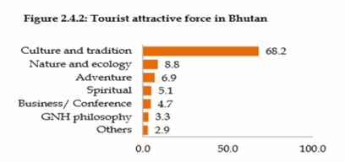
Most people visiting Bhutan, are doing so vastly for cultural reasons and festivals, followed by adventure such as trekking.
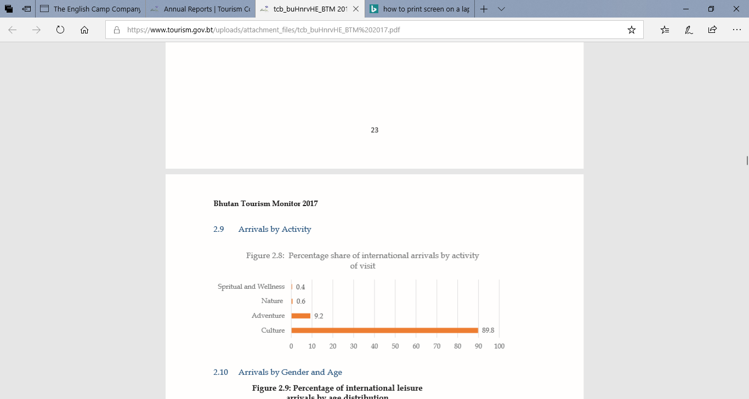

Festivals
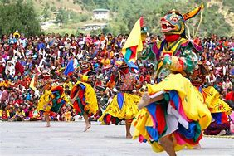
Festivals are a cultural insight into Bhutan. Usually in honour of ancient or famous gurus, monks and local people will adorn bright coloured dress and masks and will perform dances and theatrical performances.
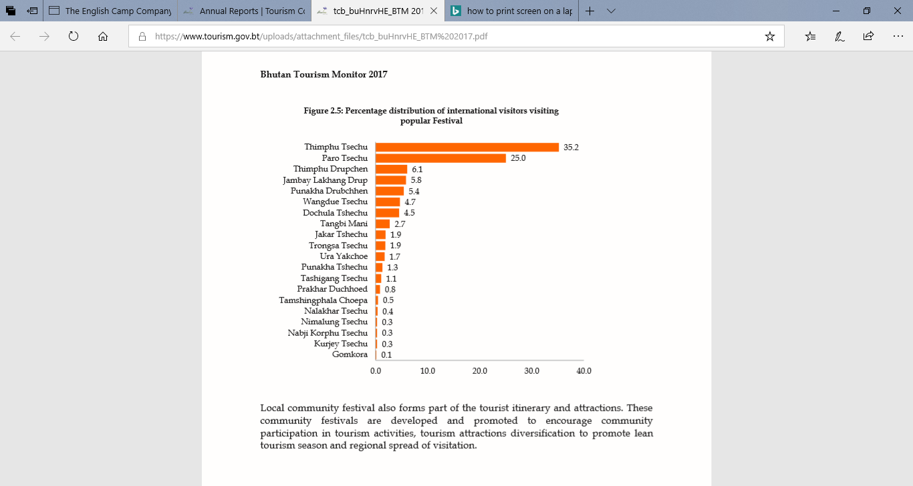
35.2% of travellers are travelling to Bhutan for the Thimpu Tsechu festival (Talk about the festival)
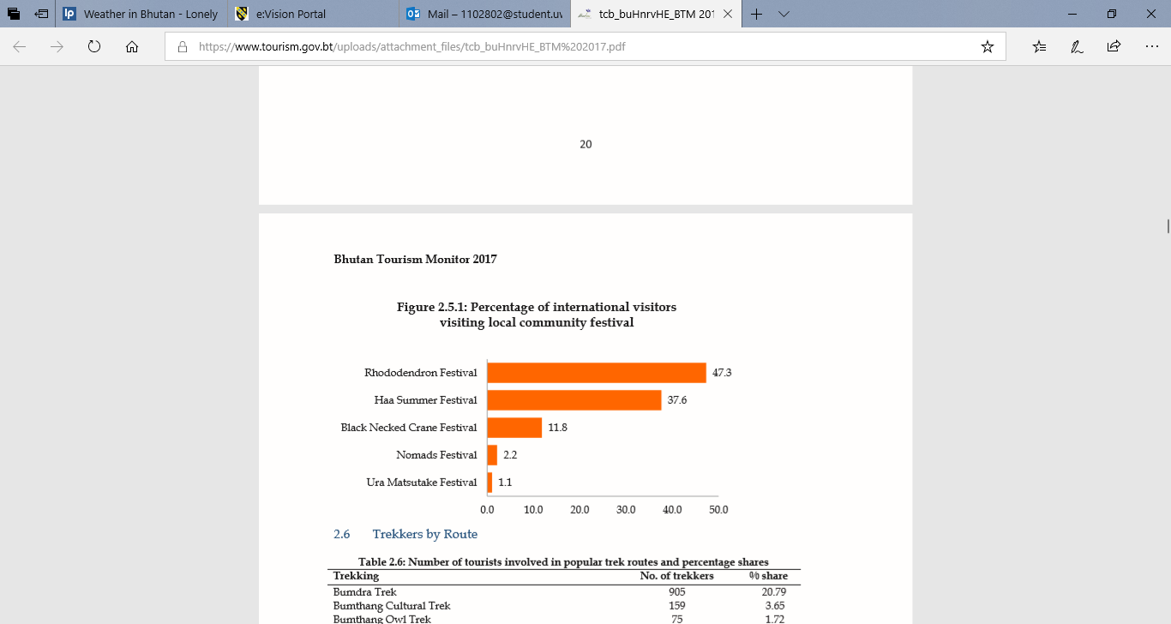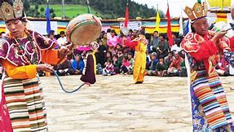

Treks
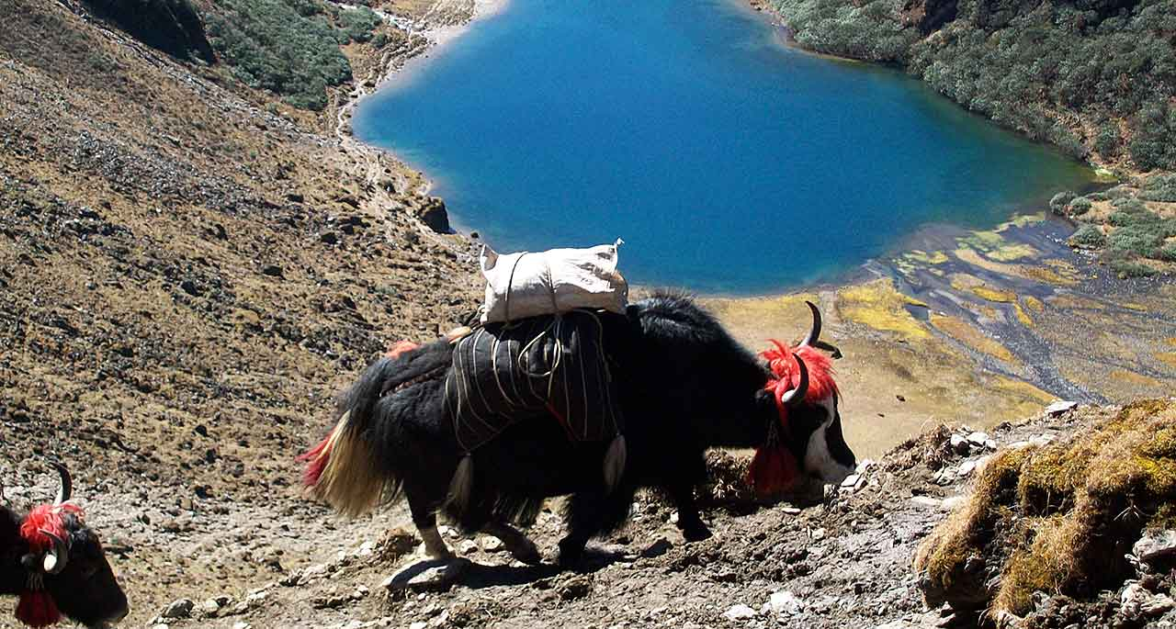
Bhutan being similar to Nepal in Topography and geographically in close proximity, is popular for trekking but also more preserved and protected from mass tourism as a country. Many treks take place in Bhutan, the Druk path trek being the most popular followed by the Bumdra trek and is a chance to escape modern life and meet local people in agricultural settings.
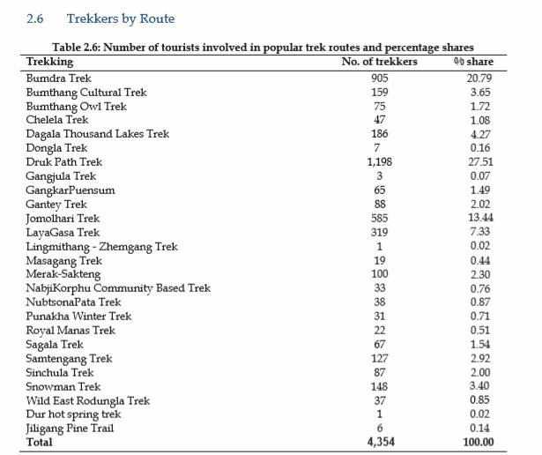
The most popular treks.
(Bhutan, 2017)

Wildlife and floral/fauna
Due to preserved land and forestry, Bhutan is an ideal place to birdwatch or spot wildlife that has never been witnessed before by international tourists.

Type of traveller
You can gather a concept of the type of traveller visiting Bhutan, they are generally mature, affluent people, with a good educational background and work status, they are seeking a cultural experience that is different to their social norms, allocentric by definition of traveller typology (Plog), they most likely have most of their essential needs met and are seeking self-esteem and self-actualisation. Due to being educated at a high level and being mainly employed, self employed and retired in professional careers, they are more likely to have a higher disposable income. This would be a lucrative country to sell and promote. “The segment of the culture core tourist or specific cultural tourist, in particular, is very attractive to tourism markets, being associated with people with higher levels of income and education, who are middle aged and rarely travel with children, they also seem to be less dependent on tourism seasons and show more respect and sensitivity towards the customs and environment of a destination.” (Sigala and Leslie, n.d.)
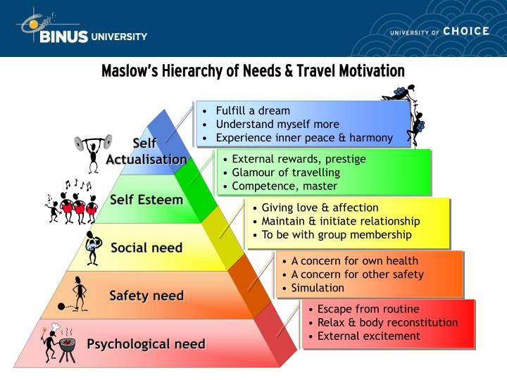
(Image.slideserve.com, 2019)
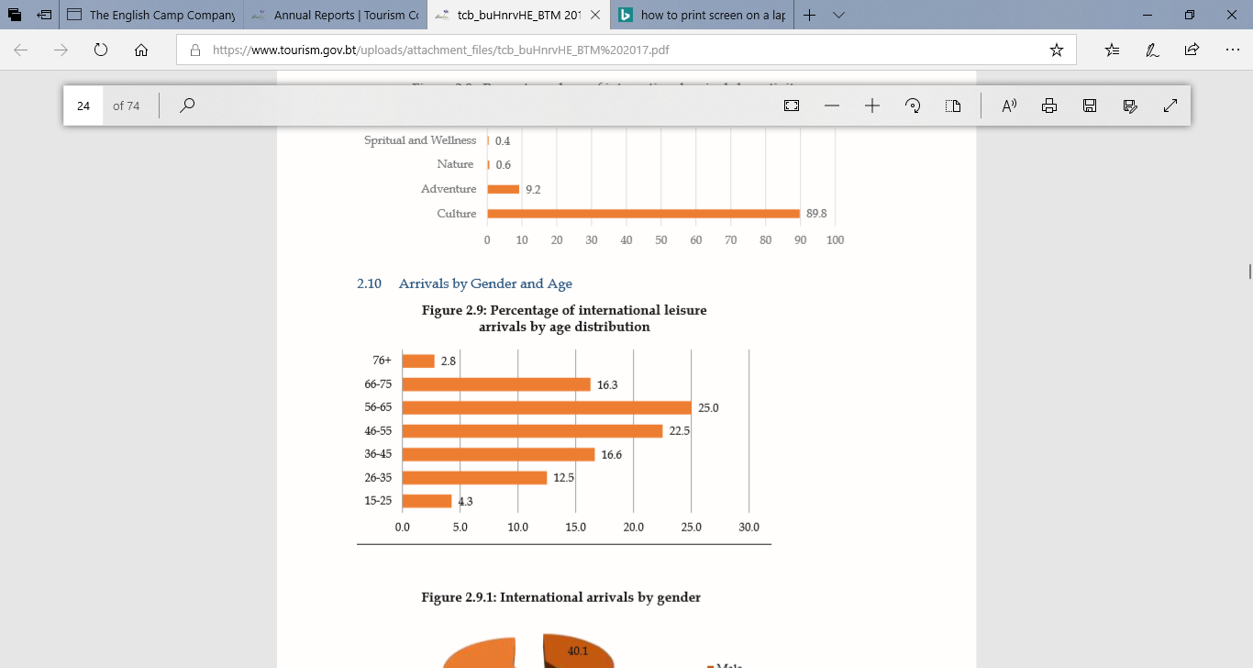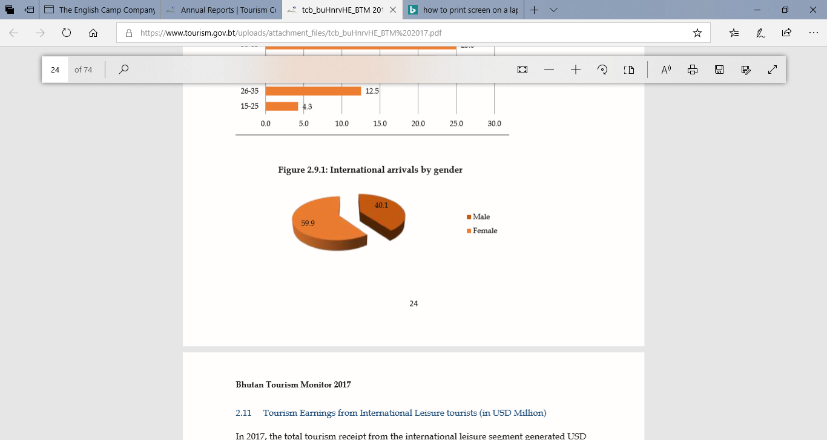
Females are the most common international traveller and should be noted and promoted to clients of this gender. There is a fairly substantial difference of almost 20% of arrivals by gender.
International tourists are most commonly between the ages of 46 to 65. This should be noted and promoted to clients of this age group.
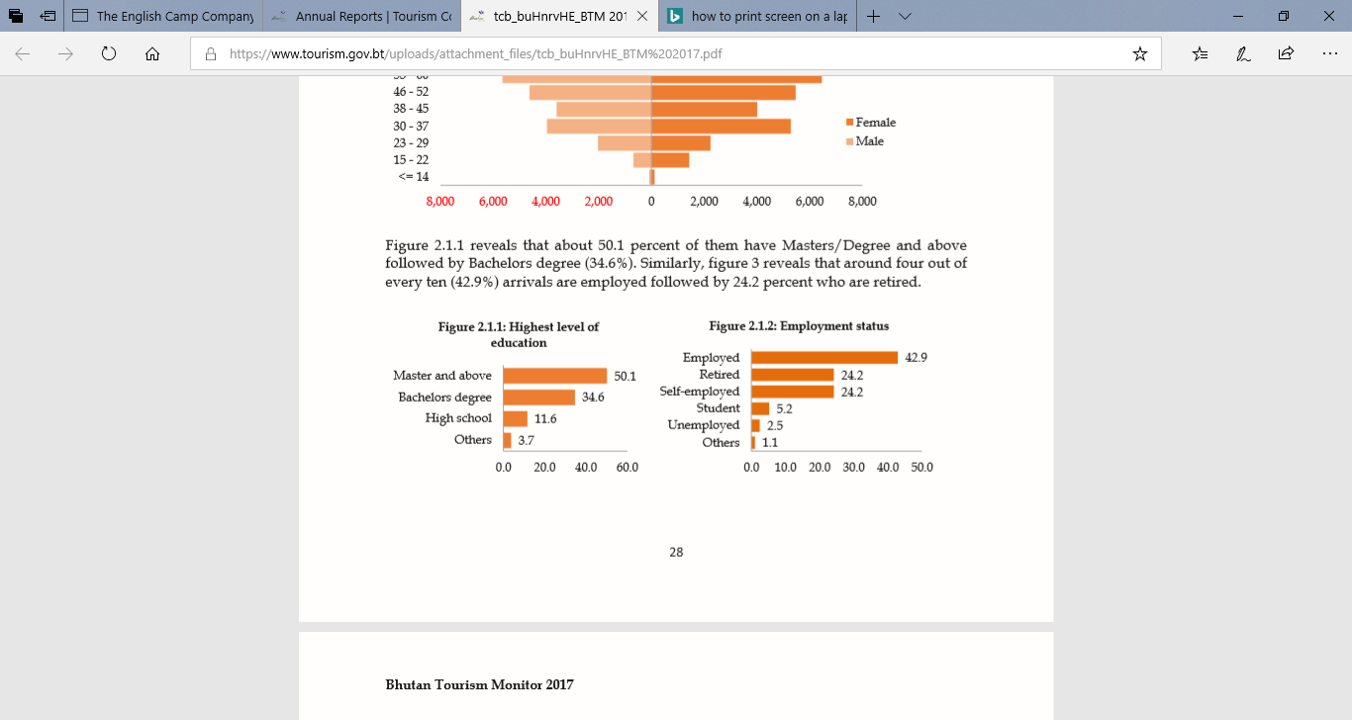
84.7% of travellers to Bhutan hold a Bachelor’s degree or higher, this shows some significance on the type of traveller. 42.9% of travellers are employed and reflects on the research noted.

Overall Bhutan is an ideal destination for a culture core traveller of any age, naturally attracting an older clientele with a high educational background and fairly high disposable income, sensitive and respectful of their present surroundings and on a quest to seek out a fairly “new” destination to the rest of civilisation. It is safe, and has strong morals and values at the core. Attracting anyone seeking a place still untouched by mass tourism and globalisation. Due to being a destination where a traveller can be fully immersed in culture it is suitable for the individual mass tourist, the explorer or even the drifter when experiencing a homestay and fully immersing themselves by staying with a local host family and the chance to live like a local, (Cohen, 1972). “In the more fugitive, trivial association of the word exotic, the charm of a foreign place arises from the simple idea of novelty and change. We may value foreign elements not only because they are new, but because they accord more faithfully with our identity and commitments than anything our homeland could provide” (de Botton, 2002: 78)

Reference list
Bhutanairlines.bt. (2019). Bhutan Airlines. [online] Available at: http://www.bhutanairlines.bt/ [Accessed 7 Mar. 2019].
Bhutanessence.com. (2019). Guide Association of Bhutan -. [online] Available at: http://bhutanessence.com/guide-association-of-bhutan/ [Accessed 7 Mar. 2019].
Bhutan, T. (2017). Annual Reports | Tourism Council of Bhutan. [online] Tourism.gov.bt. Available at: https://www.tourism.gov.bt/resources/annual-reports [Accessed 7 Mar. 2019].
Brown, L. (2007). Bhutan. Footscray, Vic.: Lonely Planet.
GOV.UK. (2019). Bhutan travel advice. [online] Available at: https://www.gov.uk/foreign-travel-advice/bhutan [Accessed 7 Mar. 2019].
Image.slideserve.com. (2019). [online] Available at: http://image.slideserve.com/375969/maslow-s-hierarchy-of-needs-travel-motivation-n.jpg [Accessed 7 Mar. 2019].
Limited, D. (2019). Drukair- Royal Bhutan Airlines. [online] Drukair.com.bt. Available at: https://www.drukair.com.bt/ [Accessed 7 Mar. 2019].
Sigala, M. and Leslie, D. (n.d.). International cultural tourism. p.41.
Smith, M. (2003). Issues in cultural tourism studies. London: Routledge.

