

Task 1 – AS1

Upload your photo of your A3 in-class notes here:
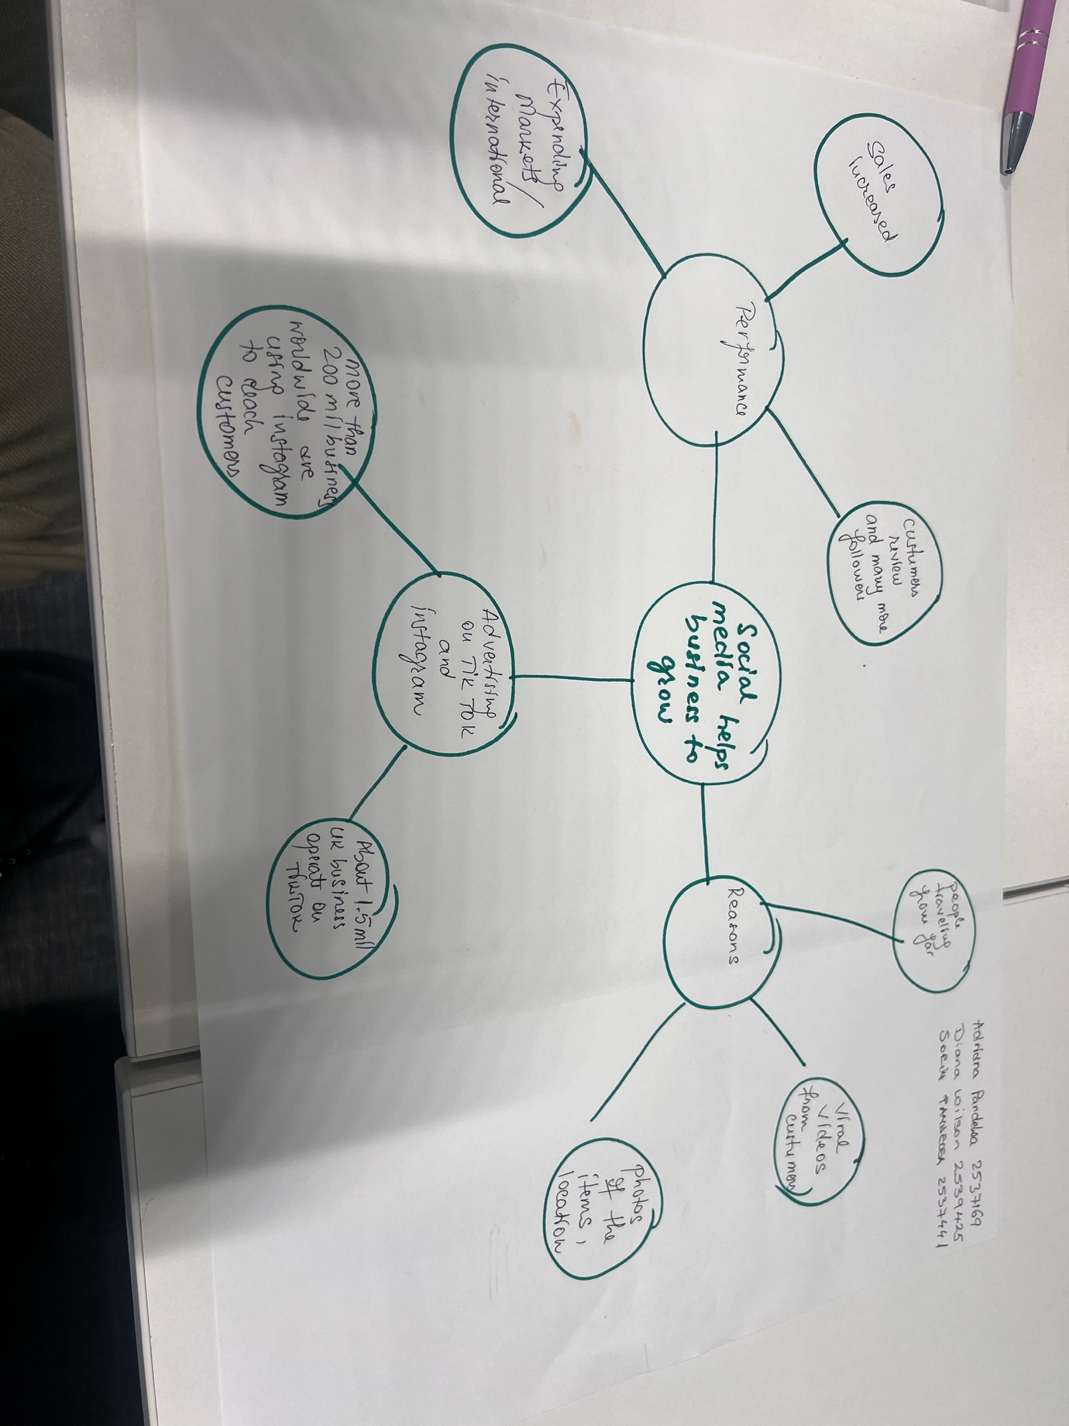
No
1. Answer these questions using the sentence starters below
a. What is the main idea of the text?
For myself, the central idea of the text, is how social media help a business to grow online.
b. What are two key points?
The first key point is those platforms, such as TikTok and instagram made the business known around the world.
The second key point is that around 1.5 million businesses run on TikTok in the Uk.
c. What part of the text did you find most important? Why?
I think the most important part from the text is the impact of social media by expanding markets local and internationally.
d. Was anything unclear or difficult to understand?
I was not very sure about how to do research on the business mentioned in the article. However, after the tutor explained us during the class, this allowed me to have a better idea of what social media has to offer.
e. How did your group help you understand the text better?
It was interesting to see how my group came together during the class, communicating their ideas and analysed them together such as, how social media helps businesses to grow internationally too. One of them, also mentioned that there are more than 200 million businesses over the world that are using Instagram to reach customers.
3. One sentence reflection
Question: What did you find challenging about this task?
For myself I consider that the hardest part was not having enough personal experience in online business, so I doubted myself in the beginning. However, after working together in the class, using the mind-maps to organise my ideas, reading the article and taking notes in class, gave me confidence to prepare my first assessment.

