Student ID Number/ Name | 2009079  IONUT PAUL MARINCU
Programme Title | BA Business Management
Module Title | Data Handling & Business Intelligence
Module Code | LCBB5000
Lecture`s name | Anupam Mazumdar
Coursework Title | Assessment 2
Academic Declaration:
In submitting this work, I affirm that my work adheres to the scholarly and intellectual standards of honesty and integrity. I affirm that this work is my work only and that in the preparation of this work I have not consulted any person. I affirm that I have not plagiarised or misrepresented the ideas or language of someone else as my own and that I have fully and accurately attributed any ideas or text of others to the sources and documented each source”.
Word Count | 3166 | Date Submitted | 09.09.2022

Table of Content

Introduction 2
Part 1 – Superstore Data Analysis in Excel 3
Part 2 – Ice Cream Data Analysis in Excel 10
2.1 Quantity of students who like vanilla 10
2.2 Quantity of students are Male and Female 11
2.3 Mean and Median of students who like chocolate and strawberry 11
2.4 Clustering with SPSS 12
2.5 Data mining and text mining methods 13
2.6 Comparative analysis of SPSS and Excel 14
Conclusion 17
Reference 18

Introduction
Data Analysis & Visualisation are essential as they help businesses and the respective stakeholders to understand the business performance and position. Data analysis helps to manipulate unprocessed data and make sense out of it using different tools such as statistical inferences and functions (GTPE, 2022). There are several data analysis software which can be used to store data, sort them, and analyse them using appropriate functions. Visualisation involves the graphical representation of the data in the form of charts, diagrams, and tables. The following report uses two different scenarios to examine how Excel can be used for diverse data analysis options.

Part 1 – Superstore Data Analysis in Excel
Using the Superstore data set provided, the following chart represents the changes in the sales and the profits over the years. Firstly, the date has been sorted from the oldest to newest using the ‘custom sort’ option. By doing this, the changes in the profits can be illustrated nicely.
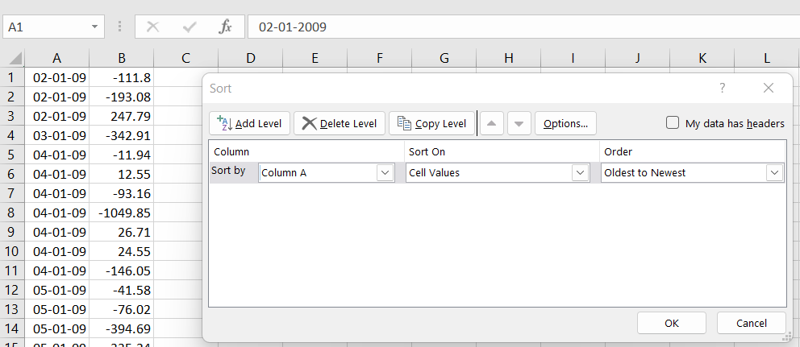
Figure 1: Custom Sort Source - Author
The changes in the profits have been illustrated in the following figure.
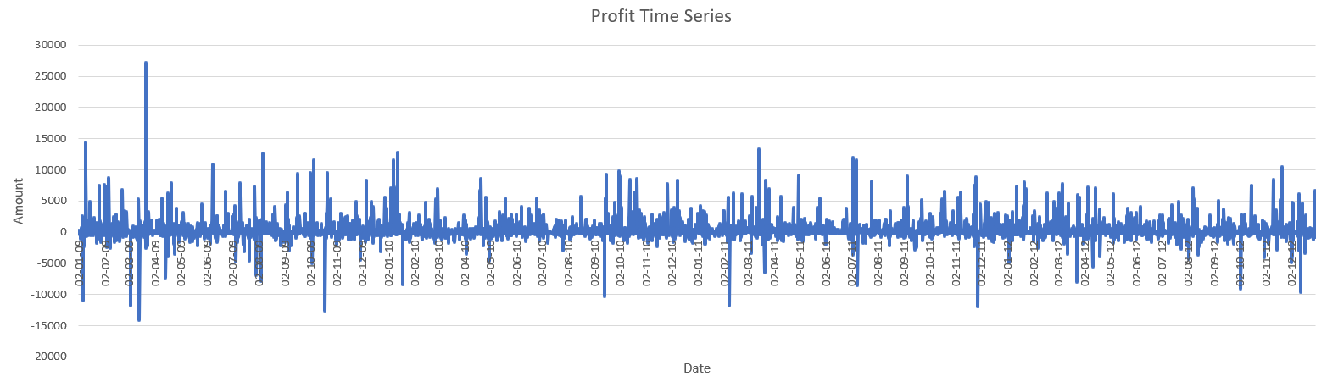
Figure 2: Changes in the Profits Source – Author
From the line graph above, it can be observed that the profits of the business are rather unstable. It has been fluctuating tremendously, as the profits increase rapidly on day and fall drastically the next. However, it can be observed that the company incurs loss every other quarter. Noticeable losses have incurred over 10 times over the course of the years monitored.
The use of Excel for pre-processing the data, analysing the data and visualising the data differs by the data nature. The pre-processing of the data using Excel helps to organise raw data so that the appropriate actionable insights can be extracted using functions. It is a very crucial stage that transforms the raw data into more understandable, useful, and efficient format. There are five main tasks in the data pre-processing stage. They have been explained below.
- Data Cleaning – this involves filling in missing values, smoothing and removing any outliers; which shall resolve any inconsistencies in the data (Singh, 2020). A small example can be observed from the figure below, where the missing values in the product margin have been filled with 0.
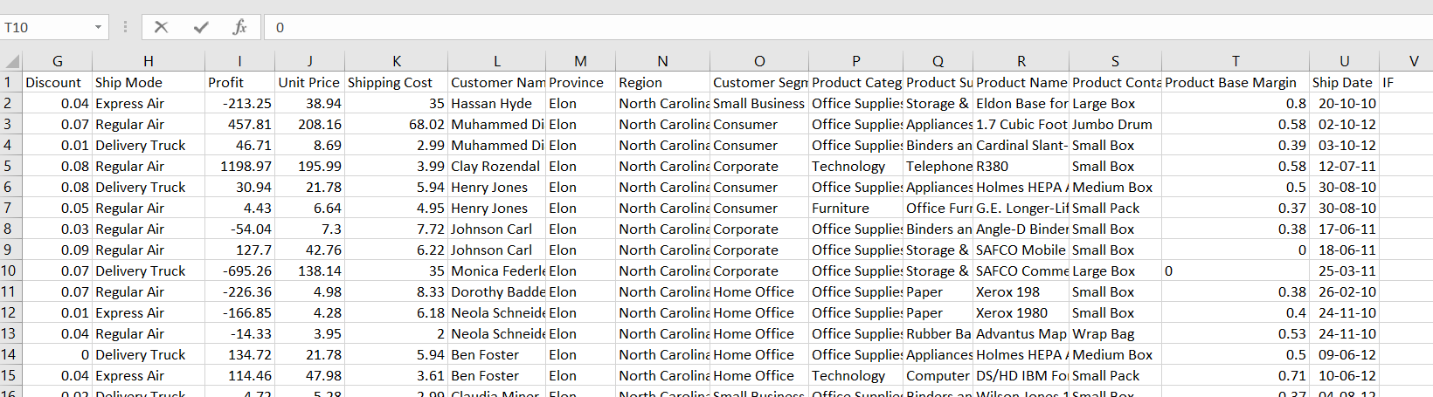
- Data Integration - this involves integrating data from multiple sources like regional and non-regional, data cubes, and files. The data can be structured, semi-structured, or unstructured.
- Data Transformation – this involves manipulation and aggression to the data according to the needs of the analysts (Cleff, 2019).
- Data Reduction – the number of data are reduced and a sample is used to represent the whole dataset.
- Data Discretisation – the data numerical attributes are replaced with nominal ones.
In the case of analysing the data, multiple functions are available in Excel. For example, IF functions can be used to determine the data and its frequencies. In the following image, the IF function has been used to examine the data which are above a certain level.
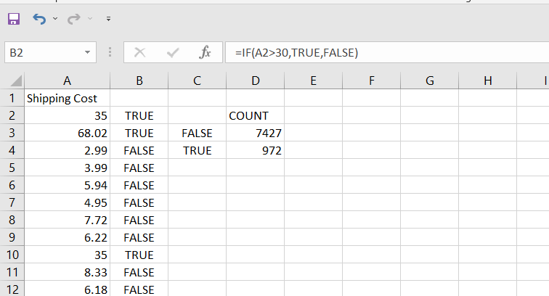
Figure 3: If and Count If Functions Source – Author
Using the IF function, it can be determined that the shipping cost of the product higher than 30 is considered to be true or very high. But any shipping cost charged below 30 is considered to be moderate or low. Moreover, count if function is used to determine the frequency at which shipping cost higher than 30 was charged. It showed that 972 times, the shipping charge was greater than 30, while, a majority of the times, 7427 times, the shipping charge was under 30.
Furthermore, data analysis tools such as correlation between two variables and a pivot table have been used to examine the data within the data set (Kafle, 2019). It can be seen that the variables chosen for correlation are the shipping cost and the price of the product. It can be seen from the figure below that the correlation between the unit price and the shipping cost have been calculated using the CORREL function. The function bar fully states the full function used for the result.
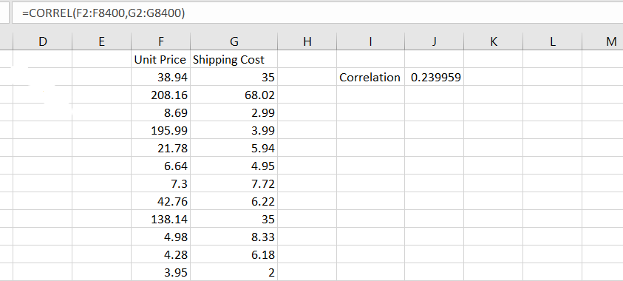
Figure 4: Correlation Between Variables Source – Author
It has been determined that the correlation between the unit price and the shipping cost is positive indicating that when one rises, the other one rises as well. However, the value of correlation is 0.239959, which is relatively very low. This indicates that the bond shared between the variables may be positive but is very weak. Further analysis of data can be executed using the pivot table. It shall help to identify the total or summation of different variables of every year (Kaula and Kaula, 2018). The below figure shows the option of Pivot Table being chosen and the table range being given. The range is usually selected automatically, moreover, the data in the spreadsheet is large in number so, the automated selection of the filled table is chosen and the ‘ok’ button is selected. Also, the outcome of the pivot table shall be presented in a new spreadsheet to keep everything organised.
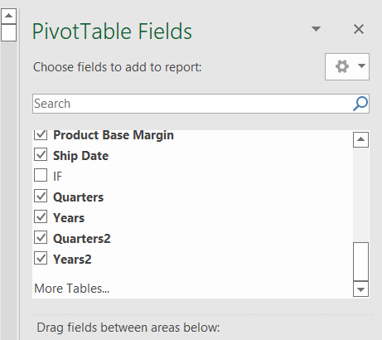
Figure 5: Pivot Table Criteria Selection Source – Author
As it can be seen in the above figure, the data with numerical values are chosen for the pivot table. The variables with qualitative values do not show up. This can be verified by the following image below.
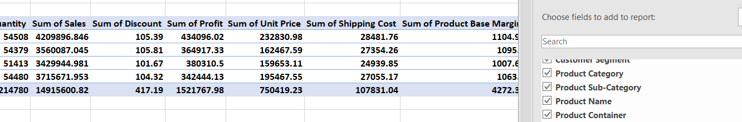
Figure 6: Qualitative Data in Pivot Table Source – Author
After all the selection has been made, the following pivot table is created.
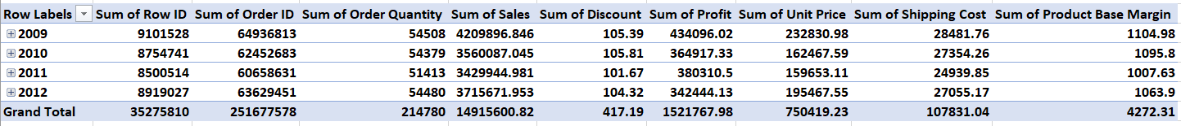
Figure 7: Pivot Table Source – Author
It can be observed that the dates have been compressed to years, and the sum of row ID and the order ID per year can be observed individually. That is not as important as the summation of order quantity every year received. From the graph below the changes of order quantity can be visualised.
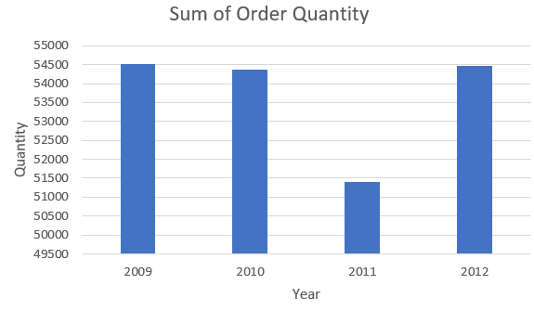
Figure 8: Bar Chart Representing Change in Order Quantity Source – Author
It can be observed that the orders in 2011 were relatively less than the other years, however, the order quantity in 2012 had increased greatly again. The changes in the sales can be observed as well below.
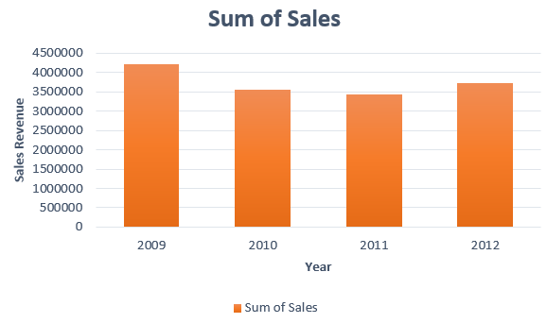
Figure 9: Changes in Annual Sales Source – Author
Similarly, the changes in the annual sales can be observed. The sales can be observed to be declining in the years 2010 and 2011, but had increase in 2012.
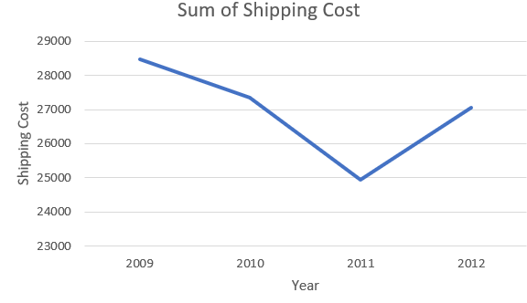
Figure 10: Annual Shipping Cost Source - Author
A line graph has been deduced from the pivot table showing the annual expense spent on shipping cost. It can be observed that the shipping cost had declining rate till 2011, when it was the lowest, but had increased in 2012.
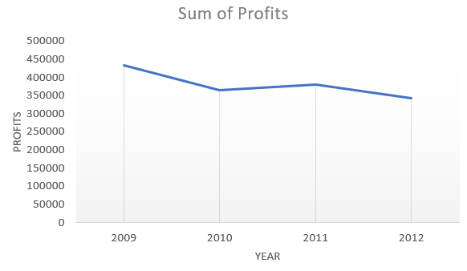
Figure 11: Changes in Annual Profit Source – Author
The above figure shows the changes in the annual profits. The highest profits were observed in 2009, which can be observed to have declined over time. Although the profits had improved slightly in 2011, the overall impression of the profit is reducing.

Part 2 – Ice Cream Data Analysis in Excel
This part involves using Excel to sort and analyse data using simple yet effective tools like mean and median of selected students based on the flavours of ice cream they like.

2.1 Quantity of students who like vanilla
There are a total of 200 students, which have been counted using the ‘COUNT’ function.
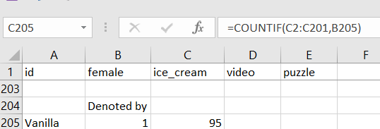
Figure 12: Count-IF Function Source – Author
Thus, using the ‘COUNTIF’ function, the number of students who like vanilla have been found. 95 out of 200 students like vanilla flavoured ice cream. The findings can be illustrated in the following figure.
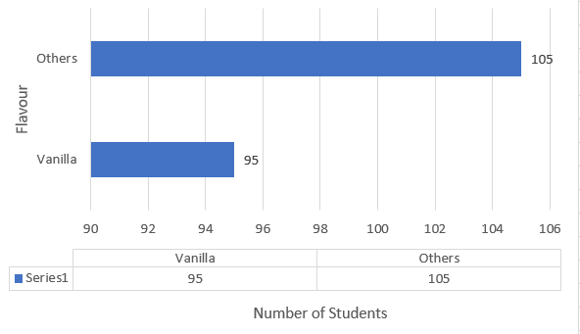
Figure 13: Students Who Like Vanilla Source - Author

2.2 Quantity of students are Male and Female
The quantity of students who are male are 91 and 109 are females. This has been deduced by using the ‘COUNTIF’ function as well which has been shown below.
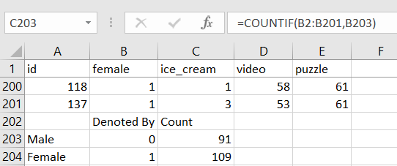
Figure 14: Count If Functions Source – Author
The ratio of the male to female can be illustrated in a pie chart as shown below. It can be observed that around 55% of the students are female while 45% students are male.
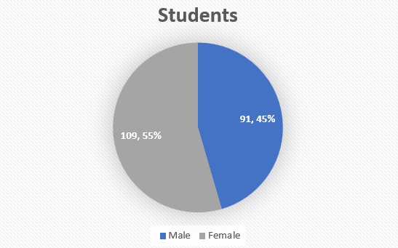
Figure 15: Pie Chart Representing the Gender of the Students Source – Author

2.3 Mean and Median of students who like chocolate and strawberry
The mean and median of students who like chocolate are 0 and 0, respectively. They have been calculated using the IF function to identify the students who like chocolate and strawberry only. The following figure shows the IF function used, as well as the average and median function used.
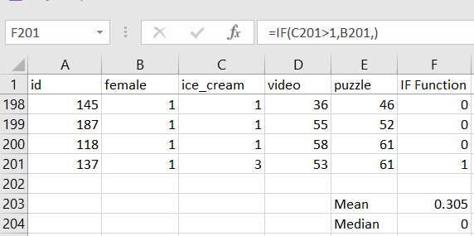
Figure 16: IF, Average, and Median Functions Source - Author

2.4 Clustering with SPSS
K-means clustering has been performed in SPSS. The following figures represent the findings.
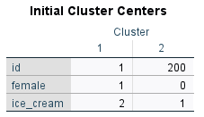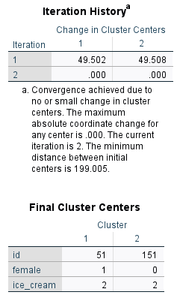
Figure 17: K-Means Cluster Source – Author
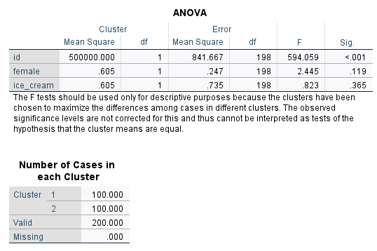
Figure 18: Anonva Findings Source - Author

2.5 Data mining and text mining methods
Data mining and text mining. Some of the most common data mining and text mining methods that can be used in businesses are explained below.
- Association – this method is used to find correlations between different variables in a dataset. There are two approaches in association data mining – single dimensional association and multi-dimensional association. single dimensional association is used when the suer wants to identify a single occurring variable like purchase of inventory. Multi-dimensional association involves looking for more than one point in the dataset (Salo et al., 2018). For example, a salesperson may look into the repeat customer demographics like age and gender.
- Classification – it is form of clustering data, where data are collected and organised into broad groups like demographic or customer segment for comparative analysis. Some of the useful tools used within data mining classification are logistic regression, decision trees, naïve bayes, support vector machine, and K-nearest neighbours. Banks may classify their customers and services according to the nature like loans, credit card, etc.
- Data Visualisation – this involves presenting the data into graphic forms for better interpretation by the viewer and users. Some of the methods used for data visualisation consists of comparison charts, maps, heat maps, density plots, network diagrams, scatter plots, etc. These provide easier understanding of the data by the managers, executives, etc. for decision making (Osman, 2019).
- Neutral Networks – this type of process involves mimicking the human brain and its complex decision-making abilities using computer processes and software. There are three main layers of neutral network methods – input, ‘hidden’, and output. Businesses can use neutral network methods to predict customer buying patterns and determine the most appropriate marketing tool to generate sales.
- Prediction – this helps businesses to forecast the future trends and patterns of the data. It also helps to make informed decisions. There are four main methods involved in prediction– forecast modelling, classification modelling, cluster modelling, and time series modelling (Mengash, 2020). These models help businesses to predict sales, production, inventory storage, etc. Private and public companies make use of prediction to estimate their budgets and allocation of resources.
- Data Warehousing – when data analysts collect data from multiple sources and store into a common archive, it is known as data warehousing. There are mainly three steps involves in the process of data warehousing. The first step is to extract the data and organise them into different categories based on their nature – structure or unstructured. The second step is to transform the data by filtering and cleaning them. The data may be formatted to accommodate into the warehouse. The third step is to load the data into the warehouse. The steps are constantly repeated to keep the data updated. Warehousing can make managing big data easier for telecommunication companies (Abbott, 2016).

2.6 Comparative analysis of SPSS and Excel
There are many data analysis software which can be used to process the data and retrieve desired outcomes. However, the most commonly used software used for data analysis are SPSS and Excel. Despite them providing similar functions and data analysis tools, the differences between them need to be examined. The advantages and disadvantages of using SPSS and Excel using relevant practical examples have been executed in the forms of tables. As it is known Excel is a spreadsheet software, that allows data storage in columns and rows. The software involves several functions as it has been examined and practically used in the above scenarios (Kronthaler, 2022). The following table identifies and explains the advantages and disadvantages of using Excel for data analysis.
Table 2: Advantages and disadvantages of using Excel Source – Author
Advantages | Disadvantages
- Large amounts of data are organised in an orderly, logical spreadsheets and charts (Lemoine, 2021). Big data can be stored and analysed using this software.  - Excel is a popular software that is used in every device. Thus, it is easier to view and edit the file using multiple devices like iPad, tablets, laptops, smartphones, computers, etc.  - Excel is a versatile software that can work with every other software present in the Microsoft Office. Excel file can be converted to Word file and also PDF.  - The software allows easy calculation, organisation, and evaluation of the dataset. Example – summation of data, calculating the average, median, mode of the frequencies. | - Data inputting and analysis may be time consuming. Large amounts of data like big data can be tedious if done manually.  - While some of the functions are easy to grasp, the overall benefit of Excel needs to be learnt over time. So, the learning point of the software can be lengthy. More complex functions like Cramer’s Value and other IF functions can require overtime learning to grasp.  - Excel cannot detect any human errors, which may result in faulty and inaccurate outcomes. Any faulty input by a user cannot be identified by the software. Example: An input of 35 instead of 53 is given.  - Cost of incorporation is not cheap, rather the more advance the software is, the higher the price is.
SPSS is a data analysis software that is a diverse and multi-viewing spreadsheet. The software allows data to be categorised according to the data nature and be processed via numerous functions which are then represented in detailed tables and charts. The following table identifies and explains the advantages and disadvantages of using SPSS for data analysis.
Table 3: Advantages and disadvantages of using SPSS Source – Author
Advantages | Disadvantages
- It is very quick and easy to learn the functions and processes of the software. Data input can be categorised according to the data nature like nominal, ordinal, sequin, etc. (Pal, 2019)  - The software is able to collect and process large amounts of data. Suitable for businesses that have huge quantities of data inputted, like restaurants and bakeries.  - It provides a suitable, simple, yet versatile interface for the users.  - The interpretation of data results is relatively easy, as it provides a detailed properly labelled table. | - It is very similar to Excel in terms of functionality. Both are spreadsheet software which provide similar statistical functions like mean, median, standard deviation, etc.  - It is one of the most expensive software to purchase for data analysis. The software must be purchased separately and is expensive.  - The software has limited functions to be used, and are all stated in the command bars.  - The graph features are a bit complicated to use compared to Excel. It requires complicated commands and inputs to produce a correct chart.
By understanding the pros and cons of the two most popular software for data storage and analysis, each provide different ease of comfort for different users. However, determining the advantages and disadvantages of the software, it can be concluded that Excel provides the most versatile and user-friendly options and functions to store and analyse the data. Furthermore, the software also helps new users to get familiarised with it easily, and learn over time of its new functions.

Conclusion
As the report suggested, Excel provides a dynamic and vast range of functions to process and analyse the data. By using different functions in Excel and evaluating the use of Excel for pre-processing the data, analysing the data and visualising the data, it has been deduced that Excel is a versatile software that can generate charts, graphs, and other visuals which help to interpret the dataset in a better form. Moreover, data sorting and identification are some of the functions which can be used to identify the frequencies of the dataset based on the given criteria. Also, the most common data mining and text mining methods that can be used in business with real world examples have been explained along with the identification of the advantages and disadvantages of using SPSS and Excel using relevant practical examples have been done.

Reference
Abbott, M.L. (2016) Using statistics in the social and health sciences with SPSS and excel. John Wiley & Sons.
Cleff, T. (2019) Applied statistics and multivariate data analysis for business and economics: A modern approach using SPSS, Stata, and Excel. Springer.
GTPE (2022) ‘10 Key Data Mining Techniques and How Businesses Use Them’, Georgia Tech Professional Education. Available at: https://bootcamp.pe.gatech.edu/blog/10-key-data-mining-techniques-and-how-businesses-use-them/ (Accessed: 3 September 2022).
Kafle, S.C. (2019) ‘Correlation and regression analysis using SPSS’, OCEM J Manag Tech Soc Sci, 1(1), pp. 126–132.
Kaula, Radhika and Kaula, Rajeev (2018) ‘Analyze data with excel power pivot: A tutorial’, International Journal of Information, Business and Management, 10(4), pp. 102–116.
Kronthaler, F. (2022) Statistics Applied With Excel: Data Analysis Is (Not) an Art. Springer.
Lemoine, J. (2021) ‘Advantages & Disadvantages of Microsoft Excel’, Tech Walla. Available at: https://www.techwalla.com/articles/advantages-disadvantages-of-microsoft-excel (Accessed: 3 September 2022).
Mengash, H.A. (2020) ‘Using data mining techniques to predict student performance to support decision making in university admission systems’, IEEE Access, 8, pp. 55462–55470.
Osman, A.S. (2019) ‘Data mining techniques’.
Pal, D. (2019) ‘What are the pros and cons of using SPSS?’, Quora. Available at: https://www.quora.com/What-are-the-pros-and-cons-of-using-SPSS (Accessed: 3 September 2022).
Salo, F. et al. (2018) ‘Data mining techniques in intrusion detection systems: A systematic literature review’, IEEE Access, 6, pp. 56046–56058.
Singh, H. (2020) ‘Understanding Data Preprocessing’, Towards Data Science, 13 May. Available at: https://towardsdatascience.com/data-preprocessing-e2b0bed4c7fb (Accessed: 3 September 2022).

