APPLICATION for Sports Placement ETHICAL APPROVAL

This form must be completed and approved prior to undertaking any activity with the organisation. It will need to be signed by the student, placement organisation and a sports lecturer.

SECTION A: About You (Student)

Full Name: | Jonathan Bayliss
Faculty/School/Centre: | Sport, Health and Outdoor Education
Campus: | Swansea Business Campus
E-mail address: | Jbayliss.150486@student.uwtsd.ac.uk
Contact Telephone Number: | 07534245618
Student Number: | P150486 | Undergraduate | ☒
Programme of Study: | Sports Management | Taught Postgraduate | ☐
Director of Studies/Supervisor: | Andrew Thomas | Research | ☐

SECTION B: Placement Activity Organisation (Employer)

Does the activity involve collaborators outside of the University? |  | YES | ☒ | NO | ☐
If Yes, please provide the name of the external organisation and name and contact details for the main contact person:

Organisation | Ysgol Gymraeg Ystalyfera
Contact person name | Ann Llewellyn
Contact person e-mail address | LlewellynA68@hwbmail.net
Contact telephone number
Number of agreed contractual hours | 200

Location of activities
Identify all locations where activities will take place.
Ysgol Gymraeg Ystalyfera

The placement student will work within the companies ethical framework
Organization representative name | Matthew Evans
Signature | M.Evans | Date | 2/04/2019

SECTION C: Scope of Activity (Student)

Will the activities include: | YES | NO
Use of a questionnaire or similar research instrument? | ☐ | ☒
Use of interviews? | ☐ | ☒
Use of diaries? | ☒ | ☐
Participant observation with their knowledge? | ☒ | ☐
Participant observation without their knowledge? | ☐ | ☒
Use of picture, video or audio recording? | ☐ | ☒
Access to personal or confidential information without the participants’ specific consent? | ☐ | ☒
Administration of any questions, test stimuli, presentation that may be experienced as physically, mentally or emotionally harmful / offensive? | ☐ | ☒
If you have answered yes to any of the above then please explain below:

Use of diaries, I will be using my diary to note down my day to day activity during placement. The school and myself know what I am doing and need to do and have agreed for me to study my placement here.

NOTE – PICTURE and VIDEO for assessment - make sure you have approval from organisation

SECTION D: Intended Participants (Student)

Who are the intended participants: | YES | NO
Students or staff at the University? | ☐ | ☒
Adults (over the age of 18 and competent to give consent)? | ☒ | ☒
Vulnerable adults? | ☐ | ☒
Children under 18? | ☐ | ☒
Prisoners? | ☐ | ☒
Young offenders? | ☐ | ☒
Those who could be considered to have a particularly dependent relationship with the investigator or a gatekeeper? | ☐ | ☒
People engaged in illegal activities? | ☐ | ☒
Others (please identify): | ☐ | ☒
If you have answered yes to any of the above then please explain below:

SECTION E: Anticipated Risks (Student)

Outline any anticipated risks that may adversely affect any of the participants, the student and/or the University, and the steps that will be taken to address them.
Risks to participants
For example: emotional distress, financial disclosure, physical harm, transfer of personal data, sensitive organisational information
Physical harm could be a risk anywhere you go, when working around children and different sports day to day, risks to yourself could occur. The steps to take here is ensure correct clothing, shoe laces done up and always be aware of your surroundings.

Risks to student
For example: personal safety, physical harm, emotional distress, risk of accusation of harm/impropriety, conflict of interest
Personal safety of yourself is always a risk. Must always be aware no matter what you’re doing, no matter what sport it is, always be aware of your surroundings.

University/institutional risks
For example: adverse publicity, financial loss, data protection
Data protection, no one other than the leader of the placement and the head of the school, will have access to information about the university and lectures information such as phone number, email and address etc.

Control measures
List measures put in place to limit and manage any of the risks identified above
Ensure all participants have correct clothing before participating in any kind of activity, ensure I am prepared before taking any lessons and be aware that all equipment is correct, and ensure details of the university doesn’t go further than the head of school and myself.

Disclosure and Barring Service
If the activity involves children or vulnerable adults, a Disclosure and Barring Service (DBS) certificate may be obtained before any contact with such participants. | YES | NO | N/A
Do you need a DBS certificate for this role? | ☒ | ☐ | ☐
Has a DBS certificate been obtained? | ☒ | ☐ | ☐
If yes, add picture copy below

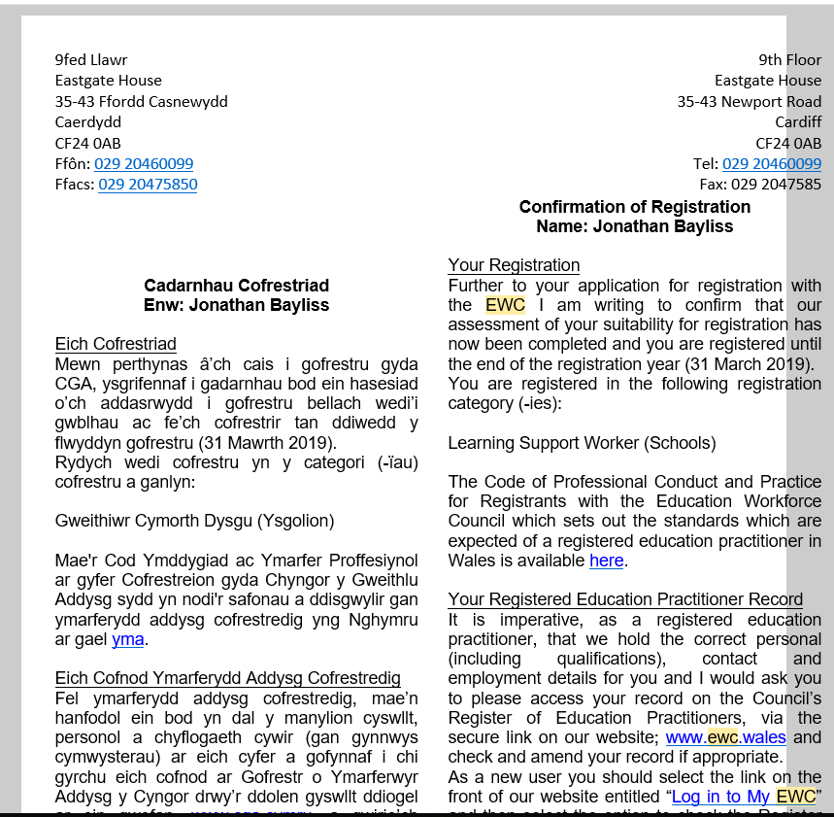

SECTION F: Declaration (Student and Staff)

For Students:
The information which I have provided is correct and complete to the best of my knowledge. I have attempted to identify any risks and issues related to the employment activity.
Name of applicant: | Jonathan Bayliss
Signature of student: | J.Bayliss | Date: | 02/04/2019

For Staff:
Placement Coordinator: | Ann Llewellyn
Signature: | A.Llewellyn
Date: | 02/04/2019

Staff Checklist: The students completed/ submitted the following:

☒ | Completed all sections of the form in full.
☐ | Attached a copy of the DBS (where appropriate)
☒ | I can confirm that the activities has been approved providing they stay within the scope specified by the student.

