Understanding the process of getting a script from page to stage.

In this essay I aim to gain a good understanding of the process that transforms a written script into a full live performance through looking at various directors’ guidance, taking influences from their styles and techniques to find out what exercises and strategies work best for me in my own rehearsal process. In doing this I will also be looking at different writers and methods to discover new ways of writing and performance as the industry is always evolving, widening my knowledge of theatre itself. Besides having a good understanding of rehearsals and scripts, I will also be hosting my own pre-production workshop that will give me a taste of a play prior to rehearsals but will also allow me to realise the benefits of exploring a play before going ahead with the production, allowing me, as a director to reflect on a play that is suitable or unsuitable to my own method of directing and rehearsals.
When it comes to a pre-production workshop, it’s a great opportunity to test out some areas that you, as a director haven’t figured out yet in the play you are studying, Katie Mitchell says (Mitchell, 2010) to ‘Use workshops to investigate grey areas in your interpretation of the text, or to test-run new steps and tools in your process’. My goal was to look for a play with a ‘challenge’ for me to be faced with, perhaps something I don’t quite understand or simply haven’t thought of exploring before. I believe its important for a director to keep developing their work, in doing new plays they deem as ‘challenging’ will allow them to understand more about plays whilst also getting familiar with what works for them and what does not. A challenging play for me would be one that is either written in a non-traditional way or one that includes another element of performance other than acting, such as movement or singing. Alice Birch is a great example of someone who is breaking away from the traditional text, having written plays such as [BLANK] a curation of a hundred scenes (Birch, 2019) where a director can pick and choose any scenes to essentially build their own play. That pressure of creating a story line from various scenes with some connected and some unconnected means the director has a challenge of building a unique play using Birch’s work whilst also keeping into consideration the length of the play as well as cast size. Anatomy of a Suicide, another play by Birch was another that took my interest, a challenge as the play itself cross-cuts between three different storylines (Birch, 2017) about three different women and how suicide affects them all in different ways. Often all scenes are happening at the same time which gives the director a difficult task of ensuring all three have their own take on the matter, whilst also maintaining good pace and tempo to keep the play alive, almost giving the director three times the work. As well as text, often performances can have elements of song and movement. A good example being Cysgu’n Brysur by Bethan Marlow (Marlow, 2016), a musical based on the pressure that school pupils face when entering their careers. This musical asks the performers to deliver live songs from the band Bromas and although I have some experience with singing, I have none in conducting itself, therefore doing this piece would be brave and very risky.
However, Stone Face by Eve Leigh (Leigh, 2016) came to my attention because as I was reading it, I could not stop thinking about it every time I put the play down. I felt so much intrigue towards this one specific character, Catherine. Although the play has many discoveries one could explore, such as child abduction, under-staffed NHS and press/news manipulation. I gravitated towards Catherine as I had very little idea of how I would accommodate that character. Catherine is a fifteen-year-old girl that has only recently been discovered after being held captive in a London apartment her whole life, resulting in very little knowledge about life itself, including how to walk and talk. Throughout the play, even her silence is loud, and the thought of exploring a character with very little dialogue really interested me, which is why I have chosen Stone Face as one of the plays to explore throughout the module.
Prior to knowing what the ‘challenge’ in Stone Face was, I decided to follow Katie Mitchell’s pre-production guidance in order to gain a better understanding of the play itself. I never thought so much work would go into a play prior to rehearsals, however in doing so, I understand the benefits of it because it gives the director more to work with. ‘Preparation also makes you more confident as a director and, in turn, gives the actors confidence in you’ (Mitchell, 2010) says Mitchell. Preparation beforehand gives the director all the material needed to enable a good structure process of rehearsals. This does not mean the director will know exactly where to go ‘next’ in rehearsals as different things may occur, but at least it gives them ideas and something to work towards, instead of guessing what is best to do next. Mitchell’s method starts with the director organising their thoughts of the play in different sections which helps them slowly build the bigger picture of the play itself. To begin with I listed down all the facts and questions, also known as the ‘back history’ lists, which is an easy way to gather new discoveries in the play. Mitchell (2010, p. 11) states that ‘you need a simple way of organising your discoveries and responses. Listing information in the form of facts and questions will help you to do this.’ As the facts are slowly written down, questions arise that one may never have thought of previously, but simply jotting down the facts gets the mind thinking. Mitchell also says that ‘questions are a way of notating the areas of the text that are less clear or that you are simply not sure of. Ask a question about anything that is not simple or clear’. Getting answers for any question, no matter how hard or easy provides the director with all the knowledge required to be able to answer actors’ questions confidently.
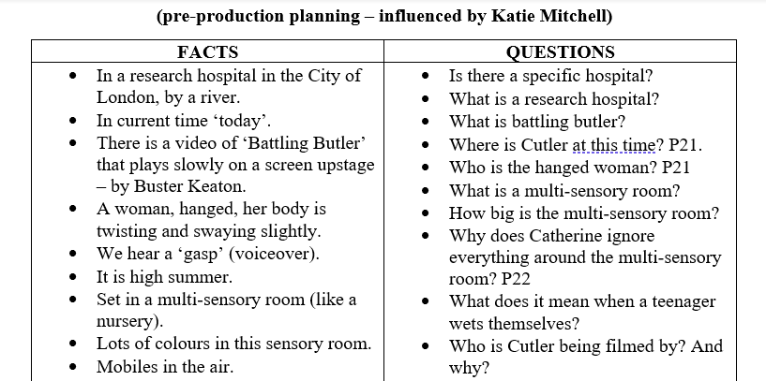
For example, here is a few facts and questions I wrote down based on Stone Face:

As can be seen, following the facts and multiple questions, a simple activity such as this one provides a lot of answers within the play once there are questions to follow the facts. Mitchell (2010, p. 19) comments that the ‘questions on your back history list will not be so easy to answer, especially events in the characters’ past that does not give any precise information about’. For example, if you look at the facts, we see a woman, hanged, which made me think who is the hanged woman? To which I believed it was Catherine’s mother as Mel’s character said (2016, p. 32) ‘out of the blue you hear the news that your Mum’s passed away and you have a sister who may not have seen the light of day’. Although there is no specific mention that Catherine’s mother hanged herself, as a reader and director it is necessary to believe in ones gut instinct and what one believes is correct. I firmly believe it is her mother as she is the only contact Catherine has ever had, and as the text above says her mother had just recently passed away. As Mitchell (2010, p. 19) states ‘you will have to rely on your impression of the text to infer factual material about past events’. As the director makes their way down the facts and questions lists, they will realise that the play gives answers as they continue reading, therefore having them on paper like this makes it easier for them to know what questions remain when moving forward to the next step of the process.
After focusing on lists and questions, a director can start to list research tasks that will give them a better understanding of the play, tasks such as ‘what are the effects of parental kidnapping and why would a parent do that?’ – this would be useful for a better insight to Catherine and her mother’s reasonings. Another one could be ‘what are the intentions of the press when selling a story?’ – this could give the director a better idea of the relationship between Mel and Ali, as finding out those intentions will change their vision of Mel which will impact Ali throughout the play. Mitchell also asks the director to find videos and/or clips that could be used as research footage for the company/actors when studying the play. Stone Face is dominated by the fact that Catherine was held captive for most of her teen life; there are many news headlines like this case and shows have come from them, which are very useful for research purposes. ‘Thirteen’ (2016) is one example, a short series about a young girl that is now rebuilding relationships with her family after being kidnapped for the past thirteen years. This will be very useful when exploring the relationship between Catherine and Ali, although they are not ‘rebuilding’ as they have never met prior to now but focusing on the struggle they had trying to be a family again will be very helpful. RUN (RUN, 2020) is another example of good research films, about a young girl named Chloe that is trapped in her mothers’ house, who uses medicine to purposefully make Chloe sick which affects the muscles in her body, meaning she cannot move as well. This film is insightful in seeing why Chloe’s mum, someone so desperate to keep her daughter to herself, acts the way she does. Although RUN is primarily focused on the abuse towards Chloe, in Stone Face there is no evidence of such thing; (Leigh, 2016) ‘No scars at all. Which, when you think about it, is maybe not such a good sign’. However, using RUN to identify reasons as to why Chloe’s mum locked her in the house, just like what Catherine experienced, will give the company various new discoveries to talk about. Finding films/shows/video footage of storylines like the play will give the company plenty to talk about as they can talk about their new thoughts and findings, which will give them a better understanding of Catherine.
There are also various news headlines and cases that have surfaced the internet over the years, shocking audiences worldwide. The biggest case that shocked me was the Turpin family; ‘David and Louise Turpin’s children had been chained to filthy beds and forced to live in squalor for years’ (White, 2021), and I remember watching a live body camera from a deputy police officer asking Jordan Turpin, one of thirteen children that had escaped to save her siblings, “do you take medication?” and “do you take pills?” insinuating that she was under the influence of drugs (The Independent, 2021). Replying to the deputy’s comments, Jordan said “what’s medication?” because the reality of the situation was Jordan had never spoken to anyone outside her house before, therefore she lacked communication skills. That lack of development had never crossed my mind before watching this clip, but if a child has never experienced the outside world before, they will almost certainly be underdeveloped in many ways. Even being held hostage for a few years can result in one having issues including concentration and memory, as well as feeling withdrawn or hopeless (Rohde, N/A). Therefore, if these are the effects after being held captive short term, Catherine may feel worse or not feel as bad as her life has always been ‘normal’ to her before being found as its all she has ever known.
The play itself refers to one case that hit the headlines dramatically, namely the Fritzl case about a young girl, Elisabeth Fritzl, whose father locked her in a basement in her family home for twenty four years. Whilst she was locked up, her father was plotting all along; ‘Her father would lie to her mother and the police, feeding them stories about how she’d run away and joined a cult.’ (Serena, 2021). Elisabeth was locked in the basement in 1984, physically and sexually abused by her father. In those twenty four years, he had impregnated her eight times, she miscarried the first time but then carried seven children to term over the course of twenty four years. Cutler speaks about one of her boys in the play (Leigh, 2016, p. 12):
After one of the boys came up out of that bunker for the first time… it was observed… that he was frightened of the grass. And then, someone showed him, that grass is safe to touch.
Again, hearing this comment by Cutler, Catherine’s psychiatrist, reinforces that lack of seeing life itself. Things that would be thought of as ‘normal’ are not so normal to those who have not experienced it, like Jordan Turpin with the lack of communication, and one of the Fritzl boys having never been on grass before. These ‘little’ things usually taken for granted, is something I must not forget about, when exploring the play and Catherine herself. Therefore, using these resources will help me get a better understanding of a child held captive, entering Catherine’s world.
Doing the pre-production lists and prep provides the director with all the knowledge required to be able to communicate effectively to the actors. Although the actors will need to do their own work, there is comfort in knowing that the director has done all the prep in order to guide the company in the right direction. ‘Eventing’ is a technique Katie Mitchell uses often, one used by many directors, this technique is a must for a director as it gives them variety of shapes and tones within the journey of the scenes, it also allows the actors to have a clear view of the tempo of the scene and it also gives the audience more to see in the sense of character development and relationships (Mitchell, 2010), therefore this technique develops changes that are helpful for everyone, not only the director.
Here is an example of two different events that may occur in the beginning of Stone Face:
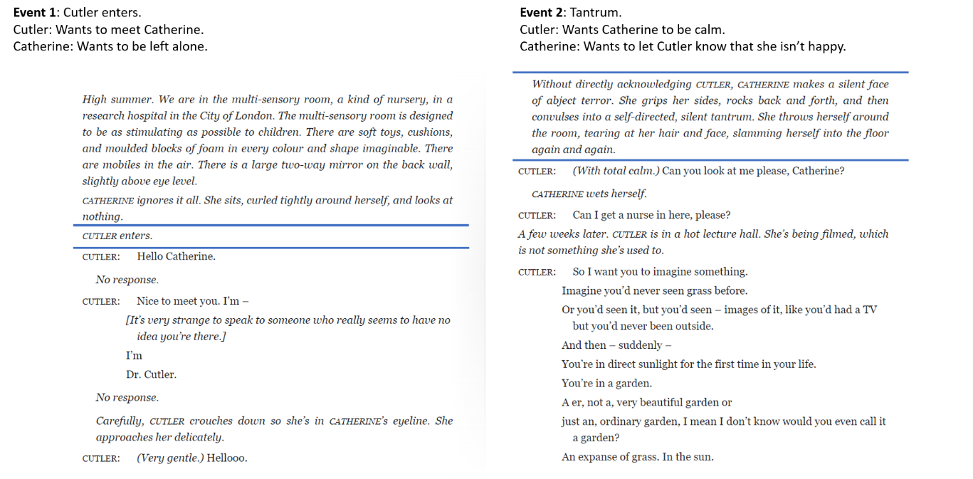

The first event is when Cutler walks into the scene. Although it doesn’t seem as dramatic as one would think an ‘event’ is; it changes the wants of both characters in the scene. Cutler wants to meet Catherine to introduce herself as her new psychiatrist, whereas Catherine simply wants to be left alone, this would be called a ‘sudden event’ as instantly we see Cutler making conversation and Catherine not responding at all. Whereas the second event would be called a ‘gradual event’ (Mitchell, 2010) as it starts with Catherine rocking back and forth gradually before slamming herself into the floor multiple times. Although there is no dialogue, the event itself is the tantrum and this changes everyone present in the scene, this is Catherine’s way to let Cutler know she is not happy and this is how she wants to express that whilst Cutler wants to keep Catherine safe and calm.
Early in my acting degree I would often question how useful this technique was, however as the months went by, I noticed how beneficial this was. Recently I was observing the third year acting and design and production students in their Mainhouse Theatre module, directed by Hannah McPake and assisted by Amelia Ryan. Whilst I was observing these rehearsals, I noticed that McPake was constantly reiterating the events within their play, making sure the actors knew exactly what their events were and how that would affect them and the scene itself, making the scenes more interesting as there were evident peaks and troughs, giving more depth to the story, relationships and characters.
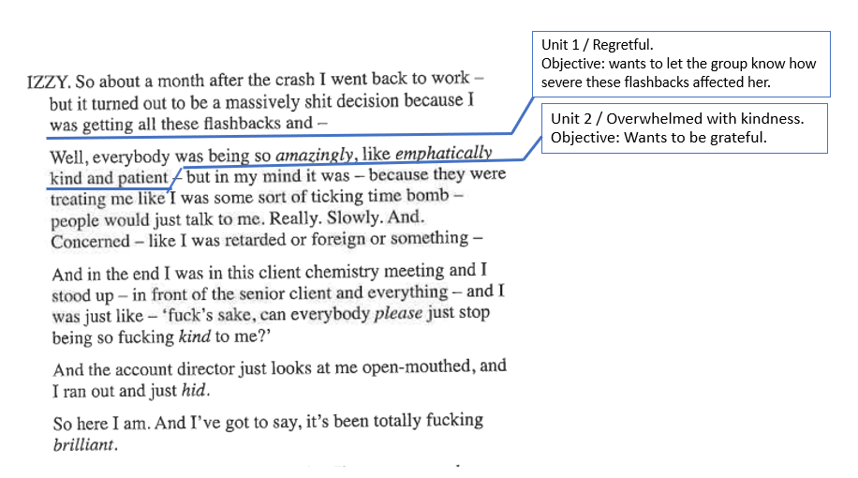
I have also been observing and working with the first year acting students throughout this module, who have been working on monologues and scenes. The first years do not ‘event’ as such, but they use a technique called ‘uniting’ a technique inspired by Stanislavski. Uniting allows the actors to break down the text, narrowing it down to understand what the character feels and is doing in the scene. With every unit, there should be an ‘objective’ where an actor will know what their character wants during that scene (Merlin, 2014). Here is a quick example of some units from Izzy’s monologue in BU21 (Slade, 2017), which is what the first years are currently studying:

As stated in the example above, Izzy feels regretful as she tried to move on with life too quickly by going to work but wants to communicate to the group how the plane crash of BU21 has affected her as well in and outside of work. In the second unit we gain understanding that she is very overwhelmed with her colleagues being so nice and she wants to be grateful for their kind words and patience. ‘Uniting’ and ‘eventing’ are different in a sense that a uniting gives the actor a sense of their thought process in a piece, whereas events are more about something happening in a scene that changes everyone’s thought process. However, both techniques are useful to gain more structure in a piece, really working on the journey and flow of a scene, but most importantly focuses on the wants of a character.
As I mentioned earlier, McPake often used her time to focus on events to make sure the actors involved knew what their characters wanted. If an actor does not take time to really think about their events or units, it can affect the overall performance of their piece. For example, I recently sat in the first years’ acting assessments, which myself and another student on the MA Theatre Directing course had worked on with them a little. With my time with them, I would often remind them to keep looking at their units and objectives and it was clear in the assessment who had done that and who had not. Doing the units at the start of the process and never revisiting them again resulted in some monologues falling a bit flat and sounding a little monotone, as they had not revisited their units which meant they had not thought about the shapes and tones within the text itself. Seeing this made me understand why a director, such as McPake would often talk about events and the importance of them, because when an actor does not know the importance of them, their overall performance lacks depth and structure.
Of course, there are various tasks that Mitchell advises directors to do in their pre-production prep, apart from facts, questions and events, and doing this is in the director’s interests especially if they are planning to do a ‘pre-production workshop’ which gives them an opportunity to explore a challenging area of the play as I mentioned in the beginning. Having done my pre-production work, it allows me to host a workshop, although I am exploring a grey area of the play, I still have enough knowledge of the play now to be able to communicate effectively with the actors involved and be confident enough to answer any questions they may have.
The ‘challenge’ I will be exploring is Catherine herself, her physicality and demeanour. I feel as if I still do not have a perfect vision of her in my mind, and in doing this workshop I hope to gain that vision by taking inspiration from all actors as we all explore her physicality. To begin with, I had 4 actors in mind for my workshop, 4-6 actors is what Mitchell would advise as you can pair them off with different tasks. I wanted three females and one male actor because, although Catherine is a girl (which is why I wanted three females) she often fluctuates between being light and heavy, which I thought I could explore using feminine and masculine energy from a male and a female. Mitchell also recommends a director to use actors they have worked with in the past, as the process can be so much easier (Mitchell, 2010), however my aim as a director in training is to push myself out of my comfort zone therefore, I looked for actors that I had not worked with at all or had little experience with. In the end I only had two actors, as the other actors could not make it due to personal reasons, and although one of them pulled out the night before, I decided to continue with the workshop as these things will always happen and I need to be able to readapt and continue with my work.
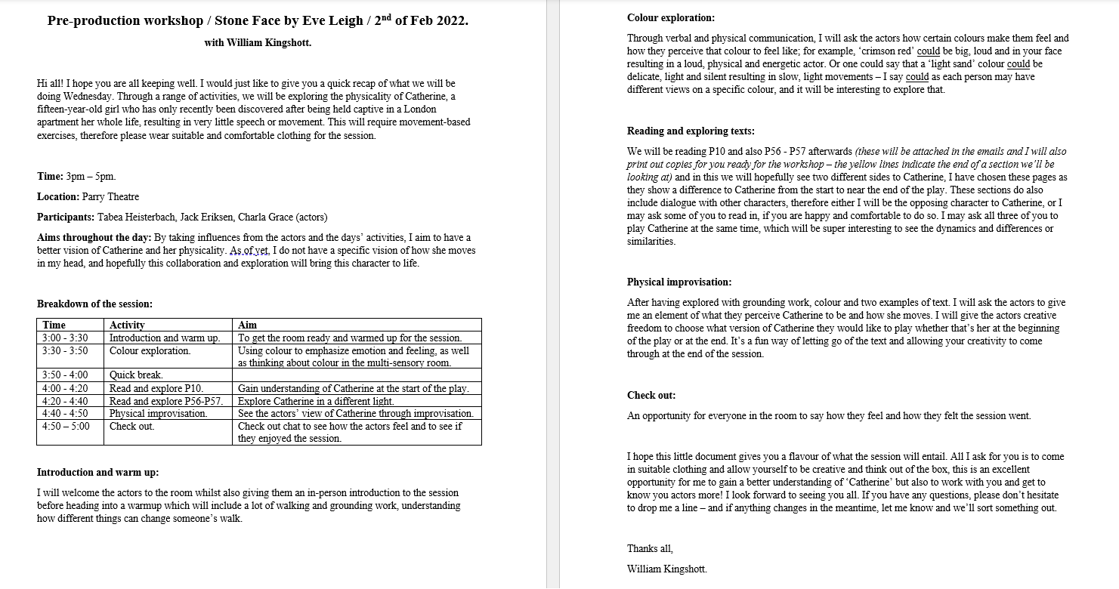
Prior to the workshop, I sent out a workshop information pack, as seen here:

This workshop pack allowed me to quickly give the actors a quick recap of what the workshop session will entail, as I had previous chats with them all independently but nothing in writing. As well as a quick recap, I also told them what I was aiming to gain in the session which was ‘By taking influences from the actors and the days’ activities, I aim to have a better vision of Catherine and her physicality. I am yet to have a specific vision of how she uses her physicality in my head, hopefully this collaboration and exploration will bring her to life.’ I also included a breakdown of the session including the time, activity and aims, followed by an elaboration of each activity.
Throughout my experiences as an actor, only having little information about a workshop when attending one resulted in many worries and questions as I had no idea what to expect. Therefore, I thought it was only right to be able to hand the actors a little pack, that gave them a taste of the workshop prior to coming therefore they could walk in comfortably knowing what they will be exploring during the session. The pack did not have every detail of every activity written down, as that is too structured and takes the creative fun away, but it certainly had enough information which was informative and planned. That pack will also be given to them in the workshop, for example if I need to go to the toilet, they still have something to read and follow, instead of leaving them wondering what they will do when I come back.
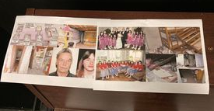
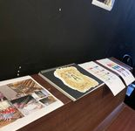

Prior to the workshop, I wanted to create a space for all participants to visually familiarise themselves with the play, therefore I printed various pictures and stuck them to the wall:
On the wall I put a mixture of collages based on each character in the play: Catherine, Ali, Cutler and Mel. Whilst doing the pre-production work, Mitchell asks the director to note down visuals of ‘places’ and from that I included collages of multi-sensory rooms, my own take on Catherine’s mother’s apartment and the Pine Ridge clinic in America that the press manipulates Catherine’s sister into taking her. Simple yet effective collages make it easy for the director to take the actors through a summary of the play without taking up too much time, as I limited the workshop to two hours. Collages about some cases such as the Fritzl case and the Turpin case was also included, allowing them to understand the severity of these cases from a true source which also gave me opportunity to talk about their on-going affects after captivity. Having these on the wall really helped me bring the synopsis to life, it was a great way to compare Catherine’s life before and during the scenes we explored, using the pictures to show comparisons.
The workshop was broken down into two sections. The first half consisted of a warmup, some physical exploration and an exercise on colours. The second half was strictly focused on two extracts of the play, allowing the actors to gain understanding of Catherine at the beginning and the end of the play and how her physicality would differ between both. The warmup was influenced by some aspects of Frantic Assembly’s warm up led by Jonnie Riordan (2017); I used this as influence as their warmups are specified for actors using movement, which I thought would be much more useful to incorporate, simple yet made their muscles ready and warm. To keep that body warmth, I quickly moved onto some grounding exercises where I asked the actors to experiment walking around the space with different ways of travelling, understanding the possibilities within movement, in hope that this will have inspired their movement when looking at the script element.
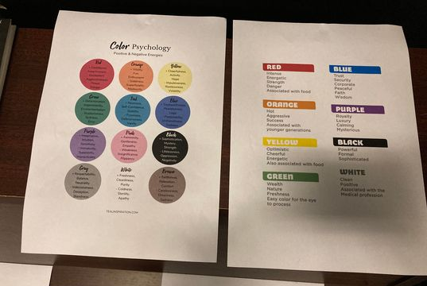
As well as learning how to use movement differently, I subsequently started to explore a technique by Ken Rea, inspired by colours only (Rea, 2015). The exercise asks the actors to embody and physicalise a colour, keeping in mind the energy of colours. This allows the actors to move without following text, making them depend more on their creativity. To help the actors, I gave them a paper copy that listed the positives and negatives of colours. The exercise itself is very different and if an actor lacks in confidence, they may feel too shy to fully embrace the colours. Giving them these papers allowed them to understand the overall tones of certain colours and handed them with all the material needed for the exercise. Colour can affect people psychologically and therefore make them feel differently (Cherry, 2020) ‘Colour is a powerful communication tool and can be used to signal action, influence mood, and even influence physiological reactions’, giving the actor playing Catherine more to work with especially in a colourful multi-sensory room. Following Rea’s exercise, I began to instruct them around the room, asking them to follow my words to create a visual image in their mind whilst also incorporating music. The first image was a red room, slowly but surely this room kept on intensifying. Quickly, there was no way out, the red light was turning into heat, they could not stay in one place for longer than fifteen seconds, it made them itch and the room was getting smaller as time went on. Suddenly, there was a music change, and I asked for them to picture this bright white room, their body was starting to cool down, still no exit, but still there was light. Having felt those two rooms allowed them to feel the two contrasting atmospheres Catherine feels in the play, going from the apartment to the hospital. Delving deep into a creative exercise following their imagery by a few change of words and music not only is good inspiration for the play (lighting and sound), but it also allowed them to lose all fears about ‘performing’ in the space as they believed it. Both actors enjoyed this exercise and I believe it was helpful to prepare their creative minds prior to the second section.
Page 10 and page 56-57 are what we explored in the second section. P10 is the first time there is an interaction between Catherine and her new psychiatrist, Cutler, resulting in a big physical tantrum. Nearly a year after that tantrum in P56-P57, Catherine is introduced to Mel from the press, who manipulated Ali, Catherine’s sister to let her in without the permission of Cutler. Mel continues to pester Catherine for information about her mother, ending with Mel being attacked by Catherine. One personal attack at the beginning to one aimed physical attack to the end. After a read of both, I explored the big attacks first before working them into the scene. With any movement piece, it’s best to understand what the movement is as it gives the actors understanding of to feed that into the text. The actors performed individually (to trust their own instincts) as well as together. This was useful for myself to pick and choose what I enjoyed about both that I could combine to create Catherine, as I found that one actor was over-performing, and the other was under-performing. Therefore, allowing them to watch each other was great for them to take inspiration, but also allowed me to create a nice balance to Catherine’s movement. At the end of the session, I asked them to give me a physical improvisation, perhaps an example of how Catherine moves in their mind, or a scene they think is missing, or a before/after of the extracts we had explored. A fun exercise for them to have creative freedom whilst giving me the opportunity to gain their discoveries and perception of Catherine, helping me build the overall character.
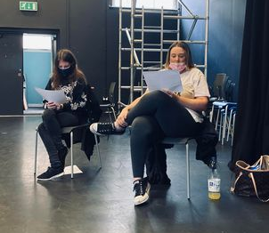
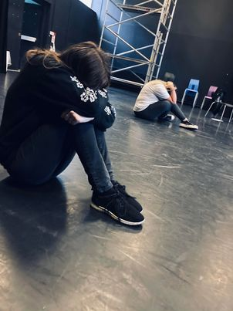

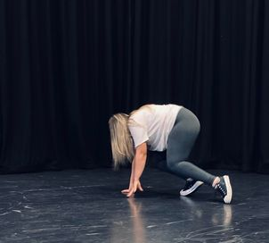
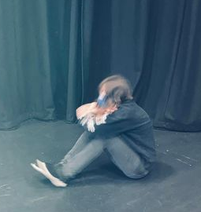
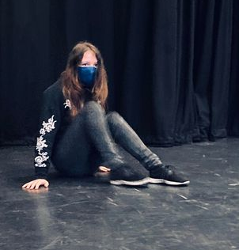

After a pre-production workshop, a director will have hopefully sorted out all ‘grey areas’ within their chosen play before moving onto rehearsals with the full company. However, prior to that, they will need to pitch their play. Therefore, a director would approach a company with a brief of the play which will be broken down into three:
- A log line – an elevated statement of the play, where the play can be sold in only one sentence:
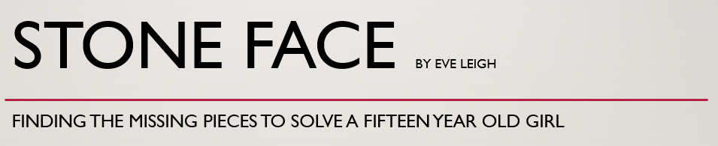

- A brief pitch – in between the log line and final pitch, a short statement of the play:
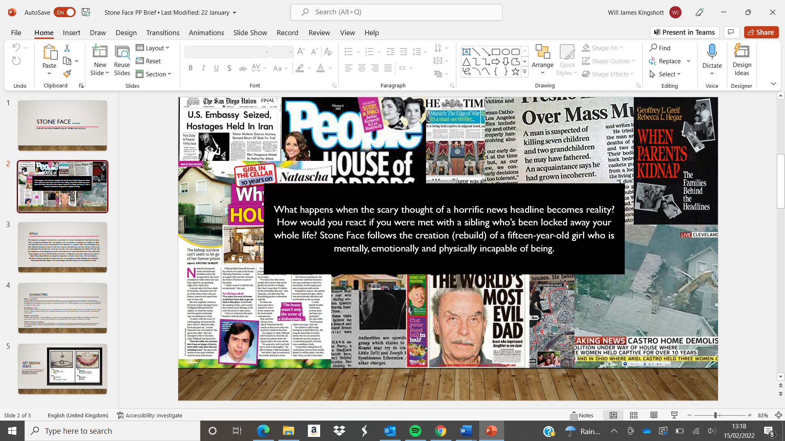

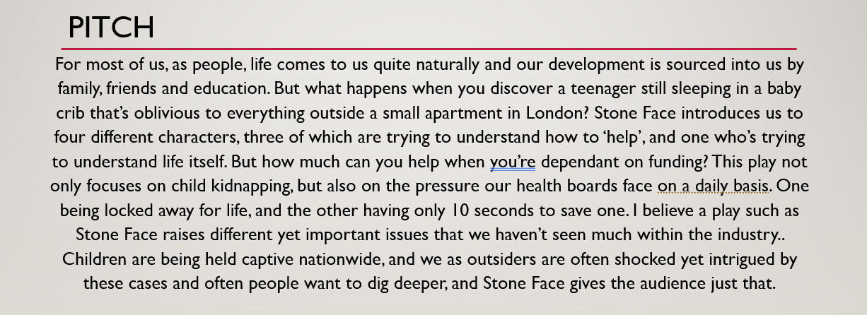
- A pitch brief, without taking too much time you would sell the play whilst adding why the play should be taken forward:

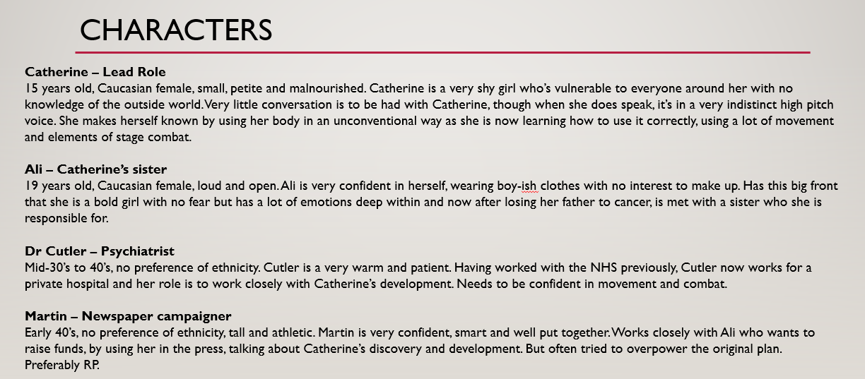
Finishing the pitch, this would also include a character breakdown for the casting process to begin:
Some directors may change the plays characters in the way I have done with Mel’s character. I changed the character from female to male as the thought of a man manipulating a young woman seems so much more intense, heightening the conflict between Ali and Martin (Mel). If the pitch is accepted, a director can then move onto rehearsals already having done the work months in advance. Working with all members of the company, the director will start to work on all various areas such as set, lighting, sound, text, and actors to make sure the whole company are on task and have something to work towards. As mentioned above, I already have visuals and worked with colours and sounds in the workshop, therefore I would take that forward with me. But depending on the budget, a lot can change, for example, if I was to give set ideas to the designer, I would hand them this:

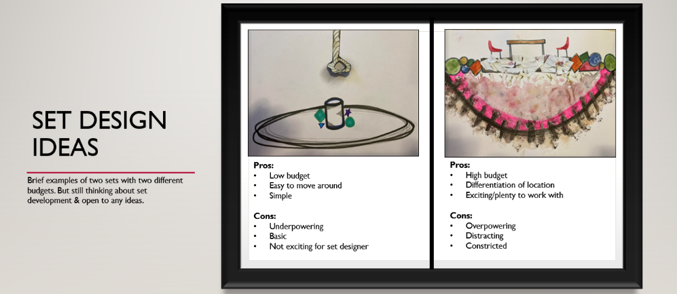
As stated, I would be ‘open to ideas’; one is low budget, the other is high budget, but both have positives and negatives to think about, which is where I would ask the set designer to add their own take to see if we can find a medium between us. As the set designer will know more than myself in regard to knowing how to manage set but it is always important for a director to have vision beforehand, working collaboratively with them.
Whilst managing set ideas, the director would also liaise with the sound and lighting technicians sharing any visions they already have. My ideas for the lighting technicians would include a lava lamp type of lighting effect with multiple bright colours when the action is taking place in the multi-sensory room. For Catherine’s old flat I would want very dim, pale orange and brown lighting almost to reflect the damp colour of the wallpapers decorating the flat. When incorporating music and sound into the mix, these would be some ideas taken forward; Instrumental ‘Run Boy Run’ by Woodkid would be great when Catherine is on the attack as it has a great build up and a very chaotic bass, also heightening the audience’s experience watching it. For the multi-sensory room, I would include a very low volume of metal wind chimes, these are often used for calming effects therefore it would make sense to add this, adding a nice, calm element. These are just a fraction of ideas I would take forward; and I believe it is very useful for the crew as they have something to work towards, making sure everyone is on task.
Working closely with the stage manager, the director would update all departments of new sounds/music/lighting that tie inn together, helping the crew during rehearsals whilst also organising rehearsal sheets with the SM. Keeping organised allows the SM to ensure everyone within the company are meeting their tasks and deadlines, working on progress towards the final show week. Regarding the actors, the director will take them through the process of everything they have done prior to rehearsals such as character breakdowns, events, locations, relationships and so on. The director should never tell the actor what to do, as they need to do their own work but having that understanding of the play allows the director to guide the actors efficiently.
During rehearsals, the director would put in place certain exercises/techniques to benefit the actors’ process, for example one could use ‘overarm and underarm’ inspired by Ken Rea (Rea, 2015). This technique is used to establish status between two characters, which would be useful for Stone Face as there are never more than two actors present in a scene. The overarm is the ‘major’ and the underarm would be the ‘minor’ however, using their arms the actors would physicalise their overarm to arch over the underarm, dominating their space, which will then inflict the underarms’ intentions as they have no space to grow. The director could also use exercises that will benefit the actors’ personal consciousness rather than simply just working on character development. Meisner’s ‘repetition exercise’ is a great example for this, although its focus is on developing the actors’ listening techniques, it also enables the actors to forget their insecurities as they are giving all their energy to their scene partner (Tannenbaum, N/A).
The director will have explored various techniques and exercises to develop the characters and their relationships and by this point the play will have developed massively as in doing that they will have gained various new discoveries as rehearsals progressed. Tech week would be coming and depending on whether the company had rehearsals outside of the theatre, they would then have the work of reworking their blocking to fit their theatre space. The director will need to be ready to answer everyone’s questions, especially the crew as they will have already had various talks with the actors during rehearsals. They will need close communication with the stage manager, ensuring all cues throughout the play were in place. They will need to work with the sound designer to ensure all volume levels were to their taste. They will need to work with lighting tech to reiterate all lighting choices, making sure they are in place whilst also communicating with the actors to ensure all members of the company understood every lighting choice. Effective communication with make up and costume will be useful at the start of the week, making sure all clothing fit and makeup was stocked. Therefore, it would be a busy week for myself as the director, as I need to manage everyone’s needs at the same time, especially the crew.
However, I personally would not continue to do Stone Face if facing a low budget. Having done the pre-production workshop, I left with lots of thoughts and questions. Although I enjoyed and felt the most comfortable I have ever been in a rehearsal space, it quickly dawned on me that I would need some assistance, especially to do with the movement and physicality involved in the play. As I was working on both extracts of the play, I noticed that I was lacking when instructing the actors on ‘how’ to move and often found myself showing them what to do instead, which gives the actors ideas but also makes it easier for them. In hindsight, I wanted them to show me how they thought Catherine would move; by showing them ‘how’ I would do it, I did not get as much inspiration out of them as I anticipated. Therefore, I think it would be best if I could bring in a movement director to help the company, allowing the actors to learn verbally and physically as I lacked knowledge of language when giving them movement ideas. Even doing just the physical exploration with them caused the eczema on my hands to flare up and I left the workshop in pain; it is good to know your personal boundaries as a director, and this allowed me to understand that.
Looking at facilities available to me as a director was something I never thought about before doing this pre-production workshop. I originally asked for the Parry Theatre as it was a big open space, but at times this gave the actors too much space in which to ‘hide’, whereas if I could have taped a smaller section on the floor, it would have confined their space, heightening the intensity of the ‘red room’ and the ‘white room’. I also brought a red lamp to the space to use in the colour exploration, however as the rehearsal space did not ‘black out’ I wasn’t able to do explore that, therefore looking at other facilities available such as the Black Box near the Halliwell would have given me a smaller, darker space to achieve what I wanted.
The pre-production workshop was very useful and I will make more use of them in the future before doing any production. It allowed me to identify what worked for me and what did not, and I believe it is important for every director to have that realisation. I had never thought of doing one before, but now I understand how helpful they are. Apart from the movement aspect, I was very happy with most of my workshop. The information pack, the use of music, the warmup, the grounding exercises and colour warm up were all effective and helped the actors to feel comfortable and ready for the session. The two extracts were also useful, the process of exploring Catherine’s physicality helped them understand her development in a year, but the movement did lack creativity. I for sure would incorporate some movement in another play however I would not direct one that heavily relies on it, unless I had a movement director there.
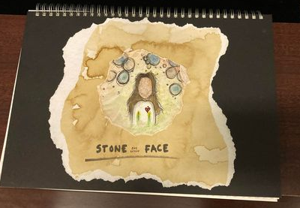
I learned that although I am a confident presence in the space, I need to also not fear silence, allowing the actors to depend on their own imagination. I learned that I enjoy being organised, but that I should not allow the organisation to restrict creativity, for example I could have further developed the colour exploration to see where it could have taken the actors instead of sticking to the schedule. I learned that in doing a pre-production workshop, it allows the director to ‘mess up’, it was not about being perfect, it was about working on myself as a director and understanding what works whilst also challenging myself. This whole module, from working on the back history lists to exploring Stone Face’s physicality has challenged me but has also taught me so much, understanding the bigger picture of a play, benefitting my career as a director. Even though it did not all go to plan, I am still proud of what I achieved, and I can already feel my development process throughout the course.
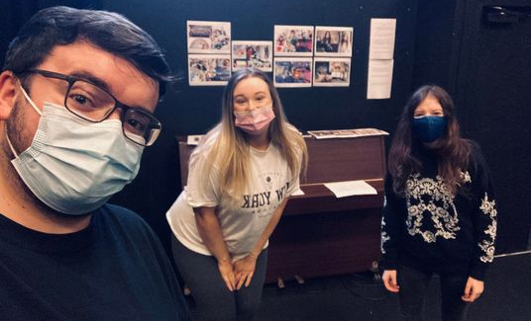


Reference list:
‘Thirteen’ (2016) Thirteen, Series 1. BBC ONE iPlayer. Available at: https://www.bbc.co.uk/iplayer/episodes/p03kbqgf/thirteen (Accessed: 1 February 2022)
Birch, A. (2017) Anatomy of a Suicide. London: Oberon Modern Plays.
Birch, A. (2019) [BLANK]. London: Oberon Modern Plays.
Cherry, K. (2020) Color Psyhcology: Does It Affect How You Feel?, Very well mind, 28th May. Available at: https://www.verywellmind.com/color-psychology-2795824#:~:text=Color%20is%20a%20powerful%20communication,%2C%20increased%20metabolism%2C%20and%20eyestrain. (Accessed: 15 Feburary 2022)
Leigh, E. (2016) Stone Face. Finborough: Oberon Modern Plays.
Marlow, B. (2016) Cysgu’n Brysur. Theatr Ieuenctid yr Urdd.
Merlin, B. (2014) The Complete Stanislavsky Toolkit. Revised edition. London: Nick Hern Books.
Mitchell, K. (2010) The director's craft. New York: Routledge.
Rea, K. (2015) The Outstanding Actor. Second edition. Bloomsbury Publishing.
Riordan, J. (2017) A Frantic Assembly Warm Up [online] Digital Theatre+. Available at: https://edu.digitaltheatreplus.com/content/workshops/a-frantic-assembly-warm-up (Accessed: 9 February 2022)
Rohde, D. (N/A) ‘GETTING BACK TO LIFE AFTER CAPTIVITY’, Hostage Us. Available at: https://hostageus.org/hostages/getting-back-to-life/ (Accessed: 15 February 2022)
RUN (2020) Directed by A. Chaganty. Available at: Netflix (Accessed: 1 February 2022)
Serena, K. (2021) The Horrifying Story of Elisabeth Fritzl – Who Spent 24 Years In Her Father’s Prison. Available at: https://allthatsinteresting.com/elisabeth-fritzl (Accessed: 1 February 2022)
Slade, S. (2017) BU21. New edition. London: Nick Hern Books.
Tannenbaum, T. (N/A) What is the Repetition Exercise?, Acting Magazine. Available at: https://actingmagazine.com/2019/11/what-is-the-repetition-exercise/ (Accessed: 15 February 2022)
The Independent (2021) Jordan Turpin’s escape from ‘house of horror’ shown in never-before-seen bodycam footage [video]. Available at: https://www.youtube.com/watch?v=iaPkpYG-ZPg (Accessed: 1 February 2022)
White, D. (2021) ‘SHOCKING FIND What happened to the Turpin family children and where are they now?’, The Sun, 3rd December. Available at: https://www.thesun.co.uk/news/5350762/where-turpin-family-children-found-perris-california-now/ (Accessed: 1 February 2022)

Bibiography:
The Director’s Craft - Katie Mitchell
Stone Face - Eve Leigh
The Complete Stanislavsky Toolkit – Bella Merlin
BU21 – Stuart Slade
[BLANK] – Alice Birch
Anatomy of a Suicide – Alice Birch
Cysgu’n brysur – Bethan Marlow
The Outstanding Actor – Ken Rea
https://www.bbc.co.uk/iplayer/episodes/p03kbqgf/thirteen
https://www.thesun.co.uk/news/5350762/where-turpin-family-children-found-perris-california-now/
https://www.youtube.com/watch?v=iaPkpYG-ZPg
https://www.verywellmind.com/color-psychology-2795824#:~:text=Color%20is%20a%20powerful%20communication,%2C%20increased%20metabolism%2C%20and%20eyestrain
https://actingmagazine.com/2019/11/what-is-the-repetition-exercise/
https://allthatsinteresting.com/elisabeth-fritzl
https://edu.digitaltheatreplus.com/content/workshops/a-frantic-assembly-warm-up
https://hostageus.org/hostages/getting-back-to-life/
https://screencraft.org/blog/how-to-write-an-effective-one-page-pitch/
https://www.barrons.com/news/children-held-captive-infamous-cases-01606843808?tesla=y
https://www.barrons.com/news/children-held-captive-infamous-cases-01606843808?tesla=y
https://www.stage-electrics.co.uk/creating-a-pre-production-checklist
https://pubmed.ncbi.nlm.nih.gov/1443068/
https://edition.cnn.com/2018/01/18/us/whats-next-for-turpin-children/index.html
https://www.divorcesource.com/blog/the-impact-of-parental-child-abduction/
https://www.thesun.co.uk/news/5350762/where-turpin-family-children-found-perris-california-now/
https://en.wikipedia.org/wiki/Fritzl_case
Movement Direction: Creating Character - YouTube
Girl held captive in dungeon by family friend: Survivor speaks | Truecrimedaily.com
Characters From Colours in The Outstanding Actor 2e on Vimeo
Digital Theatre+ (digitaltheatreplus.com)
Jodie Comer from Thirteen | The Three Brief - YouTube
https://www.provokemedia.com/long-reads/article/deconstructing-the-pitch-is-pitch-theatre-a-good-idea-
https://cutaway.shift.io/the-ultimate-guide-to-film-pitch-decks-plus-examples
Inside the horrific secret chamber where Josef Fritzl kept his daughter | 60 Minutes Australia - Bing video
Advice To First Time Directors On Directing Actors - Andrew Guerrero - YouTube
https://resource.download.wjec.co.uk/vtc/2017-18/17-18_2-27/_cym/uned01/cysgun_brysur.html
https://www.stage-electrics.co.uk/creating-a-pre-production-checklist
https://www.theauditiontechnique.com/the-benefits-of-acting-workshops/
https://actinginlondon.co.uk/reasons-why-acting-workshops-are-necessary/
Insights: What does a director do? - YouTube
https://actinginlondon.co.uk/exercises-improve-acting-skills/
https://www.nationaltheatre.org.uk/blog/five-best%E2%80%A6-theatrical-gender-swaps
https://edu.digitaltheatreplus.com/content/interviews/contemporary-performance-practice-on-directing-an-interview-with-paul-allain
Katie Mitchell on Theatre Directing - YouTube
https://www.commonsensemedia.org/tv-reviews/the-trials-of-gabriel-fernandez
https://en.wikipedia.org/wiki/List_of_child_abuse_cases_featuring_long-term_detention
https://trauma.blog.yorku.ca/2018/09/when-children-are-freed-from-captivity-what-happens-afterward/
https://yamdu.com/en/learn/preproduction/#:~:text=During%20pre%2Dproduction%20you%20will,planning%20stage%20is%20well%2Dmanaged.
https://hostageus.org/a-life-after-captivity-reintegration-guide/

