
Skills for the Workplace
Module Assignment Submission
Student Name: | Kate Hudgell
Student Number: | 2000133
Module No: | BMSK4002
Module Title: | Effective Team Working and Communication  Part 2

Statement of Confirmation of Authenticity
By the act of making this submission, the student declares that this is the work of the student named above. The work has not, in whole or in part, been knowingly presented elsewhere for assessment, or where assessment has been built on a previous assessment, this has been identified. Where materials have been used from other sources it has been properly acknowledged. If this statement is untrue, the student acknowledges that an assessment offence has been committed.
Attention is drawn to the plagiarism and unfair practice policies of both the University and of ILM.

Table of Contents
Part 2 Communication 3
1.0 3
Communication Cycle 3
2.0 5
Assessing Own Communication Skills 5
Gap Analysis 6
PDP 6
References 7
Appendix A 7
Skills You Need Communication Quiz 7
Mind Tools Communication Quiz 9

Part 2 Communication

1.0

Communication Cycle

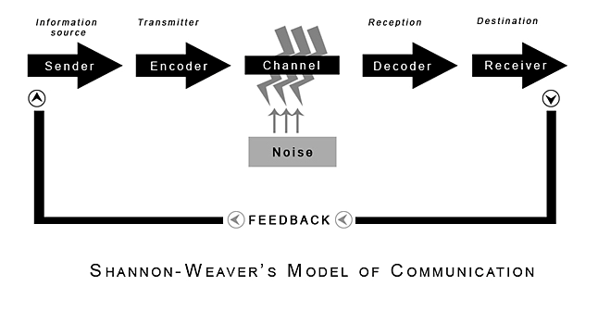
(Shannon and Weaver, 1949)

Shannon, and American mathematician and electronic engineer and Weaver an American scientist joined together to write “Bell System Technical Journal” also called a Mathematical. Theory of communication. The Shannon -Weaver model of communication is designed to develop effective communication from the sender to the receiver. It was developed firstly for technical communication. But then applied to wider fields.
The Shannon weaver model of communication breaks down the way that the way that messages are sent and received into 6 key stages, -Sender, Encoder, Channel, Noise, Decoder and receiver. This model is also known as the ‘information theory’ or the Shannon theory as they were developing it.
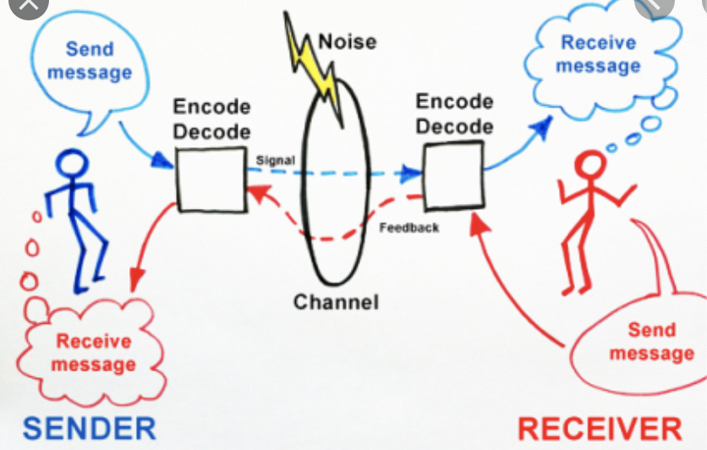

There are others that can be critical of this work. U tube study by Elliot Volkman, online community learning, claims that Shannon model is too simple, a basic model. That it is more effective on face to face communication rather than that of a group. That the sender is the primary and that then the receiver is secondary and less important, and that oneway communication loses strength.
Schramm (1954)
Derived from the Osgood Model, a circular form of communication, He emphasised on the encoding and decoding of information. Sighting 6 elements of communication, Source Encoder, Message, Channel, Decoder, and Receiver.
He added ‘Field experience’, this change based on experience, beliefs, values and learnt meanings. He enfersized that messages can be complicated by different meaning learnt by different people. Schramm suggests that messages can be denotive, which is the literal meaning or connotative, using personal or emotive feelings that can change the information of a message.

2.0

Assessing Own Communication Skills

Looking at my communication over the presentation, I applied the CRAAP test, as it was a piece that I was presenting online it took a different thoughtfulness than standing in front of people giving a power point presentation. Of course, it had currency as it was the subject that we were asked to talk about. The work was relevant to the information that i was putting across, the information verified by the bibliography, and I hope to serve the purpose as it would give me half the marks needed for the assignment.
Taking the mindtools assessment online, after asking me 15 questions about my descriptive and listening skills. On scoring 46 out of 75, they evaluated my answers by stating “You’re a capable communicator, but you sometimes experience communication problems. Take the time to think about your approach to communication, and focus on receiving messages effectively, as much as sending them. This will help to improve your ability to communicate.
Looking at myself, I need to plan what I am going to say to see a clear way to my objective, look at the people that need to format the information that I am trying to pass. Be better acknowledged so that the understanding of the objective is clear to all parties. Ask for feedback where possible to see if the improvement is happening. Check the others body language is this can indicate the feel of the person or even their reaction to the tone or message that I am giving to them. When giving the presentation on Sunday, I was nervous, I had a shout out read through a couple of times in work on the Saturday evening it was quite quiet, and I knew I could read out load without disturbing anyone. I didn’t indicate where I should change my slides on my power point presentation, so I missed two in the right place, but that is a lesson well learnt.
I thought, the writing tone was ok, I made one or two jokes, but a sense to humour isn’t a bad thing as long as it’s not too much. My grammar is normally quite good as I enjoy reading, spelling needs to be checked as my typing is a bit messy.
Communication in Tesco

YAMMER INFORM ZOOM


TWITTER FACEBOOK PAYSLIP LOGIN
COLLEAGUE i TOUCH
These are all platforms that Tesco, as a company use. Yammer being the inter company main use. Yammer is the Microsoft designed platform, launched in 2008 to assist in the workplace internal communication, but has grown into an international networking for business needs, by Microsoft who purchased it in 2012. It was then rolled out on their office suite in 2014, and today is used by 85% of fortune 500 companies.
Presented on Microsoft web page as “open and Dynamic communication across your organisation”. Microsoft office 365 which is the umbrella that the Yammer sits under, develops office applications with device management and advanced security in industry around the world.
Tesco as a company, started using Yammer in September 2014, using it as “our internal social media network” that is available to all colleagues across the U.K. from stores, distribution and offices. Using it as a platform for all colleagues across Tesco that makes it easier for staff to connect together and share ideas, supporting each other to deliver the best customer experience, and celebrate success. Building on the application to use on the go, using the yammer services for groups within a team at all levels.
Inform is a service that came into use last year, all staff can download the app, and the information given is that of food stocks in store when its delivered how many to expect, what’s on the shelf and if any stores in your area have an item. It has been really useful in the last few weeks, when certain stock has been flying off the shelf.
Tesco i Touch, Facebook and Twitter are not used by me, as they are at company level, we are not allowed to use whats app.

Gap Analysis

Objective | Current Position | Deficiency | Action
What do I want to do? | What can I already do? | What am I lacking? | How do I fix this?
Speak clearly. | Good diction. | Conviction. | Confidence.
Have more confidence | Practice… | Time. | I could see that the practice I had done made it better.
Time management | I rush things at the last minute to get them done. | The ability to find time to competed things. | Writing what I need to achieve down and how long I have to do it and sticking to the deadlines I write.

PDP

Objectives | Tasks | Success Criteria | Time Frame | Resources
List your Goals | What do you need to do to achieve these goals? | How will you identify your success? | When do they need to be done by? | Who or what do you need to help you?
Finish course. | Time manage and work. | Good result. | End of year. | Tutor.

References

Blenkinsop, P. (2010) The Communication Cycle. [online] Available at: http://manyana-education.blogspot.com/2010/10/communication-cycle.html Accessed: 15.05.2020
MindTools (2019) How good are your communication skills? [online] Available at: https://www.mindtools.com/pages/article/newCS_99.htm Accessed: 15.05.2020
Shannon, C. and Weaver, W. (1949) The Mathematical Theory of Communication. Urbana: University of Illinois Press.
Skills You Need (2019) Interpersonal Skills Self-Assessment. [online] Available at: https://www.skillsyouneed.com/ls/index.php/343479 Accessed: 15.05.2020
Perron, M. (2018) The importance of setting SMART Goals, [online] available at http://www.hydratemarketing.com/blog/the-importance-of-setting-smart-goals accessed 19th may 2020
Elliot Volkman (2012) Communication Theory and the Shannon weaver model. [online-U tube] Accessed: 18.05.2020

Appendix A

Skills You Need Communication Quiz

Total Score 59%
Listening skills 52% average
Basic grasp of key interpersonal skills but need to improve.
Emotional Intelligence 66% average
Need to develop better understanding of emotions.
Verbal Communication 50% average
When speaking to others take time to think about what you are saying and how to say it.

Communicating in groups 64% average
When next in a group watch other to pick up ideas of what you can do, and what you avoid doing.

Mind Tools Communication Quiz

Taking the mindtools assessment online, after asking me 15 questions about my descriptive and listening skills. On scoring 46 out of 75, they evaluated my answers by stating “You’re a capable communicator, but you sometimes experience communication problems. Take the time to think about your approach to communication, and focus on receiving messages effectively, as much as sending them. This will help to improve your ability to communicate.

