Romanian Winter Wonderland –

Feasibility Plan for a International Meeting

Name: Laurentiu Gelu Iftimoae
Student No: 2206170
Tutor Name: Kathryn Flynn

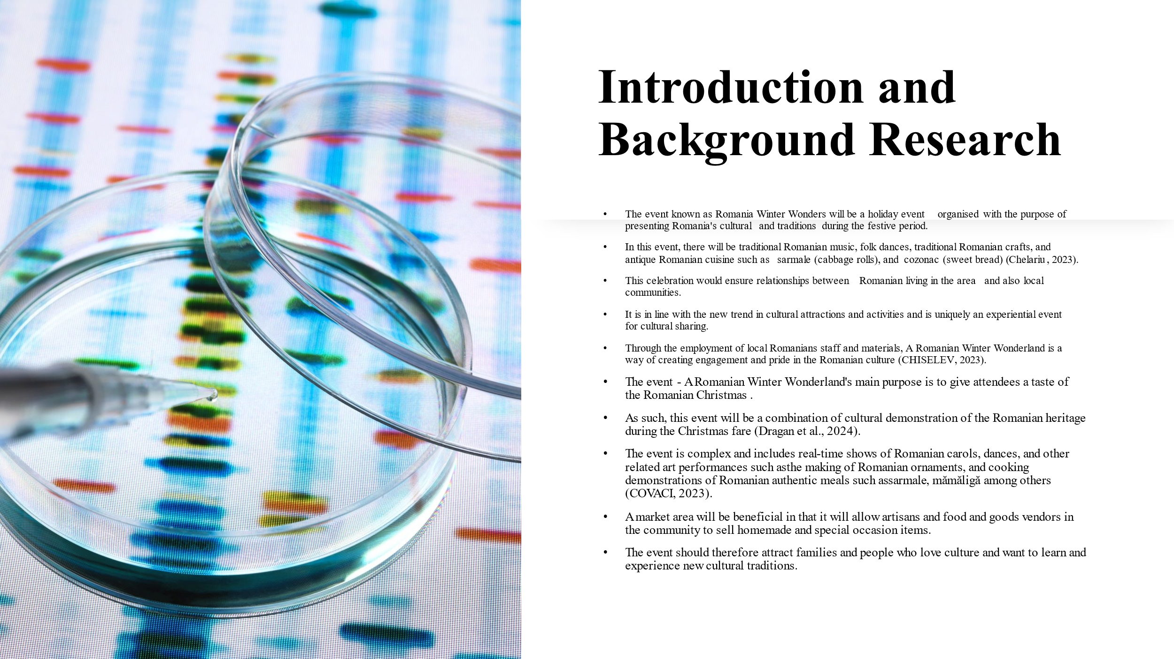

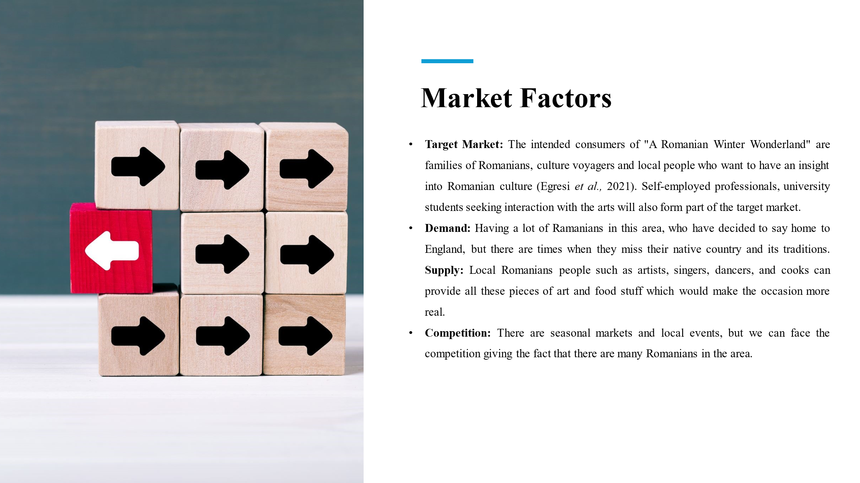

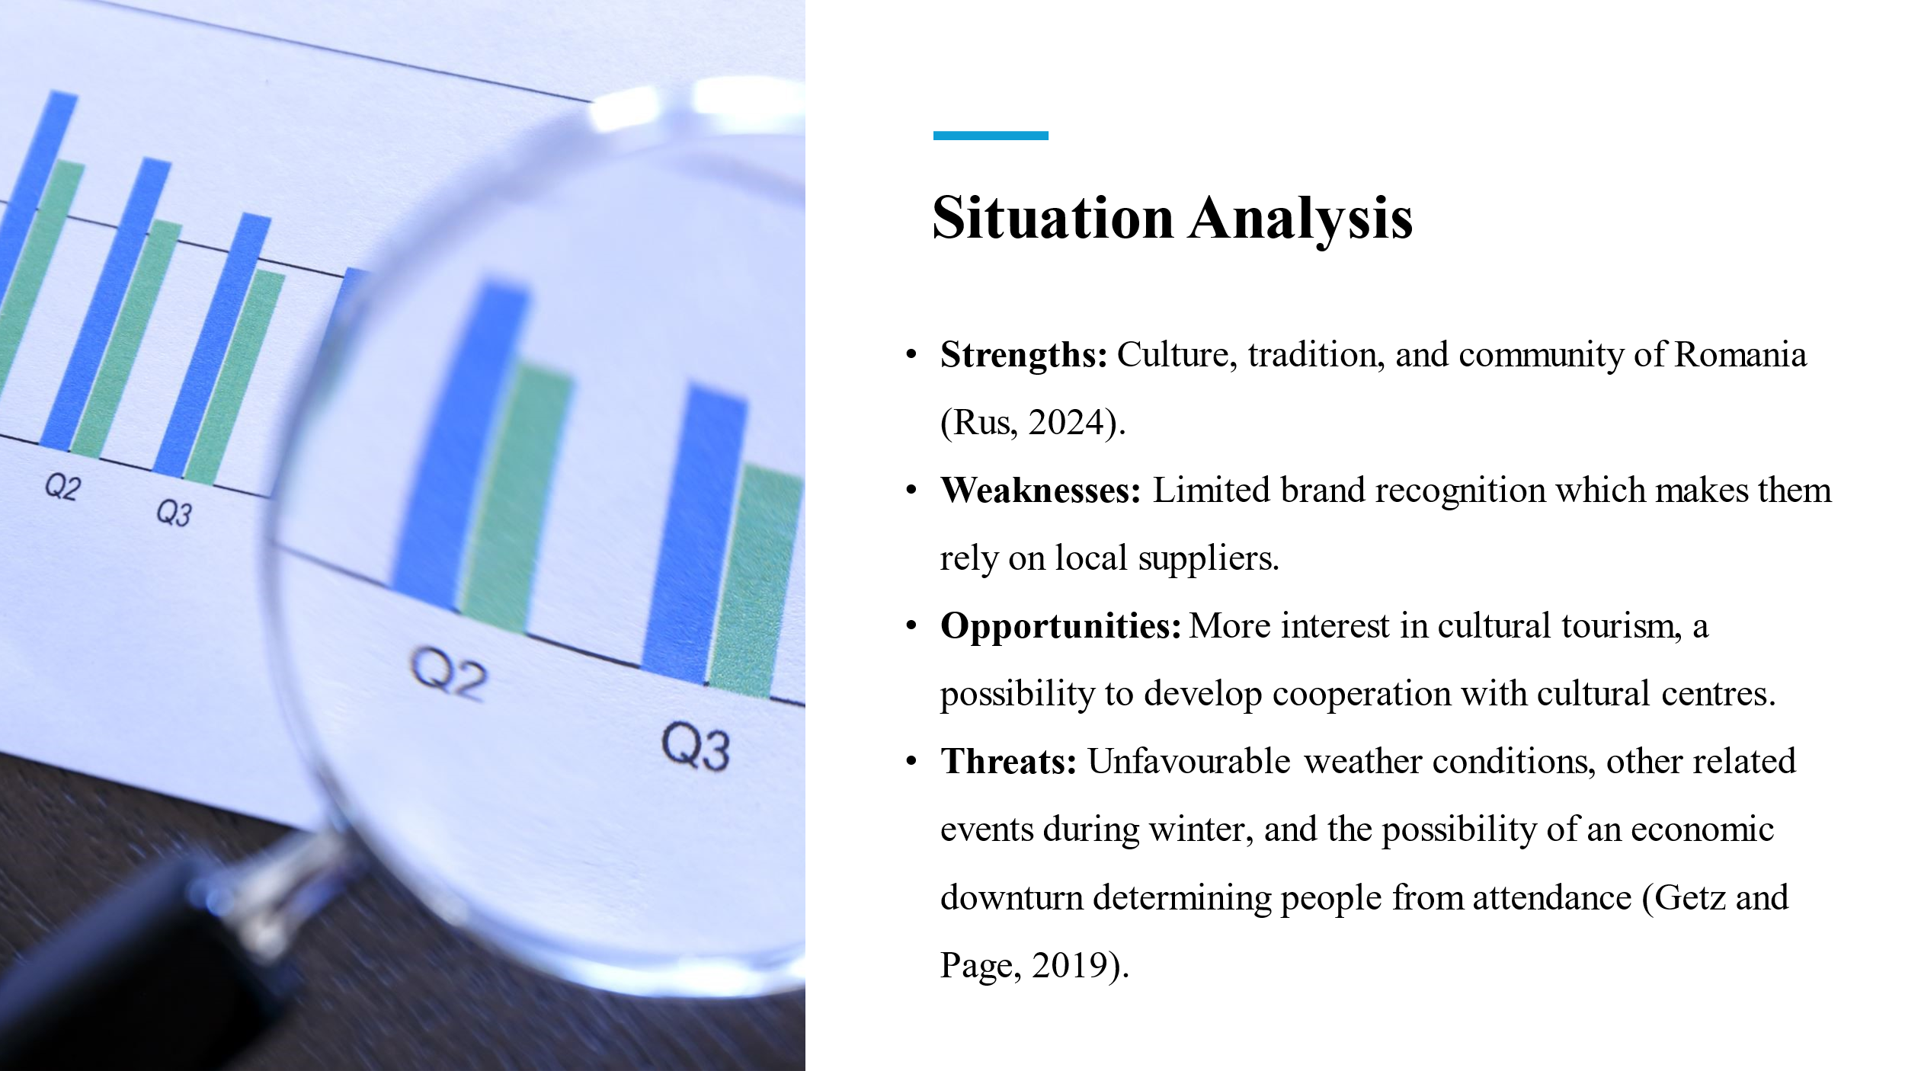

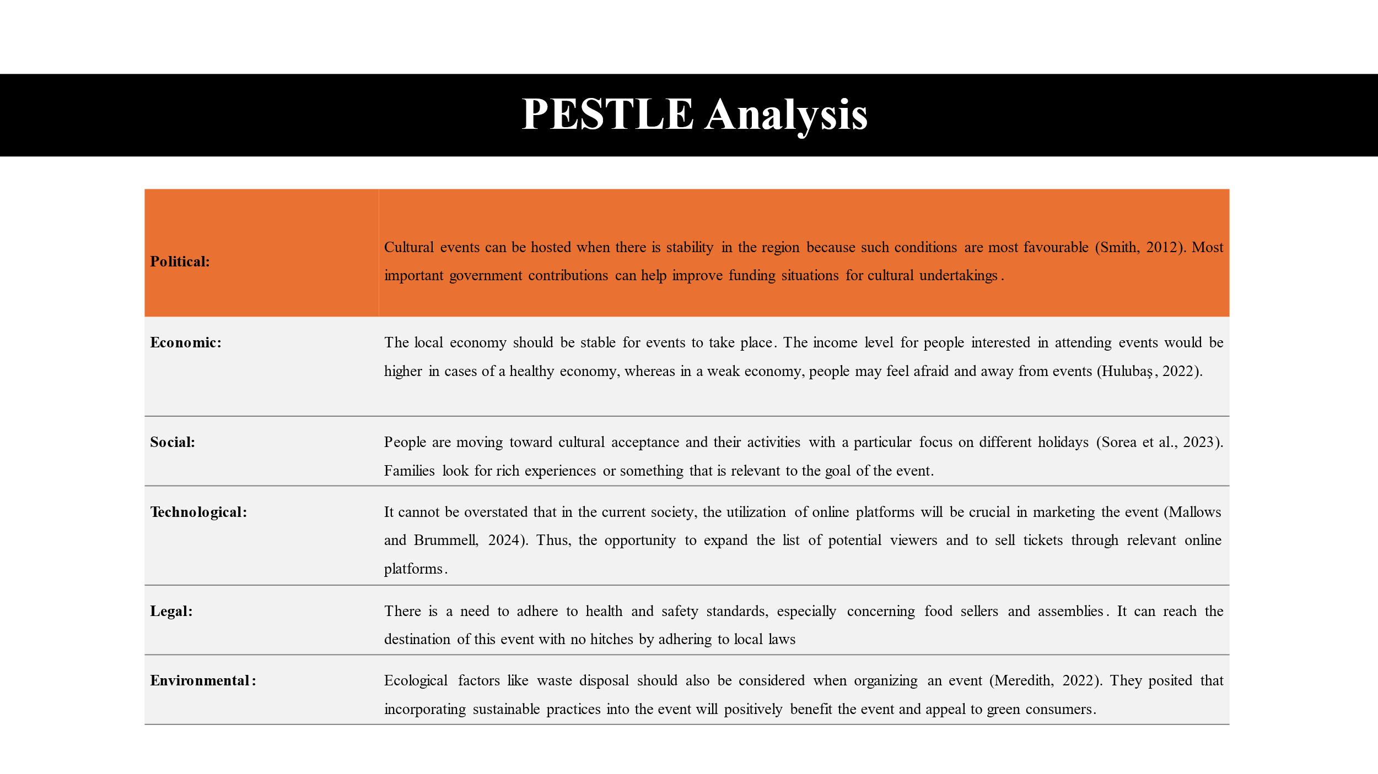

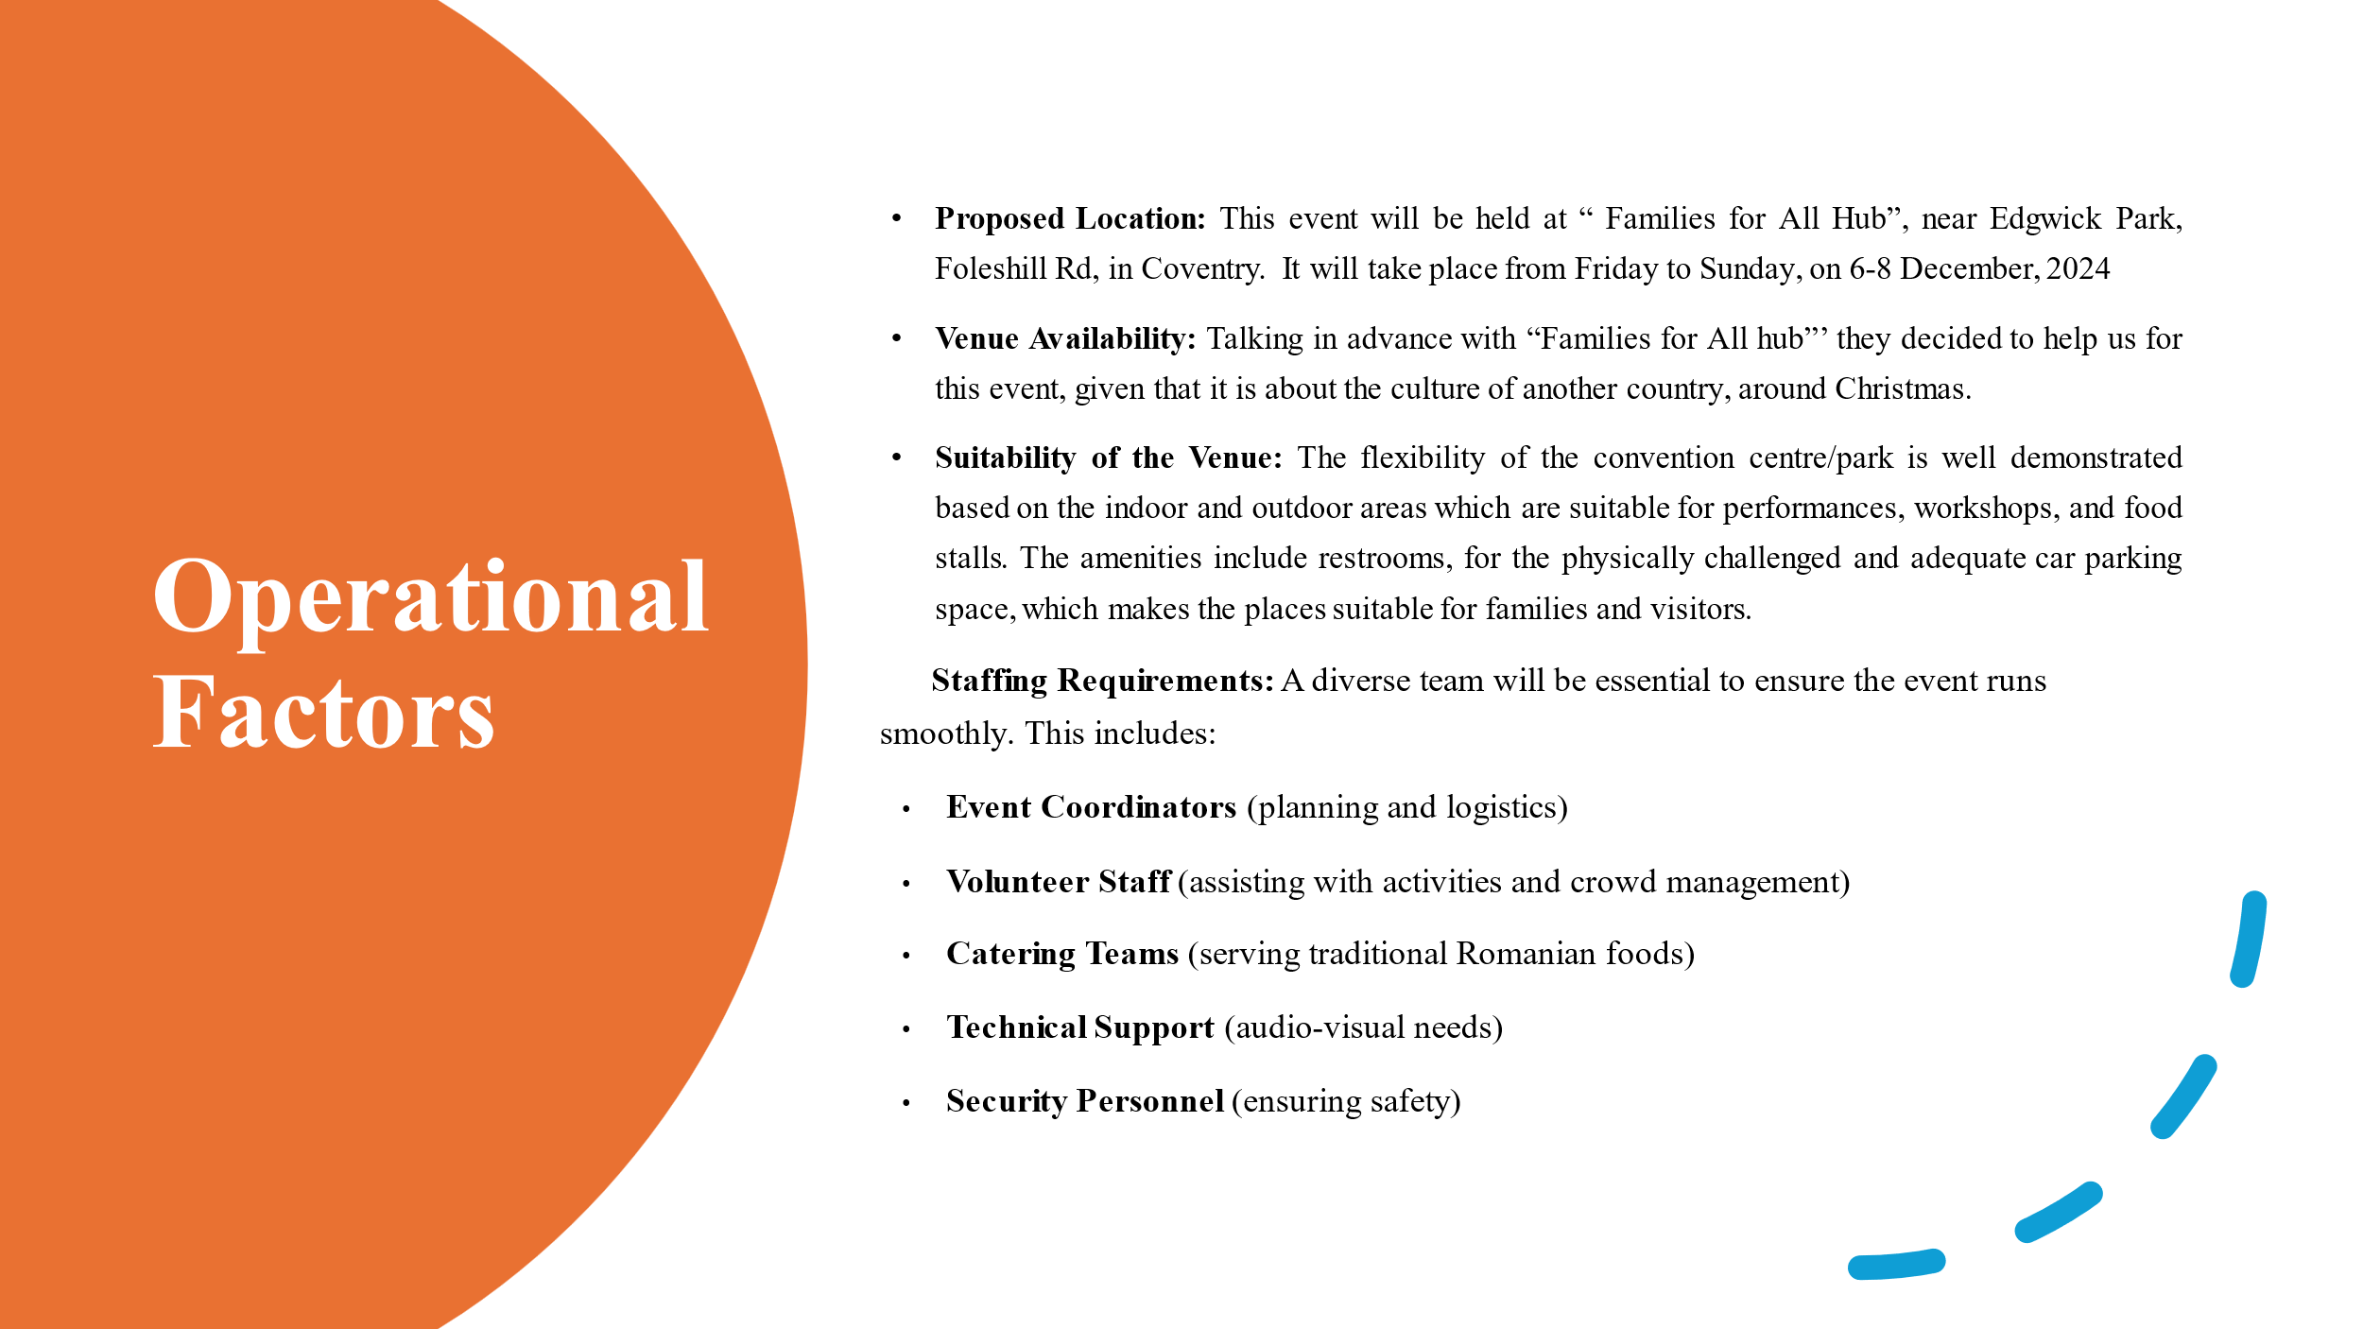

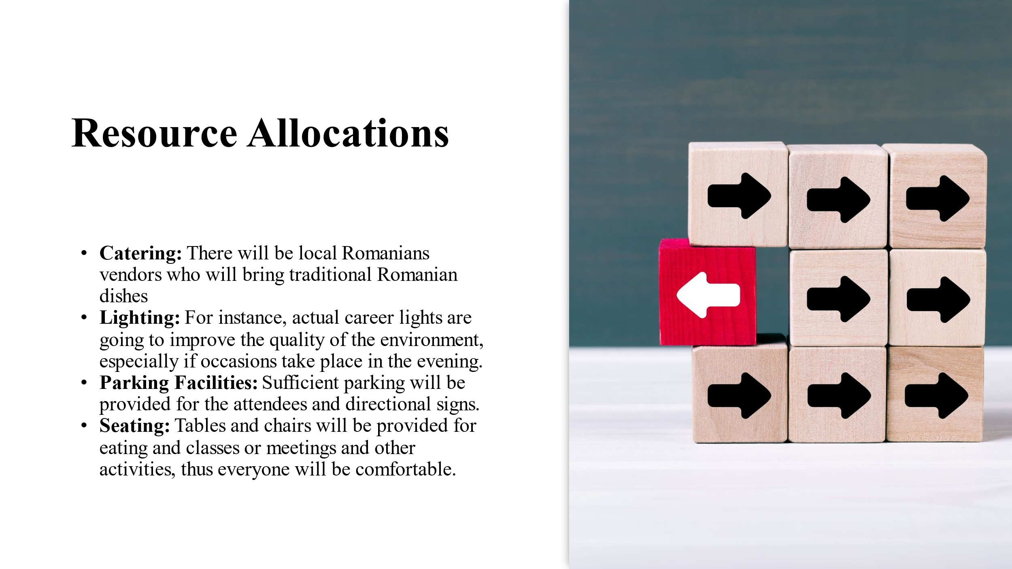

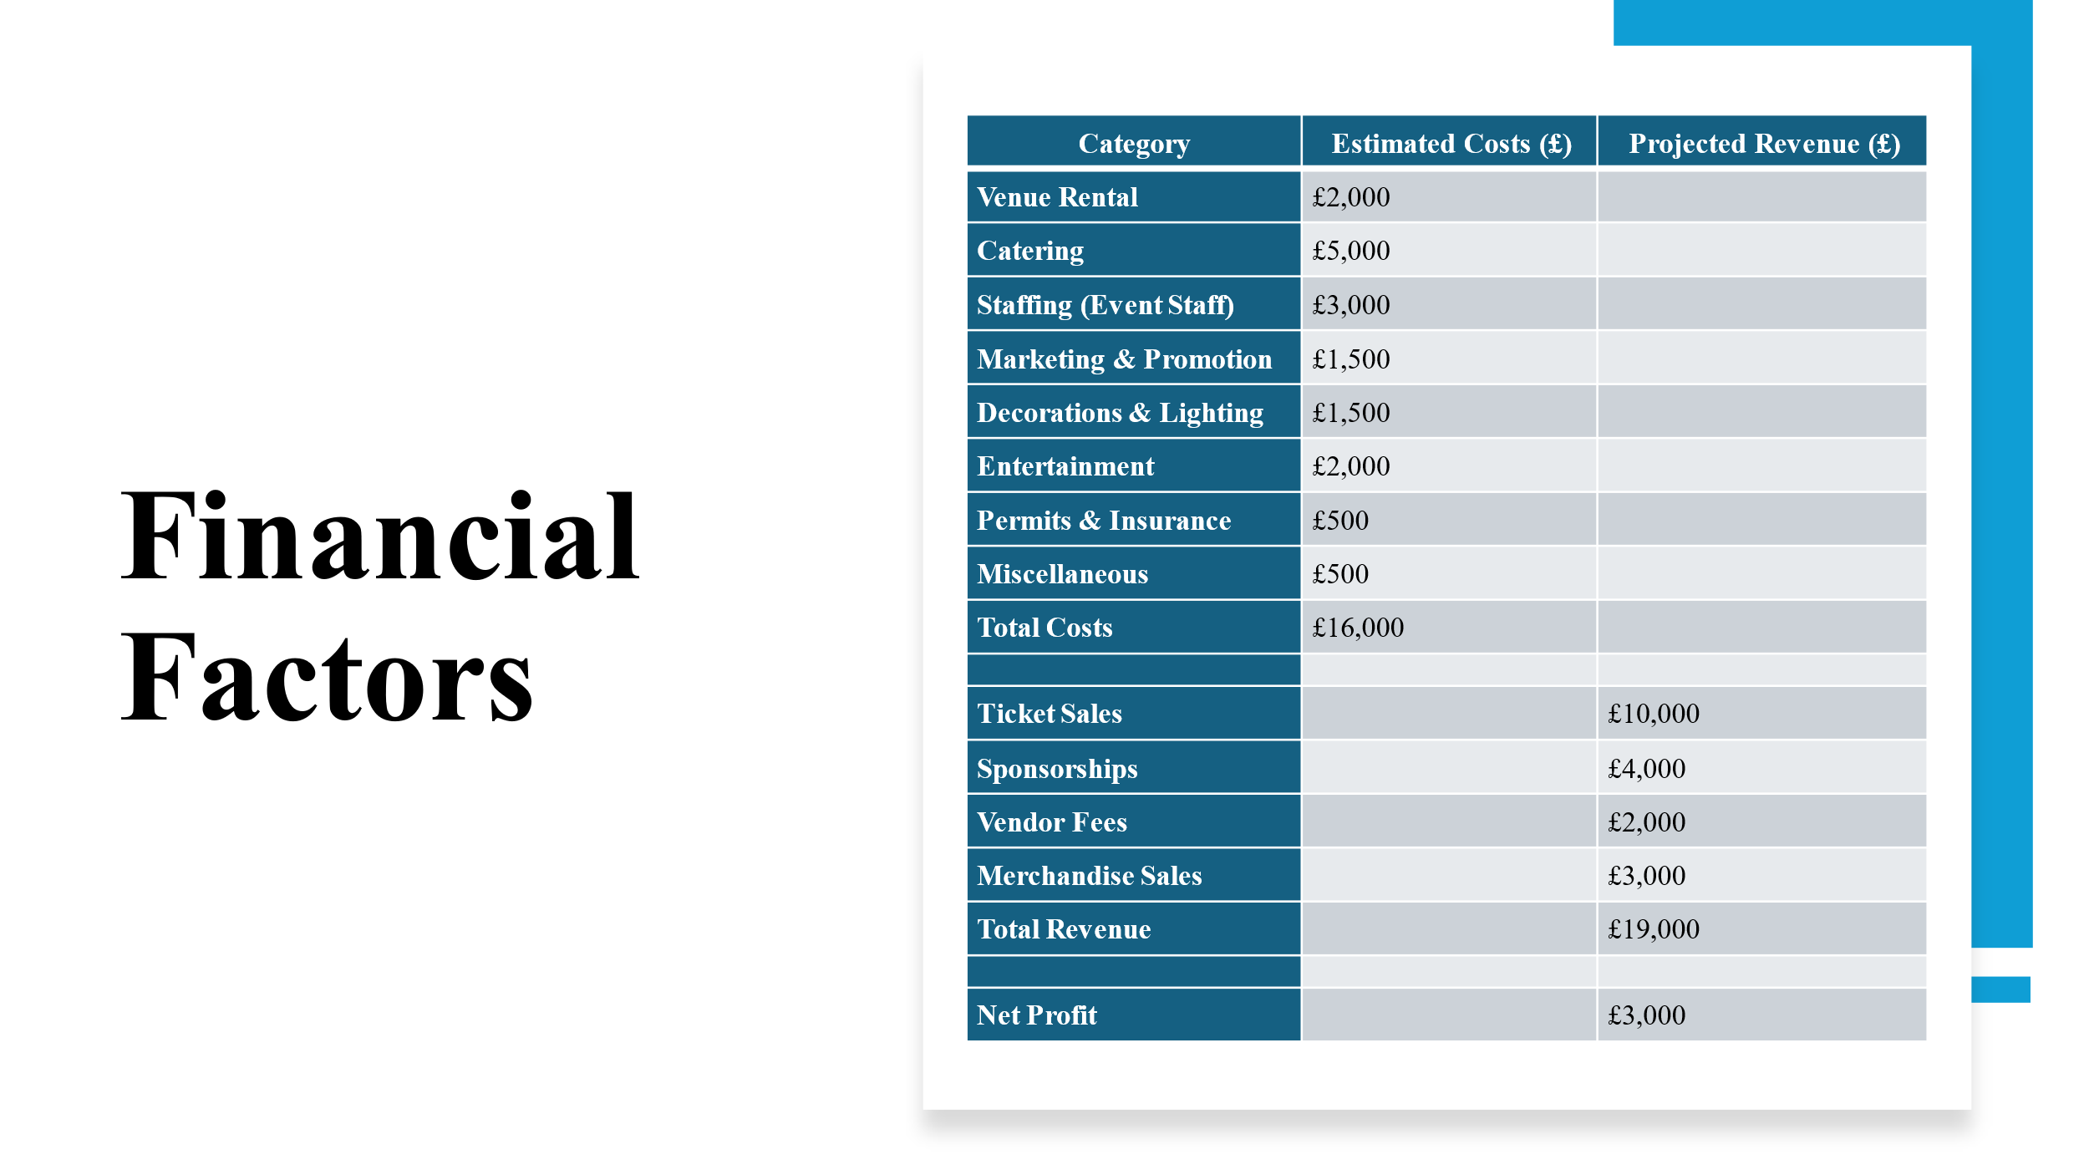

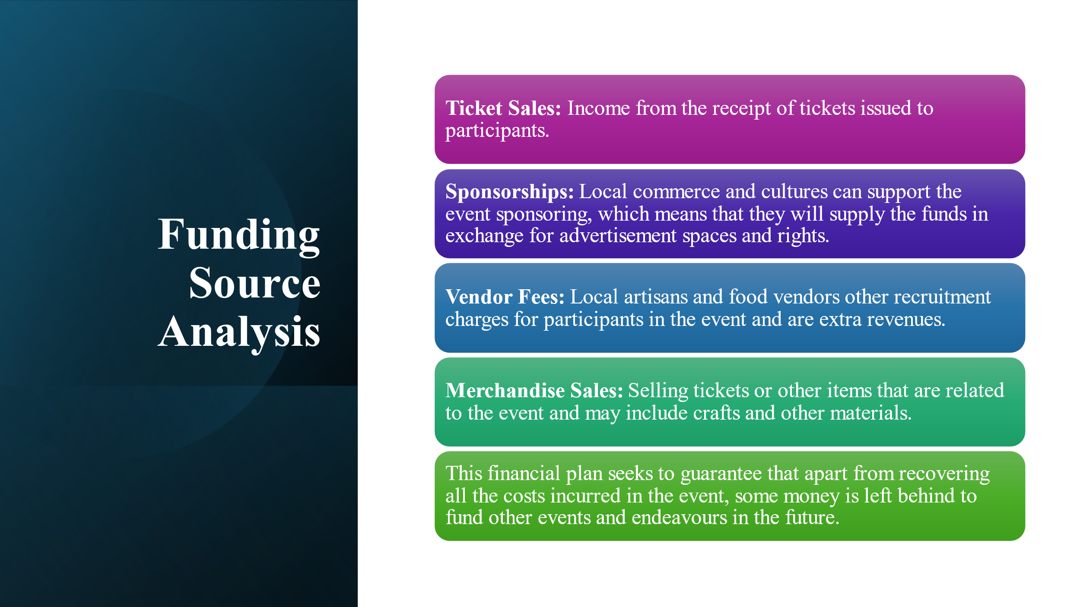

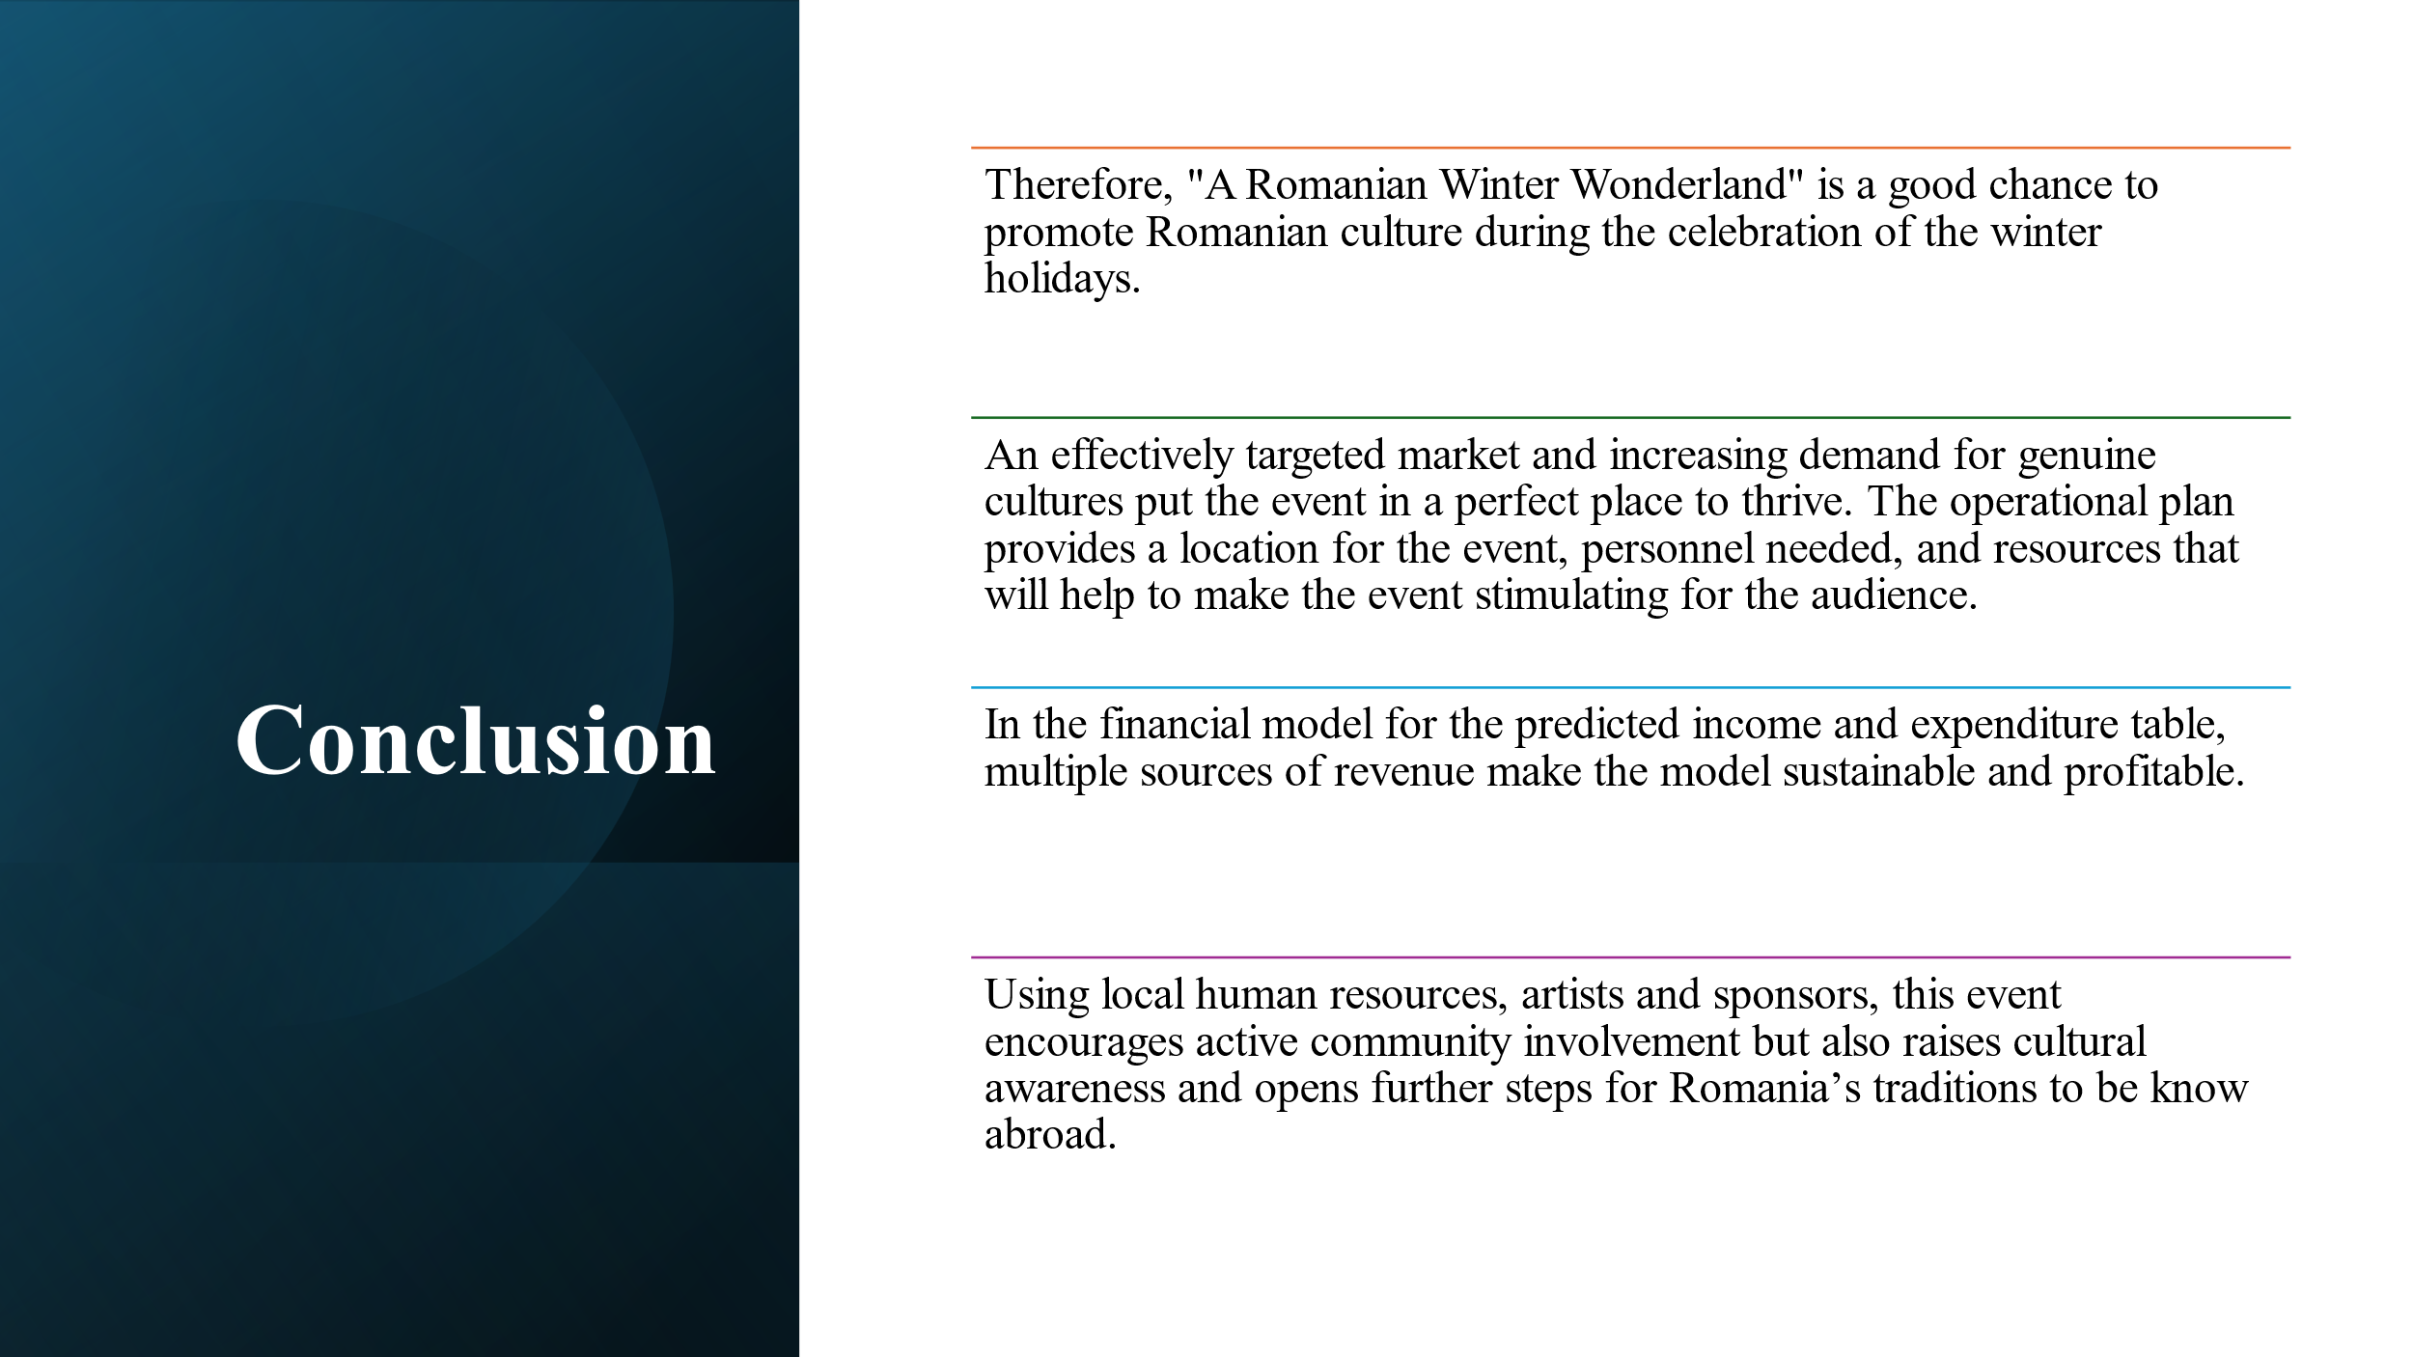

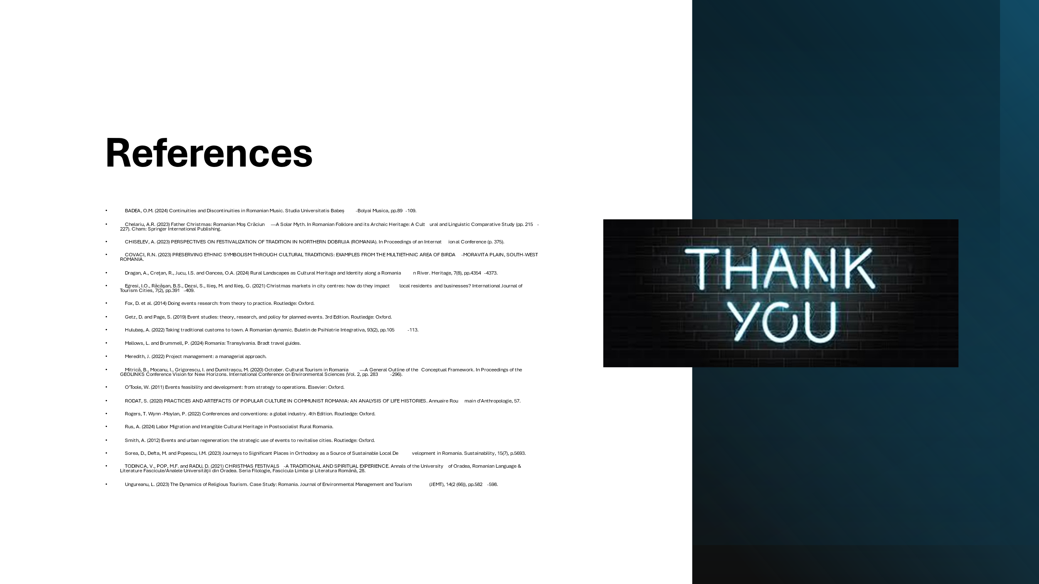

- BADEA, O.M. (2024) Continuities and Discontinuities in Romanian Music. Studia Universitatis Babeș-Bolyai Musica, pp.89-109.
- Chelariu, A.R. (2023) Father Christmas: Romanian Moş Crăciun—A Solar Myth. In Romanian Folklore and its Archaic Heritage: A Cultural and Linguistic Comparative Study (pp. 215-227). Cham: Springer International Publishing.
- CHISELEV, A. (2023) PERSPECTIVES ON FESTIVALIZATION OF TRADITION IN NORTHERN DOBRUJA (ROMANIA). In Proceedings of an International Conference (p. 375).
- COVACI, R.N. (2023) PRESERVING ETHNIC SYMBOLISM THROUGH CULTURAL TRADITIONS: EXAMPLES FROM THE MULTIETHNIC AREA OF BIRDA-MORAVITA PLAIN, SOUTH-WEST ROMANIA.
- Dragan, A., Creţan, R., Jucu, I.S. and Oancea, O.A. (2024) Rural Landscapes as Cultural Heritage and Identity along a Romanian River. Heritage, 7(8), pp.4354-4373.
- Egresi, I.O., Răcăşan, B.S., Dezsi, S., Ilieş, M. and Ilieş, G. (2021) Christmas markets in city centres: how do they impact local residents and businesses? International Journal of Tourism Cities, 7(2), pp.391-409.
- Fox, D. et al. (2014) Doing events research: from theory to practice. Routledge: Oxford.
- Getz, D. and Page, S. (2019) Event studies: theory, research, and policy for planned events. 3rd Edition. Routledge: Oxford.
- Hulubaş, A. (2022) Taking traditional customs to town. A Romanian dynamic. Buletin de Psihiatrie Integrativa, 93(2), pp.105-113.
- Mallows, L. and Brummell, P. (2024) Romania: Transylvania. Bradt travel guides.
- Meredith, J. (2022) Project management: a managerial approach.
- Mitrică, B., Mocanu, I., Grigorescu, I. and Dumitrașcu, M. (2020) October. Cultural Tourism in Romania—A General Outline of the Conceptual Framework. In Proceedings of the GEOLINKS Conference Vision for New Horizons. International Conference on Environmental Sciences (Vol. 2, pp. 283-296).
- O’Toole, W. (2011) Events feasibility and development: from strategy to operations. Elsevier: Oxford.
- RODAT, S. (2020) PRACTICES AND ARTEFACTS OF POPULAR CULTURE IN COMMUNIST ROMANIA: AN ANALYSIS OF LIFE HISTORIES. Annuaire Roumain d'Anthropologie, 57.
- Rogers, T. Wynn-Moylan, P. (2022) Conferences and conventions: a global industry. 4th Edition. Routledge: Oxford.
- Rus, A. (2024) Labor Migration and Intangible Cultural Heritage in Postsocialist Rural Romania.
- Smith, A. (2012) Events and urban regeneration: the strategic use of events to revitalise cities. Routledge: Oxford.
- Sorea, D., Defta, M. and Popescu, I.M. (2023) Journeys to Significant Places in Orthodoxy as a Source of Sustainable Local Development in Romania. Sustainability, 15(7), p.5693.
- TODINCA, V., POP, M.F. and RADU, D. (2021) CHRISTMAS FESTIVALS-A TRADITIONAL AND SPIRITUAL EXPERIENCE. Annals of the University of Oradea, Romanian Language & Literature Fascicule/Analele Universităţii din Oradea. Seria Filologie, Fascicula Limba şi Literatura Română, 28.
- Ungureanu, L. (2023) The Dynamics of Religious Tourism. Case Study: Romania. Journal of Environmental Management and Tourism (JEMT), 14(2 (66)), pp.582-598.

