How important the concept of authenticity is in the presentation of heritage
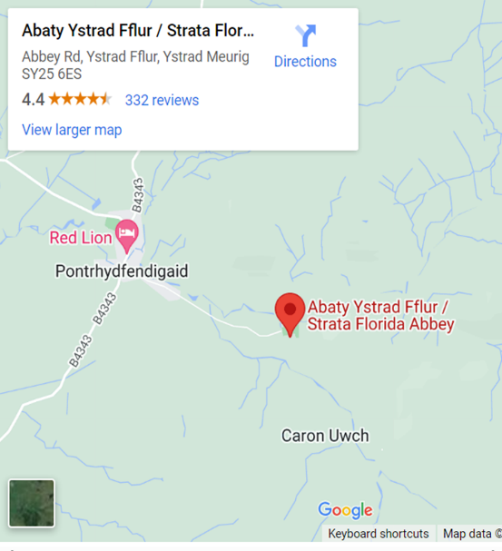
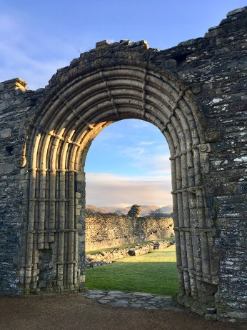
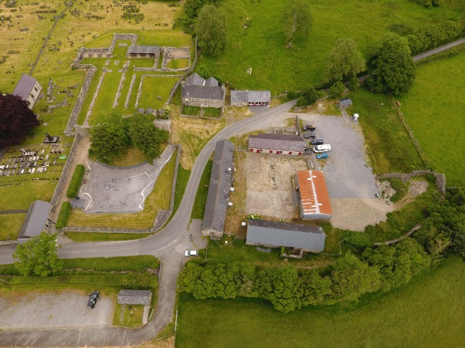
A concept is a general idea of sticking to an original plan or intention when considering a group of things from specific instances or events, and heritage is an embodiment of cultural traditions, beliefs, and customs passed down through the generations alongside legacies inherited from our ancestors. This essay will briefly examine some of the archaeological, philosophical and religious views on the concept of authenticity, using Strata Florida (Image1-3), a Cistercian abbey in Wales and its local inhabitants as its focus (Cadw, 2024b), the governing bodies responsible for looking after our heritage, dark tourism and why the way we feel about something, someone or somewhere matters and is crucial to its success. The Cambridge Dictionary defines authenticity as being ‘real’, ‘true’ or ‘genuine’, ‘the things that are what people say they are or what they appear to be,’ or because of a distinctive or historical link to a person, event or place’ (Cambridge dictionary, 2024a) and Barbara Wood from the National Trust describes authenticity as being “true to oneself or itself” (Wood, 2020). Debates on topics such as language and authenticity can cause bitter disputes when some groups or their opinions get left out. The way people remember history could influence their truth, self-image or connections to the area being portrayed, therefore all parties involved need to be included fairly and responsibly when presenting heritage (Gilmore and Pine, 2007, p.13; Silverman, 2015 p.71,72,74).
Image 2: Map location of Abaty Ystrad Fflur known as Strata Florida in English.
Abbey Rd, Ystrad Fflyr, Ystrad Meurig, SY25 6ES (The Strata Florida Trust, 2006c).
Image 1: The remaining ruins of Strata Florida abbey (The Strata Florida Trust, 2006b).
Image 3: An overview of Strata Florida containing centuries of archaeology and history (The Strata Florida Trust, 2006a).

John Ruskin, a conservationist who viewed art as an expression, argued that it was the evolution of such things as buildings over time that made them authentic. ‘He linked meaning to places and people through memory’ rather than the objects themselves or where they were housed, with a need to look after ‘places with memories’ due to the ‘construction of memory and history’ (Riskin Museum, 2024; Silverman, 2015, p.70-72,74). For people working in heritage, academics, interpreters, curators, managers, long-distance tourists and local communities, authentication is important and disregarding it can cause negative feelings, discomfort, guilt and segregation (Van-Gerven, Land-Zandstra and Damsma, 2018). Authenticity may be compromised on archaeological sites, Museums and any other place of difficult heritage. Prioritising what is in fashion, brings in the most visitors, generates the most money and assumed meanings could result in ‘ethnic and local differences’ that lead to a ‘separation between the people concerned and their cultural heritage’ (Macdonald, 2004; Silverman, 2015, p.83). Heritage covers natural and manmade spaces such as sites, Museums, buildings, languages, rare fish, animals, birds and their feeding grounds, along with many other things which are considered to have historical importance and therefore need protection and funding (Cambridge Dictionary, 2024b; Harrison, 2010, p.6,8).
The World Heritage United Nations Educational Scientific and Cultural Organisation (UNESCO) is an organisation that runs the International Council on Monuments and Sites (ICOMOS). UNESCO created the concept of World Heritage in 1972 to protect the Cultural and natural heritages of the World. In the UK it is the Department for Digital Culture, Media and Sports that acts as a state party responsible for putting a list of proposed nominations forward (Harrison, 2010, p.5). Here in Wales Cadw is the Welsh Government’s Historic Environment Service, making natural landscapes and sites safe and accessible, conserving the cultural heritage for future generations as well as making sure that the different authentic voices of the past and present are given fair exhibitions and presentations whilst creating global recognition, tourism, regeneration and education (Cadw, 2024c). Heritage studies combine a range of academic skills that include conceptual and philosophical links to tourism studies. Heritage tourism has to consider the context, aims and understanding of the history and stories being presented whilst managing questions linked to authenticity and identity (Macdonald, 2004). The level of authenticity required may depend on the setting, circumstances and experience sought after as to whether the related content needs to be original or just an authentic replication. Physical encounters with authentic museum objects are thought to promote curiosity and critical engagement far greater than replicas or digital recreations, especially for children who want to know the history surrounding the objects, creating a need for it to be considered when presenting heritage (Hyde and Harman 2011, p.15; Silverman, 2015; p 70.72; Van-Gerven, Land-Zandstra and Damsma, 2018).
During the Middle Ages, which began in approximately 476 A.D (Bishop, 2001, p.8) Medieval pilgrims travelled to meet, celebrate, and remember their spiritual dead in meaningful places (Roberts and Stone, 2014, p.9). Due to an increase in relics, more sacred parts of people turning up than they originally had, and many possessions belonging to iconic figures proclaiming to contain bodily fluids or possess healing powers, moving relics and re-burying remains led to religious reform and controversy. The French clergy aimed to defend the doctrines of the church rooted in history and tradition in the quest to preserve their faith. ‘Defenders of the Catholic faith were critical towards the aspects of the practice related to the supernatural, aiming to eradicate superstition and shield the church from accusations of fraud’. ‘Scholars within the church called for a reassessment of histories and hagiographies due to ‘scepticism and aversion’, maintaining that miracles confirmed the truth of revelation and the divine’. Protestants and sceptics tried to eradicate the events from the historical record that included extraordinary or weak miracles and the unlikely movements of relics, arguing that the 10th-11th century saints were inventions of monks and priests, who carried Saint's relics from village to village to extract money from people without calling the church's judgement into question. Investigations of human remains, funerary objects, engravings and other objects are expensive and require a wide range of experts, with many fearing the authenticity of ancient relics, they tried to leave them in place rather than risk upsetting people’s faith and questioning the true authenticity of their own beliefs (Haas, 2023, O’Praem,1996).
Cultural tourism which has evolved into heritage offers useful theoretical perspectives on dark tourism frameworks, experiences, and transactions with ‘the motivations of dark tourists possibly closely correlating those of heritage, pilgrimage and special interest tourists’ (Hyde and Harman 2011, p.11). The role of participating local and tourist communities in the development and designation of such sites is critical to ensuring its success and preventing damaging outcomes. ‘The challenge for dark or displaced heritage is to meet people’s needs and differences as a collective memory when presenting it’ (Silverman, 2015, p.70). Trying to understand the relationships between dying, death and mortality can be shocking and have a psychological impact, however, can also be a knowledgeable and meaningful experience with the potential to expand the imagination by embracing it rather than consuming it. Wales has both an opulent and stark history combined with diverse landscapes that can offer interesting sites for dark tourism (Roberts and Stone, 2014, p.11; Wales and its History, 2018; World Monument Fund, 2023).
Heritage presented through archaeology alone may not tell the whole story and by combining it with other disciplines such as science and new technology it can bring the past to life (Van-Gerven, Land-Zandstra and Damsma, 2018). How to identify or recognise something or someone through communication whether it be visual, verbal, electronic, through sound or feelings computer networks allow the Internet into all areas of people's lives, with data easily inputted and accessed, the risk of it being compromised is huge. There are different types of authentication required depending on who is using it, what risk it can pose and what kind of transaction is being made (Idrus, et. al., 2013). Whilst microscopy and new x-ray techniques can determine if an object is authentic or fake, technology such as Artificial Intelligence (AI) and Virtual reality (VR) can transport you back in time, place you at the scene, and be an open book of information with varying points of view through the documented changes of time. Although AI has caused credibility, trust, and image issues for some, it can also be beneficial and save time for businesses and organisations. The recording process of visual archives for cultural heritage has developed over time from the negatives kept by single organisations that have to be stored, treated, and maintained to keep them in their original state, to being stored on technology that can be shared around the world at the same time. Advancements in technology have aided in the authentication of objects as well as making the experience more authentic in the presentation of heritage (Park and Lim, 2013; Spencer, 2010, p.164; The Economist, 2021).
Strata Florida Abbey is a good example of an important spiritual, historical, and archaeological site that became a popular place of pilgrimage. Multiple agencies look after different parts of the development, requiring collaboration, discussion and agreement on strategies and plans of action to make it into a viable site that can be enjoyed by all that visit. Built on an earlier Iron Age and Celtic site, the former Cistercian abbey was founded in 1164 by Robert Fitz Stephen, the son of an Anglo-Norman constable of Windsor in England and Nest a Welsh Princess and daughter of the King of Deheubarth at the time. Deheubarth was an area of land in South-West Wales that was ruled by different Kings or Princes at different times, resulting in a divide, shrinkage, or growth of the included communities with each new change (Babcock, 1992, p.1-4,6-9,12-16). Strata Florida was built on land given to Robert Fitz Stephen by the English King after his help during a successful invasion of Ireland which also led to some Irish families fleeing to parts of Wales. Over a short time, the abbey’s Cistercian dwellers unruly behaviour and inability to extract money from the locals annoyed King Edward I, who then sent men to attack the abbey, leaving it damaged. Lord Rhys or Rhys ap Gruffydd who assumed patronage of the monastery was a descendant of Hywel Dda (Hywel the good/great). A ruling Prince of Deheubarth the kingdom that covered Ceredigion, Ystrad Tywi and Dyfed for more than forty years, Lord Rhys was commonly or purposely mistaken as the founder of Strata Florida due to his national, social, and political journey through the battles he fought, his connections to the people and most of all his financial input into the surrounding areas, preserving the memories of what he had achieved. The Black Death ravaged the area's local population and during Owain Glyndŵr’s rebellion, Strata Florida was taken over by English troops trying to regain control of the uprising. By 1539 Henry VIII had devolved the monasteries and Strata Florida was partially dismantled, starting with the lead being stolen and then some of the stone, which the locals repurposed, leaving the abbey to fall into disrepair. In 1887 when archaeologist Stephen Williams started excavating the site it attracted many Victorian tourists. Due to being one of the few places in West Wales at the time that had people educated enough to read and write many of the Welsh language historical texts were also created there. “The bards of Wales” were poetic, musical, and could tell a good tale which made them popular at events and ceremonies to entertain guests. Dafydd ap Gwilym one of the medieval Welsh poets is said to be buried in the churchyard at Strata Florida and the beauty of the area has attracted artists from all over the world for inspiration from the mystical lands. Over the centuries the poorer members of the community living in Wales may not have had much in the way of education or financial security, but they did have an abundance of water, wildlife, music, poetry, and each other and fought to protect every inch of it (Cadw, 2024a; Mitchell, 2016). The site itself has several owners, Cadw, the Welsh Government’s historic environment service, who care for the monument; the Parish Council and Pantyfedwen Strata Churchyard Trust, who own the car park and graveyard; the Strata Florida Trust, which has acquired the farmyard, seventeenth-century gardens, and gentry house that originally served as the monastic refectory and neighbouring farmers who own and manage the surrounding land. In 2016, the World Monuments Fund and WMF Britain announced a partnership with Strata Florida Trust to conserve the ancient buildings and implement activities to create a sustainable community asset. In 2018, the site was selected by The Prince’s Foundation as one of several heritage projects to be supported in celebration of Prince Charles’ 70th birthday. This provided the development of a conservation management plan, structural emergency repairs to the abbey farm buildings, renovation of the cattle sheds, research, archaeological excavation, and oral history documentation. The business plan recommended that Strata Florida is best placed to develop as a cultural centre for Welsh Heritage, networked with other tourism and access networks across Mid-Wales. The National Lottery Heritage Fund supported the restoration of the bakehouse, which was completed in 2021, giving Strata Florida a public exhibition venue and a presentation space to highlight Welsh rural life (World Monuments Fund, 2023).

The buildings themselves are of great beauty with secret codes and messages embedded in their walls, floors, and history (Giliberto, 2021; Taylor, 2004; World Monuments Fund, 2023), they are in a beautiful landscape that promotes health and well-being. However, underneath the beauty is a tale of suffering, persecution and crushed local identities that caused bitter disputes that caused one part of Wales to destroy another under the rule of multiple Welsh Kings and Princes, who had tried to protect and secure the land they were given or had taken after successful battles (Wales and its History, 2018). Whilst the Roman Catholics in England and Wales were doing one thing the higher-class people of Wales were doing another and the poorer members of the community doing all the hard manual labour and living in sub-standard accommodations were secretly still practising their original faiths until they were either wiped out or made to convert. Most of the original chapels in West Wales were the equivalent size and condition of an old and small garden shed or were in converted parts of an existing building of work such as a mill or farm and were not spectacular to look at like the more favoured Cistercian abbeys, which led to some Welsh priests conducting their sermons outside as Catholic places of worship were being locked up to stop them practising their Welsh oral services that were thought to be linked to witchcraft and heresy in the minds of the King of England and his academic and military followers (Gray, 2024; Llanwenog). In Strata Florida they now provide an Archaeology Field school, have coffee mornings, talks on the Cistercians in Wales, foraging expeditions, walking festivals, and workshops exploring Strata Florida’s history through creative writing, printing the Welsh Language and Night Photography all with leading experts in their field. Offering a varied range of activities that include a balanced taste of What Wales has to offer, the struggles and losses it has been through and access to the free and inventive minds, which have shaped the overall views of its inhabitants through the changes made over time (Strata Florida, 2024). Miss-representing the conditions of the time and replacing them with alternative versions of what they thought might have happened can completely distort the truth to the point that reality is forgotten and replaced. Stories that were combined over time or translated wrong and an uneducated population left little trustworthy or reliable evidence in Wales (Krill, 2014; Park and Lim, 2013). There were constant battles between the locals and any outsiders often fighting with the tools they had to hand, many of whom lost their lives leaving widowed mothers who had to make gloves and socks for the poor and to sell at fairs to be able to feed their children. The land best suited for sheep which had been the constant breed more commonly known in the area provided a source of food and income that helped the communities survive alongside cows and even some pigs (Wales and its History, 2018; Young, 2017). With relatives of those who lost their lives still farming some of the land handed down through generations of inheritance, death, re-marriage, and children with different fathers, that often led to Wales becoming a harsh and dangerous place to enter at times, How something is presented can trigger positive or negative reactions, it is about working with those groups involved to accommodate everyone’s feelings and concerns to make the area enjoyable for all who wish to go there.
You cannot change the past, but you can give it a voice. The development of technology such as AI opens up a chance for authenticity to be created in cheaper more economical ways to engage people's minds, bodies, and souls. Being mindful of other people's views can create a more pleasant experience for all rather than the select few, resulting in a more inclusive and engaged audience who are more likely to return or recommend it to others. Relying on the financial viability and the ability to sustain funds to support the upkeep, information, tourist management and future of the historical sites or landscapes.
in West Wales their philosophy was not about where you came from, as Wales had nearly always been a blended community, if you were willing to get stuck in, learn the language, and not steal anything or kill them you could become part of their community.

References:
Babcock, R.S., 1992. Rule and society in south-west Wales, 1079-1197. University of California, Santa Barbara.

Bishop, M., 2001. The Middle Ages. Houghton Mifflin Harcourt.
Cadw, 2024a. “Strata Florida Abbey”. Cadw. [Online] Available At: https://cadw.gov.wales/visit/places-to-visit/strata-florida-abbey (Accessed 15-03-2024).
Cadw, 2024b. “Monasteries and Abbeys”. Cadw. [Online] Available At: https://cadw.gov.wales/visit/best-history/monasteries-abbeys (Accessed 15-03-2024).
Cadw, 2024c. World Heritage Sites. “Understanding World Heritage Sites in Wales”. Cadw [Online] Available At: https://cadw.gov.wales/advice-support/historic-assets/conservation-areas-other-historic-assets/other-historic-assets/world#section-introduction (Accessed 15-03-2024).
Cambridge Dictionary, 2024a. “Being what it appears to be”. [Online] Available At: https://dictionary.cambridge.org/thesaurus/articles/being-what-it-appears-to-be (Accessed 05-03-2024).
Cambridge Dictionary, 2024b. “Heritage” English meaning. [Online] Available At: https://dictionary.cambridge.org/dictionary/english/heritage (Accessed 05-03-2024).
Giliberto, F., 2021. “Heritage And Our Sustainable Future: Using Digital Technologies to Innovate in Heritage Research, Policy, and Practice”. University of Leeds. [Online] Available At: https://www.changingthestory.leeds.ac.uk/wp-content/uploads/sites/110/2021/10/Using-Digital-Technology-to-Innovate-Brief-Report.pdf (Accessed 06-03-2024).
Gilmore, J.H. and Pine, B.J., 2007. Authenticity: What consumers really want. Harvard Business Press.
Gray, M., 2024. “The Cistercian Way, National Churches Trust”. [Online] Available At: https://www.nationalchurchestrust.org/explore/trail/cistercian-way-wales (Accessed 15-03-2024).
Haas, A.C., 2023. Popular Religious Practice in the Eighteenth Century. The Routledge Handbook of French History.
Harrison, R., 2010. What is heritage? Understanding the politics of heritage, 9.
Historic England, 2021. “Materials for Historic Building Repairs”. Historic England. [Online] Available At: https://historicengland.org.uk/advice/technical-advice/buildings/building-materials-for-historic-buildings/ (Accessed 20-03-2024).
Hyde, K.F. and Harman, S., 2011. Motives for a secular pilgrimage to the Gallipoli battlefields. Tourism Management, 32 6,1343-1351.
Idrus, S.Z.S., Cherrier, E., Rosenberger, C. and Schwartzmann, J.J., 2013. A review of authentication methods. Australian Journal of Basic and Applied Sciences, 7 5, 95-107.
Krill, J., 2014. “Report on manuscripts in the Welsh Language: Great Britain. Royal Commission on Historical Manuscripts” Getty Research Institute. [Online] Available At: https://archive.org/details/reportonmanuscri22grea/page/n3/mode/1up (Accessed 16-03-2024).
Macdonald, S., 2004. A people's story: Heritage, Identity, and Authenticity in Heritage, Museums and Galleries. Routledge. 299-319.
O’Praem, H.B., 1996. “Authenticity of Relics”. Relics Catholic Q&A. [Online] Available At: https://www.catholic.com/qa/authenticity-of-relics, (Accessed 05-03-2024).
Park, B.E., and Lim, D.G., 2013. Recording process of visual archive for cultural heritage. International Journal of Multimedia and Ubiquitous Engineering, 8 6, 397-406.
Riddle, J.M., 2008. A history of the Middle Ages, 300–1500. Rowman & Littlefield Publishers.

Riskin Museum, 2024. “Who was John Riskin? (1890-1900)”. Riskin Museum. [Online] Available At: https://ruskinmuseum.com/who-was-john-ruskin-1819-1900/ (Accessed 15-03-2024).
Roberts, C. and Stone, P.R., 2014. Dark tourism and dark heritage: Emergent themes, issues, and consequences. Displaced heritage: Responses to disaster, trauma, and loss, 9-18.
Silverman, H., 2015. Heritage and authenticity. In The Palgrave handbook of contemporary heritage research. London: Palgrave Macmillan UK. 69-88.
Spencer, S., 2010. Visual research methods in the social sciences: Awakening visions. Routledge.

Strata Florida, 2024. “Courses and events”. Strata Florida. [Online] Available At: https://www.strataflorida.org.uk/courses-and-events.html (Accessed 15-03-2024).
Taylor, R., 2004. How to read a church: An illustrated guide to images, symbols and meanings in churches and cathedrals. Random House.
The Economist, 2021. “New tools are making it easier to authenticate paintings”. Economist.com. [Online] Available At: https://www.economist.com/books-and-arts/2021/01/07/new-tools-are-making-it-easier-to-authenticate-paintings (Accessed 05-03-2024).
The Strata Florida Trust, 2006a. “About” (Image 3). Strata Florida [Online] Available At: https://www.strataflorida.org.uk/about.html (Accessed 25-03-2024).
The Strata Florida Trust, 2006b. “Home: A Welsh Icon in a Sacred Landscape” (Image 1). Strata Florida. [Online] Available At: https://www.strataflorida.org.uk/ (Accessed 25-03-2024).
The Strata Florida Trust, 2006c. “Visit Us” (Image 2). Strata Florida [Online] Available At: https://www.strataflorida.org.uk/visit-us.html (Accessed 25-03-2024).
Van-Gerven, D., Land-Zandstra, A. and Damsma, W., 2018. Authenticity matters: Children look beyond appearances in their appreciation of museum objects. International Journal of Science Education, Part B, 8 4, 325-339.
Wales and its History, 2018. “Welsh Battles, Wars and Rebellions from 616 to 1409” Blog [Online] Available At: https://walesanditshistory.blogspot.com/2018/08/updated-welsh-battles-wars-and.html (Accessed 14-03-2024).
Wood B., 2020. “A Review of the Concept of Authenticity in Heritage, with Particular Reference to Historic Houses”. Sagepub.com. [Online] Available At: https://journals.sagepub.com/doi/full/10.1177/1550190620904798 (Accessed 05-03-2024).
World Monuments Fund, 2023. “Strata Florida, Ystrad Meurig, Wales, Site History, and significance”. WMF [Online] Available At: https://www.wmf.org/project/strata-florida (Accessed 01-03-2024).
Young, A., 2017. “A Vision of Britain Through Time, 1776 Tour of South Wales and South Midlands”. [Online] Available At: https://www.visionofbritain.org.uk/travellers/Young/1#header (Accessed 15-03-2024).

