University of Wales Trinity Saint David
2025

Computational Methods
ACMA6012

2D Diffusion Equation model using the Explicit Finite Difference Method
(Report)

BEng Mechanical Engineering

Gavin Williams
Date: 26/01/2025
Word count: 3385

Table of Contents
List of Figures 3
List of Equations 4
1. Introduction 5
2. Constitutive equation of the problem. 6
3. Explicit finite difference form of the constitutive equation 7
3.1 Taylor Series 7
3.2 Explicit Finite Difference method 8
3.3 Spatial discretisation 8
3.4 Temporal discretisation 9
3.5 Explicit finite difference linear equation 10
4. Initial boundary conditions implemented 12
4.1 Analytical solution 13
5. Codes’ detail and explanation 14
6. Validation of the code 19
7. Sensitivity analysis of code results 21
7.1 Grid spacing, 21
7.2 The time step, 22
7.3 Thermal equilibrium tolerance. 23
8. Limitations discussion 24
8.1 Limitations due to the Numerical Method: 24
8.2 Limitations due to the coding: 24
9. Suggested improvements 25
10. Conclusion 26
References 27
Appendix: 29
Code: 29

List of Figures
Figure 1: Taylor series formula (Croft & Lilley., 1977). 7
Figure 2: Spatial discretisation 9
Figure 3: Explicit finite difference form of the heat equation 11
Figure 4: Initial Boundary Conditions 12
Figure 5: Formula for Analytical solution (Kazakov et al., 2020). 13
Figure 6: Command Window reset 14
Figure 7: Format 14
Figure 8: User Inputs specified for calculation 14
Figure 9: Thermal diffusivity equation 14
Figure 10: User Inputs specified for grid dimensions and grid spacing 15
Figure 11: User Inputs must satisfy the code for assurances of accurate approximation 15
Figure 12: Calculation of grid points for matrix 15
Figure 13: Boundary conditions 15
Figure 14: Time step input 16
Figure 15: Initialisation of temperature matrix two and calculation of Fourier’s number for temperature approximation at future steps. 16
Figure 16: Explicit finite difference equation 16
Figure 17: Colour map 17
Figure 18: Code for time to reach thermal equilibrium 17
Figure 19: Analytical solution 18
Figure 20: Absolute difference between analytical solution and numerical solution 18
Figure 21: Numerical temperature matrix at thermal equilibrium 19
Figure 22: Analytical temperature matrix at thermal equilibrium 19
Figure 23: Absolute difference between analytical solution and numerical solution 19
Figure 24: Temperature colour maps 20
Figure 25: Graph showing thermal equilibrium in seconds with respect to grid spacing (h) 21
Figure 26: Table of grid spacing used to show optimal thermal equilibrium results 21
Figure 27: Graph showing thermal equilibrium in seconds with respect to the time step (dt) input 22
Figure 28: Table of grid spacing used to show optimal thermal equilibrium results 22
Figure 29: Graph showing thermal equilibrium in seconds with respect to the convergence criterion (CCT) 23
Figure 30: Table of grid spacing used to show optimal thermal equilibrium results 23

List of Equations
Equation 2-1: Heat Equation (Croft & Lilley, 1977). 6
Equation 3-1: Taylor series forward approximation formula (Croft & Lilley., 1977). 7
Equation 3-2: Taylor series backward approximation formula (Croft & Lilley., 1977). 7
Equation 3-3: Taylor series central formula (Croft & Lilley., 1977). 7
Equation 3-4: Taylor series central difference 2nd derivative formula (Croft & Lilley., 1977). 8
Equation 3-5: Spatial discretisation in the $x$ direction (Croft & Lilley., 1977). 9
Equation 3-6: Spatial discretisation in the $y$ direction (Croft & Lilley., 1977). 9
Equation 3-7: Temporal discretisation, approximate first derivative by forward difference 9
Equation 3-8: Fouriers number (Stein & Shakarchi., 2011). 10
Equation 3-9: Derivations of the heat equation 10
Equation 3-10: Derivations of the heat equation 10
Equation 3-11: Derivations of the heat equation 10
Equation 3-12: Derivations of the heat equation 10
Equation 3-13: Derivations of the heat equation 11
Equation 3-14: Stability criterion 11

Introduction

The heat transfer equation is a fundamental aspect of thermal analysis in two-dimensional geometries. This report investigates the application of the Explicit Finite Difference Method (FDM) to solve this equation (Yuste, 2006), focusing on the numerical derivations and the use of Taylor series approximations. A MATLAB code is developed to simulate thermal equilibrium, serving as the core tool for this analysis. The primary aim is to validate the numerical model by comparing it with analytical solutions, thus assessing its overall accuracy (Recktenwald, 2004). Key objectives include analysing the impact of spatial and temporal discretisation on the model's performance, understanding stability criteria, and identifying the limitations of the current numerical methods (Chapra, 2023). This report also seeks to provide practical recommendations for improving the reliability and efficiency of the FDM approach in solving heat transfer problems. By addressing truncation, round-off errors, and stability constraints, the study aims to enhance the practical application of the FDM in real-world scenarios (Teixeira, Reynolds & Judd, 2007). This investigation aims to signify the importance of numerical methods backed by analytical solutions in accurately modelling heat transfer and to offer insights into optimising these methods for engineering applications.

Constitutive equation of the problem.
The governing equation for this report is the study of the heat equation. A partial differential equation that describes the heat distribution in each region over a period. The heat equation is vital for studying heat transfer, conduction, and thermal analysis in different and various materials. The heat equation is known to be a foundation milestone for mathematical physics. Its capabilities allow for accurate measurements and temperature distribution calculations, enabling efficient thermal systems and simulations for complex processes in many industries (Huntul, 2020).
The heat equation was found in research by Jean-Baptiste Joseph Fourier in the early 19th century. He calculated and demonstrated that heat conduction could be utilised and examined mathematically through a series of equations known as Fourier's Law. His work has been adapted over the years, contributing to more highly complex math problems with thermal properties (Widder, 1976; Narasimhan, 1999).
Mathematically, for a two-dimensional (2D) geometry with no heat source, the equation is given

$$\frac{ⅆ^{2}T}{ⅆx^{2}}+\frac{∂^{2}T}{∂y^{2}}=\frac{1}{a}\frac{∂T}{∂t}$$
Equation 2-1: Heat Equation (Croft & Lilley, 1977).
As seen in Equation 2-1, the heat equation describes the conservation of energy in a certain material where heat is conducted without any heat presented within the system. The heat equation is critical for predicting highly accurate heat distribution through thermal processes (Bergman et al., 2011).
T is the temperature
x,y: act as spatial coordinates
$∂T/∂t:$ is the rate of change in respect to time
$a$: is the thermal diffusivity, which is defined within the material property.
$a=\frac{k}{p_{C}}$
k= Thermal Conductivity [W.m^-1.K^-1]
p= Density [kg.m^-3]
c= Specific Heat [J.kg^-1.K^-1]

Explicit finite difference form of the constitutive equation
The finite difference method numerically solves heat transfer equations by discretising the domain into grid points. It replaces the partial differential equations with the finite difference equations, changing the problem in a system of algebraic equations. This method calculates the temperature distribution. Therefore, it is a valuable tool engineers use in many heat and thermal analysis applications (Recktenwald, 2004).

3.1 Taylor Series
The Taylor series uses terms involving the function's derivative at a specific point. This series allows for precise representation of functions as polynomials. This makes it useful for approximating values and solving differential equations at a specific point (Croft & Lilley, 1977; Ghosh, Deb & Sarkar, 2016).

Figure 1: Taylor series formula (Croft & Lilley., 1977).
The Taylor series formula is used to approximate a function $f\left(x\right)$ around the specific grid location $x_{0}$ Using the derivatives at that given point.

$$f^{'}\left(x_{0}\right)=\frac{+\left(x_{0}+h\right)-f\left(x_{0}\right)}{h}+O\left(h\right)$$
Equation 3-1: Taylor series forward approximation formula (Croft & Lilley., 1977).

$$f^{'}\left(x_{0}\right)=\frac{f\left(x_{0}\right)-f\left(x_{0}-h\right)}{h}+O\left(h\right)$$
Equation 3-2: Taylor series backward approximation formula (Croft & Lilley., 1977).

$$f^{'}\left(x_{0}\right)=\frac{f\left(x_{0}+h\right)-f\left(x_{0}-h\right)}{2⋅h}+o\left(h\right)$$
Equation 3-3: Taylor series central formula (Croft & Lilley., 1977).

$$f^{''}\left(x_{0}\right)=\frac{f\left(x_{0}+h\right)-2⋅f\left(x_{0}-h\right)}{h^{2}}+O\left(h^{2}\right)$$
Equation 3-4: Taylor series central difference 2nd derivative formula (Croft & Lilley., 1977).
In Equation 3-4, the second derivative of the central difference method has a much higher accuracy due to the (h²) term. Although this term adds higher accuracy and stability, it can also affect truncational errors. The error can be determined by how closely the approximation is to the true derivative, which is proportional to the term (h²). With the reduction of step size, it can significantly reduce the error. However, the (h) term must remain at a small numerical size through the differential equation; otherwise, it will be less accurate. (Ghosh, Deb & Sarkar, 2016).

3.2 Explicit Finite Difference method
The Explicit Finite Difference method (FDM) is a numerical technique used to help solve partial differential equations. The FDM method replaces the temporal first derivative with the forward difference method of approximation. Temporal discretisation is the approximation of a continuous time variable with time steps. The equation allows the user to solve small continuous-time problems in a calculation that can be solved numerically (Recktenwald, 2004).

Spatial discretisation
The spatial discretisation, which is the second derivative, reflects the temperature change rate relative to the grid location. The discretion affects the accuracy of the temperature distribution. This is approximated using the central difference method. Enabling this method allows the user to consider the difference in temperatures near the grid location, allowing for a broader temperature profile. This calculation would divide the domain into evenly spaced grid locations. This calculation would need to use the central difference method alongside the spatial domain and time step. The central point P is crucial as this represents the current temperature being evaluated at the current approximation whilst considering all other temperature changes around the four nodes, which are located north (N), east (E), south (S) and west (W) as shown in Figure 2 (Croft & Lilley, 1977).
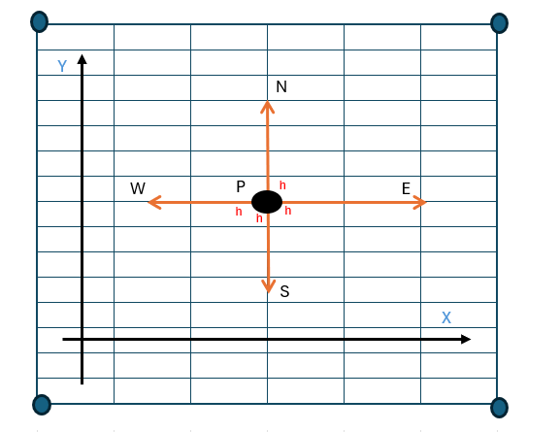
Figure 2: Spatial discretisation
The discretisation of the heat equation is formed by using the second derivates from the central difference method and the time derivates from the forward difference equation.

$$\frac{∂^{2}T}{∂x\text{²}}p=\frac{T_{E}^{t}-2⋅T_{P}^{t}+T_{w}^{t}}{h^{2}}$$
Equation 3-5: Spatial discretisation in the $x$ direction (Croft & Lilley., 1977).
$$\frac{∂^{2}T}{∂y^{2}}p=\frac{T_{N}^{t}-2⋅T_{p}^{t}+T_{S}^{t}}{h^{2}}$$
Equation 3-6: Spatial discretisation in the $y$ direction (Croft & Lilley., 1977).

Temporal discretisation
Temporal discretisation is represented by $T$ is used to create the time step, which would be calculated with Fourier’s number. $T_{p}^{t}$: represents the temperature at the location inside the grid provided at that current time step, $P$ Is the temperature at the location. t is the current time. Whereas $T_{P}^{t+Δt}$ Represents the temperature at the same grid location at the next time step. The temporal discretisation can impact the stability and accuracy of the solution if the time step is too large (Lubich & Schneider, 1992).

$$\frac{∂T}{∂t}=\frac{T_{P}^{t+Δt}-T_{P}^{t}}{Δt}$$
Equation 3-7: Temporal discretisation, approximate first derivative by forward difference

Explicit finite difference linear equation
$F_{0}$ = Fourier’s number.
$a$ = Thermal diffusivity of the set material
$Δt$ = This is the time step
$h^{2}$= This is the spatial step, also known as the grid spacing
The Fourier number is a dimensionless function crucial for the stability criterion when using FDM. When calculating FDM and approximating future temperature calculations at the next time step. The stability criterion is seen in Equation 3-10. Must remain below a certain threshold if the number exceeds; in this instance, ¼ could lead to a large error margin (Strikwerda, 2004). By reducing this number further, a more accurate approximation can be given; however, if the number is greater, this could lead to a less accurate approximation and an unrealistic calculation; this is due to the number of small errors being accumulated into a significant error (Özişik et al., 2017).

$$F_{0}=\frac{a⋅Δt}{h^{2}}$$
Equation 3-8: Fouriers number (Stein & Shakarchi., 2011).
To derive the explicit finite difference method part of the heat equation, the forward and central difference approximations are discretised by $\frac{∂T}{∂t}$. Incorporating the temporal and spatial discretisation and Fourier numbers can substitute the Taylor series approximations into the heat equation (Mazumder, 2016).
$$\frac{T_{E}^{t}-2T_{P}^{t}+T_{w}^{t}}{h^{2}}+ \frac{T_{N}^{t}-2T_{P}^{t}+T_{S}^{t}}{h^{2}}= \frac{1}{α}⋅\frac{T_{P}^{t+Δt}-T_{P}^{τ}}{Δt}$$
Equation 3-9: Derivations of the heat equation
$$\left(T_{E}^{t}+T_{W}^{t}+T_{N}^{t}+T_{S}^{t}-4T_{p}\right)+{T_{p}^{t}=T}_{p}^{t+Δt}$$
Equation 3-10: Derivations of the heat equation
$$F_{0}\left(T_{E}+T_{w}+T_{N}+T_{s}-4T_{p}\right)+\frac{F_{0}}{F_{0}}.T_{p}^{t}{=T}_{p}^{t+Δt}$$
Equation 3-11: Derivations of the heat equation
$$F_{0}\left(T_{E}+T_{w}+T_{N}+T_{s}-4T_{p}+\frac{1}{F_{0}}T_{p}\right){=T}_{p}^{t+Δt}$$
Equation 3-12: Derivations of the heat equation
$$F_{0}\left(T_{E}+T_{w}+T_{N}+T_{s}-(4-\frac{1}{F_{0}})T_{p}\right){=T}_{p}^{t+Δt}$$
Equation 3-13: Derivations of the heat equation
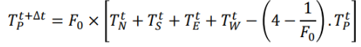
Figure 3: Explicit finite difference form of the heat equation

The finite difference method (FDM) linear equation, as seen in Figure 3, uses a time-step method to solve numerical differential equations by calculating the temperature at a future time step using the values from the current time step. We start with the Taylor series forward approximation formula to derive the full linear equation, as shown in Equation 3-1. the temperature at the next time step. The spatial derivatives are approximated using the central difference method to summarise the boundary conditions in both $x,y$ directions. By substituting these approximations into the heat equation, we obtain a discrete representation of the continuous problem. Adding Fourier's number ensures the numerical solution's stability by accounting for the relative time step concerning the spatial grid. The Courant-Friedrichs-Lewy (CFL) condition provides the stability criterion for the numerical solution. It ensures the time time is small in relation to the spatial grid spacing to prevent instability within the numerical method. This combination of approximations evolves into the FDM linear equation, providing a straightforward and explicit method to calculate temperature changes over time (Chapra, 2023; Özişik et al., 2017).

$$0<F_{0}≤\frac{1}{4}$$
Equation 3-14: Stability criterion

4. Initial boundary conditions implemented
The initial and boundary conditions are crucial for ensuring the accuracy and stability of the numerical model. Dirichlet boundary conditions are applied to the north and south boundaries, and Neumann boundary conditions are used for the east and west edges. Correctly defining these boundaries prevents numerical errors. The Von Neumann stability analysis provides a timestep selection to ensure stability. This ensures the timestep is small enough to avoid instability and unrealistic temperature changes. By validating the timestep against this criterion, the solution remains stable (Levine & Payne, 1974).
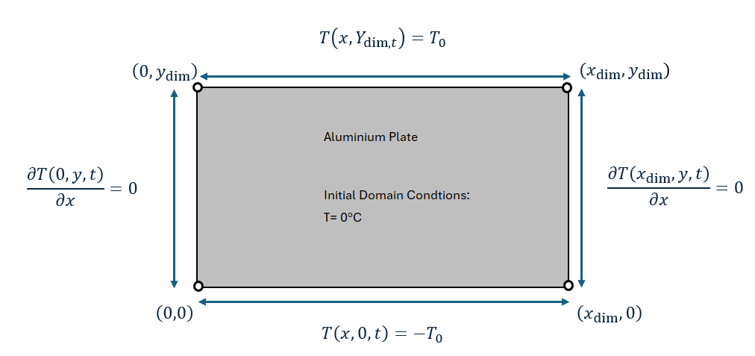
Figure 4: Initial Boundary Conditions
Figure 4 displays the initial given boundary conditions. The East and West boundary conditions are perfectly insulated walls, which means that no heat flows or travels across these boundaries. This is an interpretation of Neuman's boundary conditions. Comparing numerical results with an analytical solution, which provides an exact representation under the same conditions, validates the model's accuracy. This comparison confirms that the numerical method correctly represents the system's physical behaviour and adheres to the stability criterion (Dehghan, 2007; Schwartz et al., 2006).

4.1 Analytical solution
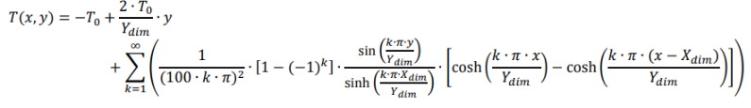
Figure 5: Formula for Analytical solution (Kazakov et al., 2020).

The analytical solution of the heat equation provides an exact measurement of the temperature distribution over time within the inputted domain. It fully incorporates the initial boundary conditions whilst using the fundamental mathematical properties of the heat equation to derive precise calculations and results. When a closed-form solution is used, it offers direct insights into how physical parameters, such as thermal diffusivity, heat source distributions, and boundary constraints. These influence the system's behaviour. This exactness not only serves to validate numerical models but also establishes a benchmark for evaluating their accuracy and stability. Analytical solutions, while exact, are often limited to problems with simpler geometries and boundary conditions (Kazakov et al., 2020).

5. Codes’ detail and explanation
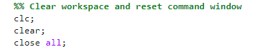
Figure 6: Command Window reset
The commands entered in Figure 6 are the first inline to be inputted into the MATLAB code to instruct the window to be cleared of all previous commands (CLC), clear the workspace of previous commands (clear) and close any previous windows that may have been opened (close all).

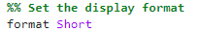
Figure 7: Format
The code in Figure 7, is set to short fixed-decimal format for precision outputs.

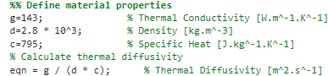
Figure 8: User Inputs specified for calculation
The defined material properties were given using Aluminium properties. (g) Is the conductivity, (d) is the density, and (c) is the specified heat. These material properties were needed to calculate the thermal diffusivity equation in Figure 8 (eqn).

Figure 9: Thermal diffusivity equation

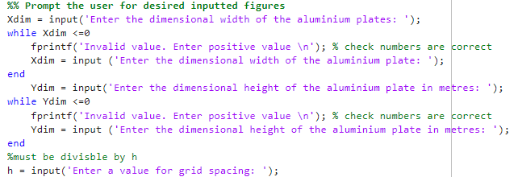
Figure 10: User Inputs specified for grid dimensions and grid spacing
User inputs are then required within the code Figure 10. The user is asked to input specified values to define the dimensions of the aluminium plate and the valid grid spacing (h). The while loops are used so that the user will continue to be prompted to put in a correct figure in case of a numerical calculation error.

Figure 11: User Inputs must satisfy the code for assurances of accurate approximation
Figure 11: User Inputs for grid spacing (h) with a remainder loop that invalid numerical inputs for width and height must be divisible by (h).

Figure 12: Calculation of grid points for matrix
The code in Figure 12, calculates the number of rows and columns in respects to the x and y dimensions of each grid point. This also initialises the matrix “T1” as shown in Figure 13.
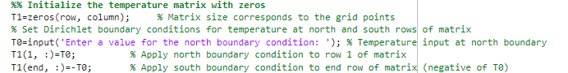
Figure 13: Boundary conditions
The code in Figure 13, is another user input for the north boundary temperature and the start of the initial matrix boundary conditions at 0 and south boundary at a negative value.

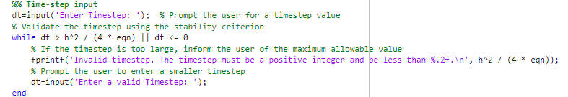
Figure 14: Time step input
The code in Figure 14 prompts the user to input a timestep; this is used for the stability criterion for the FDM method. The timestep must be a positive value.

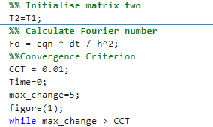
Figure 15: Initialisation of temperature matrix two and calculation of Fourier’s number for temperature approximation at future steps.
Figure 15 calculates Fourier's number Fo. The convergence criterion “CCT” is set to 0.01. This means the code will continue to run until the numerical figure is less than or equal to 0.01. This can ensure that code and numerical calculations are accurate at thermal equilibrium.
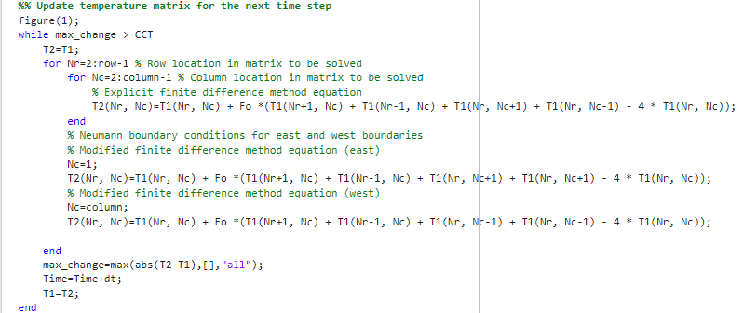
Figure 16: Explicit finite difference equation
The code in Figure 16 updates the temperature matrix “T1” to the next time step “T2” with the updated temperature using the FDM equation. At the end of the code, it initialises a temperature map so that it can be visually seen how the temperature has reached thermal equilibrium along the plotted grid points.
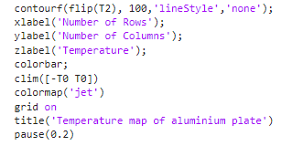
Figure 17: Colour map
The colour map code in Figure 17 initialises a graph of a colour map, allowing the user to see the temperature distribution along the aluminium plate. This makes it easier for the user to check if any errors have been made coinciding with the MATLAB code. The ‘Pause’ function of the code allows for a 0.2-second delay so that the display of the colour map can show the state of the aluminium plate reaching thermal equilibrium.

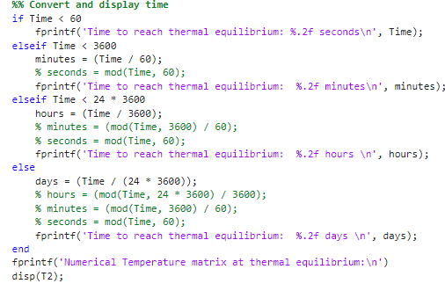
Figure 18: Code for time to reach thermal equilibrium
The code in Figure 18 calculates and defines the time taken to reach thermal equilibrium. This is displayed in seconds, minutes, hours, or days depending on the results. The “if” and “else if” loops are used with the correct “fprintf” text displayed depending on the time taken.
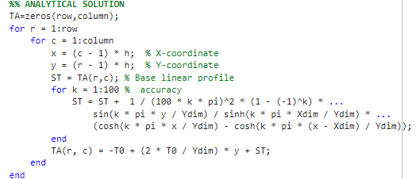
Figure 19: Analytical solution
The code in Figure 19, uses the “Analytical solution” to calculate the temperature distribution around the aluminium plate and compare it to the numerical solution. This part of the code allows it to check itself against the heat equation and validate its accuracy.

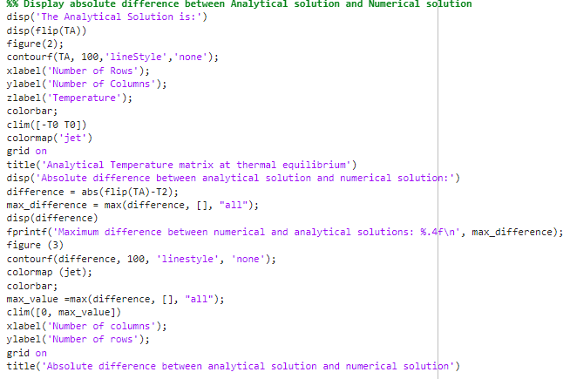
Figure 20: Absolute difference between analytical solution and numerical solution
The analytical solution and numerical solution can be seen together in this colour map. This shows the maximum difference in both codes, allowing the user to simultaneously see key differences in both parts of the code.

6. Validation of the code
The thermal equilibrium temperature map derived from the explicit finite difference method is compared with the analytical solution. The comparison from both charts, is almost identical to colour map comparisons. The minimal numerical difference cannot be seen or noticed without using MATLAB for the calculation (Figure 24). The minimal temperature difference aligns with the accuracy of the FDM implementation. These findings validate solving the heat transfer equations using FDM and the analytical solution (Yuste, 2006).

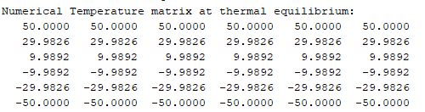
Figure 21: Numerical temperature matrix at thermal equilibrium
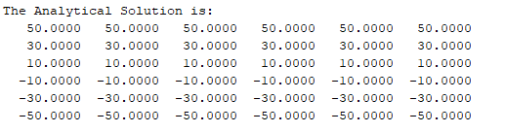
Figure 22: Analytical temperature matrix at thermal equilibrium
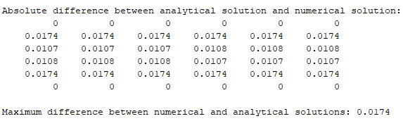
Figure 23: Absolute difference between analytical solution and numerical solution

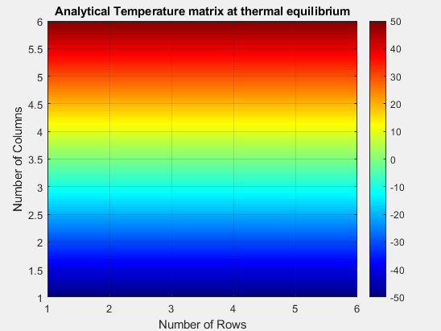
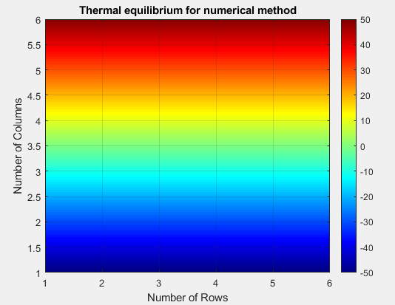
Figure 24: Temperature colour maps

7. Sensitivity analysis of code results
The time required to reach thermal equilibrium depends on the number of user inputs in the code. X and Y values define the plates dimensions; therefore, a larger area will take longer to reach thermal equilibrium. Grid spacing (h) and time steps (dt) will also correlate with the time taken. An analysis was conducted to investigate how these specific parameters affected the results of the heat equation model. The code included a set value for tolerance, which was also set out in the analysis at 0.01 (convergence criterion, CCT, Figure 15). All models were converted into seconds for this analysis to provide clear results. 12x12 values set X and Y dimensions for consistency (Korycki, 2006; Park & Yoo, 1988).

7.1 Grid spacing,
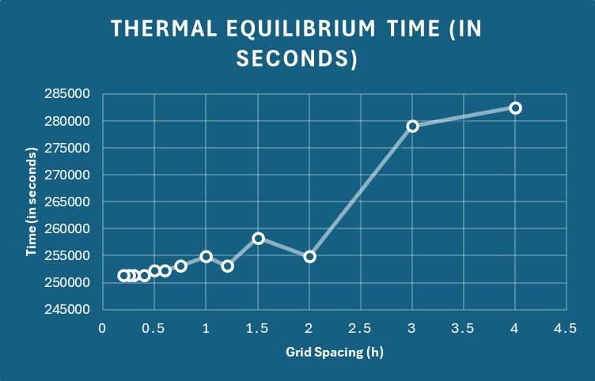
Figure 25: Graph showing thermal equilibrium in seconds with respect to grid spacing (h)
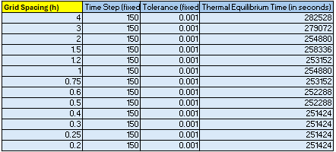
Figure 26: Table of grid spacing used to show optimal thermal equilibrium results
Figures 30 and 31 Show that decreasing the time step significantly reduces the time taken to reach thermal equilibrium. Smaller grid spacing converges towards an optimum result. However, the number of calculations and nodes increases as the grid spacing decreases. So, a larger grid space reduces computational steps; however, it is less accurate. Truncational errors have a big influence on the accuracy of this term. When (h) is decreased, the truncational errors decrease (Teixeira, Reynolds & Judd, 2007).

7.2 The time step,
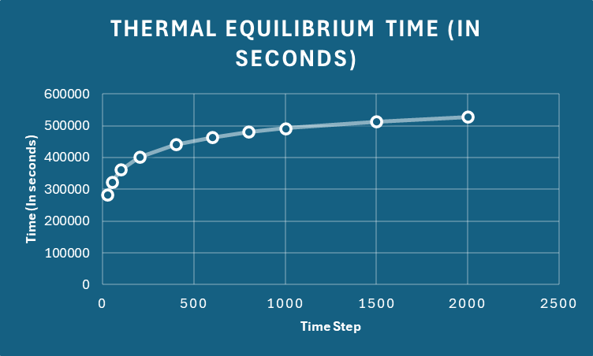
Figure 27: Graph showing thermal equilibrium in seconds with respect to the time step (dt) input

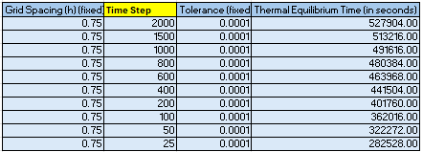
Figure 28: Table of grid spacing used to show optimal thermal equilibrium results
The time step (dt), as shown in the code in Figure 14, is vital for the overall simulation accuracy and speed. A smaller time step allows for very precise tracking of temperature changes over time. This also means that the time taken goes up significantly as there are more computational derivatives to calculate. Whereas the larger time steps offer a much faster time taken, its results are less accurate. An optimal time step is essential for ensuring accuracy and efficiency. It is important to account for computational round-off errors that can accumulate over extended iterations and, as a result, are accumulated as approximations (Iott., Haftka & Adelman,1985).

7.3 Thermal equilibrium tolerance.
This analysis must be supported by academic references to fully investigate and evaluate how changes to these fundamental code parameters affect the overall behaviour of the model.

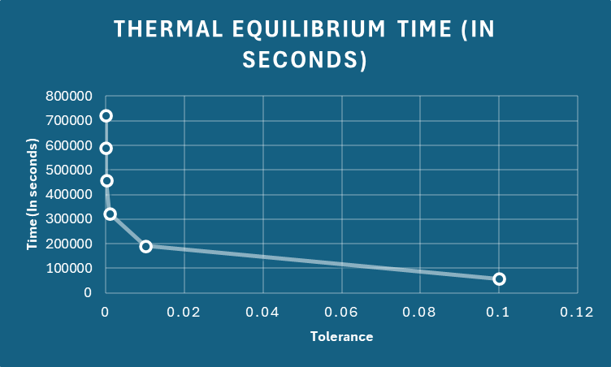
Figure 29: Graph showing thermal equilibrium in seconds with respect to the convergence criterion (CCT)

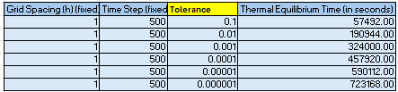
Figure 30: Table of grid spacing used to show optimal thermal equilibrium results
The convergence criterion is mainly used to set the parameter for a practical solution. The time required to reach thermal equilibrium increases dramatically as the smaller tolerances are used. As shown in Figure 35, the time taken from a tolerance value of 0.000001 is nearly 3 times more than a value of 0.01. This difference highlights the unrealistic time of waiting an extended period to reach the same result. The overall weight is extremely inefficient for such a small tolerance for any practical situation.

8. Limitations discussion

8.1 Limitations due to the Numerical Method:
Limitations in the numerical code are associated with the heat transfer equation, and the FDM has several limitations. Round-off and truncational errors can be accumulated over many iterations, impacting accuracy. Accurately using complex geometry can encounter issues when using Neumann’s boundary conditions. Stability is of concern for the result, which is affected by inputs of the time step and grid spacing. Round-off errors are specific results of the FDM linear equation used in the MATLAB code. This can cause significantly small errors that accumulate over varied iterations. Truncational errors can occur when the differential equation approximations happen too little time. Inputting smaller grid spacing and time step size can dramatically reduce these errors (Recktenwald, 2004). Using this model as a concept does not account for real-world issues; external heat sources are not interpreted, whilst valid inputs are necessary to avoid errors with negative values.

8.2 Limitations due to the coding:
The thermal equilibrium model relies heavily on the convergence criterion 0.01 (Figure 15) to define the difference between the temperature maps, which is simple from a coding perspective. However, this does not accurately represent true physics. This method depends heavily on user input, which can significantly impact the results. The coding works well under ideal conditions but will not compute well under real-world scenarios.

9. Suggested improvements
To improve the accuracy of the model, the Finite element method (FEM) would be chosen over the FDM. Meanwhile, FDM has a lower order of approximation. This method is better suited for solving time-dependent problems with forward approximations. FEM requires higher computational power; however, it can handle more complex geometries and unstructured meshes. Implementing enhanced boundary conditions, such as combining the Dirichlet and Neumann conditions, allows for more realistic boundaries (Yudin, 2012). This would lead to handling more complex geometries (Zhou, 2005). Using the FEM method, its computational advantages allow the user to adapt the mesh grid ensuring optimal results. Due to the number of errors that can occur in the MATLAB code, enabling error-controlled estimations could improve accuracy. This could include changing the time step to simulate thermal equilibrium more realistically (Recktenwald, 2004). Another improvement could be the Taylor series functions; by enabling higher-order terms, the Taylor series could significantly reduce truncation errors. Whilst the code stops at the second derivative function, it could be used to incorporate the third and fourth derivatives and provide a more accurate approximation result (Miletics & Molnárka, 2004).
AI can help understand behavioural and predictive patterns that could learn the trends and models of numerical techniques and allow itself to modify the optimisation and user inputs to have a better function of the thermal equilibrium model (Stoffel, Bamer & Markert, 2018). In Yuste (2006) study, a time-weighted average was used to account for varying durations of measured values. This enabled a more accurate average temperature calculation over multiple time steps, enhancing the thermal dynamics analysis.

10. Conclusion
In conclusion, this report has investigated the numerical and analytical equations used to model the thermal equilibrium, focusing on the Finite Difference Method (FDM) and exploring potential improvements that could impact the codes' accuracy and speed. The analysis confirmed that FDM provides consistent results when validated against analytical solutions. Sensitivity analyses revealed that while FDM is effective at approximating time-dependent problems, other numerical methods can be equally, if not more, accurate for the heat equation. The current model's limitations, such as truncation and round-off errors, are well defined within the code structure, impacting stability, accuracy, and user inputs. Practical improvements, such as incorporating adaptive grid refinement and handling complex geometries, have been suggested to enhance reliability and approximations. The Fourier number and convergence criteria significantly influence stability and efficiency, emphasising the importance of manual inputs. Overall, the report suggests that the importance of numerical methods backed by analytical solutions can be accurately calculated through the heat transfer model and its application in thermal problems.

References
Bergman, T.L., Lavine, A.S., Incropera, F.P. and DeWitt, D.P. (2011). Introduction to heat transfer. John Wiley & Sons.
Chapra, S.C. (2023). Applied Numerical Methods with MATLAB for engineers and scientists. New York, NY: McGraw Hill LLC.
Croft, D.R. and Lilley, D.G. (1977). Heat transfer calculations using finite difference equations.
Dehghan, M. (2007). ‘The one-dimensional heat equation subject to a boundary integral specification’, Chaos, Solitons &amp; Fractals, 32(2), pp. 661–675. doi:10.1016/j.chaos.2005.11.010.
Huntul, M.J. (2020). ‘Identification of the timewise thermal conductivity in a 2D heat equation from local heat flux conditions’, Inverse Problems in Science and Engineering, 29(7), pp. 903–919. doi:10.1080/17415977.2020.1814282.
Kazakov, A., Spevak, L., Nefedova, O. and Lempert, A. (2020). ‘On the analytical and numerical study of a two-dimensional nonlinear heat equation with a source term’, Symmetry, 12(6), p. 921. doi:10.3390/sym12060921.
Korycki, R. (2006). ‘Sensitivity analysis and shape optimization for transient heat conduction with radiation’, International Journal of Heat and Mass Transfer, 49(13–14), pp. 2033–2043. doi:10.1016/j.ijheatmasstransfer.2006.01.007.
Levine, H.A. and Payne, L.E. (1974). Nonexistence theorems for the heat equation with nonlinear boundary conditions and for the porous medium equation backward in time. Journal of Differential Equations, 16(2), pp.319-334.
Lott, J., Haftka, R.T. and Adelman, H.M. (1985). Selecting step sizes in sensitivity analysis by finite differences (No. NASA-TM-86382).
Lubich, Ch. and Schneider, R. (1992). ‘Time discretization of parabolic boundary integral equations’, Numerische Mathematik, 63(1), pp. 455–481. doi:10.1007/bf01385870.
Mazumder, S. (2016). Numerical methods for partial differential equations: Finite difference and finite volume methods. London: Academic Press.
Miletics, E. and Molnárka, G. (2004). Taylor series method with numerical derivatives for initial value problems. Journal of Computational Methods in Sciences and Engineering, 4(1-2), pp.105-114.
Narasimhan, T.N. (1999). ‘Fourier’s heat conduction equation: History, influence, and connections’, Reviews of Geophysics, 37(1), pp. 151–172. doi:10.1029/1998rg900006.
Özişik, N., Orlande, H., Colaco, M and Cotta, R. (2017). ‘Finite difference methods in heat transfer, Second edition’, Finite Difference Methods in Heat Transfer [Preprint]. doi:10.1201/9781315121475.
Park, C.W. and Yoo, Y.M. (1988). ‘Shape design sensitivity analysis of a two-dimensional heat transfer system using the boundary element method’, Computers &amp; Structures, 28(4), pp. 543–550. doi:10.1016/0045-7949(88)90027-2.
Recktenwald, G. (2004). Finite-difference approximations to the heat equation. Available at: https://www.researchgate.net/publication/265202152_Finite-Difference_Approximations_to_the_Heat_Equation (Accessed: 14 January 2025).
Schwartz, P., Barad, M., Colella, P. and Ligocki, T. (2006). ‘A Cartesian grid embedded boundary method for the heat equation and Poisson’s equation in three dimensions’, Journal of Computational Physics, 211(2), pp. 531–550. doi:10.1016/j.jcp.2005.06.010.
Stein, E.M. and Shakarchi, R. ( 2011). Fourier analysis: an introduction (Vol. 1). Princeton University Press.
Strikwerda, J.C. (2004). Finite difference schemes and partial differential equations. Society for Industrial and Applied Mathematics.
Stoffel, M., Bamer, F. and Markert, B. (2018). Artificial neural networks and intelligent finite elements in non-linear structural mechanics. Thin-Walled Structures, 131, pp.102-106.
Teixeira, J., Reynolds, C.A. and Judd, K. (2007) ‘Time step sensitivity of nonlinear atmospheric models: Numerical convergence, truncation error growth, and Ensemble Design’, Journal of the Atmospheric Sciences, 64(1), pp. 175–189. doi:10.1175/jas3824.1.
Widder, D.V. (1976). The heat equation (Vol. 67). Academic Press.
Yudin, M.S. (2012). Comparison of FDM and FEM models for a 2D gravity current in the atmosphere over a valley. Bull. Novos. Comput. Center, 13, pp.95-101.
Yuste, S.B. (2006). ‘Weighted average finite difference methods for fractional diffusion equations’, Journal of Computational Physics, 216(1), pp. 264–274. doi:10.1016/j.jcp.2005.12.006.
Zhou, W. (2005). Application of FDM and FEM in solving the simultaneous heat and moisture transfer inside bread during baking. International Journal of Computational Fluid Dynamics, 19(1), pp.73-77.

Appendix:

2D Diffusion Equation model using the Explicit Finite Difference Method
(Code)

Code:
%% Clear the workspace and reset the command window
clc
clear
close all
%% Set the display format
format Short
%% Define material properties
g=143; % Thermal Conductivity [W.m^-1.K^-1]
d=2.8 * 10^3; % Density [kg.m^-3]
c=795; % Specific Heat [J.kg^-1.K^-1]
% Calculate thermal diffusivity
eqn = g / (d * c); % Thermal Diffusivity [m^2.s^-1]
%% Prompt the user for the grid dimensions and spacing
Xdim = input('Enter the dimensional width of the aluminium plate: '); % Width of the grid
while Xdim <= 0
fprintf('Invalid value. please enter a positive value.\n');
Xdim = input('Enter the dimensional width of the aluminium plate in metres: ');
end
Ydim = input('Enter the dimensional height of the aluminium plate in metres: '); % Height of the grid
while Ydim <= 0
fprintf('Invalid value. please enter positive value.\n');
Xdim = input('Enter the dimensional width of the aluminium plate in metres: ');
end
h=input('Enter a value for the grid spacing: '); % Grid spacing
%% Ensure the grid spacing divides both dimensions completely with no remainder
while rem(Xdim, h) ~= 0 || rem(Ydim, h) ~=0 || h <= 0 || h == Xdim || h == Ydim
fprintf('Invalid grid spacing. Both width and height must be divisible by grid spacing with no remainder and not be equal to .\n');
h=input('Enter the grid spacing again: ');
end
%% Calculate the number of grid points in the x and y directions
column=(Xdim / h) + 1; % Number of columns (grid points along x-direction)
row=(Ydim / h) + 1; % Number of rows (grid points along y-direction)
%% Initialize the temperature matrix with zeros
T1=zeros(row, column); % Matrix size corresponds to the grid points
% Set Dirichlet boundary conditions for temperature at north and south rows of matrix
T0=input('Enter a value for the north boundary condition: '); % Temperature input at north boundary
T1(1, :)=T0; % Apply north boundary condition to row 1 of matrix
T1(end, :)=-T0; % Apply south boundary condition to end row of matrix (negative of T0)
%% Time-step input
dt=input('Enter Timestep: '); % Prompt the user for a timestep value
% Validate the timestep using the stability criterion
while dt > h^2 / (4 * eqn) || dt <= 0
% If the timestep is too large, inform the user of the maximum allowable value
fprintf('Invalid timestep. The timestep must be a positive integer and be less than %.2f.\n', h^2 / (4 * eqn));
% Prompt the user to enter a smaller timestep
dt=input('Enter a valid Timestep: ');
end
%% Calculate Fourier number (Fo) for stability
Fo=eqn * dt / h^2; % Stability parameter
%% Initialize T2 matrix (next time step) to be the same as T1
CCT=0.01; % Convergence criterion vaIue
Time=0; % Set time to zero
max_change=5; % Maximum change
%% Update temperature matrix for the next time step
figure(1);
while max_change > CCT
T2=T1;
for Nr=2:row-1 % Row location in matrix to be solved
for Nc=2:column-1 % Column location in matrix to be solved
% Explicit finite difference method equation
T2(Nr, Nc)=T1(Nr, Nc) + Fo *(T1(Nr+1, Nc) + T1(Nr-1, Nc) + T1(Nr, Nc+1) + T1(Nr, Nc-1) - 4 * T1(Nr, Nc));
end
% Neumann boundary conditions for east and west boundaries
% Modified finite difference method equation (east)
Nc=1;
T2(Nr, Nc)=T1(Nr, Nc) + Fo *(T1(Nr+1, Nc) + T1(Nr-1, Nc) + T1(Nr, Nc+1) + T1(Nr, Nc+1) - 4 * T1(Nr, Nc));
% Modified finite difference method equation (west)
Nc=column;
T2(Nr, Nc)=T1(Nr, Nc) + Fo *(T1(Nr+1, Nc) + T1(Nr-1, Nc) + T1(Nr, Nc-1) + T1(Nr, Nc-1) - 4 * T1(Nr, Nc));

end
max_change=max(abs(T2-T1),[],"all");
Time=Time+dt;
T1=T2;
end
contourf(flip(T2), 100,'lineStyle','none');
xlabel('Number of Rows');
ylabel('Number of Columns');
zlabel('Temperature');
colorbar;
clim([-T0 T0])
colormap('jet')
grid on
title('Temperature map of aluminium plate')
pause(0.2)

%% Convert and display time
if Time < 60
fprintf('Time to reach thermal equilibrium: %.2f seconds\n', Time);
elseif Time < 3600
minutes = (Time / 60);
% seconds = mod(Time, 60);
fprintf('Time to reach thermal equilibrium: %.2f minutes\n', minutes);
elseif Time < 24 * 3600
hours = (Time / 3600);
% minutes = (mod(Time, 3600) / 60);
% seconds = mod(Time, 60);
fprintf('Time to reach thermal equilibrium: %.2f hours \n', hours);
else
days = (Time / (24 * 3600));
% hours = (mod(Time, 24 * 3600) / 3600);
% minutes = (mod(Time, 3600) / 60);
% seconds = mod(Time, 60);
fprintf('Time to reach thermal equilibrium: %.2f days \n', days);
end
%% Temperature map
fprintf('Numerical Temperature matrix at thermal equilibrium:\n')
disp(T2);

%% ANALYTICAL SOLUTION
TA=zeros(row,column);
for r = 1:row
for c = 1:column
x = (c - 1) * h; % X-coordinate
y = (r - 1) * h; % Y-coordinate
ST = TA(r,c); % Base linear profile
for k = 1:100 % accuracy
ST = ST + 1 / (100 * k * pi)^2 * (1 - (-1)^k) * ...
sin(k * pi * y / Ydim) / sinh(k * pi * Xdim / Ydim) * ...
(cosh(k * pi * x / Ydim) - cosh(k * pi * (x - Xdim) / Ydim));
end
TA(r, c) = -T0 + (2 * T0 / Ydim) * y + ST;
end
end
%% Display absolute difference between Analytical solution and Numerical solution
disp('The Analytical Solution is:')
disp(flip(TA))
figure(2);
contourf(TA, 100,'lineStyle','none');
xlabel('Number of Rows');
ylabel('Number of Columns');
zlabel('Temperature');
colorbar;
clim([-T0 T0])
colormap('jet')
grid on
title('Analytical Temperature matrix at thermal equilibrium')
disp('Absolute difference between analytical solution and numerical solution:')
difference = abs(flip(TA)-T2);
max_difference = max(difference, [], "all");
disp(difference)
fprintf('Maximum difference between numerical and analytical solutions: %.4f\n', max_difference);
figure (3)
contourf(difference, 100, 'linestyle', 'none');
colormap (jet);
colorbar;
max_value =max(difference, [], "all");
clim([0, max_value])
xlabel('Number of columns');
ylabel('Number of rows');
grid on
title('Absolute difference between analytical solution and numerical solution')

