

PLC Report

ACDA6000

By Matthew Taylor

Table of Contents
Abstract 3
Introduction 3
Literature Review 4
PLC Comparison 4
Alternatives to the PLC 6
Design 7
Flow Diagram 7
Distinguishing Package Type 7
The System 7
Software 9
Connecting the Hardware 9
Human Interface Device 12
Operator Controls 15
Warning and Error Strategy 15
Conclusion 15
References 16

Abstract

The purpose of this report is to demonstrate my design of a PLC controlled sorting system. I discuss my design process showing my flow diagram, initial system, trouble shooting and final design. Additionally, I have done a literature review and compared PLCs from a wide range of manufacturers considering their cost, functionality, and security.

Introduction

My aim is to increase my understanding of PLCs and to use this knowledge to design a solution for the proposed task of sorting a range of packages. The factory process needed to be capable of sorting a range of packages based on their size and weight. The solution needed a PLC to control the factory process and required a HMI device to be incorporated.

Programmable logic controllers [PLC] are computer-based, solid-state, single processor devices that mimic the behaviour of an electric ladder diagram of the 1960’s. PLCs were invented by General Motors [GM] in order to automate the manufacture of cars. GM’s aim for the PLC was for it to be durable and able to operate in harsh environments and to make system changes simpler. Originally PLCs were set up by process engineers who were already familiar with electric ladder diagrams and for this reason, PLC software have a lot of similarities to the electric ladder diagram. GM decided to design the PLC because they reduced the cost of implementing automation within a manufacturing setting and they also offered greater reliability in comparison to their hard-wired relay and timer logic counterpart.

PLCs are about enabling automation which is a step up from mechanisation by offering systems that reduce repetitive tasks that were performed by workers. This in turn reduces human error, increasing the accuracy and safety of the process. Examples of industries that have implemented PLCs include the automotive, food and leisure industries.

Literature Review

PLC Comparison

PLCs come in a few different shapes and sizes, and this is one of the most important considerations when choosing a PLC for a system. The cheapest architecture is fixed, and fixed PLCs are characterised by having all their components built into a single unit. The components include power supply, CPU, memory, inputs, outputs and communication interfaces. If a fixed PLC doesn’t have the specifications for the intended purpose, there is usually limited options other than buying a new PLC. Fixed PLCs can be great for simple automation tasks as the unit is small and are often easy to fit with the included rail mount. Fixed PLCs aren’t appropriate for more complex automation tasks as the limited number of inputs and outputs can be a constraint, as well as the CPU power and memory limits the size of the program. As fixed PLCs don’t usually include an option to add additional features through modules, these PLCs have limited versatility.

There are a lot of fixed PLCs on the market, I have looked into a selection and compared them. Siemens have their LOGO! And S7 1200 models. The LOGO! Model starts at around £120 and start with 10 inputs and 4 outputs, and the S7 1200 models are priced around £370 and have around 14 inputs and 10 outputs. With both Siemens’ ranges, the number of input and outputs as well as the price varies on the whether the output type is relay or transistor. The LOGO! is the only PLC that I’m comparing that doesn’t use ladder programming. The LOGO! uses Siemens “Soft Comfort” software which costs £56 and works by placing nodes, which contain functions, and linking signals to these nodes (Siemens, n.d.).

Other companies have PLCs that are competitive with Siemens offerings, like Omron’s ZEN which is similar to the LOGO!. The ZEN also has a built in LCD display but has fewer inputs and outputs with 6 and 4 respectfully. The ZEN costs more at around £193 and £124 for a single software licence, but the software uses ladder programming, which a PLC programmer may be more familiar with. Mitsubishi’s FX is at a similar price point at £144 but has the fewest inputs and outputs at 6 and 4 respectfully. Mitsubishi’s software is considerably more expensive than the LOGO!’s at £302 but can be used with any Mitsubishi PLC.

Schneider Electric’s Twido is similar to the S7 1200 in price at £307 but has a similar number of inputs and outputs to the smaller form PLCs like the LOGO!, ZEN and FX. The software for the Twido is Twidosuite and is free, but this isn’t going to compensate for the high price of the unit, unless there is a large team working on a small number of units.

When comparing these fixed-form PLCs, Siemens LOGO! is likely the most suitable as it is the cheapest unit, and other than Schneider Electric’s Twido, whose software is free, but hardware is much more costly, has the cheapest software. This software is limited in functionality and is also different from the usual Ladder Logic Programming, that an engineer may already be familiar with.

The next step from fixed PLCs is the modular architecture. These PLCs are often fully customisable, as the power supply, CPU, communication interface, and the number of inputs and outputs and their types can be individually chosen and combined through the use of modules. The only limitation is the size of the backplane as well as what the manufacturer offers. These PLCs and their required software are more expensive than their fixed PLC counterparts but these PLCs are more versatile as modules can be added and removed as the requirements change.

Siemens S7-400 is fully modular with a rack being used to hold modules. The price of the rack is £1,335 and a pre-configured PLC from Farnell start at £15,483 going up to £46,593 . Mitsubishi’s MELSEC Q Series priced at £180 for a back panel with 5 slots, or £310 for 12 slots, £266 for the power supply, and around £300 for each input and output module. PLCs can also be distributed around a manufacturing environment. To do this, one of these units would be used with communication modules. This allows the inputs and outputs to be connected to the same system, but without them all individually being wired back to the main rack.

PLC | Cost | Inputs/Outputs | Software cost
Siemens LOGO! | £120.00 | 10/4 | £56.00
Siemens S7-1200 | £370.00 | 14/10 | £330.00
Omron ZEN | £193.00 | 6/4 | £124.00
Mitsubishi FX | £120.00 | 6/4 | £302.00
Schneider Electric Twido | £307.00 | 9/7 | free
Siemens S7-400 | £15483 - £46,593 | up to 576 | £330.00
Mitsubishi’s MELSEC Q | £1946 - £4046 | 160-384 | £302.00

Alternatives to the PLC

PCs can be used in the place of PLCs and are called soft PLCs when used in this way. PCs started taking the place of PLCs as they offered improved performance. Hardware PLCs are limited by the duration of their cyclic function which can be in the region of 100 to 150 ms. For example, a registration marker of a few microseconds or the output of a 1042 line encoder at several revolutions per second will not be seen by the digital PLC input (Clark & Mostert, 2006). For PLCs to be able to perform these tasks a Field Programmable Gate Array [FPGA] would be required to capture this high-speed data.

Dillon Beresford concluded in his report that security was not initially factored into the design of Siemens Simatic S7 product line and that The PROFINET communication could be open to exploitation. In his white paper, he examined the vulnerabilities of PROFINET and communication across TCP/IP port 102 (ISO-TSAP). Wool and Malin were able to gain access to a Siemens PLC and insert malicious software without the users’ knowledge and disrupt the system (Wool & Malin, 2019). As more and more processes are becoming reliant on PLCs, their security is an important concern. PLCs can be protected through physical security or avoiding the PROFINET system, but with cyber security already being an established industry, using PCs could also alleviate the concern.

Design

Flow Diagram

My first step in designing a system to meet the requirements was to lay out the process in a flow diagram. This allowed me to start logically writing the ladder program. My flow diagram starts by checking the state of the emergency button. If the button is pressed, then the program doesn’t proceed. Once the start button is pressed, the system is allowed to run and then the process will start by pacing a box on the conveyor belt and the conveyor belts are powered in sequence to limit the initial current draw. The conveyor belts move the box through the light array, which measures the height of the box and sets of one of three sequences, which is dependent on the height. For the shortest height, the extra small box counter is incremented, and the box continues on the conveyor belt until it leaves the system on the slide. For the middle height, a flag is raised. This flag causes the first pusher to push the box onto the weighing scales. Depending on the weight, the scale conveyor is driven in the corresponding direction and the box continues until the exit slide. For the highest value from the light array, the large box is incremented, and the second pusher pushes the box onto the exit slide.

As an aside, if the stop button is pressed, no more boxes will be placed on the conveyor and once all boxes have passed along the conveyor, it will stop. If the reset button is pressed all counters are set to zero.

Distinguishing Package Type

The requirements set out that the system needs to differentiate between four different packages, so I started by looking at their characteristics. I found that all the package types had a different weight, which would be sufficient for me to be able to determine what type each package is, but the brief outlined that weight, as well as height, has to be used to sort the packages so I also measured the height of each package. I found that there were three unique heights, leaving the small and medium packages that can’t be identified with height alone.

The System

The brief had a list of components that needed to be used, similar to a scenario where an old system is being repurposed. My first step as I started designing the system was to place these components set out in the brief. I aimed to keep the theoretical cost of the system as low as possible, by using these components and avoiding including additional components.

In stage 1 of the system, the boxes are placed on the conveyor belt by the emitter. The conveyor belt takes the package through the light array. The light array will read out the height as an integer while the package is travelling through it. The light array can distinguish between extra small and large package types, so the counter for those can be updated at this point. Small and medium packages are the same height and would need to be weighed to identify them, so the light array raises a flag so those packages can be sent to the weighing scales.

Stage 2 of the system is responsible for taking the small and medium packages off the main conveyor and weighing them. This is done with a pusher and a diffuse sensor whose purpose is to delay the extension of the pusher. The scales output the weight as an integer much like the light array, but the scales don’t give a consistent reading which led to the system operation needing to be adapted after the initial design. The scales include a conveyor that can be driven forwards or backwards, which I used to separate the packages based on their weight.

For stage 3 of the system, the only packages left on the main conveyor belt are the extra small and large packages. These have already been counted by the light array, so they just need to be sorted. I did this with the last pusher which is paired with a diffuse sensor. The sensor is positioned on top of the pusher which serves two purposes, firstly only the large box is tall enough to activate the sensor, and secondly, the pusher can be fired without using a delay, simplifying the software.

Software

Connecting the Hardware

Each component that is controlled by the PLC needs to be wired to it. In factory IO that is done in the driver settings. I connected all the inputs, like the sensors and buttons, to the PLC inputs and all the actuators, like the pushers, conveyors, and lights, to the PLC outputs. The light array, scales, and displays, have digital integers as input and output values, so they are connected to the digital inputs and outputs of the PLC.
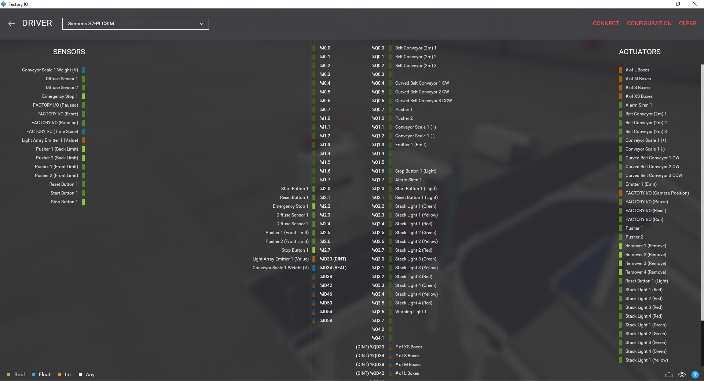
Figure 1 - PLC inputs Figure 2 - PLC Outputs

With all the components connected, the next step is to fill out the tag table, so that each input and output can be referred to by name rather than its address number. I set up the tag table in the Siemens TIA portal, identifying the input and output addresses used and giving them a tag that communicates clearly what component it connects to.

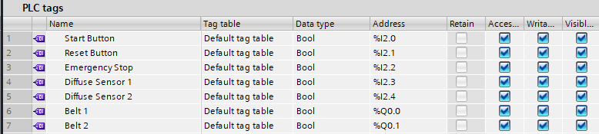
Figure 3 - TIA Portal Tag Table

The Siemens SIMATIC STEP 7 software supports writing PLC programs using three methods (Siemens, 2020), Ladder Logic (LAD), Function Block Programming (FBD), and Structured Control Language [SCL]. SIMATIC STEP 7 is included in Siemens TIA (Totally Integrated Automation) portal, which I used for writing the PLC program, setting up the Human Machine Interface (HMI), and simulating. I used Ladder Logic and separated each responsibility of the system into a different network.

Network 1 is reserved for a program block that enables the TIA portal to connect with Factory IO.

Network 2 controls the start, stop, and emergency process where the start, stop, or emergency button on the panel or HMI is pressed. When the start button is pressed the start process is initiated. As soon as the button is pressed, the button lights green, the stop button is no longer illuminated, the package emitter is enabled, and the visual and audible alarm runs for three seconds.

After the alarm has sounded, the first conveyor belt starts running, the subsequent conveyor belts start shortly before they are required to limit the initial current draw. This was done with TON timers and using an output that is set.
The stop button and emergency stop button both stop the conveyor belts by resetting the outputs, but the stop button includes a delay that is long enough to let the last package pass through the system.

Network 3 is responsible for the first stage of the system which contains the light array. Three of the rungs read the value from the light array and compare it to the values of the package heights I found during my initial tests. If the reading is 128 or 224 then the counter for the corresponding package size is incremented with the CTU block. The CV output of the block is connected to the digital output of the PLC and shown on the displays in factory IO and on the HMI.

The CTU block output, Q, is a bool output that rises when a defined value (PV) is reached, this value is stored in a memory block I created for all my data bytes used in the program. In a situation where only a certain number of packages can be sent to an output, for example, if they are being palletised, there needs to be a warning when this chosen value is reached. I did this using the Q output, and by letting the user change the value in a screen I created for the HMI.

If the value from the light array is 192 then the package is either small or medium so a flag is raised in my memory block so that when the package passes the first pusher, it can be pushed onto the weighing scales. During testing, I found a bug whereby if the system is stopped then resumed with different packages on the conveyor belt, the system would still have the flag raised, causing the next package to be pushed onto the weighing scales no matter what type it was. I resolved this issue by resetting the flag if the reset button is pressed. The only way to cause this bug now is to press the emergency stop button and manually rearrange the packages.

The brief sets out that the system should include stack lights that indicate the number of packages at the output. The stack light has three colours, so I wanted to use each colour to indicate what the count is. I decided to use red when the counter has exceeded the user-defined number, yellow when the count is equal to the user-defined value, and green when the defined value hasn’t been reached yet.

Stage 2 is responsible for taking the small and medium packages off the main conveyor, weighing them, and diverting them to the correct exit ramp. Network 4 contains the program for the first pusher in the system and is represented as an SR latch in the program. To extend the pusher the SR latch needs to be set, which is done with the first rung configured as an AND logic operation with the diffuse sensor and the raised flag from the light array. If there is either no package or the light array didn’t tag the package as needing to be weighed, the pusher won’t extend. Due to the diffuse sensor leading the pusher, a 400ms delay is required before the pusher extends, and this was done with a TON block.

Earlier in my design, the pusher system was very different, where I used multiple timers to delay the start of the extension, keep power to the pusher for it to fully extend, then retract the pusher. I found this setup unsatisfactory as it required three timers for it to function and the next package on the conveyor belt was occasionally catching on the arm of the pusher, causing the system to jam.

Rather than retracting the pusher with delays, it is now controlled by a limit sensor included in the pusher which outputs when the pusher is fully extended. By connecting the sensor to the PLC and adding a tag for it, I was able to use it to reset the SR latch and thus retract the pusher as soon as the pusher had fully extended. The output of the SR latch labelled Q activates while the SR latch is set, which in this setup happens momentarily, this signal is used to reset the flag from the light array. By using the limit switch of the pusher to trigger the next step of the program, rather than timers, I can be confident the package has been successfully moved over to the weighing scales.

I found that the scales don’t work if the package is moving on the scales or while the package is being pushed onto the scales as the reading could fall in the range of a different package type. With this in mind, it’s important that the scale reading is taken after the package has finished being pushed by the pusher and before the scales conveyor starts moving. I achieved this by taking a reading 300ms after the pusher has fully extended which I can monitor with the added sensor within the pusher.

The first rung of network 6 just counts the delay before the scales reading is taken. The weight of the packages is determined by two IN_RANGE function blocks, and the subsequent functions for that package type are carried out. The CTU block is configured the same as the previous counters, and two TON timers hold the conveyor belts on for 2 and 5 seconds for the scales conveyor and the following corner conveyor respectfully. Initially, both conveyors were powered for the same amount of time, but if the next package also need to be weighed and time was too long, it was pushed onto the scales while the conveyor was still moving, or the timer was too short, and the package wouldn’t make it to the exit ramp.
Stage 3 sorts the large from the extra small packages and this is done with a pusher paired with a diffuse sensor. As the only box that is tall enough to trigger the sensor is the large package, network 5 uses an SR latch to extend the pusher after a 150ms TON delay, and the pusher is retracted with the front limit sensor.

Human Interface Device

The Human Machine Interface (HMI) is split over three screens. The first screen, the root screen, has the four buttons, start, stop, reset, and emergency stop as well as buttons for the other two screens. The buttons' appearances are set to change, to communicate the current state of the system. If the system isn’t running, the stop button illuminates red, and if the system is running, the start button is green. The reset button is yellow while pressed to indicate it has been pressed. The emergency button toggles, so while it is active, the button blinks. There is also a replication of the stack lights and the current count of each for each of the package types.

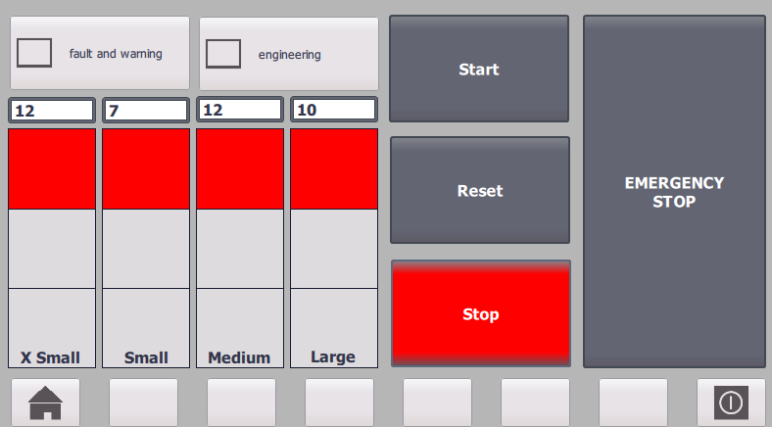
Figure 4 - HMI Root Screen

The engineering screen displays the current count for each of the package types, as well as an input field, to change the parameter for the warning. Normally the HMI is a touch screen
so tapping the number will let the user change the value with the keypad on the display.

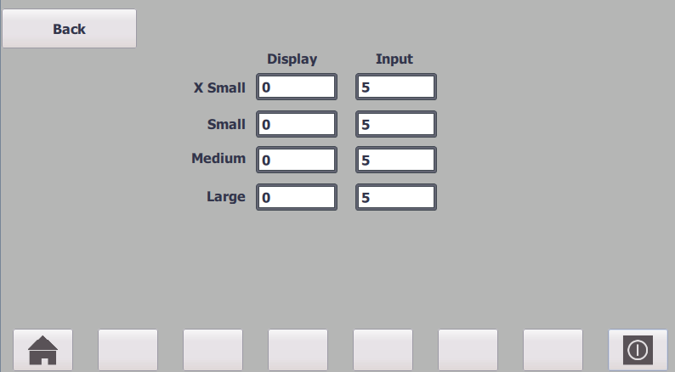
Figure 5 - Engineering HMI Screen

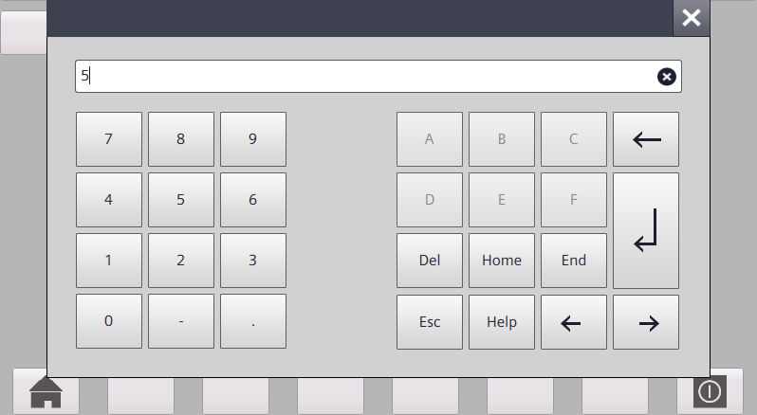
Figure 6 - HMI Touch Interface

The Fault and Warning screen will highlight any issues with the system. Firstly if a value hasn’t been set for the number of packages to be sorted, then the error will be raised for the relevant package size. There is also a warning for when the number of packages has exceeded the defined value.
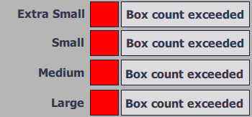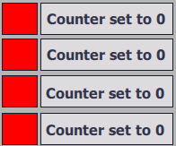
Figure 7 - Warning Indicator
Two errors can be detected, and they both stop the system as soon as they’re detected. Firstly, if a weight isn’t recognised by the weighing scales, an error is raised, as the scales conveyor won’t know which direction to move the package. Before this error was implemented, the packages would pile up as the scales wouldn’t move them. The second error is if a package is lost. This is done by counting the packages through the light array, and then deducting them as they pass a diffuse sensor on the exit slide. There can be up to six packages on the conveyor belt at a time, so if the counter raises above that then the system is stopped.
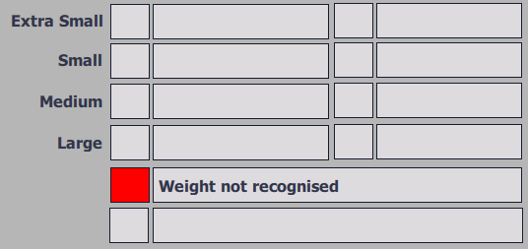
Figure 8 - Weight not recognised
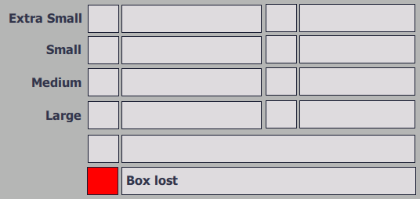
Figure 9 - Box lost

Operator Controls

The user can control the entire system through the HMI, including starting, stopping, and resetting. Through the HMI Engineering screen, the user can set the value for the package counter warning.

Warning and Error Strategy

During normal operation, the number of packages reaching the exit will climb to the defined value. During normal operation, the stack light for each counter will illuminate green. When the defined number has been reached, the stack light for that package type will illuminate yellow. The Red light is reserved for when the count is exceeded. These are only warnings, so the system will not stop itself. When the stack light switches from green to yellow, the desired number of packages have been sorted and the user needs to either set a new value or reset the counters.

Conclusion

During this process, I learnt how to integrate a PLC into the manufacturing environment, how to program a PLC with Ladder Logic, and how to configure an HMI. Through further research, I learnt of other programming methods like Function Block Programming and Structured Control Language.

In retrospect, I would have evaluated my design more through the design process. As I completed each stage of the design, the previous stage became impractical to change as each stage is dependent on the other. After I had written the program, I evaluated the system as a whole and considered the possibility of rearranging the factory to move the weighing scales to the start of the system and remove the light array. This would have had the benefit of not requiring the light array, and because every package type has a unique weight, I could have immediately counted it. The drawback would have been an additional pusher as well as additional hardware. As my original aim was to keep the cost down and use the provided hardware and limit the additional parts required, I decided that my original design better fitted my original intentions.

References
Clark, I. & Mostert, S., 2006. IS THERE A PLC ALTERNATIVE FOR INDUSTRY?, Stellenbosch: University of Stellenbosch.

Siemens, 2020. Programming Style Guide. [Online]
Available at: https://cache.industry.siemens.com/dl/files/084/109478084/att_1022099/v1/81318674_Programming_Styleguide_DOC_v20_en.pdf
[Accessed 16 1 2022].

Siemens, n.d. LOGO! Software. [Online]
Available at: https://new.siemens.com/global/en/products/automation/systems/industrial/plc/logo/logo-software.html
[Accessed 14 1 2022].

Wool, A. & Malin, U., 2019. Vulnerabilities in Siemens’ most secure industrial PLCs can lead to industrial havoc. [Online]
Available at: https://www.helpnetsecurity.com/2019/08/09/siemens-plc-vulnerabilities/
[Accessed 7 1 2022].

https://uk.rs-online.com/web/p/plcs-programmable-logic-controllers/2097104
https://uk.rs-online.com/web/p/plcs-programmable-logic-controllers/8624471
https://uk.rs-online.com/web/p/plc-accessories/8251704
https://uk.rs-online.com/web/p/plcs-programmable-logic-controllers/7609229
https://uk.rs-online.com/web/p/plc-accessories/6503016
https://uk.rs-online.com/web/p/plcs-programmable-logic-controllers/1235959
https://uk.farnell.com/mitsubishi/gx-developer-fx/software-micro-fx-plc/dp/3825577
https://uk.rs-online.com/web/p/plcs-programmable-logic-controllers/5288615
https://uk.farnell.com/siemens/6es7400-1ta01-0aa0/rack-18slot-482-5mm-wx290mm-hx27/dp/3555862?st=s7400
https://uk.farnell.com/siemens/6es7400-0hr51-4ab0/plc-programmers/dp/3486444?st=6es7400
https://uk.farnell.com/siemens/6es7400-0hr04-4ab0/plc-programmers/dp/3486443?st=6es7400
https://www.parmley-graham.co.uk/automation/siemens/plc-s/s7-400/s7-400h-redundant/s7-400h-redundant-bundles/6es7400-0hr04-4ab0
https://uk.rs-online.com/web/p/plc-accessories/4556721
https://uk.rs-online.com/web/p/plc-accessories/4556759
https://uk.rs-online.com/web/p/plc-accessories/4556664
https://uk.rs-online.com/web/p/plc-accessories/4556945
https://cache.industry.siemens.com/dl/files/740/1117740/att_903877/v1/module_data_en_en-US.pdf
https://uk.rs-online.com/web/p/plc-accessories/4556945

