Analysis of Results
This chapter will look at the results collected by the primary research that was conducted being a questionnaire and compare it to the research that it already available and that has been conducted and tested.
A significant proportion of the study were between the ages of 18 and 44, representing a wide demographic sample. A balanced gender perspective was provided by the representation of both male and female participants. This is important as it reflects the opinions, needs and experiences of everyone and avoids bias.
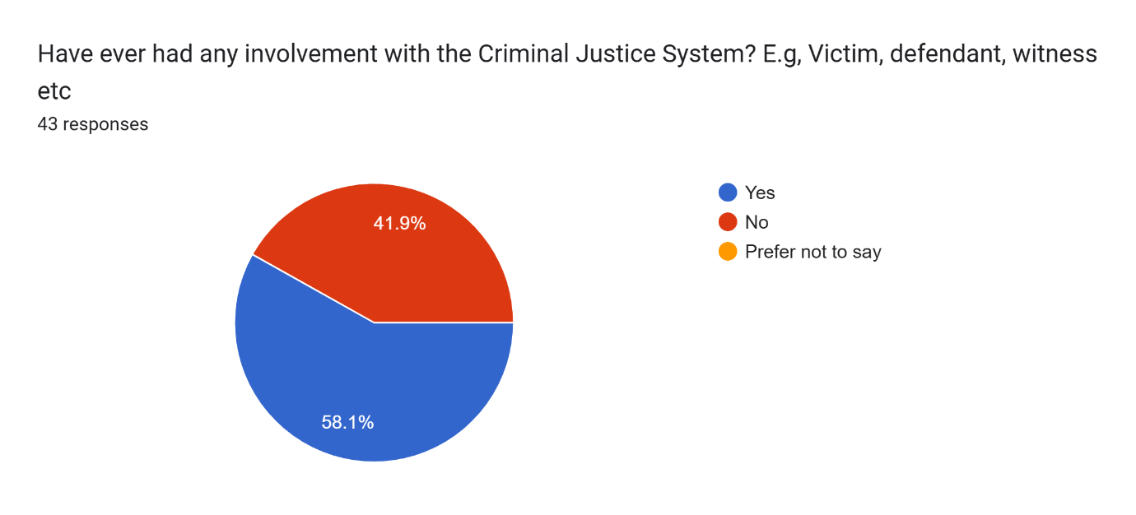
Question: “Have you ever had any involvement with the Criminal Justice System?”
58.1% of respondents had prior criminal justice system experience, while others did not (41.9%). Experience frequently coincides with more critical appraisals, which makes this divide significance. According to Roberts and Stalans (2019), and the Justice Committee (2022), people who have direct experience are more prone to doubt the fairness of the system, whilst others rely their opinions on secondary sources such as the media. This divide is reflected in the findings from the survey, which show that respondents with experience were more likely to openly discuss perceived injustice or leniency in sentencing. This is consistent with research on how scepticism is influenced by experiential knowledge.

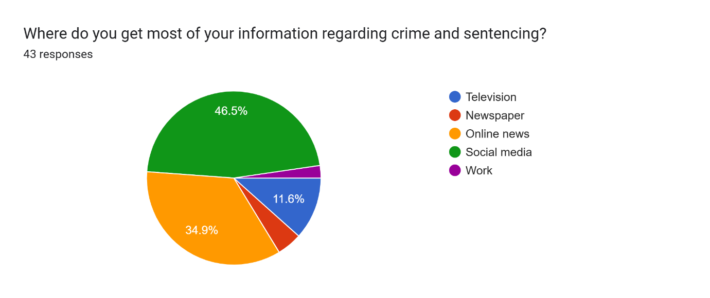
Question: “Where do you get most of your information regarding crime and sentencing?”
Social media and internet news were the most frequently mentioned primary sources (46.5%) by respondents. This supports a common theme in the literature that media narratives, not factual knowledge, have a significant impact on popular understanding. According to Marsh and Melville (2014) and Roberts and Stalans (2019), the public's perception of sentence is distorted by this reliance on the media. Pratt (2007) also presents the idea of "penal populism," in which sensationalist reporting encourages calls for more severe punishment irrespective of the facts presented by the courts. Given that respondents acknowledged media influence while also expressing strongly held opinions influenced by it, the current research lends credence to this tendency.

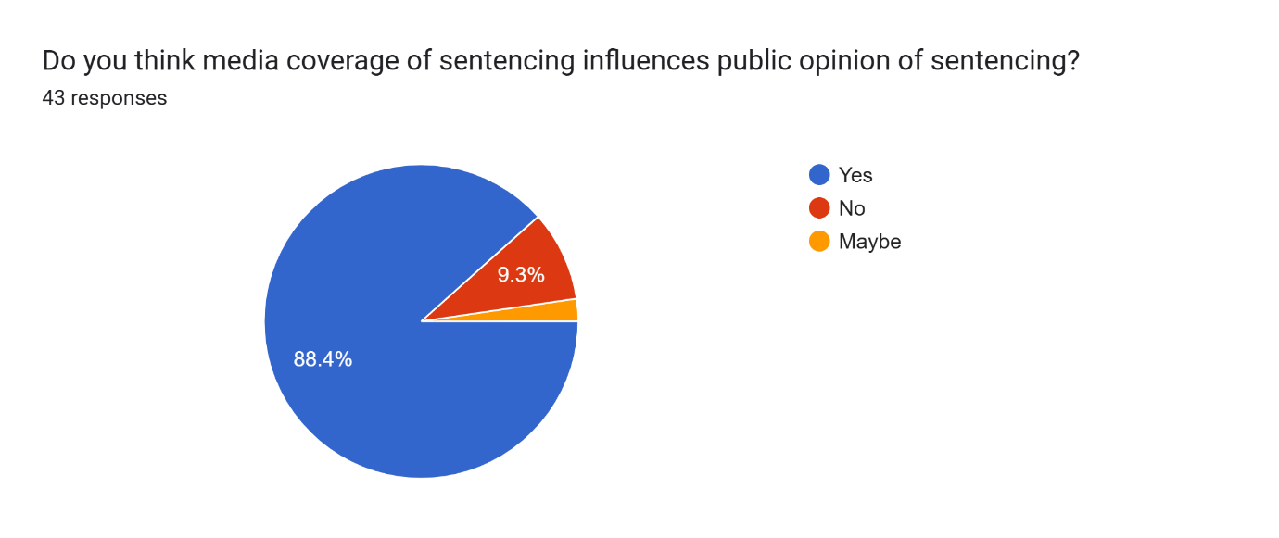
Question: “Do you think media coverage of sentencing influence’s public opinion of sentencing?”
A vast majority of the respondents (88.4%) indicated that they were aware of the media's ability to shape public opinion. This is in line with Sentencing Advisory Council studies (Gelb and Sentencing, 2006), which discovered that when the public is given media soundbites instead of the complete legal background, their attitude becomes harsher. Although it is encouraging that respondents are conscious of the impact of the media, there is a chance that, despite acknowledging bias, their opinions would still be influenced by such narratives. This finding supports the Ministry of Justice's (2013) recommendation that public legal education is necessary.

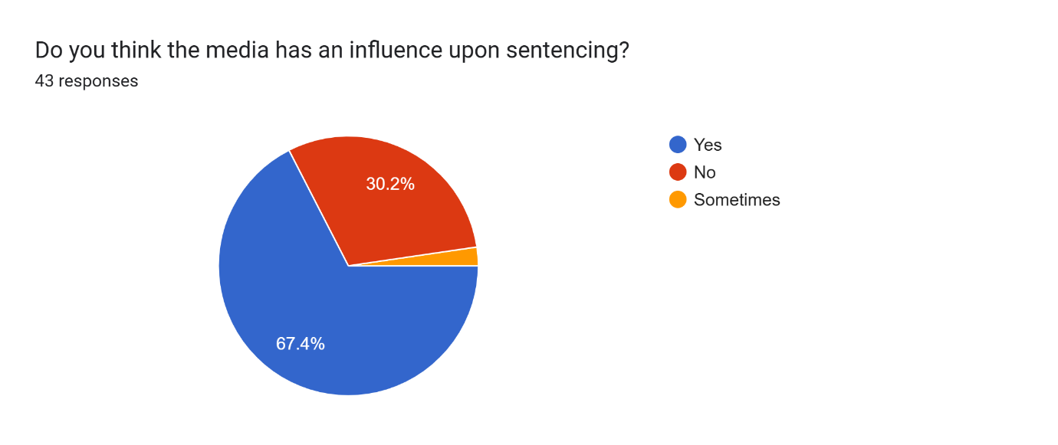
Question: “Do you think the media has an influence upon sentencing?”
Over two thirds (67.4%) believed that media pressure can affect court judgements, albeit not all of them agreed. This supports the worries expressed by Morgan, Reiner, and Maguire (2012), who warn that strong media attention, especially in high-profile cases, can impact the perception of the courts' independence. Additionally, this opinion aligns with the concept of punitive populism (Pratt, 2007), which holds that institutional and political forces indirectly influence sentencing policy. The apparent erosion of judicial integrity is probably a factor in the lack of trust that is seen in the further survey questions.

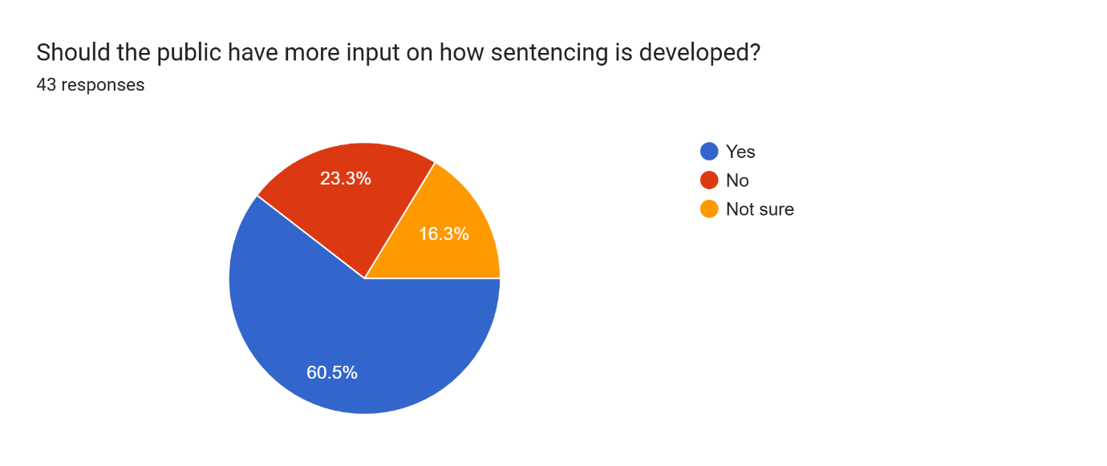
Question: “Should the public have more input on how sentencing is developed?”

The majority's affirmative response indicates that demand for participatory justice is rising. This type of public involvement could strengthen legitimacy without compromising judicial expertise, claims Marder (2016). But the literature also cautions against populism gone too far. To guarantee that the courts uphold consistency and legal integrity, Hough and Roberts (2005) argue that public involvement should be advisory rather than prescriptive. The survey's open-text responses show that the public prefers greater representation and transparency to control.
Question: “How much trust do you have in the criminal justice system?”
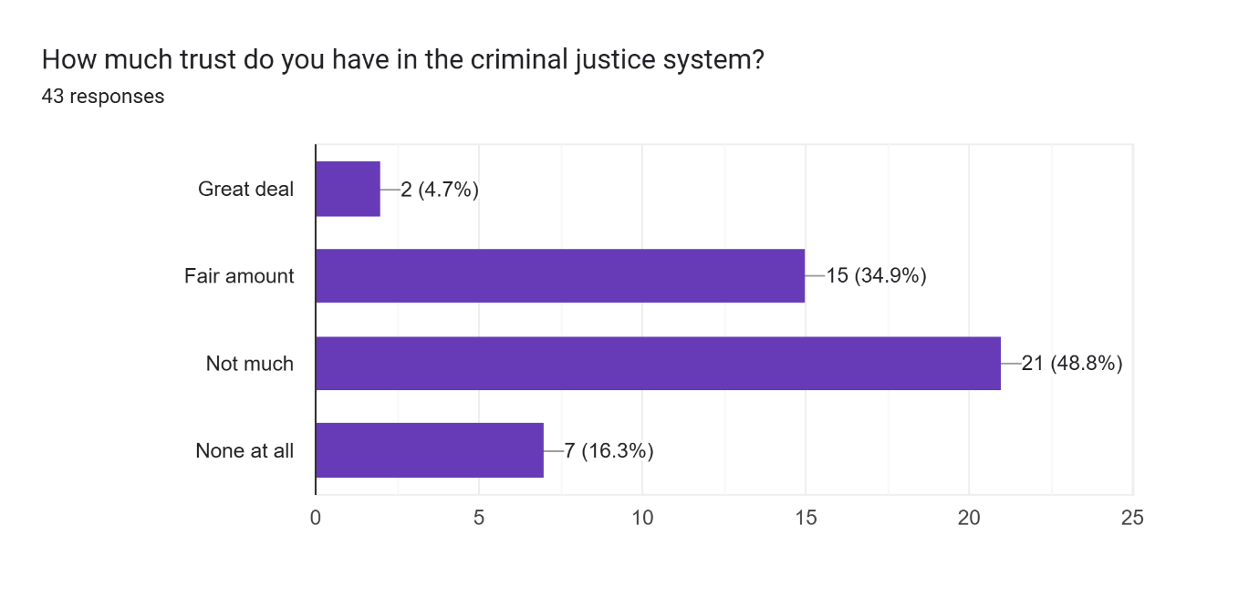
The majority of those surveyed chose "fair amount," "not much," or "none at all." These results demonstrate a weak foundation of trust, which is consistent with more general national data from the CSEW and Dodd (2024) that indicates a decline in public confidence, particularly among ethnic minorities and in metropolitan areas.

Question: “Does the way sentencing is handled affect your level of trust in the justice system?”
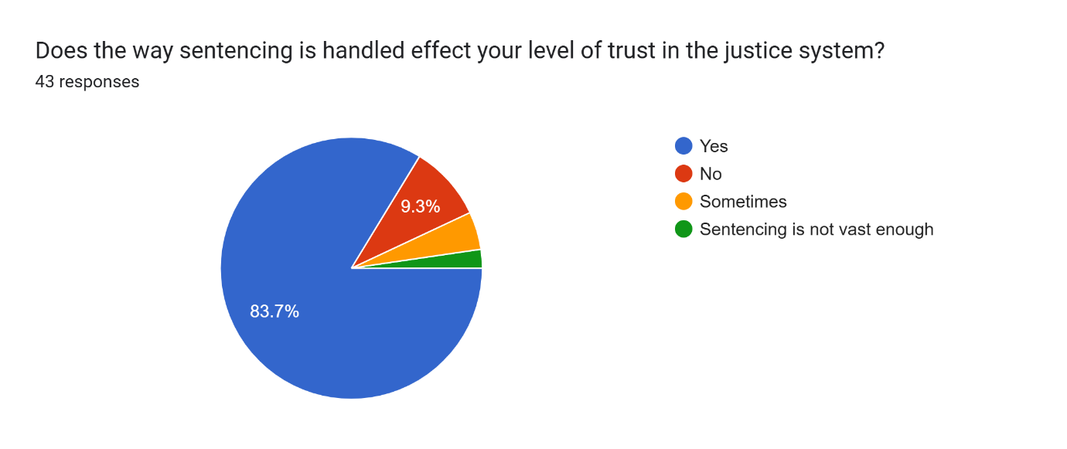
Almost everyone (88.4%) who responded said "yes" or "sometimes." This demonstrates that sentencing is a symbol of justice as well as a legal procedure. Jackson et al. (2012) contends that broader institutional trust, such as in the government and police, is impacted by how fair sentencing is regarded. This relates directly to the community trust, which demonstrates that lenient or inconsistent sentencing impair public confidence in law enforcement and criminal justice results in general (Bradford, 2017; Lammy, 2017).

Question: “Would more transparency in sentencing decisions increase your trust in the criminal justice system?”
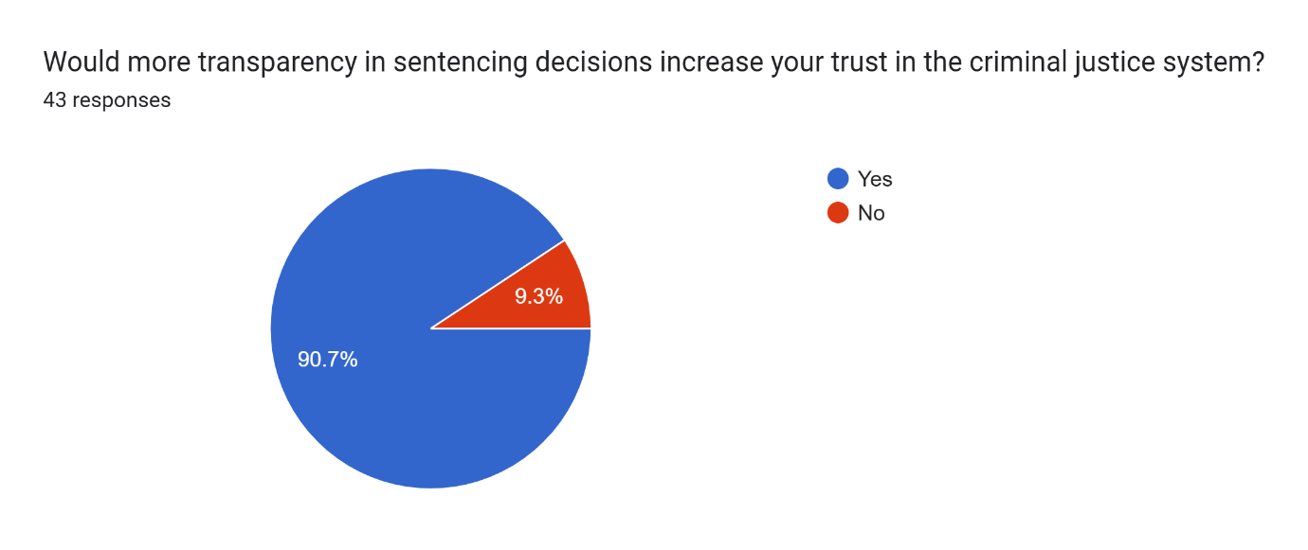
The resounding "yes" answer supports the public's demand for responsibility and clarity. According to Wood and Gannon (2011), the public frequently misunderstands legal terminology and procedures, leaving a gap that is populated by media interpretations. Several sources within the literature review section emphasised transparency, such as the punishment Council (2022) and the Justice Committee (2022), which both advocate for publicly accessible justifications of punishment to foster confidence.

Question: “What changes would help improve public trust in sentencing and the justice system overall?”
This question highlighted some reoccurring answers from the public, people suggested stricter punishments, clearer guidelines, public consultation and judicial consistency. These reaffirm the issues raised in your evaluation. According to Clark (2020), 70% of British citizens thought that sentences were too light, and your results support that conclusion. The sentence Council shares the respondents' desire for clear accountability and proportionality in sentence through the revisions to its guidelines. Additionally, requests for consultation are consistent with Marder's (2016) support of local justice forums and citizens' sentencing panels.

Question: “What are the biggest issues with how sentencing is handled today?”
When this question was answered, there were common themes throughout. The key issues identified by respondents were lack of consistency, overly lenient sentences, media influence and Unclear terminology. These answers mirror academic findings. Roberts et al. (2022) and Ashworth & Roberts (2013) both note that public opinion often exaggerates leniency due to misunderstanding and selective information. Wood and Gannon (2011) stress that confusion about terms like “on licence” or “life sentence” fuels scepticism. These responses call for education, reform, and clear communication, reflecting recommendations across the research.
The research, which shows a recurring discrepancy between popular views and court realities, substantially supports the conclusions.

Word Count – 1085

