

Student Name: Yusuf Khan
Student ID Number: 2433537
Module Name: Employability and Career Development
Module Code: LCLM4005_BIRM
Lecturer Name: Essa Bah
Assignment Title: Selection of written reflective tasks

Table of Contents
1: Job Adverts Comparison 2
1.1: Job Advert 1 - Marketing Executive 3
1.2: Job Advert 2 - Digital Marketing Executive 3
1.3 Comparison of Key Skills 4
1.4: Shared Skill 4
2: Self-Assessment and Evidence of Readiness 5
2.1: Self-Assessment 5
2.1.1: SWOT Analysis Assessment 5
2.1.2: Reflective Self-Assessment 6
2.2: Evidence of Readiness for Employability 7
3 Employment Goals and Personal Development Plan 7
3.1: Personal Development Plan 8
3.1.1: My Short-term goals 10
3.1.2: My Long-term goals 10
3.2 Personal Development Plan (PDP) 10
3.3 Continuous Professional Development - Gantt Chart 11
Reference list 13
Appendix (A) 15
Appendix (B) 17

1: Job Adverts Comparison
I have chosen two job advertisements, both of which are located in London: one for a marketing executive and the other for a digital marketing executive. I will compare and highlight the key skills and knowledge needed for each profession. I will point out any common patterns in the advertisements and discuss in more detail about one common skill and why it is essential to this role.

1.1: Job Advert 1 - Marketing Executive
The first job, Marketing Executive, is a post that focuses on tasks like managing social media, creating content and assisting with marketing initiatives (Appendix A). Good communication skills, creativity, teamwork and organisational talents are all emphasised in the job description.

These skills are crucial because marketing professionals collaborate with several organisations, supervise numerous projects and use a variety of marketing platforms to communicate messages to target audiences (O'Connor and Moran, 2024). To effectively participate in marketing initiatives, one must have knowledge about digital marketing strategies, brand promotion and consumer interaction.

1.2: Job Advert 2 - Digital Marketing Executive
The second role, Digital Marketing Executive, focuses mainly on data and digital marketing technologies (Appendix B). Search engine optimisation (SEO), data analysis and the usage of technologies like Google Analytics (GA4), SEMrush and Ahrefs are particularly mentioned in the job advertisement (Singh et al., 2025). These tools are utilised to evaluate campaign performance, analyse website traffic and increase search engine exposure (Okutan, 2025).

The position also calls for familiarity with paid advertising campaigns and content management systems (CMS), highlighting the growing significance of technical digital marketing expertise in today's marketing sector. Table 1 illustrates a comparison of the skills required for both job roles.

Table 1: Comparison of Skills
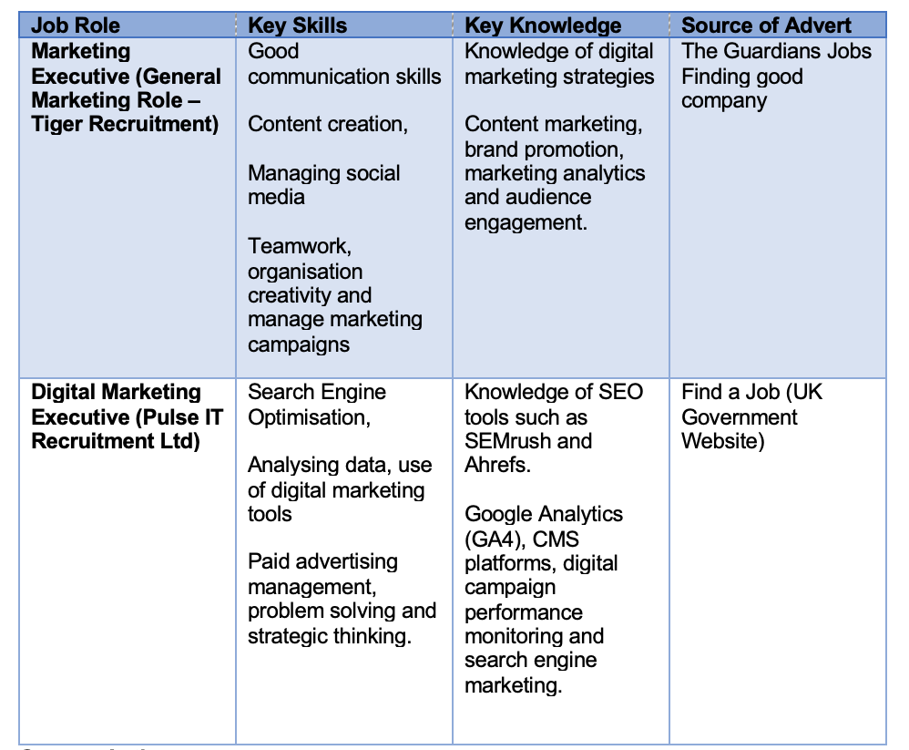

“Source: Author’s own”

1.3 Comparison of Key Skills
Despite their different focus, there are some important similarities between the two roles. Both advertisements highlight the importance of communication, digital marketing knowledge and the ability to manage marketing activities effectively. Employers also expect candidates to be organised, analytical and able to work collaboratively. These shared requirements reflect the key skills needed for marketing professionals today.

1.4: Shared Skill
Analytical thinking is a key shared skill identified in both advertisements. This skill is important because marketers must assess campaign performance and understand consumer behaviour. Data from websites, social media and digital advertising is often used to inform marketing strategies (Islam, 2024). By analysing this data, marketers can identify trends and make informed decisions to improve marketing performance and outcomes. Overall, the comparison of these job advertisements shows that the marketing industry demands a blend of technical, analytical and creative abilities. Professionals need to become well-versed in digital tools and data-driven decision-making as digital marketing expands (Alessi, 2024).

2: Self-Assessment and Evidence of Readiness

2.1: Self-Assessment
Self-assessment is a crucial process that enables individuals to consider their own skills, capabilities and areas that need improvement in order to be ready for future work (Yan and Carless, 2022). Individuals can assess how effectively they meet the requirements of their chosen job by reflecting on their own abilities and experiences.

2.1.1: SWOT Analysis Assessment
The SWOT analysis framework, which looks at strengths, weaknesses, opportunities and threats that could affect professional and personal development, offers a helpful tool for carrying out this kind of assessment. (Safitri et al., 2023). SWOT analysis is frequently used as a strategic planning technique to assist people in identifying both internal and external elements that may have an impact on professional advancement (Asrida et al., 2022).

Performing a SWOT analysis enables me to assess my present abilities and identify areas that need improvement in light of my intended profession in the marketing sector (Alizadeh and Foroughi, 2023). In addition to highlighting my career-enhancing strengths, this reflection identifies my shortcomings that must be strengthened to satisfy employers. My SWOT analysis based on my educational background, personal growth and professional goals is shown in the following table.

Table 2: SWOT Analysis

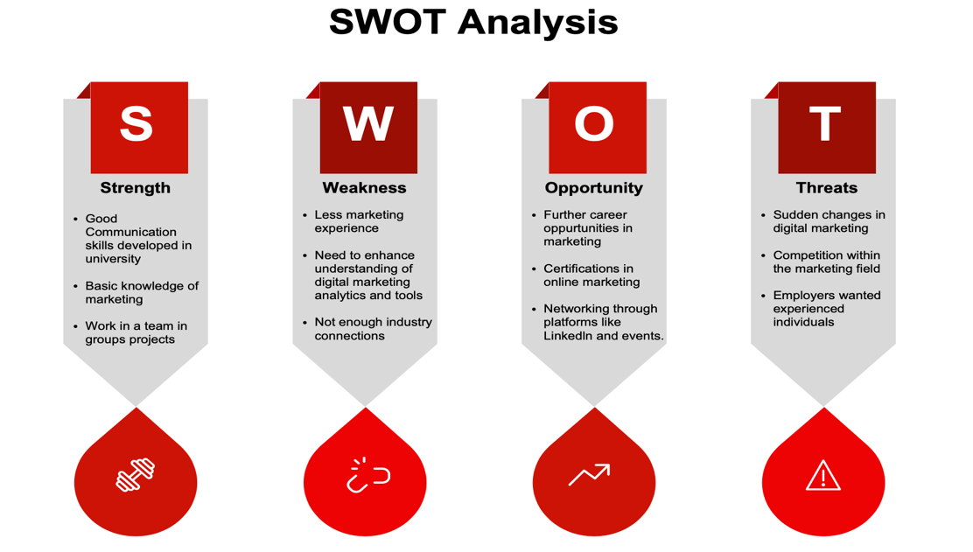

“Source: Author’s own”

2.1.2: Reflective Self-Assessment
A key component of becoming ready for a professional career is building employability skills. Employers favour graduates with transferable skills including digital literacy, problem-solving, collaboration and communication (Tushar and Sooraksa, 2023). I have started to developed several of these key skills through my coursework and personal growth initiatives, which will help me in my future marketing profession.

Communication skills are an essential component of readiness (Hidayatulloh and Ashoumi, 2022). I have written papers, given presentations and taken part in group debates during my time in university. My ability to express thoughts clearly and professionally has improved as a result of these exercises. Because marketing professionals must work with colleagues, explain marketing strategies and convey brand messages to clients, effective communication is especially crucial.

Teamwork is another crucial component of employability. It is one of the abilities that employers look for in graduates (Prada et al., 2022). Group work has been a major component of many of my academic tasks, necessitating cooperation, planning and shared accountability. Working in a collaborative setting has made it easier for me to comprehend how many viewpoints contribute to reaching a shared objective.

Along with my academic successes, balancing my private responsibilities and class deadlines has improved my time management abilities. Reliability and organisational skills are crucial for professional employment and managing deadlines shows these abilities (Pieterse et al., 2024). Time management and organisation are important employability qualities that companies look for in undergraduates entering the job. However, many areas that need improvement, are acquiring marketing experience and developing technical abilities like search engine optimisation analytics.

2.2: Evidence of Readiness for Employability
My academic accomplishments show that I am prepared for a job. I have improved my research, analytical and professional writing abilities through class projects, corporate reports and presentations. My ability to think strategically and comprehend real-world business difficulties has grown as a result of completing structured assignments like business planning. Participating in networking events, online training programs and internships will help me develop these skills and get ready for work in the marketing sector. Maintaining competitiveness in the changing world of digital marketing today requires ongoing education and professional growth (Kalandarovna and Qizi, 2023).

I consider myself prepared to collaborate at work thanks to group initiatives. For instance, I helped with team coordination, made sure deadlines were reached and offered ideas when working on marketing-related tasks. This demonstrates my capacity to function well in a group setting. Through online education and scholarly study, I have improved my computer skills. Word, Excel and PowerPoint are among the Microsoft Office products that are crucial abilities for reporting and presentations in marketing positions (Abdulkadir et al., 2024). Additionally, teachers' comments have emphasised my excellent written communication skills and approach to tasks. This shows that I am capable of producing work of a high calibre. In addition, I take the initiative to better myself through criticism and apply it to improve my work. This exemplifies a growth mindset, which is highly regarded by employers. Overall, my academic achievements, interpersonal abilities, collaborative ability and motivation demonstrate that I am prepared for a career in the marketing field and continue growing professionally, even if I still need additional real-world industry experience.

3 Employment Goals and Personal Development Plan

3.1: Personal Development Plan
Upon recognising the weaknesses in my SWOT analysis, I have developed both short and long-term employment aims to improve these shortcomings, I designed a Personal Development Plan that outlines actions, timelines and resources required for improvement for employment goals (Ilmast, 2023). Regular reflection and progress evaluation will help ensure that I remain focused on developing the skills necessary for a successful career in marketing (Allil, 2024).

Table 3: Employment Goals Table
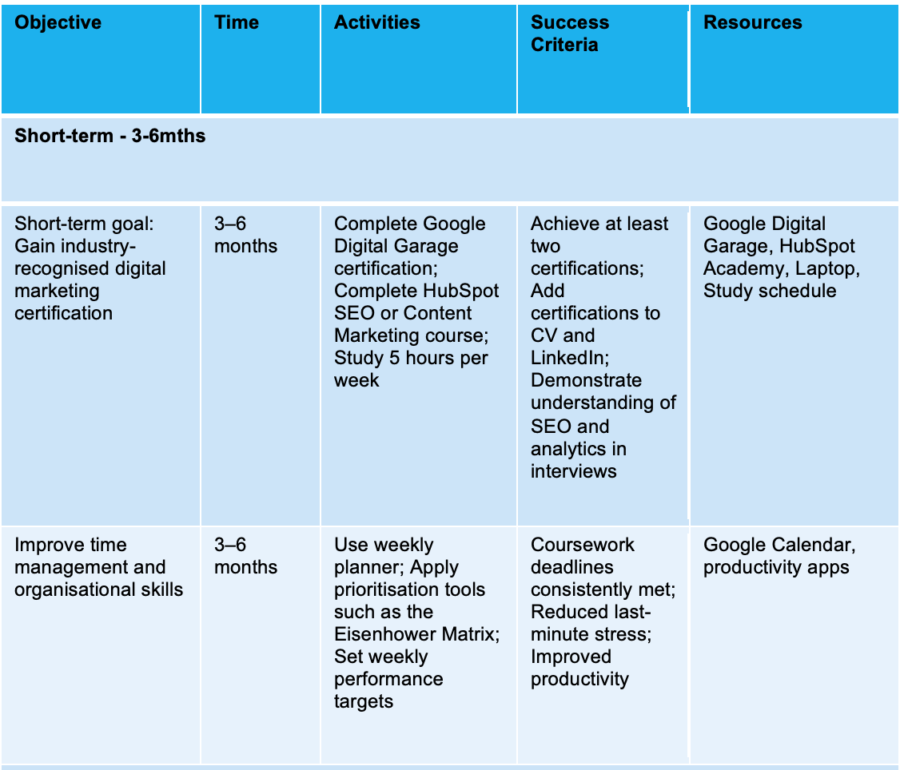

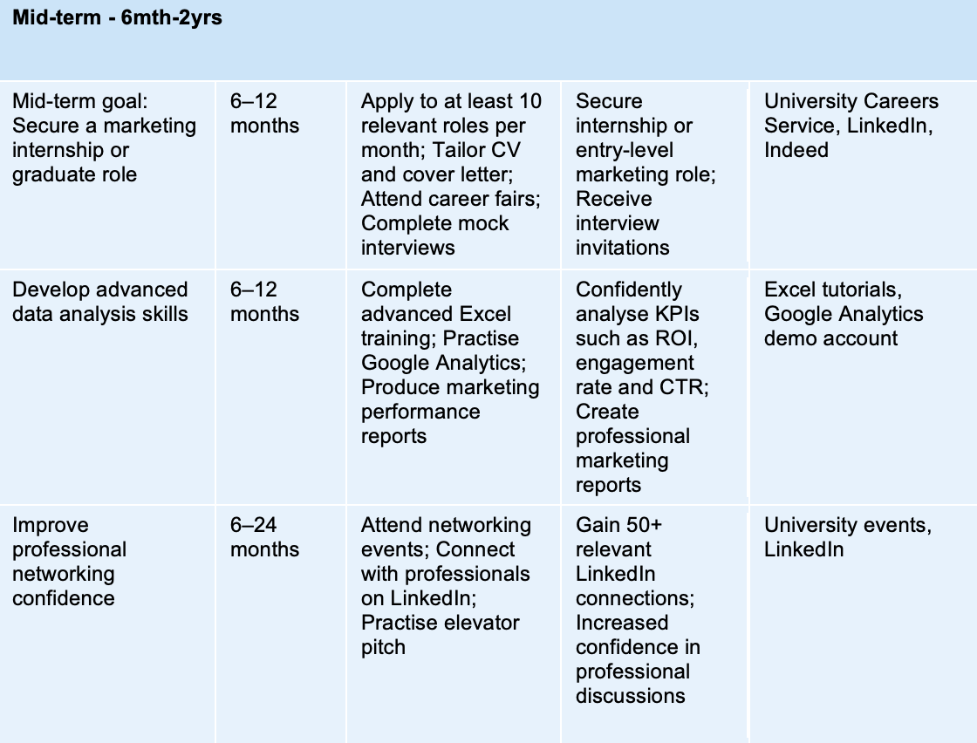
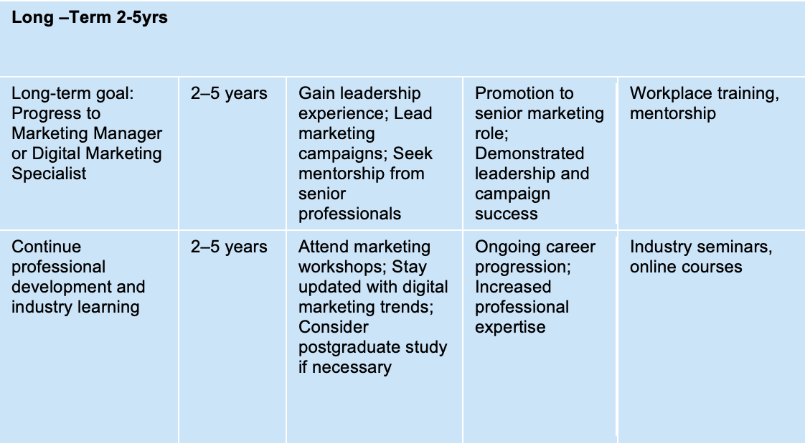
“Source: Author’s own”

3.1.1: My Short-term goals
My goal is to improve my skills in digital marketing, especially with regard to Google Analytics, search engine optimisation (SEO) and digital marketing tools. These abilities are frequently needed in marketing job postings and are crucial for evaluating campaign performance and increasing web visibility.

To accomplish this goal, I will finish courses that will increase my employability and prepare me for entry-level marketing positions. Getting real-world marketing experience through internships, part-time jobs, or volunteer work is another short-term objective. This will assist me in putting theoretical knowledge I gained in university to practice and develop important professional abilities like problem-solving, collaboration and communication.

3.1.2: My Long-term goals
My long-term objective is to secure a role as a Digital Marketing Executive within a company or marketing agency. In this position, I would manage digital campaigns, analyse marketing data and develop strategies to increase brand awareness and customer engagement. Achieving this goal will require continuous professional development and strong analytical skills.

I have created a Personal Development Plan outlining the actions, timeframes and resources needed to achieve these objectives. Regularly reviewing my progress will help ensure I remain focused on developing the skills required for a career in marketing.

3.2 Personal Development Plan (PDP)
In my Personal Development Plan table below, I have outlined specific actions that I will take to address my weaknesses. I have included timelines, required resources and how I will measure my progress.

Table 4: PDP Table
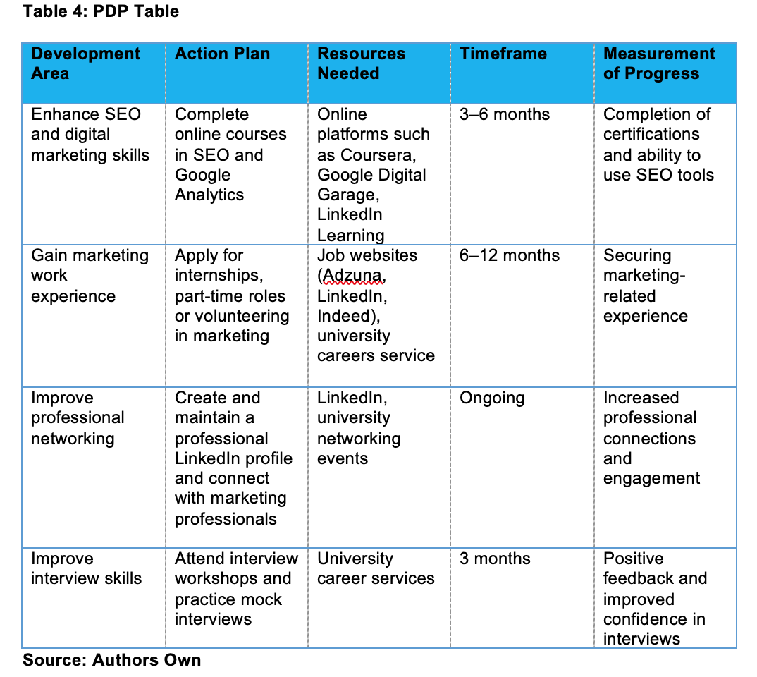

“Source: Author’s own”

3.3 Continuous Professional Development - Gantt Chart
The procedure of gaining professional expertise, skills and experience to enhance employability and career advancement is known as continuous professional development, or CPD (Nassereddine and Nassreddine, 2024). The tasks that will help me advance in the marketing sector are shown in the Gantt chart below. Completing training in digital marketing, expanding one's understanding of analytics tools, developing a professional network and obtaining experience through internships are some of these tasks. The timeline shows how these training exercises will be conducted over a six-month period to improve my abilities and get me ready for entry-level marketing positions (Sekuloska, 2025).

Table 5: Continuous Professional Development Gantt Chart

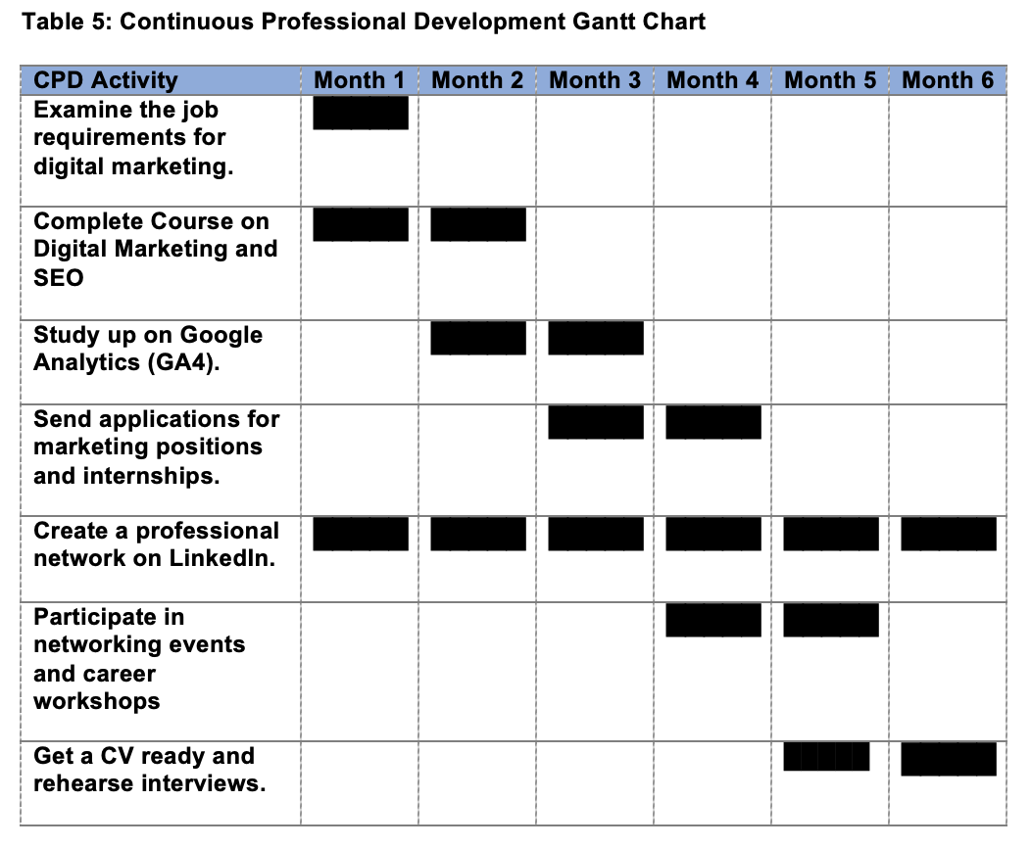
Source: Author’s own

Reference list
Abdulkadir, H., Kankara, S.B. and Sale, M. (2024) ‘Appraisal of Self-Efficacy in The Use of Microsoft Office Tools for Effective Service Delivery in The Tertiary Institutions of Katsina State, Nigeria’, International Journal of Innovative Information Systems & Technology Research, 12(1), pp.49-62.

Alizadeh, H. and Foroughi, M. (2023) ‘A strategic SWOT analysis of leading electronics companies based on artificial intelligence’. International Journal of Business Management and Entrepreneurship, 2(3), pp.59-74.

Allil, K. (2024) ‘Integrating AI-driven marketing analytics techniques into the classroom: pedagogical strategies for enhancing student engagement and future business success’. Journal of Marketing Analytics, 12(2), pp.142-168.

Asrida, A., Simahatie, M., Elfiana, E., Zahraini, Z. and Mangkuwinata, D.S. (2022) ‘SWOT Analysis and Marketing Strategy to Increase Home Business Sales Volume’. Journal Ekonomi, 11(03), pp.1492-1495.

Hidayatulloh, M.K.Y. and Ashoumi, H. (2022) ‘The Perspective of Work Readiness in Vocational School Students with 21st Century Communication and Collaboration Skills’, Cypriot Journal of Educational Sciences, 17(7), pp.2199-2206.

Ilmast, M. (2023) ‘Developing a Work Personal Development Process and Personal Development Plan Template for an Engineering Design Company’, Pp.1-109.

Islam, M.A. (2024) ‘Impact of big data analytics on digital marketing: Academic review’, Journal of Electrical Systems, 20(5s), pp.10-52783.

Kalandarovna, A.G. and Qizi, A.M.A. (2023) ‘Development and increase of competitiveness of the organisation. ASEAN Journal of Educational Research and Technology, 2(3), pp.265-274.

Nassereddine, M. and Nassreddine, G. (2024) ‘The impact of continuous professional development activities on student learning outcomes and employability’, International Journal of Evaluation and Research in Education, 13(5), pp.2971-2978.

O'Connor, C. and Moran, G. (2024) ‘The challenge of skill development through “experiencing” integrated marketing communications’, Higher education, skills and work-based learning, 14(3), pp.610-624.

Okutan, S. (2025) ‘Search Engine Optimization (SEO) and Search Engine Marketing (SEM)’, Online Retail Marketing Strategy: Foundations and Consumer Experience, 7(2), pp.85-90.

Pieterse, B., Agyekum, K., Manu, P., Mohandes, S.R., Cheung, C. and Yunusa-Kaltungo, A. (2024) ‘Examining critical project management skills for successful delivery of major maintenance projects: insights from the United Kingdom energy sector’, Engineering, Construction and Architectural Management, 31(4), pp.1556-1584.

Prada, E.D., Mareque, M. and Pino-Juste, M. (2022) ‘Teamwork skills in higher education: is university training contributing to their mastery?’, Psicologia: Reflexao e critica, 35, p.5.

Safitri, E.D., Junaedi, S.R.P. and Priono, A. (2023) ‘SWOT Analysis is used in the startup business development strategy’, Startupreneur Business Digital (SABDA Journal), 2(2), pp.136-142.

Sekuloska, F.M.J.D. (2025) ‘Increasing Project Efficiency by Utilizing Project Management Software & Gantt Charts’, Journal of University of Information Science and Technology “St. Paul the Apostle”–Ohrid, 5(2), p.5.

Singh, B., Wongmahesak, K. and Chandra, S. (2025) ‘Specifying Key Strategies and Tactics for Content Marketing: Search Engine Optimization (SEO) in Online Market’, In Practical Strategies and Case Studies for Online Marketing, 6, pp. 37-56.

Tushar, H. and Sooraksa, N. (2023) ‘Global employability skills in the 21st century workplace: A semi-systematic literature review’, Heliyon, 9(11).

Appendix (A)
https://jobs.theguardian.com/job/10036271

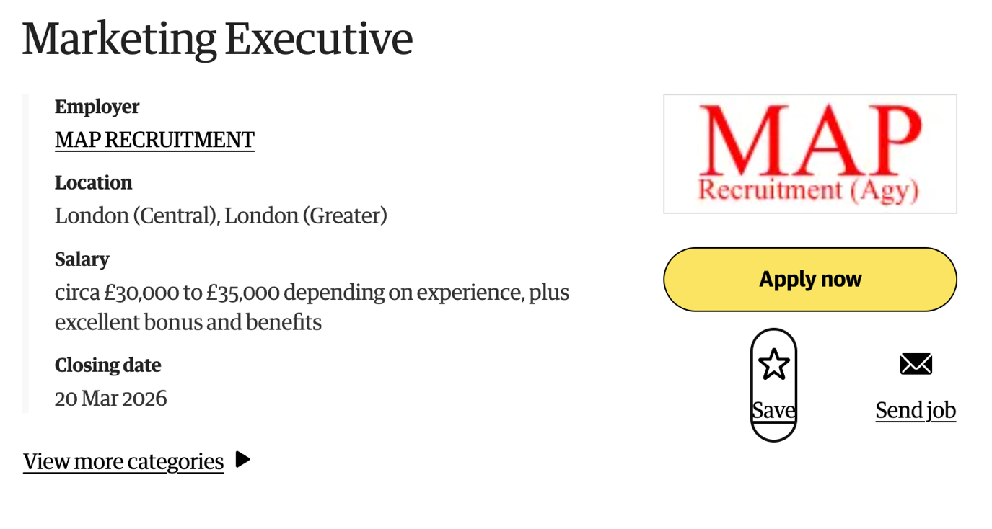
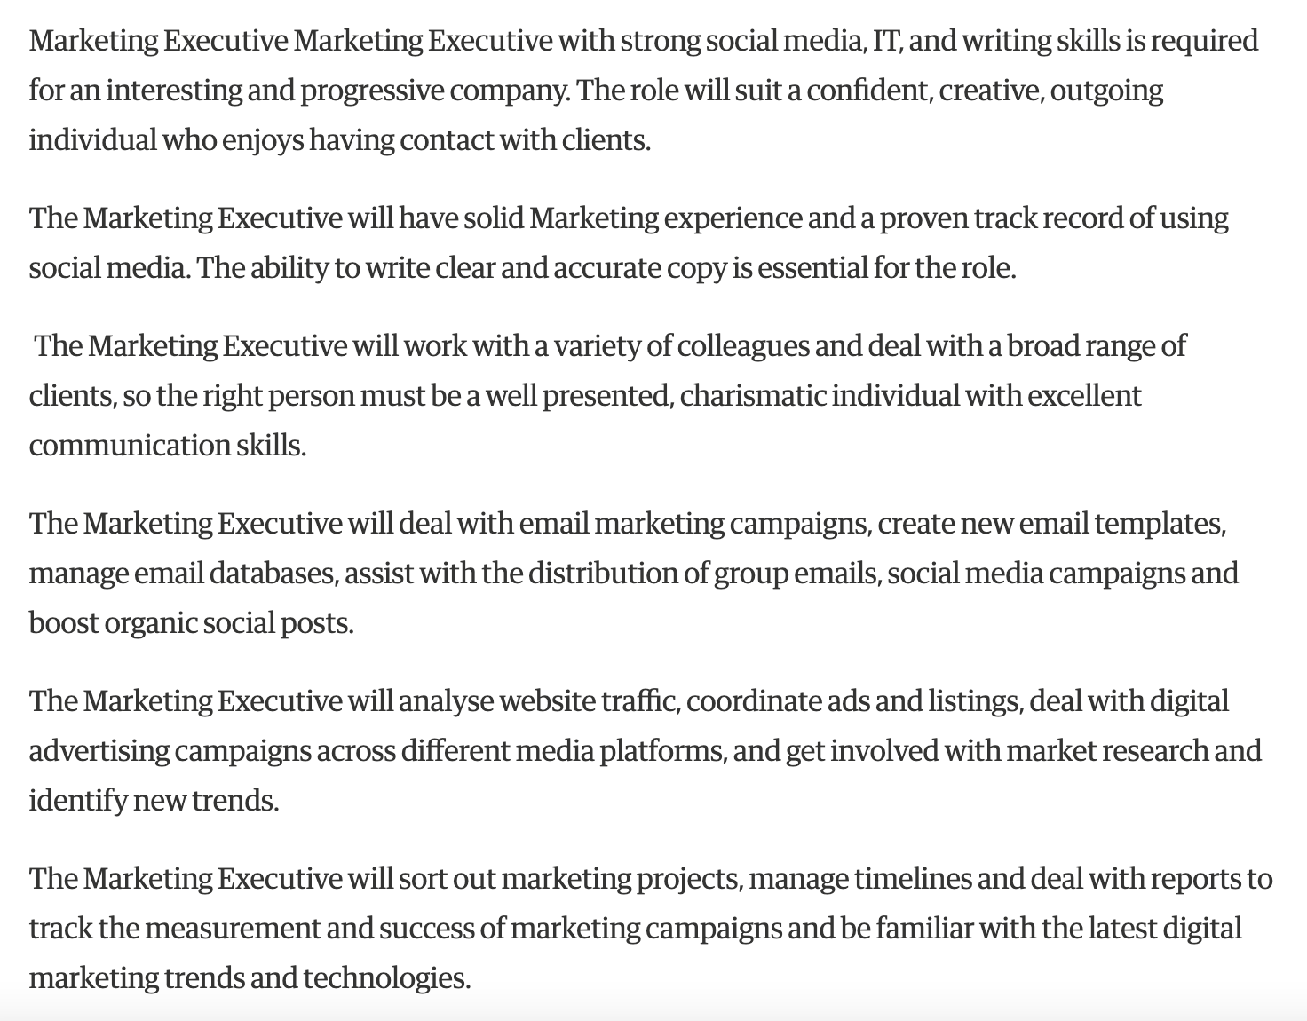
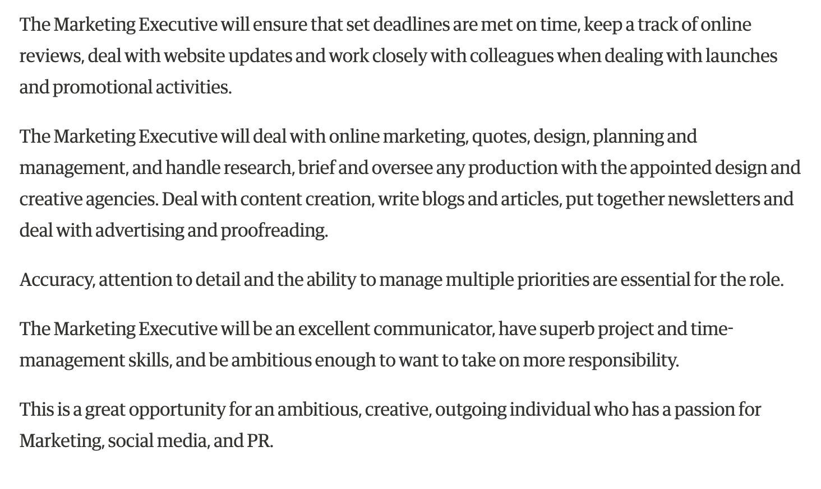

Appendix (B)
https://findajob.dwp.gov.uk/details/17205640



