Loved One with Dementia?

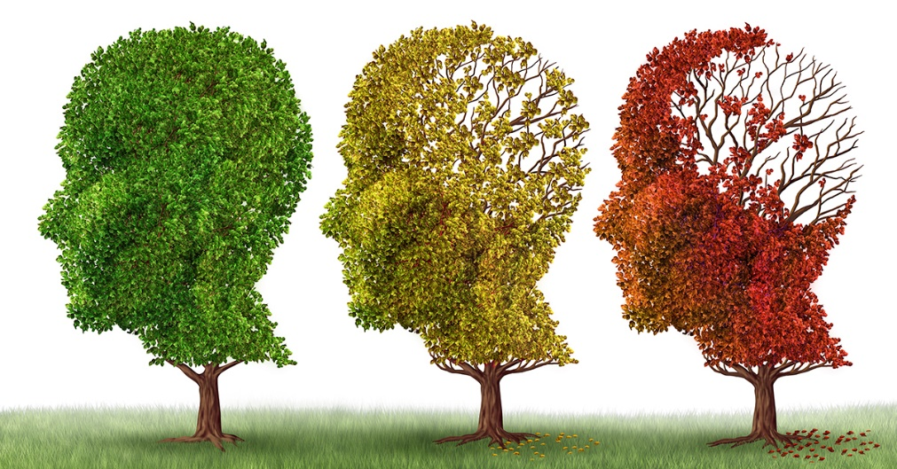
Late Stages:
- Loss of awareness and surroundings
- Difficulty communicating
- Assistance with daily needs
Early Stages:
- Misplacing Objects
- Remembering names
- Trouble organising/planning

We know caring for a loved one with Dementia can be challenging, some days will be harder to cope than others. We hope this leaflet guides you to better understand and support your loved one through this difficult time.
Symptoms:
- Difficulty eating and swallowing
- Insomnia
- Obsessive behaviour
Jaspreet Rai 2007674
Dementia is a condition which affects the neurones in the brain from working properly. There are different types of dementia all with similar symptoms. Your loved one may be displaying behaviours which seem alarming therefore it is important to understand the stages of the disease (NHS, 2020).
Alzheimer’s Disease
This form of Dementia is one of the most common, if your loved one has been diagnosed with Alzheimer’s you can expect the following stages to occur:
Middle Stages:
- Forgetting past history
- Mood change/withdrawn
- Confusion with day/time
- Wandering/becoming lost
- Loss of bladder function
(Challis, D., Giebel, C.M., and Sutcliffe, C., 2014)

Vascular Dementia
This type of Dementia is more common with those with high blood pressure or diabetes and can occur after a stroke or a series of mini strokes. Vascular dementia is more likely to affect movement in the earlier stages (Laven, P., 2019).
Mid Stages:
- Safety Issues
- Struggles with daily tasks
- Muscles weakness
- Depression/anxiety
- Getting lost
- Severe confusion

Early Stages:
- Withdrawn from family and friends
- Slowed thinking
- Memory loss
- Mild confusion (Terra Vista, 2022)

Late Stages:
- Delusions/hallucinations
- Aggression
- Inappropriate behaviour
- Physically fragile
- Full time care
Symptoms:
- Stroke like symptoms (temporary paralysis, muscle weakness)
- Movement problems
- Highly emotional

What You Can Do To Help
Depending on what stage of Dementia your loved one has reached, they will need specific needs and requirements. Dementia can have an impact on ones self-esteem and confidence, so it is important to support and encourage your loved one to continue doing the things they love (Alzheimer’s Society, 2022). 

If your loved one is experiencing problems communicating, speak slower using simple words, avoid sudden movements and tense body language or facial expressions. Maintain eye contact as this helps your loved one to focus.
Taking extra safety precautions, you can support your loved one’s independence by encouraging them to do things ‘with’ you rather than ‘for’ them i.e., gardening, shopping, laying table. Also allow plenty of time to do these tasks together whilst promoting reassurance and encouragement (NHS, 2022)
Sufferers of Dementia may experience a loss of appetite and become dehydrated which can put them at further risk, ensure you offer food your loved one likes and is easy to hold,
Medication
A number of medicines are available to treat Dementia, a medical professional would have prescribed the most suitable for your loved one depending on what type and stage of Dementia they have. Some types of Dementia such as ‘Reversible Dementia’ can be reversed by the use of hormone supplements, antidepressants, and antibiotics (Dementia.org, 2022).
However Vascular Dementia is not reversable but can be managed by such drugs as beta blockers which control hypertension. Smoking and alcohol consumption should be stopped immediately and making sure your loved one eats balanced and healthy meals is essential.
Treating Alzheimer’s by medication can involve the use of Memantine which can decrease symptoms, and a number of inhibitor based drugs such as Glutamate and Acetylcholinesterase can slow down the progress of Alzheimer’s (NIA, 2021).


Therapy and Interventions
Therapy for Dementia has been proven to help with the well-being, moods, and everyday functioning of sufferers. It is important to consider this method of treatment for your loved one as counselling and support can ease symptoms of anxiety and depression (Woods, B. 2005).
- Reminiscence Therapy – RT works by using props such as photographs, music, to evoke memories and the use of sensory stimulation can treat memory loss in dementia patients.
- Cognitive Stimulation Therapy – involves stimulating activities such as word and musical games, puzzles, and discussions. The supportive and friendly environment encourages patients to interact amongst each other, and the theory is proven to maintain memory functioning.
- Reality Orientation – this form of intervention reinforces self-identity for your loved one and reminds them of the present and surrounding environment by using props such as calendars and signposts. This can be accommodated in a group or one to one sessions.
- Aromatherapy – this would be managed with a personalised approach depending on the individual’s needs. This is an ancient practice which has some promising results when treating dementia. Certain oils can be used to aid a calm and peaceful sleep, massages can help to relieve tensed muscles and encourage calmness to an individual’s life (Dementiauk, 2020)
Adaptions and Technology for your Loved One
We understand that you would want to do everything you can to help your loved one through these stages, therefore we recommend the following adaptions and tools for you to consider:
Memory Aids
Use clocks with larger faces which display the date, making it easier to read. Introduce diaries and calendars to your loved one to remind them of upcoming events or appointments or a whiteboard for writing lists. Pill dispensers such as dosette boxes or automatic ones which can be set in advance are useful to remind your loved one to take their medication.
Household Equipment
Timers can be bought for the kitchen to remind your loved one if the oven or hob is cooking. A kettle tipper is a frame that allows the kettle to be poured safely. Nonslip gloves is a great item to have to move pots and pans, washing up and to pour the kettle. Dark coloured cutlery such as red can appear more appealing to a sufferer of dementia and could encourage a larger appetite, also using cushion handled cutlery will ensure a tighter grip
Bathroom Adaptions
Bath steps could aid your loved one getting in and out the bath along with transfer benches and grab rails. Hoists can be used to transfer your loved one in and out the bath also. Bath seats can be bough to allow sitting in the bath more comfortable, safety plugs are useful to limit how much water is in the bath.
Walking and Moving Aids
Bed hand blocks will support your loved one to push themselves up in bed independently, transfer aids such as turntables have proven to have great success to help individuals move places in their home. Ramps for wheelchair users could be inserted outside and in the home, along with a stairlift for people who have difficulty using the stairs (Farran, C.J. 1997)
Technology
Smart devices such as Fitbit or smart watches can monitor your loved ones heartbeat, temperature, and blood pressure. In home cameras can provide a sense of security for families who are concerned for loved ones who live alone. A number of safety devices are available such as sensors and fall detectors. Alexa’s can prove helpful as an individual can ask Alexa to dial a number, ask for the date or even switch on other devices within the home.
Further Information:
Dementia Connect Support Line: 03331503456
Carers UK – 080880807777
Dementia Equipment visit: https://www.AlzProducts.co.uk
Helping Hands: 03308184235
References
Ageuk, (2022) Maintenance Cognitive Stimulation Therapy (MCST), Available at: https://www.ageuk.org.uk/our-impact/programmes/maintenance-cognitive-stimulation-therapy-mcst/ (Accessed: 31st October 2022)
Alzheimer’s Association, (2022) Stages of Alzheimer’s, Available at: https://www.alz.org/alzheimersdementia/stages#:~:text=Stages%20of%20Alzheimer%27s%201%20Overview%20of%20disease%20progression,3%20Middlestage%20Alzheimer%27s%20%28moderate%29%204%20Latestage%20Alzheimer%27s%20%28severe%29 (Accessed: 26th October 2022)
Alzheimer’s Research UK, (2015) Dementia in the Family: The Impact on Carers, Available at: https://www.alzheimersresearchuk.org/aboutus/ourinfluence/policy-work/reports/carers-report/ (Accessed: 1st November 2022)
Alzheimer’s Society, (2022) Understanding and Supporting Someone with Dementia, Available at: https://www.alzheimers.org.uk/get-support/help-dementia-care/understanding-supporting-person-dementia (Accessed: 29th October 2022)
Alzheimer’s Weekly, (2022) Red Plates for Eating with Dementia, Available at: http://www.alzheimersweekly.com/2014/08/red-plates-for-eating-with-dementia.html (Accessed: 1st November 2022)
Ball, E.L., et al, (2020) Aromatherapy for Dementia, Available at: https://www.cochranelibrary.com/cdsr/doi/10.1002/14651858.CD003150.pub3/abstract (Accessed: 1st November 2022)
Challis, D., Giebel, C.M., and Sutcliffe, C., (2014) Activities of daily living and quality of life across different stages of dementia: UK study, Available at: https://www.tandfonline.com/doi/full/10.1080/13607863.2014.915920?needAccess=true (Accessed: 27th October 2022)
DSiDC, (2019) Interventions, Available at: https://dementia.ie/interventions/ (Accessed: 31st October 2022)
Dementia.org, (2022) Treatments for Dementia, Available at: https://www.dementia.org/treatment (Accessed: 29th October 2022)
Dementiauk, (2020) Aromatherapy, Available at: https://www.dementiauk.org/getsupport/livingwithdementia/aromatherapy/#dementia (Accessed: 31st October 2022)
Dungen, P.V., et al, (2011) The accuracy of family physcians’ dementia diagnoses at different stages of dementia: a systematic review, Available at: https://onlinelibrary.wiley.com/doi/abs/10.1002/gps.2726 (Accessed: 26th October 2022)
Farran, C.J. (1997) ‘Theoretical Perspectives Concerning Positive Aspects of Caring for Elderly Persons with Dementia: Stress/Adaption and Existentialism’ The Gerontologist, Available at: https://academic.oup.com/gerontologist/article/37/2/250/617150?login=false Vol13 (2) doi:10.1093./geront/37.2.250 (Accessed: 1st November 2022)
Good Therapy, (2018) Reminiscence Therapy, Available at: https://www.goodtherapy.org/learnabouttherapy/types/reminiscencetherapy#:~:text=Reminiscence%20therapy%20%28RT%29%20is%20also%20known%20as%20life,use%20props%20or%20sensory%20stimulation%20to%20spark%20memories. (Accessed: 31st October 2022)
Helping Hands (2022) Why Choose Helping Hands? Available at: https://www.helpinghandshomecare.co.uk/about-us/why-choosehelpinghands/?infinity=ict2~net~gaw~ar~~kw~helping%20hands~mt~e~cmp~Brand~ag~&Jobboard=bing&c=ppc_Brand_&infinity=ict2~net~mac~ar~76072559755351~kr~76072853346287~kw~helping%20hands~mt~e~cmp~Brand~ag~Helping%20Hands%20%20Generic&msclkid=2079aded096d1ff6b28ece8907e3b3a0&utm_source=bing&utm_medium=cpc&utm_campaign=Brand&utm_term=helping%20hands&utm_content=Helping%20Hands%20-%20Generic (Accessed: 1st November 2022)
Laven, P. (2019) What is the difference between Dementia and Vascular Dementia? Available at: https://devotedguardians.com/what-is-the-difference-between-dementia-and-vascular-dementia/#:~:text=Alzheimer%E2%80%99s%20affects%20the%20grey%20matter%20while%20vascular%20dementia,affect%20movement%20in%20the%20earlier%20stages%20than%20Alzheimer%E2%80%99s. (Accessed: 28th October 2022)
NHS, (2020) About Dementia, Available at: https://www.nhs.uk/conditions/dementia/about/ (Accessed: 26th October 2022)
NHS (B), (2022) Looking After Someone with Dementia, Available at: https://www.nhs.uk/conditions/dementia/carers/ (Accessed: 29th October 2022)
NIA, (2021) How is Alzheimer’s Disease Treated?, Available at: https://www.nia.nih.gov/health/how-alzheimers-disease-treated (Accessed: 30th October 2022)
O’Brien, J.T., and Thomas, A., (2015) Vascular Dementia, Available at: https://www.sciencedirect.com/science/article/pii/S0140673615004638 (Accessed: 27th October 2022)
Terra Vista (2022) What are the stages of vascular dementia? Treatments & Tips, Available at: https://www.terravista.org/what-are-the-stages-of-vascular-dementia-treatments-tips/ (Accessed: 28th October 2022)
Trevisan, K., et al, (Theories of Aging and the Prevalence of Alzheimer’s Disease, Available at: https://www.ncbi.nlm.nih.gov/pmc/articles/PMC6601487/ (Accessed: 2nd November 2022)
Woods, B. et al, (2005) ‘Improved Quality of Life and cognitive stimulation therapy in dementia’ Aging and Mental Health, Available at: https ://www.tandfonline.com/doi/full/10.1080/13607860500431652?scroll=top&needAccess=true Vol.10 (3) doi:10.1080/13607860500431652 (Accessed: 30th October 2022)
Woods, B., et al, (2018) Reminiscence therapy for dementia, Available at: https://www.cochranelibrary.com/cdsr/doi/10.1002/14651858.CD001120.pub3/abstract (Accessed: 30th October 2022)
World Health Organization (2022) Dementia, Available at: https://www.who.int/news-room/fact-sheets/detail/dementia (Accessed: 29th October 2022)

