Assessment 2 – Technological Change and Innovation
This report is based around the automobile industry, sustainable business practices and the circular economy [This report will be formatted in print layout Microsoft Word .docx style]

Introduction

In this report I will be proposing my idea for a sustainable business project. In this module we have been tasked with drafting a report on an innovation idea that hasn’t yet been identified but that we think is potentially viable. My idea for a sustainable business project is applying the circular economy model currently being trialled on home appliances and clothes to the automobile industry, as well as how our current national fleet of personal cars, motorcycles and transport vehicles can be modernised, made more efficient and more sustainable in the long term.

What is sustainable business?

To understand my business proposal, you must first understand what sustainability means, McGill University defines sustainability as “Meeting our own needs without compromising the ability of future generations to meet their own needs” [1]

In essence, sustainability is the practice of meeting the needs of the present without compromising the ability of future generations to meet their own needs. Sustainability encompasses social, economic, and environmental dimensions. In terms of the economy, sustainability has several impacts. For example, sustainable practices can lead to cost savings for companies through increased efficiency and reduced waste. Additionally, investing in sustainable practices and technologies can create jobs and stimulate economic growth. Furthermore, a sustainable economy can lead to more stable and resilient communities by reducing dependence on non-renewable resources and reducing the negative impacts of economic activity on the environment. However, the implementation of sustainable practices can also lead to increased costs for companies and individuals in the short term, which can be a barrier to adoption. [2]

A sustainable business can include incorporating environmentally friendly practices, treating employees and stakeholders ethically, and contributing to economic development in a way that benefits the local community.
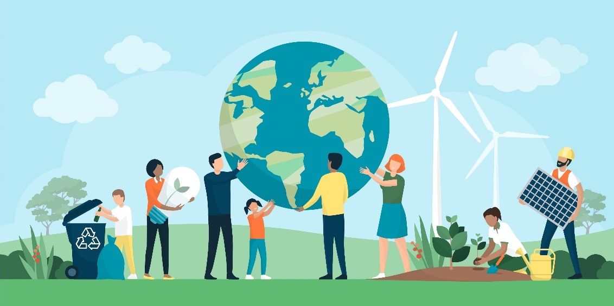
Sustainability in the global community – Art by Greenpeace
What is the Circular Economy?

The crux of my proposal lies with the implementation of circular economic principles, but what is a circular economy? Oxford Dictionary defines the circular economy as “An economic system based on the reuse and regeneration of materials or products, especially as a means of continuing production in a sustainable or environmentally friendly way.” [3]

The circular economy concept can be applied to cars in several ways. One way is by designing cars to be more easily recyclable and to use materials that can be easily reused or repurposed. Another way is by extending the life of cars through repairs and upgrades, instead of constantly producing new vehicles. Additionally, sharing and leasing models, as well as circular business models, such as product-as-a-service, can reduce the need for individual car ownership and thus decrease waste and resource use. Lastly, electric vehicles, which do not emit harmful pollutants, can reduce the environmental impact of transportation. [4]

