

UNIVERSITY OF WALES TRINITY SAINT DAVID

The impact of managerial style on the employee behaviour and success of the organization

Name: Sorina-Iulia Cosa
Student number: 2211474
Professor name: Dr Uju Ugochukwu
Introducing the Modern Workplace
LCBB4003

Table of Contents

1. Introduction 3
2.1. Amazon’s management style and employees behaviour. 4
2.1. The impact of managerial styles on the success of that organization 6
3. Conclusion 8
4. References 8

Introduction

Using employee innovation is one strategy for firms to increase their level of innovation, as De Jong and Den Hartog, 2007 stated. At the same time, they define leadership as the practise of persuading people to achieve a particular goal. A manager's tactics and attitude can affect a team's performance and output, and by extension, the entire organisation. Most individuals would agree that managers who effectively leverage team members' abilities and organize them behind shared goals would achieve higher performance results than those who stifle team member comments or provide meagre support. The management style of a leader may have an effect on the overall degree of employee engagement. (How management styles affect the workplace, 2022).
There is a cascading relationship between leadership and organisational performance. In every level of an institution, from management to employees, leaders shape values, cultures, receptivity to change and employee motivation. An institution’s leaders can be found at every level, not just in management, but all successful leaders share certain characteristics. They exert influence over those in their immediate vicinity in order to maximise the organization's resources, especially its most valuable and expensive asset: its workforce. Companies need leadership, much like in business, government, and non-profit organisations.. ( Germano et al., 2010)
Assigning duties, evaluating performance, and keeping an eye on employee behaviour are considered as management's responsibility, but planning and coordinating, establishing a vision, maintaining the group's direction, and encouraging and motivating the employees are seen as leadership's responsibilities. (Riggio,2017). Although, in my workplace which is Amazon Fulfilment Centre, the leadership and the management share almost the same duties, not following exactly the succession of responsibilities. Amazon Warehouse/ Fulfilment Centre is the workplace for qualified and also for underqualified people. Anyone can get a job at Amazon, but only the ‘old employees’ who have been with Amazon for a long time and have a permanent work contract will have the chance to become a manager or team-lead within the company. The information provided by Amazon online is not wide and also not completely true, but as a worker there, the access to information is wider and also more reliable. Leadership styles can be classified as autocratic, democratic, participative or laissez faire. The three types of leadership are situational, transactional, and transformational, depending on how authority is transferred and applied to achieve goals. However, evaluating a leader's effectiveness and quality heavily depends on their specific leadership style, especially when it comes to business objectives. (Germano et al., 2010). Below will be analysed how managerial styles affect how employees behave in Amazon fulfilment centre and how those managerial styles may affect how successful that organisation is.

2.1. Amazon’s management style and employees behaviour.

One of the most prosperous businessmen in the world is Jeff Bezos. Amazon, his business, is the biggest online retailer. I am working in one of his warehouses as a Trainer Step-Up Team-leader and my job expects me to follow Amazon’s leadership principles; from which the most important for my position are: ‘’invent and simplify’’, ‘’take ownership’’, ‘’learn and be curious’’, ‘’Develop the best’’, ‘’insist on the highest standards’’, ‘’dive deep’’ and ‘’deliver results’’. (Leadership Principles, 2014). It is very important as a team-leader to follow those principles and when applied, the other employees will feel respected and they will also show respect. It is also important to follow them for delivering the highest standards in training and coaching both new and old employees. The combination of different traits, behaviours, and qualities that leaders use to communicate with their staff is referred to as their leadership style. (Al Khajeh, 2018)
Bass distinguished between transactional and transformative leadership styles. Personal influence, spiritual encouragement, plus mental stimulation are qualities of transformational leadership. They typically take into account each individual, establish internal objectives and a vision, promote an open work atmosphere, and have faith in staff to achieve those objectives while maximising their potential. The focus of transformational leadership is on both the needs and the growth of followers. Managers who practise transformational leadership style focus on the expansion and development of employees' value systems, their degree of inspiration, and their ethical standards before talking about their technological skills. In a transactional leadership style, followers are rewarded for attaining particular goals or meeting performance requirements. The transactional leader will first confirm the link between reward and performance before exchanging it for a proper response that motivates subordinates to perform better. (Bass,1997) ‘’Leadership classifications use, directly or indirectly, the dichotomy of an autocratic leadership style versus A democratic one. Skills in interpersonal interaction may lead to democratic/participative styles, whereas lacking interpersonal skills may lead in an autocratic/directive style’’ (Taucean, Tamasila and Negru-Strauti, 2016)

Due to his strict standards, unrestricted power, and micromanaging manner, some claim that Jeff Bezos has an autocratic leadership style. However, Bezos has demonstrated that he prefers a transformational leadership style. Principles of Jeff Bezos' leadership style include Inspiration, tenacity, empowerment, learning, and flexibility. (Jeff Bezos Leadership Style). Even though Jeff Bezos is applying this type of management style, in the warehouses are plenty managers and they all apply their own management style. For example, in my workplace the managers sometimes are hired from outside as soon as they finish their studies and they are left to choose what style of management they want to apply, and sometimes they chose the autocratic one. Those managers will then chose a team leader to help them with their work and this person will behave the way that the manager wants, so they both will have an autocratic style; and so in the same workplace but different departments, employees will behave differently, depending on the way their leadership team is ‘teaching’ them. The differences between their leadership style and the employees behaviour are easy to be observed between departments, even though everything takes place in the same warehouse and certain rules are supposed to be followed by everyone.
Instead of being just directive, transformational leadership focuses on the growth and effectiveness of followers. These leaders strengthen the bond between themselves and their followers by boosting their morale and motivation. Successful firms are managed by transformational leaders who inspire, motivate, and empower their workforce. (Kalsoom, Khan and Zubair, 2018) There are numerous diverse theories of leadership which shows that the qualities set leaders apart from followers, and later ideas examined other elements such situational elements and skill levels. (Amanchukwu, Jones and Ololube, 2015) One of the theories seen to be applied in Amazon is the Transactional Theory, where there are exchanges between leaders and followers, as well as the functions of organisation and group performance. This theory attribute leadership to a mechanism of rewards and punishments. Workers are praised or reprimanded when they perform poorly and rewarded for their accomplishments. (Amanchukwu, Jones and Ololube, 2015) For example, in the warehouses the workforce is not actually valued because anytime someone is fired, someone else will quickly take its place, and employees are being let go by judging on their productivity, attendance and the quality of doing multiple jobs at once and being paid on doing just one of them.

2.1. The impact of managerial styles on the success of that organization

It is impossible to emphasize the significance of leadership in an organisation when it comes to creating a vision and mission, setting goals, creating strategies, policies, and procedures to achieve those goals, managing and coordinating internal procedures, and so on. The goal and vision must be achieved , as well as the external environment needs to be handled with excellent leadership. (Al Khajeh, 2018)
An organization's performance can be evaluated by comparing its results, or actual outputs, to its anticipated outcomes, goals, and objectives. Organizational success is comprised of three factors: financial performance (return on assets, profits, etc.), shareholder return (economic value added, total shareholder, etc.), and product/service stock performance (market share, sales). An organization's performance is significantly influenced by its leadership ideas. The leadership style has an impact on the culture of the company, which in turn has an impact on how well the company operates. ‘’ Autocratic leaders are classic and bossy in nature. The autocratic leaders want their subordinates to work according to them.’’ (Al Khajeh, 2018) In Amazon, is important for the target to be done by the end of the deadline and for this, leadership will do anything possible. They will sometimes pressuring the employees, they will take one decision one moment, and the other moment another decision and they will say they are ‘’operational needs’’, which shows that by any means necessarily they will get the job done.
When the transformational leadership style is being used in Amazon, Leadership places a strong emphasis on helping people grow their overall set of values, as well as their morals, degree of motivation and talents. The excellent communication abilities of transformational leadership enable followers and leaders to develop a solid understanding of one another's motivational levels, beliefs, and interests. (Al Khajeh, 2018) There comes the difference between the managers and the team leaders. The managers are taking administrative decisions in my workplace, and the team leaders are trying to follow their decisions, but at the same time they have to take care of the employees well-being, because they will be the ones who will help or not in achieving the success of the organisation.
The Leadership Transformational Theory is being applied in Amazon, which accentuate the bonds created between leaders and followers. Leadership, according to these perspectives, involves engaging with people and stimulating and elevating both followers and leaders through a connection with them. A transformational leader motivates and inspires their followers through helping them understand the value of the work and its larger purpose. These leaders care about each person realising their full potential in addition to the group's output. (Amanchukwu, Jones and Ololube, 2015) By this mean, if the leadership helps each employee to reach their potential, the task will be achieved and the organisation’s success will also be achieved.

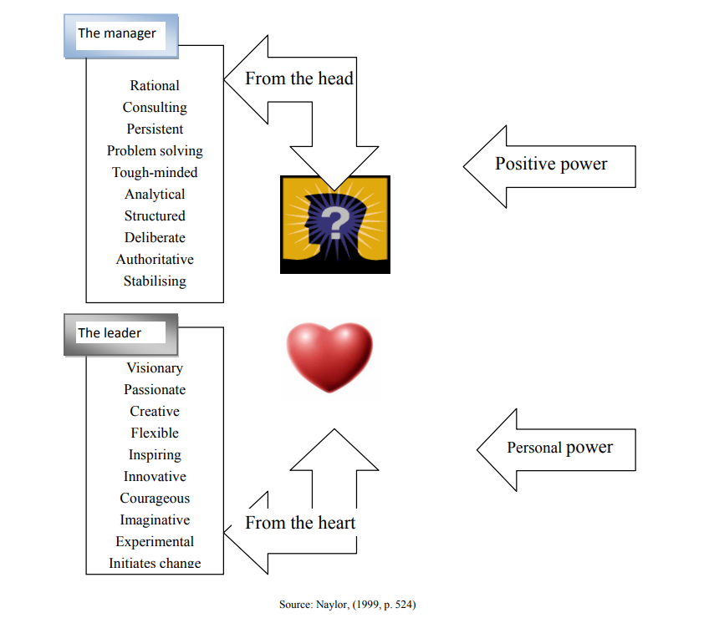

Conclusion

Upon exploring the situation from multiple perspectives, it is imperatively important to carefully consider and chose the right leadership style when running an organization, because this will dictate the behaviour of the employees and also the success or unsuccess of the organization. Amazon is a very successful business and it is all because of its way of managing everything within the organization. By choosing the transformational leadership theory and to encourage their staff to think beyond self-interest, Amazon chose their executives carefully. A transformational leader's charismatic ability, their ability to match their followers' emotional needs, and their ability to engage their followers' brains are only a few of the many ways in which they demonstrate effectiveness. (Al Khajeh, 2018)
There is a distinct difference between leadership styles, and there may be situations in which one type is more effective; as a result, there is a need for flexibility and perhaps an inventory or awareness of who may be the ideal leader for a project based on their styles. In reality, certain leadership philosophies actively damage employee dedication, creativity, and innovation. To better understand leadership and how it affects your organisation, it may be beneficial to take the time to think about the different types of leaders you have in your company. (Germano et al., 2010)

References

‘Amazon’s Leadership Principles’ Available online at: https://www.amazon.jobs/content/en-gb/our-workplace/leadership-principles (Accessed: 15 February 2023)
Al Khajeh, E. H. (2018) ‘Impact of Leadership Styles on Organizational Performance’, Journal of human resources management research (Accessed: 15 February 2023)
Amanchukwu, R. N., Jones, G. and Ololube, N. P. (2015) ‘A review of leadership theories, principles and styles and their relevance to educational management’. (Accessed: 17 February 2023)
Bass B. M., The ethics of transformational leadership, KLSP: Transformational Leadership, Working Papers (1997) (Accessed: 14 February 2023)
de Jong, J. P. J. and Den Hartog, D. N. (2007) ‘How leaders influence employees’ innovative behaviour’, European journal of innovation management (Accessed: 16 February 2023)
How management styles affect the workplace (2022) Eagle’s Flight. Available at: https://www.eaglesflight.com/resource/how-management-styles-affect-the-workplace/ (Accessed: 16 February 2023).
Jeff Bezos Leadership Style (no date) StudySmarter UK. Available at: https://www.studysmarter.co.uk/explanations/business-studies/business-case-studies/jeff-bezos-leadership-style/ (Accessed: 17 February 2023).
Kalsoom, Z., Khan, M. A. and Zubair, D. S. S. (2018) ‘Impact of transactional leadership and Transformational leadership on employee performance: A case of FMCG industry of Pakistan’. (Accessed: 17 February 2023)
Michael A. Germano, J.D., M.A., M.S. (2010) ‘Leadership Style and Organizational Impact, Ala-apa.org.’ (Accessed: 16 February 2023).
Naylor, J. (1999). Management. Harlow, England: Prentice Hall. (Accessed: 15 February 2023)
Riggio, R.E., 2017. ‘Management vs leadership: Definitions, distinctions, and early theories. The Oxford handbook of management’ (Accessed: 16 February 2023)
Simmons, J. C. (2014) ‘Leadership Principles’. Createspace. (Accessed: 14 February 2023)
Taucean, I. M., Tamasila, M. and Negru-Strauti, G. (2016) ‘Study on management styles and managerial power types for a large organization’ (Accessed: 17 February 2023)

