MODULE CODE: BMSK4003

TITLE: Digital Skills and Research Methods
Name: Sultana Sumi
ID: 1807317
Tutor: Balendran kandasamy

Introduction…………………………………
Technology……………………………….
Modern Technology (Cloud Computing, Google drive, Drop Box)…………………………..
Evaluate of effective use of modern technologies at workplace……
Technology 1(Cloud Computing)……………………….
Technology 2(Tablets)…………………………………………
Exploring Social media as a tool ……………………..
Marketing on Facebook……………………………..
Information gathering via Facebook…………………………
Communication via Facebook………………………………..
My Facebook page …………………………….
My LinkedIn page……………………………….
Bibliography………………………………………………………..

Introduction:
Technology refers to methods, system, and devices which are the result of scientific knowledge being used for practical purpose. (Collins, 2018)

Technology:
Present day technology is basically progression of old technology. The effect of modern innovation in current life is unmeasurable, we use innovation in various ways and some of the times the way in which we actualize different advancement accomplish more harm than great.
The example of transport technology; at one time steam- filed trains were generally utilized, presently they have been supplanted by electric controlled trains which move quicker ,taking into account progression effective utilization of time and better utilization natural resources.

Modern Technology: (Could storage, Drop box, Google drive)
Cloud storage: Cloud store is a way to storage data and share documents in a remote server through internet. A remote server can be accessed from different devices such as smartphones, computers or tablets. On a general basis, you can have access to cloud storage by having an email and creating an account.
Drop Box: Drop box is free cloud storage for storing, sharing and back up data for business. It mostly use to personal service for sharing photos, videos and files. To use drop box need to download the drop box app in each devices you want to use. For example: if you want to use in your Computer you need to download the drop box in to the computer, and again if you want to use in tablet you need to download the drop box app to the tablet. Drop box is accessible where there is an internet access.

Google drive: Goole drive is a file synchronisation services developed by Google 2012. To operate the google drive an individual need a google account and a password. It allows users to store file or documents on remote server. The user can view any type of file, Hd Video, photos, adobe and able to share with friends and families. The most important service of google drive is, users can store data remotely and access from various devices. There is no need to download the app in to each device.

Evaluate of effective use of modern technologies at workplace:
There are so many modern technologies are using at the workplace one of them I could say is Cloud storage which is very useful for the workplace.
Pros of using cloud storage include being able to access to the information from anywhere, provided you have an internet connection. Most of the companies that provide this kind of storage are free of charge up to a certain memory limit, which means both individuals and companies save money. Another benefit from this service is that you can use it as a backup for information. Were we to erase, for example, a picture from our device, it would be kept in the cloud storage and we would be able to recover it. But not everything is positive when it comes to this kind of service. Even though, as stated before, some companies give free access to this storage service to customers, others may charge a certain amount of money to them when they want to have more storage capacity. Another con is the need of internet connection to access your data in most of cases. A big concern about this service is data security. Some of the companies have suffered from security breaches in the past, which allowed hackers to access private data from their users. Last but not least, in some cases you are forced to download the software in each of your devices for you to be able to access your files.
The two provider of cloud storage is Google drive and drop box. I will explain these two providers are helping to use the data at workplace.

Pros and cons of Google drive and Drop box
 | Google Drive | Drop box
- Bandwidth | Google drive gives free storage up to 15 GB only | Drop Box Give free storage of 2GB only
- Download | Google drive do not need to download each device , once you have Google drive it will save your all data automatically ,you can use ,edit and make changes to the file. | Drop box need to download each devices you want to use, tablet, mobile, computer and laptop. The developers on administration who maintain the service have right to delete the data.
- Sharing facility | Google drive is easy to share large file ,photos, video with family and friends | Drop box can be using for a small business for storage, back up file sharing and update.
- Inactive account | Google drive once you have the account, it will not close until you close the account. | If you store something on drop box and abandon the account for a few months it is unlikely you will get it after you log back on.
- Editing access | Google drive you can edit or delete the file if you give the access to others. | Drop box they can edit but not delete.

After carefully discuss about the both provider I recommend Google drive. Google drive is very popular service for business. Now a days most of the educational establishments using Google drive. For example: Lecturer use Google drive in classroom to share the documents /links with the students to prepare the tuition beforehand. Students also benefited as Teachers share resources, exercises and important announcement via Google drive.
Tablet
The concept of a tablet was first sketched by Allan kay white at x-erox(1971).
Tablet is mobile computing device where there is no need to use wire. This is a touch screen system and it operates via internet chip. Tablets are very useful to use at home or anywhere anytime. This has been possible because of modern technologies like broadband internet. With smart gadgets like I pad, galaxy tablet etc. User can easily access vast amount if information through the internet connection.
For example: A user on a train can easily read breaking news while travelling, they can also buy and sell stocks while in the bedroom. Tablets are also is a good resource for the classroom, both student and the teacher can have electronic books instead of carrying heavy books. Thanks to the device, lesson can be written and student and teacher can have access to different resources such as newspaper, dictionaries, videos etc. right on the spot. The University and colleges are benefited from these modern technologies.

Tablets are also using at my workplace which is a GP Surgeries:
For Example: In a GP (general practice) surgeries patient have appointment with different doctors. Instead of waiting for the receptionist for check in on the system, patient can check themselves in by using the “Tablets” which is fixed on the reception area. So this modern technology saves the patient time and hazard of queuing system.
Another Example Big fast food restaurant such as McDonalds, allow the customer to order food through tablets. This helps the service to be faster, easier and more efficient.

Pros and cons of Samsung tablet 7 and I pad pro
 | Samsung Galaxy tab S3 Launched2017 | I Pad pro Launched March 2016
- Data Storage | 32 Gigabyte of storage, has got micro SD expansion slot which allow o add 256 gigabyte of extra storage of using micro sd card. | I Pad pro does not have this option
- Camera Quality | 13 Megapixel back and 4 megapixel front | 12 Megapixel back and 4 megapixel front
- Battery life | 7.5 hours | 11 hours
- Screen size | 9.3 inches long | 9.7 inches long
- Weight | 237.3Milimiter Height,169 millimetre wide, 6 millilitre thick,429 gram weight | 240 mm height,169.5 millimetre wide,6.1 millimetre thick,437 gram weight
- Body Structure | Glass rear , metal frame | Aluminium Body
- Pen | Samsung s pen is free, unique software capabilities such as air command menu. This menu appears when you press the side button of S pen and given you several useful software features. | Eco system I pad pro has more apps built and update specifically for the apple pencil, but it’s not included, you need to pay extra money to get it.
- Operating system | Android operating system,1. Customisation2. Echo System you can modify whatever you want. | Latest IOS system.one customisation to change your wallpaper.no sense of personalisation.
After carefully consideration I would recommend Samsung galaxy tablet S3. I feel Samsung tablet7 is cheaper that I pad pro, also Samsung tablet free S pen included and I do not need to pay extra money. Good camera quality and better storage.

Exploring Social Media as a tool of Marketing on Facebook
Online website has changed the way companies advertise their products and how they approach new potential clients. Our browsers keep our online research history. Big companies bye this information which allows them to know us better, and, consequently, offer us more suitable products and service to satisfy our desire and interest more accurately. The mail tools used for this matter are the widely known “cookies”. Our server keeps a detailed record of our online activity, from our grocery shopping to the songs we listen to the most. Companies and business know this and the exploit to its fullest to try to obtain the biggest profit possible.
Social media is a big key element for them in order to promote their goods or to attract customer based on their online history, For example: when using Facebook, one of the biggest social media platforms nowadays, the platform keeps record of your research, the private information you share, the post you give a thumb up or a thumb down or the customer that you have. After having gathered information they share with you personalised advertisements based on your likes and interest. For example: when Argos wants to place a product on sale they put the offer on their company face book page and thousands of customers come to know about the sale offer. Let’s say that you like a product and you want to get more information, you can use the live chat to get more information about the product.

Another technique used by brands and companies to reach as much customer as possible while investing the least amount of money is product placement through famous people’s on social media.
Even though product placement is nothing new as a marketing tool-it’s been widely use d in films and TV shows for decades-. It has reached a new level thanks to social media. Big companies hire famous people –actors, musicians or using a talking about certain product or service. By using this publicity method, millions of people get to know said products or service just by following one person. May be they never heard it before or they were not interested on it but seeing that famous person owing it is enough for them to grave it. The deal is done. The company has got new customers the celebrity has earned a big sum of money for just sharing a picture or a video on face book users has become a new customer just for the sake of being part of the new trend.

Face, with over million users, is a great platform for this kind of techniques, and companies know about it. For example: Cristiano Ronaldo, is a Portuguese footballer share a picture of himself drinking some expensive drink near a yachts while showing of his new and amazing watch. Second later millions of his followers will be looking up that watch trying to buy it.

My Face Book Page
https://www.facebook.com/dew.drops.5439087
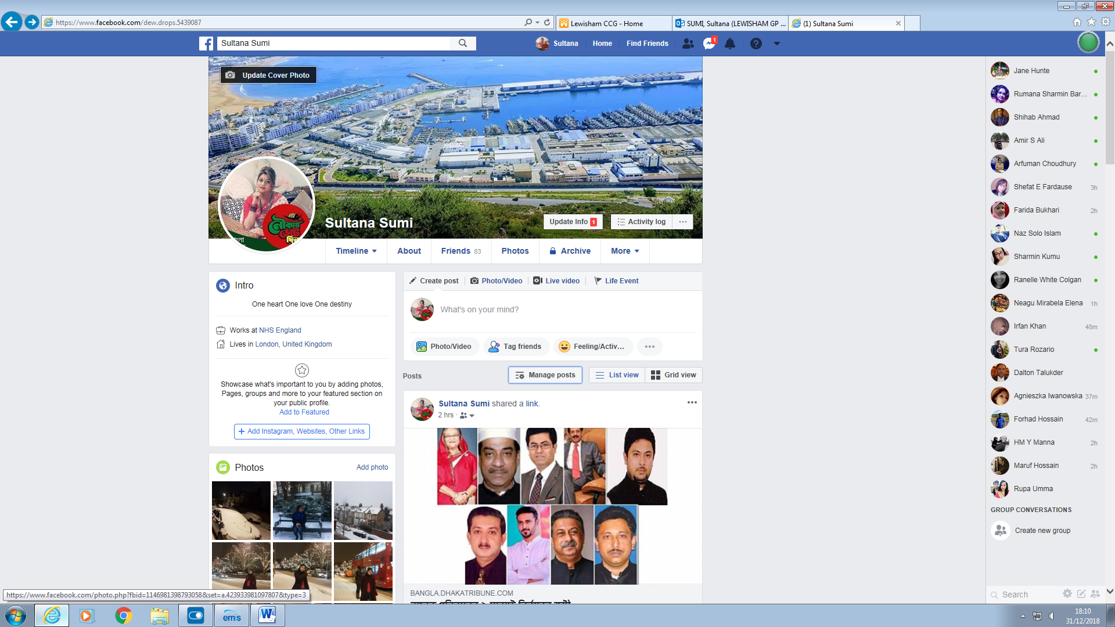

My Twitter page
https://twitter.com/amisumi2884


My LinkedIn Page
https://www.linkedin.com/in/sultana-s-0b7522177?lipi=urn%3Ali%3Apage%3Ad_flagship3_profile_view_base_contact_details%3BVaknIFp3TliKbTEoMph7ng%3D%3D
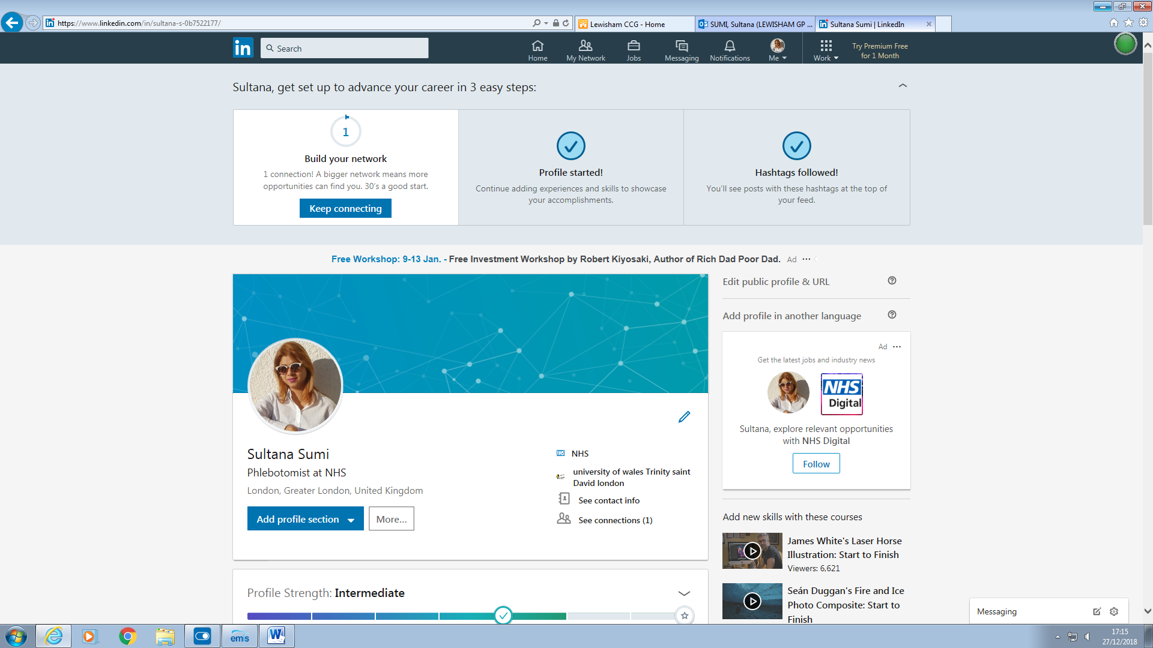

Bibliography
Maund,A.,Schriek,M.&Tinkler,p.(2017)Certificate in higher education: skills or the workplace student yearbook, London .sage
[Online].Availablefrom:https://www.collinsdictionary.com/(Accessed: 27thNovember2018).
[Online].Availablefrom:https://scholar.google.co.uk/(Accessed:27November2018).
[Online].Availablefrom:https://www.useoftechnology.com/(Accesses:21October2018)
[Online].Availablefrom:https://www.which.co.uk/(Accessed:17th Novermber2018).
[Online].Availablefrom:http://www.forbes.com(Accessed:04Nobvember2018).
[Online].Availablefrom:http://www.teachhub.com(Accessed:04December 2018).
[Online].Availablefrom: http://www.computerhope.com(Accessed: 11December2018).
[Online].Availablfrom: https://www.trustedreviews.com/reviews/brother-hl-4150cdn (Accessed: 10ecember2018).

