
Consultancy Report for Hotel Victoria Paris
Organisational Consultancy, Jaliya De Silva
Dumitru Nicolae Silviu | 3/4/25 | 2235616

I acknowledge using Grammarly and Editor from Microsoft Word on 4.03.2025.



Executive summary
Hotel Victoria Paris, a historic budget hotel in the heart of the 9th arrondissement, faces significant challenges that jeopardise its financial viability and market competitiveness. Despite its prime location near central attractions like Opéra Garnier, the hotel has experienced declining occupancy rates, negative online reviews, and operational inefficiencies. Poor service quality, cleanliness, antiquated facilities, and security issues primarily cause guest dissatisfaction. These issues have resulted in a deteriorating reputation, lower revenue, and a weaker market position.
Our consulting firm, Hospitality Solutions Group (HSG), thoroughly analysed the hotel's external and internal factors using the STEEPLED, SOAR, and TOWS frameworks. Guest feedback raises serious concerns, including complaints about rude and unhelpful staff, unsanitary conditions, broken amenities, and safety hazards. Research confirms poor customer service and cleanliness directly impact occupancy rates and revenue. According to studies, a one-star drop in online ratings can reduce revenue by up to 9%, exacerbating the hotel's financial problems. Negative word-of-mouth and low ratings on TripAdvisor and Booking.com further discourage potential guests, raising the cost of customer acquisition and lowering profitability.
Key findings from the analysis show that management and staffing issues, a lack of facility investment, and inadequate security measures all contribute significantly to guest dissatisfaction. Inadequately trained staff struggle with multilingual communication and problem-solving, alienating international visitors. Hotel Victoria falls behind its competitors due to a lack of modern amenities such as digital check-in and security improvements. Furthermore, the economic downturn following COVID-19 has put additional financial strain on budget hotels, making it critical for management to implement cost-effective yet impactful solutions.
To address these challenges, our consultancy created a strategic action plan centred on four key areas: customer service improvement, facility upgrades, security and operational efficiency. Immediate interventions include a comprehensive customer service training program to improve staff professionalism, responsiveness, and language proficiency. Research shows that well-trained employees contribute to a 40% increase in guest satisfaction. Concurrently, deep cleaning protocols and minor room renovations, such as fixing showers, upgrading bedding, and ensuring ventilation, will significantly increase comfort. A structured feedback mechanism will allow guests to report issues in real-time, allowing management to respond more proactively.
Security concerns will be addressed by installing keycard access to rooms, upgrading surveillance cameras, and implementing night security patrols. Studies show that strong security measures increase guest trust and retention. Hiring bilingual staff or integrating translation technology at the front desk will also help to overcome language barriers, resulting in better international guest experiences. Digital transformation initiatives, such as automated check-ins and streamlined reservation systems, will improve operational efficiency and reduce employee workload.
To ensure long-term success, a phased implementation timeline has been developed, with short-term (0-3 months), mid-term (3-6 months), and long-term (6-12 months) objectives. The estimated cost of these improvements ranges from £180,000 to £250,000. While this is a significant financial commitment, research shows that strategic investments in service quality and facility improvements produce substantial returns. Case studies show that hotels that invest in customer service training, digital marketing, and security upgrades see revenue growth in two to three years. Improved guest satisfaction, higher occupancy rates, and more direct bookings will help to ensure financial stability and long-term profitability.
Measuring success will be critical for assessing the impact of these initiatives. Increased guest satisfaction, improved online ratings, higher occupancy rates, and increased revenue per available room (RevPAR) are among the key performance indicators (KPIs). Weekly and monthly performance evaluations will ensure continuous improvement, with adjustments based on guest feedback and financial performance data.
To summarise, Hotel Victoria Paris has the potential to transform its market position through a strategic, research-based approach. Addressing core operational deficiencies while capitalising on its prime location and affordability will allow the hotel to compete effectively in the Parisian hospitality market. By implementing these recommendations, Hotel Victoria can rebuild its reputation, attract a more extensive customer base, and achieve long-term financial growth. When combined with a structured change management strategy, the proposed improvements will result in a more welcoming, secure, and efficient hotel environment, ensuring long-term success.

Table of Contents
- Introduction
- Identification of Key Issues
- Impact on the Hotel
- Causes of the Issues
- Analytical Frameworks
- Strategic Recommendations
- Implementation Plan
- Change Management Strategy
- Measuring Success and Key Performance Indicators (KPIs)
- Cost Analysis and Financial Feasibility
- Implementation Timeline
- Conclusion

Introduction
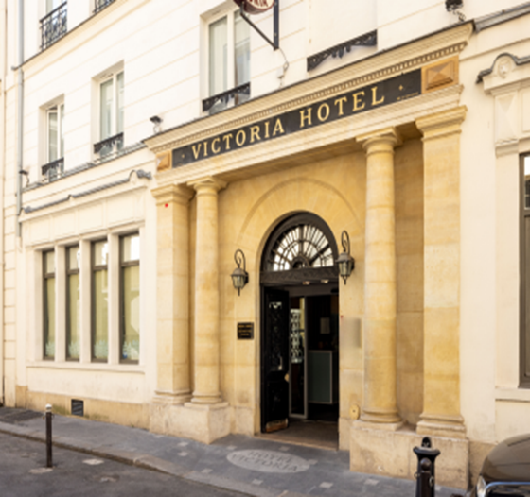
Hotel Victoria Paris, built in 1870, is a low-cost establishment with 103 rooms, conveniently located in Paris's 9th arrondissement, near the Opéra Garnier and other major attractions. Despite its historical significance and prime location, the hotel has consistently experienced guest dissatisfaction due to outdated facilities, poor service, and operational inefficiencies. Our consultancy, Hospitality Solutions Group (HSG), specialises in reviving struggling hotels through strategic operational improvements, service training, and marketing optimisation. With expertise in hospitality management, customer experience improvement, and digital transformation, we have successfully increased profitability and guest satisfaction in several European hotels.
The main issue at Hotel Victoria Paris is poor guest experiences, which leads to declining occupancy rates and financial instability. Customer feedback cites significant issues of unclean rooms, a lack of security, unresponsive staff, and outdated facilities. The hotel requires a well-thought-out strategy to address these issues, improve guest satisfaction, and regain market share. This report will use the STEEPLED, SOAR, and TOWS frameworks to conduct a thorough analysis. The STEEPLED Analysis investigates external factors influencing the hotel, including social trends, technological advancements, economic conditions, and security concerns. The SOAR Analysis identifies the hotel's strengths, opportunities, aspirations, and results, laying the groundwork for future development. The TOWS Matrix transforms weaknesses into actionable strategies for improving operations, customer experiences, and financial performance.
This report will evaluate Hotel Victoria's key challenges, propose practical solutions, and outline an implementation strategy. The emphasis is on improving service quality, upgrading facilities, strengthening security, and increasing operational efficiency. By implementing the proposed methods, Hotel Victoria Paris can boost guest satisfaction, improve financial health, and position itself as a competitive budget hotel in Paris.
Identification of the Key Issue
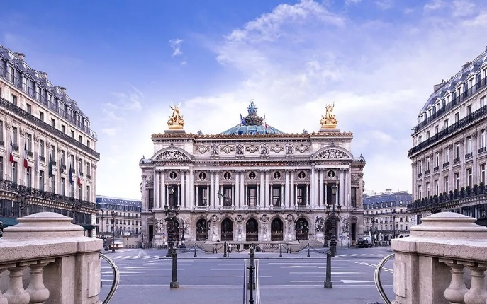
is in the heart of the 9th arrondissement, close to major attractions such as the Opéra Garnier and the Musée Grévin. However, despite its prime location and low prices, the hotel faces significant operational challenges that affect both the guest experience and overall business performance.
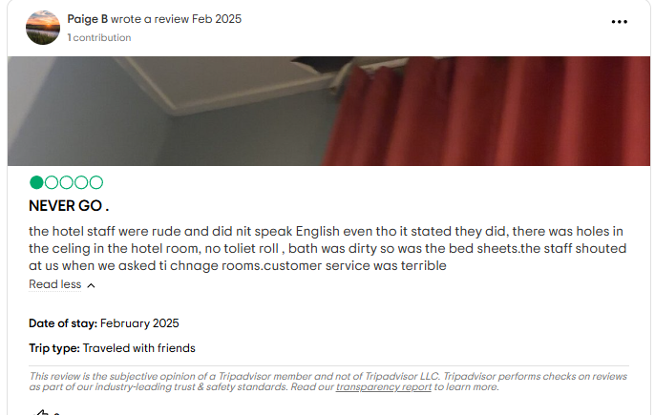
The hotel's main issues are poor service quality and subpar guest experiences, which are reflected in low customer ratings and negative online reviews. Guests frequently complain about rude and unhelpful staff, poor cleanliness, outdated facilities, and security issues (TripAdvisor, 2024). The receptionists' attitude has been flagged as hostile several times, with guests reporting that they were unwilling to assist with basic enquiries, creating a frustrating and unwelcoming environment. Furthermore, hygiene issues, broken amenities, and a lack of essential services such as fans, toilet paper, and functional showers have all negatively impacted guest satisfaction (Booking, 2024).
From a business standpoint, these issues directly impact the hotel's reputation, leading to lower occupancy rates and revenue. Poor service quality has consistently been linked to lower customer retention and negative word-of-mouth, which can be more damaging than price increases (Shah, Jan, and Baloch, 2018). Hotels with low guest satisfaction have lower profitability due to higher customer acquisition costs (Rahimi & Kozak, 2017). If these problems continue, Hotel Victoria risks overshadowing rivals in Paris' competitive hospitality market. Addressing these issues is critical to business sustainability and long-term success.

Impact on the Hotel
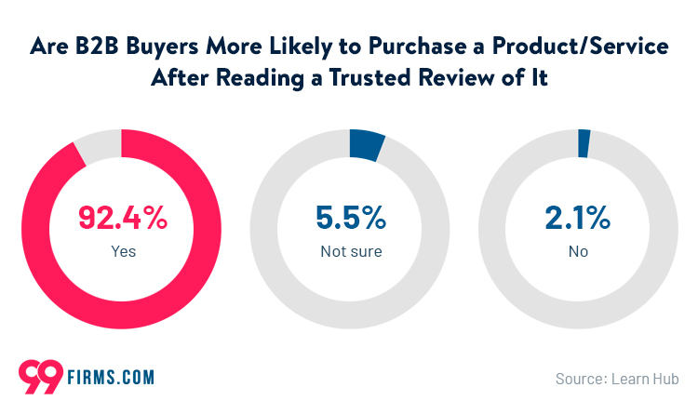
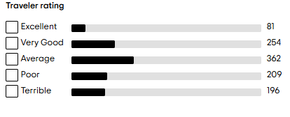
Hotel Victoria Paris is experiencing serious reputational and operational issues that directly impact its financial performance and long-term viability. The negative guest experiences reflected in online reviews, and complaints paint a troubling picture of declining service quality and mismanagement, making it difficult for the hotel to maintain its competitive position in the Parisian hospitality market.
Reputation is essential to hotel success, and Victoria's low ratings on TripAdvisor, Booking.com, and other platforms indicate widespread guest dissatisfaction. Complaints frequently highlight rude staff, poor cleanliness, outdated rooms, and security concerns, all of which harm the hotel's public image (TripAdvisor, 2024). According to research, hotels with consistently negative online feedback have lower occupancy rates, as up to 90% of travellers check online reviews before booking (The Reputation Lab, 2025). Furthermore, poor guest experiences result in negative word-of-mouth, eroding brand trust (Anagnostopoulou et al., 2019).
Financial performance is inextricably linked to reputation, and studies show that even a single star drop in online ratings can significantly reduce revenue (Tan, Zou, and Li, 2023). With mounting negative reviews, Hotel Victoria risks losing repeat customers, lowering its average daily rate (ADR), and struggling to attract new guests. Furthermore, the increased costs of damage control, refunds, and guest compensation placed additional strain on the hotel's finances (Xie & So, 2018).
Operational challenges exacerbate the hotel's difficulties. A lack of adequately trained staff, language barriers, and a negative service culture contribute to inefficiency and guest dissatisfaction. Victoria falls behind comparable budget hotels in Paris regarding service quality, cleanliness, and security measures, making it a less appealing option for travellers (Cho et al., 2023). Addressing these issues is critical to avoiding additional revenue loss and reputational damage.

Causes of the Issues
Guest satisfaction at Hotel Victoria Paris is declining due to several operational failures in staffing, facility management, security, and customer service. These issues reduce customer retention and lead to negative word-of-mouth and poor financial performance.
Management and staffing issues are among the leading causes. The hotel appears understaffed, resulting in service delays, poor housekeeping, and a lack of guest support (Dogra, 2023). Multiple reviews report hostile receptionists, a shortage of English-speaking employees, and a general lack of training (TripAdvisor, 2024). According to research, poorly trained staff have a negative impact on service quality, as unresolved complaints and slow response times result in lower guest satisfaction (Komunda and Osarenkhoe, 2012).
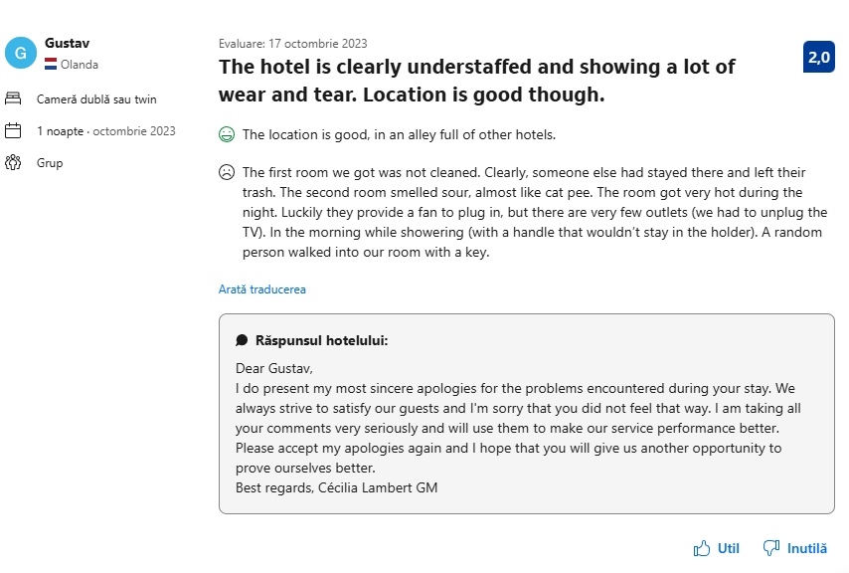
Another critical concern is facility upkeep and cleanliness. Guests frequently complain about dirty rooms, outdated bathrooms, non-functional showers, and insufficient ventilation (Booking, 2024). Poor upkeep not only raises health and hygiene concerns but it also harms the hotel's reputation. According to research, hotel guests value cleanliness and modern amenities highly.
Security concerns exacerbate the situation, with reports of unauthorised room access and insufficient safety measures (TripAdvisor, 2024). Weak security systems and a lack of staff vigilance can cause serious trust issues, discouraging future bookings (Chan and Lam, 2013).
Finally, poor customer service contributes significantly to guest dissatisfaction. Unresponsive staff, poor communication, and an unwelcoming environment reduce guests' likelihood of returning (Min, Lim, & Magini, 2015). A service quality gap is evident, with guest expectations exceeding the service (Torres, 2014). Addressing these issues is critical for re-establishing trust and improving business performance.

STEEPLED Analysis
The STEEPLED framework is an effective tool for analysing the external factors that influence Hotel Victoria Paris. Each model element identifies an area where external pressures influence the hotel's challenges or opportunities.
Category | Issues
Social | Customer expectations in Paris are high due to the city's status as a global tourism hub. Many travellers expect personalised service, multilingual staff, and high hygiene standards, which the hotel fails to provide (Mariani et al., 2019). Negative online reviews show that staff rudeness, unclean rooms, and security concerns significantly impact guest satisfaction (TripAdvisor, 2024).
Technological | The absence of modern amenities and digitalisation reduces operational efficiency. Many hotels have automated check-ins, smart locks, and efficient reservation systems, which Hotel Victoria does not. This antiquated method increases the likelihood of double bookings, lengthy wait times, and guest dissatisfaction (Balasubramanian et al., 2022).
Economic | As a budget hotel, Victoria has limited funds to invest in staff training, infrastructure, and security changes. COVID-19 has exacerbated the economic downturn, making revenue recovery more challenging (Rodríguez-Antón and Alonso-Almeida, 2020).
Environmental | Sustainability is becoming a top priority in the hospitality industry. Many hotels implement eco-friendly practices like energy-efficient lighting and waste reduction programs, but Hotel Victoria does not (Abdou et al., 2022).
Political | The hotel must follow France's hospitality regulations, which include safety, accessibility, and labour standards. Failure to meet these standards can result in fines and reputational damage (AFA, 2020).
Legal | French law requires strict safety precautions, guest rights protection, and labour law adherence. The reported security flaws at the hotel may result in legal ramifications if guests file complaints or lawsuits (Binns and Kempf, 2021).
Ethical | Misrepresentation of services, such as advertising clean and well-maintained rooms but failing to meet those standards, is an ethical concern that undermines customer trust (Hassan et al., 2024).
Demographic | Paris has a diverse international tourist base, but Hotel Victoria's lack of multilingual staff limits its ability to effectively serve non-French-speaking guests (Mariani et al., 2019).

SOAR Analysis – Positive Aspects of Hotel Victoria Paris
Despite its current operational challenges, Hotel Victoria Paris has several strengths that can be used to drive future growth. By focusing on key opportunities, the hotel can reposition itself as a reliable and competitive budget accommodation option in Paris.
SOAR Factors Analysis
SOAR Factors | Analysis
Strengths | Hotel Victoria is in a prime location near the Opéra Garnier and the Musée Grévin, which makes it appealing to tourists. It is also one of the more reasonably priced hotels in central Paris, which may appeal to budget-conscious travellers. Furthermore, the building's historical significance improves its appeal and marketing potential (TripAdvisor, 2024).
Opportunities | The hotel can improve customer service through employee training programs. Investing in renovations, particularly cleanliness, security, and ventilation, could increase guest satisfaction. Furthermore, the hotel can improve its marketing strategy by emphasising its affordability and accessibility to attract more bookings (Biswas, 2023).
Aspirations | The hotel aspires to be a reputable, budget-friendly accommodation in Paris, with consistent guest satisfaction and higher service standards. The goal is to leverage its weaknesses into competitive advantages by addressing guest complaints and creating a more welcoming and secure environment (Mariani, 2019).
Results | The hotel must implement structured employee training programs, minor renovations, and customer engagement strategies to achieve these goals. Creating a guest feedback system to track progress will be critical. Improving online reputation management through responsive customer service can also help to increase bookings and ratings over time (Sparks et al., 2016).

TOWS Analysis – Converting Problems into Solutions
The Hotel Victoria Paris has a mix of strengths and weaknesses, as well as external opportunities and threats, which affect its performance. The TOWS matrix offers a systematic approach to transforming these issues into workable solutions.
Factors | Analysis
Strengths-Opportunities (SO) | The hotel's prime location near popular attractions and reasonable prices are significant advantages. To capitalise on these, the hotel can launch a targeted marketing campaign emphasising its affordable yet conveniently located accommodations. Investing in guest experience improvements, such as minor room renovations and higher hygiene standards, will increase positive feedback and attract more budget-conscious visitors (Berezina et al., 2016).
Strengths-Threats (ST) | Competitor hotels in Paris outperform Hotel Victoria regarding service quality and guest experience. To address this, the hotel should analyse top-performing budget hotels and implement best practices such as self-check-in, multilingual staff, and upgraded room amenities. Competitive benchmarking will help to differentiate the hotel without requiring a significant financial investment (Tsai et al., 2009).
Weaknesses-Opportunities (WO) | Poor customer service has been a frequent complaint. The hotel can address this issue by implementing structured training programs emphasising hospitality etiquette, multilingual communication, and problem-solving skills. Furthermore, investing in basic guest amenities (such as improved bedding, bathroom ventilation, and dependable Wi-Fi) will help increase customer satisfaction and online ratings, making the hotel more competitive (Blal and Sturman, 2014).
Weaknesses-Threats (WT) | Security risks and staffing inefficiencies are serious threats to the hotel's reputation. To reduce these risks, the hotel should implement keycard access to rooms, improve front-desk surveillance, and institute nighttime security checks. Hiring multilingual receptionists will improve guests' experiences and reduce complaints about poor communication. Improving hiring and training processes can create a more professional and welcoming environment (Kasap, Samur & Yılmaz, 2024).

Recommendations and Change Management
Strategic Recommendations
Significant strategic changes must be made to reposition Hotel Victoria Paris as a competitive, budget-friendly accommodation. These changes prioritise customer service, facility upgrades, security measures, and operational efficiency to provide a better guest experience, increase ratings, and drive revenue growth.
A targeted action plan can address the main issues at Hotel Victoria, including poor customer service, a lack of amenities, security concerns, and operational inefficiencies. According to studies, hotels implementing customer-centric strategies, efficient service operations, and digital solutions have higher guest satisfaction and profitability (Jena, 2023). Hotel Victoria can regain its competitive advantage in Parisian hospitality by implementing modern service approaches.
Customer Service Improvement
One of the most common complaints from guests is rude and unhelpful staff. The hotel must implement structured training programs emphasising hospitality culture, multilingual communication, and problem-solving skills to address this. According to research, well-trained receptionists increase guest satisfaction by 40% through emotional intelligence, problem resolution, and proactive service (Haenraets, 2023). Furthermore, incentive-based performance models can encourage employees to provide better service and increase guest interactions.
Facility Upgrades
Many guests complain about room cleanliness, outdated bathrooms, and inadequate ventilation. The hotel should prioritise deep cleaning schedules, minor renovations, and critical facility improvements, such as repairing broken showers, providing fans, and replacing old bedding. Investing in modern amenities like high-speed Wi-Fi, upgraded bathrooms, and soundproofing can significantly improve the guest experience (Zemlina et al., 2023). These changes will reduce negative online reviews while increasing occupancy rates.
Security Measures
Guest safety concerns, such as reports of unauthorised room access and inadequate security, must be addressed immediately. Installing keycard access locks, more surveillance cameras and an on-site night security team will boost guest trust and security perception. Studies show that hotels with strong security systems have higher customer retention rates because guests prioritise safety when booking accommodations (Chan and Lam, 2013).
Operational Efficiency
The lack of multilingual staff, inconsistent service, and understaffing all have a negative impact on guest satisfaction. The hotel should implement a digital reservation system to streamline check-ins, reduce wait times, and avoid overbooking (Rei et al., 2022). Furthermore, hiring international staff or providing language training to current employees will improve communication with international visitors. Efficient workload management and shift planning will also help to prevent service delays and employee burnout.
By implementing these strategic recommendations, Hotel Victoria Paris can improve its reputation, attract more guests, and boost revenue, transforming it into a dependable, affordable, and secure hotel option in central Paris.
Implementation Plan
A well-thought-out implementation strategy is required to transform Hotel Victoria Paris into a reputable low-cost accommodation. This plan will be implemented in stages to ensure immediate results while laying the groundwork for long-term success.
Short-Term Measures (Immediate Action – 3 months)
The most urgent issues concern customer service, cleanliness, and minor facility improvements. The hotel should immediately implement an intensive customer service training program for all front-line employees, focusing on hospitality etiquette, problem-solving, and multilingual communication (Järvi et al., 2020). This will improve guest interactions and address frequent complaints about rude and unhelpful staff.
To improve hygiene standards, the hotel should hire more cleaning staff and implement stricter cleanliness protocols, ensuring that rooms are consistently sanitised, well-maintained, and meet industry cleanliness standards (McDowell et al., 2007). Small but significant renovations, such as repairing broken fixtures, ensuring every room has a functional fan, and improving bedding quality, should be completed immediately to improve guest comfort and reduce negative reviews (Mmutle and Shonhe, 2017).

Mid-Term Measures (3-6 months)
The hotel should implement a formal feedback system that allows guests to report issues in real-time using digital forms, QR codes, or an online customer portal. This will assist in identifying recurring issues and tracking improvement progress (Rei et al., 2022).
Multilingual receptionists should be hired to serve international guests better or use translation apps and AI-powered chatbots (Karagiannis, 2024).
Keycard-access locks, more surveillance cameras, and a night security patrol should all be installed to improve security. According to research, upgraded security systems can increase guest trust while decreasing safety-related complaints (Araza, 2023).
Long-Term Measures (6 months – 1 year)
Structural renovations are required to achieve a long-term transformation, particularly upgrading bathrooms, improving ventilation systems, and investing in high-quality bedding. These improvements will align Hotel Victoria Paris with guest expectations for comfort and hygiene (Zhu 2018).
To rebuild its brand reputation, the hotel should implement a rebranding and marketing strategy emphasising higher service quality, affordability, and prime location. Collaboration with influencers, travel agencies, and online booking platforms can help attract new customers and shift public perception (Yuan et al., 2022).
Finally, sustaining these gains necessitates long-term investment in employee training. The hotel should implement quarterly training programs covering hospitality trends, problem-solving techniques, and digital service innovations. Regular refresher training ensures employees remain engaged and provide excellent service (Sebola et al., 2019).
By adhering to this structured timeline, Hotel Victoria Paris will recover from its current issues and establish itself as a dependable, well-managed budget hotel in Paris.
Change Management Strategy
A structured change management strategy is required to ensure that the transformation at Hotel Victoria Paris is successful and sustainable. Change is frequently met with resistance; however, by prioritising stakeholder engagement, training, employee motivation, and continuous monitoring, the hotel can streamline improvements while maintaining a positive work environment.
Stakeholder Engagement
Effective communication is critical for obtaining buy-in from all stakeholders, including employees, management, and investors. The hotel must hold town hall meetings and distribute internal newsletters that clearly outline the reasons for change, expected outcomes, and employee roles during the transition (Shulga, 2020).
The hotel should offer incentives such as performance-based bonuses, employee recognition programs, and career development opportunities to encourage employee participation. Research shows financial and non-financial incentives improve employee engagement and cooperation during change processes.
Training and Development
Investing in employee training is critical to long-term success. The hotel should implement a Customer Service Excellence Program emphasising hospitality etiquette, conflict resolution, and multilingual communication. Furthermore, emergency response and security training will prepare employees for safety-related incidents (Sah & Nadda, 2018).
Given Paris' diverse international visitor base, cross-cultural communication workshops should be implemented to improve staff adaptability and inclusivity. Studies have shown that hotels with multilingual and culturally competent staff have higher guest satisfaction and return rates (Mariani et al., 2019).

Managing Employee Resistance
Change is often resisted, primarily in organisations that value routine and job security. To address staff concerns, the hotel should hold open forums where employees can express their views and provide feedback on proposed changes.
A phased implementation strategy should be used to gradually roll out improvements rather than overwhelming staff with drastic operational shifts. Salary adjustments and role-based incentives can motivate employees to accept more responsibilities without feeling overworked.
Monitoring and Adjustments
Maintaining change necessitates ongoing assessment and adjustments. The hotel should conduct weekly and monthly guest satisfaction evaluations to track improvements in service, cleanliness, and security (Ofondu, 2018).
A real-time feedback mechanism, such as QR code-based guest surveys, will enable management to monitor customer concerns and take immediate corrective action. Furthermore, staff performance should be evaluated using key performance indicators (KPIs) corresponding to service improvements (Aithal, 2023).
Hotel Victoria Paris can successfully implement and sustain improvements by engaging stakeholders, investing in employee development, managing resistance, and continuously monitoring progress, resulting in a higher level of service and a better overall guest experience.
Measuring Success and Performance Indicators
To ensure the success of Hotel Victoria Paris' transformation strategy, key performance indicators (KPIs) will be used to track progress in guest satisfaction, operational efficiency, employee performance, and revenue growth.
Guest Satisfaction Scores
Improved online reviews and guest feedback are key indicators of success. Altın et al. (2018) will monitor TripAdvisor, Booking.com, and Google Reviews to track ratings, recurring complaints, and overall sentiment. According to research, a one-star increase in online ratings can boost revenue by up to 9% in the hospitality industry (Murray et al. 2018).
Operational Metrics
The hotel should track service response times, complaint resolution rates, and housekeeping turnaround times to assess efficiency. The goal is to decrease check-in times, improve room readiness, and reduce guest complaints about cleanliness and service delays (Nikolskaya et al., 2019).
Employee Feedback & Performance
Employee satisfaction and engagement are directly related to service quality. A staff performance review system will be implemented, with employees evaluated based on customer interactions, responsiveness, and adherence to training programs. Positive employee feedback on training effectiveness and work environment will also predict success (Sitzmann and Wainhardt, 2019).
Revenue Growth
Occupancy rates, return bookings, and the average daily rate (ADR) will determine financial success. Improved customer retention and direct bookings will signal a successful turnaround strategy, increasing revenue and profitability (Singh et al., 2020).
By tracking these KPIs, Hotel Victoria Paris can ensure that its transformation strategy is effective in the long term and continuously improves guest experiences and business performance.
Cost Analysis
To ensure cost-effectiveness and long-term feasibility, the proposed improvements at Hotel Victoria Paris must be implemented within a well-planned budget. The estimated costs are based on industry research and feasibility studies.
Training Programs Cost
The hotel should invest in professional hospitality training to improve customer service quality. A structured three-month training program for all front-line staff, covering multilingual communication, problem-solving, and security protocols, is expected to cost between £15,000 and £20,000 (CBRE, 2022). Ongoing refresher training every six months will cost approximately £5,000 per year.

Facility Upgrades
Renovations will begin with minor repairs (fixtures, bedding, fans) and progress to significant structural improvements (bathroom upgrades, ventilation systems).

- Immediate fixes (cleaning protocols, minor room renovations): £10,000–£15,000.
- Major upgrades (bathroom renovations, new ventilation systems, modern bedding): £50,000–£70,000.
Security Improvements
The hotel must install keycard locks and more surveillance cameras and hire nighttime security personnel to improve guest safety. The estimated costs include:
- Keycard system installation: £10,000–£15,000.
- Additional surveillance cameras: £5,000–£7,000.
- Security personnel hiring (one full-time staff): £30,000 annually (Bodyguard, 2025).
Staffing Costs
The hotel should hire two additional front-desk staff and cleaning personnel to address service gaps.
- Additional staff salaries: £50,000–£60,000 annually.
- Multilingual hiring incentive: £5,000 per new bilingual employee.
Marketing & Rebranding
Improving the hotel’s online reputation will involve targeted digital marketing campaigns, website updates, and influencer partnerships.
- Social media advertising, online travel agency promotions: £10,000 annually.
- Website redesign and reputation management: £8,000 (Nilead, 2025).
The estimated investment for all improvements ranges from £180,000 to £250,000. These changes are expected to boost occupancy rates, guest satisfaction, and long-term profitability, keeping Hotel Victoria Paris competitive in the Parisian hospitality market.
Implementation Timeline
The implementation timeline for Hotel Victoria Paris is structured to ensure that necessary improvements are implemented feasibly and effectively. This action plan outlines the key challenges, proposed solutions, desired outcomes, projected costs, and timelines.
Number | Problem | Solution | Desired Outcome | Time Scale | Completion Date | Planned Budget
1 | Poor customer service due to untrained staff | Implement customer service training, introduce language programs, and conduct security response training. | Staff provide higher quality service and improve guest satisfaction. | 3 months | Month 3 | £20,000
2 | Lack of hygiene and outdated room conditions | Hire additional cleaning staff, enforce stricter cleanliness protocols, repair damaged fixtures, and improve ventilation. | Improved guest experience, reduction in complaints related to cleanliness and comfort | 2 months | Month 2 | £15,000
3 | Security concerns, unauthorised room access | Install keycard access for guest rooms, upgrade CCTV surveillance, and introduce night security patrols. | Improved guest safety, increased trust in hotel management | 6 months | Month 6 | £25,000
4 | Negative online reputation and marketing gaps | Launch digital marketing campaigns, boost guest feedback system, and collaborate with influencers. | Increased brand awareness, higher online ratings, more direct bookings | 6 months | Month 6 | £10,000
5 | Insufficient multilingual staff leading to communication issues | Hire bilingual front-desk staff or integrate translation technology | Improved guest experience for international travellers | 5 months | Month 5 | £10,000
6 | Structural deficiencies affecting guest comfort | Upgrade bathrooms, improve ventilation systems, soundproof rooms | Higher guest retention, increased competitive positioning in the Paris hotel market | 9 months | Month 9 | £70,000
7 | Inconsistent staff performance due to lack of ongoing training | Implement quarterly refresher training for customer service, security, and guest engagement | Sustained high service quality, reduced employee turnover | Ongoing | Continuous | £5,000 annually
8 | Weak branding and outdated guest experience | Rebranding, modernised guest experience standards, better marketing materials | A more substantial brand presence improved customer loyalty. | 12 months | Month 12 | £15,000

By implementing this action plan, Hotel Victoria Paris will systematically address its challenges, ensuring a smooth transition to reputable, budget-friendly accommodation. These changes are expected to significantly improve guest satisfaction, revenue, and the overall hotel experience while remaining financially viable.
The feasibility of implementing service and facility improvements at Hotel Victoria Paris is based on data-driven ROI projections, which ensure long-term financial sustainability. The estimated €180,000-€250,000 investment must result in measurable financial returns through increased guest satisfaction, occupancy, and revenue growth. Studies on hotel investment trends show that capital investments in strategic renovations and service upgrades can significantly improve financial performance.
Turner and Hesford (2018) analysed 305 hotel renovation projects. They discovered that capital expenditures on guest experience improvements resulted in short-term revenue increases, higher profitability, and a significant increase in occupancy rates within the first three years. They also mentioned that these investments reduce long-term maintenance costs, strengthening the case for Hotel Victoria's upcoming renovations.
Skordoulis et al. (2024) investigated the impact of service quality on financial performance, finding that hotels that invest in customer service training and environmental sustainability saw increases in EBITDA and ROI metrics. This suggests that Hotel Victoria's planned customer service training and facility upgrades will increase measurable revenue.
Domínguez & Pholphirul (2020) studied 2,627 hotels and discovered that improving facilities increased revenue from both local and international guests. Modernised facilities resulted in an average ADR increase of 10-15%. This is consistent with Hotel Victoria's upgrade strategy, which aims to improve room conditions and security while positioning the hotel as a more appealing option for travellers.
Chivers (2018) emphasised the significance of capital improvements in increasing hotel profitability, claiming that well-planned renovations modernise physical structures, improve competitive positioning, and generate long-term financial returns. The proposed security upgrades, such as keycard access and better surveillance, are consistent with this research, ensuring guest safety and fostering long-term trust, which leads to repeat business.
Hou and Zhao (2021) investigated service-improvement investments in the hospitality industry. They discovered that customer-focused improvements lead to an 8-12% increase in retention rates, reducing reliance on third-party bookings and increasing direct revenue streams. This reinforces the importance of Hotel Victoria's multilingual staffing initiative and customer experience training, which are expected to increase guest loyalty and satisfaction.
Marketing investments are also critical for revenue optimisation. Kim, Boo, and Qu (2018) discovered that hotels that used social media and influencer marketing saw a 30% increase in direct bookings. This complements Hotel Victoria's proposed digital marketing and reputation management strategy, increasing brand visibility while reducing reliance on costly third-party platforms.
Vinnikova and Vinnikova (2021) investigated the financial impact of capital investment in service quality and discovered a strong link between increased guest satisfaction and continued revenue growth. According to their findings, hotels that consistently reinvest in quality improvements maintain a competitive advantage and financial stability.
Based on these studies, the ROI timeline for Hotel Victoria's proposed improvements is estimated to be 2-3 years, with incremental gains from increased ADR, occupancy, and guest retention. The planned investments in service developments, security, digital transformation, and facility upgrades are financially justified, as evidenced by extensive empirical research demonstrating positive long-term financial results. The structured implementation of these changes will increase profitability, improve guest satisfaction, and strengthen Hotel Victoria's market position in Paris.

Conclusion
The consultancy report on Hotel Victoria Paris includes a comprehensive analysis of the hotel's key challenges and a detailed strategic plan for improvement. This report has investigated customer dissatisfaction, operational inefficiencies, security concerns, and facility deficiencies, all of which have had a negative impact on guest experiences, financial performance, and the hotel's image.
One of the most pressing issues identified is poor customer service, with many guests complaining about rude and unhelpful staff, a lack of multilingual support, and slow service responses. This issue has been a significant cause of negative online reviews, resulting in low occupancy rates and decreased revenue. To address this, a customer service training program has been recommended to help front-line employees improve their communication skills, problem-solving abilities, and cultural awareness to improve guest interactions.
The hotel's facilities have also been a concern on several occasions. Complaints about unclean rooms, outdated bathrooms, insufficient ventilation, and uncomfortable bedding have significantly impacted guest satisfaction and retention rates. The proposed solution includes immediate cleaning improvements, short-term room repairs, and long-term structural renovations aimed at bringing the hotel up to contemporary hospitality standards.
Another essential factor influencing guest satisfaction is security. Visitors have expressed serious safety concerns following reports of unauthorised room access and inadequate surveillance. Keycard access for all rooms upgraded CCTV surveillance, and nighttime security patrols have been proposed to mitigate these risks. This measure will improve guest safety and build trust in the hotel's management.
Operational efficiency has also been identified as an area that requires immediate improvement. The lack of sufficient cleaning staff, undertrained receptionists, and language barriers have caused service delays and unnecessary frustration for guests. The hotel can significantly improve service efficiency while lowering employee turnover by hiring multilingual receptionists, redistributing staff workloads, and investing in digital solutions such as automated check-ins.
To ensure the long-term success of these changes, an implementation timeline has been developed, with actions broken down into short-term (0-3 months), mid-term (3-6 months), and long-term (6-12 months) strategies. This structured approach ensures a gradual and sustainable transition without disrupting the hotel's operations. Key performance indicators (KPIs) such as guest satisfaction, operational metrics, employee performance, and revenue growth have also been established to track progress and assess success.
The financial feasibility of these changes has been assessed, with an estimated investment of £180,000-£250,000. While this requires a significant financial investment, the return on investment (ROI) is expected to be substantial, as higher guest satisfaction, better reviews, and higher occupancy rates will result in greater long-term profitability.
Hospitality Solutions Group consultancy report outlines realistic, research-backed solutions that will address current issues and establish Hotel Victoria as a leading budget-friendly hotel in Paris. By implementing the recommended strategies, the hotel will improve its reputation, attract new customers, and significantly improve its financial performance.
We are grateful to Hotel Victoria Paris for entrusting us with this project. Analysing and creating tailored solutions to improve the hotel's competitiveness and guest satisfaction was a pleasure. We hope this collaboration is the start of long-term improvements, and we look forward to seeing the hotel benefit from these strategic improvements. We would be delighted to help with future operational, branding, or service improvement projects if additional consultancy support is required.

References
- Komunda, M. and Osarenkhoe, A., 2012. Remedy or cure for service failure? Effects of service recovery on customer satisfaction and loyalty. Business Process Management Journal, 18(1), pp.82-103. https://www.proquest.com/scholarly-journals/remedy-cure-service-failure/docview/923392027/se-2?accountid=130472
- Mariani, M.M., Borghi, M. and Kazakov, S., 2019. The role of language in the online evaluation of hospitality service encounters: An empirical study. International Journal of Hospitality Management, 78, pp.50-58. https://doi.org/10.1016/j.ijhm.2018.11.012
- Altın, M., Köseoglu, M.A., Yu, X. and Riasi, A., 2018. Performance measurement and management research in the hospitality and tourism industry. International Journal of Contemporary Hospitality Management. https://www.proquest.com/scholarly-journals/performance-measurement-management-research/docview/2011312978/se-2?accountid=130472
- Anagnostopoulou, S.C., Buhalis, D., Kountouri, I.L., Manousakis, E.G. and Tsekrekos, A.E., 2020. The impact of online reputation on hotel profitability. International Journal of Contemporary Hospitality Management, 32(1), pp.20-39. https://www.proquest.com/scholarly-journals/impact-online-reputation-on-hotel-profitability/docview/2336176781/se-2?accountid=130472
- McDowell, L., Batnitzky, A. and Dyer, S., 2007. Division, segmentation, and interpellation: The embodied labors of migrant workers in a greater London hotel. Economic geography, 83(1), pp.1-25. https://doi.org/10.1111/j.1944-8287.2007.tb00331.x
- Abdou, A.H., Shehata, H.S., Mahmoud, H.M.E., Albakhit, A.I. and Almakhayitah, M.Y., 2022. The effect of environmentally sustainable practices on customer citizenship behavior in eco-friendly hotels: does the green perceived value matter?. Sustainability, 14(12), p.7167. https://doi.org/10.3390/su14127167
- AFA, 2020. Gifts and Hospitality Policy in Private and Public Sector Corporations and Non-Profits. Practical Guide. https://www.agence-francaise-anticorruption.gouv.fr/files/files/Practical%20Guide%20gifts%20and%20hospitality%20policy%20in%20private%20and%20public%20sector%20corporations%20and%20non-profits.pdf
- Booking.com, 2024. Guest Feedback on Hotel Victoria Paris. https://www.booking.com/Share-kHxWan
- Cho, S., Pekgün, P., Janakiraman, R. and Wang, J., 2024. The Competitive Effects of Online Reviews on Hotel Demand. Journal of Marketing, 88(2), 40-60. https://doi.org/10.1177/00222429231191449
- Tsai, H., Song, H. and Wong, K.K., 2009. Tourism and hotel competitiveness research. Journal of travel & tourism marketing, 26(5-6), pp.522-546. https://doi.org/10.1080/10548400903163079
- Haenraets, B., 2023. Front Desk impact on Customer Satisfaction Unlocking the Potential of the Hotel Front Desk: Strategies for Enhancing Guest Satisfaction. https://www.viqal.com/blog/front-desk-impact-on-customer-satisfaction
- Järvi, H., Keränen, J., Ritala, P. and Vilko, J., 2020. Value co-destruction in hotel services: Exploring the misalignment of cognitive scripts among customers and providers. Tourism Management, 77, p.104030. https://doi.org/10.1016/j.tourman.2019.104030
- Sebola, I.C., Roberson, J.R. and Vibetti, S.P., 2019. Attitudes of institutional catering employees in Gauteng towards training programs. Cogent Social Sciences, 5(1), p.1681925. https://doi.org/10.1080/23311886.2019.1681925
- Dogra, T., 2023. A comparative analysis of service quality in public and private sector hotels. Journal of Tourism Management Research. https://doi.org/10.18488/31.v10i1.3369.
- The Reputation Lab, 2025. The Online Review Impact: Guest Feedback Shapes Hotel Success. https://www.thereputationlab.com/the-online-review-impact-guest-feedback-shapes-hotel-success/
- Grynko, T., Hviniashvili, T., Oliinyk, T., Saihak, Y., Yudina, O., & Korneyev, M., 2024. IMPROVEMENT OF THE CHANGE MANAGEMENT MODEL AT THE HOTEL INDUSTRY ENTERPRISES. Financial and credit activity problems of theory and practice. https://fkd.net.ua/index.php/fkd/article/view/4418/4131
- Balasubramanian, S., Sethi, J.S., Ajayan, S. and Paris, C.M., 2022. An enabling framework for blockchain in tourism. Information Technology & Tourism, 24(2), pp.165-179. https://www.proquest.com/scholarly-journals/enabling-framework-blockchain-tourism/docview/2712119747/se-2?accountid=130472
- Biswas, A., 2023. Reconnoitering enablers of travelers' online hotel booking intention: moderation of service affordability and perceived pandemic risk. International Journal of Quality & Reliability Management, 40(2), pp.542-565. https://www.proquest.com/scholarly-journals/reconnoitering-enablers-travelers-online-hotel/docview/2768584211/se-2?accountid=130472
- Berezina, K., Bilgihan, A., Cobanoglu, C. and Okumus, F., 2016. Understanding satisfied and dissatisfied hotel customers: text mining of online hotel reviews. Journal of Hospitality Marketing & Management, 25(1), pp.1-24. https://doi.org/10.1080/19368623.2015.983631
- Bodyguard, 2025. Understanding the bodyguard role and the professions of close protection. https://www.ips-bodyguard.com/en/news/close-protection/
- Jiang, L. and Zhou, N., 2024. Research on Hotel Service Quality Improvement Based on Text Analysis. Academic Journal of Management and Social Sciences. https://doi.org/10.54097/4wx4gy74
- Chan, E.S. and Lam, D., 2013. Hotel safety and security systems: Bridging the gap between managers and guests. International Journal of Hospitality Management, 32, pp.202-216. https://doi.org/10.1016/j.ijhm.2012.05.010
- Binns, C. and Kempf, R.J., 2021. Who Has Legal Responsibility for Safety and Security in Hotels Versus Home Sharing? http://dx.doi.org/10.1007/978-3-030-59306-3_4
- Kasap, G., Samur, A. and Yılmaz, I., 2024. Organizational barriers to service quality failures: The case of hotel businesses. Journal of Multidisciplinary Academic Tourism. https://doi.org/10.31822/jomat.2024-9-3-213.
- Araza, C., 2023. 10 Must-Have Security Features for Hotels. https://main.hospitality-career.net/career_guide/post/hoteljob-0016
- Barbosa-McCoy, V., 2016. Hotel managers' motivational strategies for enhancing employee performance. Walden University. https://www.proquest.com/dissertations-theses/hotel-managers-motivational-strategies-enhancing/docview/1767384200/se-2?accountid=130472
- Jena, S.K., 2023. Impact of customer-centric approach and customer dissatisfying cost on supply chain profit under price competition. Journal of Business & Industrial Marketing, 38(11), pp.2341-2359. https://www.proquest.com/scholarly-journals/impact-customer-centric-approach-dissatisfying/docview/2890669320/se-2?accountid=130472
- Karagiannis, M., 2024. Using AI to Enhance Multilingual Guest Communication. https://medium.com/hotel-tech/using-ai-to-enhance-multilingual-guest-communication-ef1dce94bf22
- Blal, I. and Sturman, M.C., 2014. The differential effects of the quality and quantity of online reviews on hotel room sales. Cornell Hospitality Quarterly, 55(4), pp.365-375. https://doi.org/10.1177/1938965514533419
- Murray, P., Lockwood, A. & Škokić, V. (2018) 'A critical realist investigation of the measurement-performance link in hospitality.' Hospitality Research Journal. Available at: https://consensus.app/papers/a-critical-realist-investigation-of-the-murray-lockwood/709355de5bb8583fa9578251375bf88e/?utm_source=chatgpt
- Sitzmann, T. and Weinhardt, J.M., 2019. Approaching evaluation from a multilevel perspective: A comprehensive analysis of the indicators of training effectiveness. Human Resource Management Review, 29(2), pp.253-269. https://doi.org/10.1016/j.hrmr.2017.04.001
- Torres, E.N., 2014. Deconstructing service quality and customer satisfaction: Challenges and directions for future research. Journal of Hospitality Marketing & Management, 23(6), pp.652-677. https://doi.org/10.1080/19368623.2014.846839
- Hassan, T.H., Ammar, S., Abdelhay, H.F., Fayyad, S., Noreldeen, M.A., Salem, A.E., Gayed Abdel, A.H., Janzakov, B., Mahmoud, M.H. and Al-Azab, M.R., 2024. THE IMPACT OF DECEPTIVE HOSPITALITY AND TOURISM MARKETING TACTICS ON TOURISTS’SOCIAL MEDIA INTERACTIONS AND TRUST AND DESTINATION IMAGE IN EMERGING MARKETS. Geojournal of Tourism and Geosites, 56(4), pp.1732-1743. https://gtg.webhost.uoradea.ro/PDF/GTG-4-2024/gtg.56428-1342.pdf
- Sparks, B.A., So, K.K.F. and Bradley, G.L., 2016. Responding to negative online reviews: The effects of hotel responses on customer inferences of trust and concern. Tourism Management, 53, pp.74-85. https://doi.org/10.1016/j.tourman.2015.09.011
- Nikolskaya, E.Y., Kovaleva, N.I., Dracheva, E.L., Gadimova, F.K. and Novikova, N.G., 2019. Methodological techniques for measuring performance in the hospitality industry. Journal of Environmental Management & Tourism, 10(3 (34)), pp.379-384. https://www.proquest.com/scholarly-journals/methodological-techniques-measuring-performance/docview/2433185492/se-2?accountid=130472
- Ofondu, M. M., 2018. Assessing the Effectiveness of Innovation Management in the Hospitality Industry: A Study of Selected Hotels in South-East, Nigeria. Business Management and Strategy. https://doi.org/10.5296/bms.v9i1.13300
- CBRE, 2022. Investing in Training Hotel Employees. https://www.cbre.com/insights/briefs/investing-in-training-hotel-employees
- Rei, M., Cadorniga, A.M., Dela Cruz, C. and Cruz, G.L., 2022. Website Design of West Corner Hotel to Improve Service Operations. Proceedings of the International Conference on Industrial Engineering and Operations Management. https://doi.org/10.46254/AN12.20220772
- Sah, S. K. and Nadda, V., 2018. Managing Change and Strategic Thinking: Evidences from Hospitality and Tourism Sector of the UK. The International Journal of Academic Research in Business and Social Sciences. http://dx.doi.org/10.6007/IJARBSS/v7-i12/3792
- Rodríguez-Antón, J.M. and Alonso-Almeida, M.D.M., 2020. COVID-19 impacts and recovery strategies: The case of the hospitality industry in Spain. Sustainability, 12(20), p.8599. https://doi.org/10.3390/su12208599
- Shah, S.N.U., Jan, S. and Baloch, Q.B., 2018. Role of service quality and customer satisfaction in firm's performance: Evidence from Pakistan hotel industry. Pakistan Journal of Commerce and Social Sciences (PJCSS), 12(1), pp.167-182. https://hdl.handle.net/10419/188340
- Aithal, P.S. and Aithal, S., 2023. Key performance indicators (KPI) for researchers at different levels & strategies to achieve it. International Journal of Management, Technology, and Social Sciences (IJMTS), 8(3), pp.294-325. https://www.academia.edu/download/119994832/19._Key_Performance_Indicators_for_Researchers.pdf
- Shulga, L. V., 2020. Change Management Communication: The Role of Meaningfulness, Leadership Brand Authenticity, and Gender. Cornell Hospitality Quarterly. https://doi.org/10.1177/1938965520929022
- Singh, R., Charan, P. and Chattopadhyay, M., 2020. Evaluating the Hotel Industry Performance Using Efficiency and Effectiveness Measures. International Journal of Hospitality & Tourism Administration, 23, pp. 408 - 431. https://doi.org/10.1080/15256480.2020.1769521.
- Tan, K., Zou, S. and Li, X., 2023. Implications of Electronic Word-of-Mouth on Hotel Profitability. Asian Journal of Business Research. https://doi.org/10.14707/ajbr.230141.
- TripAdvisor, 2024.Customer Reviews for Hotel Victoria Paris. https://www.tripadvisor.com/Hotel_Review-g187147-d276931-Reviews-Hotel_Victoria-Paris_Ile_de_France.html?m=19905
- Min, H., Lim, Y. and Magnini, V.P., 2015. Factors affecting customer satisfaction in responses to negative online hotel reviews: The impact of empathy, paraphrasing, and speed. Cornell Hospitality Quarterly, 56(2), pp.223-231. https://doi.org/10.1177/1938965514560014
- Rahimi, R. and Kozak, M., 2017. Impact of customer relationship management on customer satisfaction: The case of a budget hotel chain. Journal of travel & tourism marketing, 34(1), pp.40-51. https://doi.org/10.1080/10548408.2015.1130108
- Xie, K., & So, K., 2018. The Effects of Reviewer Expertise on Future Reputation, Popularity, and Financial Performance of Hotels: Insights from Data-Analytics. Journal of Hospitality & Tourism Research, 42, pp. 1187 - 1209. https://doi.org/10.1177/1096348017744016.
- Yuan, Y., You, T., Xu, T., & Yu, X., 2022. Customer-Oriented Strategic Planning for Hotel Competitiveness Improvement Based on Online Reviews. Sustainability. https://doi.org/10.3390/su142215299.
- Mmutle, T. and Shonhe, L., 2017. Customers' perception of service quality and its impact on reputation in the hospitality industry. https://www.researchgate.net/publication/319208588_Customers'_perception_of_Service_Quality_and_its_impact_on_reputation_in_the_Hospitality_Industry
- Zemlina, Y., Peresichna, S., Oliinyk, O., Danylenko, O., Krasovskyi, S. and Vasylenko, O., 2023. Ensuring the Efficiency of Service, Technology, and Management Processes in the Hotel and Restaurant Business. WSEAS TRANSACTIONS ON ENVIRONMENT AND DEVELOPMENT. https://doi.org/10.37394/232015.2023.19.105.
- Nilead, 2025. Understanding Hotel Website Costs: A Guide for SMB Owners. https://nilead.com/article/hotel-website-costs-for-smbs
- Chivers, A., 2018. A Six-Step Strategy for Increasing Hotel Profitability. https://vtechworks.lib.vt.edu/bitstreams/8628e8e9-64ed-46c6-a387-c0ad0b215f5e/download
- Domínguez, J. and Pholphirul, P., 2020. Service facilities and hotel performance: empirical evidence from hotel-level data in Thailand. International Journal of Services and Operations Management. https://www.nderscienceonline.com/doi/pdf/10.1504/IJSOM.2010.108120
- Hou, H. and Zhao, C., 2021. Service-enhancement Investments and Price Competition in a Hotelling Model. Journal of Innovation and Social Science Research. https://doi.org/10.53469/jissr.2021.08(08).07.
- Kim, Y., Boo, S. and Qu, H., 2018. Calculating tourists' customer equity and maximizing the hotel's ROI. Tourism Management. https://doi.org/10.1016/J.TOURMAN.2018.05.001 .
- Vinnikova, V. S. and Vinnikova, V. A., 2021. Investment Quality Assurance of Hotel Services: The Regional Aspect. Business Inform. https://doi.org/10.32983/2222-4459-2021-8-2-29

