Critical Analysis of The Proposed Precious Plastic Set-up.

Contents
Introduction 3
Current Setup 4
Industrial Considerations 6
Proposed Changes 7
Productivity: 7
Health & Safety: 7
Cost Reduction: 8
Accessibility & Education: 8
Selection of Facets to Focus upon Improving: 9
Chosen Optimizations: 9
Health & Safety: 9
Education & Accessibility: 9
Optimizations Summary 11
Selected Design Sketches: 12
Design Suggestion One: 12
Design Suggestion Two: 13
Design Suggestion Three: 14
Additional Design Suggestions: 15
Final Design Analysis 17
Conclusions 19
References 20
Bibliography 21
Appendix 22

Introduction
Precious Plastic is an idea of open-source, small-scale recycling of plastic to better the environment, and make use of what is otherwise effectively a waste material. This is done by dedicated people setting up small plants based on the original design by Dave Hakkens (Precious Plastic) and modifying the setup to suit their needs as necessary. The purpose of this project is to do just that, but to improve the efficiency of the operation by looking at it from the perspective of an engineer whilst doing so, e.g. making parts simpler to produce and repair.
The primary focus of this report is to compare and contrast the setup of Precious Plastic to a standard industrial process, whilst also locating potential alterations in order to optimize the workplace for the intended audience: average laymen, with a focus on primary school students, and the community in the area around Ammanford. The main intent of the optimization, therefore, is to increase the safety of the setup whilst allowing for maximal interactivity with the equipment. That is, to allow the average person to use the machinery with simple written instructions and no supervision after a short induction period, and to thereby gain an understanding of the work involved in processing plastic waste into recycled material and thence into a domestically useful product.

Current Setup
The existing design for the internal layout of the shipping container flows from left to right, though it becomes somewhat scattered towards the end of the production line. The plastic waste is first delivered, then it is sorted into bins by the various compositions, then segregated by color, and finally readied for shredding. It is then taken back outside for cleaning, then dried, and at last stored in jars, ready for further processing. Afterwards, the shredded plastic is delivered to one of three different processing stations for transformation into a finished product: these machines are for performing extrusion, injection, and compression of the plastic, some of the more common modes of plastic production.
Figure 1. Present Configuration (Precious Plastic)
Whilst this design allows for somewhat continuous workflow, it is not perfect. The recommended usage is to sort, shred, and then clean the plastic, which is impeded by the existing internal layout of the container, as the washing station is located earlier in the line than the shredder, meaning that backflow is, unnecessarily, going to occur, and slow down the effective output of material, leading to a bottleneck in the system, and retarding the production processes by preventing them from operating at full capacity. This can have major implications for the time efficiency of the program, potentially causing a sizable reduction in whatever revenue may possibly be produced.
At present, once shredded and washed, the plastic is dried and stored, ready to use in one of three processing stations. These stations are aligned with the direction of material flow, though the injection and compression machines restrict the maximum output, as they are both particularly inefficient batch processes, making discrete amounts of product, as opposed to a continuous process, like the extruder, which constantly outputs product so long as the raw materials are fed into the setup in an uninterrupted manner. A continuous output, therefore, would reduce the accrued setup time over the working period, and therefore drastically improve temporal efficiency.
Currently, the positioning within the setup of the washing and sorting being located adjacent to each other provides an effective method of containing any possible mess and ensures that no spillages will be located near to the major pieces of electrical equipment, sockets, or customer occupied spaces. However, this may be done more efficiently, as the current implementation can be shown to stifle positive workflow, negating the one major advantage it initially may have promoted in the first place.
There is an area for display of items produced using the machines, located at the end of the container, next to the large cutout in the wall. This is an interesting way of promoting the products produced by the project, but not necessarily the proper one. This display is located right next to the processing equipment, encroaching upon the workspace, and creating an unsafe environment for the prospective purchaser of the plastic products. This can easily be alleviated by moving the display, which will be covered in a later section.
In addition, whilst the injection molder and the compression machine are located under an undescribed ventilation system of some sort, the extruder is not. This is rather peculiar, as the extruder is just as likely to spout noxious fumes when misused as the other two items, and should really be located under a fume hood as well, to halt any encroachment of gas from the molten plastic towards the operators’ lungs.

Industrial Considerations
Whilst the aim of Precious Plastic is not to operate on the same scale and style as the major industrial concerns that operate in the same field, there are some aspects of the industrial processes, and the lessons learned in the making thereof, that may be beneficial to the order of the system. In addition, the local council will run the proposed project, and will therefore need to be compliant with the relevant regulations from the Health and Safety Executive:
- Plastic packaging recycling is regulated by a publicly available document found on the British Plastic Federation’s website (British Plastic Federation). This document provides forms for classifying the material to be recycled, and suggestions on how to sort and manage it.
- Machinery in industry must also comply with regulations, to demonstrate that they are safe for operation, and minimizing the risk of harm to life or limb (HSE, 1974).
- Guards are to be sufficient to prevent unintentional removal or negation. Interlocking guards, where the guard must be in place to protect the operator for the machine to function, should be used (HSE).
- The sound levels must be controlled, and under 85 dB, if no ear protection is provided, per the Noise at Work Regulations 1989 (HSE). This will be especially important in the proposed setup, as it is to be in a public area in the middle of a village, and prevention of noise pollution will enable the machines to be used for longer hours in a given day, increasing maximum production capability.
- Industrial recycling may handle hazardous waste, necessitating certain protective equipment (HSE). This should not be a major problem with the setup in question, as it will be domestic waste only, yet some precautions should be taken, as domestic waste may still include some potentially hazardous chemicals, e.g. bleaches, solvents, paints, etc.
Whilst this is hardly an exhaustive list, it demonstrates that it is necessary to make some drastic changes to the Precious Plastic system, if only from the health and safety perspective.
Additional changes to the system need to be made in order to simplify the machinery, layout, and operation, of the operation. Because larger companies can afford to invest in systems that are outside the scope of this project and make the processes much more efficient, they can use conveyors and automated processes to further enable faster processing of material, whilst requiring less human oversight and interaction, and on a much larger scale.
These factors, when coupled with a large consumer base, enable industrial processing plants to generate greater production volumes, even when the system is not working at full capacity, which allows them to reduce the costs associated with production to the bare minimum. This is especially true in companies that follow the principles of only producing what the customer wants, when the customer wants it, and not keeping anything around longer than is necessary to move it into the next stage, or LEAN manufacturing (D3 Technologies). This principle may have some application here, though storage of material is not considered waste in this process, unlike in most.

Proposed Changes
As the primary intended audience members are not trained machine operators, the system needs to have a focus on user safety, whilst retaining ability to be easily maintained by a designated technician. Therefore, to encourage efficiency in the system and expedite the processes, several changes may be made, implementing modifications to the machines and process to promote productivity. These include the following suggestions, this list, however, is not exhaustive:

Productivity:
The present levels of productivity are hampered due to the setup of the process. Some alterations that may improve the levels of throughput include:
- The first change would be to complete the linearity of the workflow: moving the cleaning station to after the shredder, allowing simpler entry of the shredded plastic into the washing process, and potentially automating the cleaning process. I addition, this could potentially be made more compact than the current system, depending on how changes made to the shredder affect its footprint.
- To add more storage, as the purpose of the entire system is to reduce waste by processing the plastic that would otherwise be brought to landfill in such a way as to make something useful out of it. Large industry does not use as much recycled plastic as it potentially could, due to it taking too much time and energy to be worthwhile, relative to just buying the plastic new. As Precious Plastic aims to reduce waste, without necessarily making a profit from it, processing the plastic to such a state where it would be usable by an industrial process to make an item would be sufficient to justify its existence. Therefore, the simple act of shredding the plastic adds value to it, and as such, storing it after shredding is more effective than it would be to store it in the raw, unprocessed, form in which it was initially delivered.

Health & Safety:
Promoting safety in the system is especially important in an environment involving children, and as such is a main priority for this project. This may be achieved in several ways including:
- Additional fencing around the machines, to prevent unintentional loss of limbs or other injury by the equipment.
- Automatic cutoffs, interlocking guards, and dead-man switches on operable equipment, to prevent personnel from accessing the working parts of the machinery when they are in operation.
- Ensuring that no sharp edges are left on any apparatus, again to prevent injury via equipment.
- Extra lighting and ventilation, to be doubly sure of doing no damage to personnel by way of noxious fumes and smoke, should any be produced.
- Sound damping around the machines and low-volume motors, to reduce noise levels, as the alternative of providing hearing protection to every person that could enter the site is a greater problem logistically, and this also deals with potential noise pollution.

Cost Reduction:
As this is being done for the Council of a rural village, budget will likely be limited. Therefore, it is imperative to reduce both the initial and running costs of the project. Mainly, this will be done by altering the machinery, as stated:
- Simplification of as many parts as possible, as machining processes are high in usage of both energy and time, which are expensive commodities, and not necessarily accessible to everyone.
- Reduction in number of moving parts, as moving parts are typically the first things to break in a given system; the less things there are that move, the less likely there is to be a failure of such a part, and spares will be more readily available for replacement, as less resources will be spent to obtain them.
- Modification of plans to allow for production of whatever material is available, as not all people have access to the same resources, and as not all resources are equal, the component designs will have to account for the varying mechanical properties of the various materials, so as to not cause an involuntary failure at some point before the intended lifespan of the item has ended.

Accessibility & Education:
One of the secondary purposes of this project is to educate the people who are using the machine, and to make recycled items regardless of qualifications, the machinery needs to be accessible to the majority of potential operators with little assistance or oversight. Additionally, it needs to be organized in such a way as to encourage learning. Therefore, use of the below changes is advised:
- Make all the machines loadable via chutes from the front-end, and that the operations are available to be controlled from the same location. This will maximize interactivity, whilst maintaining safety for the operators.
- Encasement of the operating parts of the machines in a clear acrylic or polycarbonate, so that the processes may be observed.
- Potentially locate every machine inside a contained area, so that operation is available without risk of entrapment or other physical injury, because the machines themselves will be physically inaccessible from the operating position. This would be the safest for the operators, but the least interactive.
- Maintain a clear walkway through the container, to allow access to all stations and enable visitors to observe without interfering, or inadvertently harming themselves or the machinery.
- Ensure that the equipment is well labeled, with displays, including the items produced, and information readily visible and readable, to maximize the educational value of the facility, and capture the attention of passers-by.
- Encourage students to collect their own plastic waste in order to remake it into useful items by utilizing the production facilities of the container, increasing the interaction, and making for a more interesting, hands-on, experience.
- Allow for fund-raising events, gathering money for charity or other good cause by organizing sales of items made in the facility, which could involve the whole community.

Selection of Facets to Focus upon Improving:
Not all of the proposed changes may be made, as limitations on budget and time affect what can realistically be achieved. Therefore, it is of utmost importance to prioritize what most needs to be altered to allow the maximal positive effect on the system, with regards to the end-goals of the customer. As previously stated, the main goal of this project is to create a site of interaction and creation in a village community, and to educate people about the process of recycling polymers. The optimizations must, therefore, focus on allowing these two agenda to be fulfilled. The primary areas of improvement are thus Health & Safety and Education & Accessibility.

Chosen Optimizations:
To implement the optimizations, some designs must be devised. These will eventually be turned into fully fleshed out engineering drawings, demonstrating the options for optimization, the basic designs, along with commentary, are shown below:

Health & Safety:
To fully enhance the safety of the system, homologation with regulation would be in the best interests of the owners and users. As such, fire exits will be clearly marked and accessible, electrical equipment will be PAC tested, etc. Additionally, the following ideas have been selected to carry through:
  - Provision of a ventilated sub-area for the use of the processing machines, separated from the initial area for product preparation, and the final area for finishing and maintenance. This will provide protection for the workers inside that zone, and also to those outside, from potential fumes from the polymer processing.
  - Compartmentalization of the workplace, to contain the hazards found in each area, dampen sound from the machines, and enable extra efficiency by demarcating the areas for each sort of process, to prevent unintentional misuse or misplacement of material.
  - A fence, added toward the center of the container, will prevent passage of unauthorized individuals into direct contact with the machinery. This shall be in the form of a full wall where the forming machines are, to provide sound protection from the machinery, both physically and aurally, and a removable wall in the other two sections, to provide room to maneuver when visitors are not present.

Education & Accessibility:
Augmentation for accessibility may be achieved by altering an assortment of features, but only a few major alterations should be required to bring the existing operation in line with the prospective operator’s intent:
  - All protective fencing to be transparent, any areas of high-sensitivity should be colored and clouded, as opposed to purely opaque, to keep the “fun factor” up.
  - Large labels and diagrams of what the machinery does, and the operations behind them where possible, either around the machines on the fence, or on the opposite wall, behind the viewers.
  - Remote operation of some of the processes, as and when the machinery is redesigned to allow for this. This adaptation may not be immediately possible, but it would be a good future addition for parties wishing to gain education about the process from this site.
  - Windows and loading hatches on the outside wall of the container, behind the machinery. This would provide the ability to interact with the machinery from both a safe distance, and from an area where space occupied by the interested party would not hamper the internal processes of the plant. This method would also ensure that the majority of the possible types of person would be able to interact with the system in some way, allowing for those who may not otherwise be able to have some form of stimulation via use of this equipment to do so.

Optimizations Summary
In short, there are two major areas of optimization, which have been described above. Some proposals for implementing these improvements can be found in the following section. These have been designed with simplicity in mind, in order to speed the construction and implementation of the plans discussed previously, whilst easing the burden on the budgetary constraints in comparison to alternative methods of improvement, which may prove costly and time consuming to execute.

Selected Design Sketches:
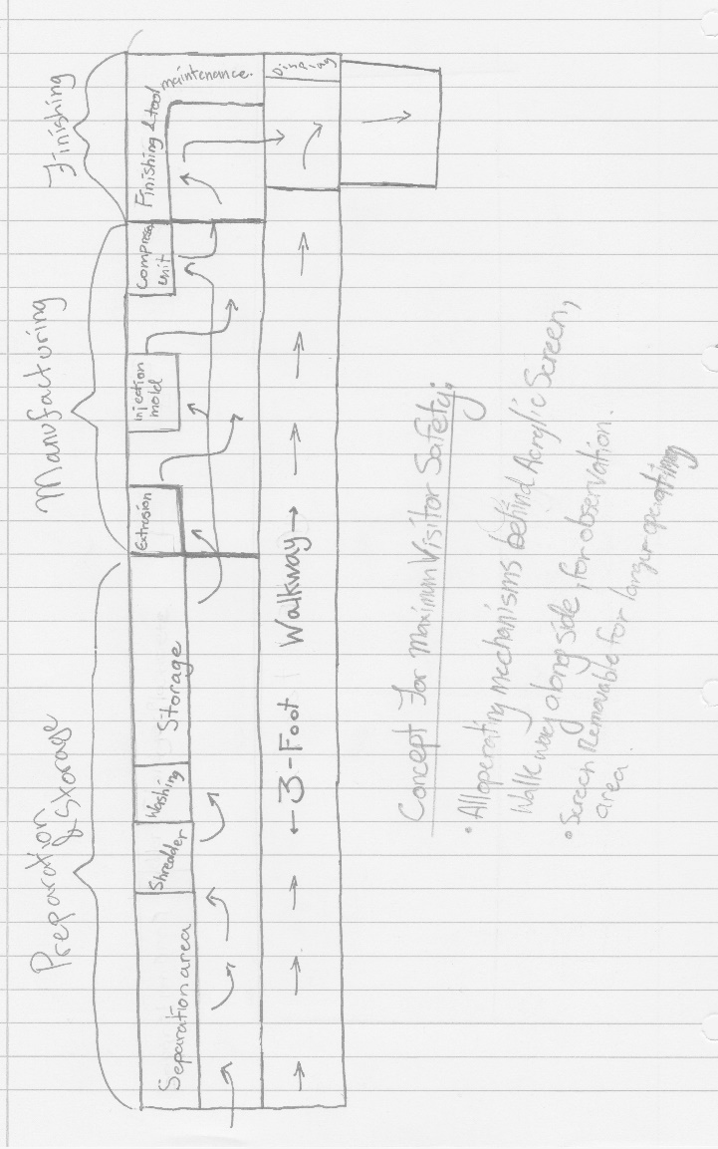
As visualization is an important part of most people’s work process, sketches to demonstrate the ideas presented above are a necessary part of this report. Therefore, in the section located immediately below this paragraph, some diagrams of the planned optimizations are displayed. These serve to show where improvements are being made, and what exactly is entailed in each iteration.

Design Suggestion One:
Figure 2. Potential layout, optimized for H&S, and Accessibility.
- The figure above shows a design optimized for accessibility and education, with a wide, open walkway down one side, providing plenty of poster space, with clear views of the equipment and working processes.
- All of the machinery has been positioned against one wall, simplifying electrical layout, and giving rise to an opportunity to place windows and hatches on that wall to be utilized in external operation or usage.
- Clear direction of flow for the work and operators, enabling efficient operation, and simple explanation of the process to observers.
- A small display area at the end of the walkway, to show off some of the produced items, in a space that is accessible to anyone interested in entering the premises, and not obstructing the work, nor being located in an area where viewers could potentially be at risk from one of the production stations.
- Shredder integrated into washing area, to allow for speedier processing, and this integrated into both the sorting and storage areas, in order to provide greater ease in preparing the materials for use in production.

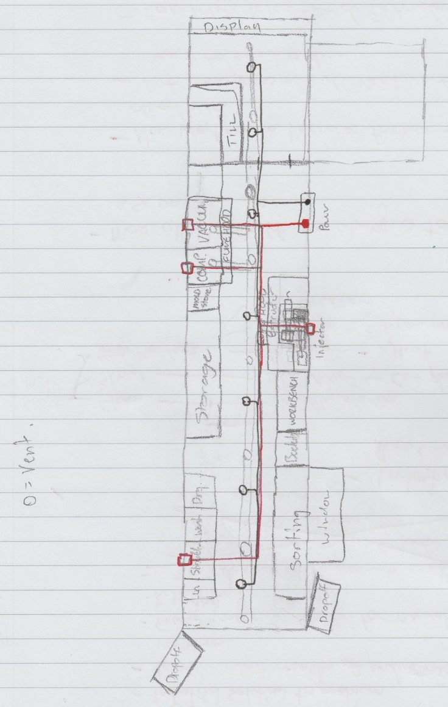
Design Suggestion Two:
Figure 3. A Slightly Modified version of the Original Setup; Red marks high-voltage wire for machinery, and black for lighting.
- Figure 3 includes a simple wiring and lighting diagram, on a setup that is only slightly modified from the original. The wiring is simplified as far as reasonably possible, reducing the length of cable needed, and minimizing the space necessary for the wires.
- This setup provides for a walkway through the center of the container. This enables easy access to all parts of the process, whilst allowing maximum utilization of the floor and wall spaces.
- Units have been relocated closer together in order to save space, allowing for a more useful customer area at the end of the line, complete with a till for purchase of the products. This is more of a commercial feature, but it may prove useful nonetheless.

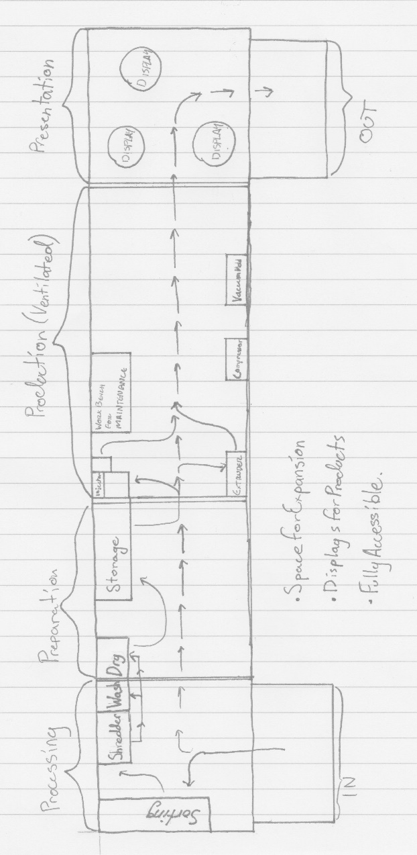
Design Suggestion Three:
Figure 4. Optimization of Space and Flow
- Fully compartmentalized to keep the processes separated, ventilated area where machinery is located.
- Automated washing system, attached directly to shredder, to minimize mess, and prevent spillages by being self-contained, keeping the hazards list short, so long as the machine is designed in such a way as to isolate the electrical parts from the water.
- Extensive display area, to contain all the products and information one could want, with large amounts of space available on the walls and floors of the preceding areas. This is in line with the goal of promoting education, whilst keeping the system accessible to all.
- Relatively wide, open spaces to facilitate access to several people at once, including school groups, without causing major problems to the workflow.
- This design also has a straight workflow, with only minor turns to utilize the equipment, leaving the path free for other users.
- Provision for expansion, allowing for additional machinery to be added to the system, extending its potential production capabilities, and allowing for further upgrades over the lifetime of the facility.

Additional Design Suggestions:
Additional designs will be added once the designs for the individual machines have been finalized, as concluding the design process for the container, and the system thereof, would be pointless without concrete knowledge of the proposed dimensions and power requirements of the equipment that is to be installed inside container. As this is not currently possible, this concludes the section on possible design solutions for the present, until such a point where this data is in existence.

PART FOUR

Final Design Analysis
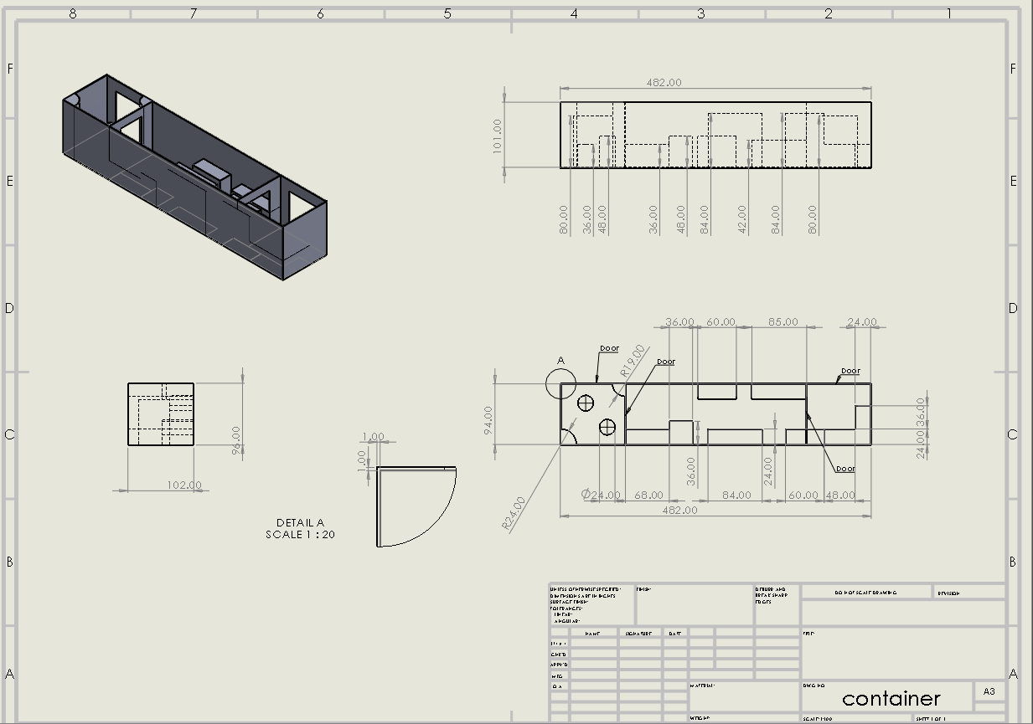
Having considered all of the previous designs, one final selection of features has been chosen, to be implemented into one combined plan of what the setup shall be. Thus, a computer-aided design (CAD) model has been produced, in order to provide a guide to the layout and relative positioning of the items inside, and to visualize the facility in a way that two-dimensional imagery does not allow. In addition, said two-dimensional imagery is also useful, for providing easy to read diagrams for measurements of specific parts of the setup. These diagrams are displayed and discussed below:
Figure 5. Engineering Diagram of the Final Plan
This diagram demonstrates the final design for the container, along with providing measurements necessary to complete the setup by insertion of the required articles of equipment, into the predetermined locations with measurements as to how large they and the work tables that they may be placed one or used with, may be. The measurements are all in inches, as the container is measured at specifically forty feet, and following that allows for simpler math with regards to ratios and lengths, than converting into the metric equivalents would produce.
Additionally, it is shown that the final design is split into three discrete rooms, allowing for a space for preparation of material and for display of the finished products, separate from the actual production area. This production area has been designed to leave a wide walkway through the center of the container, which improves on the ability to move from one end of the process to the other, relative to the original design.

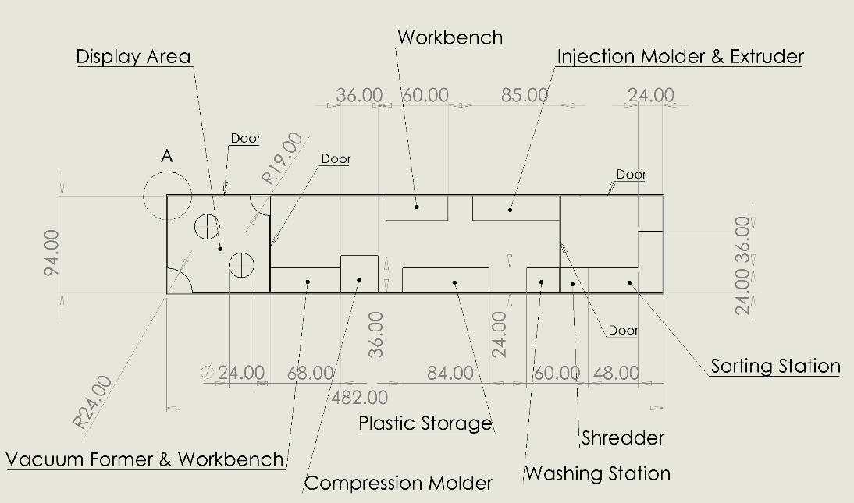
Speculative measurements for machinery have been provided, shown both diagrams above, and the placement of the machinery is shown in Figure 6. As can be seen therein, a relatively large space has been left empty at the end of the production area, allowing potential for future expansion. Following that train of thought, the space could be easily redesigned, if necessary, by placing all of the equipment on caster wheels, which will additionally reduce the load on moving them. It should be noted, however, that these specifications are reliant on the assumption that the redesigned equipment fits the sizing estimates shown here. In the event of these estimates being wildly inaccurate, the specifications above must be redrawn, which is not particularly concerning, as that just requires modifying a few measurements, and can be rectified rather rapidly.
Figure 6. Locations of the Various Pieces of Equipment
The display area, located near to the exit, is designed in such a way as to allow maximal observable area for the displays, whilst enabling relatively large numbers of people to view concurrently. These displays can, if needed, be moved, or removed, creating an open space where talks, lessons, or storage may be located. This promotes both the education requirements, and, to an extent, accessibility, whilst allowing maximal utilization of the space provided. This is in keeping with the goals of the project, as it is intended to be used for production, social stimulation, and education about the processes that are ongoing during its use.
In order to provide an experience that is both productive and safe, the workspace has been separated from the rest of the container by enclosing it in the center of the area. This enables the section with the propensity for producing fumes to be ventilated well, while eliminating the need for such extraction in the areas that are not working with the hot plastic. This ventilation may be provided with windows, which would also provide natural lighting, or through ducting, either per machine, or for a more general use, from the ceiling.
The storage for shredded plastic is located centrally in the processing area, to shorten the trip between station and storage, thereby improving the workflow, and removing potential chokepoints. These chokepoints would be problematic for both people working at the stations, and people who may just be observing, or passing by. This principle is a driving force behind the system as implemented here, which is why the floorplan is designed in the way that is shown.

Conclusions
As shown in the analysis of the current situation, the Precious Plastic setup has many aspects that need improvement, yet there is quite a lot of good in it at present. The various machine units will require drastic changes, and improvements to their safety, to make them suitable for a working environment, which will come in time. The process itself is, however, sound at its core, and will be usable once modified to fit the necessary regulations, to ensure that it will be made both safer for the worker and more pleasant for the bystander, both to be in proximity to and to use.
Proposed changes to the system, shown in the eponymous section, should allow for a high enough degree of safety that the intended audience would be able to use it unsupervised, after a minimal amount of training. This would fulfill the main criterion for the project and should create a decent level of satisfaction in the customer, given the current situation, and the parameters therein.
The optimizations described in the section on optimization selections lead to detailed plans of how to use this system to its best ability, with regards to the desired outcomes of the project’s intended usage. These sketches of designs are the first major step in creating a plan of action with the end goal of fully realizing the concept of a functioning, small-scale, recycling and manufacturing plant, and will be utilized in the next part.
In the final design, various aspects of the previous parts’ work came together to provide a final design solution. This design is not a perfect example of what could be achieved with this project, but it is what has been possible in the constraints thereof. Thus, there are still some problems with this design, but those can be readily removed over the course of implementing this system, and afterward during its use.
Overall, the initial plans provided by the Precious Plastic website showed great promise as a premise where interested parties could manufacture small items whilst boosting the levels of recycling in their local areas. This system had its faults, however, and the solving of which have been the objectives of this report. A plan to do this has been created, which has several changes which attempts to fix the issues and provides solutions overall. This final plan is not perfect, nor is it claimed to be so, but it does what it was intended to, which satisfies the needs set out in the beginning of the project.

References
British Plastic Federation. (n.d.). Publicly Available Specification (PAS) 103 . Retrieved from http://www.bpf.co.uk//media/download.aspx?MediaUid=C08108AB-E833-4843-914B-08CAED937C63
D3 Technologies. (n.d.). Retrieved from LEAN ENGINEERING: http://www.leanengineering.com/
HSE. (1974). Health and Safety at Work etc. Act 1974. Retrieved from legislation.gov.uk: http://www.legislation.gov.uk/ukpga/1974/37/contents
HSE. (n.d.). Plastics Recycling. Retrieved from TANGRAM TECHNOLOGY Ltd.: http://www.tangram.co.uk/TI-HSE-PPIS-02.pdf
Precious Plastic. (n.d.). Container Floorplan. Precious Plastic.
Precious Plastic. (n.d.). Precious Plastic mission. Retrieved from Precious Plastic: https://preciousplastic.com/en/mission.html

Bibliography
https://sketchfab.com/models/0428987718b542a2ab73f04813c2044e
http://www.hse.gov.uk/legislation/
http://www.bpf.co.uk/sustainability/plastics_recycling.aspx
http://www.tangram.co.uk/TI-HSE-PPIS-02.pdf
http://www.hse.gov.uk/pubns/ppis4.pdf
http://www.hse.gov.uk/pubns/ppis6.pdf
http://www.hse.gov.uk/pubns/ppis7.pdf
http://www.hse.gov.uk/pubns/ppis9.pdf
http://www.hse.gov.uk/pubns/ppis10.pdf
http://www.hse.gov.uk/pubns/ppis13.pdf
http://susproc.jrc.ec.europa.eu/activities/waste/documents/EoWPlasticsfinalDrepMar2013WEB.pdf

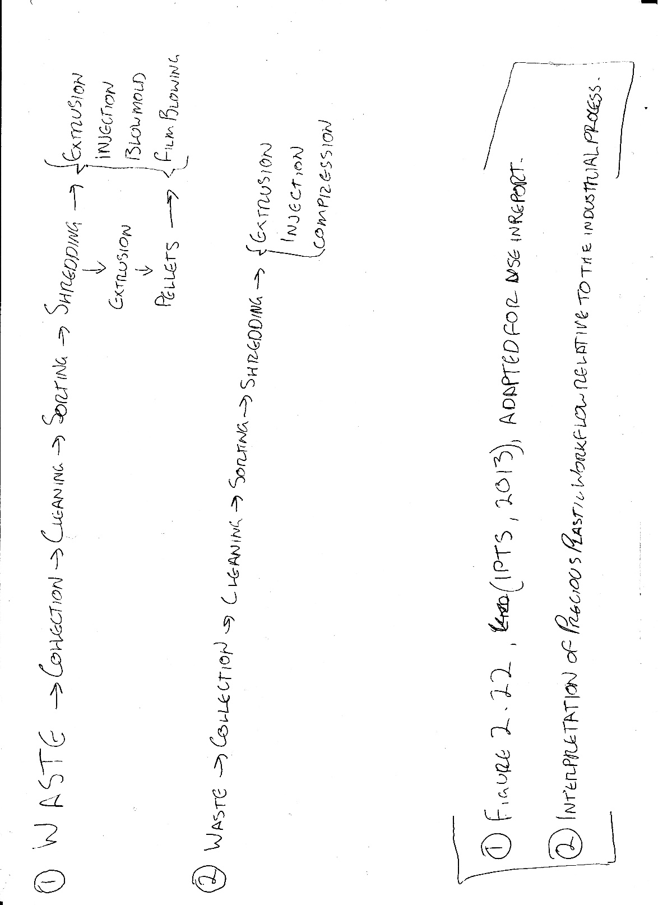
Appendix
Figure 7. Flowchart comparison of a standard industrial recycling plant to the Precious Plastic system.
Figure 8. A Proposed Alternate Layout for the Container, with Lighting and Power lines added.

