

Installation and Use of a Particulate Matter Sensor for Cartridge Rupture Detection and Predictive Maintenance of an Industrial Filter Unit

by

Niall Rees

Supervisor: Stalin Jacob

Second Marker: Dr Stephen Mosey

Project submitted as part of the requirements for the award of BEng (Hons) Electrical and Electronics Engineering

April 2024

Declaration Form and Form of Consent

DECLARATION

I, Niall Wyn Rees declare that I am the sole author of this Project; that all references cited have been consulted; that I have conducted all work of which this is a record, and that the finished work lies within the prescribed word limits.

This work has not previously been accepted as part of any other degree submission.

FORM OF CONSENT

I Niall Wyn Rees hereby consent that my Project, submitted in candidature for the BEng (Hons) Electrical and Electronics Engineering degree, if successful, may be made available for inter-library loan or photocopying (subject to the law of copyright), and that the title and abstract may be made available to outside organisations.

Contents
Declaration Form and Form of Consent 2
Table of Figures 5
List of Tables 6
Abstract 7
1.0 Introduction 8
1.1 Industrial Emissions 8
1.2 Project Motivation 10
1.3 Project Aims and Objectives 13
2.0 Literature Review 15
2.1 Sensor Technology Overview 15
2.1.1 Electrostatic Sensors 15
2.1.2 Optical Sensor Technology 16
2.1.3 Novel Solutions for Filter Monitoring 17
2.1.3 Bag Filter Monitoring Systems 18
2.2 Hazardous Areas and Regulations 18
3.0 System Development and Requirements 23
3.1 System Overview 23
3.2 Sensor Selection 24
3.2.1 Signal Output 25
3.2.2 Installation Requirements 26
3.3 ATEX Compliance 27
3.4 Associated Apparatus and Enclosure 30
3.4.1 Associated Apparatus 30
3.4.2 Enclosure (JB1) 32
3.5 Cable and Gland Requirements 33
3.5.1 Cable Requirements 33
3.5.2 Gland Requirements 35
3.6 PLC Interface 36
3.7 HMI Requirements 36
3.8 Software Requirements 37
4.0 Design and Implementation 38
4.1 Intrinsically Safe Circuit Calculations. 38
4.1.1 4-20mA Output Loop Electrical Parameters 38
4.1.2 Cable Properties (4-20mA) 40
4.2 Descriptive System Document and Circuit Diagram 43
4.3 Junction Box 45
4.4 Probe Installation 47
4.5 PLC Program 48
4.5.1 Analogue Scaling 48
4.5.2 Alarm Configuration 50
4.6 Operator HMI 54
4.7 Historian/SCADA Datalogging 55
5.0 Evaluation 57
6.0 Conclusions and Recommendations 62
6.1 Recommendations for Further Work 63
7.0 Reflection 64
References 65
Appendices 68
Appendix 1: Remote Zero IS Verification 68

Table of Figures

Figure 1 - Camfil Cross Flow Filter Unit Located at Sandvik Osprey, South Wales 8
Figure 2 - Damaged Filter Cartridge 11
Figure 3 - UV Powder Testing of Cartridge Filter 12
Figure 4 - UV Powder On Exhaust Ducting 12
Figure 5 - Example of Area Classification Drawing 20
Figure 6 - ATEX Motor Data Plate Displaying ATEX Information 21
Figure 7 - Sensor Signal and Data Flow 23
Figure 8 - Dwyer PMT2 Particulate Transmitter [19] 25
Figure 9 - Zener Barrier Circuit [22] 31
Figure 10 - HAWKE ATEX Gland 35
Figure 11 - IC694ALG223 Analogue Input Card [27] 36
Figure 12 - Particulate Transmitter DSD 44
Figure 13 - Junction Box JB1 3D model. 45
Figure 14 - Installed Junction Box with Outgoing Circuits 46
Figure 15 - Probe Installed in Plant Ducting 47
Figure 16 - Sensor Linear Response Characteristics and Sensitivity 49
Figure 17 - PLC Analogue input Scaling Block 50
Figure 18 - PLC Data Flow and Alarm Trigger Conditions 51
Figure 19 - Baseline Alarm Monitoring 52
Figure 20 - Spike Alarm Trigger 52
Figure 21 - Particle Monitor HMI Screen. (1) Graph Window. (2) Sensor Reading. (3) Alarm Threshold Data Entry. (4) Plant Status. (5) Alarm Message Grid 54
Figure 22 - Alarm Messages and Trigger Bit Conditions 55
Figure 23 - Historian Datalogging Dashboard 55
Figure 24 - Web Based View of Trend Data 56
Figure 25 - Particulate Levels and Filter Differential Pressure 18/03/2024. 58
Figure 26 - Particulate Emissions vs Differential Pressure 08/04/2024. 59

List of Tables

Table 1 - Emission Limits of Monitored Elements 9
Table 2 - List of Entity Parameters associated with Equipment in Hazardous Areas 28
Table 3 - Entity Parameter Descriptions for Associated Safety Barriers 29
Table 4 - Cable Entity Parameters 34
Table 5 - Comparison of Entity Parameters 38
Table 6 - PLC Input Scaling 49

Abstract

Environmental monitoring and permits issued by local authorities set out the maximum concentrations of metals in the air. Sandvik Osprey, is an atomisation plant, manufacturing high quality metal powders. As such, the process utilises industrial cartridge filters. These filters, when they degrade, allow particulate to be emitted from the exhaust, reducing their efficiency, and increasing pollution.
This project covers the installation of a Dwyer PMT2 electrostatic induction probe into the hazardous area exhaust ducting of a filter unit, where its output signal is proportional to the particulate passing over it. This project covers the installation of the sensor including the selection of associated apparatus, verifying intrinsic safety, and integrating the 4-20mA output loop to a plant PLC. The design of a HMI monitoring screen, and integration into a site Historian datalogger has allowed trends in bag deterioration and anomalies, such as spikes in particulate from filter cleaning to be monitored.
Alarms monitoring baseline emissions drift and spike levels have been configured. This can be used to judge the condition of the filters, and whether inspection or maintenance should be carried out. This predictive maintenance method will reduce costs and minimise plant down time, extending remaining useful life of assets.
From testing, baseline levels remained low due to new filters being installed at the end of 2023. Results after 166 atomisation runs indicates the filters are robust, with no noticeable increase in particulate emissions. The probe with its sensitivity set at 5-1000pA, registered several spikes in particulate during fan startup. This shows powder settles in the duct once one run is complete and is then pushed over the probe during the next startup.
Reducing the sensor range to 5-500pA, increasing its sensitivity has been recommended to provide more accurate readings of filter health due to the charge levels of metal powders. Recommendations to install the system on an older, more failure prone unit, with individual pulse cleaning signals interfaced with the PLC is discussed. This will allow pinpointing where filters are breached in the system from cleaning spikes.

Introduction

Industrial filters are readily used in any applications where a dust, powder or vapour is emitted from various process industries. The filters at Sandvik pneumatically convey metal powders through a proprietary atomisation process. Sandvik are a manufacturer of fine gas atomised metal powders ranging from copper, steel, and stainless-steel alloys as well as cobalt and nickel-based superalloys. Any powder that escapes the collection process is drawn through large, pleated filters within a Camfil Gold Series cross flow filter unit [1]. The dust that accumulates on these filters is displaced using an air pulse from a solenoid actuated diaphragm valve manifold, where it is collected in a waste drum beneath the unit. Figure 1 shows the filter in situ.
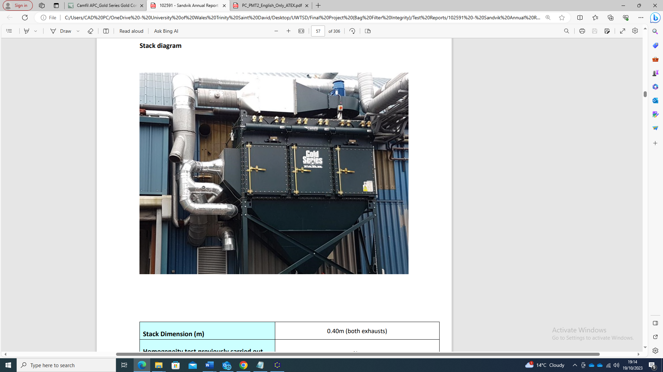
Figure 1 - Camfil Cross Flow Filter Unit Located at Sandvik Osprey, South Wales
Pulse Jet Manifold
Filter Inlet
Filter Exhaust

Industrial Emissions

As an industrial site, Sandvik is required to comply with its environmental permit issued by Neath Port-Talbot Council and enforced by Natural Resources Wales (NRW) [2]. The legislation regarding permits is set out in the Environment Permitting Regulations 2016 [3]. This permit details activities regarding industrial emissions released into the air. As metal powders are processed; a prescribed emission limit is set in the permit as per the process guidance notes 6/35(13) from DEFRA [4]. Table 1 displays the elements monitored and their concentration limits.
Table 1 - Emission Limits of Monitored Elements

To minimise particulate discharge, best available techniques (BAT) set out by the UK government guidelines in [5], should be adhered too, these include.
- Rigorous maintenance routines of industrial Filters
- Appropriate technology to capture process emissions.
- Annual testing and reporting of particulate from stacks and filters.

Monitoring of these elements is carried out using certified stack testing companies to comply with the best available monitoring techniques set out by the UK government. Reports are issued annually and indicate the amount of particulate passing out of the filters.
The area surrounding the plant is a designated air quality management zone, monitored by the local authority under the Air Quality Standard Regulations 2010 [6]. The emission concentration limit is currently set at 20 ng/m³ for nickel. This monitor is very close to the site, if the local authority were to detect an increase in nickel levels, the first call would be to Sandvik, as its activities routinely involve nickel powder. If emissions are found to be originating from the facility, NRW can force fines, or a HSE enforcement notice to investigate compliance with the issued permits.

Project Motivation

A system to provide an early warning of filter deterioration is required outside of annual stack testing. A sensor that provides an output proportional to the particulate flowing from the exhaust can indicate a breakdown or leak from one or multiple cartridges. Currently, filters are inspected routinely on a preventative maintenance regime on an annual basis and are replaced during this time. Each Camfil filter contains 12 pleated filters at a cost of £707 each, some of which may have a remaining useful life. This maintenance activity represents a significant cost to the company.
If an issue arises during production activities, plant down time can be a considerable cost to the company. Replacing the filters requires them to be inspected to identify the problem unit, then the additional time to acquire spares and replace them. Inspection is subject to individual assessment and visibility, therefore ambiguity introduced can lead to failed filters not being spotted, and a problem persisting.
Ruptured filters can reduce the process efficiency overall, leading to product losses. Filter rupture has a risk of creating a potentially hazardous area due to excess combustible dusts inside the filter unit. This topic will be discussed further into the report. Figure 2 displays the extent to which a filter can be damaged during operation.
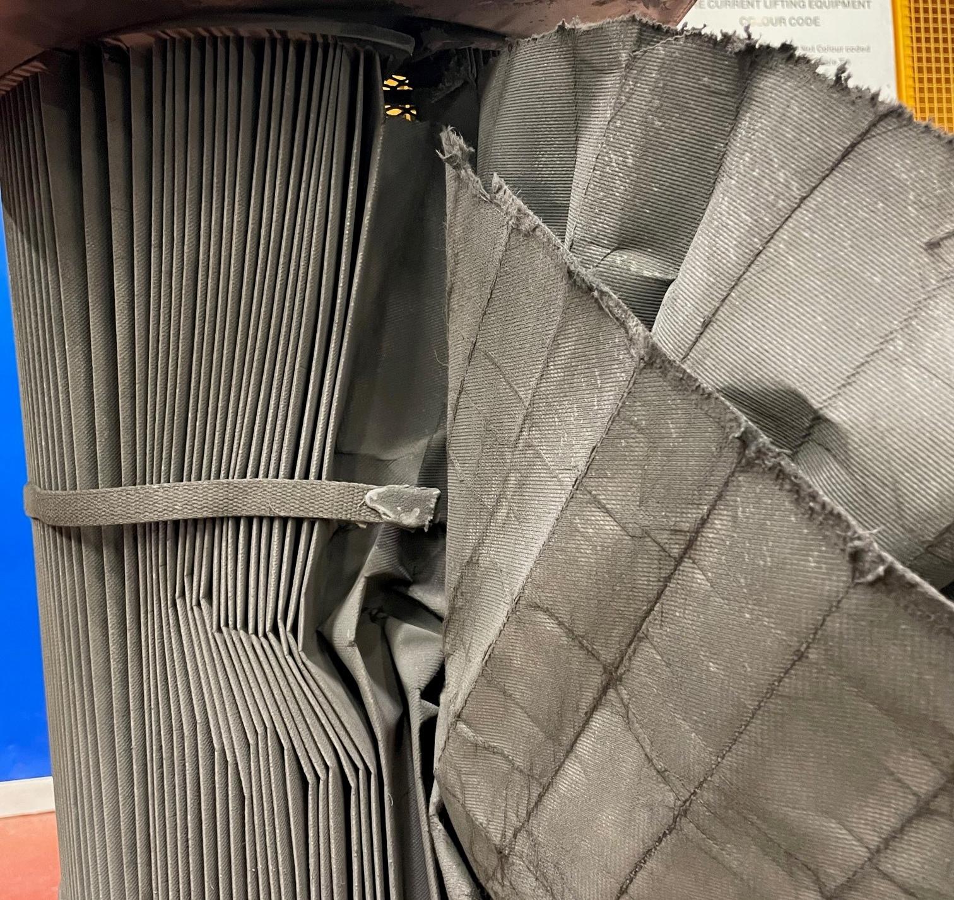
Figure 2 - Damaged Filter Cartridge

Dramatic filter failures as shown in figure 2 are easy to spot, however, prolonged use of the filters over multiple production runs may present degradation that may be less obvious. During the summer of 2023, emissions picked up by local authority meters showed an increased trend in nickel concentration levels in the atmosphere, that prompted a full investigation into the health of the filters on site as the reports fell between periods of stack testing. Initial visual inspections were carried out on units, but yielded no conclusive evidence of filter degradation, indicating the issue was not an obvious fault. Without continuous monitoring in place, there was no easy way to judge what filters were degraded. This led to the use of a UV powder being introduced into the airstream. This UV powder would be drawn over the filters, and any that escaped through the unit would be deposited on the exhaust ducting. A UV lamp could be used to see the deposits more clearly. This process led to a time consuming and dirty task to capture information on multiple units. Figure 3 shows the extent of the task along with figure 4 displaying UV powder emissions at an exhaust duct, proving there has been filter degradation.
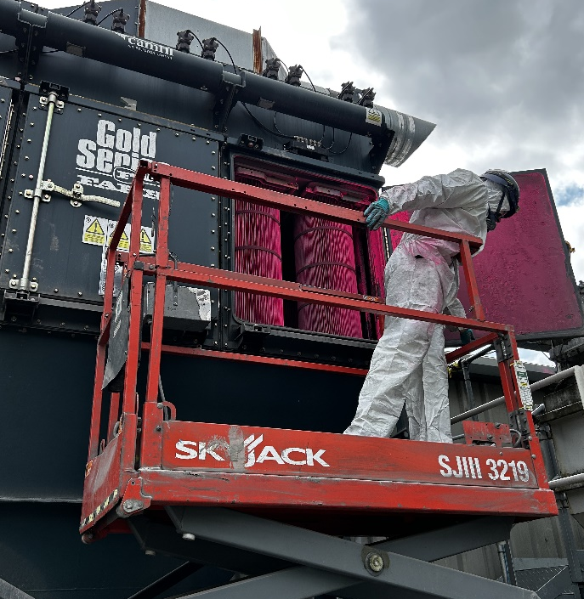

Figure 3 - UV Powder Testing of Cartridge Filter
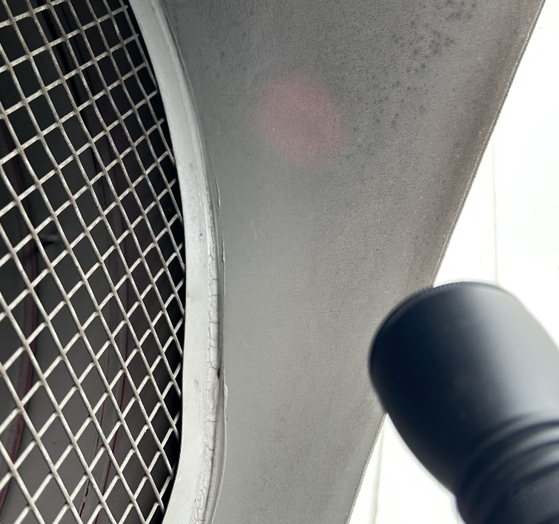

Figure 4 - UV Powder On Exhaust Ducting

Project Aims and Objectives

The aim for the project is to install a particulate sensor into the ducting of a filter unit to detect a change in particulate levels whilst the plant is running to indicate filter rupture, degradation, and prediction of failure. This live sensor reading will then be interfaced into a plant control system for data acquisition. The signal from the sensor will be available to operators and maintenance personnel via a plant Human Machine Interface (HMI). Alarms to indicate a baseline drift in particulate will be programmed to warn operators of a deteriorating filter. In addition to elevated emissions, an alarm to detect spikes in particulate when the filter is pulse cleaning will be programmed into the control system. This alarm will allow maintenance personnel to detect a specific row or individual failing filter within the plant. This signal can then be passed to a site Supervisory Control and Data Acquisition (SCADA) System and Historian, where it can be logged over time, allowing users to monitor trends in particulate emissions. As well as the new transmitter installation, existing instrumentation such as filter inlet temperature and differential pressure will be utilised. Elevated temperature at the inlet to the filter will degrade the resin binding the filters. Differential pressure readings may indicate a damaged filter and will also give an indication of the level of the dust layer caking the filter cartridges.
For a successful outcome, the following objectives shall be completed to satisfy the aim of the project.
- Source and install appropriate sensor technology.
- Generate Electrical circuit diagrams for installation and maintenance – including cable schedules, loop diagram and Hazardous area descriptive document.
- Interface the sensor signal with the plant control system via the Programmable Logic Controller (PLC) and calibrate analogue inputs appropriately.
- Develop a plant HMI screen to display live sensor data, display alarms and adjust threshold limits.
- Integrate existing plant instrumentation signals into HMI for total filter monitoring.
- Export sensor data to site SCADA system for historical datalogging.

The following chapters of this report will discuss the current technology available for this type of application that will determine the selection of the sensor to be used. The consideration of hazardous area regulations will be discussed, and how the design of an instrumentation installation is dictated around these requirements. PLC logic and alarm strategies will be demonstrated, along with a clear HMI design, and how an operator or technician will interact with the data coming from the plant.

2.0 Literature Review

The purpose of the literature review for this projects application is to assess the current sensor technology available to detect particulate matter within stacks, flues, and extraction systems. The literature reviewed outlines common sensor technology such as DC and AC coupled electrostatic discharge sensors, laser measurement techniques such as back scattering, forward scattering, and opacity measurement systems for particulate detection.
Whilst these common industrial sensor applications have been researched, some novel methods of bag filter rupture detection have been presented. These include the use of fibre-optic sensing technologies to pinpoint hole size and locations in bags, as well as using conductive fibres to measure a grids resistance change due to bag filter rupture or wear.
The literature review will introduce the regulations and implications of hazardous areas in industrial processes, and the protection concepts required for instrumentation systems operating in these environments.

2.1 Sensor Technology Overview

2.1.1 Electrostatic Sensors

Fundamentally, to detect a breakdown of bags or cartridges in a filter system, a property relating to the amount of particulate must be converted into a proportional signal output to be measured. A method of detecting particulate in pneumatically conveyed systems such as filters, is to utilise the triboelectric effect. This phenomenon arises when particles gather an electrical charge as they come in to contact with other objects in a process. The principle of electrostatic sensors is discussed in papers by Yong Yan, [7] and [8]. These articles cover the use of electrostatic sensors for use in continuous measurement of particulate in pneumatically conveyed systems.
Electrostatic sensors operate on the principle of electrostatic induction. An electrode, embedded in an insulating material is inserted into the flow of particulate, where the moving charged particles interact with the electric field of the electrode, analogous to capacitive coupling. The electrodes are connected to a signal conditioning circuit to filter and amplify the small charge currents. These signal conditioning circuits may be charge amplifiers, or current conditioning circuits utilising an Op-amp and feedback components, or in a transimpedance amplifier topology to convert small currents to a proportional voltage.
The differing types of signal conditioning circuits and the connection of the electrodes leads to either AC or DC coupled electrostatic sensors. The articles cited, explain the repeatability and elevated performance of AC type electrostatic sensors over the DC arrangement, where overall signal magnitude is measured with disregard for the alternating elements of the measured signal.
Using electrostatic sensors to measure accurate particulate concentrations has drawbacks, because of environmental conditions, stack air velocity and particulate properties. These instruments can be calibrated if stable conditions and particle properties are known. In the application presented in this report, particle metallurgy will vary due to the process nature, so therefore, the use of electrostatic sensors is common for qualitative trending of data, where increased signal levels will only indicate a relative change in the amount of particulate passing the probe.
Electrostatic sensors have an advantage of being simple and rugged devices allowing them to be utilised in harsh environments at elevated temperatures or outdoors.

2.1.2 Optical Sensor Technology

Particle measurement can be carried out using instruments where the transmission, reflection, refraction and scattering of light interacting with particulate is measured. Such instruments are shown in an application note from manufacturer Ametek LAND [9] for use within stacks and ducts, primarily in the power industry where combustion emissions are monitored.
Sensors using optical technology include opacity sensors, where a light source mounted to one side of a stack is aimed towards a receiver through the duct. The received light level is related to the obstruction caused by particulate. This method relies on an expensive instrument to be mounted to either side of a duct as is most effective with high concentrations of particulate – leading it to be less suited for filter breach applications.
Sensors using laser scattering techniques such as forward and back scattering utilise the effect of particle size fractions refracting light and measure the received light intensity and angle of incidence. The received light levels are then related to particle size and concentration.
These instruments are sensitive and have the benefit of being mounted to one side of a duct. However, they cannot distinguish between particulate and droplets of water, so are limited to dry applications or indoor locations.
Laser scattering is an established technique and can be found in low-cost indoor air quality monitors. Use of low-cost air quality monitors have been trialled experimentally against more expensive units for monitoring emissions of a bag filters individual filters as they are being pulse cleaned in [10]. Here, a reference instrument has been used to verify the spikes in emissions seen by the low-cost monitors as the filters are cleaned. This presents a useful method of monitoring individual bags for breakdown or leaks. To implement this in a realistic industrial environment where there may be hazardous areas or elevated temperatures will greatly decrease the low-cost sensors service life.

2.1.3 Novel Solutions for Filter Monitoring

Established techniques for measuring bag filter breakdown by placing a measurement instrument in the exhaust of a filter unit can give a quantitative insight into a systems condition. Some experimental studies have been conducted to pinpoint the size and location of filter leaks using fibre optic cables draped through individual bags where pulsed laser light is sent through the optical fibres [11] [12]. Vibrations induced by leaks caused the returned light to be scattered at varying frequencies that can be demodulated from the carrier frequency of the pulsed light. The experiments were carried out with bags in various states of repair with differing size holes. Machine learning techniques using neural networks were then trained to recognise individual faults from the vibration packets and pinpoint their locations within the filters to a high degree of accuracy. Whilst this is an interesting method of pinpointing leaks, further development into an off the shelf instrument may make it possible to integrate into an industrial environment.
Another novel solution to monitor filter degradation is presented in [13], where a grid of resistive fibres was included in the structure of a filter bag. The measured resistance change was recorded over bags subjected to thermal, chemical, and mechanical damage indicating a breakdown in the filter condition. This method allowed for degradation of bags to be detected at an early stage. This method proposes an interesting solution for filter monitoring; however, filter manufacturers would need to adapt the technology within their systems. The use of electrical sensing within a bag filter may raise issues if the media being filtered was explosive as is the powder being processed in the main body of this project report.

2.1.3 Bag Filter Monitoring Systems

An application note published by Auburn FilterSense alongside a cement manufacturing facility seen in [14] involved the installation of an electrostatic sensor probe into the exhaust duct of an industrial bag filter. This signal was coupled with differential pressure sensors and the pulse signal from the cleaning jets to create an automated baghouse condition monitoring system. The system allowed data to be logged using a monitoring software along with connection to an industrial PLC and datalogging system. The system allowed pulses seen at the exhaust to be related to the rows of bags being pulse cleaned, pinpointing the location of breaches or degradation. The use of non-clogging differential pressure sensors would allow operators to see the layer of build-up on the filter system, this is needed to maximise efficiency of the filtration system. All these additional sensors allowed for optimal cleaning cycles to be carried out, saving energy and maximising system efficiency, whilst monitoring particulate output for environmental and predictive maintenance reasons.

2.2 Hazardous Areas and Regulations

Within industry, many process have the potential to form explosive atmospheres. Explosive atmospheres may be formed from explosive gasses, vapours and dusts that are suspended in the air. The Dangerous Substances and Explosive Atmosphere Regulations (DSEAR) 2002 [15] provide guidance for industry on the assessment of risk associated with hazardous substances, with a view to reduce the risk of fires and explosions to employees, public and assets. The regulations give guidance to the classification of explosive areas into defined zones and methods to eliminate, reduce or mitigate hazards from potentially explosive atmospheres.
The other legislation relating to explosive atmospheres are the ATEX 137 user directive and ATEX 95 Equipment Directive. These are implemented under DSEAR in the UK, giving guidance on the classification of areas, risk assessment and protection of the workforce. ATEX 95 was introduced to remove trade barriers ensuring equipment manufactured met the required safety standards for use in hazardous areas.
The standards covering the requirements for equipment installed in hazardous areas is covered by in a multi part document BS EN 60079 – Explosive Atmospheres. These standards cover the area classification guidance, BS EN 60079 – 10 – 2 Classification of Areas: combustible dust atmospheres [16]. From this standard, the following area classifications for combustible dusts are as follows:
- “Hazardous Area: an area in which an explosive atmosphere, in the form of combustible dust in air is present or may be expected to be present, in quantities such as to require special precautions for the construction, installation and use of apparatus”.

- “Non-Hazardous Area: an area in which an explosive atmosphere, in the form of combustible dust in air is not expected to be present, in quantities such as to require special precautions for the construction, installation and use of apparatus”.

- “Zone 20 (continuous grade) (>1000Hrs/Year): an area where an explosive atmosphere, in the form of combustible dust in air, is present continuously or for long periods or frequently for short periods”.

- “Zone 21 (primary grade) (between 10 and 1000Hrs/year): an area where an explosive atmosphere, in the form of combustible dust in air, is likely to occur in normal operation”.

- “Zone 22 (secondary grade) (< 10Hrs/year): an area where an explosive atmosphere, in the form of combustible dust in air, is not likely to occur in normal operations but if it does occur will persist for a short period only”.

Equipment to be used in these zones must have the correct equipment protection level for the nature of the hazardous material. These Zones are then marked on a classification drawing that is made available to operators and technicians, indicating the potentially explosive atmospheres. An example is shown in figure 5 of the plan view of a dust filter. It shows the internals of the machine are Zone 21 and that external ducting is Zone 22.

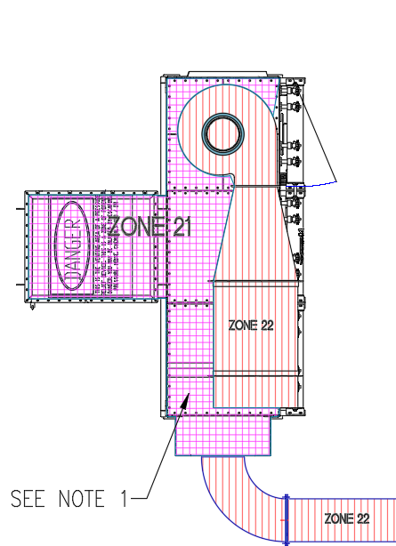
Figure 5 - Example of Area Classification Drawing

The requirements for electrical installations and design are covered in BS EN 60079 – 14: Electrical installations design, selection, and erection [17]. This standard provides details of protection concepts of rated equipment. These are methods of preventing an ignition source when an item is operating in a hazardous area. Items that are certified to operate in explosive atmospheres are subject to stringent testing and design compliance to meet their equipment protection levels for different zones. Protection concepts can range from the enclosure through to intrinsic safety. Temperature classifications are defined for equipment, ensuring that during operation surface temperatures cannot go beyond levels that can cause an ignition. These vary depending on the type of equipment but are important to consider when selecting equipment, as the substance in the defined zones will have a known ignition temperature or ignition energy.
To ensure equipment is suitable for use in a classified area, the manufacturer will apply a data plate on the equipment displaying a code relating to its protection concept, equipment group (Gas/Dust), temperature classification and equipment protection level. The equipment must also have its ATEX certificate number displayed from the notified body who carried out the approval. This contains valuable information, such as special requirements of use. Figure 6 displays an example plate from a ATEX rated motor.
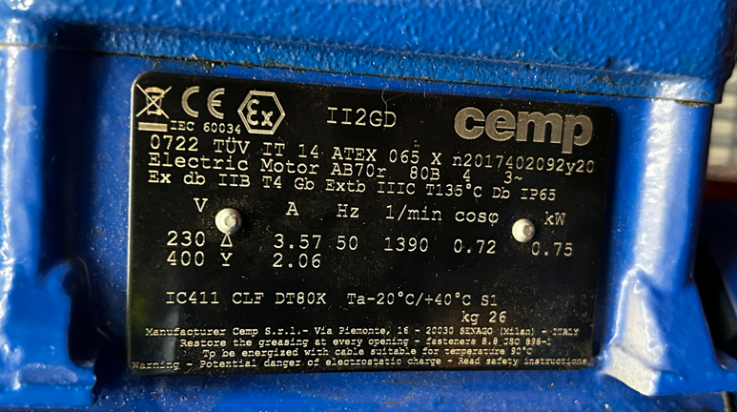
ATEX Certificate Number
Protection Level
Ambient Operating Temperature
Figure 6 - ATEX Motor Data Plate Displaying ATEX Information
From figure 6, this information can be decoded to ensure the motor is rated for the area its installed. The code for the protection level is as follows.
- Ex tb: This shows the motor has a protection concept of ‘Enclosure’ meaning the IP rating is sufficient to stop dust entering the motor and that it has minimal surfaces for dust to collect. The ‘b’ notation is the level of protection of this enclosure, this motor is only certified for use in Zones 21 and 22.

- IIIC: This shows the motor is suitable for use with conductive dusts. This equipment group can also be used for non-conductive dusts, IIIB and combustible fly ins, IIIA.

- T135°C: This is the temperature classification of the motor. This states under use, the temperature on the surface of the motor will not rise above 135°C. This is to avoid layer or cloud ignition of any dust in the area. These motors are usually thermistor protected to stop if temperatures rise.

- Db: This is the Equipment Protection Level (EPL), this is another method of stating, that the motor is suitable for dusts ‘D’ and has a rating of ‘b’ allowing it for use in Zones 21 and 22 only.

- IP65: This is the standard ingress protection rating of the motor. 6 indicates the unit is dust tight, and 5, indicates its resistant to jets of water.

The ATEX certificate number displays the notified body that carried out the approval, a date code and the ‘X’ shows there are special conditions for use noted on the certificate.
The electrical inspection and maintenance of electrical installations is covered in BS EN 60079 – 17 [18]. This provides details of documentation and inspection criteria to ensure the safe operation of equipment and compliance with DSEAR.
The information shown in this section of the literature review will influence the selection and installation of an appropriate instrument to maintain compliance with DSEAR guidance. Discussion of the sensor selection constraints such as protection concepts and temperature classifications due to hazardous areas will be covered in the design chapter of this report.

3.0 System Development and Requirements

This chapter introduces the specific project requirements and how the installed device will be used to achieve the project outcomes. A system block diagram shown in figure 7, displays the main features to be designed for the project. Selection criteria for the sensor will be discussed, and have been based upon constraints regarding environmental conditions, physical dimensions, signal output and measurement method. Intrinsically safe protection concepts, including the selection and use of associated apparatus will be shown.
The signal will be interfaced into an industrial control system, comprising of a plant PLC and HMI, this section shows the design requirements to present the data to operators and technicians, including alarm outputs and setpoints. Other design criteria such as installation requirements, including cable selection and hardware will be defined in this chapter.

3.1 System Overview

Figure 7 displays the proposed topology for the installation.
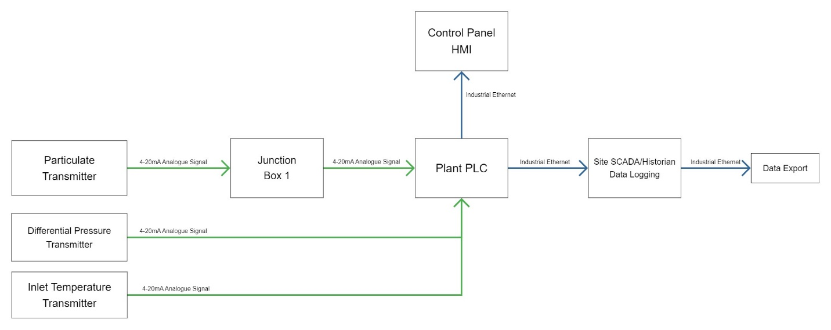
Figure 7 - Sensor Signal and Data Flow

The differential pressure (DP) and inlet temperature transmitters are existing on the plant and interfaced using a standard 4-20mA current loop signal to the PLC located in a control room. These are currently the only indication of filter health for the plant. The filter will lock out if a high temperature alarm is reached, allowing a run to be completed, but the filter cannot be restarted until the cartridges are checked. The differential pressure alarm detects if the pressure across the filter is too low, indicating a cartridge is severely damaged or if the pressure is too high, indicating that the filters are blinded with dust. The DP transmitter is not an ideal solution to monitor filter rupture as low DP is found when new filters are installed as there is no dust layer formed. This leads to alarms being forced off until the pressure rises. High differential pressure is not desirable; however, it only indicates that the filters require more cleaning cycles. The addition of a particulate sensor will give a true representation of filter health, with the DP and temperature sensors acting as further tools to determine the condition of the filter when a particulate alarm occurs.

3.2 Sensor Selection

From the literature review, the use of electrostatic induction sensors has been shown to be a common method of monitoring particulate from a duct. This technology is appropriate for the application due to it being robust, low maintenance, easy to install and readily available from industry manufacturers. As the sensor is not required to provide an absolute reading of dust concentration in mg/m³, this type of sensor is appropriate. An electrostatic induction sensor from Dwyer Instruments, the PMT2 series transmitter has been selected [19]. This consists of a straight electrode, coated in PTFE to minimise powder sticking to it, with a rugged enclosure to work well in harsh environments. Figure 8 displays the chosen sensor. Justifications for the choosing this sensor are discussed in the following sections.
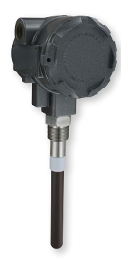
Figure 8 - Dwyer PMT2 Particulate Transmitter [19]

3.2.1 Signal Output

Electrostatic sensors typically generate an electrical current signal in the range of picoamps, via the effect of electrostatic induction from charged particles. This is inappropriate to measure in an industrial setting. The unit will have internal signal conditioning and amplification to provide a standard signal interface, proportional to the amount of charge transferred. Common industrial analogue signal types are in the form of a current loop, either 0/4-20mA or 0-10V. For this application, the Dwyer PMT2 uses a 4-20mA current loop output. Current loop outputs are a relatively old technique but are proven and standardised throughout industry. A current output enables easy incorporation to the plant PLC analogue input cards. 4-20mA current loops see no signal loss due to cable runs. A voltage output will suffer from signal degradation due to voltage drop from the resistance of a cable run from instrument to plant. 4-20mA current loop signals are more resistant to noise from external sources such as 50Hz mains frequency induced noise from adjacent cable runs, PWM high frequency noise from drives, or in the case of Sandvik, induced noise from induction furnace coils and inverters.
The 4-20mA signal, is a live zero signal, and allows the detection of transmission faults in the signal line. This feature can be used to indicate an open circuit from a line break, as the current would fall to zero. Conversely, currents over 20mA may indicate shorts on a transmission line [20]. The chosen transmitter is loop powered, making it a convenient method to provide power and measurement using one pair of wires.
The sensor output has a choice of 6 range settings to account for the different charge levels seen due to varying materials and their charge polarity. This feature will allow the range to be tuned for the most common alloys being produced on the plant.
The unit also includes a separate remote zero channel. This can be switched using a digital output from the plant PLC after cleaning to null the sensor before operation.

3.2.2 Installation Requirements

The unit is to be installed outside, exposed to the weather. The enclosure must be a minimum of IP65 to withstand rain and dust ingress and made of a corrosion resistant material. The Dwyer unit enclosure is constructed of powder coated aluminium and is sealed giving an IP rating of IP65.
The probe length required is governed by the duct size it is installed to. The datasheet recommends allowing the electrode to sit at least halfway across the diameter of the duct, away from turbulent airflow. The ductwork of the filter exhaust is 400mm in diameter, therefore, a probe length of 250mm has been selected, to allow sufficient protrusion whilst allowing for the mounting hardware.
The probe must be removable for cleaning and inspection. The unit has been specified with a threaded tri-clamp mount to facilitate quick release of the probe with no tools. This will aid in maintenance and troubleshooting.
The unit has been specified with M20 female threaded entries. This will allow the use of standard M20 cable glands.

3.3 ATEX Compliance

The unit is installed in a filter that has been area classified as hazardous. The exhaust duct of the filter is a Zone 22 area, with conductive dusts. The material that this plant produces is of a volatile nature and is highly explosive, with a low ignition energy. To satisfy the ATEX requirements of this zone, the sensor would have been satisfactory with an EPL of, Ex II 3D IIIC Dc, rated for Zone 22 only. However, a requirement of the process department of the facility, due to the cost of the instrument, may require it to be in an area with a more severe classification. This influenced the sensor selection to be of a higher protection rating, for further development.
The Dwyer PMT2 has an ATEX compliance of II 1D Ex ia IIIC Da T120°C (-40°C ≤ $T_{amb}$≤ 63°C) (-40°C ≤ $T_{Process}$≤ 120°C). This leaves the probe with the following rating of; suitability for surface activities (Group 2), for use with conductive dusts (IIIC), for use in Zone 20, 21 and 22 (1D) and (Da). It is certified for use in an ambient temperature range between -40°C to 63°C, with a maximum process temperature of 120°C.
The protection concept is intrinsically safe (I.S), ‘ia’. This protection concept is one of the only ATEX protection methods that is wholly electrical. Intrinsic safety is the principle of preventing enough energy to cause an ignition source into the hazardous area. This is achieved by limiting the power going to a device via additional certified apparatus, such as Zener Diode or galvanically isolated barriers and careful circuit design. The requirements for electrical systems with an intrinsically safe protection concept, and their design are covered in BS EN IEC 60079 – 25: Intrinsically Safe Electrical Systems [21].
Intrinsic safety is a system concept, where the whole loop of a circuit must be analysed to ensure it is intrinsically safe. This requires the comparison of the maximum power, voltage and current of a field device, and the maximum output values of any associated apparatus. The lumped circuit capacitance and inductance values of components and cables must be carefully considered to ensure hazardous energy levels cannot be stored, potentially causing an ignition.
Table 2 displays a list of the entity parameters associated with a piece of equipment in a hazardous area.

Table 2 - List of Entity Parameters associated with Equipment in Hazardous Areas

To select a piece of associated apparatus to protect the circuit in the hazardous area, initial values from the transmitter must be compared from the datasheet to the entity parameters of the associated apparatus. Table 3 displays the parameters for safe area equipment.

Table 3 - Entity Parameter Descriptions for Associated Safety Barriers

Comparison of the voltage, current and power entity parameters of the hazardous area equipment and associated safety barrier / apparatus must comply with the following rules.
These entity parameters shall be recorded and presented in a Descriptive System Document (DSD) as required in IEC60079 – 25.

3.4 Associated Apparatus and Enclosure

3.4.1 Associated Apparatus

The associated apparatus in an intrinsically safe circuit, forms a barrier interface between the hazardous area circuitry and the non-hazardous, plant side wiring. These barriers are put in place to limit the energy that can be transferred to the hazardous area.
A Zener type barrier utilises Zener diodes across the input and output terminals of the device. They feature a fuse that will open in a fault condition and an infallible current limiting resistor. Figure 9 displays a typical Zener Barrier topology.

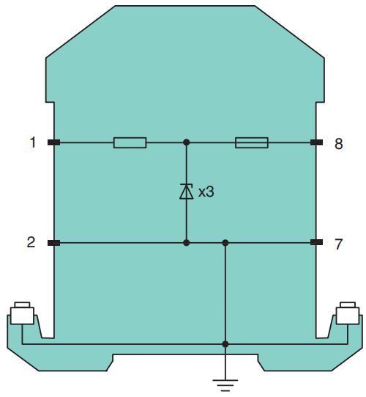
Figure 9 - Zener Barrier Circuit [22]

When hazardous voltage levels are seen at the device input terminals, above the reverse breakdown voltage of the Zener diodes, they begin to conduct. The hazardous fault current is then shorted directly to a high integrity, low impedance ground connection. The fault current then causes the fuse to open, removing power to the device in the hazardous area. The current limiting resistor reduces current drawn by the field device to safe levels.
The level of safety provided by intrinsically safe barriers and equipment is denoted by ‘ia’, ‘ib’ and ic’. These indicate the level of redundancy and fault tolerance in a system. An ‘ia’ rated Zener barrier has 3 Zener diodes, meaning if two fail, the fault current will still be directed to ground by at least one diode. Similarly, ‘ib’ devices are one fault tolerant, and ‘ic’ are not fault tolerant.
Another common barrier technology, galvanic isolation utilises a separation between hazardous area connections and safe area connections. This is normally achieved with an isolating transformer, in the case of analogue signals, or opto-isolation for digital signals, using photodiodes and LED’s. Some galvanic isolators use a Zener diode barrier at the front end as additional protection. Galvanic isolators are selected for specific signal interfaces such as 4-20mA loops, digital communications and discrete inputs and outputs.
For this application, a Zener barrier, Z728 from Pepperl and Fuchs [22] has been chosen. This is a DC positive polarity barrier, suitable for analogue signal interfaces. This choice is based upon the following:
- The entity parameters satisfy the intrinsic safety requirements for the particulate transmitter.
- Simple to implement.
- Minimal signal degradation
- Small form factor and high packing density.
- Low cost.
- Multipurpose – Can be used for standard digital signals as well as analogue. Lower parts count and spares required.

The main drawbacks of a Zener barrier over a galvanic isolator are the limitations with the grounding. Zener barriers recommend a high integrity, dedicated intrinsic safety earth connection. The ground of the Zener barrier should not be tied into the general plant earth. This may induce unwanted ground loops, causing signal loss, and multiple earth fault paths. IEC 60079-14 recommends an earth impedance of less than 1Ω. The plant where this apparatus will be installed has a dedicated ‘clean’ earth connection for instrumentation and a separate plant earth for general instrument and metalwork bonding.
Galvanically isolated barriers alleviate this need for a dedicated earth connection, however, they are more complicated, higher cost and required to be specific for the signal type they are interfaced with.

3.4.2 Enclosure (JB1)

An enclosure has been selected to house the Zener barriers and act as a junction box between the instrument and the plant PLC control panel. This allows the hazardous area equipment to be kept local to the filter unit, for ease of installation and ongoing inspection, maintenance, and lack of space inside the plant control panel.
Part of the ATEX directive requires all intrinsically safe circuits to be routed with a minimum separation of 50mm from non-intrinsically safe circuits. Running one cable from the transmitter to the plant control panel would not allow this separation due to the plant design and poor condition of existing cable management. Running the I.S cable from the instrument to a local junction box would minimise the potential for damage from other equipment and hot surfaces. The outgoing cable from the junction box to the plant is not considered intrinsically safe due to it being terminated on the safe area terminals of the Zener barrier.
The enclosure chosen is the Schneider Spacial S3DEX [23]. This is a compact steel enclosure with an IP rating of IP66, making it suitable for outdoor locations and dusty environments. The enclosure is also IK rated to IK10; this is the impact resistance rating of the enclosure for electrical enclosures as per BS EN 62262 [24]. Impact rating is important for the location of the enclosure due to potential contact with plant vehicles. The enclosure is also certified for use in hazardous areas to Zone 21.

3.5 Cable and Gland Requirements

3.5.1 Cable Requirements

Cable for this application is required to be UV stable for use outside, armouring is preferred for extra mechanical protection and should be suitable for instrumentation systems. The cable between the sensor and the junction box is carrying intrinsically safe circuits and should be coloured light blue to indicate this as per BS 60079. The cable should be screened to reduce noise via electromagnetic induction from surrounding equipment.
The cable chosen for this application is a 2 Pair Part 1 Type 2 Single wire armoured (SWA) BS5308 instrumentation cable [25]. This cable has individually screened pairs and a collective screen. Screening is achieved with a foil tape, covering the entire pair, and grounded using a drain wire.
This cable is suitable for instrumentation systems with intrinsically safe circuits. The cable is UV stable and has an installation ambient temperature range suitable for its location. The cable will contain both the analogue circuit from the transmitter 4-20mA loop, and the digital output from the PLC for remote zeroing the device. This cable is compliant for use with multiple I.S circuits as it meets the criteria set out in BS60079-25-9.2.2, where the dielectric strength of the insulation has been tested to 500VAC and does not contain circuits with voltages above 90V.
As with the associated apparatus and the transmitter, the cables parameters shall be used in verifying intrinsic safety. These entities are shown in table 4. Cable capacitance and inductance must be considered due to the energy storage capability over the length of the cable run. These parameters are provided by the cable manufacturers datasheet.

Table 4 - Cable Entity Parameters

3.5.2 Gland Requirements

To maintain the IP rating of the device, and to satisfy the minimum standards for the hazardous area classification a suitable ATEX rated, IP rated gland is to be selected.
Gland Selection Criteria:
- Cable OD = 11.8mm
- SWA (Single Wire Armoured) clamping ferrule.
- M20 Thread for cable entry.
- IP65
- ATEX II 2D Ex tb IIIC Db IP65 required for area classification.

The specified for the application is the HAWKE 501/453/Universal/O cable gland [26] shown in figure 10, complete with IP sealing washer and earthing tag.
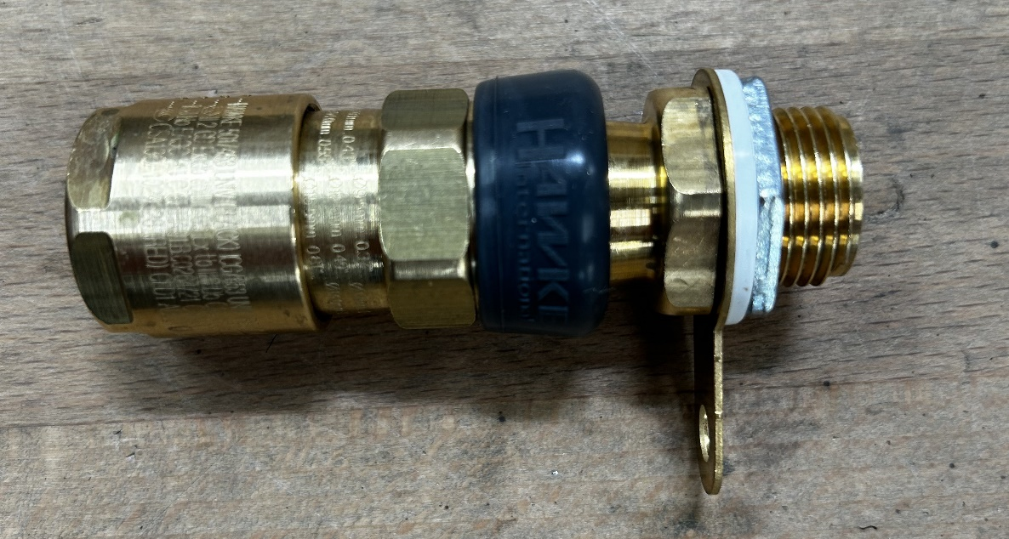
Figure 10 - HAWKE ATEX Gland

3.6 PLC Interface

The plant PLC is from the Rx3i range of processors from GE. The 4-20mA signal is to be interfaced with a 12-bit, 16-way, single ended analogue input card, IC694ALG223 [27] to convert the time varying current signal into a 0 – 32000 discrete count level in the PLC CPU. This allows the PLC input to be scaled for the process units required. The input card is mounted in a rack, consisting of power supply, communications module, CPU, and various I/O cards. Figure 11 displays the analogue input card.
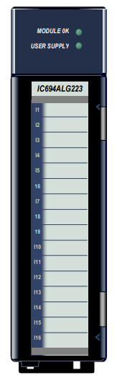
Figure 11 - IC694ALG223 Analogue Input Card [27]

3.7 HMI Requirements

To display the live readout of the particulate level exiting the filter, a screen shall be configured to display process values, active alarms, and allow data entry. The HMI installed on the plant control panel is a 15” touch screen unit from GE. This screen is used to control all aspects of the atomising plant and provide feedback to operators and maintenance staff of plant status.

The HMI is connected directly to the PLC via an industrial ethernet fieldbus system. This allows the use of common networking protocols to send and receive data from the HMI to the PLC, and from the HMI to the site Historian datalogging system.
For this application the HMI requirements are as follows.
- Live readout from sensor current loop, displaying charge levels in pA.
- A trend graph to show spike levels, and emissions trends from the filter unit.
- Alarm banners to communicate when there has been an impermissible spike or raise in baseline particulate levels.
- Data entry boxes, allowing alarm level setpoints to be changed.

3.8 Software Requirements

To program the PLC and create the HMI design, GE PAC Machine Edition software is to be used. The sensor data will be programmed using ladder logic, utilising analogue function blocks to process and scale the data from the instrument. Comparison blocks, timers and Boolean data types will be used for handling alarm levels. Timers will be utilised to dampen spikes and ensure genuine alarm conditions are met.
The HMI will be programmed using the software’s graphical panel editor. Standard function blocks will be used to display data, graph traces, and provide input data entry. The HMI design will be unambiguous, and clear to operators.
To create circuit diagrams, loop diagrams and I.S DSD documentation, AutoCAD drawing software will be used, including AutoCAD Mechanical, and Electrical. To aid in junction box manufacture, Autodesk Inventor will be used to create a 3D model of components. This will be used to visualise installation locations, providing clear requirements to installation technicians.
The data from the particulate transmitter will be recorded to a site Historian from GE. This software allows process variables to be stored on a secure control server. From here, data can be retrieved and viewed between any period. This will aid in spotting changes in overall particulate level. This software allows graphs to be created and data to be exported to other applications such as Excel.

4.0 Design and Implementation

This chapter will demonstrate the design of an intrinsically safe circuit, using the methods prescribed in BS EN600079-25. This will compare the entity parameters of each piece of equipment to verify intrinsic safety. This information, along with the loop diagram for the instrumentation will be displayed in a descriptive system document. This document will be used to install and inspect the equipment.
This chapter will cover the programming of the plant PLC ladder logic for the process data, as well as the HMI design for operators and maintenance staff. From the initial design, installation and commissioning will be shown of the device on the plant, with its output data being displayed in the site datalogging system.

4.1 Intrinsically Safe Circuit Calculations.

From chapter 3, the entities described in table 2 relate to the instrument in the hazardous area. For the Dwyer Particulate Transmitter, the analogue output and the remote zero input, are treated as sperate intrinsically safe circuits. These entity parameters are compared to those of the associated apparatus, from table 3 to ensure they comply; their entity parameters are shown in table 5.

4.1.1 4-20mA Output Loop Electrical Parameters

Comparison of Entity Parameters
$$U_{e} ≤ U_{m}$$
26.5V | 250V
$$U_{o} ≤ U_{i}$$
28V | 28V
$$I_{o} ≤ I_{i}$$
93mA | 93mA
$$P_{o} ≤ P_{i}$$
650mW | 651mW
Table 5 - Comparison of Entity Parameters
From table 5, the maximum permissible input values are all greater than or equal to the maximum output values from the Zener barrier. This would indicate upon first inspection that the equipment is safe for use. However, one check that is often overlooked in the verification of intrinsic safety, is the effects of lumped capacitance and impedance of the connected instrument. The values of Ci and Li, represent the maximum internal unprotected capacitance and inductance values. As more sophisticated instrumentation is being employed, attention should be paid to the energy storing potential of internal circuitry from power supply filter inductors and capacitors.
The maximum capacitance and inductances that can be connected to an associated apparatus, Co and Lo must not exceed certain levels, depending upon the gas or dust groups they are to be used in. The Z728 barrier ATEX certificate, will highlight these maximum values.
The maximum values are shown below,
Dwyer Probe internal capacitance and inductance.
$$C_{i}=0.022µF$$
$$L_{i}=0.373mH$$
Z728 Zener barrier maximum permissible external inductance and capacitance for combustible dust group IIIC.
$$C_{o}=0.65µF$$
$$L_{o}=16.44mH$$
According to 60079-25 part 12.7.4, if the value of $L_{i}$ is greater than 1% of $L_{o}$, and $C_{i}$ is greater than 1% of $C_{o}$, these values must be reduced by 50%, with $C_{o}$ not exceeding 1µF for group IIIC. This reduction of connected capacitance and inductance effectively reduces the maximum cable length between the barrier and the field device to minimise stored energy. These values are checked below.
If $C_{i}≥(C_{o} ×0.01)$and $L_{i}≥(L_{o} ×0.01)$reduce values of $L_{o}$ and $C_{o}$ by 50%.
Therefore $C_{i}$ is greater than 1% of $C_{o}$.
Therefore $L_{i}$ is greater than 1% of $L_{o}$.
With the check carried out, the capacitance and inductance values exceed the 1% hurdle, therefore the system parameters of $L_{o}$ and $C_{o}$ must be halved. Further analysis of the interconnecting cable will use new values of $L_{o}$ and $C_{o}$.
$$C_{o}=\frac{0.65×{10}^{-6}}{2}$$
$$C_{o}=0.325µF$$
$$L_{o}=\frac{16.44×{10}^{-3}}{2}$$
$$L_{o}=8.22mH$$

4.1.2 Cable Properties (4-20mA)

To calculate the maximum permissible cable run between barrier and the hazardous area, the entity parameters displayed in table 4 shall be used. The total capacitance $C_{c}$of all cabling between the hazardous area equipment and associated safety barrier / apparatus must not exceed the value given by:
$$C_{c}=C_{o}- C_{i}$$
$$C_{c}=0.325×{10}^{-6}- 0.022×{10}^{-6}$$
$$C_{c}=0.303µF$$

To ensure safe operation, the value of $C_{c}$ must be greater than the product of the capacitance per meter of cable and the length of a cable run, where,
$$C_{c}> \left(C_{m}× N_{m}\right)$$
$$C_{m}=115pF/m$$
$$N_{m}=10m$$
$$Cable Capacitance= \left(C_{m}× N_{m}\right)$$
$$Cable Capacitance= \left(115×{10}^{-6}× 10\right)$$
$$Cable Capacitance= 1.15nF$$
The cable capacitance of the connected cable is well below the limit of 0.303uF. This value represents a maximum cable length of over 2600m at 115pF/m, therefore cable length in this application does not pose significant risk from stored energy.
The total inductance (Lc) of all cabling between the hazardous area equipment and associated safety barrier / apparatus must not exceed the value given by:
$${L_{c}=L}_{o}- L_{i}$$
$$L_{c}=8.22×{10}^{-3}-0.373×{10}^{-3}$$
$$L_{c}=7.847mH$$
To ensure safe operation, if cable inductance is expressed in L/R form, then calculation becomes:
$$L_{c}> \left(\frac{L}{R}×R_{m}×N_{m}\right)$$
$$\frac{L}{R}=\frac{25µH}{Ω}$$
$$R_{m}= \frac{0.026Ω}{m}$$
$$N_{m}=10m$$

From the values provided by the cable datasheet, the total cable inductance is calculated as follows.
$$Total Cable Inductance= \left(\frac{L}{R}×R_{m}×N_{m}\right)$$
$$Total Cable Inductance= \left(25×{10}^{-6}×0.026×10\right)$$
$$Total Cable Inductance= 6.5µH$$
From the calculations, the cable inductance from the cable run for this application is insignificant to the maximum permissible. To reach an inductance near maximum, other electrical criteria would be more of a significant issue for the circuit to operate correctly.
From these calculations, the sensor 4-20mA loop output, associated apparatus connection and cable runs are considered intrinsically safe. The electrical parameters ensure that under fault conditions, excess power cannot be transmitted to the hazardous area. The current is limited, to minimise the risk of high surface temperatures causing an ignition. The connected capacitance and inductance levels have been reduced to safe levels, and the capacitance and inductance of the cable run is sufficiently small as to not store electrical energy that may be dissipated in the hazardous area as a spark.
The remote zero loop parameters are verified in the same manner as the 4-20mA loop and can be seen in Appendix 1.

4.2 Descriptive System Document and Circuit Diagram

A requirement of BS EN 60079 is all intrinsically safe circuits should have a DSD. This is a document that describes the circuit, in detail with the following information.
- A block diagram of the circuit
- Connection details
- Earthing and bonding details
- Results of the intrinsic safety calculations seen in section 4.1
- Equipment protection levels and ambient operating temperatures of equipment.

The DSD for this application, contains the apparatus parameters, protection levels, cable details and notes of bonding of equipment. The DSD also states where cable screens should be terminated. This is important for signal accuracy from the transmitter. The screens of each pair and the overall screen are isolated at the instrument end, and only connected to the I.S earth at the control panel, the screens are carried through the junction box on isolated terminal blocks TB1 – 1 and TB1 – 2. This isolation minimises ground loop potentials that could induce unwanted currents, causing signal inaccuracy, and provide a low impedance path to earth for any induced noise.
The circuit diagram indicates the terminals of the Zener barrier and the PLC inputs at the control panel. Figure 12 shows the final circuit DSD, created in AutoCAD, and provided to a Comp Ex installation technician to erect.
It is important to create these documents for ongoing maintenance and inspections of the system. To pass an inspection, all apparatus must match the documentation. If a component is replaced, that is not like for like, the circuit must be re verified for that equipment, and the DSD updated.

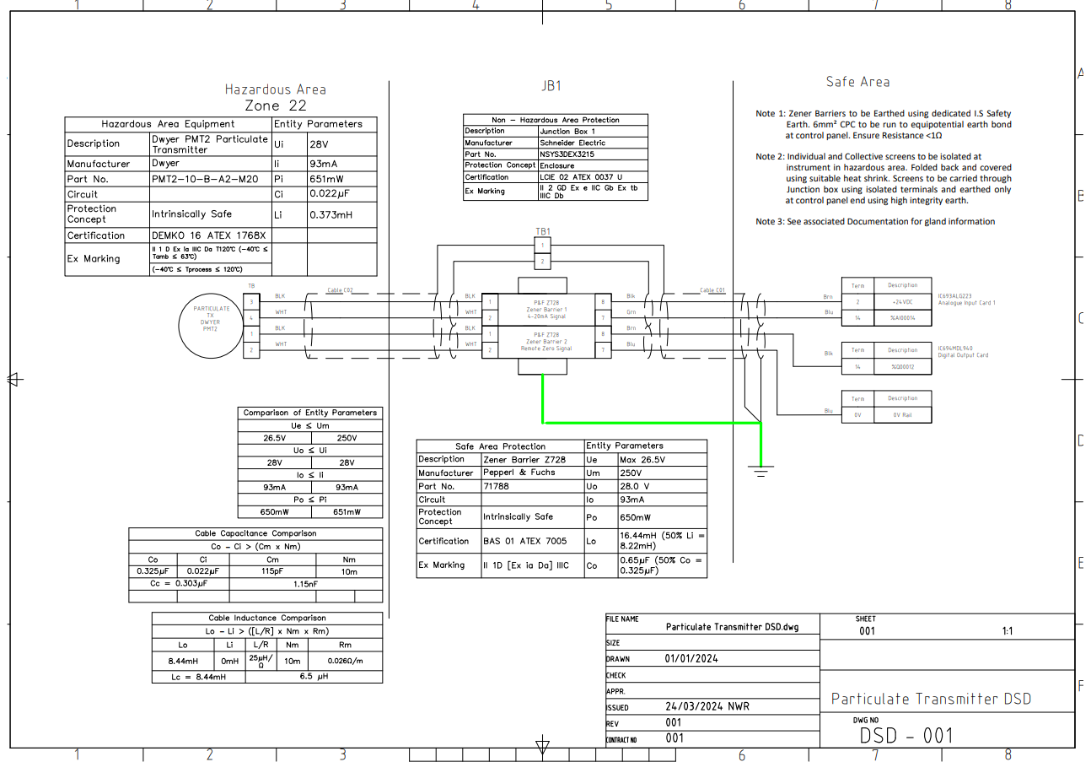
Figure 12 - Particulate Transmitter DSD

4.3 Junction Box

From the requirements set out in section 3.4.2, the junction box needed to house the Zener barriers on the unit has been drafted in Autodesk Inventor. This allows components to be modelled, ensuring they fit within the panel, and there is space to carry out terminations. Figure 13 displays the modelled box, complete with the HAWKE glands, cable trunking and standard DIN rail mounts. All components have been modelled using available data from the manufacturer’s website.
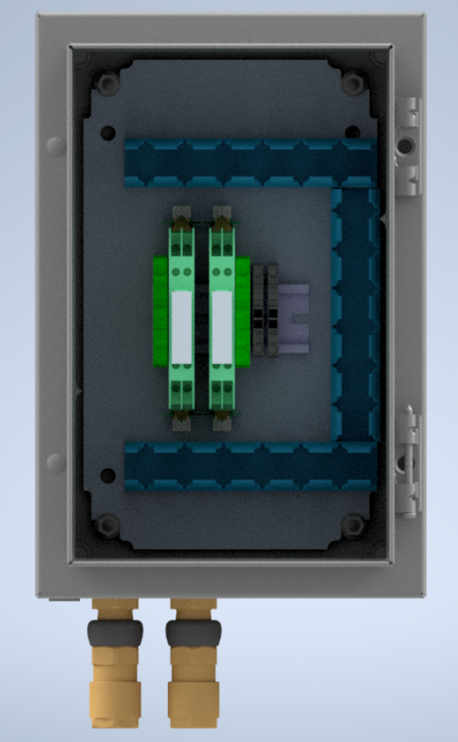
Figure 13 - Junction Box JB1 3D model.
The 3D model shows the terminals for the cable screens to be carried through to the plant control panel, along with the earthing terminals for the Zener barrier I.S earth connection. The trunking has been shown as blue, to indicate that it contains I.S circuits, and that it should be separated from non - I.S circuits. From this model, the junction box could be fabricated and mounted on the plant. Figure 14 displays the box in position, and the internals.

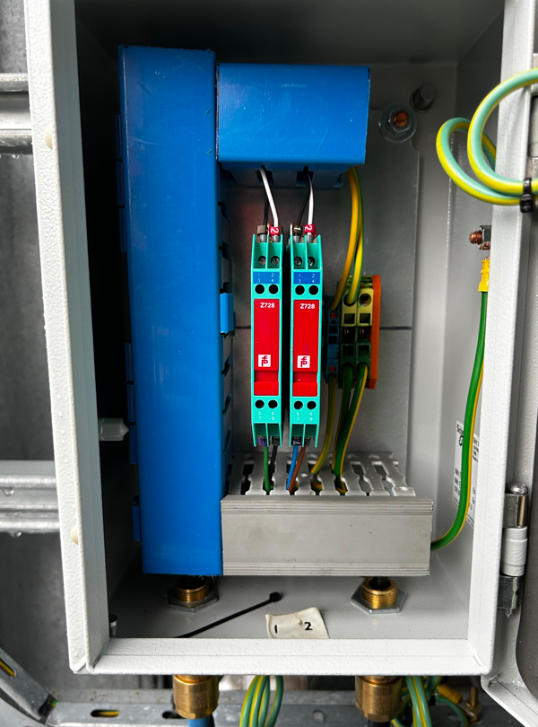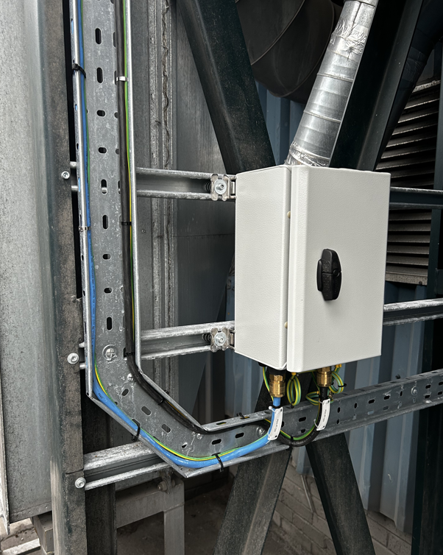
Zener Barriers
I.S Trunking
Circuit to Plant
I.S Circuit to Probe
Figure 14 - Installed Junction Box with Outgoing Circuits

The fabricated junction box differs from the initial drawing due to cable routing constraints, and to accommodate the cable tray to the instruments. The outgoing cabling is housed in the grey trunking to maintain separation from the I.S circuits. The glands have the correct IP washer installed to maintain the integrity of the panel.

4.4 Probe Installation

From the requirements set in section 3.2, the probe must be mounted within the duct. To mount securely, an existing port has been utilised. A 4” threaded bung, drilled and tapped to accept the 1” NPT threaded portion of the probe tri-clamp mount was manufactured. The tri-clamp assembly can then be permanently mounted, allowing quick removal of the probe for cleaning and maintenance. The bung should still allow the electrode of the probe to protrude far enough into the duct to capture emitted particles. Figure 15 displays the sensor in position on the filter unit. The probe can be mounted in any orientation around the duct. Its position facilitates easy access from a movable platform for inspection, the gland entries are horizontal to minimise ingress of rain, allowing moisture to run off the cable, with an IP rated stopper blanking the other cable entry.
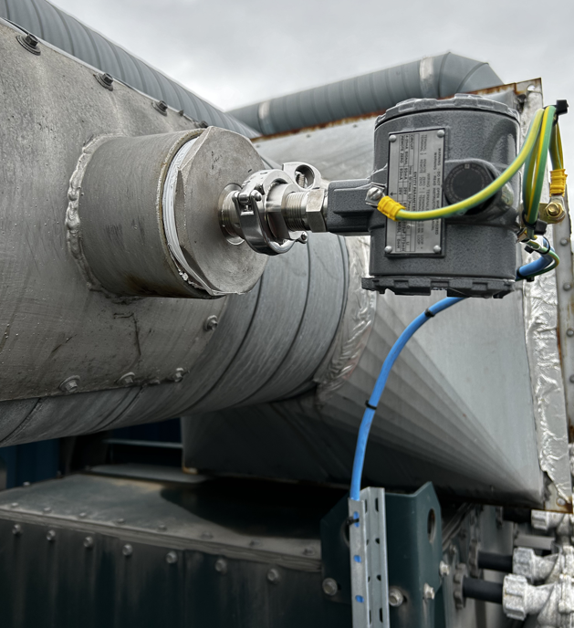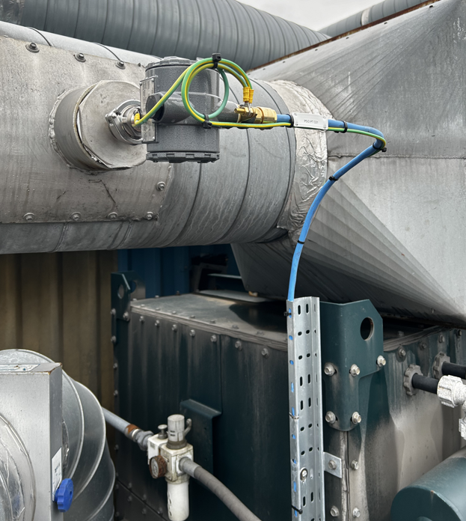
Threaded Bung
Tri-Clamp Assembly
Figure 15 - Probe Installed in Plant Ducting

From the current installation, the probe electrode protruded sufficiently into the ductwork, however, reducing the size of the mounting boss would be required to get the tip exactly on centre. This was not practical due to time constraints as the plant was in production. From using the unit, it does register changes in particulate from this mounting position. The probe is situated far enough from the rectangular to circular plenum to reduce turbulent flow from the filter exhaust, and away from the duct exit to minimise the effect of the wind causing air currents when not in use.

4.5 PLC Program

4.5.1 Analogue Scaling

The plant PLC seen in section 3.6, requires the 4-20mA signal output from the sensor to be interfaced with the analogue input card. This value is then scaled proportionally to the sensor process units. The sensor has a selector, to set the output range in pA. For the initial installation, a range of 5 – 1000pA has been chosen, as this would cover the range of materials that the plant produces, where charge levels will differ between alloy type, ambient conditions, and exhaust temperatures. Due to the nature of charged metal powders in a pneumatically conveyed system, the ideal instrument range is unknown. The instrument sensitivity is then calculated.
$$Senstivity= \frac{ Deflection (mA)}{Value of Measureand (pA)}$$
$$Senstivity= \frac{ 20-4 (mA)}{1000-5 (pA)}$$
$$Senstivity=0.0161\frac{mA}{pA}$$

This sensitivity value corresponds to the slope of the characteristic straight-line equation, as the sensor output is linear, with a span of 995pA. Figure 16 displays the straight-line graph and its equation. This graph can be used to aid in calibration and observe the ideal sensor response.

Figure 16 - Sensor Linear Response Characteristics and Sensitivity

The 4 – 20mA signal is interfaced to the 12-bit analogue input card on the plant PLC, with a normal range of $2^{12}=4096$ counts. The Rx3i card from GE has a factory calibrated resolution of 4µA/bit, giving a total of 4000 counts at the ADC. This is then scaled in software for a 4-20mA range between 0 – 32000 counts in the CPU. The input scaling is seen in table 6.

Table 6 - PLC Input Scaling

To scale this block in the ladder logic, an integer scale function is used, where the raw analogue counts level is set using the input high and low rungs, with the output value scaled in the output high and low rungs. This value is passed to an internal register in the PLC. This register is converted using an Integer to REAL value conversion, giving the output as a floating-point decimal number. This value can then be used throughout the program. Figure 17 displays the ladder logic rung to process the sensor output.
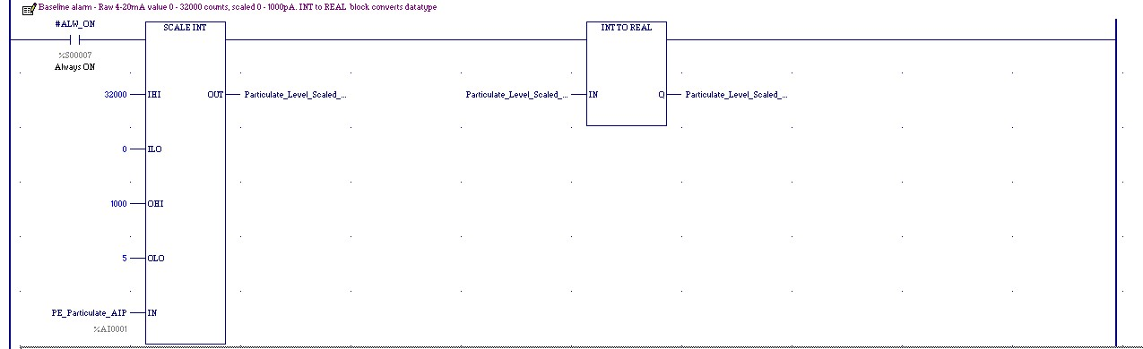
Figure 17 - PLC Analogue input Scaling Block

4.5.2 Alarm Configuration

The PLC program has two alarms configured for monitoring filter wear. The baseline alarm monitors the steady increase from a known ideal condition and will trigger if the particulate level is consistently above this setpoint. The spike alarm, monitors short, high-level spikes in particulate. These could arise from initial filter startup, or during pulse cleaning cycles. Figure 18 displays the information flow for the alarm triggers.

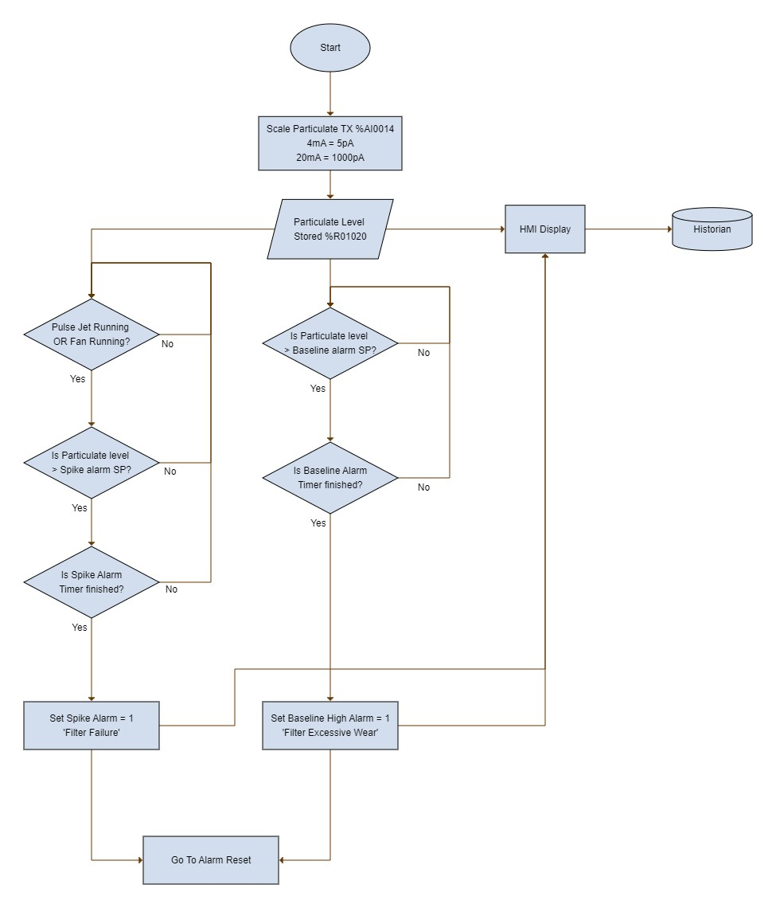

Figure 18 - PLC Data Flow and Alarm Trigger Conditions

To monitor the baseline alarm, the scaled analogue data is fed to a greater than comparison block, where the entered baseline level threshold is entered. If this block becomes true, a one-minute timer begins. If this times down, a set coil is made in the logic. Figure 19 displays the ladder rung for this alarm.

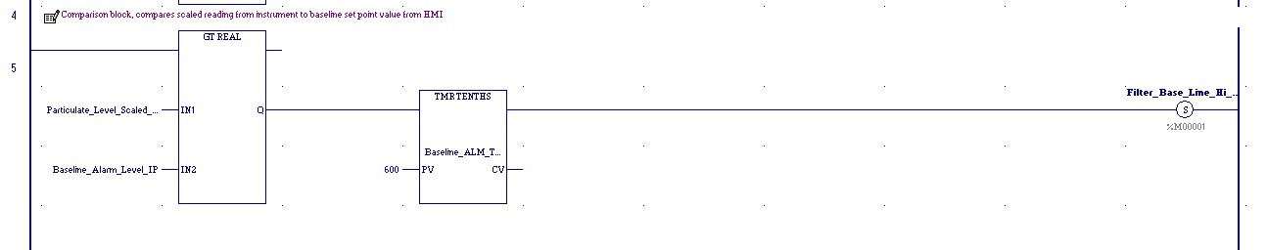
Figure 19 - Baseline Alarm Monitoring

The spike alarm monitoring follows the same philosophy. A comparison block compares the scaled value to an entered alarm threshold with a one second timer to dampen, and debounce the set coil trigger. The fan running or the pulse jets running must be true before this alarm will trigger. These will capture spikes from startup and pulse cleaning. These inputs exist in the plant program already and have been used as normally open contacts in the alarm rung. The shorter time delay differentiates the alarm between spike or baseline drift. Figure 20 displays the code for the spike alarm.
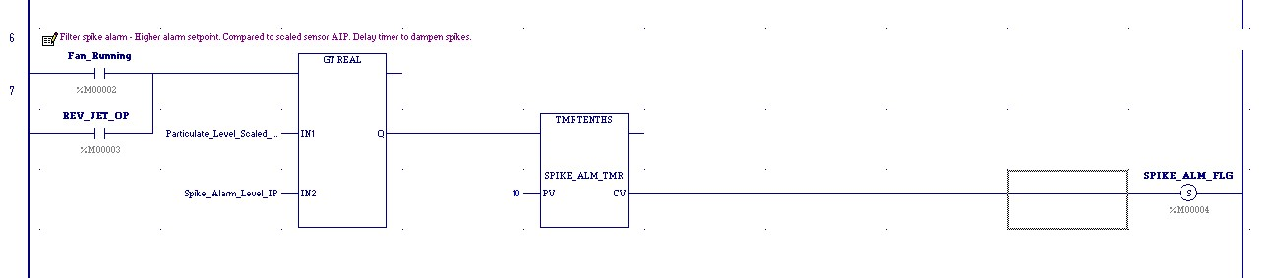
Figure 20 - Spike Alarm Trigger

Due to the plant damage, explosive nature of powder and environmental considerations, to reset these alarms, a competent person must go into the PLC code and set the bits to zero. This can only be done once the filter has been inspected for damage, and a report raised. Removing the reset from the operators ensures this is carried out. These alarm bits are provisionally placed into the start sequence code for the filter, inhibiting the unit if they are present. As the instrument is still in its trial phase for reliability, and to minimise plant disruption, this feature is still subject to further data collection to determine suitable alarm thresholds over a variety of alloys and running conditions.
The instrument has been wired and configured for a remote zero setting. This is not configured for use in the PLC or from the HMI, as incorrect use could cause the baseline reading to be offset, such as zeroing the transmitter when it is dirty, or when the fan is running. To zero the instrument, it must be removed, the electrode cleaned and inspected, then zeroed at the device with the plant idle.

4.6 Operator HMI

The HMI screen has been configured for the plant control panel. This HMI view is available to operators from a logging tab on the main control screen. This screen is separate from the main run screen due to space limitation and information blinding. Figure 21 displays the HMI.
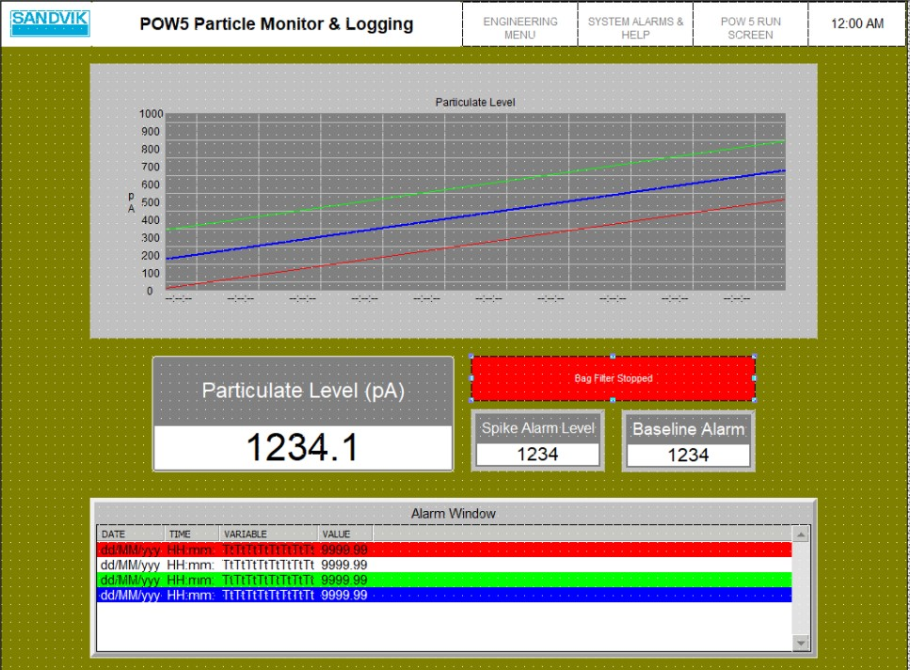
1
4
3
2
5
Figure 21 - Particle Monitor HMI Screen. (1) Graph Window. (2) Sensor Reading. (3) Alarm Threshold Data Entry. (4) Plant Status. (5) Alarm Message Grid

Using GE machine edition’s graphical panel editor, these features have been added. The live data passes the value of the particulate scaled register to a data display box. This register is used as a trend trace in the graph window, shown by the blue line. The spike alarm and baseline alarm threshold levels can be set in the data entry boxes, where the values are stored in registers and passed to the comparison blocks for the alarm. These alarm levels are shown by the green and red traces on the graph window and give a visual representation of how close the particulate emissions are approaching these levels throughout the plant run. The plant status box will update the operator if the filter is running, stopped, tripped, in automatic or manual mode. The alarm message grid displays any baseline or spike alarm messages. The alarm messages are configured in machine edition. Figure 22 displays the messages from the trigger coils.
Figure 22 - Alarm Messages and Trigger Bit Conditions

4.7 Historian/SCADA Datalogging

Logging the sensor data enables engineers and technicians to see how particulate levels have changed over a longer period. This tool enables other plant parameters such as filter differential pressure and inlet temperature to be overlayed with the particulate data. Using other plant parameters may help in diagnose the nature of the failure. Configuration of this feature requires the analogue tag to be input into the collector, data type selection as well as a collection interval. Figure 23 displays the configuration dashboard for the datalogger.
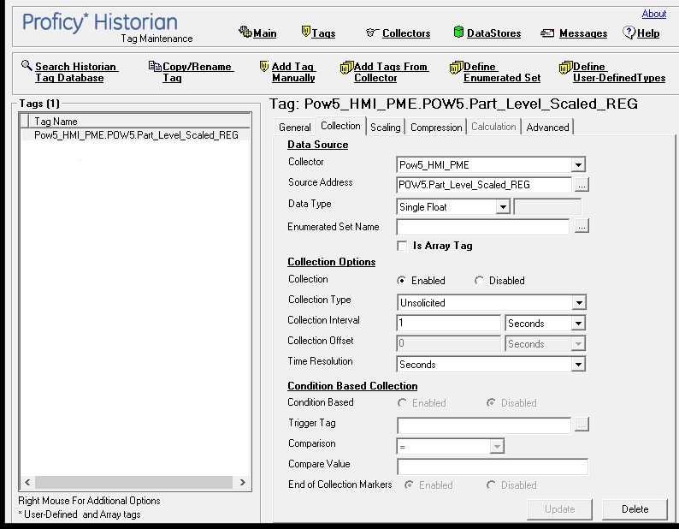
Figure 23 - Historian Datalogging Dashboard
The data recorded from historian can be viewed on a web-based browser, where data ranges can be set to monitor trends. Figure 24 displays an example of the particulate data over a month. This data can be extracted into Excel for further analysis and formatting using standard functions.

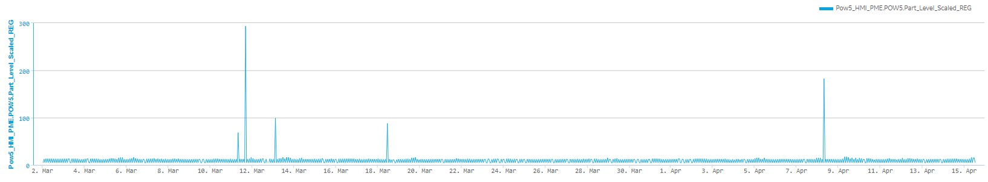
Figure 24 - Web Based View of Trend Data

5.0 Evaluation

The particulate sensor has been installed since the 9th of February 2024, and has monitored 166 plant runs to the 15th of April 2024. From figure 24, the overall baseline level of particulate did not significantly increase, indicating no significant wear has been seen on the filters. The baseline level of particulate has stayed between 5 to 12pA with the transmitter’s current resolution settings. The differential pressure across the filters has been consistent, indicating that the pulse cleaning is working efficiently, by removing excess dust, whilst leaving enough on the filter media for optimal capture. This consistent differential pressure also indicates that no breaches have been seen in the filters, which matches with the minimal particulate discharge. This result was to be expected due to the filter cartridges being replaced at the end of 2023, with limited production runs to the period when the transmitter was installed.
Some spikes were detected during this period. The largest spike seen in figure 24 was due to testing of the transmitter output. After installation, the electrode was touched. The charge on the skin saturated the instrument to full scale, indicating that the sensor is responding and reading correctly on the HMI. Figures 25 and 26 display the sensor output and filter differential pressure where spikes have been seen during running. These show a peak in particulate emissions, during filter startup, as shown by the rise in differential pressure across the filter. This may have come from excess particulate that has settled in the duct after the filter has shutdown, this has then been pushed past the sensor as the airflow increases when the fan accelerates. The red spikes in differential pressure roughly indicate where the pulse jets blow down the cartridges during running.

Figure 25 - Particulate Levels and Filter Differential Pressure 18/03/2024.

Figure 26 - Particulate Emissions vs Differential Pressure 08/04/2024.

From monitoring the particulate data, the range selected for the sensor is too wide. The plant has processed multiple different alloys, in varying environmental conditions. The sensor range should be brought down to 5 – 500pA, as this would provide a more sensitive output from the transmitter, and potentially give more accurate trends of filter health. Another advantage of reducing the sensor range, is the graphical window on the operator HMI will have a smaller Y axis, allowing them to see changes in baseline levels more easily.
The overall functionality of the system has achieved the main objectives of the project.
- The HMI displays the process information.
- The sensor data can be extracted and post processed to monitor filter health.
- Alarms have been configured to capture spikes and baseline drift.
- ATEX considerations have been met, and the instrumentation is compliant.

One feature that has not been achieved is the ability to pinpoint which row of filters has been damaged. This would have been achieved by using a signal from the pulse jet controller to the PLC. The pulse jet solenoids are triggered using a serial data stream on this model of filter, rather than individual digital outputs. This would have required a serial communicator in line with the signal to decode which row of filters is being pulsed down. This data would then have been used as a condition in the alarm logic, where individual filter rows would have been monitored and compared to the entered spike alarm threshold.
The monitoring carried out on this plant has shown the type of cartridges installed, are very robust. If this project were to be repeated, the device would be installed on a filter where there are components that can fail easily, allowing powder to pass out of the exhaust. These alternative filters are found on other plants on site. These filters also have individual digital outputs per pulse jet, allowing easy signal interfacing to the PLC to carry out more precise condition monitoring and alarms.
As this project was initiated as a trial for development, with tight time constraints, any new transmitters installed would have a dedicated mounting system into the duct, to ensure the electrode is placed precisely in the centre of the duct to achieve the most accurate readings.
From the design of the Intrinsically safe circuit, if this project were to be repeated on another, older plant, Zener barriers would not be used as associated apparatus. Using galvanic barriers significantly reduces installation time and requirements by removing the need for a dedicated earth connection. The drawback of the cost per unit would be offset in the installation savings.
The sampling time of the datalogger would be reduced if the project was repeated, to match or exceed the refresh rate of the PLC data to minimise aliasing of the signal and to ensure all events are captured for review.

6.0 Conclusions and Recommendations

This project was set out by Sandvik Osprey, to utilise the best available technology to monitor particulate emissions from an industrial filter unit. This was required to warn operators and technicians that a filter is beginning to fail, minimising the risk to the environment and to avoid unplanned downtime from unexpected breakdowns.
The available technology such as electrostatic sensors, light-based sensing techniques and novel solutions such as fibreoptics and resistive filter fibres have been shown, and how they are used to detect breaches or degradation of filter media. Current applications of filter monitoring have been shown, and how it can aid in the condition monitoring of an industrial system.
This project has covered the selection of an instrument, ensuring it is suitable for its intended environment. Erection of hardware, and circuit design for use in potentially hazardous areas. The process of verifying intrinsic safety by calculation and selection of the correct associated apparatus and the creation of a descriptive system has been shown.
The programming of an industrial PLC and HMI has been shown, indicating the necessary alarms and logic required. Live data visualisation required for operators and maintenance personnel has been shown with an individual readout and a trend graph.
The sensor output has been shown from the site datalogging system, along with extracted data showing spikes in particulate during filter startup. This has led to the recommended adjustment of the sensor range to provide a more accurate reading.
This work has been beneficial to production at Sandvik, as the health of a filter can now be directly read and compared to run data. This will now enable more experimentation with other process parameters that may have been limited due to the unknown effects on the filter media. These trials can now be carried out confidently, knowing the system will alarm should any issue arise. This will enable Sandvik to maintain its competitive advantage in the development of high-quality materials. The benefit to maintenance and cost reduction will be improved over longer periods of time, as failure can now be predicted through baseline level drift and down time planned accordingly.

6.1 Recommendations for Further Work

Further work to carry out on this system would involve installing another probe on an older filter, that is more susceptible to failure, with discrete, individual outputs from the pulse jets, allowing accurate location of filter failure.
Use of the filter differential pressure and inlet temperature is already utilised to inhibit the filter if their alarm parameters are exceeded. Placing the spike and baseline alarms permanently in the same code after longer trial periods with adjusted sensitivity would provide a total filter protection solution.
The sensor data has been integrated into the plant PLC and Historian Datalogger, however the site’s true SCADA system, iFix from GE is still in its infancy. Creating a maintenance dashboard for the engineering workshops displaying sensor data may be beneficial allowing personnel with no access to the historian web interface to monitor filter health and see active plant alarms.
The use of electrostatic sensors, due to their rugged nature, may allow them to be installed in the process side of the plant before the filter. This may be used to indicate how much powder is being lost from the process and entering the filter unit. This may lead to experiments being carried out to increase overall yield by minimising powder losses.

7.0 Reflection

Carrying out this project has allowed me to use my technical knowledge and experience to solve a particular work-based problem, that has significant bearing on the performance of an asset at Sandvik Osprey. I feel that the work carried out has highlighted the importance of researching and using technology to enable businesses to act sustainably, not only in directly preventing emissions to the environment, but by increasing the remaining useful life of equipment, and ensuring it functions correctly minimising waste.
Throughout this project, I have learned to quantify the benefits of equipment, in a cost-effective manner. Managing a small budget for this installation has made sure that equipment selected is right fist time and satisfies the objectives.
As the facility is in continuous production, allocating downtime to install equipment has had to be clearly communicated. This resulted in coordinating with production planners and the process department to allocate sufficient time to install and test equipment. This required clear goals for what is to be achieved and realistic timescales to minimise production disruption. Being able to communicate effectively and work with multiple teams to get the desired outcome is a skill I have developed through this project.
From carrying out this project, I have had to create technical drawings, documentation, and models, learning the skills to present information clearly to people who may be installing and maintaining equipment. During my time as a technician, this is information I wished I had available from other engineers. From completing this project, I now have an appreciation of what is required at this small scale and will continue to develop new standards for my ongoing work, to complete larger, complex projects.
Managing my time effectively has been a key learning from this project. Ensuring I have the information available to those who require it on time. The significant amount of work required from this project has led me to become more organised, breaking down larger problems into manageable goals and milestones, using planning tools such as Gannt charts and task lists.

References

[1] | Camfil, “Gold Series X-Flo,” 2024. [Online]. Available: https://www.camfil.com/en-gb/products/dust-fume-and-mist-collectors/dry-dust-and-fume-collectors/gold-series/gold-series-x-flo-_-46369. [Accessed 12 10 2023].
[2] | Natural Resources Wales, “Natural Resources Wales,” 10 2023. [Online]. Available: https://naturalresources.wales/permits-and-permissions/environmental-permits/?lang=en.
[3] | UK Government, “The Environmental Permitting (England and Wales) Regulations 2016,” UK Government, 2016. [Online]. Available: https://www.legislation.gov.uk/uksi/2016/1154/contents/made. [Accessed 25 01 2024].
[4] | Department for Environment Food and Rural Affairs, “Metal powder and other thermal spraying: process guidance note 6/35,” 01 July 2013. [Online]. Available: https://assets.publishing.service.gov.uk/government/uploads/system/uploads/attachment_data/file/582717/metal-powder-and-other-thermal-spraying-processes-process-guidance-note-6-35-_13_.pdf. [Accessed 2024 01 25].
[5] | UK Government, “Industrial emissions standards and best available techniques,” 2023. [Online]. Available: https://www.gov.uk/guidance/industrial-emissions-standards-and-best-available-techniques#industrial-emissions-directive-ied. [Accessed 15 10 2023].
[6] | UK Government, “Legislation.gov.uk "The Air Quality Standards Regulations 2010",” 2010. [Online]. Available: https://www.legislation.gov.uk/uksi/2010/1001/contents/made. [Accessed 25 01 2024].
[7] | Y. Yan, “Continuous Measurement of Particulate Emissions,” IEEE Instrumentation and Measurement Magazine, pp. 35 - 39, October 2005.
[8] | Y. H. L. W. X. Q. W. Z. K. R. J. W. G. Z. Yong Yan, “Electrostatic sensors – Their principles and applications,” Measurement, vol. 169, no. 108506, 2021.
[9] | Land Ametek, “Opacity and PM Monitoring in Emission Stacks: Application Note,” 2009. [Online]. Available: https://www.ametek-land.com/-/media/ameteklandinstruments/documentation/industries/coalpower/ametek_land_opacity_vs_pm_application_note_rev_1_en.pdf. [Accessed 15 10 2023].
[10] | J. J. A. P.Bachler, “Simultaneous measurement of spatially resolved particle emissions in a pilot plant scale baghouse filter applying distributed low-cost particulate matter sensors,” Journal of Aerosol Science, vol. 150, p. 105644, 2020.
[11] | X. L. W. W. J. Li, “Leak monitoring and localization in baghouse filtration system using a distributed optical fiber dynamic air pressure sensor,” Otical Fiber Technology, vol. 57, p. 102218, 2020.
[12] | J. L. B. S. G. D. F. D. Z. Z. Xu'an Liu, “Intelligent detection technology for leakage bag of baghouse based on distributed optical fiber sensor,” Optical Fiber Technology, vol. 52, p. 101947, 2019.
[13] | Y. G. R. S. F. D. X. Z. J. L. Weidong Hw, “In-situ leakage detection of single bag filter in baghouse based on the resistance change of conductive polymer fibers,” Journal of Applied Polymer Science, vol. 140, no. 39, p. e54453, 2023.
[14] | J. W. G.Kaelin, “Automated baghouse troubleshooting diagnostics maximize efficiency,” in IEEE-IAS/PCA Cement Industry Conference (IAS/PCA), Nashville, 2018.
[15] | UK Government, “The Dangerous Substances and Explosive Atmospheres Regulations 2002,” UK Government, 2002. [Online]. Available: https://www.legislation.gov.uk/uksi/2002/2776/regulation/1/made. [Accessed 25 01 2024].
[16] | British Standards Institution, BS EN 60079-10-2: Explosive atmospheres - Classification of areas. Combustible dust atmospheres, British Standards Institution, 2015.
[17] | British Standards Institution, BS EN 60079-14: Explosive atmospheres - Electrical installations design, selection and erection, British Standards Institution, 2014.
[18] | British Standards Institution, BS EN 60079-17: Inspection and maintenance of electrical installations in hazardous areas, British Standards Institution, 2024.
[19] | Dwyer Instruments, "Series PMT2 Particulate Transmitter," FR#444122-00 Datasheet Revision 3, Michigan City, 2021.
[20] | R. L. Alan.S.Morris, “7.2.2 Current Loop Transmission,” in Measurement and Instrumentation Theory and Application, London, Academic Press, 2021, pp. 193-194.
[21] | British Standards Organisation, BS EN IEC 60079 Part 25: Intrinsically Safe Electrical Systems, BSI Standards , 2022.
[22] | Pepperl & Fuchs, “Zener Barrier Z728 datasheet 071788_eng.pdf,” 06 04 2023. [Online]. Available: https://www.pepperl-fuchs.com. [Accessed 25 03 2024].
[23] | Schneider Electric, “Spacial S3DEX (ATEX certified), Datasheet NSYS3DEX3215,” [Online]. Available: https://www.se.com/. [Accessed 01 03 2024].
[24] | British Standards Institution, BS EN 62262:2002+A1:2021 Degrees of protection provided by enclosures for electrical equipment against external mechanical impacts (IK code), British Standards Institution, 2021.
[25] | ELAND Cables, “PAS BS 5308 Part 1 Type 2 PE/CAM/PE/SWA/PVC Cable,” [Online]. Available: www.elandcables.com. [Accessed 24 01 2024].
[26] | Hawke International, “Cable Glands 501/453/UNIV Datasheet,” 2023. [Online]. Available: https://www.hubbell.com/hawke. [Accessed 03 01 2024].
[27] | GE Fanuc, GE Fanuc IC694ALG223, Datasheet GFK-2314C October 2005, GE Fanuc, 2005.

Appendices

Appendix 1: Remote Zero IS Verification

Safe Area Protection |  | Entity Parameters
Description | Zener Barrier Z728 | Ue | Max 26.5V
Manufacturer | Pepperl & Fuchs | Um | 250V
Part No. | 71788 | Uo | 28.0 V
Circuit | A02 | Io | 93mA
Protection Concept | Intrinsically Safe | Po | 650mW
Certification | BAS 01 ATEX 7005 | Lo | 16.44mH
Ex Marking | II 1D [Ex ia Da] IIIC | Co | 0.65µF

Cable |  | Cable Parameters
Type | PAS BS5308 PE/CAM/PE/SWA/PVC Cable | Cm | 115pF
Cores/CSA | 4 x 0.75mm² | Rm | 0.026Ω
Ref | C01 | Lm or L/R | L/R = 25µH/Ω
Ex Marking | NA

Non - Hazardous Area Protection
Description | Junction Box 1
Manufacturer | Schneider Electric
Part No. | NSYS3DEX3215
Circuit
Protection Concept | Enclosure
Certification | LCIE 02 ATEX 0037 U
Ex Marking | II 2 GD Ex e IIC Gb Ex tb IIIC Db

Hazardous Area Equipment |  | Entity Parameters
Description | Dwyer PMT2 Particulate Transmitter | Ui | 28V
Manufacturer | Dwyer | Ii | 93mA
Part No. | PMT2-10-B-A2-M20 | Pi | 651mW
Circuit | A01 | Ci | Neg
Protection Concept | Intrinsically Safe | Li | 0mH
Certification | DEMKO 16 ATEX 1768X
Ex Marking | II 1 D Ex ia IIIC Da T120°C (-40°C ≤ Tamb ≤ 63°C)  (-40°C ≤ Tprocess ≤ 120°C)

System Classification
Safe Area Equipment | II 1D [Ex ia Da] IIIC
Hazardous Area Equipment | II 1 D Ex ia IIIC Da T120°C
Resultant System | II 1 D Ex ia IIIC Da
Area Requirement

Comparison of Entity Parameters
Ue ≤ Um
26.5V | 250V
Uo ≤ Ui
28V | 28V
Io ≤ Ii
93mA | 93mA
Po ≤ Pi
650mW | 651mW

Cable Capacitance Comparison
Co – Ci > (Cm x Nm)
Co | Ci | Cm | Nm
0.65µF | 0 µF | 115pF | 10
Cc = 0.65 µF |  | 1.15nF

Cable Inductance Comparison
Lo – Li > ([L/R] x Nm x Rm)
Lo | Li | L/R | Nm | Rm
16.44mH | 0mH | 25µH/Ω | 10m | 0.026Ω/m
Lc = 16.44mH |  | 6.5 µH

