Oct – Nov 2024
Lab Notebook
Op-Amp Design & Build
Tamsin McKerrow (2415958)
Workshop skills for electronics – ACDA4022
BEng Embedded Electronic Systems
Contents
Introduction 1
Schematic 1
Simulation in Proteus 2
PCB Layout 4
Breadboard 4
Testing 5
Breadboard Results 5
Comparison 6
PCB Population 7
Build 7
Testing 8
Comparison 9
Suggested Improvements 10
References 11
Appendices 11
1: Circuit to Reproduce 11

Table of Figures
Figure 1: 741 Typical Application [1] 1
Figure 2: Proteus Schematic 1
Figure 3: Easy PC Schematic 2
Figure 4: Simulation Results at 1kHz, 200mV input 2
Figure 5: 10kR Resistor Simulation 3
Figure 6: PCB Layout Top Layer 4
Figure 7: PCB Layout Bottom Layer 4
Figure 8: Breadboard Preparation 4
Figure 9: Breadboarded Circuit 5
Figure 10: Test Setup for Breadboarded Circuit 5
Figure 11: Breadboard Bench Test Results 6
Figure 12: Comparison of Simulation and Breadboard 6
Figure 13: PCB - Soldering TH Resistors 7
Figure 14: PCB - Added Headers 7
Figure 15: PCB - Added IC 7
Figure 16: PCB - Soldered Resistors 7
Figure 17: Finished PCB - Top 7
Figure 18: Finished PCB - Bottom 7
Figure 19: Finished PCB Testing 8
Figure 20: Test Setup for PCB 8
Figure 21: Oscilloscope Results 8
Figure 22: PCB Bench Test Results 9
Figure 23: Comparison of All Results 9

Table of Tables
Table 1: Simulation Results 3
Table 2: Breadboard Results 5
Table 3: PCB Test Results 8

Introduction
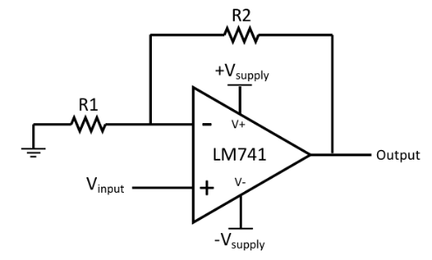
I have been tasked to reproduce and test a non-inverting amplifier circuit with a gain of 3. The circuit diagram reproduced is shown in Appendix 1.
This notebook depicts the creation of a schematic and PCB layout, as well as the construction and testing of the breadboarded design and the printed circuit board.
The circuit uses a 741 operational amplifier, and their typical application is shown in figure 1.
Figure 1: 741 Typical Application [1]

Schematic
Below is the schematic diagram drawn using Proteus. According to the 741 datasheet [1], R4 and R3 are used to calculate the gain: Gain = 1 + (R4/R3).
For the circuit below the gain can be calculated as 1 + (20000/10000) = 3.
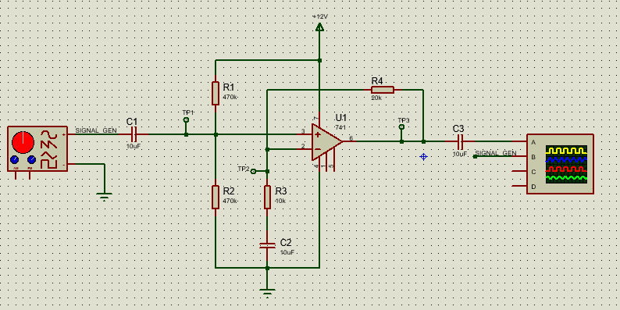
Figure 2: Proteus Schematic
R1 and R2 create a voltage divider – where Vout = (R2 x Vin) / (R1 + R2). Meaning that the output voltage going into pin 3 of the op-amp = (470k x 12V) / (470k + 470k) = 6V.
R4 is the feedback resistor – this takes a small part of the output voltage signal and applies it to the inverting input terminal of the op-amp, which produces negative feedback [2].
The circuit is a non-inverting amplifier because the input signal is applied to the positive input of the op-amp. This means that the output signal will be in-phase with the input signal [2].

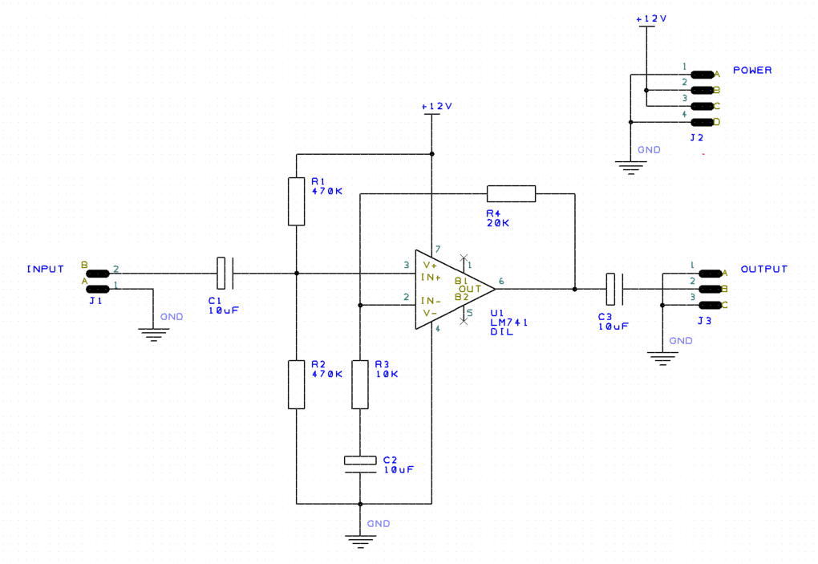

Figure 3: Easy PC Schematic

The schematic shown in figure 3 is the replication of figure 2 with the addition of connectors so testing the PCB will be easier. Also, the schematic had to be redrawn in Easy-PC to be able to create the PCB layout.

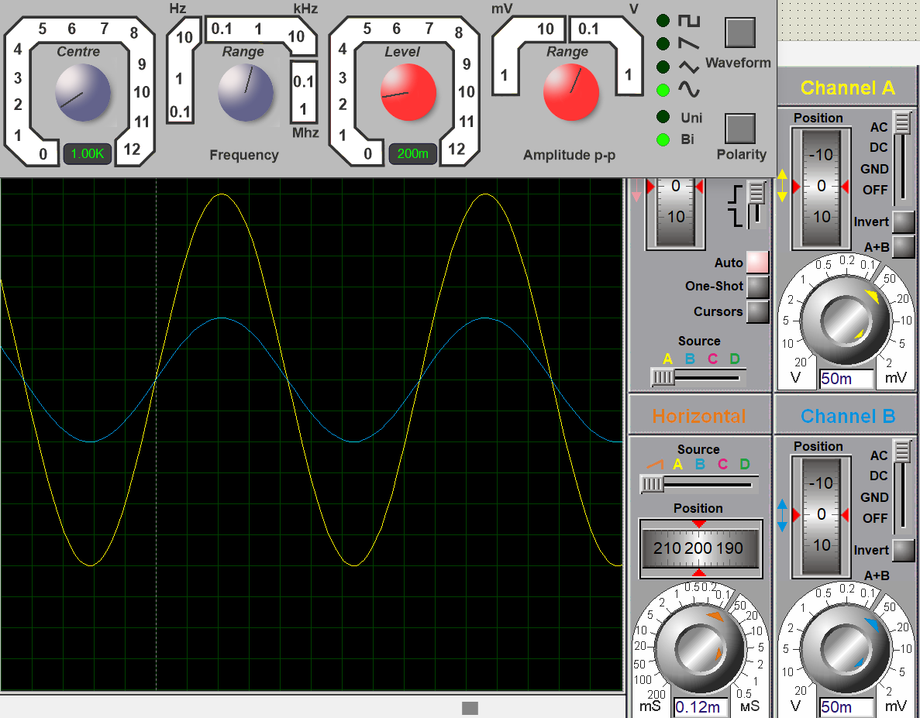
Simulation in Proteus

Channel A shows the output waveform and channel B shows the input waveform.

Figure 4: Simulation Results at 1kHz, 200mV input

Table 1: Simulation Results
Upper -3dB Frequency
Frequency (Hz) | Vout  (V) | Gain  (dB) | Voltage Gain (Av) | Frequency (Hz) | Vout  (V) | Gain  (dB) | Voltage Gain (Av)
1 | 0.355 | 4.983967148 | 1.775 | 18000 | 0.6 | 9.542425094 | 3
1.5 | 0.4325 | 6.699122323 | 2.1625 | 19000 | 0.6 | 9.542425094 | 3
2 | 0.485 | 7.694234859 | 2.425 | 20000 | 0.6 | 9.542425094 | 3
5  Lower -3dB Frequency | 0.575 | 9.172756981 | 2.875 | 25000 | 0.595 | 9.469739401 | 2.975
10 | 0.5925 | 9.43316718 | 2.9625 | 30000 | 0.5925 | 9.43316718 | 2.9625
20 | 0.5925 | 9.43316718 | 2.9625 | 35000 | 0.5975 | 9.506158279 | 2.9875
50 | 0.6 | 9.542425094 | 3 | 40000 | 0.5925 | 9.43316718 | 2.9625
100 | 0.6 | 9.542425094 | 3 | 45000 | 0.595 | 9.469739401 | 2.975
200 | 0.6 | 9.542425094 | 3 | 50000 | 0.593 | 9.440493954 | 2.965
300 | 0.6 | 9.542425094 | 3 | 55000 | 0.593 | 9.440493954 | 2.965
400 | 0.6 | 9.542425094 | 3 | 60000 | 0.59 | 9.39644032 | 2.95
500 | 0.6 | 9.542425094 | 3 | 65000 | 0.5875 | 9.359557506 | 2.9375
750 | 0.6 | 9.542425094 | 3 | 70000 | 0.5875 | 9.359557506 | 2.9375
1000 | 0.6 | 9.542425094 | 3 | 75000 | 0.585 | 9.322517408 | 2.925
2000 | 0.6 | 9.542425094 | 3 | 80000 | 0.5825 | 9.285318681 | 2.9125
3000 | 0.6 | 9.542425094 | 3 | 85000 | 0.5825 | 9.285318681 | 2.9125
4000 | 0.6 | 9.542425094 | 3 | 90000 | 0.5775 | 9.210439858 | 2.8875
5000 | 0.6 | 9.542425094 | 3 | 95000 | 0.5775 | 9.210439858 | 2.8875
6000 | 0.6 | 9.542425094 | 3 | 100000 | 0.575 | 9.172756981 | 2.875
7000 | 0.6 | 9.542425094 | 3 | 200000 | 0.515 | 8.215544668 | 2.575
8000 | 0.6 | 9.542425094 | 3 | 300000 | 0.4425 | 6.897665587 | 2.2125
9000 | 0.6 | 9.542425094 | 3 | 320000 | 0.425 | 6.547178688 | 2.125
10000 | 0.6 | 9.542425094 | 3 | 350000 | 0.405 | 6.128500551 | 2.025
11000 | 0.6 | 9.542425094 | 3 | 400000 | 0.375 | 5.460025441 | 1.875
12000 | 0.6 | 9.542425094 | 3 | 500000 | 0.32 | 4.082399653 | 1.6
13000 | 0.6 | 9.542425094 | 3 | 600000 | 0.2775 | 2.844659836 | 1.3875
14000 | 0.6 | 9.542425094 | 3 | 700000 | 0.245 | 1.762721774 | 1.225
15000 | 0.6 | 9.542425094 | 3 | 800000 | 0.216 | 0.66847511 | 1.08
16000 | 0.6 | 9.542425094 | 3 | 900000 | 0.194 | -0.264565315 | 0.97
17000 | 0.6 | 9.542425094 | 3 | 1000000 | 0.177 | -1.061134586 | 0.885

The gain in dB was calculated using the following formula: $20\log_{10}[ \frac{V_{OUT}}{V_{IN}} ]$. Where Vin = 0.2V.
The voltage gain (Av) was calculated using the following formula: $Av= \frac{V_{OUT}}{V_{IN}}$
Bandwidth = 320000 – 1.5 = 319998.5Hz
Gain Bandwidth Product = Av x Bandwidth = 3 x 319998.5 = 959995.5Hz
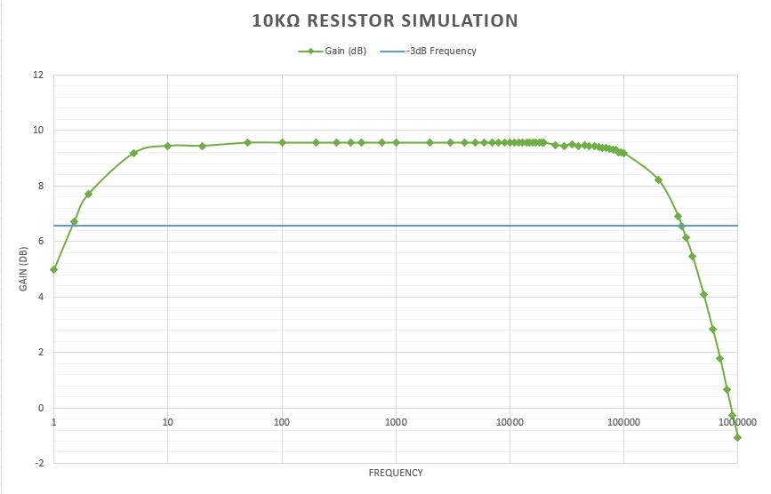

Figure 5: 10kR Resistor Simulation

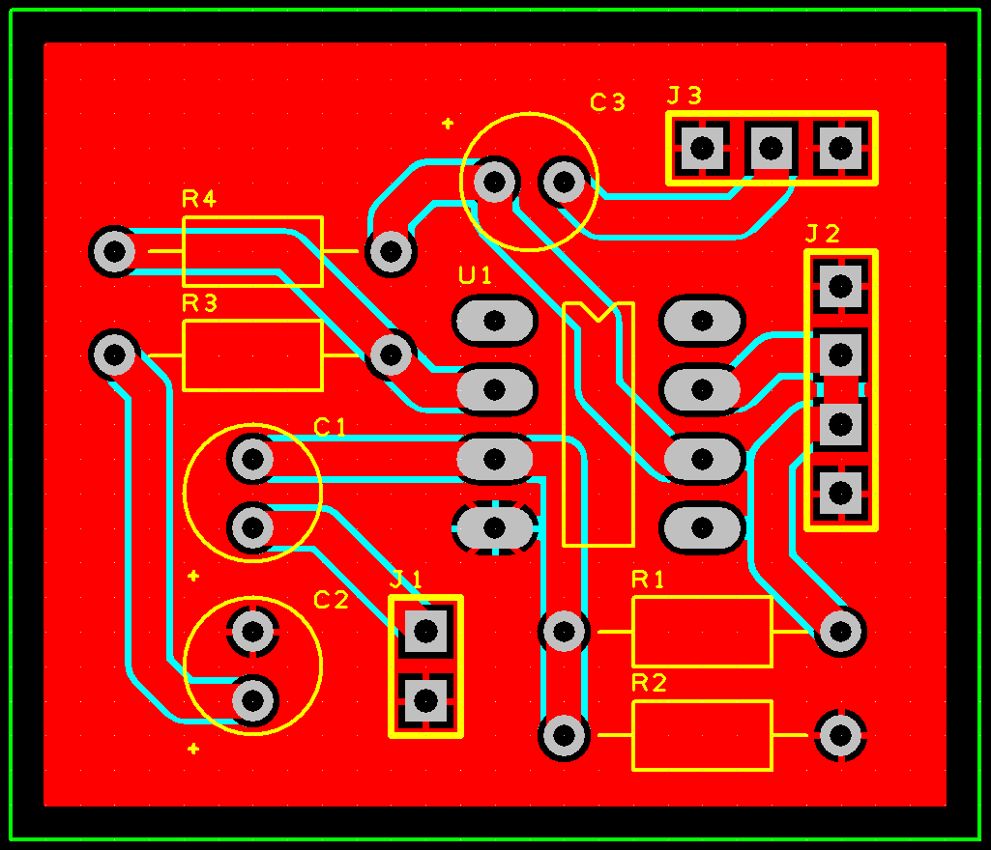
PCB Layout
Figure 6: PCB Layout Top Layer
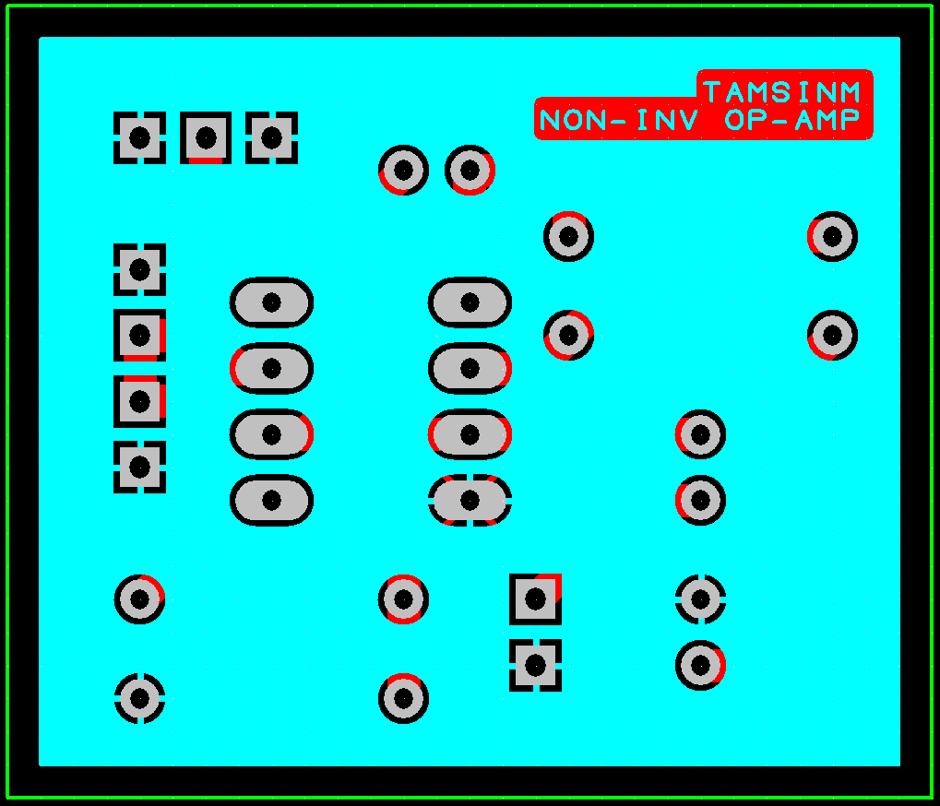
Figure 7: PCB Layout Bottom Layer

This is the second revision of the PCB as it was too big to begin with. I added a ground plan on both the top and bottom layers.

Breadboard
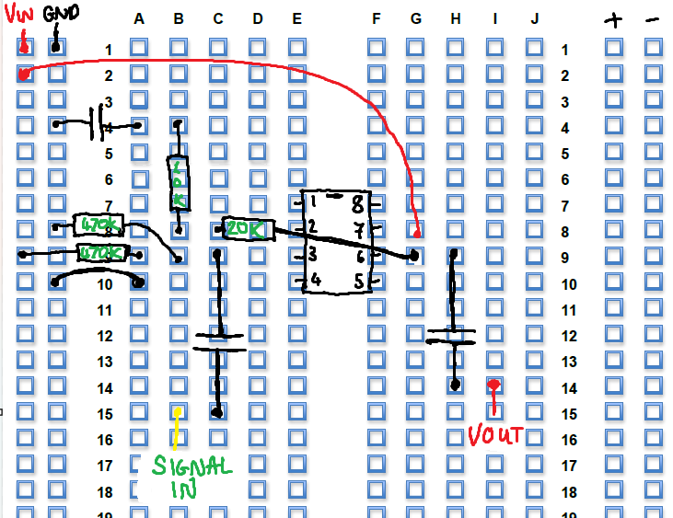

I used the schematic to connect all the components on the breadboard planning sheet, so it makes it easier when I build the breadboard.
All the capacitors are 10uF. And a 741 Op Amp is used.

Figure 8: Breadboard Preparation

The built breadboard is shown in the picture below.

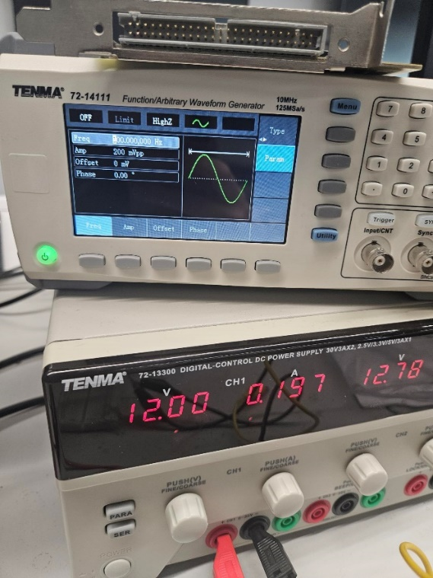
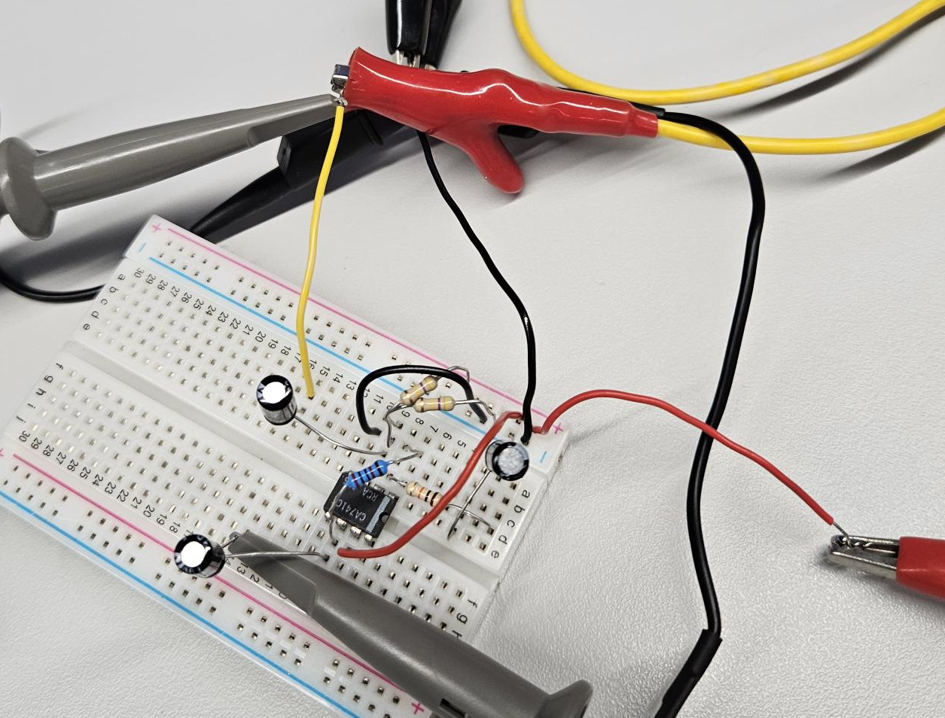
The input voltage from the signal generator was 0.2V and the supply voltage was 12V.
Figure 9: Breadboarded Circuit
Figure 10: Test Setup for Breadboarded Circuit

Testing

Breadboard Results
Before connecting all the test equipment, I double checked that all the connections were correct and made sure that the legs of components were pushed into the board enough.
The input signal was connected to C1 (yellow circle in Figure 9), and the output voltage was measured after C3 (blue circle in Figure 9) both of these capacitors are DC blocking caps. I then connected the 12V to the power rail of the breadboard and GND to the negative rail of the breadboard. I made sure to connect all the grounds together.
Table 2: Breadboard Results
Upper -3dB Frequency
Frequency (Hz) | Vout  (V) | Gain  (dB) | Voltage Gain (Av) | Frequency (Hz) | Vout  (V) | Gain  (dB) | Voltage Gain (Av)
1 | 2.4 | 1.411621486 | 1.176470588 | 30000 | 6.08 | 9.485468237 | 2.980392157
2 | 4.24 | 6.354713783 | 2.078431373 | 35000 | 6.12 | 9.542425094 | 3
5 | 5.72 | 8.955317227 | 2.803921569 | 40000 | 6.12 | 9.542425094 | 3
10  Lower -3dB Frequency | 6.04 | 9.428135424 | 2.960784314 | 41000 | 6.08 | 9.485468237 | 2.980392157
20 | 6.12 | 9.542425094 | 3 | 45000 | 6.04 | 9.428135424 | 2.960784314
50 | 6.12 | 9.542425094 | 3 | 50000 | 5.96 | 9.312321846 | 2.921568627
100 | 6.12 | 9.542425094 | 3 | 55000 | 5.72 | 8.955317227 | 2.803921569
200 | 6.12 | 9.542425094 | 3 | 60000 | 5.4 | 8.455271848 | 2.647058824
300 | 6.12 | 9.542425094 | 3 | 65000 | 5.08 | 7.924670897 | 2.490196078
400 | 6.12 | 9.542425094 | 3 | 70000 | 4.76 | 7.359535706 | 2.333333333
500 | 6.12 | 9.542425094 | 3 | 75000 | 4.48 | 6.832956931 | 2.196078431
750 | 6.12 | 9.542425094 | 3 | 80000 | 4.2 | 6.272382459 | 2.058823529
1000 | 6.12 | 9.542425094 | 3 | 85000 | 3.96 | 5.76130037 | 1.941176471
2000 | 6.12 | 9.542425094 | 3 | 90000 | 3.76 | 5.31115355 | 1.843137255
3000 | 6.12 | 9.542425094 | 3 | 95000 | 3.56 | 4.836396611 | 1.745098039
4000 | 6.12 | 9.542425094 | 3 | 100000 | 3.4 | 4.436974992 | 1.666666667
5000 | 6.12 | 9.542425094 | 3 | 150000 | 2.28 | 0.966093591 | 1.117647059
6000 | 6.12 | 9.542425094 | 3 | 175000 | 1.96 | -0.347481921 | 0.960784314
7000 | 6.12 | 9.542425094 | 3 | 200000 | 1.72 | -1.48203441 | 0.843137255
8000 | 6.12 | 9.542425094 | 3 | 240000 | 1.44 | -3.025353507 | 0.705882353
9000 | 6.12 | 9.542425094 | 3 | 250000 | 1.4 | -3.270042635 | 0.68627451
10000 | 6.12 | 9.542425094 | 3 | 300000 | 1.16 | -4.903443564 | 0.568627451
11000 | 6.12 | 9.542425094 | 3 | 400000 | 0.92 | -6.916846802 | 0.450980392
12000 | 6.12 | 9.542425094 | 3 | 500000 | 0.72 | -9.04595342 | 0.352941176
13000 | 6.12 | 9.542425094 | 3 | 600000 | 0.64 | -10.06900387 | 0.31372549
14000 | 6.12 | 9.542425094 | 3 | 700000 | 0.52 | -11.87253648 | 0.254901961
15000 | 6.12 | 9.542425094 | 3 | 800000 | 0.44 | -13.32354982 | 0.215686275
20000 | 6.12 | 9.542425094 | 3 | 900000 | 0.4 | -14.15140352 | 0.196078431
25000 | 6.12 | 9.542425094 | 3 | 1000000 | 0.36 | -15.06655333 | 0.176470588

Bandwidth ≈ 75000 – 2 = 74998Hz
Gain Bandwidth Product = Av x Bandwidth = 3 x 74998 = 224994Hz
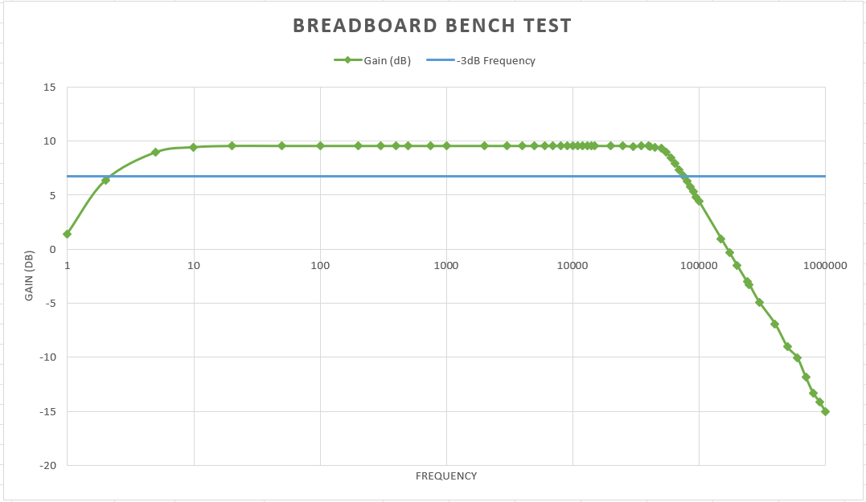
Figure 11: Breadboard Bench Test Results

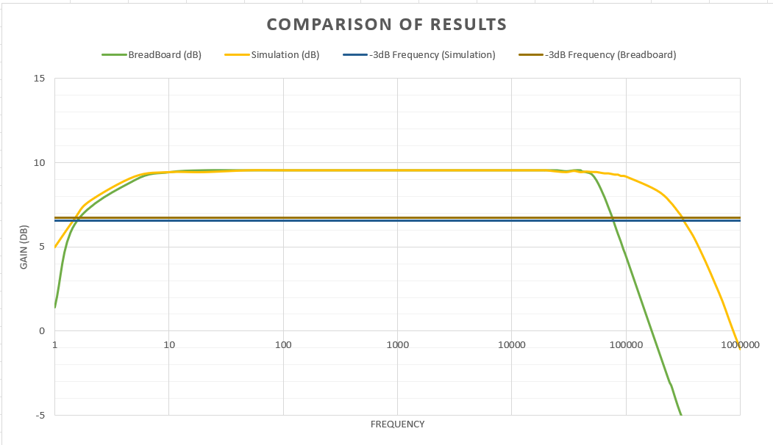
Comparison

Figure 12: Comparison of Simulation and Breadboard

The cut-off frequency on the breadboard circuit is a lot lower than the simulated circuit. This could be due to various factors – which include, poor connections, component tolerances and temperature. The simulation does not consider any of these factors and the results of this are usually the ‘ideal’ value.

PCB Population

Build
For all the solder joints, I first put the soldering iron on the pad to ensure that the pad and component leg is slightly heated up. Then I added the solder and kept the iron on the pad for a few seconds so that I could be sure a good connection was made.
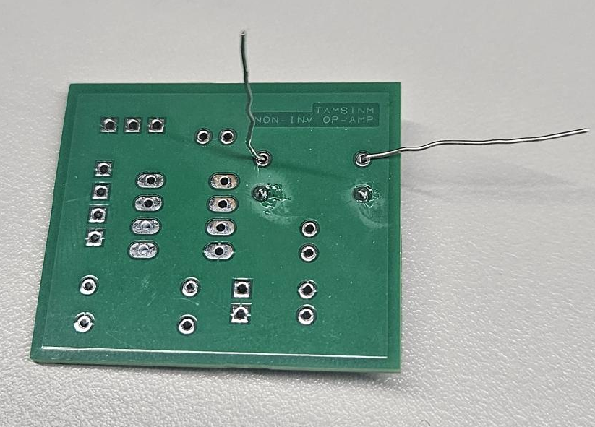
For all the resistors and capacitors, I bent one leg down to secure the component, then I soldered the straight leg. I then double checked that the component was flush with the board and straight. After this I bent the other leg straight then soldered this.
Figure 13: PCB - Soldering TH Resistors
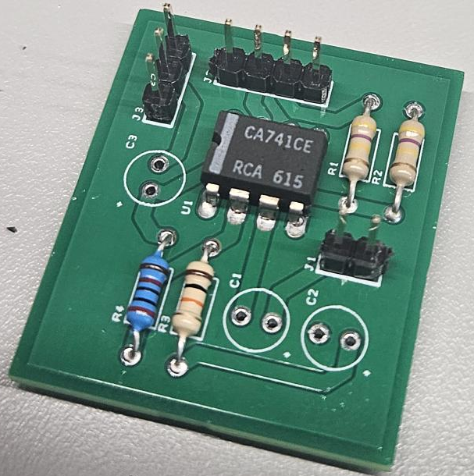
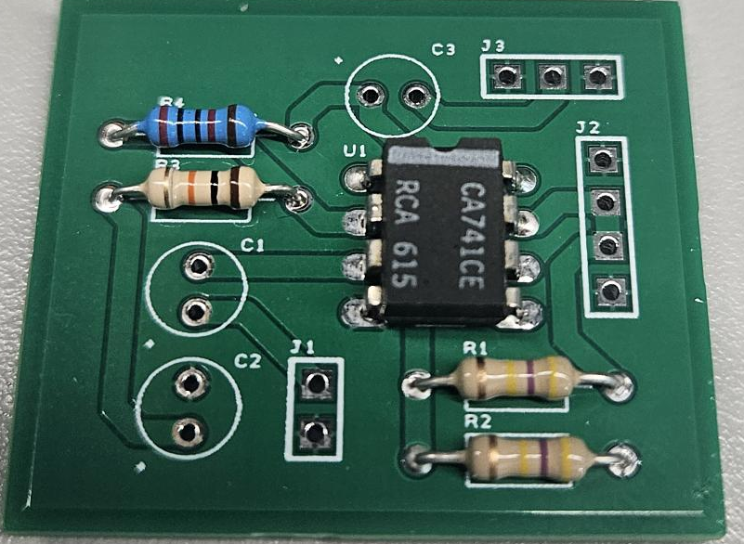
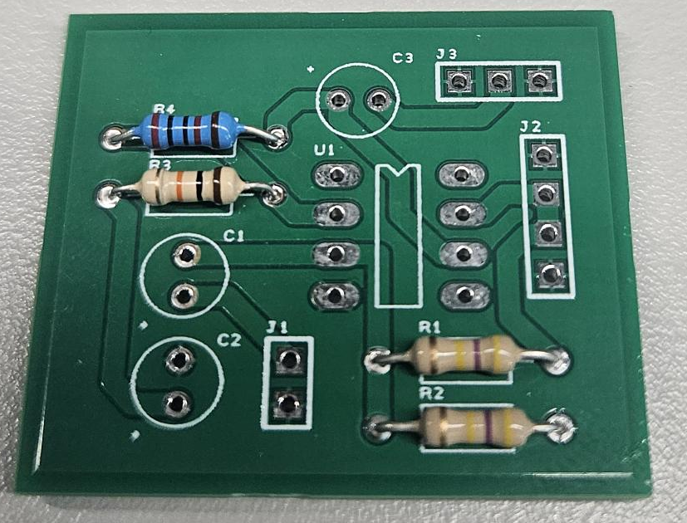
Figure 14: PCB - Added Headers
Figure 15: PCB - Added IC
Figure 16: PCB - Soldered Resistors

I soldered the components in order of height.
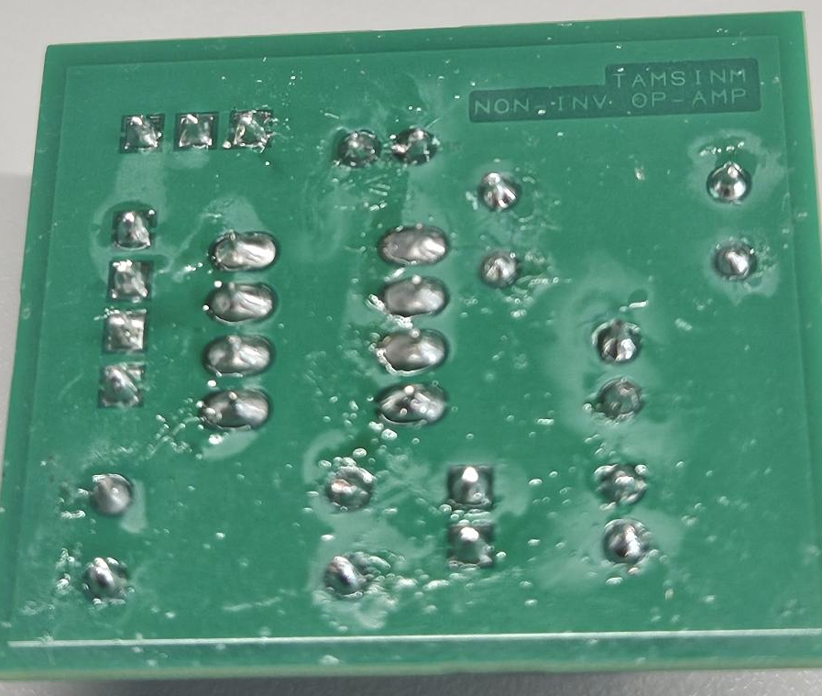
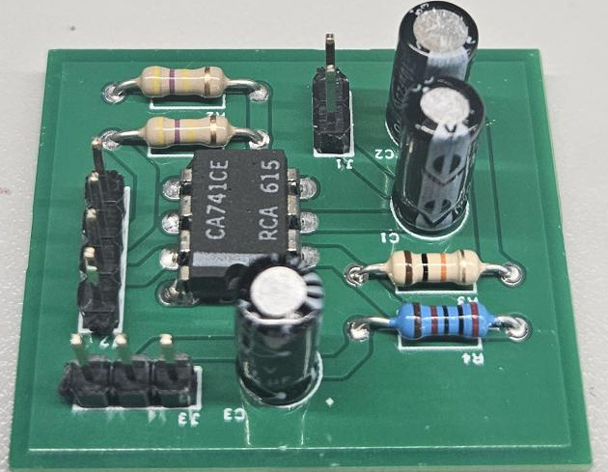
Figure 17: Finished PCB - Top

Figure 18: Finished PCB - Bottom

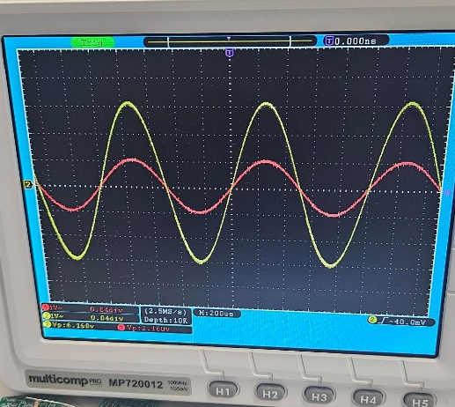
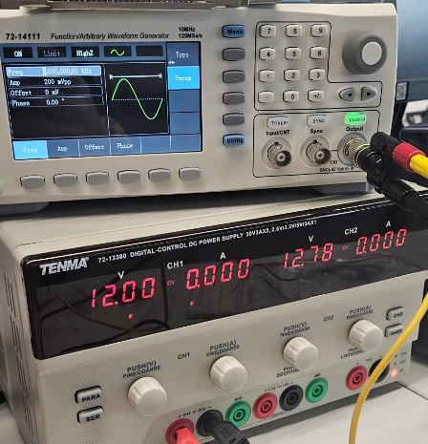
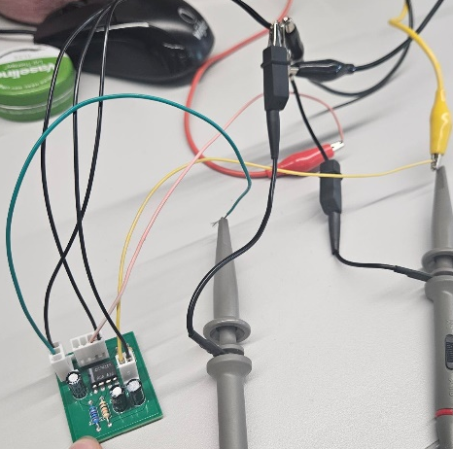
Testing
Figure 19: Finished PCB Testing
Figure 20: Test Setup for PCB
Figure 21: Oscilloscope Results

The input voltage from the signal generator was 0.2V and the supply voltage was 12V.
Table 3: PCB Test Results
Lower -3dB Frequency
Upper -3dB Frequency
Frequency (Hz) | Vout  (V) | Gain  (dB) | Voltage Gain (Av) | Frequency (Hz) | Vout  (V) | Gain  (dB) | Voltage Gain (Av)
1 | 2.52 | 1.501293597 | 1.188679245 | 25000 | 6.08 | 9.151354367 | 2.867924528
2 | 4.2 | 5.938268589 | 1.981132075 | 30000 | 6.08 | 9.151354367 | 2.867924528
2.25 | 4.52 | 6.576051478 | 2.132075472 | 35000 | 6.08 | 9.151354367 | 2.867924528
2.5 | 4.84 | 7.170190014 | 2.283018868 | 40000 | 6.08 | 9.151354367 | 2.867924528
3 | 5.12 | 7.658682001 | 2.41509434 | 41000 | 6.08 | 9.151354367 | 2.867924528
5 | 5.84 | 8.801539724 | 2.754716981 | 45000 | 6.08 | 9.151354367 | 2.867924528
10 | 6.12 | 9.208311224 | 2.886792453 | 50000 | 6.08 | 9.151354367 | 2.867924528
20 | 6.16 | 9.264897025 | 2.905660377 | 55000 | 6.08 | 9.151354367 | 2.867924528
50 | 6.16 | 9.264897025 | 2.905660377 | 60000 | 6.08 | 9.151354367 | 2.867924528
100 | 6.16 | 9.264897025 | 2.905660377 | 65000 | 6.12 | 9.208311224 | 2.886792453
200 | 6.16 | 9.264897025 | 2.905660377 | 70000 | 6.12 | 9.208311224 | 2.886792453
300 | 6.16 | 9.264897025 | 2.905660377 | 75000 | 6.08 | 9.151354367 | 2.867924528
400 | 6.16 | 9.264897025 | 2.905660377 | 80000 | 6.12 | 9.208311224 | 2.886792453
500 | 6.24 | 9.376974575 | 2.943396226 | 85000 | 6.08 | 9.151354367 | 2.867924528
750 | 6.24 | 9.376974575 | 2.943396226 | 90000 | 6 | 9.036307789 | 2.830188679
1000 | 6.2 | 9.321116571 | 2.924528302 | 95000 | 6 | 9.036307789 | 2.830188679
2000 | 6.2 | 9.321116571 | 2.924528302 | 100000 | 6.12 | 9.208311224 | 2.886792453
3000 | 6.2 | 9.321116571 | 2.924528302 | 150000 | 5.96 | 8.978207976 | 2.811320755
4000 | 6.2 | 9.321116571 | 2.924528302 | 175000 | 5.84 | 8.801539724 | 2.754716981
5000 | 6.2 | 9.321116571 | 2.924528302 | 200000 | 5.68 | 8.560249496 | 2.679245283
6000 | 6.2 | 9.321116571 | 2.924528302 | 240000 | 5.44 | 8.185260775 | 2.566037736
7000 | 6.2 | 9.321116571 | 2.924528302 | 250000 | 5.36 | 8.056578575 | 2.528301887
8000 | 6.16 | 9.264897025 | 2.905660377 | 300000 | 5 | 7.452682868 | 2.358490566
9000 | 6.16 | 9.264897025 | 2.905660377 | 350000 | 4.38 | 6.302764992 | 2.066037736
10000 | 6.16 | 9.264897025 | 2.905660377 | 400000 | 4.28 | 6.102158162 | 2.018867925
11000 | 6.16 | 9.264897025 | 2.905660377 | 500000 | 3.64 | 4.695310454 | 1.716981132
12000 | 6.16 | 9.264897025 | 2.905660377 | 600000 | 3.2 | 3.576282348 | 1.509433962
13000 | 6.16 | 9.264897025 | 2.905660377 | 700000 | 2.76 | 2.291464423 | 1.301886792
14000 | 6.16 | 9.264897025 | 2.905660377 | 800000 | 2.44 | 1.221079308 | 1.150943396
15000 | 6.16 | 9.264897025 | 2.905660377 | 900000 | 2.14 | 0.081558248 | 1.009433962
20000 | 6.12 | 9.208311224 | 2.886792453 | 1000000 | 1.92 | -0.860692645 | 0.905660377

Bandwidth ≈ 350000 – 2.25 = 349997.75Hz
Gain Bandwidth Product = Av x Bandwidth = 2.94 x 349997.75 = 1030182.06Hz

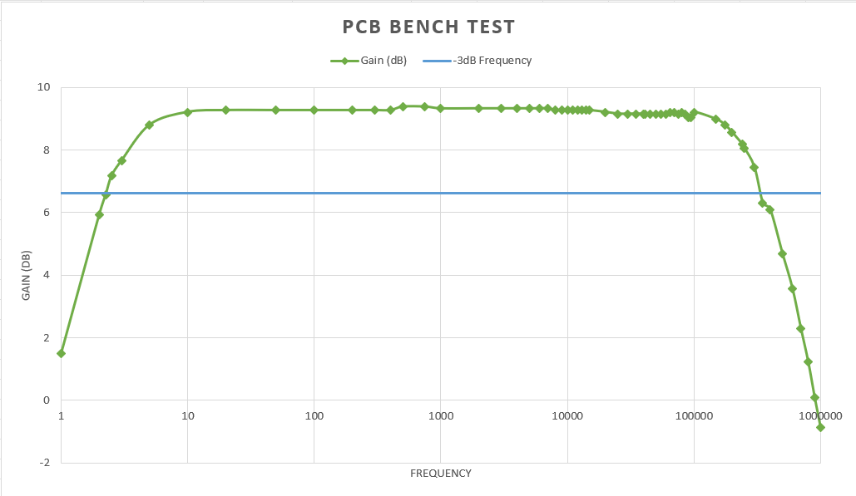

Figure 22: PCB Bench Test Results

Comparison
I took the -3dB point of each of the tests and plotted the average (mean). The -3dB point is essentially the half-power point or the cut-off frequencies.
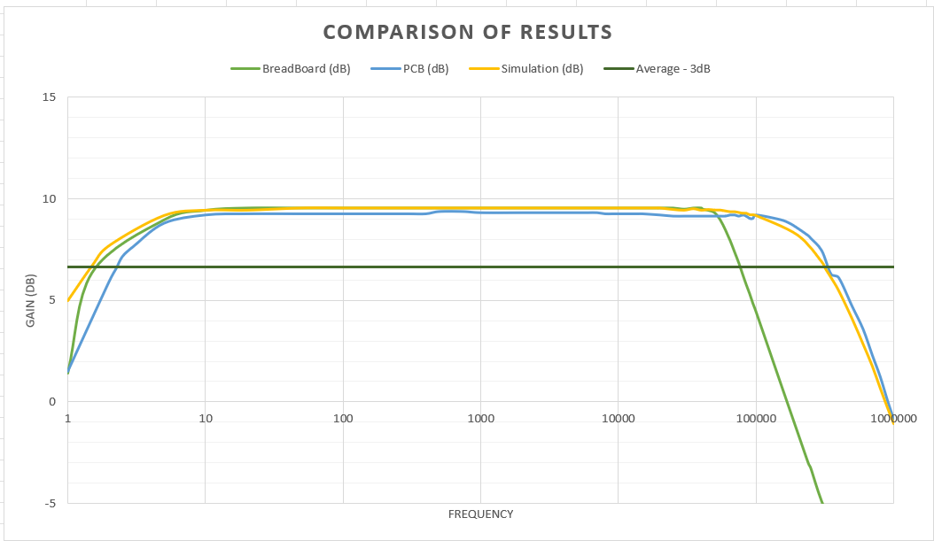

Figure 23: Comparison of All Results

The PCB results match the simulation a lot better than the breadboard results. This indicates that the issue may be with poor connections or human error as the same components were used for the breadboard and the PCB. The lower cut-off point of all the tests are quite similar.

Suggested Improvements
If a second revision of the PCB was created – I would make the designators a bit bigger and put the components closer together so the board can be smaller.
I could also change to traces to the bottom of the PCB so it is easier to see what connects to what.
I would also re-do the breadboard test to see why the results were so different to the simulation and PCB.

References

[1] | Texas Instruments, “LM741 Operational Amplifier Datasheet,” October 2015. [Online]. Available: https://www.ti.com/lit/ds/symlink/lm741.pdf?ts=1732536694956&ref_url=https%253A%252F%252Fwww.ti.com%252Fproduct%252FLM741. [Accessed 26 November 2024].
[2] | W. Storr, “Non-inverting operational amplifier - the non-inverting op-amp,” Electronics Tutorials, 04 August 2022. [Online]. Available: https://www.electronics-tutorials.ws/opamp/opamp_3.html. [Accessed 26 November 2024].

Appendices

1: Circuit to Reproduce
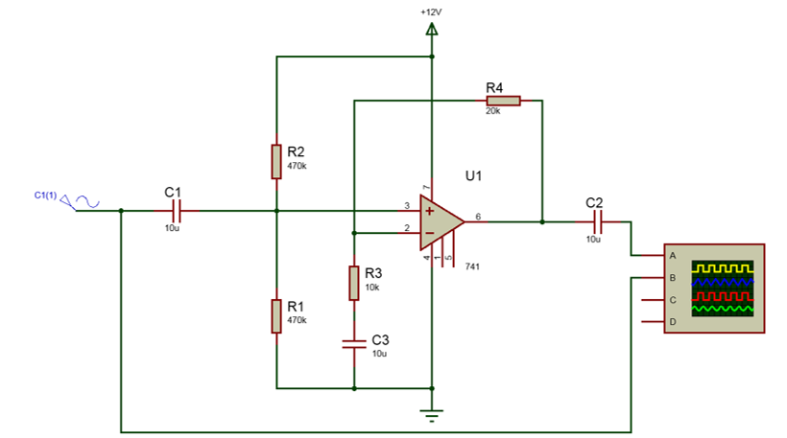
This schematic was taken from the assignment specification and is a non-inverting amplifier with a gain of 3.

