A comparison of the marketing methods of two multinational hotel brands.

Name: Mirabela Elena Radu
Student ID: 2244611
The module title: Marketing Essentials BMIH4005
Lecturer name: Scott James
Word Count: 1499

To sustain the competition in the hospitality industry, it is required to understand the business dynamics of the competitors' brands. The chosen companies for this essay are Premier Inn and Hilton Hotel. This essay will develop a comparative analysis by exploring the marketing strategies, environmental analysis, and target market analysis of the global market. Hilton Hotel has a global presence, while Premier Inn has a vast domestic presence. This essay will use marketing frameworks such as SWOT, PESTLE, STP, and Marketing Mix, considering its global market. For the marketing mix, 7P’s will be used, such as product, price, place, promotion, people, process, and physical evidence, to compare the marketing strategies of these two renowned brands and know how these elements are contributing to brand development and gaining competitive advantage. This essay will also focus on key insights into the brands' opportunities and challenges in the global and local markets.

Situational Analysis / External Analysis
According to Buttle et al. (2023), SWOT and PESTLE analysis provide valuable feedback on the internal and external dynamics of two renowned brands Premier Inn and Hilton Hotel. These models provide structured analysis to understand strategic challenges and competitive positioning in the global market. Premier Inn has a widespread presence in the UK market and offers affordable and quality services. George (2023) discussed how its brand positioning focuses on trust and value for all kinds of travellers. Its major weakness is its limited global market compared to the Hilton Hotel. The Hilton Hotel has a diverse footprint in the global market. It allows this company to benefit from economies of scale. The Hilton Hotel offers a loyalty program to retain its global customers. It also faces challenges in maintaining its consistent premium services in all locations, which might impact the reputation of the company. Hudson (2024) stated that using the PESTLE framework reveals that the external environment of Premier Inn and Hilton Hotel has opportunities and challenges in the local and global markets. From a political viewpoint, various factors such as taxation policies, political instability, regulatory issues, and relationships with governments have an impact on the business of both brands. George (2022) mentioned that economic factors such as GDP growth, monetary policies, exchange rates, and inflation influence customers to get services from premium hotel brands. For the hospitality industry, social trends, consumer preferences, income level, travel facilities, and demand for accommodations are critical factors. Chang et al. (2023) mentioned that both Premier Inn and Hilton Hotels have streamlined their operations using modern technologies and ensure smooth reservation systems. The rapid changes in technologies also create threats for both companies to protect information from cyberattacks. Legal factors such as labour law, minimum wage and property rights also impact the daily operations of both hotels and its degree depends on the geographical operations. Williams (2023) stated that Environmental factors are very important for both Premier Inn and Hilton Hotel to maintain increasing awareness of environmental conservation and sustainability issues. By implementing a proper waste management system and reducing the carbon footprint from hotel operations, both brands will be able to appeal to more customers, especially eco-conscious travellers. However, country-wise regulations, resource availability, and usage of renewable energy pose threats to the hotel operations of both brands.

Marketing Mix
Khirin and Phalitnonkiat (2023) stated that Hilton Hotels and Premier Inn are renowned brands in the industry. Each brand follows unique marketing mix strategies to enrich its position in local and domestic markets. In terms of product, Premier Inn focuses on the affordability of quality services with basic amenities for leisure, luxury, and business travellers. On the other hand, the Hilton Hotel has a diverse portfolio to support various markets and offers a wide range of experiences, from basic to luxury. In terms of pricing, Schrand et al. (2023) mentioned that Hilton Hotel is a premium brand and seeks premium pricing for all its locations to maintain its global brand value and upscale the properties. Premier Inn is well known for its value-based pricing strategies to offer quality services at competitive prices across all locations. Regarding placement strategies, Applegate et al. (2023) stated that Premier Inn emphasises the domestic market and Hilton Hotel operates in major global locations around the world. Hilton Hotel targets prime cities strategically where the income level of the people is high. In contrast, Premier Inn established its hotels near the public hub and major tourist attractions. Zeng (2022) mentioned that both brands use digital and traditional promotional tools to reach their customers through strategies that vary from brand to brand and location to location. Both Premier Inn and Hilton Hotels use digital marketing strategies for their cost-effectiveness and extensive reach to their target audiences. Social media, official apps, and websites are the main channels to engage with customers and get the fastest reservations. Hilton Hotel also uses traditional promotional methods to establish its presence in the global market by printing billboards, enabling loyalty programs and sponsoring global events. In contrast, Tanford et al. (2023) stated that people mix, and there are differences in service standards and training of the employees. The Hilton Hotel focuses on priority services, personalised and luxury services. In contrast, Premier Inn trains its staff for consistent and efficient services for its limited portfolio. For both brands, process and physical evidence make huge differences in the perceived valuation of services. Gustavo (2023) mentioned that Premier Hotel made the reservation process easier by enabling a contactless check-in process and providing standard operational efficiency to ensure the best services. The process strategy of the Hilton Hotel emphasises luxury and elegance through amenities, services, and exclusive room design (Nalley and Gregory, 2021). Both hotel brands have strong physical evidence, as Premier Inn has 72,000 rooms and Hilton Hotel owns around 219,264 rooms.

Segmentation Targeting and Positioning
Renaghan (2023) stated that segmentation, targeting, and positioning (STP) strategies are very essential and fundamental to understanding the marketing strategies of Premier Inn and Hilton Hotel. By using analytical tools such as Similarweb, it is possible to understand the web traffic, engagement of the customers, and valuable insights of the customers from target market segments. By using the tool, Bhandari and Sin (2023) mentioned that we can easily identify the segmentation of the customers that Premier Inn and Hilton Hotel planned to attract and develop potential markets based on geographic, demographic and behavioural factors. The data shows that 80% of the customers of Hilton are from the USA and the second position is maintained by the UK market.

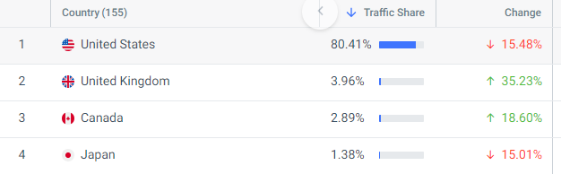
Fig: Geographical Segmentation of the Hilton Hotel. (similarweb.com, 2024)
From the demographic’s perspective, 45% of customers in this group are female, and most of the customers are aged between 25 to 34 years old.
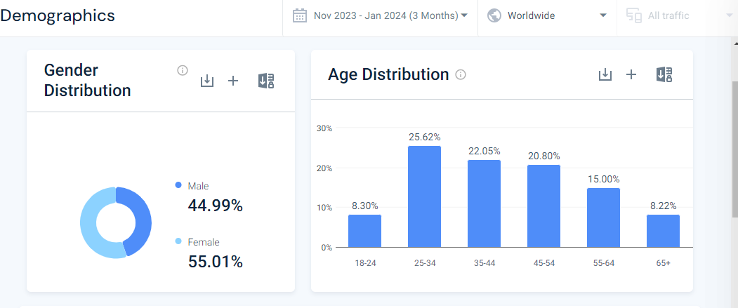
Fig: Demographic Segmentations of Hilton Hotel. (similarweb.com, 2024)
Premier Inn has the opposite condition in geographic segmentation. 80% of customers belong to the UK market, and 52% of them are male. Similar to Hilton Hotel, most of the audience is to 25 and 34 years of age.
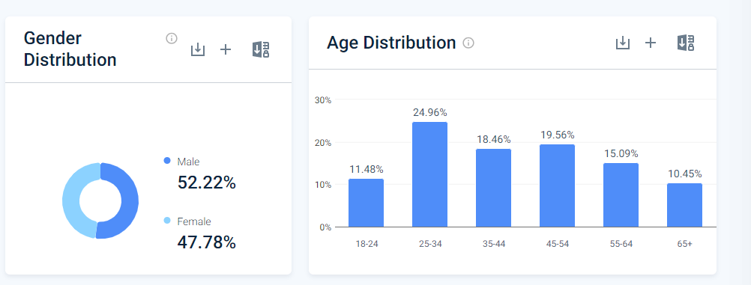
Fig: Geographical Segmentations of Premier Inn. (similarweb.com, 2024)

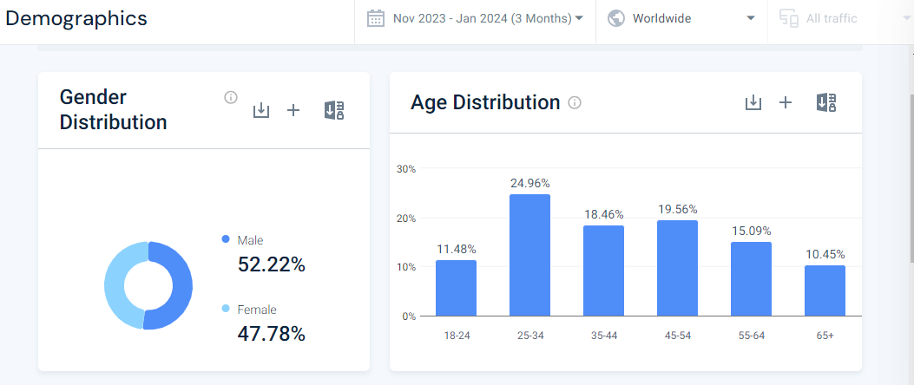
Fig: Demographic Segmentations of Premier Inn. (similarweb.com, 2024)
For this company, the data also shows that it attracts budget-conscious travellers who are looking for affordable accommodation while travelling. They look for convenient stays rather than luxury amenities. Conversely, data shows that the customers of the Hilton Hotel target frequent travellers, business travellers and luxury seekers looking for upscale amenities. Yadav et al. (2023) stated that the target market of these two brands has a common age range, which is between 25 and 35 years. Hilton Hotel focuses on repeat customers through loyalty programs, whereas Premier Inn focuses on offering value-based services. Perceptual maps show the Hilton Hotel has positioned itself as a global luxury brand by emphasising its luxury services and diverse amenities. Oppositely, Premier Inn positioned itself as a reliable and affordable brand in the domestic and global markets by offering value-based services to its customers.
In conclusion, after analysing various research, analyses, and studies, it is found that marketing plays a very critical role in the hospitality and tourism industries. By implementing strategies in this valuable field, companies can create perceived value and gain more market share in the global market. This essay found that both Premier Inn and Hilton Hotel engage their resources for marketing strategies to attract their vast market so that they can stand out in the crowd. The market is very competitive, and both companies are using social media analytics and digital marketing tools to reach maximum customers and retain them for longer periods of time. Moving forward, further development is required for both Premier Inn and Hilton Hotel to continue their better services and market development to handle the competitive dynamics of the market.

References
Applegate, L. M., Piccoli, G., & Dev, C. S. (2023). Hilton hotels: Brand differentiation through customer relationship management. Harvard Business School Pub.
Bhandari, R., & Sin, M. V. A. (2023). Optimizing digital marketing in hospitality industries. Startupreneur Bisnis Digital (SABDA Journal), 2(1).
Buttle, F., Bowie, D., Brookes, M., & Mariussen, A. (2023). Hospitality Marketing. Taylor & Francis.
Chang, Y. C., Ku, C. H., & Chen, C. H. (2023). Social media analytics: Extracting and visualizing Hilton hotel ratings and reviews from TripAdvisor. International Journal of Information Management, 48, 263-279.
George, R. (2022). Tourism and Hospitality Products, Branding, and Pricing. In Marketing Tourism and Hospitality: Concepts and Cases (pp. 249-283). Cham: Springer International Publishing.
George, R. (2023). Tourism and Hospitality Marketing Principles. In Marketing Tourism and Hospitality: Concepts and Cases (pp. 3-31). Cham: Springer International Publishing.
Gustavo, N. (2023). Marketing management trends in tourism and hospitality industry: facing the 21st century environment. International Journal of Marketing Studies, 5(3), 13.
Hudson, S. (2024). Marketing for tourism, hospitality & events: a global & digital approach.
Khirin, W., & Phalitnonkiat, P. (2023). Tourism destination marketing and IMC of Hilton Hotel Pattaya. In The Proceedings of 1st World Conference on Hospitality, Tourism and Event Research and International Convention and Expo Summit 2013, Bangkok, Thailand, 25th-28th May 2013 (pp. 188-199). International Program in Hotel and Tourism Management, Siam University.
Nalley, M. and Gregory, A., 2021. A Case for Change, Market Segmentation and Brand Management. Journal of Hospitality & Tourism Cases, 9(2), pp.60-65.
Renaghan, L. M. (2023). A new marketing mix for the hospitality industry. Cornell Hotel and Restaurant Administration Quarterly, 22(2), 31-36.
Schrand, A., Schlieper, T., & Hansen-Hagge, C. (2023). Strategisches Hotel-Marketing. Management in der Hotellerie und Gastronomie-Betriebswirtschaftliche Grundlagen, 8
Tanford, S., Shoemaker, S., & Dinca, A. (2023). Back to the future: progress and trends in hotel loyalty marketing. International Journal of Contemporary Hospitality Management, 28(9), 1937-1967.
Williams, C. (2023). Marketing process of hotel services: case: Transcorp Hilton Hotel, Nigeria.
Yadav, R., Kumar Dokania, A., & Swaroop Pathak, G. (2023). The influence of green marketing functions in building corporate image: Evidences from hospitality industry in a developing nation. International Journal of Contemporary Hospitality Management, 28(10), 2178-2196.
Zeng, L. (2022). Analysis of Hilton Worldwide Hotel Group’s Transnational Operation Strategy. Academic Journal of Business & Management, 3(11), 20-27.

