Marketing Fundamentals
Analysis and Evaluation
Assessment 2

Student: Rosiyana Domozetska
Student Number: 2217516
Module: Marketing Fundamentals
Module code: LCBB4004
Module Lecturer: Tushara Balendran

Table of Contents
Section 1: Introduction. 4
Section 2: PESTEL analyses 6
First the report will explain the PESTEL Analyses. 6
Section 3: Porter Five Forces 8
Section 4: Impact of Covid 19 and advantages and disadvantages 10
Section 5: Segmentation, targeting and positioning. 10
Section 6: Marketing mix 12
Section 7: Conclusion 14
Section 8: Recommendations 15
Section 9: Referencing list……………………………………………………………………………………………………………….16

Analysis and Evaluation of ASDA Stores LTD

Section 1: Introduction.

I will conduct Internal and External factors and the impact of Covid 19 on the company ASDA.
ASDA is a supermarket group headquartered in Leeds, United Kingdom. It is one of the biggest supermarket brands and has more than 600 stores across the UK. New monthly research from October 2022 showed that ASDA offering online shoppers the most affordable prices.(Daily Record. 2022). According to Kotler and Armstrong, (2019) marketing is the activity of organizing and carrying out the pricing, promotion, and distribution of goods and services to generate exchanges that meet both individual and organizational objectives. This process tries to meet the needs of a target market. This process delivers goods and services from producers to consumers. These processes are interconnected and interdependent with other businesses just to satisfy the consumer needs.
A marketing process is a tool through which companies can create customer value and long-lasting customer relationship. The marketing process is a five-step process. The figure below shows it.
Figure 1
https://www.iedunote.com/marketing-proces
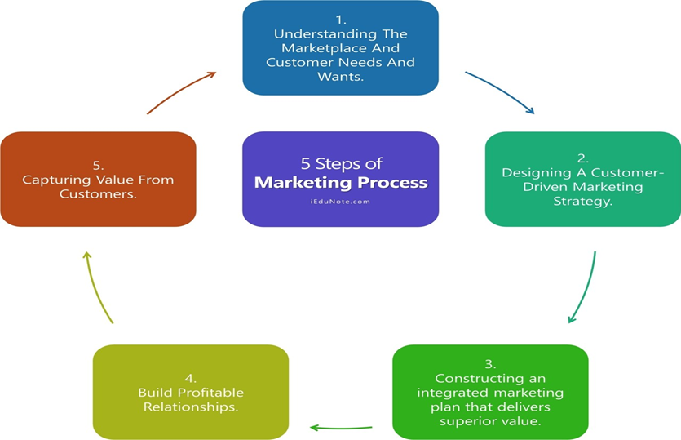
Kotler and Armstrong (2019) explained them in detail.
First step is to understand customers needs and wants. It is very important because it creates demand in a market. It is good to create combinations of products for better price, or include new services for example: deliver services or repair services. Market has to cover the right level of expectations. After that, is necessary to create a marketing strategy involving market segmentation, targeting and positioning. Which customers to target and how? Then the company has to create a marketing plan. It relates to 4ps of marketing: product, price, promotion and place. The marketing planning process include: Internal and External analyses, establishing marketing goals and objectives. Once the plan had been established the company has to build customer relationship and customer loyalty. It is very important to increase customer satisfaction. The last stage is capturing value from customers. That means that the brand stays profitable in the long run. Asda is in the second position as the cheapest supermarket in the UK. The goals and objectives of Asda are to give better products and services than other supermarkets. The company wants to become British most reliable retailer and to provide more than the needs and wants of the customers. Also they want to provide modern services, adding more products and develop new channels of distribution. At the moment the company is successfully implemented the policy of lower prices. The customers are ordinary working people and the main arm is to meet their needs. To achieve the marketing objectives the brand must follow some strategies. One of the most important is to understand where to compete. In this reason there has been opened so many stores around the country. Retailers often point that the success comes with the location. Most stores today cluster together to increase their customers. The location of most of them is in the big shopping centres where there are many shops and many people do shopping there. The second strategy is a way to compete. Asda do this by increasing the variety of products and selling them at lower prices. The third strategy is when to compete. Asda uses all festival seasons like Christmas, New Year, Valentine’s Day to sell their products. The impact of Covid-19 focusing on online shopping and the company develop this kind of distribution. If the company wants to keep good position on the market is very important to have control of its activities. With good research Asda can know what kind of products the customers like and how much they are ready to pay. The good relationship is very important and Asda has loyalty cards to keep more clients. In this reason the brand has excellent profitability. To achieve their goals Asda make many advertising on the TV, Radio and through internet. There are also various internet web pages. The company tries to monitor and regulate their marketing activities to achieve their goals.
There are two main types of environment which show the situation in the competitive market. Internal environment contains employees, products, and communication. External environment contains PESTEL Analyses, Porter Five Forces, SWOT analyses. We will examine them in depth in this report. Macro environment is very important for businesses. It consists of external factors which come outside the organisation. These factors can create threats or opportunities for the company.

Section 2: PESTEL analyses

First the report will explain the PESTEL Analyses.
The main elements in the Macro environment are Political, Economical, Social and cultural forces, Technological, Environmental and Legal forces.
Figure 2

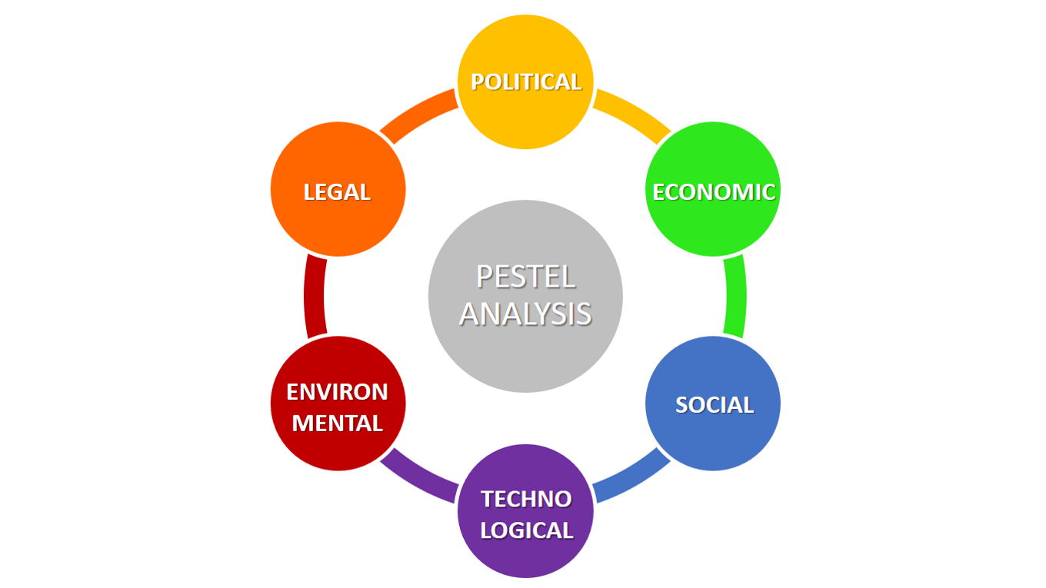
https://i0.wp.com/www.business-to-you.com.
PESTEL Analyses give clear understanding of marketing situations and have impact on an organization’s performance. Political factors show the political stability or instability, corruption, tax policy and labour law. Hooley,(2022) wrote in his book that prior to taking any action, we need recognise how changes in the business environment will affect marketing and be prepared to do so. Secondly, we need to be aware that the nature of the change that companies are confronting is also evolving. Some of these changes are summarising and referred to as PESTEL Analysis. First group is political factors, which include political stability or instability, corruption, tax policy, labour law and others. Asda, as a selected company must follow the law of the UK. One of the benefits for Asda is that the UK has stable political environment. The company follow consumer rights, employee rights, and tax policy in the country. However, Brexit impact the brand in negative way and it forced the company to focus on internet chain. The war in Ukraine also play negative role on the business. The democracy in current government system in the UK makes benefits for Asda and we can say that it is favourable.
Economic factors include economic growth, interest rates, inflation rates, and unemployment rates. All of them have direct or indirect impact on a company. Consequently it also affects of the prices of products and services which the company offers. Understanding these factors help businesses develop and introduce new products and services. The disadvantage of the economy is faced by all the businesses and all the businesses along with Asda are facing the negative side of the economy. The brand needs to take into consideration pay level, cost of living, competitive pressures, and energy prices. Lockdown in 2020 reduced customers and their shopping activities. Many people lost their jobs and reduced their demands.
Social factors are: the population growth rate, cultural barriers, age, religion and lifestyle of the customers. It also includes the development of society in terms of change in trend of preference. The competition companies attribute the change in trend to the market. Last years the demand for organic, and vegan food is growing fast and Asda tries to meet them. It sells a huge number of products that meet ethnic groups demand. Long term believes and values pass down from one generation to another effect the consumer behaviour.
Technology continues to develop and affect not just industry but each part of the life. To be ahead of your competition the company has to use current technology. The explosive growth in digital technology has fundamentally change the way we live. Everyone is digitally connected to everything.”Digital and social media marketing involves using digital marketing tools, such as websites, mobile ads and app, online videos, emails blogs and others digital platforms to engage consumer everywhere”. (Kotler, and Armstrong, 2019.p.23) Asda has also implemented the latest technology which has helped in different ways. The brand used these technologies in its retail outlet and distribution. The company rolls out a number of new technologies to help make shopping easier for its customers. They can collect online orders in less than 60 seconds. Mobile apps with click and collect delivery services are extremely important for the company in the last years during the pandemic. Asda also use data base like internal and external data for planning and focus on develop better marketing plan.
Environmental factors play huge role in the last decade. More and more companies are concerned about the environment issues. There is a significant amount of pressure on all companies and industries to operate in on environment friendly manner. In the last years Asda become one of the most sustainable companies if the UK.
Legal factors are also very important. Every company has to abide by the law of the country where it is located. For example it cannot pay less than the minimum wage. The businesses have to follow all the laws like labour law, consumer law, employment law and others set up by the Government. All the documentation of the company is under the legal structure. On the other hand too much intervention by Government legal system may harm the business operations. Asda must strictly comply with the country’s laws.
To do successful business Asda has to use PESTEL analyses as a tool to create a good planning strategy. It is very important to identify the opportunities and threats in external business environment if the company wants to stay ahead of the competition. The PESTEL analyses show that the company has favourable environment to do successful business.

Section 3: Porter Five Forces
Also this report will focus of the Porters Five Forces.(Poster,2008) suggested that five main forces shape competition at the level of strategic business unit and that a systematic analysis of each intern can help managers identify the keys to competitiveness in their particular industry.
Figure 3
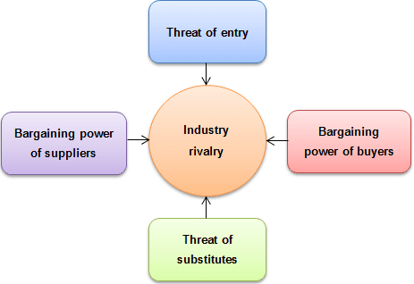
These factors influence an industry's structure and amount of competitiveness. The less profitable industry is, the more intense the forces of competition. An industry with minimal entry barriers, few buyers and suppliers, but lots of replacement of products and competitors won't be as appealing owing to its poor profitability because it will be perceived as very competitive.
First on is rivalry among existing companies. When a company find it difficult to exists a market where they have entered we can say that they will compete hard to success. Also the low differentiation will force the customers to switch and go to another company. Tesco, Morrison and Lidl are main competitors for Asda. All of them want to capture large groups of people. We can say that there is high level of competition. The next force is threat of entrants. To enter the market new competitors must to have huge capital investment. So this stage is low. Asda, Sainsbury and Tesco are the main retails in the market and for new brands will be very difficult to enter. The next on is power of customers. They play very important role for every brand to be profitable. Asda has to provide them excellent quality for lower prices and give then maximum satisfaction. The company provide variety of products and services to keep the buyers. The next one is the power of suppliers. Each company must have strong relationship with its suppliers. Asda has huge number of suppliers which deliver different products to it. But if another retails give them better price they can switch .The last one is threat of substitute. In different supermarkets and grocery buyers can find the same products. There are so many substitutes available and Asda has to give better price and quality. That means that the threat of substitute is high.
Now the company is on the second position on the retail market. The brand has been able to achieve this by low prices and good services. But to keep this position the company has to create new strategies and promotions to satisfy customers. To reach more and more buyers Asda offer online shopping and different variety of products and services. Some of the disadvantages for the company are that there are many other shops and groceries that offer the same products.

Section 4: Impact of Covid 19 and advantages and disadvantages
Impact of Covid 19 gave the company created new ways to sell its products. Asda (2022) gave the information that it resulted in previously unheard-of strain on Asda to keep up with deliveries, modify its stores, and maintain stock levels. Within a short period of time the stores were designed with social distancing in mind, and sourcing was modified to ensure continued supply of necessary items, notably for vulnerable individuals and NHS workers.

It is very important to see the advantages and disadvantages when we analyse the PESTEL. PESTEL Analysis show the external environment in which the company operate. All of them help businesses to understand external trends. They can clearly show the potential threats and opportunities. By analysing them the company can develop successful strategies to do business better. After analysing them the company can develop successful strategies to do business in a better way. PESTEL analyses are cost effective because the brand can develop methods to exploit opportunities. Also the company can produce the threats and try to avoid them.
Although, it is a successful tool for planning your business these factors are not constant. It is one of the disadvantages. The political or economical factors can be changed and these changes will affect the company’s profitability. Another one is that the company cannot see the whole picture. To understand the competitions, customer behaviour and supplier behaviour the company must to use Porter’s Five Forces methods.

The next part of the report will focus on internal analyses.

Section 5: Segmentation, targeting and positioning.
According to Hooley, (2020) segmentation is a process which shows how the marketers can divide the market into small groups. Identifying the customers in these groups should give the information of their buying behaviour and what kind of products they prefer. A company must determine whether a target sector is profitable for them to serve once they have discovered it. When the company knows that to focus on it can to satisfying the customer’s needs. The groups can be demographic and geographic, different social class, and different life style. In the last years many people are interested of healthy food and Asda increase the variety of these products. The company is focused on age and gender segmentation. Also George and its line of fashion and home goods bring new customers. Selling clothes and shoes for all ages make good profit for the company. Some of the segments are food, clothing, toys, electronics, selling petrol, pharmacy and etc. The company tries to appeal to families with lower incomes. In the primary market, Asda is the cheapest shop and its goals are to be the best affordable pricing market.
According to Asda (2009) it is targeting all groups of society. Marketing strategy of Asda shows that it is not specified on one group. But most customers are women of age 20’s to 30’s.Targeting is a process that show who are the customers of a particular company. The brand has undifferentiated marketing. Most of the products are suitable for many different types of consumers. It is also know as a mass marketing. The next step in the targeting process is differentiation. The product which the company produce is for all market segments. It is undifferentiated. When a product is produced slight modification within a segment is differentiated. And niche is when an organisation produces a product or service to satisfy a specific group of people. Asda used the differentiated targeting level to reach muss consumer.
Positioning is a process, which create the company’s image and its competitive position on the market. Companies which are in competition with Asda are Tesco and Sainsbury’s. Positioning also applies at the level of the product’s quality and brand name. The company use George as a brand name for clothes, shoes, and home goods. A huge number of customers can be bring by multiplicity of products. Another competitive strategy should be good communication with buyers and how important they are. Asda advertise on the TV, radio and social media. Quinn, (2021) wrote that Asda had appointed ‘Havas London Agency’ to advertise its products. Also they use a family Sunny, Amy and their children for Christmas campaign.

Section 6: Marketing mix
The next part of the report is focused on the marketing Mix. It refers to the four key elements of the marketing strategy. They are product, price, promotion and place. 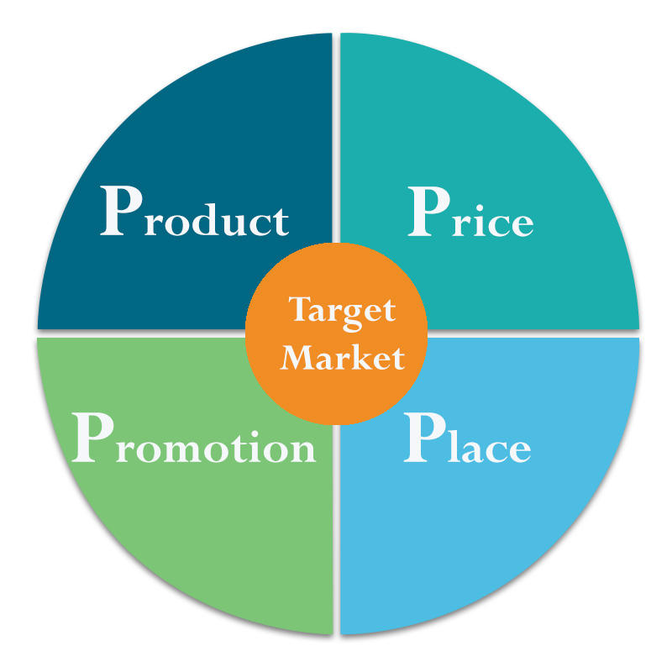Figure 4

Product is an item or service which tries to satisfy customer needs. If a company want to sell more products, it is necessary to offer good quality, design, logo, good service and after service relationship. Asda’s product portfolio increased in the last years. The company try to sell their products on the cheapest prices. The brand is offering brand products to customers and giving them valuable suggestions. Stores started sell clothing, petrol, and variety of essential items. As a result they made strong and successful market.
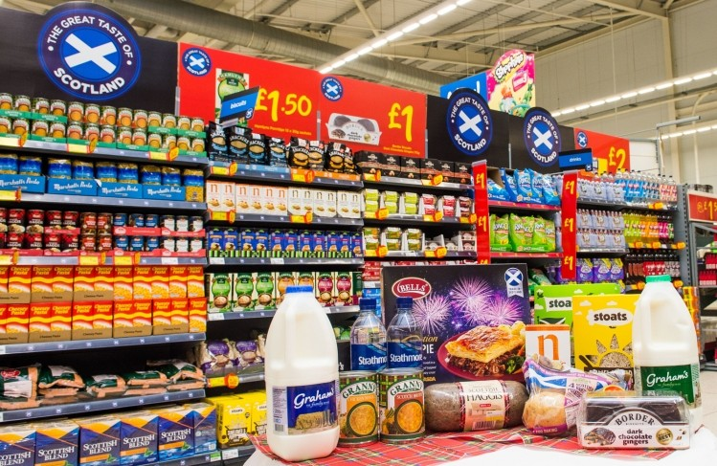
Figure 5 Figure 6
One specific branding strategy that Asda use it, that the company sell George products. They are on good quality and excellent price. The brand name is very popular and people like their products. George sells clothes and shoes for all ages, from babies to old people. Another strategy is that George innovate its products in style, design, and price. All products can be found in Asda stores and on different internet platforms. Another strategy is that the company took care of the environment and uses environmentally friendly materials. George clothing has a wide range of selections. All products are designed to cover the wants and needs of the working group of people. Consumers look for good quality, low prices and good style. Asda ‘s brand strategy is to satisfy these needs. Another strategy is to keep the lower price. The George brand clothes and home goods are at affordable prices.
The place is definite by Chhabra, (2017.p.13).“Place or the marketing channel describes the groups of individuals and companies, which are involved in channelizing the flow and sale of product and services from the provider to the eventual customer”. The chosen company uses both direct and indirect channel of distribution. Many stores are located where the huge population life with a good transport links, near the shopping centers. It gives the brand a competitive edge with other stores like Tesco and Lidl. Also there are many apps to buy Asda’s products. Asda uses a direct channel of distribution to keep lower prices. Customers can go to the stores and buy their products. Also, they can use the internet platform to save time. The company has supercenters, superstores and Petrol Filing Stations. Last years they created many online platforms to sell their products. Click and Collect, Asda.com and george.com are some of them. Customers enjoy using them. Asda does everything to make their products available to their consumers.
Price is key element for Asda. The brand offer low prices for huge range of products. Customers can buy fresh or frozen food, health and beauty products. There are private-label products which give value to their customers. They are different pricing strategies which the company use. Psychological pricing is very popular. We can see many products sell for £1.99, £ 5.99 and etc. Some basic products are for lower pricing. You can buy 3 packets of meat for £10.
£1, 70 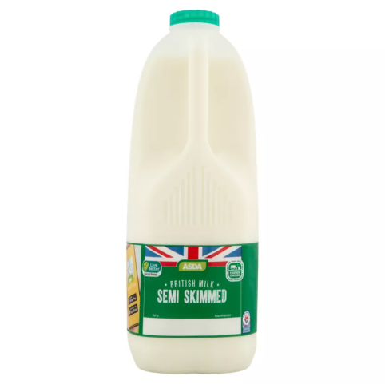 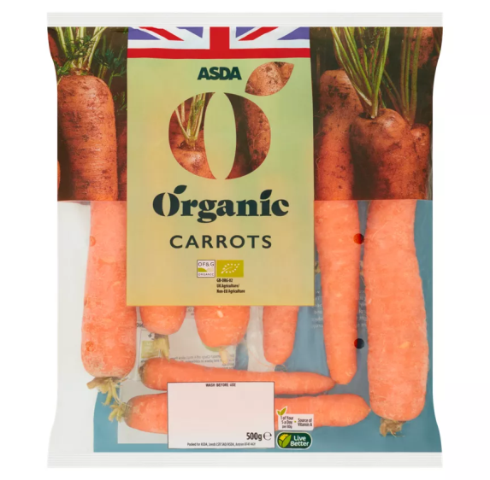 £ 0,70
Figure 7 Figure 8
Asda successfully run the policy to give the lower prices of their products. The last 12 years it runs this policy successfully.
The next element of marketing mix is promotion. According to Bishop (2012) promotion or advertising is a process of getting the product known. There are different ways to promote a product or service. The brand can use social media, TV, radio, special events or discounts, internet advertisement or newspapers. Asda use many techniques to attract their clients. The stores display some low price products in front of the store to grab the attention. The slogan” Saving your money every day” play very important role to keep customer’s attention. The brand use ordinary families to promote their products. Television advertising can reach a huge audience. Sales promotion, which includes a wide assortment of goods attract consumer attention. They use Christmas, New Year, and other holydays for discounts.

Section 7: Conclusion
In conclusion we can say that Asda is in very good position on the market. The PESTEL analyses show that they are favourable for doing successful business. The political situation at the moment is stabile and the social environment is excellent. Asda meet all the criteria elements to keep huge number of clients. The company give low prices and create new products and services to attract new customers. There are pharmacies in most of the stores and fuel stations. This new target strategy is very successful because customers can find everything in one place. The Porters Five Forces also show that the company benefits of many things. The barriers to entry are high and there are less companies which can afford to pay high entry cost. Asda knows their competitors and use different strategies to keep lower prices and keep consumers. Giving loyalty cards and a large amount of products are another strategy which kept customers to do shopping in Asda. The company tries to cover all groups of people. Selling products for each age from babies to old people gave good profit to the company. Also it easily adapt to the new wants and needs of the customers.

Section 8: Recommendations
Although Asda is on the front position on the market we can recommend it: to do research how to keep lower prices during the inflation time in which we are now. The company can ask their customers for feedback to understand better their needs and wants. Asda has to identify the environmental scanning because it will affect the organisation in the future. It is very important because the company will create successful plan to compete on the market. It is very important to track the customer behaviour and create new products and services. If the political, technological or economic situation is change the brand must to change its strategy to keep their customers. It is very important to know the competitors weaknesses and use them as your opportunities. The company has to keep good reputation and strong brand name. The good reputation between suppliers and distributors is very important too. Asda has more than 300 suppliers and farmers. All Asda’s suppliers meet qualitative, quantitative and subjective criteria. All the products are with good quality. Another opportunity for selected company is that their stores are open for long hours and some of stores are open 24 hours and work on Sundays. We can recommend work long hours and have qualified staff. Also to train their workers and give them good salary is very important because it will motivate them. With a good planning and research the company can become on the first position on the UK market.

Referencing list

- Asda (2020) Available at: https://www.asda.com/creating-change-for-better/better-lives/supporting-customer-health/covid-19. (accessed on 15.12.2022)
2. Bishop, T. (2012) Principles of marketing management. World Technologies.
3. Chhabra, S. (2017)’Mutual Fund: Marketing mix and Promotional
Strategies’. Strategic Marketing Management and Tactics in the Service Industry. Chapter 6. pp.13 Available at:Strategic Marketing Management and Tactics in the Service Industry DOI: 10.4018/978-1-5225-2475-5.ch006. (accessed on 15.12.2022)

4. Hooley, G. Nicoulaud, B .Rudd, M.J. Lee, N. (2020) Marketing Strategy and competitive Positioning. 7th Ed. Pearson. pp 56-60.
5. Kotler, T. Ph. Armstrong, G. Harris, C.L.,and He,H. (2019) Principles of Marketing”. Publisher; Pearson Education
6. Lifestyle (2022) “Asda retains title as UK's cheapest online supermarket as inflation reaches record-high” .By Williams, R. 20 October 2022
https://www.dailyrecord.co.uk/lifestyle/food-drink/asda-retains-title-uks-cheapest-28286050.
7. Porter, M.E. (2008). The Five Competitive Forces That Shape Strategy. Harvard Business Review. Available at: https://hbr.org/2008/01/the-five-competitive-forces-that-shape-strategy. (Accessed on 25.12.2022)

8. Quinn, I. (2021).Asda appoints Havas London as new advertising agency. The Grocer. Available at;
Asda appoints Havas London as new advertising agency | News | Accepted on 25.12.2022

Figures

Figure 1
Available at: https://www.iedunote.com/marketing-process .(accessed on 19.12.2022)
Figure 2
Available at: https://i0.wp.com/www.business-to-you.com/wp-content/uploads/2016/12/PESTEL-analysis-updated.png.at (accessed on 20.12.2022)
Figure 3
Available at: http://www.odhq.net/porter%E2%80%99s-five-forces. (accessed at 17.12.2022)

Figure 4
Available at:
https://www.bing.com/images/search?view=detailV2&ccid=vjcYLDoB&id=C1CF6C00535373E62500FD54893EE89D8A2268D7&thid=OIP.vjcYLDoBymzqjZdFY6hh (accessed on 17.12.2022)

Figure 5
Available at: https://www.foodmanufacture.co.uk/Article/2016/01/22/Scottish-food-firms-to-grow-sales-thanks-to-retailer (accessed on 19.12.2022)

Figure 6

Available at:
https://www.alamy.com/toilet-bathroom-cleaning-productsbleach-toilet-duct-in-asda-supermarket-uk-image224106063.html (accessed on 18.12.2022)

Figure 7
Available at:
https://groceries.asda.com/product/semi-skimmed-milk/asda-semi-skimmed-milk/20504?&cmpid=ppc-_-ghs-_--_-google-_--_-dskwid-92700073236333161_dc&s_kwcid=AL!11432!3!623321953439!!!u!294493680380!&gclid=CjwKCAiAkrWdBhBkEiwAZ9cdcPz6eBMgFWzIBd1nNP6Kz9sFm4HJQBdkCIPwHI2aOQhHTy-1PJCjgRoChxcQAvD_BwE&gclsrc=aw.ds (accessed on 27.12.2022)

Figure 8
Available at:
https://groceries.asda.com/product/carrots-root-vegetables/asda-organic-carrots/910003036565 (accessed on 18.12.2022)

