

Digital Skills and Research Methods

Student Name: Nadia Al Jarrah
Student Number: 1714896
MODULE COD: BMSK4003
Module Title: Digital Skills and Research Methods
Module Lecturer’s Name: Balendran Kandasamy

Contents

Contents 1

Introduction 2

Cloud storage 2

Dropbox 3

iCloud 3

Recommendation 4

Smartphones 5

iPhone S8 vs Samsung galaxy S8 5

Recommendation 7

Facebook 8

Facebook, twitter and LinkedIn accounts 9

References 10

Introduction

This report has 3 parts. The first part is to evaluate 2 providers from 2 different technologies. I choose to compare drop box and iCloud from cloud storage technology, and Samsung galaxy S8 with iPhone 8 from smartphones technology, and I will recommend which provider is more suitable for a workplace. In the second part of the report I will explore Facebook as one of the social media technologies and how it will influence the business. The last part of the report will be my Facebook, twitter and LinkedIn account details, showing my online presence.

Cloud storage

Cloud storage is also known as utility storage, it is a cloud computing model, where data is stored on remote servers accessed from the internet. It is managed, maintained, and operated by a cloud storage service provider on a storage server. This technique is built on virtualization.
The data centre virtualization allows cloud storage to work through it, giving end users and applications a virtual storage structure. Cloud storage works through a web-based API that is remotely applied through its interaction with the client application's in-house cloud storage infrastructure for input/output (I/O) and read/write (R/W) operations.
Cloud storage is identified as utility storage once it is delivered through a public service provider. Private cloud storage delivers the same storage mechanism, scalability, and flexibility with non-public or limited access. (Janssen., n.d.)
In more simple words cloud storage is when you access or store your data and programs over the Internet instead of your computer's hard drive.

Dropbox

Dropbox is functioned by the American company Dropbox, Inc. Dropbox is a file hosting service that offers cloud storage, client software, file synchronization, and personal cloud. Dropbox create a special folder on the user's computer, the contents of the files are then synchronized to Dropbox's servers, devices that the user has installed Dropbox on and to other computers. The same file will be kept up-to-date on all devices.
Dropbox operate on a freemium business model. Dropbox users can access a free account with a set storage size, and a paid subscription, that offer additional features and more capacity. The basic users of Dropbox have 2 gigabytes free storage space. Dropbox Plus users will get 1 terabyte of storage space, plus additional features, remote wipe, advanced sharing controls, and an optional Extended Version History add-on.
Dropbox are available on mobile apps for iOS, remote wipe, Android, and Windows Phone smartphones and tablets. As well as on Android, Microsoft Windows, and Linux computers. Dropbox is available for private people or business, anyone can use Dropbox if internet connection is available. (Wikipedia, n.d.)

iCloud

iCloud service is operated by Apple company. Only apple users can store documents, photos, apps, videos, and more and updates everything across users' synced devices. iCloud allows users to save their calendar, address book, notes, Safari browser bookmarks and photos on Apple's servers. The users log in with their Apple ID, once they are signed in, they can make any changes, and the iCloud subscription services will be activated. All devises that uses the same Apple ID are synced together.
Users need an iOS or macOS device to set up iCloud, there after they can inter their accounts on the Apple Watch or Apple TV, other iOS or macOS devices. (Janssen., n.d.)
Basically, iCloud is also a storage system over the internet restricted for Apple users only.

Recommendation

The Dropbox and iCloud are very similar cloud storage system. Both providers allow user to access the system from anywhere if you have internet connection. There is competition between the 2 providers, and a few differences. The different is the iCloud is only for Apple users and that put a limit of use. Dropbox structure is different than iCloud, it does not look as a separate folder. Apple iCloud creates hidden files and folders. The price also is different depends on the storage space.

Storage | Drop Box | Apple iCloud
2GB | Free | –
5GB | Free | Free
15GB | Free | 16 pounds
25GB | Free | 32 pounds
50GB | Free | 80 pounds
100GB | 78 pounds | –
200GB | 156 pounds | –

I prefer Dropbox, as better option for business or workplace in general, especially if need lot of devices running. Dropbox is cheaper if you do not need big storage space, as a business you save money by choosing Dropbox. It is also easy to work with Dropbox than iCloud, the folder structure is simple. Finally, you are not restricted with Dropbox as with iCloud, Apple company allows only users with apple ID to use iCloud.

Smartphones

A smartphone is a cell phone with a computer. Smartphone has web browser, an operating system, and the capability to run several software applications. Added to that you have video chatting, support for biometrics and digital assistants.
The most important feature of the smartphone is the connection to App-store, where you can download or search software applications. The App-store will suggest thousands of Mobil apps, that can be used for gaming, social media, notes, organizer, word program and more. Here are some of the smartphone key features:
- download applications
- internet/Wi-Fi
- memory
- browser
- touchscreen
- several email account to one device
- a hardware or software-based keyboard
- wireless synchronization with other devices
- digital camera with video capability
- Gaming
- GPS
A smartphone has blue tooth, accessories, power charging cables and extra speakers. Smartphones run an OS and applications and has steady software updates. (Anon., 2019)

iPhone S8 vs Samsung galaxy S8

I choose to compare Galaxy s8 and iPhone S8 in a table showing different key features. (Anon., 2019)
Smartphone iPhone s8 Samsung galaxy S8
CPU | Apple A11 Bionic | It has a snapdragon 835
ram | 2 gb ram | 4gb of ram
Graphics card | Apple gpu | It has an adreno 540 gpu
storage | 64/256 configurations | 64 or 128 gb storage configurations
os | iOS 11 | Android 7.0 Nougat
Camera’s | 12MP rear camera and a 7MP front camera | The rear camera is 12mp (MP=mega pixel) and the front facing camera is an 8mp camera
Fingerprint sensor | Fronted mounted finger print sensor | It has a fast front mounted rear finger print sensor
Iris scanner | n/a | It has an iris scanner on the front of the phone
battery | 1821 mAh battery | 3000mAh
charging | Fast charging via apple charger | Fast charging via usb-c
display | 1080p | 1440p
Price + picture of device | 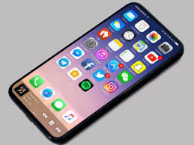  £849 | £799  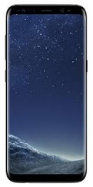

Recommendation

The Samsung galaxy S8 is cheaper in cost, have a bigger display, both phones have good charger. The battery capacity is bigger in the galaxy s8, which means the phone battery will last longer. The camera is also better in the galaxy S8 with 8mp.
Samsung Galaxy S8 runs on Android 7.0 Nougat Os, and has bigger ram up to 4gb, that gives the Samsung galaxy a bigger memory and storage space than the iPhone s8. I would recommend the Samsung Galaxy S8.
Smartphone can be used in business and workplace. With different applications, that can make work easier and faster. You can use Maps to travel from and to work finding you the best and fastest route, this will save you time and efforts.
I use my Galaxy S8 to make a work plan or write a reminder, that will help me to be more organised. Smartphones can also help improve sharing information once working in a team. I will suggest Whatts-App. With this application you can create groups, share pictures or ideas in form of text messages, calls or video calls.
You can also use smartphone for a quick internet search in the browser, find the information you need to complete your work.
The reason I like the Samsung galaxy S8 over the iPhone s8 is that I find it easy to use and you can enjoy more options, it is a better phone for less money. The use of smartphone at the workplace is very practical, the size of it is a pocket size and easy to use.

Facebook

Facebook can be used as business free of charge, but the adds you need to pay for. It is an amazing, marketing and communication tool. Can also be useful for information gathering.
To create a business account is very simple, you need to flow the steps required by Facebook, but first you need to create or have a personal Facebook account. You can create separate ad accounts for each business or client. You must link your personal Facebook account to all Facebook business pages or fan pages. The business account is a free public profile where you can advertise for your business. Facebook can be used for different marketing strategies, follow your competitors and read information.
To summarise here are the important steps:
- Create a personal business presence using a fan page: the most important thing of social media marketing is to create relationships between the businesses and clients.
- Join Facebook groups: Facebook groups creates opportunity for professionals.
- Maintain a robust brand presence: You need to pay to promote your business, but you can post advert on your brand’s page. People can search different information on Facebook about companies, keep you contact information up to date with opening hours. To keep your client engaged you need to maintain an activity on your page by posting new deal, promotion, picture and comments.
- Syndicate your blog: this is an automatic service, that will post each new blog to your Facebook page.
- Create your own group: You can create your own group by simply adding members, posting articles to discuss and create conversation.
- List your events: Create an event page and invite friends and people in the groups you’re in. You can even see how many RSVP and get feedback from attendees.
- Ask your network to share blog posts. You can ask your employees or members to share blogs, that will help you marketing your business.
- Reach out! Check regularly your messages to keep a good communication on your account. You can send message as well to people on Facebook.
- Stream live video with Facebook Live: this is a service where you can communicate with your clients or member and add comment.
- Create a community: Facebook allows you to create a community, where you are free to send messages, engage with people by writing on their walls, respond to the comments on your page, keep groups conversation, or introducing people to each other.
Facebook gives you as a business holder a great opportunity to develop your business, create relationship, promote your business, share information and build a reputation. (Vahl, 2014)
Facebook is not only a great marketing tool, it is also a good communication tool, that connect people together. You are creating a social network that will help you develop your business. (Stearn, 2014)

Facebook, twitter and LinkedIn accounts
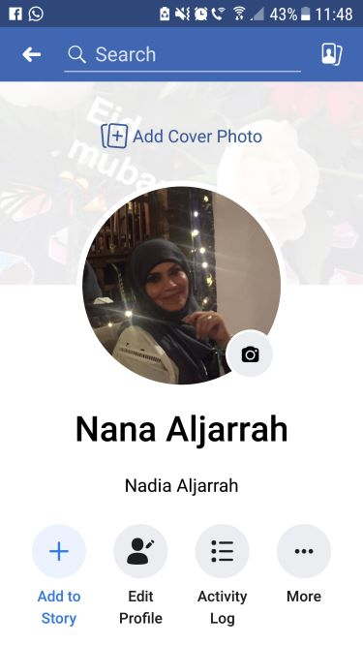
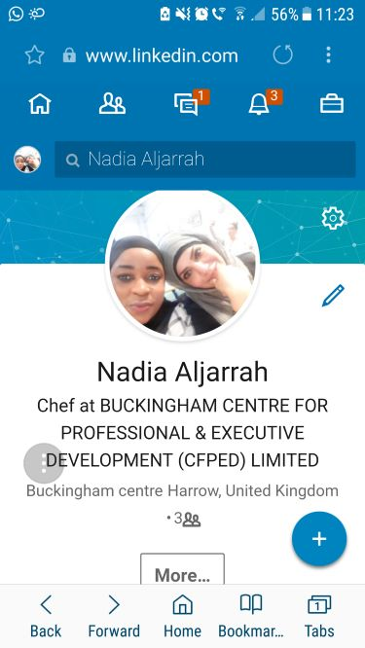

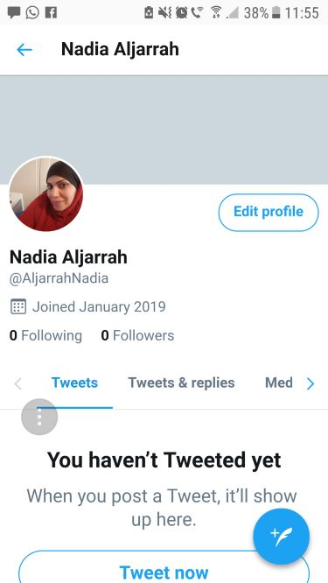

References

Anon., 2019. Gadets now. [Online]
Available at: https://www.gadgetsnow.com/compare-mobile-phones/Apple-iPhone-8-vs-Samsung-Galaxy-S8
[Accessed 09 january 2019].

Anon., 2019. techtarget. [Online]
Available at: https://searchmobilecomputing.techtarget.com/definition/smartphone
[Accessed 07 january 2019].

Janssen., D. a. C., n.d. technopedia. [Online]
Available at: https://www.techopedia.com/definition/26535/cloud-storage
[Accessed 07 january 2019].

Stearn, A., 2014. Make Facebook Work For Your Business. 1st ed. uk: Alex Stearn.

techtarget, n.d. techtarget. [Online]
Available at: https://searchmobilecomputing.techtarget.com/definition/iCloud
[Accessed 07 january 2019].

Vahl, A., 2014. How to Research Your Competition on Facebook, article. [Online]
Available at: https://www.socialmediaexaminer.com/research-competition-on-facebook/#
[Accessed 09 january 2019].

Wikipedia, n.d. Wikipedia, the free encyclopedia. [Online]
Available at: https://en.wikipedia.org/wiki/Dropbox_(service)
[Accessed 07 january 2019].

