
Community Care and Development
(BMHP6022_LON)
Assignment component 2
Poverty and elderly population in Camden

Student: Claudia-Ancuta Dragan
Student nr: 2021166
Lecturer: Jolly Nwankwo

Introduction

This report will cover the following information: what is community and how we can define it and the aim of the project it to raise awareness about elderly community in Camden town and what issues they face, poor housing/homelessness, proverty, safety/ high criminal rate. The topic of this report is the same as Component 1 viva voce.

The report will be focusing on the overview of the community’s main characteristics, demographics, and health and social care needs in Camden town. Will be identify the economic, cultural and social issues and what are the recommendation to make positive change by health promotion and social care activities that had being suggest for the community of Camden.

Definition of the community.
A community is a collection of individuals who share common beliefs, interests, and challenges while coexisting (MacQueen et al. 2001). A community may be defined by the common characteristics of its members, as well as the strength of their relationships. You need a group of individuals who are similar in some manner and share a sense of belonging or interpersonal connection (MacQueen et al. 2001).
Examples of communities: people from ethnic minorities, religious groups, children and elderly, people with disability, homeless or unemployed etc. Those are few examples of communities (GOV.UK 2024).

Camden town
Camde is inner borough of London, is a unique place in London known for amazing shopping, food, and music centre. People can enjoy the tour of Camden Market and explore the neighbourhood of alternative lifestyle. Camden give easy access to tree very important train stations: Euston, King’s Cross, St Pancras
Cultural Diversity
The 2021 Census shows that Black Africans are the largest minority ethnic group in seven Camden wards, followed by Bangladeshis in six, Chinese in one, and Indians, making the town to be culturally diverse (How life has changed in Camden: Census 2021). The population Camden town, 218,000 residents at Mid-2021-2022 the average age in Camden town is 25-35 years old (How life has changed in Camden: Census 2021). The town is attracting the young generation to come to live, work or visit but the living cost and livings conditions are not grate for an elderly person (Older 2019). Elderly population is at risk to face being homeless and they may struggle with affording paying rent, energy bills, medication, or food. Often elderly are vulnerable to being abuse (economic, mental, and physical, neglect, etc.) (Older 2019). According with GOV UK statistics, rough sleeping in England had incise in 2023 by 27% since 2022.

Classification | Percentage in Camden
85 years and over | 1.5%
75 to 84 years | 3.9%
65 to 74 years | 6.5%
50 to 64 years | 16.3%

Religions date
Camden is not just culturally diverse but here we can fine people with diverse religions and believes, according with the statistics, may people have no religions/atheists, the most practiced religion is Christian (Demographic Databook | Open Data Portal 2023).
- had no religion 35%,
- Christian 31%,
- Muslim 16%,
- Jewish 5%,
- Hindu 2%,
- Buddhist 1%,
- no stated 9%. (Demographic Databook | Open Data Portal 2023).

Main issues in Camden town
Poor housing
The main issues in Camden town are the poor housing, Camden council had received many complains. Many houses, care homes have been without heat and hot water. The older population of Camden had faced the cold season without having a warm place to live, they have difficulty paying for the heat, electricity, and hot water. Or they live in a hose with an old heat system that is not working properly, and they can’t afford to change it (Salcombe Lodge 2023).
Poverty
Camden is good place for businesses and nightlife but is one of the most expensive boroughs of London live. According with AgeUK 46% of elderly of London are living in property in social hosing, and the number of people or 50 years old that face property has increased by 5% in past few years ( AgeUK 2023).
High criminal rate
Camden is in top 10 most dangerous borough in London the criminal rate in 2023 was 118 crime per 1000 people. The most common crime is theft, sexual violence, drugs anti-social behaviour and at last possession of weapons (Camden Crime and Safety Statistics 2024).
‌Support for the community development
To make Camden town a place when people from the community can come together and live in harmony, the government, council, and the people they have to work together towards improving of the community (GOV.UK 2017). Is important involve people in try engaging to the community development, to promote prevention and holistic approach and to empower the community to make decision for a good outcome. Involving everyone, families, government services, businesses and many different stakeholders is crucial for progression and development of the community(GOV.UK 2017)..

Stakeholders involved in the program.

- Camden town council
- Government
- Supports workers/NHS
- Charity's ( AgeUK)
- Community
- Social prescriber team

To lower the rate of property, homelessness and the criminal rate stakeholders need to be involved in the process. St8arting with Camden town council and Government agencies to imply new policies rules and strategies for the safety and improvement of the community. NHS, charities, and the community to work together and support people in needs and ensure they have all the support they need according with everyone unique situation (NHS England, 2023). Social prescriber team work is very important, they are the key of ‘’component of universal care ‘’ they approach is to connect people to socialise and improve health and wellbeing (NHS England, 2023).

Use of digital media and technologies for community development

Today everything is based on using of digital media and technology. We use different type of technology from the moment we weak up until bedtime. Technologies are a important part of our life and can be use in communication promoting, educating and support everyone (Wakefield, 2020).. Can by sometime difficult for elderly to adapt to the new technology’s but with support from people and community they can adapt.
Digital media can be used to raise awareness about the issues Camden town face by radio and tv news. Or educational videos or text share use online platforms Facebook, Instagram, ect (Wakefield, 2020).

Maslow’s Hierarchy of Needs 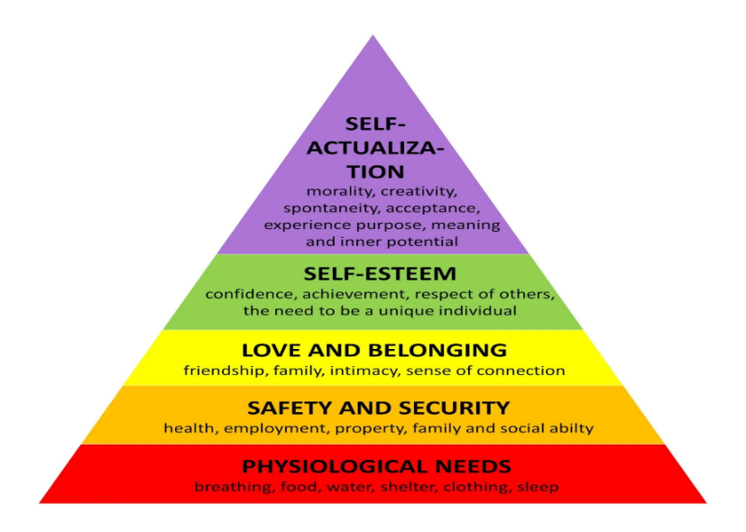
(McLeod 2024)

Poverty in Camden town is affecting the life of elderly. They will be at the life stage when the basic need can be achieved by themselves.
Ex. Being homeless, lonely, financier straggles, sickness.

The most important level from the pyramid is the third love and belonging , having family, an friends , people that care about us in the most important need somebody need to archive because is the only need we can’t archive alone ,any others need to we can archive or we can archive or not because depending on the life stage those need can be provide to as by somebody else (McLeod 2024)
.

legislation and policy impact the support and growth of a community.
UK authorities are working towards creating legislation to lower the number of homeless and reduce the high criminal rate. Equality Act 2010 -to stop any type of discrimination and promoting equality. Homes (Fitness for Human Habitation) Act 2018 – any issues related with housing, poor housing facility. Human Rights Act 1998 -respecting people right The Homelessness Reduction Act 2017 – the act was created to prevent and help homeless people. Safeguarding Vulnerable Groups Act 2006, was made to help in preventing harm or risk by stopping people that cab hurt others (Legislation.gov.uk, 2017).

Barriers/obstacles to community development

Inefficient funds from the government is the most commune barriers in the community’s . The government can’t afford to finance and provide better and enough housing facilities for everyone. Government is aware about these issues and is trying to come with solution to address this problem (Government Digital Service, 2011).

Not enough council houses for provide for the elderly homeless. In Camden town and every where in Uk the number of homeless people had incise and the government can’t accommodate everyone. The waiting list can be long and waiting months or years to have a house from the council and still not guaranteed a place to live (Government Digital Service, 2011).

Recommendations
Implementing prevention programmes to address root causes of homelessness, developing early intervention services to identify and support at-risk youth, increasing affordable housing options, providing education and employment support, and offering wraparound services to address complex needs are among the recommendations.
May be impossible to end the poverty but are many actions that can be taken to support the elderly population.

Increase uptake levels of Pension Credit will help elderly to afford a better life style and to don’t be worried about affording rent, food, medication, etc.

Food bank is a great idea a meal for homeless or foe people when they can afford food.
Provide accommodation to the elderly in need and protect them. Community support can come together and help people in needs.

Conclusion

Poverty is a big issue and can affect all the population, elderly face hardship because of the age, sickness and loneliness,
The local authorities, communities and family to support and care for the elderly
Theories like Maslow's Hierarchy of Needs and Attachment Theory are highly helpful to understand how dysfunctional family and social situations can impact the elderly.
Addressing juvenile homelessness involves a diverse strategy that includes coordination among government agencies, local governments, charities, community organisations, and young people. This strategy should prioritise prevention, early intervention, and comprehensive support services that are customised to the different needs of homeless kids. Safe housing, access to school and career possibilities, mental health assistance, and advocacy for homeless youth rights are all critical components of any successful plan.

Reference
AgeUK 2023: Almost a quarter of older Londoners are living in poverty n.d., Camden.
https://www.ageuk.org.uk/camden/about-us/news/2023/almost-a-quarter-of-older-londoners-are-living-in-poverty/ Accessed 20 April 2024
Camden Crime and Safety Statistics 2024. https://crimerate.co.uk/london/camden Updated 08 Apr 2024. Accessed 21 April 2024

Demographic Databook 2023 | Open Data Portal n.d., opendata.camden.gov.uk, viewed 24 March 2024, <https://opendata.camden.gov.uk/People-Places/Demographic-Databook/jif6-mgz6/about_data>. Last update 18 December 2023
‌GOV.UK. (n.d.). Health matters: community-centred approaches for health and wellbeing. [online] Available at: https://www.gov.uk/government/publications/health-matters-health-and-wellbeing-community-centred-approaches/health-matters-community-centred-approaches-for-health-and-wellbeing#why-work-with-communities. Accessed 12 April 2024
GOV.UK 2017, Community development handbook, GOV.UK. https://www.gov.uk/government/publications/community-development-handbook/community-development-handbook Accessed 21 April 2024
Government Digital Service (2011). Council housing. [online] GOV.UK. Available at: https://www.gov.uk/council-housing. 20 April 2024
‌

How life has changed in Camden: Census 2021 n.d., sveltekit-prerender. https://www.ons.gov.uk/visualisations/censusareachanges/E09000007/ Accessed 10 April 2024

MacQueen, KM, McLellan, E, Metzger, DS, Kegeles, S, Strauss, RP, Scotti, R, Blanchard, L & Trotter, RT 2001, ‘What Is community? an evidence-based Definition for Participatory Public Health’, American Journal of Public Health, vol. 91, © American Journal of Public Health 2001, no. 12, pp. 1929–38. Accessed 12 April 2024
Merriam-Webster 2019, Definition of COMMUNITY, Merriam-Webster Accessed 29 March 2024
Legislation.gov.uk. (2017). Homelessness Reduction Act 2017. Available at: https://www.legislation.gov.uk/ukpga/2017/13/contents. Accessed: 15 April 2024

Rough sleeping snapshot in England: autumn 2023 2024, GOV.UK. https://www.gov.uk/government/statistics/rough-sleeping-snapshot-in-england-autumn-2023/rough-sleeping-snapshot-in-england-autumn-2023. Accessed 16 April 2024
NHS England (2023). Social Prescribing. [online] NHS England. Available at: https://www.england.nhs.uk/personalisedcare/social-prescribing/. Accessed 24 April 2024

Older 2019, Policy Position Paper.
‌ https://www.ageuk.org.uk/globalassets/age-uk/documents/policy-positions/housing-and-homes/ppp_older_homelessness_england. Accessed 12 April 2024
Salcombe Lodge: Elderly left without hot water or heating after boiler bungle 2023, Camden New Journal, , <https://www.camdennewjournal.co.uk/article/salcombe-lodge-elderly-left-without-hot-water-or-heating-after-boiler-bungle>. Accessed 15 April 2024
Wakefield, MA, Loken, B & Hornik, RC 2020, ‘Use of Mass Media Campaigns to Change Health Behaviour’, The Lancet, vol. 376, no. 9748, pp. 1261–1271. https://www.ncbi.nlm.nih.gov/pmc/articles/PMC4248563/ Accessed 22 April 2024
‌

