

Cover Page

Name: Patient Mohamed
Student number: 2332011
Changemakers: Building your personal brand for sustainable employment
BMHP5015_BIRM
Lectures name: Tsiwani Khumalo

Task 1 – Personal Brand
Personal branding is a way of promoting your own skills and values to make yourself different from others. This will help you stand out from other candidates when applying for a job (Gorbatov, Khapova & Lysova, 2018). My employment goal is to become a social worker with the Children's Trust and the NHS.
My current personal brand reflects good listening, detail-oriented, compassionate, and empathetic. I am known for working hard, persevering and always helping others.
I have a good teamwork skill and communication skill as I developed this skill during a group presentation last term, in the group we were 4, but at the last minute one of the members said that they would not be able to attend the presentation so 3 of us we reorganised the work, the communication and teamwork was effective making us the 3rd group with the best scores.
My Unique Selling Point (USP) is my ability to be patience, calm in stressful situations, I have good communication skills and a good active listener. I developed those skills through my experience in a nursery, as my college offered me the opportunity to participate in a work experience program for three weeks. I also have an Aid certificate, dementia bus certificate, good IT skills, and I also speak three languages.
My target audience includes Employers, recruitment agencies, the NHS, other companies and the Children’s Trust Company.
My action plan will be improving and preparing my CV, it will be more detailed and create a few cover letters for different jobs, I would also update my LinkedIn profile with more up-to-date information, such as my education, employment status, experience and more. Another action plan would be attending workshops and training to create professional relationships.
I will be using the SMART method, Chartered Management Institute (2020) to explain my action plan to get my dream job.
(S) I will start improving my CV and making sure that my CV is up to date to give me more chances to get a better job. (M) After making improvements to my CV, I plan to start applying for a social work assistant in the Children’s Trust website and the NHS website. I will be applying to 5 jobs on each website every 3 days.
(A) To support my goal, I will also attend any career event in Birmingham, and I will also update my LinkedIn profile. (R) My goals will be achievable, as it requires me to improve my CV, attend careers events, as networking is a way I can find a job by meeting people, National Career Service (2026). (T) In 2 weeks, I will start improving my CV, and in 4 weeks, I will attend a career event in Birmingham.

Task 2 - Network Map and Rationale
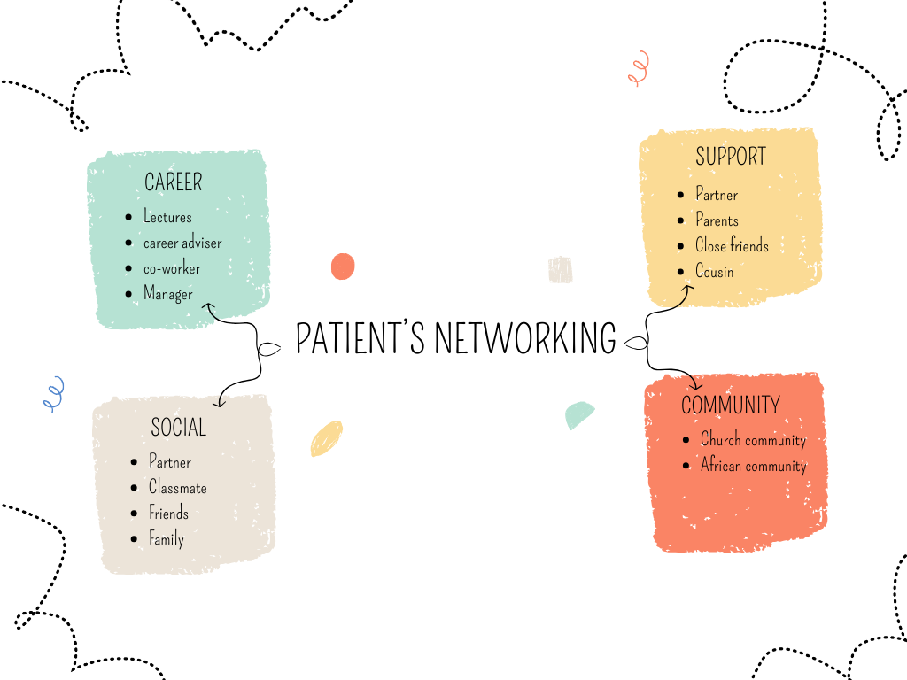
(Canva)

As you can see in the image, those are my networking
My Career network is formed by Lecturers, Career advisers, co-workers and my manager, as they provide me with advice about my career and my future goals.
My social media networking is LinkedIn, Instagram, Facebook and Tik Tok. Those platforms help me as they notify me when there's any vacancy for a job I would love to work, the platforms also help me to sell and promote my personal brand and expand my career networking.
My support network is my partner, my parent, my close friend and my cousin, as they provide me with all the support I need to achieve my goals, they support me unconditionally, no matter what.
My community network will be the church community and the Green Party community. I’ve learned a lot from being part of those communities, and they have also supported me. I have learned skills such as being compassionate, having a good understanding of people's feelings and opinions, good communication, and problem-solving.
The benefits of networking are that it will help you find jobs, apprenticeship and training opportunities, you can also learn new skills and career opportunities and offer opportunities from other companies. You can also receive advice from people who are more experienced in the field (National Career Service, 2026).

Task 3- Blog
The pressure to be perfect: social media and eating disorders in teen girls.
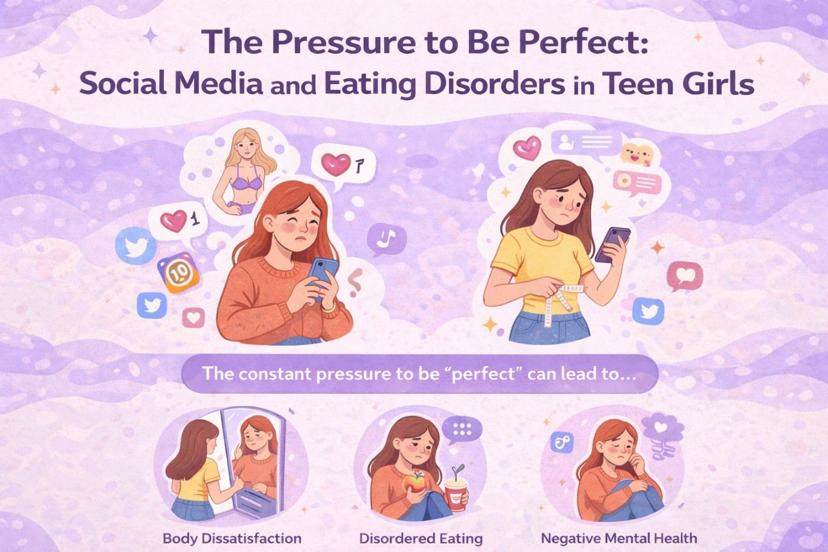 (Canva)

Introduction
The rate of eating disorders in adolescent girls is increasing worryingly, as in 2017, the rate of adolescent girls aged 17 to 19 was 60.5 per cent. However, in 2023, it increased to 77.5 per cent (NHS England, 2023). Social media is affecting adolescent girls' lives as influencers are causing adolescents to develop bad eating habits, such as not eating, or seeing themselves as “ugly” or “too fat”, affecting their self-esteem (Suhag and Rauniyar, 2024).
Social media platforms are mostly used by adolescents, exposing them to “unrealistic bodies”, causing teen girls to develop eating disorders as they are concerned about their body image, causing them to have unhealthy eating behaviours. According to the Mental Health Foundation (2026) survey, 56% of girls said that images on social media caused them to be worried about their appearance.
What's an eating disorder? According to Nawaz et al. (2026), eating disorders “are a group of mental illnesses” and they can affect mental health. Eating disorders (ED) are more common in adolescent girls; however, they can affect any age range and any gender but are more common in girls. Eating disorders include limiting the amount of food, not eating at all, and eating too much or causing themselves to vomit to get rid of the food. Beat eating disorder
What can be done:
Professionals and families should work together to provide the right support for girls with eating disorders by talking to the patient, encouraging the patient to eat and discuss safe diets and exercises, encourage positive image, which will help the teen to change their mindset and feel more secure with themselves, (Suhag and Rauniyar, 2024).
Conclusion:
In conclusion, adolescent girls who suffer from an eating disorder (ED) should receive more support from families and professionals. Social media platforms such as Instagram, TikTok, and Facebook images are not always real. If you feel that someone needs help or they feel complex about their body, support them, she may need a positive environment

Task 4- NHS Equality, Diversity and Inclusion Quiz

1. What is the primary goal of the NHS Equality, Diversity, and Inclusion Improvement Plan?
The primary goal of the NHS EDI is to upgrade the quality of jobs in the workplace by improving equality, diversity and inclusion, referring to the nine protected characteristics from the Equality Act 2010 (NHS, 2023).
2. How does the NHS EDI Improvement Plan propose to tackle the gender pay gap?
The NHS EDI plan to tackle the gender pay gap by analysing the data to understand and study pay gaps by protected characteristic, then create an improvement plan. The plan will be controlled and monitored by the NHS. Another solution will be implementing a” flexible working policy” (NHS, 2023).
3. What is meant by the term ‘intersectionality’ as used in the NHS EDI Improvement Plan?
Intersectionality refers to the understanding that inclusion should be improved, as in a workplace, staff members may face any type of discrimination (NHS, 2023).
4. Why is it important for the NHS to create a psychologically safe work environment?
It is important for the NHS as it makes people feel that they are respected and treated equally in their workplace (NHS, 2023).
5. How does the NHS EDI Improvement Plan suggest improving the experience of internationally recruited staff?
The NHS EDI suggest improving the experience of internationally recruited staff by making sure that the employee has received clear communication, guidance and support. An example will be the guidance of the Home Office immigration policy and more. They also need to respect the employee's background and religion, following the nine protected characteristics (NHS, 2023).
6. What role does leadership play in advancing EDI objectives according to the NHS Improvement Plan?
Leadership plays an important role as it empowers the staff to provide the best care to the patients and makes them have a good experience. It also improves diversity, (NHS, 2023).
7. Identify one way the NHS EDI Improvement Plan aims to reduce health inequalities within the workforce.
One way the NHS ESI Improvement Plan aims to reduce health inequalities is by reducing bullying in the workforce; the organisation will be offering employment opportunities and career development opportunities (NHS, 2023).
8. Why does the NHS EDI Improvement Plan emphasise the importance of collecting and analysing data on protected characteristics?
It emphasises the importance of collecting and analysing data on protected characteristics, as it helps the NHS analyse and understand how individuals' experiences in the workforce can be improved. It also helps the NHS monitor any progress made (NHS, 2023).
9. Explain how flexible working policies can contribute to equality and inclusion in the NHS workforce.
Flexible working policies support workers with special needs and people who have limited access, as it makes the job more accessible (NHS, 2023).
10. What is one strategy mentioned in the NHS EDI Improvement Plan to combat bullying and harassment in the workplace?
One strategy mentioned is that they will provide psychological support for all individuals who have suffered any type of discrimination, bullying, violence or harassment and have been reported (NHS, 2023).

Task 5- A Letter to Yourself
39 West Street
Birmingham
B10 9PY

Dear younger me,
I know that right now you feel lonely and lost, you thought that level 4 at the University would be an impossible challenge and that you wouldn't know anyone. I know you're embarrassed to answer in class, even knowing the answer and that assignments are something new for you and too long. I know how much you are suffering alone and in silence, feeling that what you feel is nonsense or an exaggeration, you feel that you can't trust anyone and least of all your family.
I would have loved you to know more about emotional intelligence and resilience. Now I understand it more, and I'm learning every day without giving up. I would love you to know that you don't have to be afraid to ask for help and that your classmates and teachers will always be there to help and support you. I know you are very embarrassed, but seriously, once you understand what emotional intelligence is, you will see life differently.
If you had developed emotional intelligence, you would understand that your feelings are not nonsense or an exaggeration, that with constancy and consistency you could fulfil any challenge you set out to do, and you would know how to handle your feelings.
If at the time you had what’s resilience, you would have known how to adapt to new and difficult situations, and you would understand that everything goes in its time and that you should not be in a hurry, you would also understand that not everything will go as you have planned, but it does not mean that you are a disaster person.
I advise you to learn more about emotional intelligence, since that will help you a lot to be more extroverted, and you could build confidence at the same time. Never give up on your dreams.
Best wishes to my younger me.
With love
Patient.

Task 6- GANTT Chart
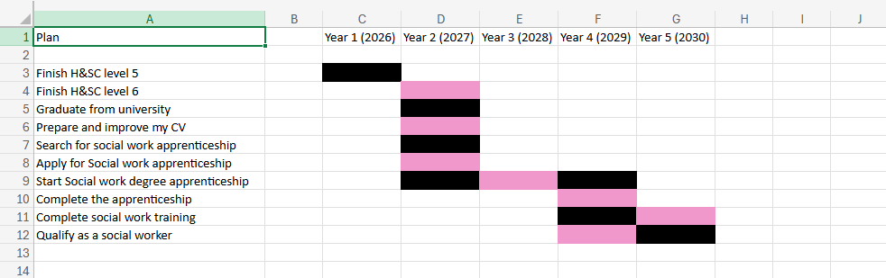

This Gantt chart shows my plan to become a social worker. As you can see, my plan for the first year is to complete and pass my level 5 in health and social care,
For the second year, I plan to complete and pass my level 6 in health and social care and graduate from this course. After completing my level 6, I plan to improve my CV and prepare it to make it suitable for my future jobs. In this case, I plan to become a social worker, but first, I need to start looking for a social work degree apprenticeship. After finding an apprenticeship, I will need to apply and wait for the company’s response. In the 2nd year, I will start my social work apprenticeship and finish it in the 4th year. In the 4th year, I will also complete the training required to become a social worker, and finally, by the 4th and 5th years, I will be qualified to become a social worker.

Task 7- Making Changes- Report

For this report, I will be using the Lewin's Change model.
As a manager of a care home, I need to make sure that the staff are properly trained, to improve the patients’ experience in our care home, I will be implementing online staff training. I will use the fishbone model to identify the problem, Kumah et al. (2024) as the fishbone model help analysing the root of the problem.
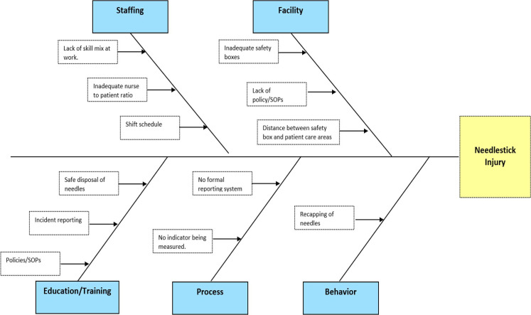
(Kumah et al. 2024)

To achieve this goal, I will be using the Lewins three stages change model (Hussain et al. 2018).

In the unfreeze stage, I will gather the staff in a meeting and convince the team that the change is needed as it’s a challenge that most of the staff needs up to date training, as there is new information regarding some treatments. I will try to convince the team and make it easy for them by making the training to be online instead of in person, and the training will be every two months. There may be some challenges, as not everyone knows how to use a laptop and find it difficult to use it, Neoma Toersen, (2026), but in person training will be provided for those who don’t know how to use a laptop.
For the Change stage, I will start with a pilot study to see how it goes and monitor the staff's progress during the online training, then ask the staff who are participating to provide feedback to see if the training needs any improvement before providing the training to the rest of the team.
Then, finally, the Refreeze stage. For this stage, all the staff members will gain access to the training online, and those who need training on how to use a computer/laptop will receive it in person. The necessary skills needed for this change will be good communication, its skills and time management.

Task 8- Self-Reflection
For this task, self-reflection, I will be using the Gibbs reflection cycle, McLeod (2025)
Description- During this module, I’ve learned about my personal branding and how networking is helpful when searching for a better job.
Feeling: This module helped me realise how valuable I am as a person, as digging in more about who I am and what makes me different from others, it made me feel unique.
Evaluation: This module also helped me know what areas of myself need improvement and what steps I need to take to achieve my goals.
Analysis: I now know that in order to achieve my dream job, I need to expand my networking by attending career events or fires to achieve my goals and get my dream job.
Conclusion: In conclusion, this module helped me understand how important networking and building my personal brand are. I will use what I have learned in this module to get my dream job.
Action plan: My action plan will be improving my CV as I now know more about myself and my capacity, and I will also expand my networking, edit my LinkedIn profile and attend Jobs fair in Birmingham or around.

Reference List:

Beat eating disorders (2026) Types of eating disorder. Available at: https://www.beateatingdisorders.org.uk/get-information-and-support/about-eating-disorders/types/ ( Accessed date: 11 March 2026)
Chartered Management Institute (2020) Setting SMART objectives (Checklist 231). Available at: https://www.managers.org.uk/wp-content/uploads/2020/03/CHK-231-Setting_Smart_Objectives.pdf (Accessed date: 6 February 2026)
Gorbatov, S,. Khapova, S,. & Lysova, E. (2018) Personal Branding: Interdiciplinary systematic revew and research agenda. Available at: https://www.frontiersin.org/journals/psychology/articles/10.3389/fpsyg.2018.02238/full (Accessed date: 13 March 2026)
Hussain,S,. Lei,S,. Akram,T,. Haider,M,. Hussain,S,. & Ali,M. (2018) Kurt Lewin’s change model: A critical review of the role of leadership and employee involvement in organisational change. Journal of innovation & knowledge, 3(3), pp. 123-127. Available at: https://www.sciencedirect.com/science/article/pii/S2444569X16300087 (Accessed date: 12 March 2026)
Kumah, A,. Nwogu, C,. Issah, A,. Obot, E,. Kanamitie,D,. Sifa, J,. & Aidoo, L. (2024) Cause-and-Effect (Fishbone) Diagram: A tool for generating and organizing quality improvement ideas. Available at: https://pmc.ncbi.nlm.nih.gov/articles/PMC11077513/ ( Accessed date: 16 March 2026)
Mental Health Foundation (2026) Body image in childhood. Available at: https://www.mentalhealth.org.uk/explore-mental-health/articles/body-image-report-executive-summary/body-image-childhood ( Accessed date: 11 March 2026)
McLeod, S. (2025) Gibbs Reflective Cycle. Available at: https://www.simplypsychology.org/gibbs-reflective-cycle.html ( Accessed date: 11 March 2026)
National Careers Service (n.d.) Networking. Available at: https://nationalcareers.service.gov.uk/careers-advice/networking ( Accessed date: 7 February 2026)
NHS (2023) NHS equality, diversity, and inclusion improvement plan. Available at: https://www.england.nhs.uk/long-read/nhs-equality-diversity-and-inclusion-improvement-plan/#introduction ( Accessed date: 8 March 2026)
NHS (2023) Mental health of children and young people in England, 2023- wave 4. Available at: https://digital.nhs.uk/data-and-information/publications/statistical/mental-health-of-children-and-young-people-in-england/2023-wave-4-follow-up/part-5-eating-problems-and-disorders ( Accessed date: 11 March 2026)
Nawaz, F,. Riaz, M,. Banday, N,. Singh, A,. Derby, H,. Arshad, Z & Sultan, M. (2024) Social media use among adolescents with eating disorders: a double-edged sword. Available at: https://www.frontiersin.org/journals/psychiatry/articles/10.3389/fpsyt.2024.1300182/full ( Accessed date: 11 March 2026)
Suhag, K,. Rauniyar, S. (2024) Social media effects regarding eating disorders and body image in young adolescents. Available at: https://assets.cureus.com/uploads/review_article/pdf/184476/20240724-319105-hdazlp.pdf ( Accessed date: 11 March 2026)
Toersen, N. (2026) Common problems with care home software and how to avoid them. Available at: https://www.theaccessgroup.com/en-gb/blog/hsc-common-problems-with-care-home-software-and-how-to-avoid-them/ ( Accessed date: 12 March 2026)

