Appendices

Appendix 1: Copy of Approved Ethics Form

APPLICATION FOR ETHICAL APPROVAL

In order for research to result in benefit and minimise risk of harm, it must be conducted ethically. A researcher may not be covered by the University’s insurance if ethical approval has not been obtained prior to commencement.

The University follows the OECD Frascati manual definition of research activity: “creative work undertaken on a systematic basis in order to increase the stock of knowledge, including knowledge of man, culture and society, and the use of this stock of knowledge to devise new applications”. As such this covers activities undertaken by members of staff, postgraduate research students, and both taught postgraduate and undergraduate students working on dissertations/projects.

The individual undertaking the research activity is known as the “principal researcher”.
Ethical approval is not required for routine audits, performance reviews, quality assurance studies, testing within normal educational requirements, and literary or artistic criticism.

This form must be completed and approved prior to undertaking any research activity. Please see Checklist for details of process for different categories of application.

SECTION A: About You (Principal Researcher)
Full Name: |  | Alice Brown
Tick all boxes which apply: |  | Member of staff: | ☐ | Honorary research fellow: | ☐
Undergraduate Student | ☒ | Taught Postgraduate Student | ☐ | Postgraduate Research Student | ☐

Faculty/School/Centre: | ITE: Yr Athrofa, UWTSD
Campus: | Carmarthen
E-mail address: | 1701466@student.uwtsd.ac.uk
Contact Telephone Number: | 07960061977
For students:
Student Number: | 1701466
Programme of Study: | BA Primary Education (QTS)
Director of Studies/Supervisor: | Dr Sioned V Hughes

SECTION B: Approval for Research Activity
Has the research activity received approval in principle?  (please check the Guidance Notes as to the appropriate approval process for different levels of research by different categories of individual) |  | YES | ☒ | NO | ☐
 |  |  |  | Date
If Yes, please indicate source of approval (and date where known): Approval in principle must be obtained from the relevant source prior to seeking ethical approval | Research Degrees Committee |  | ☐
 | Faculty Research Committee |  | ☐
 | Other: Module Lead |  | ☒ | 06.02.2020

SECTION C: Internal and External Ethical Guidance Materials
Please list the core ethical guidance documents that have been referred to during the completion of this form (including any discipline-specific codes of research ethics, and also any specific ethical guidance relating to the proposed methodology). Please tick to confirm that your research proposal adheres to these codes and guidelines.
UWTSD Research Ethics & Integrity Code of Practice | ☒
UWTSD Research Data Management Policy | ☒
BERA (British Educational Research Association) guidelines- Ethical Guidelines for Educational Research (2018) | ☒
The research is within the bounds of the normal classroom and in accordance with the Athrofa guidelines for parental consent as per Athrofa letter | ☒
Education Workforce Council (EWC) Research and Ethics Guidelines (2019) | ☒

SECTION D: External Collaborative Research Activity
Does the research activity involve collaborators outside of the University? |  | YES | ☐ | NO | ☒
If Yes, please provide the name of the external organisation and name and contact details for the main contact person and confirmation this person has consented to their personal data being shared.as part of this collaboration.
Institution
Contact person name
Contact person e-mail address

Has this individual consented to sharing their details on this form? |  | YES | ☐ | NO |  |  | ☒
Are you in receipt of a KESS scholarship? |  | YES | ☐ | NO |  |  | ☒
Is your research externally funded |  | YES | ☐ | NO |  |  | ☒
Are you specifically employed to undertake this research in either a paid or voluntary capacity? | Voluntary | YES | ☐ | NO |  | ☒
 | Employed | YES | ☐ | NO |  | ☒
Is the research being undertaken within an existing UWTSD Athrofa Professional Learning Partnership (APLP) | If YES then the permission question below does not need to be answered. | YES | ☒ | NO |  |  | ☐
Permission to undertake the research has been provided by the partner organisation | (If YES attach copy)  If NO the application cannot continue | YES | ☐ | NO |  |  | ☐

Where research activity is carried out in collaboration with an external organisation
Does this organisation have its own ethics approval system? | YES | ☐ | NO | ☒
If Yes, please attach a copy of any final approval (or interim approval) from the organisation

SECTION E: Details of Research Activity
Indicative title: | An exploration of classroom and behaviour management within a special needs school.
Proposed start date: | 10.02.2020 | Proposed end date: | 01.07.2020
Introduction to the Research (maximum 300 words)
Ensure that you write for a Non-Specialist Audience when outlining your response to the three points below:
- Purpose of Research Activity
- Proposed Research Question
- Aims of Research Activity
- Objectives of Research Activity
Demonstrate, briefly, how Existing Research has informed the proposed activity and explain
- What the research activity will add to the body of knowledge
- How it addresses an area of importance.
Purpose of Research Activity

The purpose of the research activity is to explore how behaviour and classroom management is managed within a special needs school and to use this research and experience to develop my professional knowledge and understanding to inform future practice.

(this box should expand as you type)
Research Question

An exploration of classroom and behaviour management within a special needs school.

- Approaches to Classroom Control within a special needs school.
- How do methods of communication impact classroom and behaviour management?
- What resources are available to support children with BESD?

(this box should expand as you type)
Aims of Research Activity

Behaviour and classroom management is fundamental to ensure that students are not only safe, but also to ensure that interruptions to learning by preventable incidents are minimised (Estyn, 2014). Students who experience barriers to education such as communication difficulties or differences, or poor emotion regulation can present their frustrations through behavioural outbursts (Estyn, 2014; Dean, 2009). These barriers are manageable through behaviour and classroom management techniques (Dean, 2009; Peer and Reid, 2012).

The research project intends to explore some of the approaches to classroom and behaviour management within a special needs school. Furthermore, the research project will explore the affect that these approaches have upon the students, including their progression and attitude towards learning, and the general organisation of classroom practice.

The overriding aim of this research project is to develop my professional knowledge and understanding of educational matters that can influence my future practice, which is supported by the Teaching Standards for Wales (Welsh Government, 2017).
(this box should expand as you type)
Objectives of Research Activity

Observations of general classroom practice will be undertaken to identify and explore classroom practice. Supporting these observations, interviews and questionnaires may be used to provide insight into the theoretical reasoning behind the use of certain strategies or approaches. Samples of work, learning walks and other means of evidence gathering may be used to provide contextual reasoning behind the use of certain approaches to classroom and behaviour management, or support comparison between practice across the school.

(this box should expand as you type)
Proposed methods (maximum 600 words)
Provide a brief summary of all the methods that may be used in the research activity, making it clear what specific techniques may be used. If methods other than those listed in this section are deemed appropriate later, additional ethical approval for those methods will be needed.
Observations:
I will observe and make notes upon the approaches to behaviour and classroom management. Through these observations, I will note apparent effect upon the students, the students’ responses to the techniques used and any perceived impact upon learning (both immediate and delayed impact). At times, I may observe a whole class, intervention/support groups or individual students and staff. At times, I may observe different teachers’ pedagogical approaches to classroom and behaviour management with different students and cohorts. This is to ensure that the breadth of the research question is explored. To further explore the research question, I may discuss observations or notes with a participant (staff or student, where appropriate) to gather greater detail or explanation of approaches or techniques used.

Where possible, observations will be made on a laptop, but an observational notebook may also be used at appropriate times. No names will be used within any notes, instead a pseudonym may be used if needed.

Audio/video taping:
With permission granted by the school and the involved individuals, video or audio taping may be used to support this research project. Video or audio taping may be used during group or individual interviews and used to enhance my discussion of the research question. Photographic evidence may be collected. To comply with ethical and safeguarding guidelines, a discussion with relevant staff will occur to identify any students or staff who cannot be photographed, and any staff or student can refuse having their photograph taken at any point. Recording of good practice or interviews with staff may be gathered and used to support the research project. This will only take place with direct permission from the school and involved staff members.

Learning Walks:
To support the research project, a learning walk to explore, observe and identify aspects of classroom and behaviour management throughout the whole or part of the school may take place. These learning walks could be self-directed or led by staff and/or students. Evidence from the learning walk may include video and/or photographic evidence or observational notes. Prior to gathering the evidence in any format, permission will be obtained from appropriate staff and involved participants.

Examples of work:
At times, an example of staff or student work may be the best piece of evidence supporting an aspect of classroom or behaviour management. In these cases, permission from the owner of the work and the student’s class teacher will be obtained. To comply with confidentiality agreements, and safeguarding guidelines, any names and/or personal information will be removed or redacted from any copies of work used to support the research projects before it is used in the project.

Questionnaires:
A questionnaire may be used to gather a greater range of responses. These questionnaires would involve staff within the school. Any individuals involved in a questionnaire will be informed that the questionnaire is anonymous and voluntary. Participants will be aware that they can withdraw at any point up to submission of their answers, at which point there is no means of discerning which response is theirs. Participants will be encouraged to avoid including any personal information, names of children or other sensitive data within their responses. Guidelines will be provided in the cover page, including personal contact details should any participants have any questions or concerns.

(this box should expand as you type)

Location of research activity
Identify all locations where research activity will take place.
The proposed research will take place in a Special School.

(this box should expand as you type)
Research activity outside of the UK
If research activity will take place overseas, you are responsible for ensuring that local ethical considerations are complied with and that the relevant permissions are sought. Specify any local guidelines (e.g. from local professional associations/learned societies/universities) that exist and whether these involve any ethical stipulations beyond those usual in the UK (provide details of any licenses or permissions required). Also specify whether there are any specific ethical issues raised by the local context in which the research activity is taking place, for example, particular cultural and/or legal sensitivities or vulnerabilities of participants.
N/A
(this box should expand as you type)
Use of documentation not in the public domain: Are any documents NOT publicly available? | NO | ☒
 | YES | ☐
If Yes, please provide details here of how you will gain access to specific documentation that is not in the public domain and that this is in accordance with prevailing data protection law of the country in question and England and Wales.

(this box should expand as you type)

SECTION F: Scope of Research Activity
Will the research activity include: | YES | NO
Use of a questionnaire or similar research instrument? | ☒ | ☐
Use of interviews? | ☒ | ☐
Use of diaries? | ☒ | ☐
Participant observation with their knowledge? | ☒ | ☐
Participant observation without their knowledge? | ☐ | ☒
Use of video or audio recording? (Interviews/observations) | ☒ | ☐
Access to personal or confidential information without the participants’ specific consent? | ☐ | ☒
Administration of any questions, test stimuli, presentation that may be experienced as physically, mentally or emotionally harmful / offensive? | ☐ | ☒
Performance of any acts which may cause embarrassment or affect self-esteem? | ☐ | ☒
Investigation of participants involved in illegal activities? | ☐ | ☒
Use of procedures that involve deception? | ☐ | ☒
Administration of any substance, agent or placebo? | ☐ | ☒
Working with live vertebrate animals? | ☐ | ☒
Other primary data collection methods, please explain in this box  For example, ‘focus groups’. Please indicate the type of data collection method(s) in this box and tick the accompany box. | ☒ | ☐
Details of any other primary data collection method:  Learning Walks  Samples of work  (this box should expand as you type) | ☒ | ☐
If NO to every question, then the research activity is (ethically) low risk and may be exempt from some of the following sections (please refer to Guidance Notes).

SECTION G: Intended Participants
Who are the intended participants: | YES | NO
Students or staff at the University? | ☐ | ☒
Adults (over the age of 18 and competent to give consent)? | ☒ | ☐
Vulnerable adults? | ☐ | ☒
Children and Young People under the age of 18? (Consent from Parent, Carer or Guardian will be required) | ☒ | ☐
Prisoners? | ☐ | ☒
Young offenders? | ☐ | ☒
Those who could be considered to have a particularly dependent relationship with the investigator or a gatekeeper? | ☐ | ☒
People engaged in illegal activities? | ☐ | ☒
Others (please identify specifically any group who may be unable to give consent) please indicate here and tick the appropriate box. | ☐ | ☐
Other – please indicate here:  (this box should expand as you type) | ☐ | ☐

Participant numbers and source
Provide an estimate of the expected number of participants. How will you identify participants and how will they be recruited?
How many participants are expected? | Up to 62 participants within the school.  (this box should expand as you type)
Who will the participants be? | 1 Head teacher and 1 Deputy Head Teacher  Up to 20 teachers  Up to 30 teaching assistants/1:1s  Up to 10 pupils across the school  (this box should expand as you type)
How will you identify the participants? | Prior to conducting the research, I will seek advice from head teacher/senior mentor/appropriate staff member in the school setting.  (this box should expand as you type)

Information for participants: | YES | NO | N/A
Will you describe the main research procedures to participants in advance, so that they are informed about what to expect? | ☒ | ☐ | ☐
Will you tell participants that their participation is voluntary? | ☒ | ☐ | ☐
Will you obtain written consent for participation? | ☒ | ☐ | ☐
Will you explain to participants that refusal to participate in the research will not affect their treatment or education (if relevant)? | ☒ | ☐ | ☐
If the research is observational, will you ask participants for their consent to being observed? | ☒ | ☐ | ☐
Will you tell participants that they may withdraw from the research at any time and for any reason? | ☒ | ☐ | ☐
With questionnaires, will you give participants the option of omitting questions they do not want to answer? | ☒ | ☐ | ☐
Will you tell participants that their data will be treated with full confidentiality and that, if published, it will not be identifiable as theirs? | ☒ | ☐ | ☐
Will you debrief participants at the end of their participation, in a way appropriate to the type of research undertaken? | ☒ | ☐ | ☐
If NO to any of above questions, please give an explanation
(this box should expand as you type)

Information for participants: | YES | NO | N/A
Will participants be paid? | ☐ | ☒ | ☐
Is specialist electrical or other equipment to be used with participants? | ☐ | ☒ | ☐
Are there any financial or other interests to the investigator or University arising from this study? | ☐ | ☒ | ☐
Will the research activity involve deliberately misleading participants in any way, or the partial or full concealment of the specific study aims? | ☐ | ☒ | ☐
If YES to any question, please provide full details
(this box should expand as you type)

SECTION H: Anticipated Risks
Outline any anticipated risks that may adversely affect any of the participants, the researchers and/or the University, and the steps that will be taken to address them.

If you have completed a full risk assessment (for example as required by a laboratory, or external research collaborator) you may append that to this form.
Full risk assessment completed and appended? |  | Yes | ☐
 |  | No | ☒
Risks to participants
For example: emotional distress, financial disclosure, physical harm, transfer of personal data, sensitive organisational information
Risk to Participant:  The risks to participants include non-consensual participation in the research project and associated research gathering.  Due to the nature of the school and the children attending, there is potential for children to become distressed due to my sudden presence, which they may not understand.  (this box should expand as you type) | How will you mitigate the Risk to Participant  To combat the risk of non-consensual participation in the project, all participants will be asked whether they would like to participate, and will be regularly reminded that they can withdraw at any point.  In order to minimise emotional distress, advice and guidance will be sought from appropriate staff members regarding students who may become confused or distressed at the presence of an unknown adult. Furthermore, all participants will be reminded regularly that they can withdraw at any point. If a participant becomes distressed, any observation or interview etc. will be stopped and support and advice sought from appropriate staff members.  (this box should expand as you type)
If research activity may include sensitive, embarrassing or upsetting topics (e.g. sexual activity, drug use) or issues likely to disclose information requiring further action (e.g. criminal activity), give details of the procedures to deal with these issues, including any support/advice (e.g. helpline numbers) to be offered to participants. Note that where applicable, consent procedures should make it clear that if something potentially or actually illegal is discovered in the course of a project, it may need to be disclosed to the proper authorities
N/A

(this box should expand as you type)
Risks to investigator
For example: personal safety, physical harm, emotional distress, risk of accusation of harm/impropriety, conflict of interest
Risk to Investigator:  The risk to the investigator is that I could be accused of unprofessional practice.  Due to the nature of some of the students at the school, there is a risk of unintentional harm to me,\ including physical and emotional.  (this box should expand as you type) | How will you mitigate the Risk to Investigator:  I will manage the risk of being accused of unprofessional practice by ensuring that I always adhere to ethical guidelines and maintain good ethical practice. This will also be achieved by following the ethical plan detailed within this ethics form, including always asking for consent to participate in any research methods, and regularly reminding participants of their rights to stop or withdraw at any point.  To combat the risk of harm to myself, I will ensure that employed and trained staff are present during any discussion or observation of practice. Guidance will be sought from class teachers/staff as appropriate to minimise risks.  (this box should expand as you type)
University/institutional risks
For example: adverse publicity, financial loss, data protection
Risk to University:  The risks to the university include potential bad press and harm to the reputation of the university and/or school partnership.  (this box should expand as you type) | How will you mitigate the Risk to University:  Provided that I manage the risks to the participants and investigator as detailed above, there should be no risk to the university or school partnership.  Legal, professional and ethical guidelines and frameworks will be complied with at all times.  (this box should expand as you type)

Disclosure and Barring Service
If the research activity involves children or vulnerable adults, a Disclosure and Barring Service (DBS) certificate must be obtained before any contact with such participants. | YES | NO | N/A
Does your research require you to hold a current DBS Certificate? | ☒ | ☐ | ☐

SECTION I: Feedback, Consent and Confidentiality
Feedback
What de-briefing and feedback will be provided to participants, how will this be done and when?
Conclusions of the 7-day study will be presented to appropriate staff on the final day. Prior or subsequent to this, feedback will be provided if requested, with all sensitive data omitted.

(this box should expand as you type)
Informed consent
Describe the arrangements to inform potential participants, before providing consent, of what is involved in participating. Describe the arrangements for participants to provide full consent before data collection begins. If gaining consent in this way is inappropriate, explain how consent will be obtained and recorded in accordance with prevailing data protection legislation.
Before any evidence is gathered in any format, all participants involved will be briefed on my intentions and their right to stop or withdraw at any point. All participants will be explicitly asked whether they wish to participate on a voluntary basis before any research begins. Staff will be consulted before any observations take place, or before any interviews, samples of work, learning walks or any other practices involving students or staff is undertaken. Throughout every method of data gathering, staff and students reserve the right to stop, postpone or withdraw any or all involved participants. Wellbeing checks will also be made regularly to ensure that the participants maintain control over their participation and can express, verbally or non-verbally, whether they wish to continue. This may involve using a thumbs-up/thumbs-down exercise or an alternative approach of a similar nature, such as red and green cards.

(this box should expand as you type)
Confidentiality / Anonymity
Set out how anonymity of participants and confidentiality will be ensured in any outputs. If anonymity is not being offered, explain why this is the case.
Throughout the research project, all sensitive and personal data or responses will be omitted from any records. This includes all names of participants. If referral to particular individuals is required within the report, a pseudonym may be assigned. This could be a number or letter but will have no relation to the participant.

Any data will be stored in the Cloud. If any paper is used to note observations etc. then no sensitive information will be recorded and transferred to the cloud as soon as possible. Any notes on paper will be kept on my person until transferred to the cloud and then destroyed. All evidence and data on the cloud will be kept until

(this box should expand as you type)

SECTION J: Data Protection and Storage
In completing this section refer to the University’s Research Data Management Policy and the extensive resources on the University’s Research Data Management web pages (http://uwtsd.ac.uk/library/research-data-management/).
Does the research activity involve personal data (as defined by the General Data Protection Regulation 2016 “GDPR” and the Data Protection Act 2018 “DPA”)? | YES | NO
“Personal data” means any information relating to an identified or identifiable natural person (‘data subject’). An identifiable natural person is one who can be identified, directly or indirectly, in particular by reference to an identifier such as a name, an identification number, location data, an online identifier or to one or more factors specific to the physical, physiological, genetic, mental, economic, cultural or social identity of that natural person. | ☐ | X
If YES, provide a description of the data and explain why this data needs to be collected:
(this box should expand as you type)
Does it involve special category data (as defined by the GDPR)? | YES | NO
“Special category data” means sensitive personal data consisting of information as to the data subjects’ –  (a) racial or ethnic origin,  (b) political opinions,  (c ) religious beliefs or other beliefs of a similar nature,  (d) membership of a trade union (within the meaning of the Trade Union and Labour Relations (Consolidation) Act 1992),  (e) physical or mental health or condition,  (f) sexual life,  (g) genetics,  (h) biometric data (as used for ID purposes), | X | ☐
If YES, provide a description of the special category data and explain why this data needs to be collected:
Special personal data (e) - namely the mental or physical health or condition of an individual- may be included to provide context behind why certain techniques are/are not used. This will be handled sensitively and will only include broad terms, such as “BESD” “SPLD” or “ASD” for example. The specific health condition(s) of an individual will be omitted from any notes, discussion, analysis or inclusion within this research project. This is because approaches to classroom or behaviour management differ depending upon the physical or mental health or condition that a student may have.

(this box should expand as you type)
Will the research activity involve storing personal data and/or special category data on one of the following: | YES | NO
Manual files (i.e. in paper form)? | ☒ | ☐
University computers? | ☐ | ☒
Private company computers? | ☐ | ☒
Home or other personal computers? | ☐ | ☒
Laptop computers/ CDs/ Portable disk-drives/ memory sticks? | ☒ | ☐
“Cloud” storage or websites? | ☒ | ☐
Other – specify: | ☐ | ☒
For all stored data, explain the measures in place to ensure the security of the data collected, data confidentiality, including details of password protection, encryption, anonymisation and pseudonymisation:
Paper notes will be used only when a laptop is not available or cannot be used. All paper notes will be kept on my person at all times and transferred to the laptop as soon as possible. Once transferred, the paper notes will be destroyed.

The laptop and the ‘cloud’ storage website used will both be password protected. When the laptop is not in use it will remain locked and therefore inaccessible to anyone except myself.

(this box should expand as you type)
All Data Storage
Will the research activity involve any of the following activities: | YES | NO
Electronic transfer of data in any form? | ☐ | ☒
Sharing of data with others at the University? | ☒ | ☐
Sharing of data with other organisations? | ☐ | ☒
Export of data outside the European Union or importing of data from outside the UK? | ☐ | ☒
Use of personal addresses, postcodes, faxes, emails or telephone numbers? | ☐ | ☒
Publication of data that might allow identification of individuals? | ☐ | ☒
Use of data management system? | ☐ | ☒
Data archiving? | ☐ | ☒
If YES to any question, please provide full details, explaining how this will be conducted in accordance with the GDPR and DPA (and/or any international equivalent):
On request, raw data will be available to the university module lead and external examiner. All data will be stored until the assignment has gone through the exam board. Once this has happened, the data will be destroyed.
All data will be archived on the university one drive and password protected to comply with UWTSD data management guidelines.

(this box should expand as you type)
List all who will have access to the data generated by the research activity:
Alice Brown (researcher)
Marker
Supervisor
(this box should expand as you type)
List who will have control of, and act as custodian(s) for, data generated by the research activity:
Alice Brown (researcher)

(this box should expand as you type)
Give details of data storage arrangements, including security measures in place to protect the data, where data will be stored, how long for, and in what form. Will data be archived – if so how and if not why not.
Any electronic data will either be stored on a password protected memory stick or on a password protected UWTSD One drive. Any paper copies of work or data will be kept on my person and immediately uploaded onto either the memory stick or One Drive, and then the paper copies will be destroyed. If this is impossible at any point, the paper copies will be temporarily stored in a locked cupboard, and only I will have access. All data will be stored until the assignment goes through UWTSD exam board. After this, all data will be destroyed. All data will be archived on UWTSD One Drive and password protected to comply with UWTSD data management guidelines.

(this box should expand as you type)
Please indicate if your data will be stored in the UWTSD Research Data Repository (see https://researchdata.uwtsd.ac.uk/ ). If so please explain. (Most relevant to academic staff)
N/A

(this box should expand as you type)
Confirm that you have read the UWTSD guidance on data management (see https://www.uwtsd.ac.uk/library/research-data-management/) | YES | ☒
 | NO | ☐
Confirm that you are aware that you need to keep all data until after your research has completed or the end of your funding | YES | ☒
 | NO | ☐

SECTION K: Declaration
The information which I have provided is correct and complete to the best of my knowledge. I have attempted to identify any risks and issues related to the research activity and acknowledge my obligations and the rights of the participants.

In submitting this application I hereby confirm that I undertake to ensure that the above named research activity will meet the University’s Research Ethics and Integrity Code of Practice
Signature of applicant: | 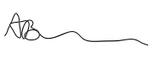 | Date:  06.02.2020

For STUDENT Submissions:
Director of Studies/Supervisor: | Dr Sioned V Hughes | Date:  07.02.20
Signature: | S.V.Hughes | Date:  07.02.20

For STAFF Submissions:
Head of School/Assistant Dean: |  | Date:
Signature: |  | Date:

Checklist: Please complete the checklist below to ensure that you have completed the form according to the guidelines and attached any required documentation:
☒ | I have read the guidance notes supplied before completing the form.
☒ | I have completed ALL RELEVANT sections of the form in full.
☒ | I confirm that the research activity has received approval in principle
☐ | I have attached a copy of final/interim approval from external organisation (where appropriate)
☐ | I have attached a full risk assessment (and have NOT completed Section H of this form) (where appropriate) ONLY TICK IF YOU HAVE ATTACHED A FULL RISK ASSESSMENT
☒ | I understand that it is my responsibility to ensure that the above named research activity will meet the University’s Research Ethics and Integrity Code of Practice.
☒ | I understand that before commencing data collection all documents aimed at respondents (including information sheets, consent forms, questionnaires, interview schedules etc.) must be confirmed by the DoS/Supervisor, module tutor or Head of School.
☒ | I have deleted the guidance notes before submitting the PG2 for consideration

Appendix 2: Summative Report

An Exploration into Classroom and Behaviour Management within A Special Needs School:
A Summative Report

Background
Over the course of 7 days an exploration into Classroom and Behaviour Management within a special needs school was undertaken. This process involved observation of numerous mixed-age and mixed-ability classes, general discussion with staff, interviews with staff and the collection of photographs exemplifying approaches used within specific classrooms. The purpose of this research project is to expand current understanding of classroom and behaviour management techniques and approaches, with the goal to apply this knowledge within future practice in both mainstream and special education settings.
School Context
The special needs school involved within this research project is based in Wales, providing pupils with a variety of learning difficulties with specialised and personalised education. Pupils can access the school from age 3 to 19 years old and are assigned to a class based upon their age and ability. Pupils are split between 11 mixed-age and mixed-ability classes, including one specialist class for pupils with Autism Spectrum Disorders (ASD). There are approximately 110 pupils on roll. The school is equipped with a sensory room, hydrotherapy pool, a soft-play room and specialist rooms for science, design technology and food technology which are regularly used by most classes.
Discussion
Personalised learning is prioritised within this school, which is reflected throughout all practices, including communication, management approaches, general teaching and school practice. Observation revealed that this personalised approach to teaching and learning, and the recognition of each pupils’ individual needs and approaches, is maintained throughout all classrooms and is applied to all pupils. Observation and discussion revealed that each class and each pupil within those classes require different approaches to teaching and learning opportunities. Progression from Ash class through to Elder class is evident and differentiation of approaches, including communication techniques, classroom and behaviour management techniques can be clearly identified, but some continuity can be seen.
Whilst some personalised behaviour management techniques are used for specific pupils, there is evidence of approaches that are consistently used across the school. One of these approaches is positive praise which is used across the school by all staff with all students. The approach involves using praise rather than drawing attention to negative behaviours that other pupils exhibit to indirectly improve their behaviour. Furthermore, immediate praise is used within most classrooms as a mode of recognising positive behaviour and classwork instead of more abstract concepts that pupils cannot relate to. It is evident that this method of recognising positive behaviour and re-directing other pupils’ behaviour is successful and maintained as a whole-school approach.
Through observation it was quickly established that this school is an excellent model of effective and diverse approaches to communication. It is these diverse approaches to communication that form the foundations for effective classroom and behaviour management. Visual symbols combined with written English form one core element of the whole school approach to communication, which is differentiated based upon each cohort and each pupil’s verbal ability. Within certain classes, communication methods, including the use of visual symbols and Makaton, are consistently used to ensure pupils understand instructions or information. These visual behaviour and class management techniques ensure understanding of expectations is maintained and that inclusion is promoted.
Conclusion
Interviews and discussions with staff combined with observations of each class (excluding the specialist ASD class) revealed that whole school initiatives and approaches to teaching and learning, specifically classroom and behaviour management techniques, are consistently used and applied across the school by all staff members. All staff place the needs and understanding of the pupils at the core of their practice, which influences their actions and approaches to classroom and behaviour management and general teaching practice.
This research has confirmed that classroom and behaviour management within this school is reflective of the needs and abilities of the pupils and is adapted to ensure fitness for purpose. Furthermore, many of these techniques, particularly alternative modes of communication, will be transferred into future mainstream and special needs personal practice due to the clear impact upon the pupils.

Appendix 3: Visual Timetable

Below are some examples of visual timetables that were used within the participating school. Most classes have a general timetable displayed on the wall or door, however the extent that these are used varies from class to class.

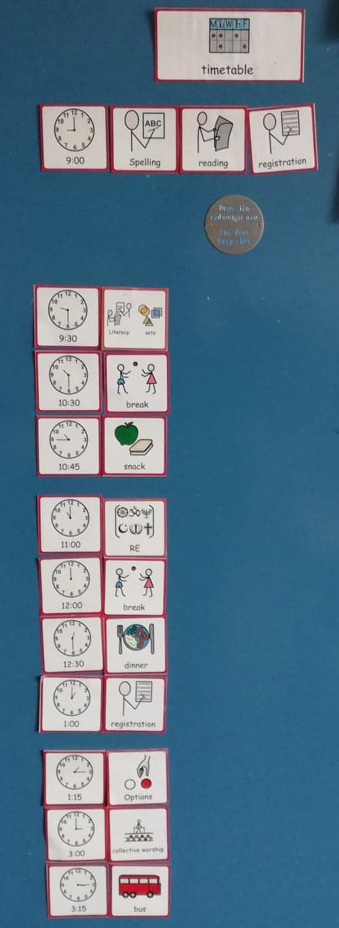

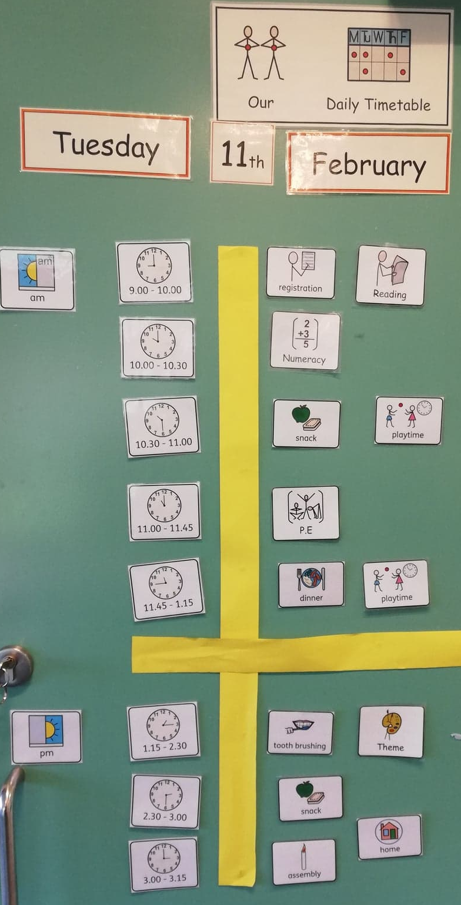

Appendix 4: Alternative Visual Timetables

Pictured below is an example of a ‘now and next’ timetable. The purpose of this resource is for staff and pupils to be able to identify the current and next task. This ensures pupils anxiety can be reduced and pupils can be made aware of the work expectations. Additionally, these resources are sometimes used as a reward: pupils must complete the task in the ‘now’ box in order to receive a reward, typically a task or an object that the individual pupil enjoys.
Photographs of these resources were not taken to ensure pupils’ names nor faces were included in the research project. Instead, a replica has been provided..
Now
Next

Additionally, some pupils might use a ‘now, next, then’ board. These are intended to broaden expectations of pupils and can provide security to those with anxiety.

Now
Next
Then

Appendix 5: Interview Questions

Below is a list of questions that might have been used in the interviews with practitioners. Some questions may not have been included due to a previous response proving an answer. These questions are indicative and may change dependent on each participant, the nature of the class etc.

Can you describe some approaches to class and behaviour management that you use?

How do you promote effective communication between staff and pupils?

How do you manage transitions?

What are some classroom management techniques that you use?

What methods do you use to prevent behavioural escalation where possible?

How do you try to prevent over-reliance upon routines (where possible)?

How are transitions at the beginning of an academic year managed?

Appendix 6: Ash Class- Class Context

The text highlighted in yellow identifies notes relating to communication.
Ash Class Overview

The following refers to the range of diagnoses/needs within the class:
4 ASD
1 Turners (plus other ?s)
1 Global Delay
1 Wang Syndrome
2 Tube Fed
1 Cerebral Palsy (+others)
2 pupils permanently use wheelchairs
1 pupil sometimes uses a wheelchair- learning to walk
2 verbal, 1 partially, 6 non-verbal

Most pupils have multiple diagnoses
Total of 9 pupils

3-7 years old. Nursery- Year 3

Pupils who are non-verbal are guided in activities, gestures, Makaton, facial expression, posture and tone of voice is all used regularly. Many pupils will lead staff to identify what they would like, e.g. a pupil leads a member of staff to the kitchen area and tries to open the fridge indicates that the pupil might be hungry.
During activities, all staff move around the pupils, providing guidance to all pupils, asking questions and encouraging any kind of communication. Pupils are strongly encouraged to participate in short group activities and once involved all pupils appear to enjoy the process.
Most pupils do not interact, instead choosing to explore independently. Group activities encourage pupils to work/play near one another.

Appendix 7: Ash Class- Behaviour and Classroom Management

Classroom and behaviour management- Observation Notes
Ash Class (Nursery-Y3)
The text highlighted in yellow identifies notes referring to timetabling/approach to organising learning
- Verbal praise- ‘well done… you are building a very tall tower’ – pupils are praised on positive behaviours, effort, activities completed etc.
- Timeout cushion- generally not used as it is too abstract for the pupils
- Musical cues- e.g. to tidy up
- Objects of reference e.g. associate tablecloth with breakfast- objects of reference are used instead of a visual timetable- pupils learn the times of the day based around the use of objects. Staff also use spoken English and Makaton to support this concept
- Home-school communication book
- Breakfast- pupils are on school transport for a while before arriving so are hungry by snack time and behaviour worsens, so breakfast is provided
- Pupils held responsible for some of their actions- e.g. they mop up their spilt drink
- Pupils know the basic structure of the day (e.g. free play, breakfast, circle time etc.)
- No timetables are used- pupils become obsessed/overly reliant upon it
- Now and Next is used instead
- Eye contact and gentle leading/guiding of pupils
- Picture cards- pecs etc. – generally not used in this class as they are so young
- Choice boards- pupils can make certain decisions using these
- Gesture and signs used in combination with voice by practitioners
- Redirection is key- especially with behaviours that may arise
- Time- staff know how long certain pupils Need to respond
- If pupils pre non-verbal and cannot independently use Makaton then staff support and use praise
- Boundaries are fundamental
- No sticker charts etc. too abstract for the pupils- immediate verbal praise is much better

Appendix 8: Sycamore Class- Behaviour and Classroom Management

Classroom and behaviour management- Observation Notes
Sycamore Class (Y1-Y3)
The text highlighted in yellow identifies notes relating to free movement
- “thank you for joining us” and similar phrases are used to acknowledge a child joining the group
- Singing “I need (child) I need (child)- using singing as an attention grabber
- Pupils are held responsible as appropriate for their actions, e.g. mopping up their spilt drink- “oh dear, time to clean up please”
- Child wanted to go to the sensory room with other pupils- teacher moved the lesson by the door to join said child, ensure he did not run, and gain his attention again
- Increase in behaviour prompts an immediate change in activity- must have some activities for back up
- Use of music/singing- this ‘grounds’ the pupils
- Positive praise is immediate- there is no delay. Abstract concepts such as sticker charts etc. are not used, instead high fives and lots of verbal praise is given
- Sand timers- these are used consistently with inappropriate behaviours, such as physical outburst on another child
- Picking your battles- is this behaviour really bad, or will it escalate further if action is taken? Knowing the pupils
- Using bargaining as a tool- “okay, if you want to draw a girl, first you have to write I like drawing girls”
- Giving pupils time to re-join group
- Using pupils’ names to gain their attention- this redirects them back onto task
- “Oh, thank you for coming over”
- Using calm but stern voice- “no thank you”- this is used in combination with eye contact where possible and facial expression. The simplified language ensures that pupils understand the need to stop and are not overwhelmed by information in a long sentence
- Pupils roam the room if not under direct instruction- this is accepted- movement is needed for many of these pupils

Pupils move around the room freely when not engaged in an activity. Staff must monitor the doors. Some pupils spin on chairs, spin whilst standing, run from side to side, jump, climb, vocalise (humming, making noises, stimming vocally etc.). Pupils are allowed to do this within reason- many have an autism diagnosis and use these actions as stims. Pupils are only stopped if the action is a danger to themselves or others, if they are required to take part in an activity, or if it is time to move to another part of the building. At times, stopping a pupil from stimming can prompt further behaviours that are more challenging, but staff are aware of how to handle these situations. Dialogue between staff is regular throughout the day.

Appendix 9: Larch Class- Sensory Room

Sensory Room Session
Larch Class (Y3-Y9)
The text highlighted in yellow identifies notes referring to free movement.
- Whole class go to the sensory room together
- On entering, pupils are encouraged to take off their shoes and their socks if they wish, some pupils keep their shoes on
- Pupils are encouraged to find somewhere to sit/lie down on the soft cushions around the room
- Each pupil is given a blanket and a pillow- some pupils identify a preference for which they like or dislike by pushing one away, pulling another in, signing or verbalising in some way
- Some pupils move around/wander- particularly those with ASD- pupils are encouraged to relax but are not forced to stay still unless there is risk of harm/disruption of others
- Staff use quiet, calm, soft tones at all times in keeping with the atmosphere
- Pupils who display physical behaviours are stopped, intervention is immediate, including staff member discussing the behaviour at an appropriate level with the pupil and ensuring other pupils are okay (separate staff) some pupils believe they are the ones in the wrong so become upset but are immediately reassured and comforted
- Netted materials are used as a calming tool- wafted over the pupils’ heads
- Pupils can choose whether they want the netting or not- this is a skill that is worked on in and out of sensory
- There is a waterbed in the sensory room which many pupils enjoy using
- Air con is used to regulate the temperature of the room/some pupils – certain pupils become hot when they become flustered and struggle to get cool again
- Coloured lights are associated with certain tunes

Impact upon the pupils.
- All pupils are visibly more relaxed and comfortable
- The pupils are able to develop skills including choice making and regulation
- An approach to support behaviour regulation and support pupils with ASD who require sensory input
- All pupils appeared to enjoy the sensory session, were very eager to enter the room and take part
- Pupils who were previously restless and moving around a lot are more relaxed and able to sit or lie down with minimal movement- this indicates that pupils feel relaxed in the sensory room and that they are getting the sensory input that they need

Appendix 10: Larch Class- Behaviour and Classroom Management

Classroom and behaviour management- Observation Notes
Larch Class (Y3-Y9)
The text highlighted in yellow identifies notes referring to communication amongst staff.
- Stickers and star charts are the main behaviour strategies used within the class
- Some pupils require more tailored approaches- these tailored approaches are used by all staff
- E.g. 1 pupil has a now, next, then board, where the ‘then’ refers to a reward
- E.g. another pupil requires instant reward due to behaviour, another due to memory- this pupil would not get the concept of gradually working towards an incentive
- E.g. another pupil would get the concept of gradually working towards an incentive, e.g. extra golden time
- Another pupil has a ‘now, then’ approach, where a reward will be received after the completion of a task
- Praise is consistent and successes are shared between staff- this might be at the end of the day or immediately with the pupil- pupils show great pride when their successes are shared
- Class dojo- the CT used this in previous years, but it is too abstract for the current class
- Picture based rules are displayed in the classroom for easy reference and to ensure pupil understanding
- Marble jar- in the past the CT awarded pupils with a marble for good behaviour/work etc., which equated to one extra minute of golden time. However, this is also too abstract and not immediate enough for these pupils
- Signing is used by all staff within the class- this is a whole school approach and is being broadened- training in Makaton is provided each week after school to any staff who want to expand their knowledge
- Signing is clearly an effective strategy within this class, particularly for pupils Who are non/partially verbal or have reduced capacity of understanding- this visual communication approach paired with oral communication engages students and reduces potential behaviours that may arise due to communication barriers/issues
- Some pupils are able to sign successfully, highlighting that the communication approach works for these pupils
- When a member of staff who does not normally support the class joins the class for the day, they enquire about various practices with certain pupils, including methods of communication, behaviour procedures etc. This ensures continuity in approaches to supporting pupils are maintained
- AT the end of the day, one pupil starts displaying behaviours that could cause harm to himself. A member of staff who was not normally in the class asked the pupil to put his shoes on, which he normally only does right before the end of the school day. This led to the pupil become confused and frustrated. This exemplified the importance of continuing the same practices with pupils when they are well established

Appendix 11: Beech Class- Morning Routine

Beech Class (Y8-Y10)
The text highlighted in yellow identifies notes relating to positive praise.

- The pupils all come into school independently (bar one who is met and brought in by staff)
- Pupils put their own things away, including anything in the fridge that needs refrigerating
- Pupils are reminded to get a drink and go to the toilet, especially after the long journey- this reminder is sometimes aimed towards specific pupils who need reminding, whereas at other times the reminder is aimed at the pupils in general- this is a management technique to ensure that certain pupils do not ignore the blanket guidance- especially those with ASD/development delay. Staff use pupils’ names to ensure they understand the directions include them
- Pupils begin by getting their reading books out, staff go around the pupils and listen to them 1:1
- Once the pupils have read they then do a short writing exercise based upon their book or another topic. Some pupils are asked to copy a sentence, others are asked to answer a question and write three sentences (e.g. what are you doing in half term?) Once again, this is a management technique- the pupils are all on task and developing skills whilst sticking loosely to a routine which is important to some pupils who do not have routine at home. Some pupils are given extensions and praised for their hard work- they then seem more eager to work than before
- Pupils are asked what they would like for lunch- this is bilingual for all pupils with some being asked and answer in Welsh, others are asked bilingually and answer either in Welsh or English
- Pupils receive stickers for participation/good work alongside positive verbal feedback. Staff make a point of making eye contact with pupils, smiling and demonstrating how pleased they are with the pupil. Other pupils are immediately more attentive when they hear their peers are receiving praise and stickers

Appendix 12: Sycamore Class- Behaviour and Classroom Management (2)

Classroom and behaviour management- Observation Notes
Sycamore Class (Y1-Y3)
The text highlighted in yellow identifies notes relating to simplified language, tone of voice, facial expression and posture
- “thank you for joining us” and similar phrases are used to acknowledge a child joining the group
- Singing “I need (child) I need (child)- using singing as an attention grabber
- Pupils are held responsible as appropriate for their actions, e.g. mopping up their spilt drink- “oh dear, time to clean up please” (simplified language ensures comprehension- this is not a long instruction during which a pupil can become distracted or move away) Staff vary their tone of voice and use actions to support language- this keeps pupils more engaged
- Pupil wanted to go to the sensory room with other pupils- teacher moved the lesson by the door to join said pupil, ensure he did not run, and gain his attention again
- Increase in behaviour prompts an immediate change in activity- must have some activities for back up
- Use of music/singing- this grounds the pupils- change in tone of voice and movement captures pupils’ attention
- Positive praise is immediate- there is no delay. Abstract concepts such as sticker charts etc. are not used, instead high fives and lots of verbal praise is given
- Sand timers- these are used consistently with inappropriate behaviours, such as physical outburst on another pupil
- Picking your battles- is this behaviour really bad, or will it escalate further if action is taken? Knowing the pupils
- Using bargaining as a tool- “okay, if you want to draw a girl, first you have to write I like drawing girls”
- Giving pupils time to re-join group
- Using pupils’ names to gain their attention- this redirects them back onto task
- “Oh thank you for coming over”
- Using calm but stern voice- “no thank you”- this is used in combination with eye contact where possible and facial expression. The simplified language ensures that pupils understand the need to stop and are not overwhelmed by information in a long sentence
- Pupils roam the room if not under direct instruction- this is accepted- movement is needed for many of these pupils.

Pupils move around the room freely when not engaged in an activity. Staff must monitor the doors. Some pupils spin on chairs, spin whilst standing, run from side to side, jump, climb, vocalise (humming, making noises, stimming vocally etc.). Pupils are allowed to do this within reason- many have an autism diagnosis and use these actions as stims. Pupils are only stopped if the action is a danger to themselves or others, if they are required to take part in an activity, or if it is time to move to another part of the building. At times, stopping a pupil from stimming can prompt further behaviours that are more challenging, but staff are aware of how to handle these situations. Dialogue between staff is regular throughout the day.

Appendix 13: Behaviour Policy Notes

The text highlighted in yellow identifies notes relating to the use of facial expression, tone of voice and posture in the classroom.

Person-centred planning

School Wide Positive Behaviour Support

Social Role Valorisation Team Teach

School Wide Positive Behaviour Support (SWPBS)
Person Centred Planning
- One page profile
- Good day bad day
- Relationship circle
- 4 plus 1 questions
- Person centred reviews

Good day bad day
- What does a good/bad day look like?
- What must/must not happen to be a good/bad day?
Relationship Circle
- Who a person knows, how they know them
- A way of identifying who is important to a person and explore important issues around those relationships

4 plus 1 questions
- What have you tried?
- What have you learned?
- What are you pleased about?
- What are you concerned about?
- Based on what we know, what should we do next?
- These questions are a group activity and are answered by more than one person

Social Role Valorisation
- The environment is normalised, not the individual

Team Teach
- 95% de-escalation (emphasis upon changes in the following before physical contact is needed)
  - Use of space
  - Time management
  - Change to the environment
  - Stance, posture and gestures
  - Facial expressions
  - Eyes
  - Voices
  - Words
- 5% physical contact
  - Prompts, comfort and reassuring touch
  - Guides, escorts and holds
  - Physical interventions
At the elective school, restraint is not used but physical intervention may be used instead.

Appendix 14: Interview- Timetabling

The text highlighted in yellow shows the parts of the transcript that discuss timetabling and preparing for unexpected or planned changes.

Interview with a Class Teacher: Beech Class
Before the interview takes place, the researcher explains to the participant that the recording is taking place to aid transcription. Participants are reminded that they do not have to be recorded and that the audio recording of the interview will not be shared with anyone and deleted immediately after transcription. Participants are reassured that if any information, such as pupil names, are disclosed during the spoken interview that this information will be omitted in transcription. Participants are reminded that this is a voluntary activity and they are not obliged to participate.
This participant was invited to view the list of indicative questions prior to interview.
The participant was informed that pausing the interview at any point was possible.
The participant was reminded of their right to withdraw and that confidentiality will be maintained.

Researcher: Can you describe some approaches to class and behaviour management within this class?
Teacher: It is very changeable, so we have sort of a bank of things that we use. Most importantly at the beginning of the year we set out class rules with them. They came up with what sort of a good classroom looks like an so that we can then use those as the year goes on and bring them back to them and say ‘remember when you said that we should be listening, somebody's talking, that is what we should be doing now’ so they've got some ownership over it. That does seem to help rather than just being told these are the rules. But then with these guys being very relaxed with them works because if you sort of become too confrontational or sort of too strict with them, they can react to that and you can cause more of an issue. Obviously, there is a time for that if they're pushing the boundary and then you sort of get a bit firmer. I kind of try to push using talking strategies if somebody is kind of not quite doing what they are meant to be doing and you just give them a little reminder of what they should be doing or you know if somebody is out with their seats instead of saying ‘get back to your seat’ I’ll say ‘oh where are you going?’ and it reminds them ‘oh I’m not supposed to be here, hold on I'm going back to my seat now.’ So rather than kind of making a big deal of it and then it is very relaxed. Especially with this cohort the more relaxed the better but they know their boundaries, so they know when it is too much. We use quite a bit of gestural and kind of nonverbal cues, to ask them to be a quiet or something. We are wearing symbols so we might point to those. So for some of them we might just sort of point to the symbol and it is a very quick way of just bringing them back to ‘Oh I’m supposed to be waiting’ ‘Oh I’m supposed to be listening’ and ‘oh I’m supposed to be quiet at the moment’ that sort of thing. So I might be delivering a lesson and somebody is not quite listening so I might just say their name and then carry on my sentence and it just jogs their mind into ‘oh hang on a minute, she just said my name I should be listening’ but I never stop and use kind of very traditional methods of stopping and getting their attention back it is all very fluid. A lot these kids will react if you make too much of it-it becomes a bigger thing.

Researcher: Okay, how do you promote effective communication to prevent escalation of behaviours?

Teacher: So, we always try to make sure that we are calm as much as possible and we try to keep our voices very calm. If somebody looks like they're about to lose the plot, then we go in with simplified language. We might say ‘think about what needs to be done, think about what the next step is, do we need to have a reaction like this, or can we just talk about it?’ Obviously sometimes it is an ongoing thing and afterwards you might have to speak to them once they've calmed down. For a lot of them you can say ‘think about it, what needs to happen next?’ and you can encourage them then to verbalise what the problem is, to talk to you about it before it becomes an issue. Quite often it is a conversation that happens afterwards if they had a ‘big behaviour’ [so] then we'll have a chat about what we could have done differently. If it is something that is a repetitive issue with somebody, if you think ‘this person really needs to work on talking before they explode’ then we might use visuals. So, we might have a chart of some sort which might be a little visual reminder, e.g. ‘what can I do if I'm feeling frustrated?’

Researcher: Thank you. Okay, how do you manage routines within the classroom without become overly reliant or focused upon them?
Teacher: Good question, I like it! Okay, so we have a timetable but what I do in here- I know further down the school they are a bit more rigid with their timetables- but as they start getting a bit older I like to start preparing them for the fact that things may change. I do have an overarching timetable, which we have as a visual on the wall, but that is just the main times of the day. It [shows] morning activities, break time, snack time, lunchtime, assembly, and home time. Then in-between I will say it is work time, but I do not set what that is, so that might change. That gets them used to most of their day being structured. So, the main timings are structured, but then what they're doing in-between is not always the same and it starts introducing them to the fact that things may not quite be the same all the time. So, it is almost a 1/2 rigid routine. I think it is important to sort of have elements that are rigid because obviously a lot of this cohort need that, but then introducing things that can be flexible as much as possible. But also then if there is something that is completely different we prepare them for it in advance, so we will talk to them maybe the week before, the day before, then the morning of [the change], and say ‘remember we've talked about this, this is happening today’ if it is something completely out the ordinary. There's lots of prep to help them to cope with that.

Interview ends. The participant is thanked for their participation, is reminded about their right to withdraw and is reminded about the transcription process.

Appendix 15: Interview- Tailoring approaches

The text highlighted yellow shows parts of the transcript that discuss the importance of using sensitive and appropriate language.

Interview with a Class Teacher: Elder Class

Before the interview takes place, the researcher explains to the participant that the recording is taking place to aid transcription. Participants are reminded that they do not have to be recorded and that the audio recording of the interview will not be shared with anyone and deleted immediately after transcription. Participants are reassured that if any information, such as pupil names, are disclosed during the spoken interview that this information will be omitted in transcription. Participants are reminded that this is a voluntary activity and they are not obliged to participate.
The participant was invited to view the list of indicative questions prior to the interview.
The participant was reminded that pausing the interview was an option at any point.
The participant was reminded of their right to withdraw and that confidentiality will be maintained.

Researcher: Okay, so my first question is can you describe some approaches to class and behaviour management within your class?
Class Teacher: Yes. So, in a school like this it really is more an individual approach that you have to take for each student. We've got one student who you may have heard me talking to about warnings. With him there's a set procedure that he will go through if he's showing defiance or not listening or being excessively loud. Sometimes he can be very anxious and it is not that he's misbehaving but that he is worried about something and sometimes it can be difficult to tell between the two. So, we've got a set procedure that will get him to a place where he can calm down. In this setting one of the big focuses is de-escalation. So, we've got a process with him whereby we get him outside into a place where he can sit supervised by staff for a set time period and we found that that works really well. When the student came to us he was in a period where he was experiencing very high levels [of anxiety] and overtime staff developed this system that works really well and as you can see he's been able to be involved around present an involved and throughout day.
Interview paused at the request of the teacher.
Class Teacher: At the beginning of the year we came up with a class contract which they all signed and have in their trays. That is something that we can refer back to, to remind students about expectations and to be honest I rarely need to do that with these students. The students in this class respond very well to staff when asked to do things, but when they do not [respond well], often being reminded of expectations is enough to refocus them. There is one student in the class where they have a protocol that we go through where again they are encouraged to go outside sometimes. That person is verbal so they are able to talk through to some extent with their feelings before things escalate. Our design- our procedure- is to get them to a point where they can talk about that feeling and begin to calm down. So that person has had work from a mental health expert, so she has been given techniques to help de-escalate and to calm, and they are like mindfulness techniques and being aware of what is around her, like the blueness of the sky etc. She can be encouraged to use those techniques by a member of staff. I find that procedure works very well. Parent communication is really important with that person as well so I make it really clear when I'm working with that student that I will be phoning home and there's a really good parent-school relationship there where we support each other and so that works really well.
There is another student where a risk assessment is in place. A risk assessment is used when thinking about everything around that student, where staff-student ratios are concerned, that influences what we say around that student and how they are spoken to and then that influences how we manage that student’s behaviour.

Researcher: Thank you. Okay, the last question is how do you promote effective communication with the pupils?
Class teacher – Elder: So again, that varies. What I use at the moment to communicate really well with the more able students is a something called Google Classroom which I find really effective. Are you familiar with that?

Researcher: Yes.

Class Teacher: When it comes to student work I'm able to have a dialogue privately with my students in the comments bar down the side. So my students are 18/19 years old and do not take kindly to being presented with work that is like clearly designed for people in primary school, which is totally understandable. I use that [Google Classroom] and my staff are also trained on how to use it. We are able to highlight errors on there and communicate with the students directly about their work in a sensitive and adult way the respect that age and their maturity, and they in turn respond well to that, and communicate back to us, so that is something that is brilliant. I am not sure whether that refers directly to behaviour management, I would say it does because obviously work can be a flair point for behaviours, so if students are struggling that in itself can be a flair point for behaviours to occur. But with this tool we are able to observe at a glance everyone’s progress in the task and privately intercede in a way that is respectful to ask if they need help. And if they need [help] they are encouraged to ask for help when needed. We want to make it clear to the students that we are available for them.
Some of my students have social stories that we write using widgit so that is one that I gave to one student who fixates on trips (Class teacher shows the researcher the social story). He really likes trips, we do a lot in this class, so we use [social stories] with him if there are any changes. So today for example, that student was meant to be going on a trip, but because we did that he was able to process that and was able to take part today. So we use social stories to communicate what is going on.
In a recent training session that I went on that focussed on differentiation, one of the big focuses was teacher chat and having a class conversation was really helpful when giving tasks because students get an opportunity to participate in what is being said and showing that they have got an opinion that is valid, so I do talk with the students and make sure they are confident in approaching the task. We use lots of ICT in my class, voice to text software to ensure everyone has the opportunity to get their thoughts down.

Interview ends. Class teacher is thanked for their input and reminded of their right to withdraw and the transcription process.

Appendix 16: Interview- Behaviour Lead

The text highlighted in yellow shows parts of the transcript that discusses timetabling and Team Teach.

Interview with the Behaviour Lead
Before the interview takes place, the researcher explains to the participant that the recording is taking place to aid transcription. Participants are reminded that they do not have to be recorded and that the audio recording of the interview will not be shared with anyone and deleted immediately after transcription. Participants are reassured that if any information, such as pupil names, are disclosed during the spoken interview that this information will be omitted in transcription. Participants are reminded that this is a voluntary activity and they are not obliged to participate.
This participant was invited to view the list of indicative questions prior to interview.
The participant was informed that pausing the interview at any point was possible.
The participant was reminded of their right to withdraw and that confidentiality will be maintained.

Researcher: In terms of behaviour and classroom management and transition, whether into the school or between classes and teachers, is there anything in place as a whole school approach or is it a class-by-class basis?

Behaviour Lead: What we do is we have a big transition day at the end of the school year in the summer term. That would be for class changes [where] all pupils and staff move to their new classes for the whole day to do fun activities and no work. Transition for children who are coming into [the school] is robust especially because we have got ASD pupils. So after [May half-term] new pupils who are new starters for the September will come in for one day a week. We will offer activities like hydrotherapy, sensory massage, sports, Lego therapy, the soft-play room for the smaller children. These activities are offered first. Getting to know friends, they might come on a school trip, watch a show. They would also come on the transition day as well. Some children come with support from their old school, some come without. Day to day transitions we rely heavily on our visual timetables and our ‘now and next’ cards.

Researcher: I cannot remember who mentioned ABA to me, but they said that you would be the best person to ask about it.
Behaviour Lead: Okay. ABA is Applied Behavioural Analysis. You can teach functional living skills from ABA but you can also do tasks, in the ABA world they are called trials and they are repeated over and over again to modify somebody’s behaviour. To get rid of an unwanted behaviour or to encourage a behaviour that you want to see more often. It relies a lot on data. There’s a lot of observation of the pupils. It is about trying to find the function of behaviour. So, say for example a child is flicking the switch on and off trying to gain our attention. What ABA would do is look at a more socially acceptable way of that child having attention, so that you are meeting the need for attention. What they call them is functionally equivalent skills. They are still getting out what they want from that behaviour, but it is more socially acceptable. So, they might learn to come and ask, ‘please can you come and do this with me?’ There’s lots of different trials that you would do and depending on all your observations of the child, so you would have to count how many times he does it, see if you can find any triggers, quite often you will get the function of the behaviour wrong. We do all our observations again. If you start seeing an improvement you know you’ve got the function of the behaviour right.

Researcher: In terms of parental links relating to behaviour, I know that you have a home-school link book. Is there anything else in place?
Behaviour Lead: The ISPs are sent home for parents to sign. All parents are made aware that we are a Team Teach school. The policy of our school is to keep everyone safe and the environment safe, and if we have exhausted 95% de-escalation and your child is being a danger, we will physically intervene. We’ve only had a couple of parents who do not like Team teach. You have to be sensitive about it. You are safeguarding their child as well. We have the person-centred reviews, so anything of any concern comes up in that. We send email rather than letters for correspondence. We might do a best-interests meeting if we are concerned about a pupil. We also have a TAF system- for the families you do not want to get to social services level.
The participant was thanked and reminded of their right to withdraw. The participant was reminded of the transcription process.

Appendix 17: Photographic Evidence- 4 Core Purposes

The image below shows an example of the posters that were placed in most classrooms around the school. The 4 core purposes poster has been included to demonstrate the extent that the participating school promoted communication in a variety of forms.
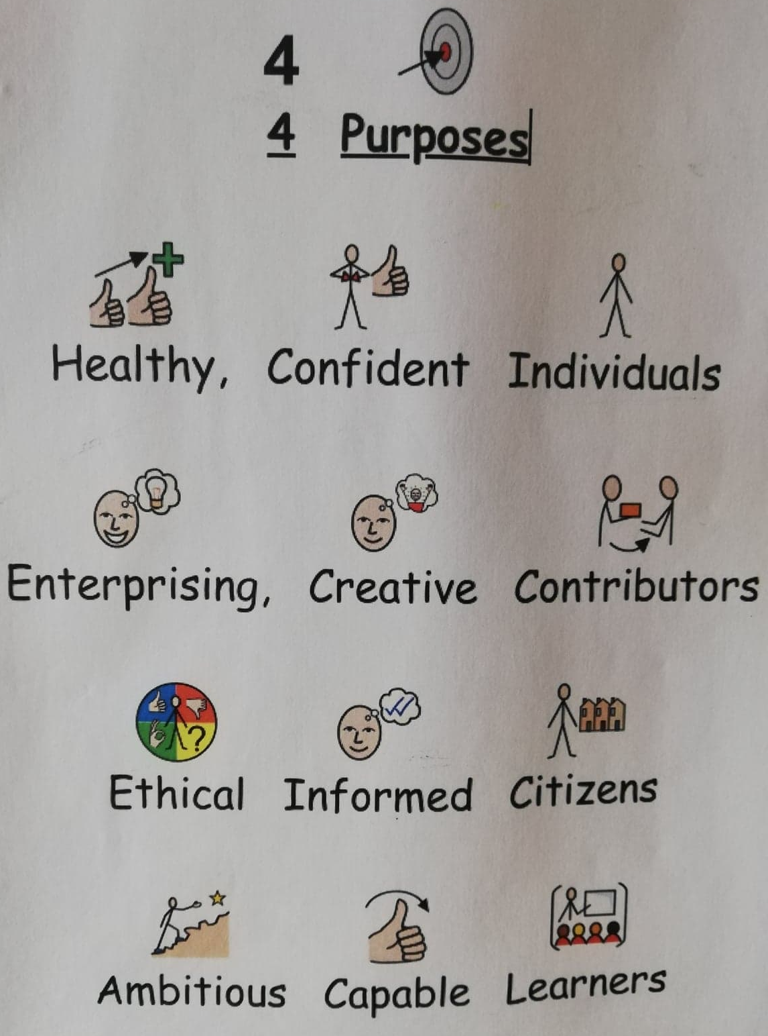

Appendix 18: Photographic Evidence- Marking Guidance

Pictured below is a photograph of a marking guidance sheet found in many of the senior classrooms. Once more, this is intended to demonstrate the participating school’s commitment to ensuring information is accessible to all.

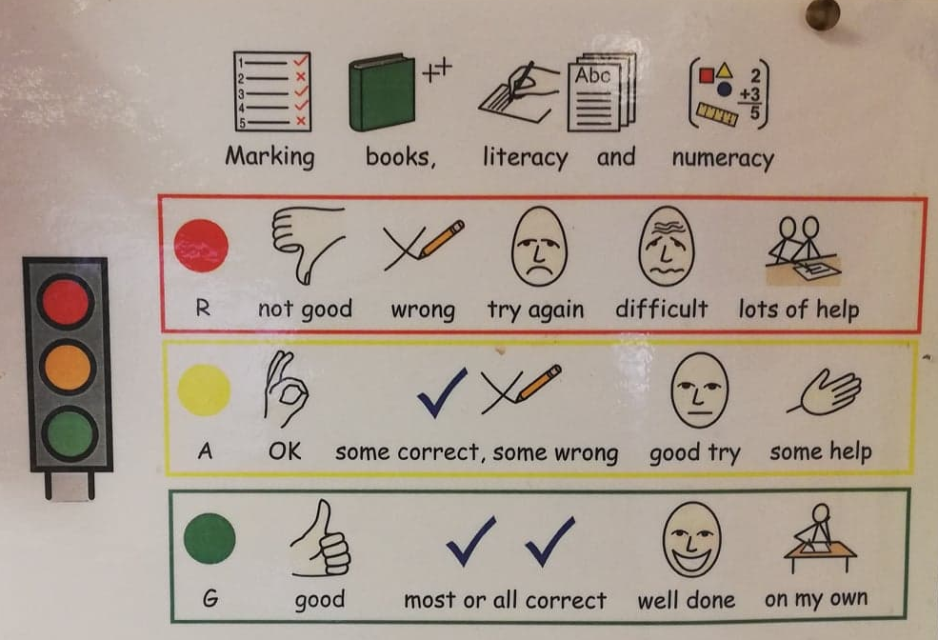

Appendix 19: Photographic Evidence- Examples of Work

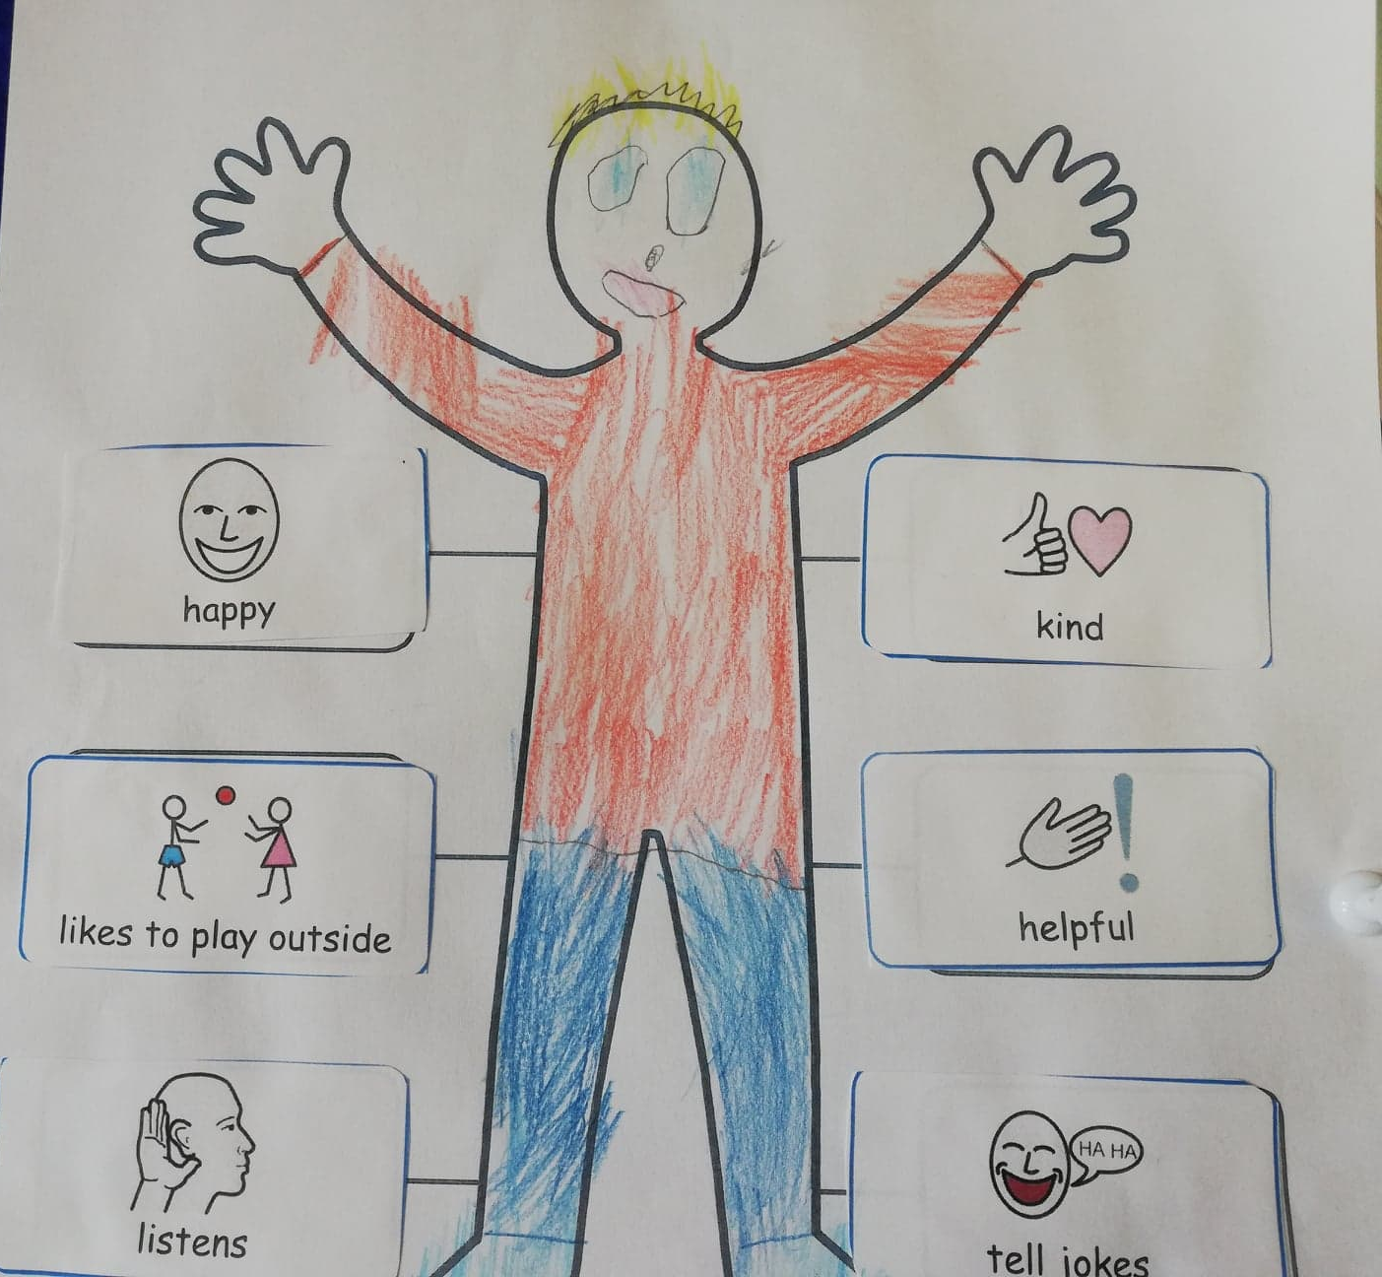
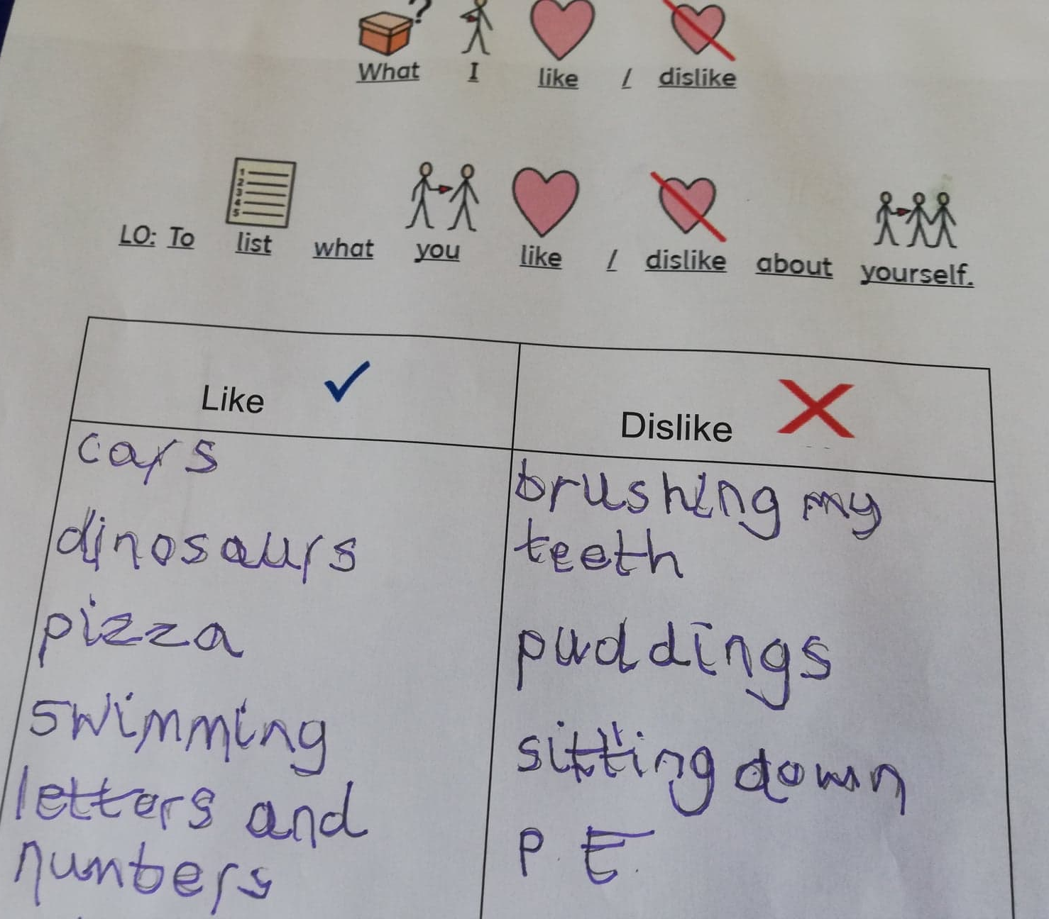
Pictured below are some examples of pupils’ work that shows widgit symbols being used to support communication of expectations and completion of work. Using these symbols to support communication will reduce the possibility of frustration and/or escalation of behaviours due to miscommunication or misunderstanding of expectations.
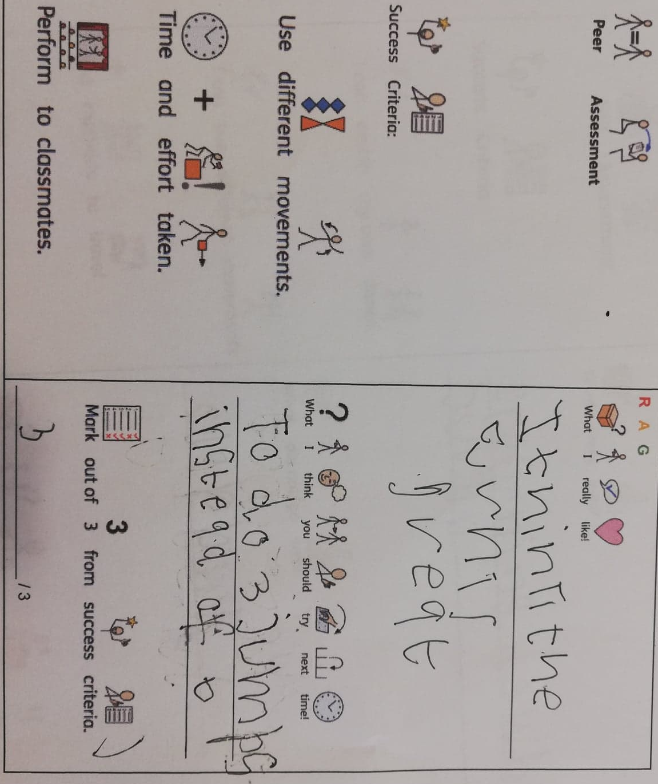
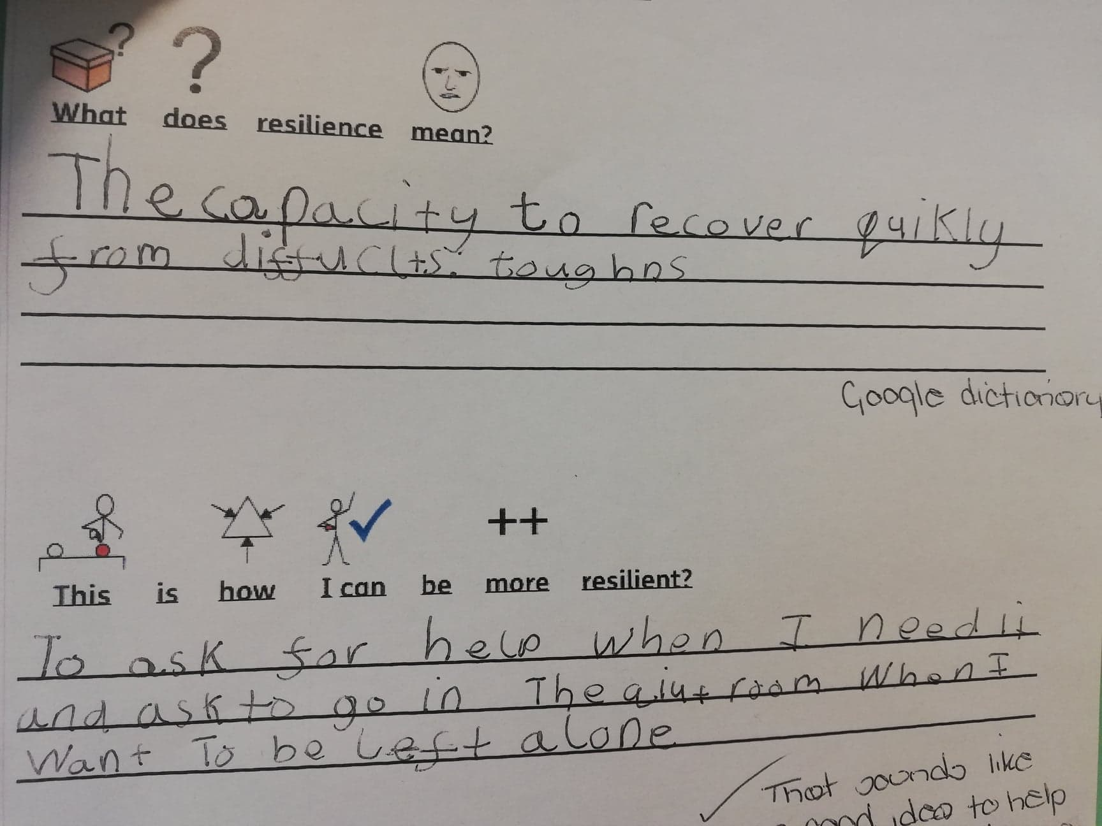

Appendix 20: Photographic Evidence- Social Stories

This is an example of a social stories. These resources were used as tools to provide a visual reminder to selected pupils about any changes in routine or any expectations. This resource is used to ensure communication is clear and as a method to prevent behavioural escalation.



