

MODULE CODE: BMIH5007

MODULE: FINANCIAL MANAGEMENT FOR THE HOTEL INDUSTRY

ASSIGNMENT 2: REPORT ON THE CITY HOTEL
Student id: 2242891
Student name : Lidia Leva
Module leader : Tristan Hawkins

Table of Contents
Assessment 2 3
1.0 Introduction 3
2.0 Evaluation of the trends in the financial performance of the past three years of The City Hotel 3
2.1 Trends of revenue and expenses 3
2.2 Profitability Trends 4
2.3 Patterns of Liquidity 5
2.4 Trends of Solvency 6
3.0 Key aspects that are resulting to impact the profitability with a focus on real-world events and the current economy 7
3.1 Changing consumer behaviours 7
3.2 Limited integration of technologies leads to lower customer satisfaction 8
3.3 Increasing cost of living 8
4.0 Strategic alliance to enhance the financial condition and brand image of the City Hotel 9
4.1 Providing customised service as per the demands of the consumers 9
4.2 Enhancement of the digital marketing for enhancing customer engagement 9
4.3 Revision of the pricing strategy 9
5.0 Conclusion 10
References 11

Assessment 2

1.0 Introduction
In the organisational context, financial management is one of the important aspects by which the business organisations can be able to maintain the balance between the overall expenditure of the company and the acquired revenue in the market. This also includes the records of financial transactions of the company so that the enhancement of the profit level of the company can be ensured (Eun et al., 2021). The discussion of this study is based on the financial performance of City Hotel in the financial years of 2021, 2022 and 2023 by examining the financial trends of the company including the calculation of profitability, solvency, and liquidity ratios. The discussion also includes the impact of real-world scenarios for declining the profit of the company along with several strategies by which the organisation can be able to improve the level of brand reputation in the market.

2.0 Evaluation of the trends in the financial performance of the past three years of The City Hotel

2.1 Trends of revenue and expenses
The amount of revenue and overall expenditure of the company are the major determinants of the financial condition of the company. In the case of City Hotel, the amount of revenue gained in 2021, 2022 and 2023 are differing from each other. In 2023, a sharp decline in the revenue is seen as compared to the revenue gained in 2021 and 2022. The amount of revenue of the company is dependent on the inflow and outflow of financial resources by which the business activities can be managed in a proper manner (Bukvic and Pavlovic, 2023). The revenue of the company is also affected by several factors of the external environment including high level of competition, change in trend and demands among the consumers and negative economic conditions. Due to the negative impact of the Covid-19 pandemic, the companies in the hotel industry suffered from the lack of consumers, low occupancy rate which detrimentally affected the revenue of the companies (Shapoval et al., 2021). Thus the organisations in the hospitality industry are required to be focused on revenue and expense trends by which the overall income can be enhanced.
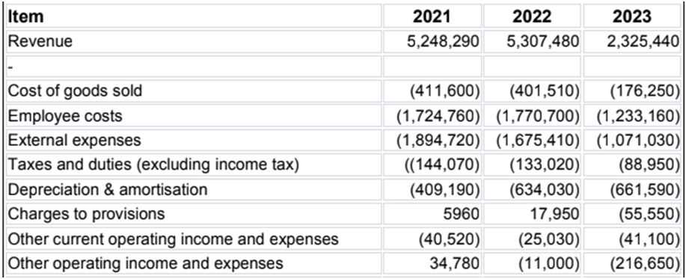
Figure 1: Revenue and expenditure of City Hotels
The above analysis revealed that the amount of overall expenses of the company had been enhanced due to the increased value of depreciation which negatively impacted the amount of revenue gained from the consumers. Additionally, the change in preference of the guests for selected other hotels apart from the City Hotel also contributed in decreasing the amount of revenue in the UK market. As per the opinion of Matsuoka (2022), the decline in the rate of occupancy is one of the contributing factors for reducing the overall financial performance of the company. Therefore the company is suffering from the lack of revenue even though the tax and external expenses have decreased.

2.2 Profitability Trends
The profitability trend is the analysis of the consistency of the financial performance of the companies in terms of the revenue generated from the consumers over different financial years (Alabdullah et al., 2021). In this regard, the financial performance of the City Hotels regarding the amount of profit had declined in 2023 as compared to the revenue amount gained in 2021 and 2022. Due to the inappropriate pricing strategy of City Hotels without the consideration of the affordability of the consumers is one of the contributing factors for declining the amount of profit of the company. This is also creating challenges for the company to remain competitive in the market as the loyalty of the consumers is being affected in a negative manner and the purchase decision of the consumers is made against the company (Khan et al., 2022).

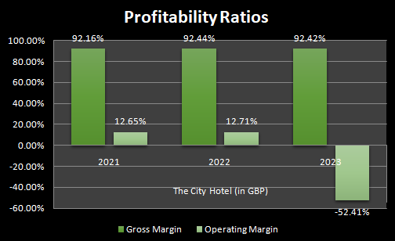
Figure 2: Profitability ratios
(Source: created by the learner)
From the above financial ratio analysis, it can be seen that the profitability ratio of City hotels in 2023 had been declined as compared to 2021 due to the exponential trend and the operating margin. The amount of gross profit was intact however the actual profit had been decreased due to the change in the preference of the consumers. The increment of the number of new companies in the hospitality industry of the UK is also impacting the availability of the alternative options for the consumers. Therefore the authority of City Hotels is facing challenges of attracting the consumers and the occupancy rate is also getting negatively impacted.

2.3 Patterns of Liquidity
The pattern of liquidity is based on the ability of the organisation to convert the tangible assets to the financial cash so that the overall financial condition of the company can be enhanced (Effiong and Ejabu, 2020). Due to the negative impact of the external factors on the overall performance of City Hotels, the overall level of cash flow had been detrimentally impacted. In the case of City hotels, the company is facing the challenges of managing the operations cost due to the lower cash flow so that the position of liquidity of the company is also getting impacted in a negative way.
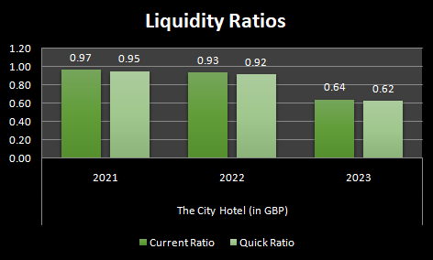
Figure 3: Liquidity ratio
(Source: created by the learner)
The above analysis is showing that the company is suffering from the low rate of current liabilities so that the liquidity position of the company has declined in 2023 as compared to the financial years of 2021 and 2022. The lack of cash inflow of the company is contributing to the low level of financial performance of the company (Beladi et al., 2021). Thus the mentioned company is facing the problem of reducing the financial problems and achieving the short-terms goals of the company.

2.4 Trends of Solvency
The solvency trend is responsible for analysing the capability of the organisation for achieving the long-term goals along with reducing the financial risks which can be resulted in the enhancement of overall financial condition of the company (Horobet et al., 2021). Therefore the analysis of solvency trend of City Hotels is dependent on the amount of debt compared to the level of assets and equity causing the negative financial condition of the business. If the revenue of the companies decreased then the company cannot be able to fulfil their long term financial obligations so that the companies have to bear the burden of high level of liability.
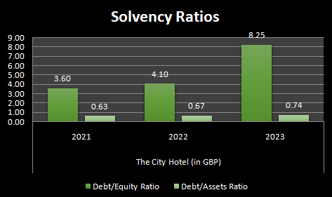
Figure 4: Solvency ratio
(Source: created by the learner)
The above analysis has depicted that the mentioned company is using a high level of debt so that the rate of solvency of the company is decreasing. Therefore it is important for the mentioned company in order to be focused on the enhancement of the level of satisfaction of the consumers so that the overall brand value of the company can be enhanced in the market. In this manner, the authority of City hotels can be able to increase the utilisation of equity capital within the company so that the amount of debt ratio can be reduced. This can result in the solvency performance of the company and they can also be able to optimise the long-term investment.

3.0 Key aspects that are resulting to impact the profitability with a focus on real-world events and the current economy

3.1 Changing consumer behaviours
As technologies are advancing and people are becoming more integrated through the technologies, this has significantly impacted altering or transforming consumer behaviours across the globe. Breda et al. (2019) stated that demands for personalisation, increasing online booking, technology interaction, and rising trends of micro travel amongst others are a few aspects that are leading to changes the consumer behaviours. In this aspect, when hoteliers such as the City Hotel are unable to identify and catch up with the changing business landscapes and understand the trends, this may restrict them from fulfilling the satisfaction levels of th customers, thus resulting in lowering the profitability.

3.2 Limited integration of technologies leads to lower customer satisfaction
In order to be competitive in the ever-evolving hospitality industry, technology is crucial. As per Ravishankar and Christopher (2020), the success of every hospitality business depends on information technology because it provides hotels, restaurants, and other businesses with the resources they need to enhance customer service and streamline operations. IT technologies such as Hotel management software, CRM, point-of-sale (POS) systems, Digital signage, Online reservation systems and more (Umiten, 2024). IT technologies have helped hotel businesses manage their inventory, reservations, and client data more effectively. Installing systems like POS, property management, and CRM solutions allows businesses to keep an eye on customer data, manage reservations, process payments, and regulate inventory levels. This increases production, reduces costs, and improves customer service. However, failure to integrate or lack of integration of the IT technologies can lead the hotel to lower its scope to offer enhanced customer services. This eventually may lead to poor customer experiences and incline customer attrition rates, and in the longer term, it would lead to hurt the profit revenue of the firm.

3.3 Increasing cost of living
As per the report of Francis-Devine et al. (2024), the inflation rate of the UK peaked at 11.1% in October 2022. The rise in the inflation rates has led to an incline in the cost of living for the common people in the UK, as well as purporting an additional burden on the people's livelihood. The impact of the inclining cost of living is making employees and related stakeholders in the UK hospitality sector need greater wages or wage hikes to sustain as well as meet the inflation demands. This can be another demand wherein hospitality brands such as the City Hotel have to focus on providing greater wages to motivate the employees, which as a result will improve the customer service dynamics.

4.0 Strategic alliance to enhance the financial condition and brand image of the City Hotel

4.1 Providing customised service as per the demands of the consumers
The authority of City Hotels can consider using and implementing AI technology in providing service to the consumers. The implementation of this technology is beneficial for the companies to understand the requirements and demands of the consumers (Reim et al., 2020). Therefore the mentioned company can be able to design the products and services of the company as per the requirements of the consumers. In this manner, the satisfaction level of the consumers can be enhanced. The company can also obtain feedback from the consumers regarding their experience during their stay in hotels. Therefore the company can be able to understand the areas of improvement from the level of dissatisfaction of the consumers. Therefore the consumers can be attracted to the company and the overall revenue of the company can be enhanced.

4.2 Enhancement of the digital marketing for enhancing customer engagement
The top management of the company can consider enhancing their presence through different social media such as Facebook, Instagram and YouTube. In this manner, the company can be able to reach a wide range of consumers and the awareness of the brand among the consumers can be enhanced. Around 82.8% people in the UK are engaged in social media in the UK on a daily basis (Statista, 2023). Therefore with the help of enhancement of the social media presence, the company can be able to reach the target consumers in a more effective manner.

4.3 Revision of the pricing strategy
The company can consider revising the pricing strategy with the consideration of the competitive pricing. This strategy can help the business organisations in order to maintain competitiveness in the presence of similar companies in the same industry. Therefore the consumers can be attracted to the company for affordable prices of the products and services. Moreover, the company can also consider reducing the overall cost of operations so that the revenue can be enhanced from the overall income of the company.

5.0 Conclusion
The study noted that there is a noticeable drop in revenue of the City Hotel in 2023 when compared to 2021 and 2022 revenue. As a result of the COVID-19 pandemic, hotel businesses experienced a decline in customer base and a low occupancy rate, both of which had a significant influence on their bottom line. The study also noted three main aspects which might have led to an impact on the profitability and also noted the Strategic alliance to enhance the financial condition and brand image of the City Hotel.

References
Assessment B
Alabdullah, T.T.Y., Ahmed, E.R., Almashhadani, M., Yousif, S.K., Almashhadani, H.A., Almashhadani, R. and Putri, E., (2021). How significantly to emerging economies benefit from board attributes and risk management in enhancing firm profitability?. Journal of Accounting Science, 5(2), pp.100-109. doi: 10.21070/jas.v5i2.1530
Beladi, H., Deng, J. and Hu, M., (2021). Cash flow uncertainty, financial constraints and R&D investment. International Review of Financial Analysis, 76, p.101785. https://www.sciencedirect.com/science/article/pii/S105752192100123X
Breda, Z., Pacheco, C. and Dinis, G., (2019). FUTURE TRENDS IN THE HOSPITALITY INDUSTRY: AN ANALYSIS FROM THE CONSUMERS'POINT OF VIEW. Tourism in Southern and Eastern Europe..., 5, pp.139-162.
Bukvic, R. and Pavlovic, R., (2023). The Cash Flow Concept in Modern Financial Analysis of Internal Sources of Companies’ Investment Financing. Current Aspects in Business, Economics and Finance, 7, pp.111-132. https://mpra.ub.uni-muenchen.de/116053/1/MPRA_paper_116053.pdf
Effiong, S.A. and Ejabu, F.E., (2020). Liquidity risk management and financial performance: are consumer goods companies involved. International Journal of Recent Technology and Engineering, 9(1), pp.580-589. DOI:10.35940/ijrte.A1692.059120
Eun, C.S., Resnick, B.G. and Chuluun, T., (2021). International financial management. McGraw-Hill. Available at: https://thuvienso.hoasen.edu.vn/bitstream/handle/123456789/12533/Contents.pdf
Francis-Devine, B., Harari, D., Keep, M., Bolton, P., Barton, C., Harker, R. and Cromarty, H. (2024). Rising Cost of Living in the UK. House of Commons Library, [online] 9428(1). Available at: https://commonslibrary.parliament.uk/research-briefings/cbp-9428/.
Horobet, A., Curea, S.C., Smedoiu Popoviciu, A., Botoroga, C.A., Belascu, L. and Dumitrescu, D.G., (2021). Solvency risk and corporate performance: A case study on European retailers. Journal of Risk and Financial Management, 14(11), p.536. https://doi.org/10.3390/jrfm14110536
Khan, R.U., Salamzadeh, Y., Iqbal, Q. and Yang, S., (2022). The impact of customer relationship management and company reputation on customer loyalty: The mediating role of customer satisfaction. Journal of Relationship Marketing, 21(1), pp.1-26. doi.org/10.1080/15332667.2020.1840904
Matsuoka, K., (2022). Effects of revenue management on perceived value, customer satisfaction, and customer loyalty. Journal of Business Research, 148, pp.131-148. https://www.mdpi.com/2071-1050/12/11/4697
Ravishankar, B. and Christopher, P.B., (2020). Impact of innovative services on customer satisfaction and enhancing tourism: Airline and hotel services from a tourist perspective. Journal of Critical Reviews, 7(11), pp.705-711.
Reim, W., Åström, J. and Eriksson, O., (2020). Implementation of artificial intelligence (AI): a roadmap for business model innovation. Ai, 1(2), p.11. doi.org/10.3390/ai1020011
Shapoval, V., Hägglund, P., Pizam, A., Abraham, V., Carlbäck, M., Nygren, T. and Smith, R.M., (2021). The COVID-19 pandemic effects on the hospitality industry using social systems theory: A multi-country comparison. International Journal of Hospitality Management, 94, p.102813. https://www.ncbi.nlm.nih.gov/pmc/articles/PMC8631802/
Statista.com, (2023), Social media penetration UK 2024 [online], Available at: https://www.statista.com/statistics/507405/uk-active-social-media-and-mobile-social-media-users/#:~:text=The%20United%20Kingdom%20(UK)%20was,the%20population%20of%20the%20UK. (Accessed on: 15 October, 2024)
Umiten, A. (2024). Revolution Ordering. [online] www.revolutionordering.com. Available at: https://www.revolutionordering.com/blog/importance-of-information-technology-in-hospitality-industry.

