Gobbet
No billionaire left behind. Satirical Activism in America
Pg 64

Context
The source is stating that there is a double standard between the working class and the wealthy in society. The example they give is the removal of such social security networks, benefits for example for people who are not financially well off, in the hope that they will learn to depend on themselves as a form of freedom whilst massive corporations, NGOs ( Non-Government Organisations), and international businesses are given large subsidies to stop them from falling into financial disaster.
In our course this claim is relevant especially at looking at power relations. This could be looked at through the Marxist lens as the crushing perspective and exploitation of the proletariat by the bourgeoisie. This is characterised by the generous subsidies to NGOs in comparison to the shrinking social beneficial system to save money. Furthermore the source explains this even further by using the real life disaster of Hurricane Katrina and the clash with the decisions already made by the government and the people. By this I mean that the romantisization/ fetishization of the market was not all that compatible with events such as natural disasters and therefore helping to create a double standard and what appeared at first to be an idealistic view but was unrealistic. (Marx & Engels 1946) (Marx & Engels 1985)
Lastly this extract also reflects on how the idea of the free market wishes to erode the government’s power so it can be destroyed, further reflecting the power relation going on here in our discourse. This text is suggesting that the free market is really seizing power where it should not and ordinary people are suffering as a result. (Haugerud 2013)

Analysis
This source is written from an activist perspective and so its views will be biased in a particular direction and will not be objective.
This source has a mixed impact on the Anthropological discourse. This sort of context has been analysed many times over, however it is relevant as it relates to how power dynamics in society (particularly America and Britain) are operating and shifting. It relates well to economic anthropology and the shift of resources from one group to another. The Marxian lens is very useful for analysing this as is the romantisization lens similar to Orientalism and the powers of the government and nation itself over these forces. (BBC 2018) (BBC 2018) (Marx & Engels F 1946) (Marx & Engels 1985)
The Marxian perspective is obvious as this shows a clear distinction between the treatment of the ordinary people and particularly working classes and the NGOs which is the clash between the proletariat and the bourgeoisie. Here resources are being pulled (stolen) from the working classes to foster freedom and independency from the government and then given to the bourgeoisie, the NGOs to stop them slipping into financial disaster. (Marx & Engels 1946) (Marx & Engels 1985)
Then there is romantisization which has similarities to Orientalism or fetisization of the other. It should be said however that Orientalism is a reference to a specific geographical location, mainly certain areas in the East but is a product of romantisization which makes it relevant to mention. Here the market, particularly the free market, has been romanticized giving it its exotic, vibrant and attractive nature with the promise of new opportunities which is similar to Orientalism. This revived form of liberalism known as neo liberalism mainly uses the financial and marketing perspectives of classical liberalism somewhat, formed by Adam Smith in his book Wealth of Nations although this approach had its differences. This is because classical liberalism brought great prosperity to Britain in the industrial revolution and to the European powers and America at the same time in history. (Marx & Engels 1946) (Marx & Engels F 1985) (BBC 2018) (BBC 2018) (Smith A 2008)
There is also the view from the national and governmental perspective that this favours them and their power as they do not need to expend as much resources for the welfare system. Also nationalism will have a part to play here as these ideals (neo liberalism a newer version of classical liberalism) are well ingrained into the ideals of both countries. This policy can be delivered in the guise of more freedom to the people and less reliance on the state, a key principle in democracies around the world. (Smith A 2008)
The writer’s biases are quite clear however. They appear to be heavily against the policy of removing the new deal safe guards, a safety net or benefit system for those who are not so well off and against the activities of massive corporations. This perspective is very distinctive and is highly reminiscent of the Marxian perspective of exploitation, alienation, proletariat and bourgeoisie. This is because of the way the writer makes the clear difference between the NGOs and the people by showing the NGOs receiving financial aid and wanting to erode the government’s power to the point they can destroy it, whilst comparing this to those who have suffered at the hands of hurricane Katrina who did not get very much financial aid from the government. (Marx & Engels 1946) (Marx & Engels 1985)

Evaluation
The anthropological significance of this source is distinct as its themes relate to the topics thus far covered in our course. There are references to romantisization which link to orientalism. Clear Marxian distinctions. Ties to the government, the nation and its ideals. Also liberalism and neo liberalism. For these reasons this source is excellent to analyse in relation to our discourse and to use the topics we have learned. (BBC 2018) (BBC 2018) (Free to Choose network 2016) (Free to Choose network 2016) (Smith A 2008) (Marx & Engels F 1985)
The source does not however show many changes to the anthropological theories, methods and practices as it seems to be regurgitating older Marxian contexts and themes. For this reason this particular source/ extract is problematic as it is making this distinction so clear between the double standards happening which comes across as quite Marxian. Alternatively the main issue could be the subject matter it is tackling. By this I mean that the author may not be able to help writing like this because the perspective they are coming from is one that cannot help being biased or pitched in this manner. (Marx & Engels 1946) (Marx & Engels 1985)
Finally as this source is written from an activist perspective this brings another anthropological approach to the forefront and results in a more biased approach but not necessarily an incorrect one. It does bring an issue to the forefront in a strong, passionate and complex way which has its own benefits to analyse as anthropologists.
Rufus Malim

References

BBC. 2018. An A- Z of –isms: Neoliberalism… the story of a big economic bust up. [Online] Available at: https://www.bbc.com/ideas/videos/neoliberalism-the-story-of-a-big-economic-bust-up/p06ltnvp?playlist=the-a-z-of-isms [Last accessed: 20/02/2019]

BBC. 2018. An A- Z of –isms: When will be stop stereotyping people?. [Online] Available at: https://www.bbc.com/ideas/videos/when-will-we-stop-stereotyping-people/p06p97cr?playlist=the-a-z-of-isms [Last accessed: 20/02/2019]

Free to choose network. 2016. The Real Adam Smith: Ideas that Changed the World Full Video. [Online] Available at: https://www.youtube.com/watch?time_continue=2&v=8ruiUOQERnw [Last accessed: 19/02/2019]

Free to choose network. 2016. The Real Adam Smith: Morality and Markets- Full Videos. [Online] Available at: https://www.youtube.com/watch?v=V6S6pMsKzlI [Last accessed: 19/02/2019]

Haugerud, A. 2013. No Billionaire Left Behind. Satirical Activism in America. California: Stanford University Press. p.64.

Marx K. Engels F. 1946. Capital. London. Swan Sonnenschein, Lowery & Co.

Marx K. Engels F. 1985. Karl Marx and Friedrich Engels, The communist Manifesto, with an introduction by AJP Taylor. St Ives Plc. Penguin

Nisbet R A. 1975. The sociology of Emile Durkheim. London. Heinemann

Smith A. 2008. Wealth of Nations. St Ives Plc. Oxford University Press

Blog
The origins and complications of Neo-Liberalism
Introduction
Neo-Liberalism, which means new liberalism, came about in the late 1970s in response to the stagnation in the economic market. By this I mean a situation where inflation and unemployment were increasing and the market was becoming stagnant. Thatcher and Reagan decided to solve this issue by revisiting classical economic liberalism where government interference was low and restrictions on the market were loosened up or removed to allow a freer movement of capital. This led to a boost in the economy and was named Neo-Liberalism (BBC 2018) (The School of Life 2016) (Smith A 2008).
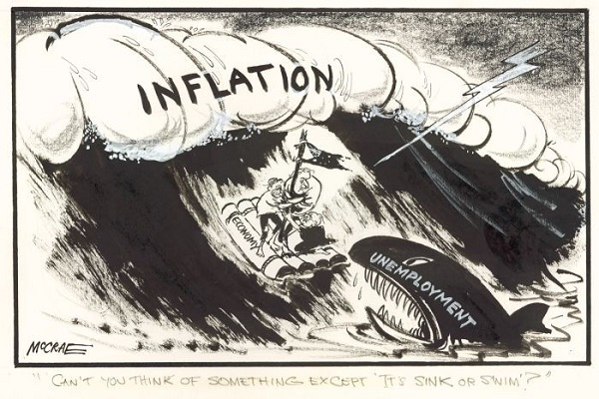
Brian. 2014. Whitlams economic performance: Time to think again. [Online] Available at: http://www.climateplus.info/tag/piketty_thomas/ [Last accessed: 25/02/2019]

Historical Origins and Growth
Liberalism has been around for a long time and exists as both an economic and political philosophy.
As a political philosophy it came to the forefront with John Locke in the 1600s as a political philosophy advocating for the virtues of individuality, freedom, tolerance, reason, rationality, the protection of rights and equality. Later the political version of liberalism became heavily associated with states to achieve peace through the exploitation of mutual interests and negotiation to avoid coercion or military might to achieve their aims. The European Union has been the best example of this theory in action and has been successful in achieving the aims of peace through the exploitation of mutual aims through negotiation and trade (Locke 1948).
Classical liberalism as an economic theory emerged with Adam Smith in the 1700s during the period of enlightenment. Adam Smith disliked mercantilism, a system of trade where the state heavily interfered with markets often imposing large taxes on imports into the country and maximising all exports and funding certain businesses ensuring a monopoly on a particular product, place, resource etc. Adam Smith advocated for the government to step back and allow the market to act independently. He also advocated for a country to maximise the industries it is best at and that another country to maximise what it does best and then trade the different products leading to mutual gains in wealth for both sides. With less state interference the market could move freely and expand creating great wealth for all, leading to wealth trickling down to those less wealthy so that all would benefit from this over time. The more specialisations a country had the greater wealth it could generate and the more luxury items a society produced the more surplus wealth could be generated to provide for those who were disadvantaged (Smith A 2008) (The School of Life 2014) (Free to choose network 2016) (Free to choose network 2016).
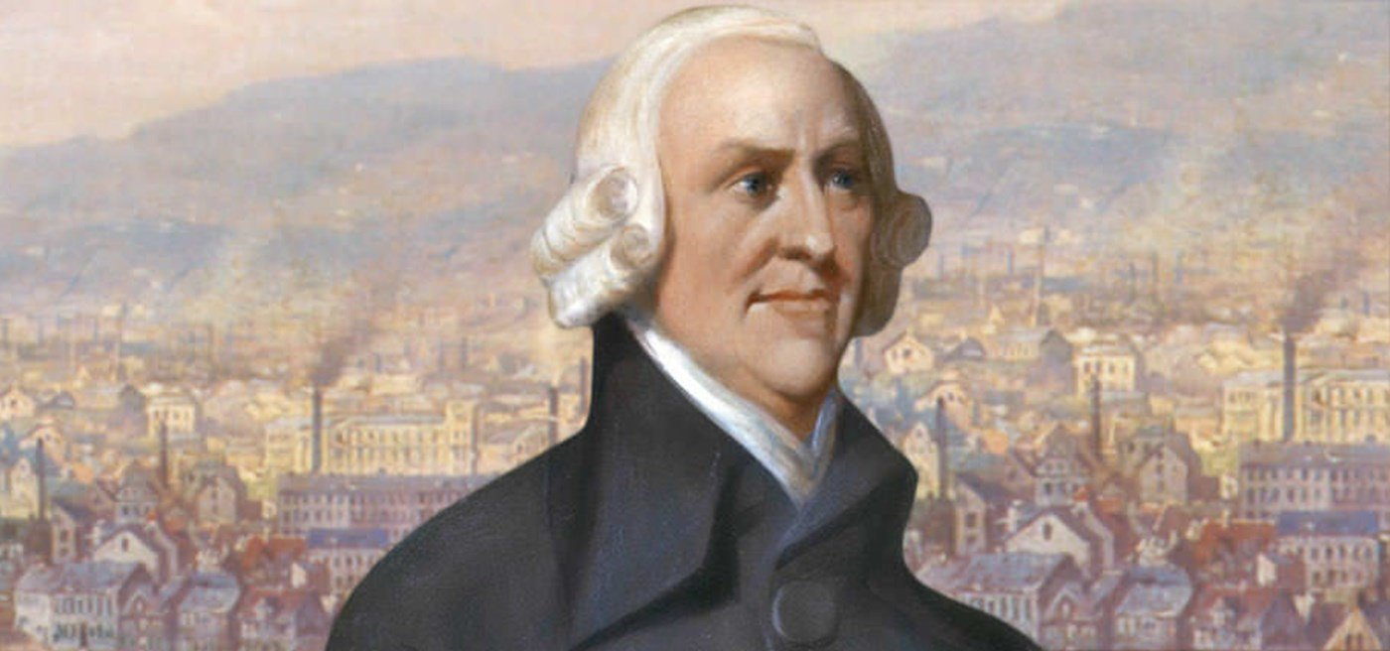
Adam smith Institute. 2017. Its Adam Smith’s Birthday. [Online] Available at: https://www.adamsmith.org/blog/its-adam-smiths-birthday [Last accessed: 25/02/2019]

Neo Liberalism emerged in the late 1970s due to the stagnation of the market in Britain and America where inflation and unemployment increased. This happened because after the Great Depression and World War Two an economist named Keynes advocated for the government to interfere with the market by creating large scale woks to create jobs for people during times of economic depression. Therefore as the depression finally shifted these projects could be sold off to capitalists and the government could earn its money back. However, this tactic eventually led to economic stagnancy during the 1970s which started to cause problems for the world economy and its governments. Another economist, Friedrich Hayek, advocated for a more classical approach to economics in the vein of Adam Smith with limited to no government interference, encouraging competition and the allowance of the market to shift freely. This way greater wealth can be generated and Margaret Thatcher and Ronald Reagan implemented this policy which led to large economic booms (The School of Life 2016) (The School of Life 2017) (Free to choose network 2016) (BBC 2018).
Issues
Neo-Liberalism has several problems. The outcomes and even intentions are rather different to what Adam Smith supported and is not the same kind of system he had advocated for.
One of the most pressing issues was that Neo-liberalism lacks the moral sentiment of which Adam Smith incorporated into his work. The wealthy who have gained these great riches do still give away great deals of wealth for charitable purposes but also manage to retain great portions of it despite the lack of needing it. Adam Smith claimed that vanity was at the heart of the desire for wealth and that those who seek great riches wish to be respected by others in society. Therefore it was a matter of exploiting that vice or giving it room to grow so that the wealthy could care for the poor or those less fortunate than them. However this particular value was not incorporated into Neo Liberalism and so has not been used to the extent it could be. Adam Smith also maintained the importance of purpose in work for the workers. When an industry was in a village everyone felt like they had meaning in that business whilst if it grew to a massive scale then people would begin to feel separate or as Marx put it, alienated. Adam Smith claimed that this was not good and so it was up to the capitalists or those in charge to try and keep a sense of community and purpose within their workforce. Again Neo-Liberalism lacks this moral sentiment as well, as we can see so many people feeling alienated from their jobs (Marx & Engels 1946) (Nisbet 1975).
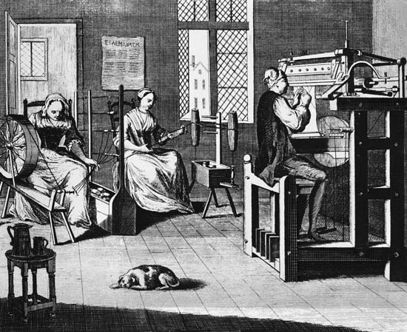
Britannica Kids. 2019. The cottage Industry in 18th Century England. [Online] Available at: https://kids.britannica.com/students/assembly/view/122191 [Last accessed: 25/02/2019]
Following on from this another central issue is that there are massive industries that have become transnational (NGOs known as non-governmental organisations). This has led to large workforces being alienated or feeling a lack of belonging or not feeling as though they are contributing anything meaningful. This has consequences for both the worker and the industry. If the employee does not feel they have meaning, it will lead to a lack of enthusiasm and poor mental health. For the industry an unmotivated workforce who feel a lack of meaning or belonging are not as productive and therefore not as profitable (Marx & Engels 1946) (Nisbet 1975).
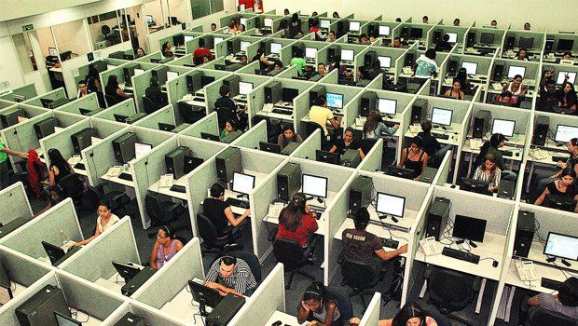
Gavroche.J. 2016. Against Labour, Against Capital: The Phenomenon of bullshit jobs. [Online] Available at: http://autonomies.org/2016/11/against-labour-against-capital-the-phenomenon-of-bullshit-jobs/ [Last accessed: 25/02/2019]
Furthermore with the rising power of NGOs, particular countries and especially companies dominating the markets of not only their home countries but others as well, reduce the ability of other countries to make gains in wealth and better circumstances in living (Marx & Engels. 1946) (Nisbet 1975) (BBC 2018).
Neo Liberalism, particularly in the form of globalization, has also had an erosive effect on the cultures around the world by replacing certain products which would normally be produced in the country in question and replacing them with (most likely) with mass producible products which the company creates and sells instead. Because of this the values of the culture from which the companies originate can become a dominating influence in the culture where they end up. As a result cultural norms can slowly erode over time as these industries become depended upon.
Lastly industries have grown to become so powerful and the market to be so important that the sovereignty of a state can become compromised by enormous NGOs and market forces. The weakest and most powerful nations on Earth are prey to these forces and some NGOs have the power or influence to control entire countries. Furthermore it has led to excessive consumption of natural resources which risk damaging or even destroying the lives of not only our generation but those who come after us, as well as the natural world in which we live (Wendt A 2005) (Marx & Engels 1985)
Conclusion
Neo Liberalism is a new form of classical liberalism which helped solve the economic issues of the 1970s leading to major economic boons. The government let the market ‘loose’ and withdrew their intervention to an extent. This had similarities to classical liberalism but had some drawbacks. This led to new wealth but it also helped with overconsumption, alienation, NGOs, erosion of state power and lacks much of the moral sentiment that Adam Smith advocated for in classical liberalism and based it on pure economics. Neo-Liberalism is a double edged sword and if it is not reformed then it will lead to disastrous outcomes in the long run.

Bibliography

BBC. 2018. An A- Z of –isms: Neoliberalism… the story of a big economic bust up. [Online] Available at: https://www.bbc.com/ideas/videos/neoliberalism-the-story-of-a-big-economic-bust-up/p06ltnvp?playlist=the-a-z-of-isms [Last accessed: 20/02/2019]

Free to choose network. 2016. The Real Adam Smith: Ideas that Changed the World Full Video. [Online] Available at: https://www.youtube.com/watch?time_continue=2&v=8ruiUOQERnw [Last accessed: 19/02/2019]

Free to choose network. 2016. The Real Adam Smith: Morality and Markets- Full Videos. [Online] Available at: https://www.youtube.com/watch?v=V6S6pMsKzlI [Last accessed: 19/02/2019]

Marx K. Engels F. 1946. Capital. London. Swan Sonnenschein, Lowery & Co.

Marx K. Engels F. 1985. Karl Marx and Friedrich Engels, The communist Manifesto, with an introduction by AJP Taylor. St Ives Plc. Penguin

Nisbet R A. 1975. The sociology of Emile Durkheim. London. Heinemann

Smith A. 2008. Wealth of Nations. St Ives Plc. Oxford University Press

The School of Life. 2014. Political Theory- Adam Smith. [Online] Available at: https://www.youtube.com/watch?v=ejJRhn53X2M [Last accessed: 25/02/2019]

The School of Life. 2016. Political Theory- Friedrich Hayek. [Online] Available at: https://www.youtube.com/watch?v=SHsCkinrCPE [Last accessed: 25/02/2019]

The School of Life. 2017. Political Theory- John Maynard Keynes. [Online] Available at: https://www.youtube.com/watch?v=qtAeINU3FKM&list=PLwxNMb28XmpeuwUhM0OT338_T5XTtJJok [Last accessed: 25/02/2019]

Wendt A. 2005. Constructivism and International Relations. London. Routledge
Locke. 1948. The Second Treatise of Civil Government and A Letter Concerning Toleration by John Locke. Oxford. Basil Blackwell

