DS 1 Template
Student ID: 2219181

My Screenshots/Photos
- Please add 4–6 screenshots or photos of your digital life.
- You can use your phone or laptop.
- For each screenshot, write one or two sentences explaining what it shows.

Screenshot/Photo 1
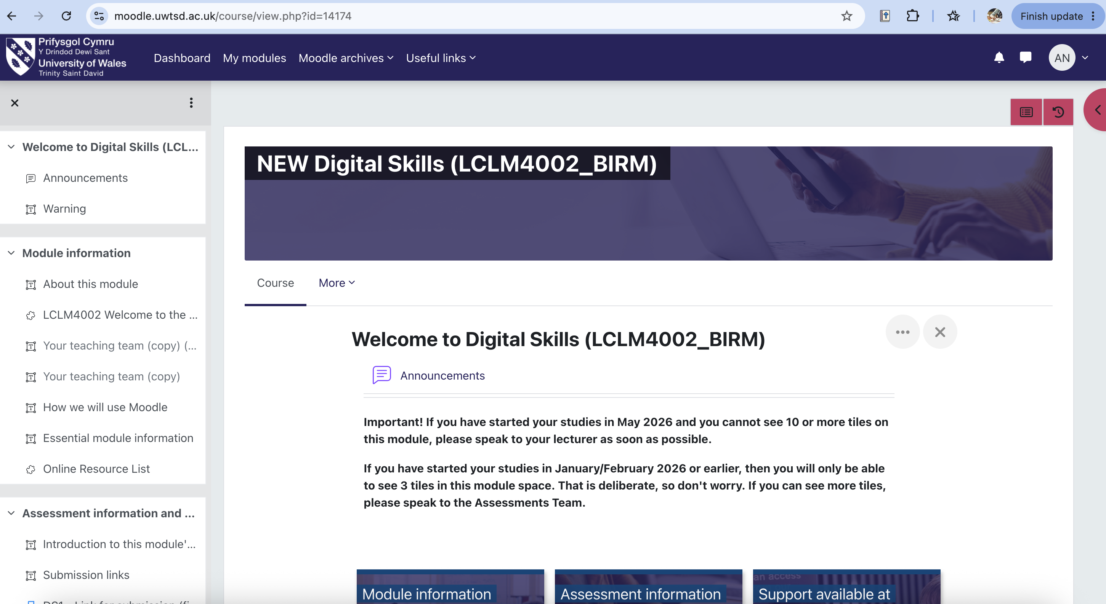
My screenshot shows the Moodle platform that I use for all my university studies. I use this platform to access my course materials, assessments and information related to the module

Screenshot/Photo 2
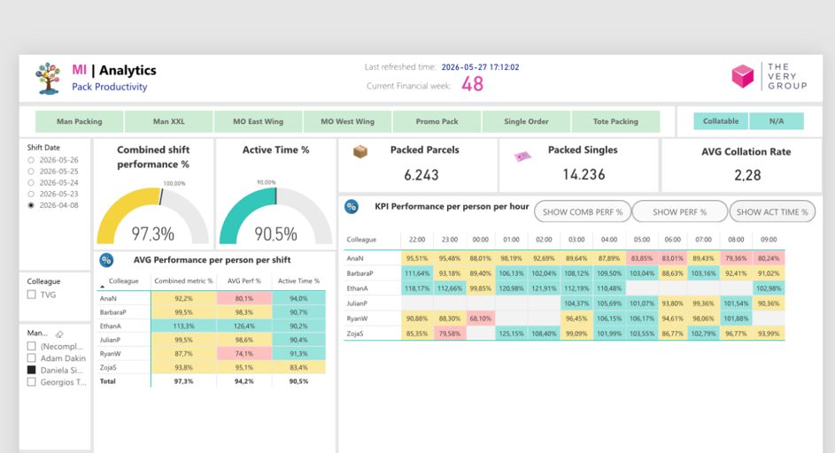
This screenshot shows the software called Power Bi, a data analytics tool I use at work. This software is mainly used to monitor performance but also analyze productivity data and track key performance indicators to support better decision making.

Screenshot/Photo 3
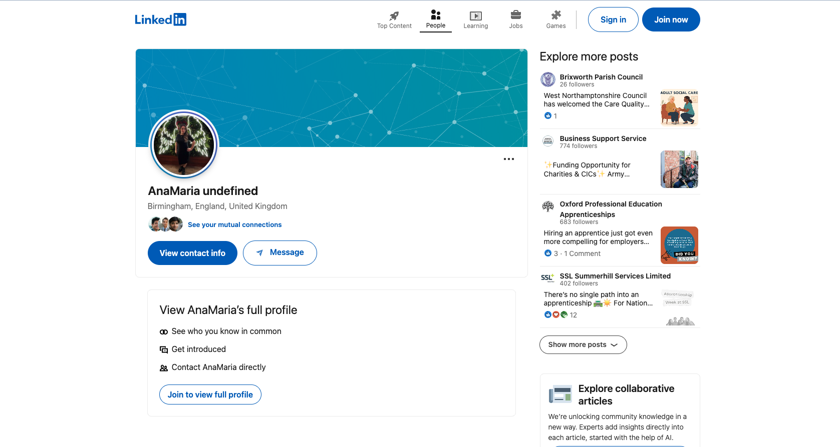
This screenshot shows my personal LinkedIn profile. I chose this platform to grow my professional network but also to find out about any opportunities that arise in my career. Another important reason why this platform is useful to me is to help me stay up to date with business and industry news. This is a very important tool especially for career development but also for career growth.

Screenshot/Photo 4
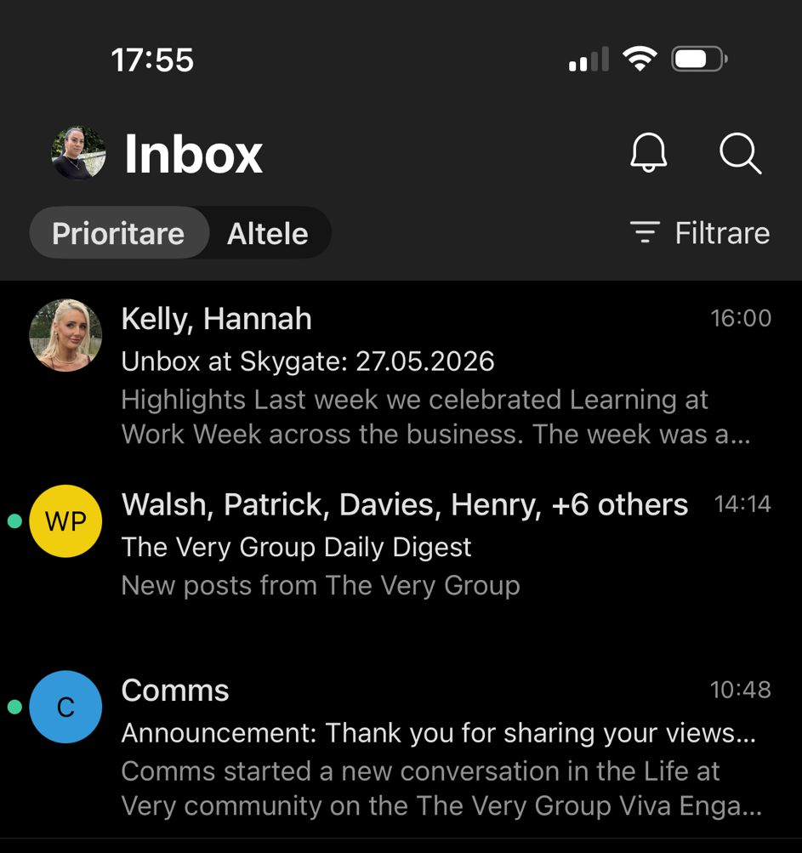
This screenshot shows my work email inbox, which I use to communicate with colleagues and receive important company updates. Thus, email is a very important digital tool that helps me stay organized, manage information, and stay on top of all my work-related tasks and announcements.

Screenshot/Photo 5
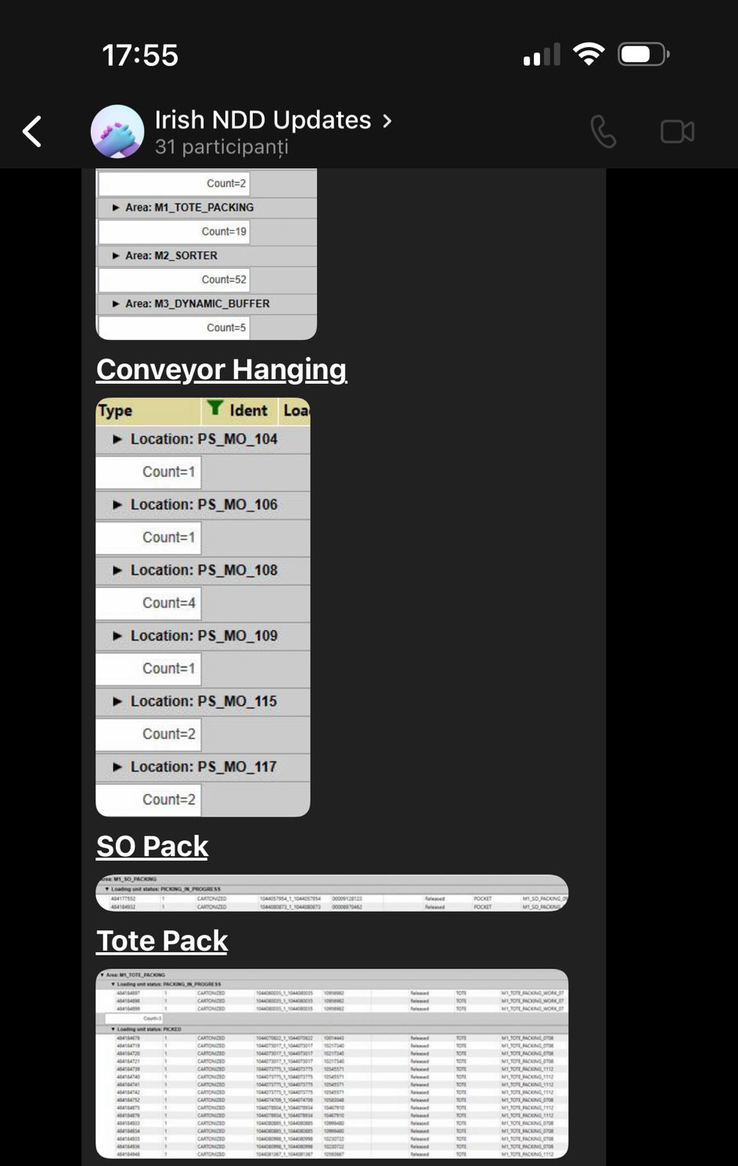
This screenshot shows a Microsoft Teams workgroup that I use to receive operational updates and work-related information. Teams helps me a lot to communicate with colleagues, share information quickly, and stay informed about tasks, such as work activity in real time.

Screenshot/Photo 6
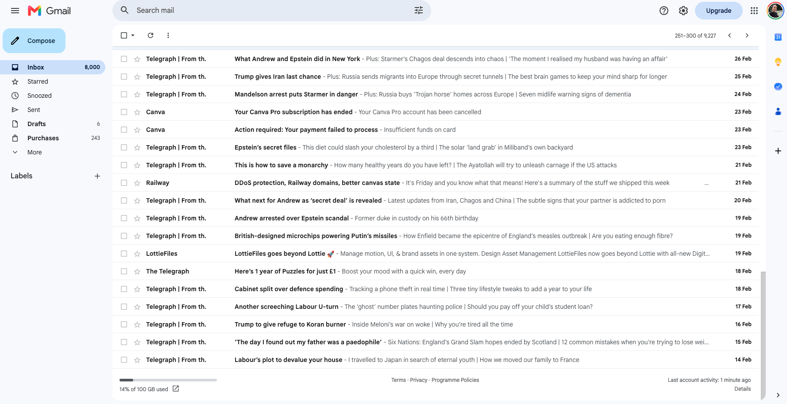
This screenshot shows my personal Gmail account, which I use to manage my emails and online accounts. Gmail helps me communicate, receive important updates, and keep track of all information related to my studies, work, and personal activities.

My Short Reflection
- Write 5–8 simple sentences about your digital life.
- You can use the sentence starters below if helpful.
I use digital tools every day for my personal life, for work and for studies. First of all, Moodle helps me access the materials offered by the university and complete all my university assessments. On the other hand, email and Microsoft Teams help me communicate and stay organized. I also use Power Bi at work to analyse data and monitor performance. I feel confident when using such digital tools, because it helps me work much more efficiently and manage information effectively. I want to improve my data analysis and digital communication skills, so that I can become more productive both in my studies and in my career. Very often I feel stressed and nervous when I have to learn a new software because very often it takes me a long time to learn and understand all its features.
I hope that this module will help me develop my digital skills as much as possible and increase my self-confidence when using technology. Digital skills are therefore important to me because they support my education, professional development, and future career opportunities.

Submission Checklist
Before you submit, please check:
​​​ ☒ I added 4–6 screenshots
☒ I wrote short sentences for each screenshot
☒ I wrote my short reflection
☒ My work is my own
☒ My file opens correctly
​​☒ My file opens correctly

