

LOCATION: Swansea | LLEOLIAD: abertawe
LEVEL 5 | LEFEL 5
EXAMINATION PERIOD | CYFNOD ARHOLIADAU
July 2017 | Gorffennaf 2017

MODULE CODE: M5X01118
DIGITAL ELECTRONICS
TIME: 2 HOURS
ANSWER ALL OF SECTION A
ANSWER ONE out of two in section b

Equipment or materials required – None
Adnoddau neu ddefnyddiau sydd eu hangen - Dim

SECTION A
ANSWER ALL OF SECTION A

- Design a circuit using the minimum number of gates to satisfy the truth table of table Q1a:

A | B | C | Y
0 | 0 | 0 | 1
0 | 0 | 1 | 1
0 | 1 | 0 | 0
0 | 1 | 1 | 0
1 | 0 | 0 | 0
1 | 0 | 1 | 1
1 | 1 | 0 | 0
1 | 1 | 1 | 1

Table Q1a

(6 marks)

- Write the Boolean equation and truth table for the circuit shown in figure Q1b

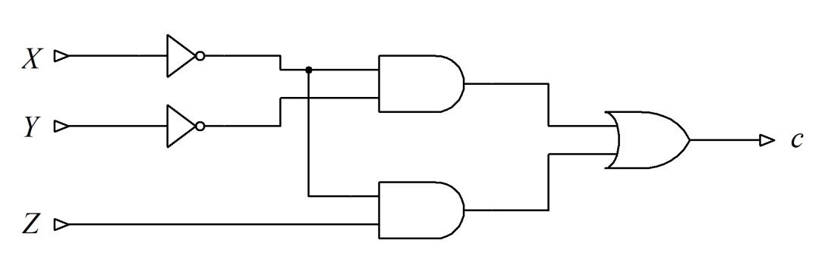
Figure Q1b
(6 marks)

- Find a simplified expression for the function F represented by the Karnaugh map of figure Q1c

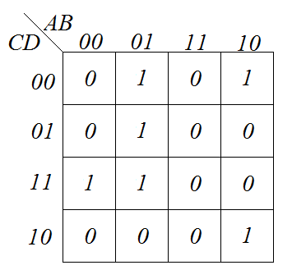
Figure Q1c
(6 marks)
- State the name of the logic function shown in each of the following truth tables

A | Y
0 | 1
1 | 0

A | B | Y
0 | 0 | 0
0 | 1 | 0
1 | 0 | 0
1 | 1 | 1

A | B | Y
0 | 0 | 0
0 | 1 | 1
1 | 0 | 1
1 | 1 | 0

A | B | Y
0 | 0 | 0
0 | 1 | 1
1 | 0 | 1
1 | 1 | 1

A | B | Y
0 | 0 | 1
0 | 1 | 0
1 | 0 | 0
1 | 1 | 0

A | B | Y
0 | 0 | 1
0 | 1 | 0
1 | 0 | 0
1 | 1 | 1

A | B | Y
0 | 0 | 1
0 | 1 | 1
1 | 0 | 1
1 | 1 | 0
(7 marks)

- Using De’ Morgan’s theorem to manipulate the following expressions, draw a circuit to satisfy each expression using only NAND gates.

- $L=\left(X+\overline{Y}+Z\right)∙\left(X+Y+\overline{Z}\right)$

- $M=\overline{A+\overline{B}+C}$

- $N=\left(X∙Y\right)+\left(\overline{X}∙Y∙Z\right)+(\overline{X}∙Y∙\overline{Z} )$
(9 marks)

- The circuit shown in figure Q2b has a fault in its design. It should function as shown in the truth table of table Q2b. Determine which gate or gates are incorrect and

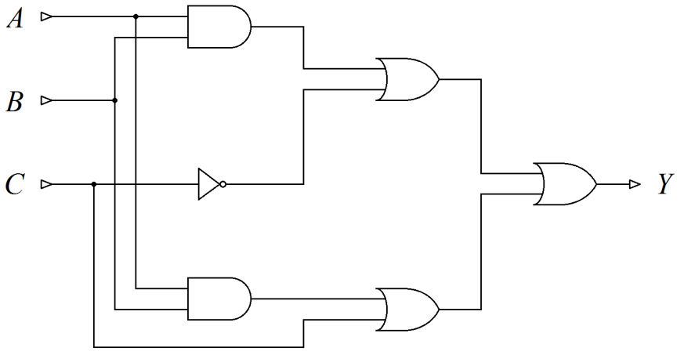
Figure Q2b

A | B | C | Y
0 | 0 | 0 | 0
0 | 0 | 1 | 0
0 | 1 | 0 | 0
0 | 1 | 1 | 0
1 | 0 | 0 | 0
1 | 0 | 1 | 0
1 | 1 | 0 | 1
1 | 1 | 1 | 1

Table Q2b
(16 marks)

SECTION B
ANSWER ONE out of two in section b

- Design a circuit that will operate as a three to eight line decoder, as described by the truth table of table Q3a

A | B | C | S | T | U | V | W | X | Y | Z
0 | 0 | 0 | 0 | 1 | 1 | 1 | 1 | 1 | 1 | 1
0 | 0 | 1 | 1 | 0 | 1 | 1 | 1 | 1 | 1 | 1
0 | 1 | 0 | 1 | 1 | 0 | 1 | 1 | 1 | 1 | 1
0 | 1 | 1 | 1 | 1 | 1 | 0 | 1 | 1 | 1 | 1
1 | 0 | 0 | 1 | 1 | 1 | 1 | 0 | 1 | 1 | 1
1 | 0 | 1 | 1 | 1 | 1 | 1 | 1 | 0 | 1 | 1
1 | 1 | 0 | 1 | 1 | 1 | 1 | 1 | 1 | 0 | 1
1 | 1 | 1 | 1 | 1 | 1 | 1 | 1 | 1 | 1 | 0

Table Q3a
(19 marks)
- Design a state diagram from the following specification:

A vending machine serves coffee for 20p per cup. The machine will only accept 5p and 10p coins and does not give change. When the total of all coins entered is equal to, or greater than 20p the vending machine will dispense a cup of coffee and return to an idle state to wait for the next customer.

Note: A circuit design is NOT required.
(6 marks)

- Design a circuit using combinational logic and D-type flip flops that will repeatedly count through the following sequence: …,0,7,5,3,1,2,6,4,0,7,5,3,1,2,6,4,0…
(19 marks)

- Show how D-type flip flops can be used to construct a 4 bit serial input shift register.
(6 marks)
Diwedd/End

