Arif Khamis Yussuf

EVOLVING YOUR CREATIVE CRAFT
(ACCA5045 – Component 1)
ARIF KHAMIS
2305406
Contents – Assignment Component 1
TASK A – Mind Map – 2-5
TASK B – Moodboard – 6
TASK C – Rough Designs – 7-9
References – 10

TASK A – MIND MAP - Room Design
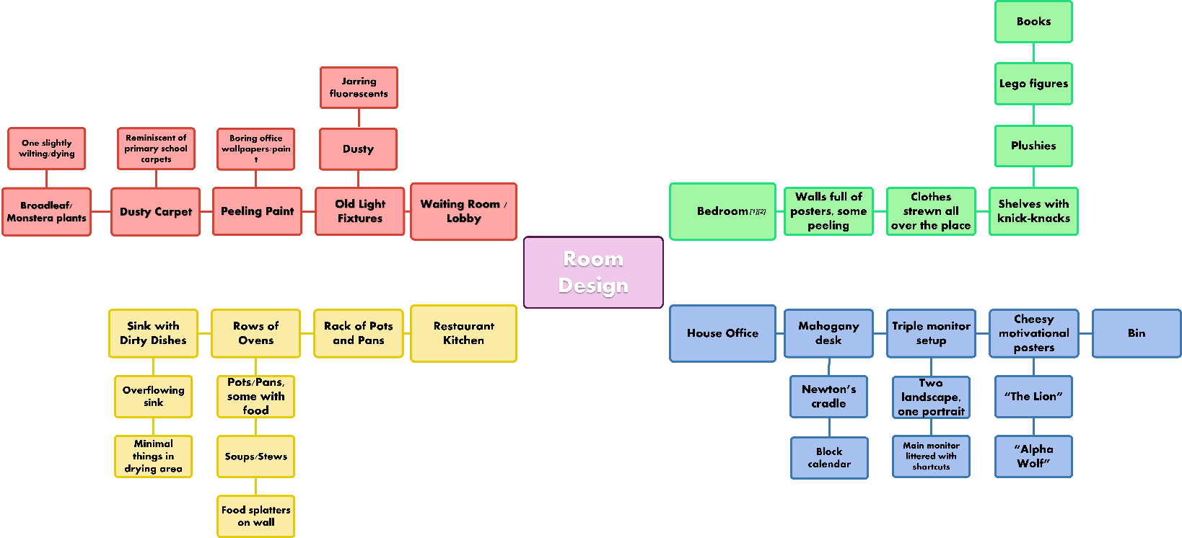
(Location)

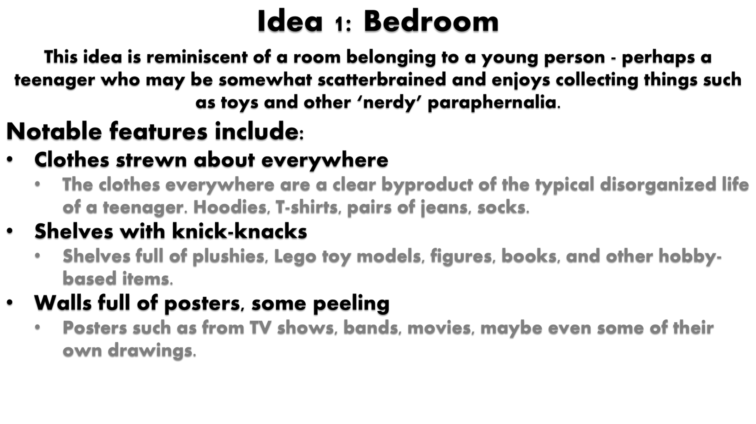
Mind Map – Elaboration

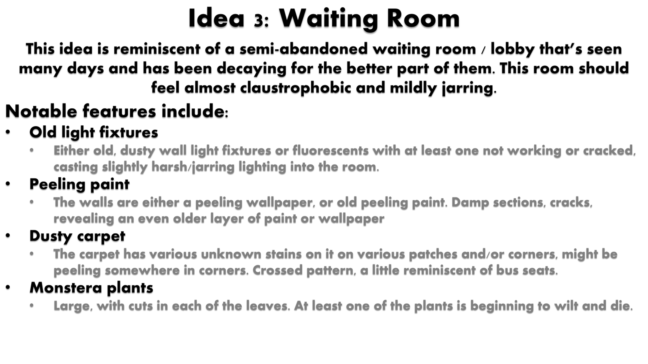
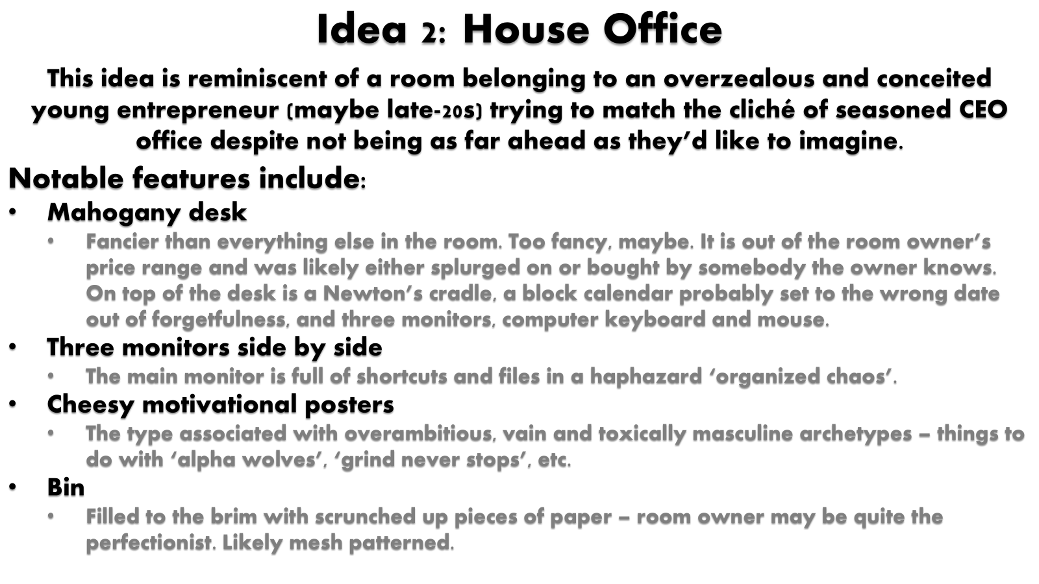
[3]

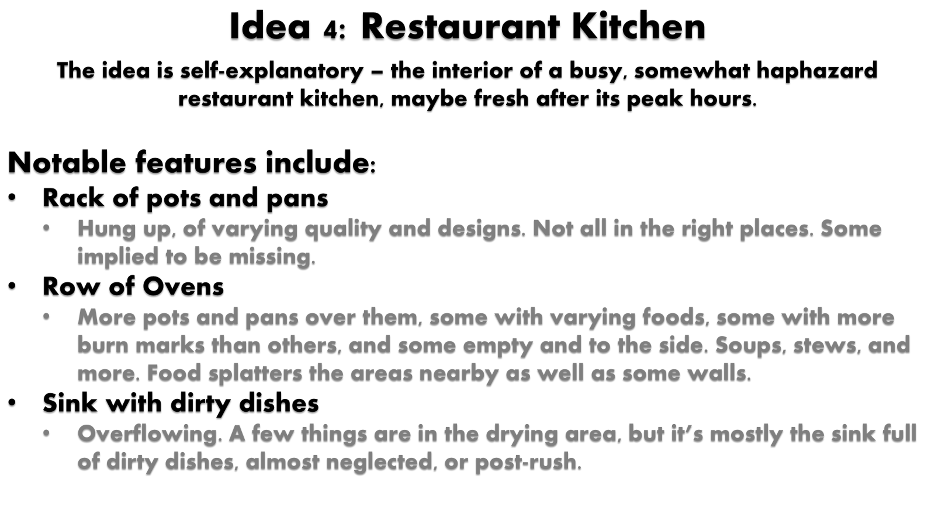

TASK B – MOODBOARD

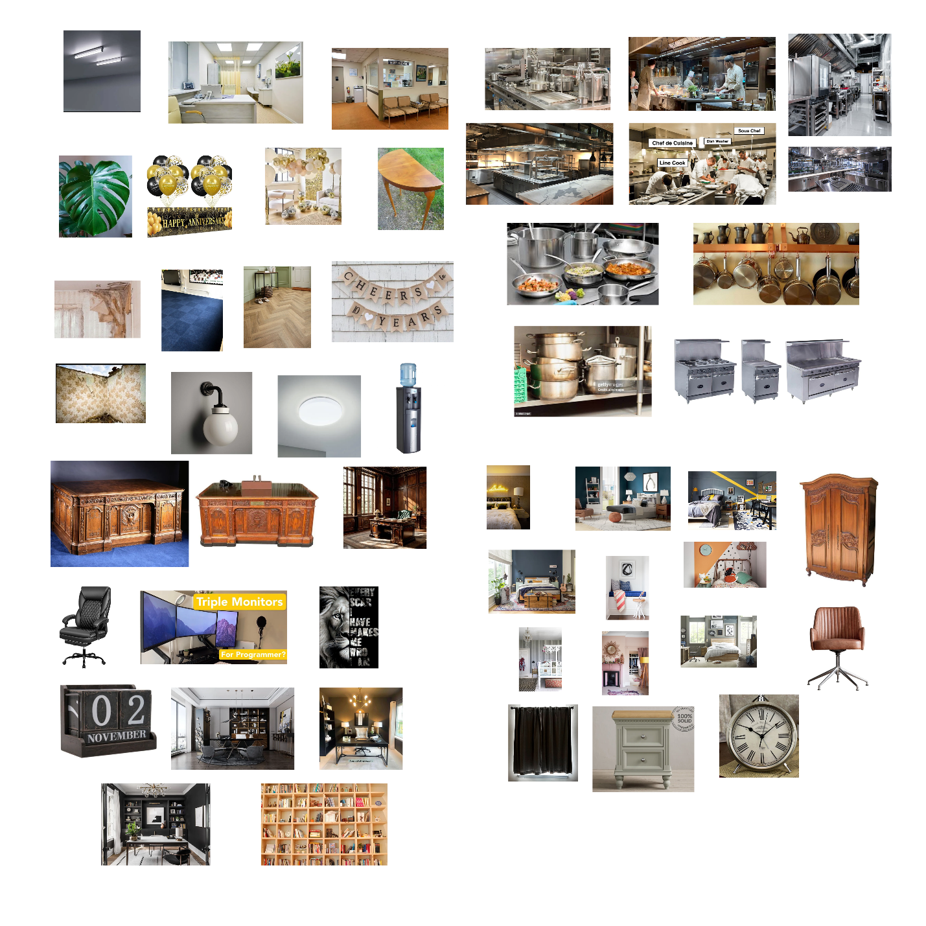

TASK C – ROUGH DESIGNS

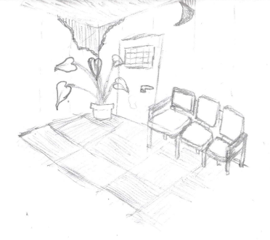
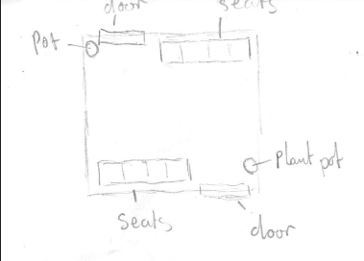

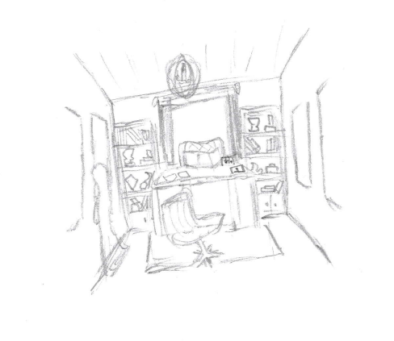
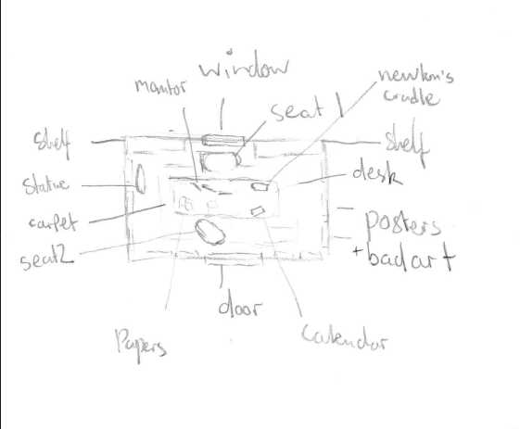

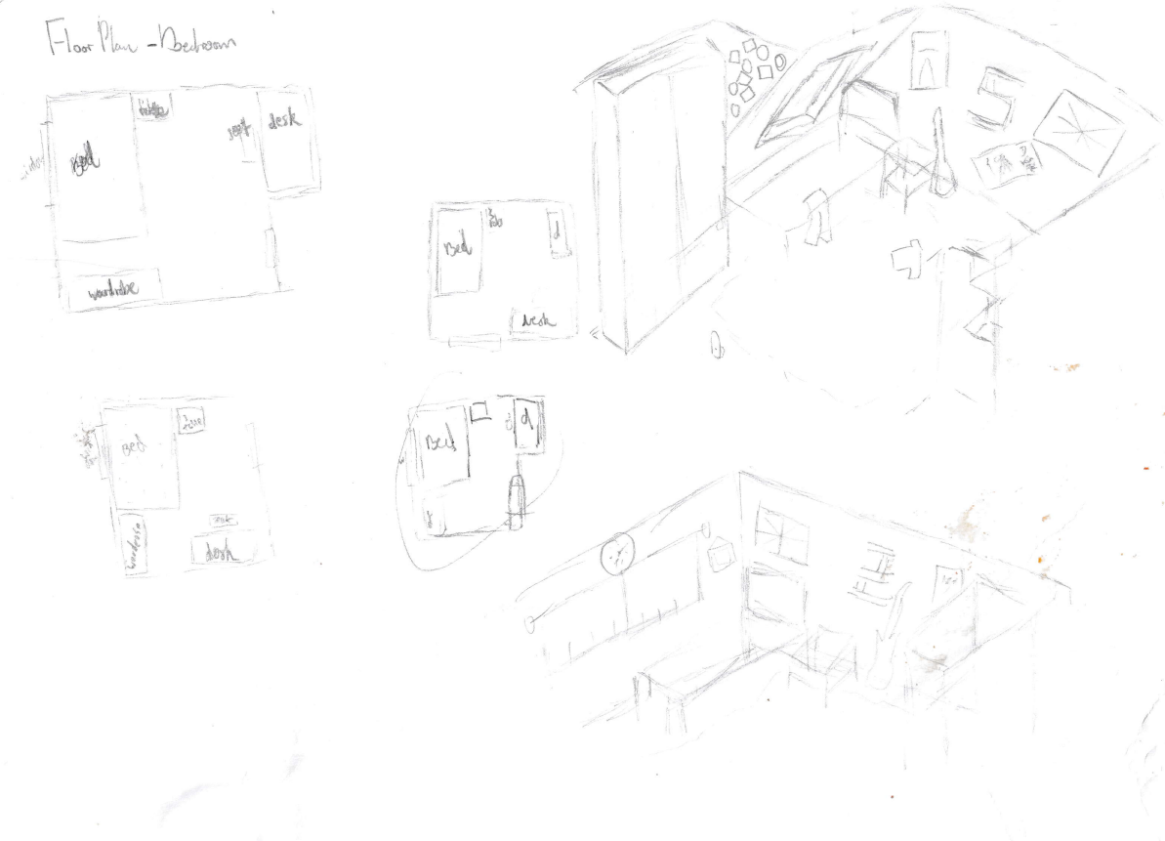

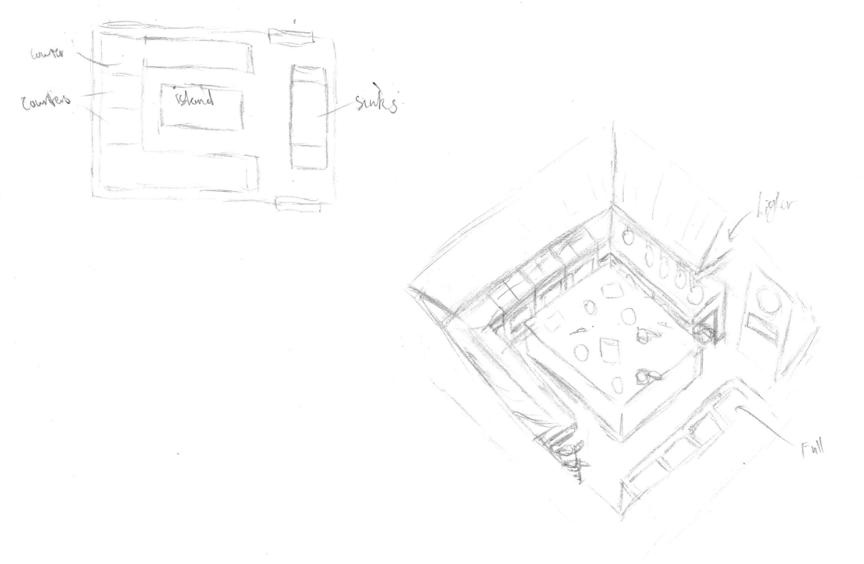
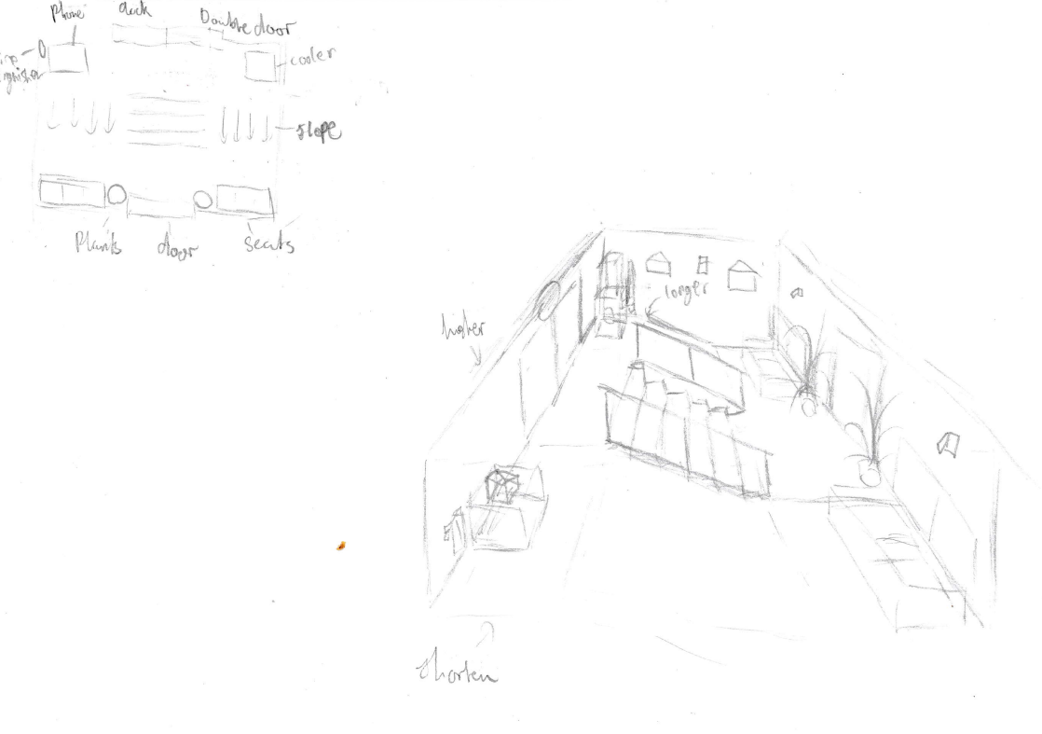
[1]
C. Best, “10 teenage bedroom ideas your children will love according to interior designers,” HELLO!, Mar. 14, 2023. https://www.hellomagazine.com/homes/20230314166720/teenage-bedroom-ideas/
‌
[2]
H. Hatton, “20 teenage bedroom ideas to make decorating a teen’s space simple,”
Livingetc, Oct. 07, 2021. https://www.livingetc.com/ideas/teenage-bedroom-ideas‌

[3]
saxon, “Office Reception & Waiting Room Ideas | Designs & Layouts | Sofas by Saxon,” Sofas by Saxon | Blog -, Sep. 05, 2023. https://www.sofasbysaxon.com/get-inspired/office-reception-and-waiting-room-ideas-design-tips-and-layouts/?srsltid=AfmBOorgAJgnMhyLFi00HTf2fK-LPmHVKhjysYgd28vciQIjS2BrfeE1‌

