Digital portfolio

Module: Managing Organisations
Module Code: SHNS4008
Motivation in Leadership and Management Report

Contents Page
Abstract
Introduction
Aims and Objectives
Main Body and Key Findings
Conclusion and Recommendations
Reference List

Abstract 100 words
This report is evaluating: The role of leadership & management within the NHS. The aims and objectives of this report is to evaluate the role of leadership & management within the NHS.
Introduction 300 words
This report is evaluating: The role of leadership & management within the NHS.

Aims and Objectives 200 words
The aims and objectives of this report is to evaluate the role of leadership & management within the NHS.
Main Body and Key Findings
The evidence shows that within the NHS there is at least one management/leadership theory in practice (Rowling, 2011). John Kotter’s Management Theory (1996) is the theory most in use in the NHS. Kotter (1996) outlines the management tools that are needed to create good management practice, they are;’ planning, budgeting, organising, staffing, controlling and problem-solving and leadership processes that involve establishing direction, aligning people, motivating and inspiring’ (Kotter, 1996 cited in Rowling, 2011, p.12).
According to the Corporate Finance Institute (CFI) (2015-2019) ‘management theories are concepts surrounding recommended management strategies, which may include tools such as frameworks and guidelines that can be implemented in modern organizations’ (CFI, 2015-2019, p.1). Usually individuals do not rely exclusively on one management theory, but use several different management theories that best suit their workforce and company (CFI, 2015-2019, p.1).
There are several popular management theories these include; the Scientific Management Theory, created by Fredrick Taylor in 1911, the Systems Management Theory, the Contingency Management Theory, created by Fred Fiedler in the 1960’s and the Theory X and Theory Y, created by Douglas McGregor in 1960 (CFI, 2015-2019, p.1). (See Fig.1)
Firstly the Scientific Management Theory (1911) Taylor’s philosophy highlighted the fact that forcing people to work hard wasn’t the best way to get results. Taylor recommended making things simpler to increase productivity, he developed the “fair day’s wages for a fair day’s work” concept (CFI, 2015-2019, p.1). Secondly the Contingency Management Theory (1960) Fiedler’s theory suggests that there is a set of leadership qualities for every situation, which means that a manager must be flexible enough to adjust to any changes in the work place (CFI, 2015-2019, p.1). Lastly the Theory X and Theory Y (1960) McGregor’s theory looks at two concepts of work place practice, those people who work for just the money and those who work as they find the job rewarding bringing much more to the work place, they are not motivated by the money. McGregor developed these two contrasting concepts these ‘theories refer to two management styles: the authoritarian (theory X) and participative, (theory Y)’ (CFI, 2015-2019, p.1).
There are three basic types of management skills that are needed to be a good manager and an asset to the NHS, Robert Katz explains them as Technical skills, Conceptual skills and Human or Interpersonal Skills (CFI, 2015-2019, p.1). (See Fig.2)
According to the King’s Fund Commission’s report, Rowling (2011) ‘the health service has a long history of attempting to improve both management and leadership’ (Rowling, 2011, p.9). There have been many reports on the management and leadership in the NHS since the 1960’s. The Griffith’s report of 1983 stated that, ‘if Florence Nightingale were carrying her lamp through the NHS today, she would be searching for the people in charge’ (Griffith, 1983 cited in Rowling, 2011, p.9). The King’s Fund Commission’s report goes on to say in its recommendations that, ‘over recent years there has been considerable investment in both management and leadership development. These gains must not be lost in the transition to a redesigned health system’ (Rowling, 2011, p. viii).
Rowling (2011) goes on to say that ‘leadership development needs to extend ‘from the board to the ward’. The biggest weaknesses in the NHS is its failure to involve clinicians in a continuous way in management and leadership. Individuals within the NHS need to have the ability and the confidence to challenge poor practice (Rowling, 2011, p. ix).
In order to evaluate of the importance of leadership and management within the NHS, health care depends on interaction between all areas of the NHS, the organisation and management of its delivery does not always reflect this understanding. In the UK, the NHS has’ separate budgets and performance targets for primary care, secondary care, and social services promotes an internal focus on the operation of each of these parts, but not necessarily the good functioning of the system as a whole’ (Plsek and Wilson, 2001).
The evaluation of the impact of organisational structure and culture in supporting or hindering leadership and management within the NHS, with particular reference to the motivation of employees. The NHS in England has had a number of initiatives that have had a complex impact on the management and administration costs, more widespread is the contracting out the support services much more than in either Scotland or Wales. This has directly increased the numbers of contract managers in the NHS (Rowling, 2011, p. 8).
Not all NHS management is effective, in many reports from the National Audit Office prove that far better value for money could be achieved by improving the management of purchasing, behind the scenes functions and estates, the skills needed to manage these essentials of the NHS are in short supply across the public sector (Rowling, 2011, p. 8).
According to Dorgan et al. (2010) cited in Rowling, (2011, p.15) in Europe and the USA well-managed hospitals giving higher quality patient care and improved productivity, were those who had clinically qualified managers, so producing much better results. The uses of these health care professional in decision-making and accountability should be entrusted as closely as possible to the clinical front line. Successful performance in the NHS needs continuous leadership and that sustains a focus on improving performance line (Dorgan et al. (2010) cited in Rowling, 2011, p.15).
‘Leadership must be exercised across shifts 24/7 and reach to every individual: good practice can be destroyed by one person who fails to see themselves as able to exercise leadership, as required to promote organisational change, or who leaves something undone or unsaid because someone else is supposed to be in charge’ (Turnbull and James 2011, cited in Rowling, 2011, p.19).
The evaluation of the possible impact upon service users if NHS employees are lacking in motivation.’ Line managers need training and support to manage employees’ (Weyman, Meadows and Buckingham, 2013, p.33).
For staff to remain productively employed there needs to be a fit between the demands of their job, their working environment, their personal circumstances and their capability. (Weyman, Meadows and Buckingham, 2013, p.32).
According to Weyman, Meadows and Buckingham (2013, p.32) there are extensive claims of disruption between the way that jobs have traditionally been configured in the NHS and the preferences and needs of the workforce for example; older workers, young parents and disabled people. Weyman, Meadows and Buckingham (2013) go on to say that opportunities for flexible or reduced hour working in the NHS are limited. The possibilities for flexible and part-time options varies by job role and grade.

Conclusion and Recommendations 300 words

Reference List
Corporate Finance Institute (2015-2019) Management Theories. Available at: https://corporatefinanceinstitute.com/resources/careers/soft-skills/management-theories/ (Accessed: 28 March 2019).
Corporate Finance Institute (2015-2019) Management Skills. Available at: https://corporatefinanceinstitute.com/resources/careers/soft-skills/management-skills/ (Accessed: 28 March 2019).
Plsek, P. E. and Wilson, T. (2001) ‘Complexity science Complexity, leadership, and management in healthcare organisations’, British Medical Journal, 323(September), pp.746-749.
Rowling, E. (ed.) (2011) The future of Leadership and Management in the NHS: No More Heroes: Report from The King’s Fund Commission on Leadership and Management in the NHS. London: The King’s Fund Commission.

Weyman, A. and Meadows, P. and Buckingham, A. (2013) Extending Working Life: Audit of research relating to impacts on NHS Employees. London:NHS.

Appendix
Fig. 1
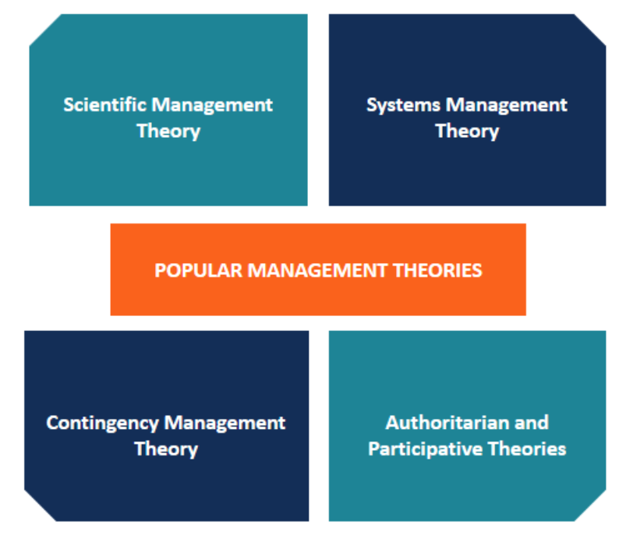
Corporate Finance Institute (2015-2019) Management Theories. Available at: https://corporatefinanceinstitute.com/resources/careers/soft-skills/management-theories/ (Accessed: 28 March 2019).

Fig.2
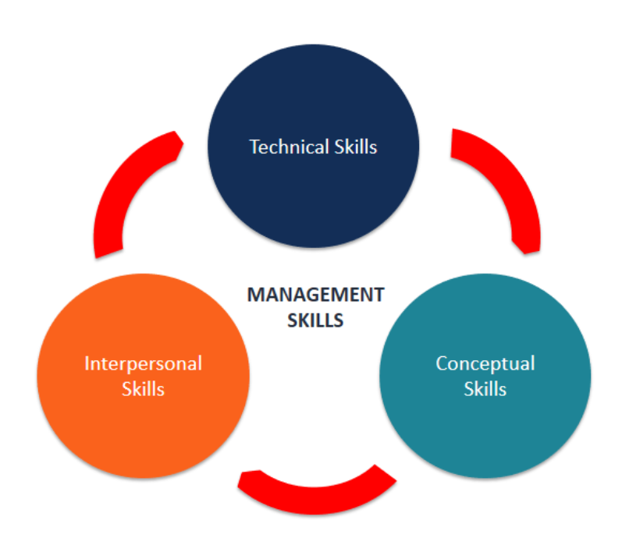
Corporate Finance Institute (2015-2019) Management Skills. Available at: https://corporatefinanceinstitute.com/resources/careers/soft-skills/management-skills/ (Accessed: 28 March 2019).

Stephanie Hall Digital Professional Portfolio SHNS4007
1809862

Interview Write-Up
This report is a write-up and reflection following the mock-interview I attended. I shall be using Gibbs’ reflective cycle (1988) in order to reflect on my experience during the interview and will organise my thoughts according to the following: Description, Feelings, Evaluation, Analysis, Conclusion and Action Plan. It is important to apply the reflective cycle because it encourages people to think about their experiences, to learn from them and to put an action plan in place for the future.

Description
The interview was held on 8th March 2019 and included me and five other nursing students. The purpose of the interview was to give us practice in interview techniques and the opportunity to reflect on experience so that we can improve our performance in the future. We were also given feedback on our cvs (CV Library, 2019). On the interview panel was a representative from the Welsh government as well as two second year students from UWTSD. We were asked four questions, which are stated below:
- What skills do you possess that will help you to become a nurse?
- Why is communication important when working as a nurse or a health professional?
- What is the best way for staff from the health sector to show dignity for all service users and patients?
- Describe a challenging situation you have experienced and how you dealt with it.

Feelings
I did not feel very confident because I was in a group with others who were quite talkative. However, I felt I dressed in the right clothes for the occasion, which were smart/casual, even though this was a mock interview. I did think that if this were a formal interview, I would wear a dress and jacket. I was sitting cross legged and felt quite tense throughout the whole interview. When we were asked the first question, I was keen to give my response, which I thought was good as I explained that I felt strongly that people who are vulnerable should have a voice, and that I can act as a voice for them. However, as the interview went on, I felt less confident because the other students seemed to have much more to say than me. I felt I could have said more when I responded to the other questions, but it was difficult to interrupt others who were talking. I felt the more I tried to think of what to say, the more my mind shut down. This made me feel anxious and overwhelmed. I felt the interviewers could have done more to make sure everyone had a chance to speak, although for the last question, the woman on the panel from the Welsh government tried to encourage me to think of a challenging situation so that I could answer the question. Even though I felt nervous throughout the interview, I was pleased with the feedback I received.

Evaluation
Whilst I could have contributed more during the interview, my responses were relevant, even if they were brief. When I received my feedback, it was better than I was expecting, and I was told I had met the requirements in the answers I gave. This suggests that my lack of confidence got the better of me at the time and that had I not been so nervous, I could have done much better. My nervousness showed in my body language as I sat cross-legged and hunched. I have since learned there is a correct way to sit in interviews so as to appear relaxed (Health Careers, n.d.). I also feel I could have prepared more as this is expected (People First, n.d.) and if I had done so I would have appeared more confident.

Analysis
What was helpful during the interview was that the interviewers seemed friendly and keen for us to learn from this experience. It was helpful to listen to what others had to say so I could learn more about how to conduct myself in interviews (People First, n.d.). However, I was very put off by the overconfidence of some of the other students who I felt dominated the interview; this made me feel as if I did not have anything valuable to say. I also felt that the interviewers could have broadened the questions to include other work in the health sector as the questions were all geared towards nursing, and I want to pursue a career in social work. If this had been the case, I might have been able to say more.

Conclusion
I could definitely have contributed more to the interview and in future I would prepare better (Interview tips). I need to learn how to develop my responses and I could do this by giving more thought to the kind of questions that might be asked, especially in relation to essential skills needed to work in the health sector (Skills for Care n.d) and difficult scenarios that I have dealt with in my work. I now realise that this is an essential part of the planning process for interviews (People First, n.d.) and that if you are prepared then you are less likely to feel nervous.
I am pleased that the feedback I received from the panel was quite positive and it was useful to help me develop and feel more prepared in the future. I also received constructive feedback in relation to my cv and will research more on how to improve it (Socialcare, n.d.). I learned a lot from this experience about how to improve my performance.

Action Plan
These are my points for my action plan:
- Make sure I prepare well for future interviews and prepare responses to questions on skills and what I have learned from particularly challenging situations
- Develop my cv more and tailor it to the role that I am applying for
- Ensure that I appear relaxed by sitting properly and maintaining eye contact with the panel
- Seek further advice from tutors about how I can improve my performance and take their comments on board
- Be more confident in myself that I have the skills to make a positive contribution to other people’s lives, as I believe this is the most important quality to have if you work in the health and social care sector

References
Gibbs, G. (1988). Learning by Doing: A Guide to Teaching and Learning Methods. Oxford: Oxford Further Education Unit
CV Library, (2019) Job Interview Tips: Your Complete Guide to Success Available at:
https://www.cv-library.co.uk/career-advice/interviews/job-interview-tips-complete-guide/
(Accessed: 1st May 2019)

NHS (n.d.) Applications and Interviews Available at:
https://www.healthcareers.nhs.uk/career-planning/improving-your-chances/planning-your-career/applications-and-interviews
(Accessed: 1st May 2019)

People First (n.d.) Competency Based Questions and Sample Answers Using Situation, Task, Action, Result (STAR) Available at:
https://peoplefirst.nhsbt.nhs.uk/People%20First%20-%20Document%20Library/OWD/Guidance%20-%20Competency%20Based%20Questions%20and%20Sample%20Answers.pdf
(Accessed: 1st May 2019)

Skills For Care (n.d.) Core Skills Available at:
https://www.skillsforcare.org.uk/Documents/Learning-and-development/Core-skills/What-are-core-skills-in-social-care.pdf
(Accessed: 1st May 2019)
Socialcare (n.d.) Create a Social Care CV Available at:
https://www.socialcare.co.uk/care/blog/create-a-social-care-cv/
(Accessed: 1st May 2019)

Stephanie Hall 1809862 Introduction to Health Research SHNS4006

Evaluating the Research Article on The Role of District and Community Nurses in Bereavement Care: a Qualitative Study

It is important to review other people’s work for several reasons. Firstly, it helps to gain a deeper understanding of a research area which is useful to further your own knowledge. Also, by reviewing research, it highlights areas of concern and tests hypotheses in relation to a research topic. It also gives you an insight into the research process which is an essential part of improving the quality of care in the health sector (Robert Wood Johnson Foundation, 2008)
The title is clearly stated which is important because it gives a condensed summary of what the research paper is about and it also tells us what kind of study it is, namely a qualitative study. From this, readers will know that the research has used a qualitative methodology to gather data in relation to the delivery of bereavement care.
The study is about the role of district and community nurses when they are delivering palliative and bereavement care. The study is important because as it is stated at the beginning of the article, for those people who are recently bereaved, the care that they receive is an ‘essential component’ of quality care of their loved ones (Johnson, 2015, p. 494). The writer of the article is a lecturer in Adult Nursing at Oxford Brookes University, so it is very likely that she has the necessary professional background to undertake the study.
The abstract is informative because it provides an overview of the whole study as well as a brief statement in relation to each section of the study. In other words, it outlines the background, aim, method, findings and conclusion of the research undertaken and also includes headings to make this information more accessible (Johnson, 2015). The purpose of providing an informative abstract is to give the reader a sense of the purpose of the study, the context in which it was conducted and a brief reference to the study’s conclusions (Robert Wood Johnson Foundation, 2008). Key words are also provided in the abstract in order to focus the reader’s mind on important elements of the study.
The researcher chose to publish the literature review in a separate document, published in the same year as this paper, namely 2015. It is not clear why the researcher chose to do this. Therefore in this research paper, there was no literature review even though it was referred to.
The aim of the study is to find out more from the district nurses about how bereavement care is incorporated into end of life care. This is particularly important because district nurses are the main providers of end of life care. The researcher states that the importance of bereavement care is not always recognised, so the study’s aim is to establish whether this is because of a ‘lack of awareness’ about how to deliver it (Johnson, 2015, p. 494). In this respect, the aim of the study is very important because it gives the reader focus when reading the article, but also it is something the reader can refer back to and judge whether the study’s aims were met. In relation to this article, the study aim is clearly stated and also highlights the challenges in relation to bereavement care.
The study design is commented on and the methodology justified as a ‘qualitative paradigm’. This paradigm is most appropriate because the aim of the study was to gain insight into people’s ‘perceptions or meanings, attitudes, beliefs, feelings and emotions’ (Denscombe, 2014 cited in Johnson, 2015, p.495). As the research is exploring the quality of bereavement care, it is most appropriate to use a qualitative methodology. A qualitative methodology seeks to explore phenomena, or situations, using flexible styles, such as interviews and observations, to gather data (Rangachari, 2005).
The sample for this research project was small, consisting of five nurses with a background in district or community nursing. In the article, it states that the participants needed to have at least two years’ experience; it was felt that this would ensure that the participants had adequate experience in the provision of bereavement care. The sample was restricted to five people because it was felt that otherwise there would be too much data to analyse from the transcripts and because a larger sample might produce repetitive responses (Parahoo 2014, cited in Johnson, 2015). In this respect, the sampling was purposive and the ‘determinant’ was establishing whether the nurses had sufficient skills and knowledge to deliver effective care (Johnson, 2015, p. 496).
The data was collected using a semi-structured interview with each of the sample group. In the article, it states that a semi-structured interview is a significant form of data collection in qualitative studies (Braun and Clarke, 2013 cited in Johnson, 2015). This is because semi-structured interviews give participants the opportunity to ask questions or provide more detail in their responses (Robert Wood Johnson Foundation, 2008). The researcher states that this method is preferred because of the study’s aim to gain insight into the nurses’ perspectives on bereavement care. It was also felt that because this is a study about bereavement, which is a sensitive topic, participants should be free to discuss problems or barriers they have encountered in their practice (Johnson, 2015).
However, the researcher does not provide procedures for assessing the reliability and validity of their data collection and this could be considered a weakness. Neither does the researcher provide any further detail the format of the semi-structured interview other than what has already been mentioned. This could be also considered a weakness of the study. However, the researcher does justify their choice of method in collecting data and clearly sets out why the semi-structured interview was the most appropriate method of gaining data.
The researcher sought approval for this study from the University of Chester as well as the NHS establishment where she had previously worked. In addition to this, the researcher sent each participant a description of the project and its objectives so that they could spend time thinking about whether they wanted to participate. Consent forms were signed by all participants and anonymity was maintained from the start to the finish so that no nurse could be identifiable. However, it is not clear whether participants were given the right to withdraw from the study if they so wished (Johnson, 2015).
The data was transcribed verbatim, which means that everything that was said during the participants’ interviews was written down. The researcher describes this as a ‘phenomenological study’, which means that it is a study into a particular event or experience (Centre for Innovation in Research and Teaching, n.d.) As stated in the article, a thematic analysis is usually used because this study is analysing the experiences of the participants and trends or patterns in their experiences. This is clarified when the researcher states that patterns and trends within the data were identified and linked as ‘representative of the same phenomena’ (Gibbs, 2010 cited in Johnson 2015, p.496). The researcher claims it was easier to group the data from transcription according to themes, and where data was ‘missing’ or ‘hidden’ this too was felt to be appropriate to a thematic analysis.
In Table 1, the proposed questions for this study are listed. There are 10 questions in total, all of which demand individual responses and an encouragement to develop personal and professional views on bereavement care. In this respect, the questions are open rather than closed and clearly give the researcher the opportunity to probe further in relation to responses given (Johnson, 2015, p.496).
The themes have been grouped into a table (Table 2). In Table 2. themes were separated in to ‘main themes’ and ‘sub-themes’ within each main theme. This made it easier to establish how the data had been analysed and interpreted.
The results were presented in the form of a table to identify themes and then sub sections within the themes. This makes it easier to interpret the results and identify the issues that were of concern to the participants. The main themes were identified as time management, case specific/attachment, interprofessional working, role/scope and experience/learning. Within each theme, sub-themes were derived to contextualise the findings. According to the researcher, where similar answers were given, such as in the first two themes, they were interpreted as being dependent on each other (Johnson, 2015, p.497).
The findings were first discussed by taking each main theme and giving examples of responses grouped around it, then in the Discussion section, each main theme was taken in turn and the responses given were compared with previous research studies (Johnson, 2015, p.499). The researcher’s aim was to explore the role of nurses in bereavement care and in this respect she was able to identify common themes and issues in relation to the delivery of effective care, however whether this amounts to achieving the research aims is questionable as she says ‘no definitive answer surfaced to a standardised approach’ to bereavement care (Johnson, 2015, p. 500).
The researcher accepted that there were limitations to the study, in that there was no triangulation (Heale & Forbes, 2013), or method of checking the validity of the research by reference to other studies, and that the data was subjective because it was drawing on the perceptions of a small number of participants. Furthermore, she acknowledged that her own interpretation of the data was subjective, as well as the themes that she identified. She questions whether the way she worded the questions may have been guided by her own personal view and therefore she anticipated the responses she would get. However, she also justified her method and the questions asked as she claimed the literature review that she had published earlier in 2015 highlighted gaps in her own knowledge which prompted her to adopt this method and use the questions she asked (Johnson, 2015). She acknowledges that this could be a limitation and she could have adopted a more ‘multidimensional view of the phenomena’ (Parahoo, 2014, cited in Johnson, 2015, p.500).
The researcher referred to the similar answers produced to questions 1 and 2 as a limitation that could have been avoided if the study had been conducted over a longer period of time. The researcher also acknowledged that comparisons with other studies was limited because the sample size was small and only related to a particular area; this may have skewed the results.
The researcher concluded that the results from the study suggested that whilst bereavement care is an important part of palliative care, there are other aspects of the district nursing role that are more important, in that they take up more time and are less unpredictable and complex than bereavement care. The conclusions she draws from this are that more clarity and understanding of bereavement care theory is needed to eliminate ambiguity. The researcher calls for more training in the theory of bereavement care to reduce associated risks and to develop more collaboration with specialist services (Johnson, 2015).
From reading this article, I have learned more about bereavement care and how important it is for families and those affected by the loss of a loved one. I have also learned that there are gaps in delivering bereavement care. I thought that the writer was honest about the limitations of the study, although the fact that there was no literature review made it difficult to measure this study against previous research. There is a danger that the study could be viewed as too subjective for this reason, although the researcher does signpost the reader to the literature review which was published in a separate article (Johnson, 2015).

References
Centre for Innovation in Research and Teaching (n.d.) Phenomenology Methods and Data Collection Available at:
https://cirt.gcu.edu/research/developmentresources/research_ready/phenomenology/methods_data
(Accessed: 2nd May 2019)
Heale, R. & Forbes D. (2013) Understanding Triangulation in Research Available at:
https://ebn.bmj.com/content/16/4/98
(Accessed: 2nd May 2019)
Johnson, A. (2015) ‘Role of district and community nurses in bereavement care: a qualitative study’, British Journal of Community Nursing, 20(10), pp. 494-501.
Rangachari, P. (2005) An Introduction to Critical Analysis of Publications in Experimental Biomedical Sciences Available at:
https://www.science.mcmaster.ca/biopharm/images/files/handouts/critanal.pdf
(Accessed 2nd May 2019)
Robert Wood Johnson Foundation (2008) Qualitative Research Guidelines Project Available at:
http://www.qualres.org/HomeSemi-3629.html
(Accessed 2nd May 2019)

Video Critique

Within this assignment it has been requested to make a simulated counselling session between counsellor and client by using the Carl Rogers personal centred therapy to evaluate the counselling skills within the session. Communication and counselling skills will be evaluated throughout and the importance and value of these skills within a health and social care environment will be explored. Wilkins (2016) tells us the person centred therapy approach was first established in the 1940s and continued to be developed in the 1950s following the end of the second world war. Carl Rogers was an influential American humanistic psychologist; whose new approach marked a move away from the widespread use of Psychoanalytical techniques which had previously dominated the field. He emphasised on human beings having their own destiny and having responsibilities to ensure their own outcomes.https://study.com/academy/lesson/carl-rogers-theories-lesson-quiz.html
In America, Rogers initially named this new approach as ‘non-directive Counselling’ (Rogers,1942). Over the next decade, Rogers changed this to client centred therapy (Rogers,1951) and later, when it was introduced to the United Kingdom (UK), it was adapted to person centred therapy. Rogers identified six necessary and sufficient conditions required for therapeutic change (Rogers, 1957; 1959). These were later condensed into three core conditions. Congruence, the willingness to transparently relate to clients without hiding behind a professional or personal facade. Unconditional positive regard, offering acceptance and prizing for their client for who he or she is without conveying disapproving feelings, actions or characteristics and demonstrating a willingness to attentively listen without interruption, judgement or giving advice. Empathy, the therapist communicates their desire to understand and appreciate their client's perspective.

Casemore (2011) Indicates that Rodgers felt that it was beneficial for the client to understand their feelings and to feel that they can open-up and express their emotions. Rogers was not prescriptive in telling his clients what to do but believed that the answers to the patients' questions were within the patient and not the therapist. Under these three conditions, the client would be able to move towards self-actualisation (Abraham Maslow) and be able to find the answers in themselves.

The counselling session was arranged to take place in the client’s home as she felt more comfortable in her own environment, and she felt safe and more at ease to talk. It is important for the client to be relaxed in these sessions as it makes them feel calmer and hopefully more willing to talk about their feelings. If the client doesn’t feel happy in their environment, they are less likely to open-up to the counsellor.

The counsellor started the session with a warm greeting, relaxed body language and ensuring to make eye contact. These are all aspects of non-verbal communication which demonstrates empathy and helps establish a safe environment for the client to express their feelings. Communication can be defined as a process during which information is shared through the exchange of verbal and non-verbal messages (Brooks and health 1985)

The client at first seemed nervous, as she kept fidgeting and was reluctant to start. The counsellor asked the client how he she was feeling today, and the client began to talk to the counsellor and started expressing how she felt. The client revealed she was feeling anxious and had lot of issues that she had kept building up.

Rogers approach allows the counsellor to engage with the client but encourages the client to take centre stage in expressing their thoughts without judgement, and the counsellor responds, paraphrasing the more significant statements. This form of self-analysis makes the client aware of the most significant issues. As the client became more comfortable in the session, she became more relaxed and open to talk about her main issues. The client was concerned about university deadlines, social life and family commitments. One of the client's main issues was being able to maintain a healthy work-life balance.

The counsellor spoke about how the client could focus on building different strategies that would enable us both to listen and think together, helping to put the client in control, as the person centred approach suggests (https://www.hwns.com.au/about-us/our-company/person-centred-approach-and-active-support/). By narrowing down the main issues the client was feeling, the client realised that it came down to time management and ensuring that she set time aside to be able to do all the things she wanted to do.

…............................................................
The counsellor’s role is not to provide the answers, but to encourage the client to find their own solution. This is what it is referred to unconditional positive regard, sometimes referred to UPR. This refers to offering support to the client and treating them fairly and not judging them. UPR focusses on every individual has capacity to help themselves.
The client seamed tense at the beginning of the counselling session and then started to relax after she opened up to the counsellor. The client’s tone of voice seamed calm and relaxed, and the individual was talkative and happy to express her feeling's to the counsellor. The person being counselled was comfortable in her own home and her body language showed they were at ease. However when the counsellor suggested different solutions to the client about her problems, there was a slight change in the body language which appeared oversensitive.

As the client started Speaking aloud and verbalising her thoughts and emotions lets the counsellor see them from a new perspective, instead of just in the interior of their own mind. Saying them to another person also makes them consider what their view is, meaning you can gain new ways of thinking about problems, simply by letting them out

Finally, examining your emotions with another person allows you to see yourself from the outside, resulting in a heightened sense of self-awareness. And once processed, this can have hugely beneficial effects in making people feel more at peace with themselves, and more confident in the rest of their lives.
….............................................................
As a nurse or a health care professional interacting with patients and communication is a key point of the importance of the role as we interact with our patients. We could be using counselling skills as a way of connecting with them and building trust with the patients and making them feel at ease https://journals.rcni.com/nursing-standard/best-practice-in-counselling-skills-ns.9.7.3.s63

Communication is vital within the healthcare sector and in particular the patient, nurse relationship. It is one of the 6 fundamental values of nursing which also include Care, Compassion, Competence, Courage and Commitment. http://www.alps-cetl.ac.uk/len/RCN6Cs.pdf

