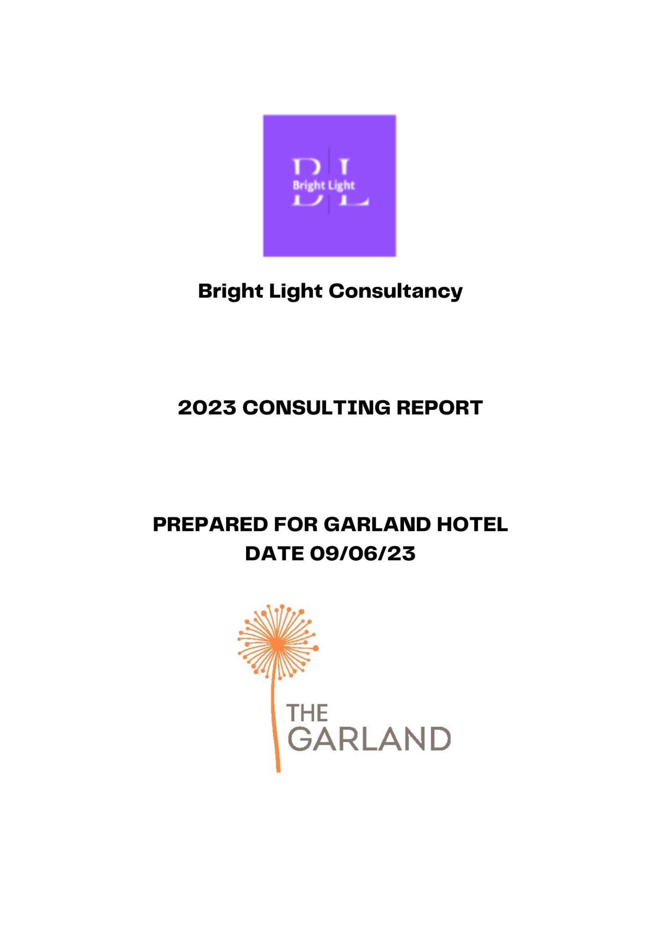
Bence Csapo (2025411)

Executive Summary
The following consultancy report is created to help the hotel organisation of the US known as Garland Hotel to increase its performance level and to remedy the various issues that are faced by it. The study has included models like PESTLE and SWOT analysis to examine the various external and internal factors that are impacting the operation of the hotel company. The PESTLE analysis has provided information on the various factors that can influence the operation of the company in both positive and negative ways. From this model, it is found that the main issues that can hinder the business operation include economic, social, environmental and political factors. In the US the inflation rate has increased to 8.1% which has led many organisations to face the problem of rising operation costs (Statista, 2022). The political factor includes the tax policy can leave a huge adverse impact on the profitability rate of small hotel companies like Garland Hotel. Also, the changing preferences of the customer towards the hotel industry have a huge impact on the business operation of the Garland Hotel. Such customers are focused more on gaining better experiences from the hotel company.
Garland hotel has to focus more on bringing innovative ideas for bringing new products and services that will deliver quality experiences to the customers. The SWOT analysis model has been used to identify both internal and external factors that are influencing the operation of Garland Hotel. Garland has been successful in gaining a strong brand position in the market which is the main factor that is helping the company to gain a better financial gain and at the same time gain a competitive hold. The SWOT analysis has been utilised to provide an in-depth examination of the various challenges and opportunities that are present for the development of Garland Hotel. The 7S model and Star models will be used to analyse the organisational structure and design of the hotel company. It will be used to explore the organisational strategy, structure, development of the employees and many more.
This model has helped to gain an insight into the management system of Garland Hotel which is necessary for the effective development of the overall performance of the company. The problem tree is also provided to place clarity on the problems that are being faced by the company. This method will help in defining the root cause and develop a plan that can be implemented to increase the performance level of the hotel company. With the help of all these models, it is analysed that the main problem which is hindering the effective growth of Garland Hotel include the limitation of product line, increased focus on luxurious and expensive goods and services, decrease in market share and many more. All these challenges need to be addressed for bringing necessary changes for increasing the performance level of the whole company. The main recommendations which are analysed in the report include the development of new budget hotels, the development of customer loyalty programs and so on. Fostering these processes and methods will help Garland Hotel to increase its productivity level and gain a competitive hold in the market.
Table of Contents
Executive Summary 2
Introduction 5
“Scope and analysis” 6
“Main Body” 17
“Findings & Results” 20
“Action Plan” 24
Recommendations 30
Conclusion 31
Reference 32

Introduction
Organisational consulting is defined as the professional service that helps the business organisation in evaluating the gap and brings effective measures in enhancing its growth. They take the responsibility of designing and establishing a better working structure that supports the main aim and goal that is set by the business organisation (Buttrick, 2009). This service facilitates the organisation in enhancing its internal capabilities for gaining a successful hold in the market. The following report is prepared by Bright Light Consultancy with the purpose of providing consultancy services to the hotel organisation known as The Garland Hotel. The study will analyse and address the various problems and issues that are faced by the hotel company. The report will use the analysis model like PESTLE, SWOT and TOWS for determining the various factors that can influence the performance level of the company. These models will be used to explore the various internal and external factors that are impacting the business operation of Garland Hotel.
The study will also provide a discussion on the models like 7S Model and Star Model for examining the various operations of the business organisation. This model will be used to determine and develop the best strategy that will help a company like Garland to increase its performance level. All these models will be used to place clarity on the provided information and to analyse the various issues that are prevailing in and out of the business operation of Garland Hotel. Based on the analysis the report will provide a finding and result section where the whole information will be summarised. This section will be used to develop the action plan where effective solutions will be identified for bringing necessary development in the operation of Garland Company. Lastly, the report will include recommendations where effective methods will be developed for helping the company to mitigate the arising issues.

“Scope and analysis”
Company background
The Garland Hotel is a small-scale four-star hotel company based in Los Angeles, United States. The company was founded back in the year 1970 and has around 257 rooms that provide quality experiences to customers. The hotel company provides better product and services which includes deluxe hotel rooms, excellent food and beverages and other facilities like free Wi-Fi, children's activities, free shuttle and taxi services, a fitness centre and more (Garland, 2023). The hotel company is well known for its friendly and comfortable services which are provided to the customers (TripAdvisor, 2023). The Garland hotel is also focused on environmental sustainability and has incorporated a solar system which reduces energy consumption by 40%, LED lighting in its hotel rooms, replacement of HVAC systems and many more (The Garland, 2023). The hotel also provides services for organising events like weddings and business meetings. The company is well-known for its vintage designs and Hollywood suites (The Garland, 2021). The hotel company has around 200 employees that provide excellent services to customers (Zoom, 2019). The company has been successful in gaining a better brand name and growth in the US hospitality market with its excellent services which are provided to its targeted customers. However, there are many factors that can influence the operation of the company in both positive and negative ways. For analysing such factors, the following models will be used.
“PESTLE Analysis of The Garland”
PESTLE analysis is the model that helps the business organisation in identifying the external factor that can impact its overall operation and performance level (Anderson et al., 2019). The external factor that can impact the operation of The Garland Hotel is provided with the help of the following table.
Factor | Issues | Impact
Political | Global tax policies | - Changes in the tax policies in can impact the operation of business organisation (Garrett et al., 2020)  - The changing government policies will hinder the profitability growth of the Garland Hotel as it has to comply with comply with the different and changing tax policies of the government
Economical | Higher inflation rate | - In 2022 the inflation rate in the US increased by 8.3% (Statista, 2023)  - This rising rate has declined the purchasing power of the customer  - Such a decline in the buying power of the customer has led Garland Hotel to face a decrease in sales by 26.1% (GarlandNewsroom, 2022)
Social | Changing customer preferences | - In the recent field, the spending of customer is changing more towards experiences and services rather than the product which is around 58% (Forbes, 2022)  - This can impact the profitability rate of Garland Hotel  - To overcome such challenges Garland Hotel, have to develop new product and services to meet the demand of the customers
Technological | Technological advancement | - In the global hospitality industry, the technologies like robotics, cloud computing, virtual reality and more are implemented to enhance its performance level  - Garland Hotel can take this opportunity by investing more in technology for developing its customer service along with its effective growth  - However, for implementing new technologies Garland Hotel have to make a huge investment which can impact the financial growth in an adverse way
Legal | Lawsuit | - The lawsuit has a negative impact on the smooth operation of the business organisation  - The hotel organisation like Garland has to comply with the rules and regulation that are introduced by the Government in the US to avoid indulging in the any kind of lawsuit in the coming future  - These issues will impact the positive brand image of the company which can threaten its successful growth in the market
Environmental | Climate change | - The hotel industry is known as the sector that is responsible for the emission of the larger amount of carbon which has a direct impact on the environment that result in the climate change (Umrani et al., 2020)  - These issues can impact the positive reputation and the sustainable growth of Garland hotel in the longer run  - However, the company can set the goal of reducing the carbon emission from its daily operation, reducing the use of unwanted energy, focusing on recycling methods and many more
Table 1: “PESTLE analysis of the hotel”
Source (Created by the learner)

“SWOT Analysis of The Garland Hotel”
Strength | Weakness
- Effective customer services  - Experienced workforce | - Limited market share  - Focused heavily on US market  - Lower brand differentiation
Opportunity | Threat
- Utilise internet  - Extend its business operation  - Extend its product portfolio | - Intense competition  - Customer expectation  - Presence of cheap and robust hospitality service
Table 2: “SWOT analysis of Garland Hotel”
Source (Created by the learner)
From the SWOT analysis, the main strength of the Garland Hotel includes the excellent customer services. The company provides various services like free taxi services, various cuisines, deluxe rooms, gyms and more. The company has also been successful in developing a trained and a competent workforce where every employee provides excellent services to the customers. This strength of the Garland Hotel is helping the company to satisfy the needs of the customers that is helping it gain better financial growth. Also, these factors are helping the company to gain successful growth in the market.
Despite such strength, the main weakness of Garland Hotel is the limited market share because of the competition in the global market. Although the company was founded in 1970 the company has not expanded its business operation in the other regions except the US market. The company is also dependent heavily on the US market which can make it vulnerable to the changing political and economic area in the other region where it operates. Also, the company provides expensive and limited products and services which is creating a major challenge for the Garland Hotel to increase its customer base.
The company has a huge opportunity in utilising the internet to develop effective marketing campaigns to increase its brand visibility in the global field which will help it to increase its market share (Essential Noordzife, 2014). This will facilitate the hotel in increasing its brand awareness to reach a wider audience and generate their interest in buying the product and services that are provided by the company. Also, the company can focus on bringing innovation in its product and technology to provide better experiences to the customers. The Garland Hotel also has the opportunity to extend its product portfolio by developing budget hotels catering to the needs of the customers with middle-level income.
The main threat which is faced by Garland Hotel is the stiff and increasing competition in the global hospitality market. The main competitors of Garland include The Belamar, Oasis Hotel & Convention centre which provides higher quality services to the customers in the US (Craft, 2022). The presence of these hotel companies will hinder the sustainability of Garland Hotel in the market (Statista, 2022). Another threat to Garland Hotel includes customer expectations. As the customer prefers online booking they have the huge option in finding the budget travel packages that provide excellent facilities at lower prices (Further Mavridopoulou and O’Mahoney, 2020). This habit of the customer can affect the revenue generation of the Garland Hotel. Also in the recent field, there is a larger presence of cheap and robust hospitality services that provide homestay and hotel services to customers with better experiences. One example is the presence of Airbnb in the US which provides the customer with numerous information on vacation rental and accommodation and connects people who want to rent their homes for accommodation (Airbnb, 2023). These kinds of boutique alternatives can create a major threat to the Garland Hotel which is based mainly on higher prices.

“Mckinsey 7S model analysis of Garland Hotel”
The 7S model provides the framework for analysing the organisational design of the company (Odeh, 2021). It includes two components which include the hard element and the soft element. The hard element includes structure, strategy and system while the soft element includes skills, style, staff and shared values.
Structure: It is the way in which the company is organised based on the chain of command and accountability relationship (Further Kotter, 2012). The organisational structure of Garland Hotel includes a hierarchical structure. In a hierarchical organisational structure, the chain of command flows from the top executives to the lower subordinates (Pospisil and Zavodna, 2022). At Garland Hotel, the CEO James Crank prepares the major decision which is communicated to the middle management team and to the final employees that are working in the various regions (The garland, 2023).
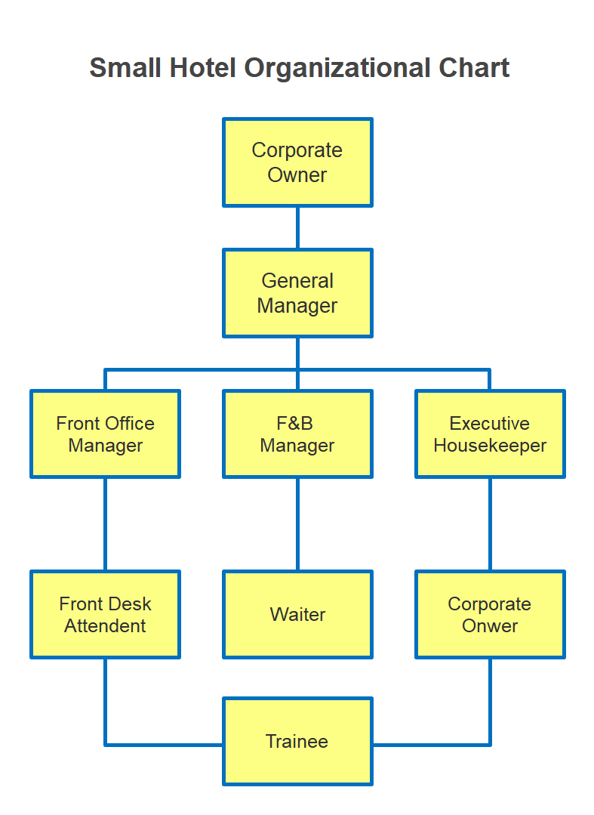
Fig 1: “Organisational structure implemented in the Garland Hotel”
Source (Edrawsoft, 2022)
This structure has facilitated the Garland Hotel in managing the larger base of employees with an effective flow of information and clear awareness of individual roles and responsibilities.
Strategy: The strategy is regarded as the plan of action which is prepared by the business organisation in gaining a competitive advantage (Futher Subramaniam et al., 2011). The strategy of Garland Hotel is to provide higher quality services to the customers at an affordable rate. The main focus of this strategy is to deliver comfortable and authentic experiences to its customers.
Systems: Garland Hotel has been successful in balancing effective communication in its various business segments. The main system of the company includes employee recruitment, an employee performance evaluation system and many more. All these elements are managed effectively by the human resource department of the company.
Skills: It is the capabilities and competency level of the whole team members (Further Newton, 2010). In Garland Hotel the employees are provided with initial training as per their job role (Glassdoor, 2023). This program facility has helped the whole company to build a highly skilled and competent workforce that is helping the hotel to enhance its performance level.
Style: In Garland Hotel, the leaders have been successful in managing a better working culture with proper management. The leadership style which is implemented by the leader includes the democratic leadership style as the employees are allowed to share their ideas and concerns. The CEO of the hotel is always open to the information that is being shared by the employees which is the main reason that is helping the company to maintain a positive working environment.
Staff: It includes all the human resources that are present within the organisation. Garland Hotel has around 200 staff members who are from various cultures, races, genders and more. The employees are provided with ongoing training facilities and rewards that are facilitating the company to build a motivated workforce. Also, the HR department has developed an organisation policy where ethical practices are conducted to avoid any kind of harassment or discrimination in the workplace (Stone et al., 2020). All these methods are helping the hotel company to create an inclusive and positive working place for its staff members.
Shared value: The shared value of Garland Hotel is built upon respect, comfort and integrity (The garland, 2023). This value has helped the company to remain consistent with its goal of providing better experiences and services to the customers and valuing the hard work of every team member.
“STAR model”
The star model helps the business organisation in identifying the component of developing organisational effectiveness (Lemus-Aguilar et al., 2019). It includes the elements like people, strategy, structure, processes and rewards.

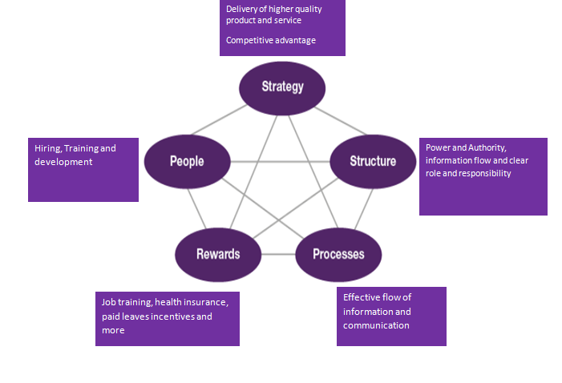
Fig 2: “Star model of Garland Hotel”
Source (Created by the learner)
Strategy: The main strategy of Garland Hotel is to deliver quality products and services to the customers with the aim of gaining a competitive edge in the market.
Structure: The organisational structure of Garland Hotel has an effective chain of command where power and authority lies in the top management leaders which has helped the company in fostering a clear flow of communication where every department and employee is clear of their roles and cuties.
Processes: Garlandhas maintained effective communication where information is shared effectively in every department of its hotel. In the vertical process, the HR department is responsible for hiring, recruiting, training and providing rewards to the employees and many more. In the horizontal process, the employees are focused on completing their job role for delivering better products and services to the customers.
Rewards: In the Garland Hotel, the employees are provided with various rewards like job training opportunities and rewarding benefits like flexible spending accounts, medical facilities and more (The garland, 2023). This is helping the hotel company to build a competent and motivated workforce where every customer is provided with better quality services.
People: The people include the employees of the Garland Hotel. The HR department of the company takes the responsibility of hiring the right talent and providing effective training that facilitates the company in building a competent workforce.
“Problem Evaluation Tree”
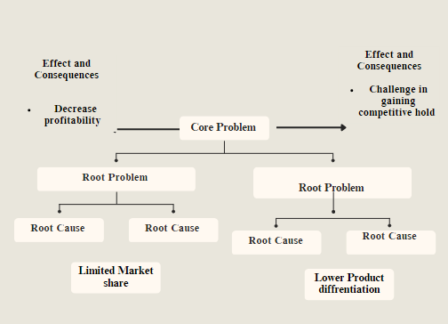
Fig 3: “Problem Tree of Garland Hotel”
Source (Created by the learner)
From the above analysis, the main problem that is faced by Garland Hotel includes limited market share and lower product differentiation. The company was founded back in 1970 and has failed in gaining a better market share. The main root cause of such problems is the presence of a lower product line and lower customer base. As the hotel industry has demand from the customer who prefers luxurious services, Garland Hotel will not be able to meet their needs. Failing to meet such demand will lead the company to gain lower profitability which will hinder its successful hold in the market in the long run. In many of the studies, it was found that 13 to 18% of the customers selected the accommodation as per its premium services and price (SuperOffice, 2023). The presence of such a customer group will hinder the company from gaining a competitive hold in the market as the product which is provided by Garland Hotel is limited. The main focus of the company is based on the vintage and deluxe designs. The company can take this opportunity to develop a new hotel chain to target the customer that prefers luxurious experiences. The company can also develop an effective digital marketing campaign to increase its brand awareness and reach a wider audience. This process will help the Garland hotel to build a strong brand recognition that will help it to increase its market share.

“Main Body”
Garland Hotel has been successful in gaining a competitive hold in the market which is evident in its smooth operation in many countries of the global field. From the analysis of the PESTLE model, the advancement of the technological state will facilitate the company to increase its performance level. It is found that many hotel organisations have implemented technology like robotics, cloud computing and many more (Nandonde, 2019). This technology is helping the hotel company to bring improvement in its product and services which is delivering higher satisfaction and personalised experiences to the customers (Luis Sanchez, 2019). Garland Hotel should also focus on bringing new technologies for enhancing its performance level. For example, the hotel company can implement technology for providing better security to the customers. Technology like electronic keycard systems can be implemented to control access to hotel rooms and other hotel areas (Further Newton, 2010). This system will help the hotel company to provide valuable experiences to the customers which will ultimately add value to its positive brand image.
The fact that Garland Hotel possesses a significant amount of influence within the market is evident through its global operational capabilities. From the PESTLE analysis that has been conducted above it has been derived that improving the technological factors will help the hotel business to grow further. By utilising digital technologies such as robotics, cloud softwares, Garland Hotel will be able to boost the efficiency and competence of its operations. With the use of digital technologies, the business will be able to improve their personalised services offered. This will boost the customer satisfaction provided by Garland Hotel to its residents. This is how digital technologies will help the hotel in the aspect of its customer service and experience provided. To improve its operational capabilities with the use of technologies. The company for instance can implement the use of “electronic keycards.” By doing so the security provided by the hotel line will be improved. This facility will also contribute to boosting the customer experience leading to more demand for the hotel. The image of the Garland Hotel brand is also significantly improved with the implementation of digital technologies that helps to better its performance while improving sustainability.
The positive aspect from the SWOT analysis that has helped the company to be successful in the global field is the higher quality product and services that are provided to the customers and its global presence in 69 countries. The positive aspect of Garland Hotel includes strong brand recognition. Garland is well known for the vibrant experiences that are being provided to its customers. The hotel has vintage designs, larger event spaces, and world-class food and beverages. This quality product and service has facilitated the hotel company to gain strong brand recognition that is increasing its sustainable growth in the global hotel market. Through the use of the “SWOT analysis” it has been determined that the strength of Garland Hotel lies in its higher standard product and services offerings. The company has also successfully expanded into 69 countries which is another strength of Garland Hotel. It is an international brand and well recognised. Garland is highly regarded within the accommodation industries and among the customers owing to the quality of its offerings. The infrastructure of Garland is known for its unique architectural designing, the large areas and halls for events and occasions. The fooding provided by the hotel line is also of the best quality which makes the Garland Hotel the ideal destination for the customers. Owing to these factors Garland Hotel has been able to build a well-recognised and reliable brand image. The company has also been focusing on sustainability within its processes which further adds to the good image of the brand.
The other element that has helped Garland Hotel reach the heights of success it is currently at is its competent workforce. The total number of employees employed by the company is estimated to be around 200. The employees are experienced and know what functions and roles they have to perform to contribute to the success of the hotel line. Training is the factor that has helped the company to develop such a competent workforce. During the course of training the employees are made aware of their roles and responsibilities. Since the employees are aware of what they have to do and effectively trained on it. The productivity and the consistency levels of the employees are high which helps in meeting the goals of the organisation. The employees are also informed about Garland Hotel’s vision, mission, culture and other aspects that will help guide the employees in their conduct. The employee’s effort is all aligned to meet the goals of the company according to the mission, vision, and the corporate culture of the company. The company is known to possess many accommodation properties throughout the countries it operates in. Garland hotel is known for its high-quality offerings and customer service.
In the analysis of 7S and STAR model it can be found that the company has been successful in managing the internal organisation function. The main strategy of the company is to provide higher quality services to the customer which is evident in its luxurious product and excellent services. Owing to the company’s selection of leadership type, hierarchical structure the company has been able to develop high employee engagement and the means of communication is also highly effective. The HR department also contributes significantly to the success of the hotel line by selecting the ideal candidates from the interviews. The remuneration policies and the training provided to the employees help them to perform productively and effectively. Based on this positive aspect of Garland Hotel the company has been successful in increasing its productivity level which is adding advantage to its sustainable growth.
However, in the above analysis, there are many negative factors that are creating a major challenge for the company to enhance its organisational performance. One of the major issues which are faced by the hotel includes the lesser focus on environmental initiatives. In the recent field, the hospitality industry is responsible for the higher carbon emission. In the UK the carbon which is emitted for staying in a room is estimated to be around 10.4kg per night (Circular Ecology, 2023). Also in the US, the carbon which is emitted from the use of energy is around 28% (EESI, 2023). Garland Hotel has been ignoring the need for sustainability in recent years, this has negatively impacted the brand image of the company.
From the above analysis, the main issue which is faced by Garland Hotel is the limited market share. Although the company has a relatively lower share due to the presence of higher competitiveness in the market. The lower market share of the company will affect its profit generation in the longer run. The low market share of the company can have disastrous consequences for the Garland Hotel line. This is because owing to the low market share of the company the profitability of the company is also low. With the decline in the sales of the offering of the Garland Hotel the company can face issues in being able to afford maintaining the quality of its offerings. The company will also find difficulty in covering the operational cost, marketing expenses and administrative salaries (Sheikh, 2019). This kind of issue will hinder the Garland Hotel from gaining a sustainable hold in the market

.

“Findings & Results”
The Garland Hotel has been successful in gaining its effective growth in the hospitality market of the US. From the analysis, it has been found that the company has been providing excellent customer services that cater to the needs of the targeted customers who are mainly from a social background of middle level income. The competent employee base is helping the Garland hotel to provide higher quality and satisfying services to the customers. The TOWS model will be used to extract the main findings from the above analysis in more depth. It is the model which is defined as a simple planning tool for developing an effective strategy for developing the performance level of the company (Abbott, 2022). TOWS model is also regarded as the extension of SWOT analysis whose focus starts from analysing threats, opportunities, weaknesses and strengths which adds a relation between the external and internal factors.
“TOWS model analysis of Garland Hotel, US”
TOWS Matrix |  | Internal factor
 |  | Opportunities | Threat
 |  | To extend its product line  Develop effective marketing strategy | Higher level of competition  Lesser product differentiation
External factors | Strength | Strength/Opportunities | Strength/Threat
External factors | Strength | Excellent customer service  Effective communication  Component workforce | Diversify the product line  Build effective marketing strategy
External factors | Weakness | Weakness/Opportunities | Weakness/Threat
External factors | Weakness | Lesser market share  Lower customer base | Initiate business expansion  Develop customer loyalty program  Form partnership  Conduct market research
Table 3: “TOWS analysis of Garland Hotel”
Source (Created by the learner)
In the above findings it is evident that The Garland Hotel faces the major threat of stiff competition. The top competitors of Garland include The Belamar, Oasis Hotel & Convention centre and LaGuardia (Zoom, 2019). Although the Garland Hotel has been successful in providing quality services to its customers at an affordable rate the company has a lower product differentiation (Jeong et al., 2023). From the above analysis, it has been found that the Garland Hotel has relatively lower market share and lower customer base. This limitation can pose a threat to the successful operation of The Garland as there is the presence of many hotel companies that provide lower-cost and higher-quality products and services to a larger base of customers. In the US some of the budget hotels in the US include Hotel Hive, Hotel La Croix and so on (TripAdvisor, 2023). The presence of such lower-cost hotels will threaten the successful growth of The Garland in the longer run. The company needs to work on this area to increase its competitiveness and to cater to the various needs and demands of the larger customers that are present in the market. To mitigate such issues the company can develop customer loyalty programs by providing free gifts, discount facilities, membership facilities and many more. This factor will help the Garland Hotel to build a positive image and generate the interest among the customers to increase its sales.
From the analysis, the main finding is that the Garland Hotel has a huge opportunity to overcome the rising threat in the market. The company has the chance to expand its product line by developing new hotel chains, developing cafes, upgrading rooms and many more. This factor will help the company to increase its profitability rate and also to increase its customer base. Based on the above analysis the company also has the opportunity to increase its market share by expanding its business operation. The company can focus on partnering with the local hotel chain of the US and develop effective marketing strategy for conducting market research.
From the above findings, the main strength of The Garland Hotel includes the better customer services. The hotel organisation has been well known as the company that provides comfortable and excellent services to its customers. The company can take this opportunity to extend its product line by developing new hotel chains, forming partnerships and developing customer loyalty programs and more. The new hotel chain can be developed to target the customer who acquires higher level income. This will help the company to increase its customer base by catering to the needs of both customers with middle level income and high-income level. Implementing this method will help the company to increase its brand image while gaining a competitive hold. The company also has the strength of a competent workforce which will benefit the company in providing better services to the customers. The management of effective communication in Garland Hotel is the key factor that is facilitating it in increasing its productivity level. The company needs to focus on developing effective training programs and reward systems to remain persistent in upskilling the whole workforce (Further Baron and Armstrong, 2007). The company can use this strength to overcome the rising threat by creating an effective marketing strategy by utilising the social media channel and also by working with influencers. This method will help the company to increase its brand awareness which will add value to its better growth.
In the above findings, it has also been found that the main weakness of the company is the lower market share and higher price for every product and service. One of the main reasons which have hindered the company in gaining a larger market share can be the lower customer base. The company can focus on targeting the market with both higher and lower income levels. Not only that, but the company can also develop a customer loyalty program by providing offers and discount facilities in its hotel rooms and food products, customer rewards and many more. Also, the company can focus on an effective marketing process for meeting a wider audience and increasing its brand visibility. All these methods will help the company to increase its performance level and to gain a competitive hold in the market.

“Action Plan”
Based on the above findings an action plan has been created to increase the performance level of the Garland Hotel with the help of the following table. This action plan will set an effective direction which can be followed by Garland Hotel to enhance its performance level in every aspect of its internal and external operations.
No | Problem | Solution | Desired outcome | Time scale | Completion Date | Planned Budget
1 | Limited market share | The company can focus on developing digital marketing strategy by using social media channels and by working with the influencers. The company can also develop effective customer loyalty programs. | The marketing strategy will help Garland Hotel to increase its brand awareness among the wider audience and the customer loyalty program like offers, customer rewards and more will facilitate it to increase its customer base. All these will help the company to increase its customer base along with the increase in market share | 6 months | 10/11/23 | £1000000
2 | Lower product differentiation | The company can extend its product line by developing new hotel chain and by providing offering and discount facility to the customers | The budget hotel and the discount facility will help Garland Hotel to target the customers who acquire both higher and lower income levels. This will help the company to fulfil the need of every customer that will increase its positive brand image | 10 months | 3/03/24 | £2000000
3 | Higher competition | The can company develop new hotel chain and effective marketing strategy to increase the brand awareness | The new product line will help the company to meet the needs of the customers that prefer luxurious and affordable hotel rooms. This will help the company to increase its customer base that will add value to its profitability and competitive growth | 1 year | 1/03/24 | 10000000
4 | Effective training program | The company can focus on developing the training program as per the requirement of every team member (ScrapeHero, 2023). The leader can gather feedback from the employees which will benefit them in creating a better program that will fulfil the needs of the employees | This method will help Garland Hotel to increase employee engagement and construct an effective workforce that will provide highly skilled employees | 1 months | 1/07/23 | £20000
Table 4: “Action plan for Garland Hotel”
Source (Created by the learner)

Recommendations
Some of the recommendations for effective development in Garland Hotel include the following:
- The main issue which is faced by The Garland Hotel includes the limited market share despite its strong presence in the global market. To overcome such problems the company can focus on developing an effective digital marketing strategy. The company can create advertisements and marketing campaigns on social media channels like Facebook, Instagram and YouTube that will share all the information on the product and services that are being offered by the company (Grano, 2021). The hotel company can also work with social media influencers for displaying its hotel rooms, excellent cuisines and many more. This method will help the company to reach a wider audience and convert them into potential customers. The increase in the customer base will help the company to increase its sales revenue which will extend its market share in the global field.
- Another recommendation for the development of Garland Hotel includes the development of budget hotels and customer loyalty programs. The budget hotel will help the company to generate interest among the customers with lower income and the loyalty programs will help the company to build a better relationship with every customer. This method will help the company to gain a positive brand image which will increase its effective growth in the market.
- The company can also focus on developing environmental initiatives to reduce carbon emissions and to operate in an eco-friendly way. The company can develop the goals like Hilton Hotel to reach net zero carbon, decrease the use of plastic products and foster recycling methods and many more (Hilton, 2015). This process will help the company to reduce the negative impact on the environment from its daily operation and at the same time gain a positive brand image in the market.
- The recommendation for Garland Hotel includes the development of effective training programs. The leader of the company should focus on gathering feedback from the employees for developing a better training program as per their requirements. This method will help Garland Hotel to develop the needed skill level of the employees which will facilitate the whole company in building a competent and motivated workforce.

Conclusion
In the context of the above information, it can be summarised that the business organisation should focus on various aspects for gaining successful results in the market. By examining the case of Garland Hotel, it can be found that the hotel company has focused on delivering higher quality and luxurious products and services while building a competent workforce. Although this strategy has helped the company to gain a better brand position in the global market, there are many areas that are needed to improve to increase the overall performance in a better way. The company is only focused on upscale and expensive services which do not fulfil the needs of the customer that have lower incomes. Also, it was found that the company was not focused on taking environmental initiatives which is the main drawback that will hinder its long-term sustainability in the future. All these kinds of issues need to be addressed by Garland Hotel to increase its sustainability and to keep pace with the intense competition in the market. With the study, it can be concluded that a business organisation like Garland Should be vigilant in all areas to fight back against the challenges that can arise in the market. The development of an effective strategy will help every business organisation to gain long-term success and a competitive hold in the market.

Reference
Abbott, A. (2022). Top 11 Hilton Hotel Competitors & Alternatives. [online] Business Strategy Hub. Available at: https://bstrategyhub.com/hilton-hotel-competitors-alternatives/#:~:text=There's%20no%20question%20that%20Marriott,Hilton%20competitors%20in%20the%20world [Accessed 6 Jun. 2023].

Airbnb. (2023). Holiday Homes & Apartment Rentals - Airbnb. [online] Available at: https://www.airbnb.co.in/ [Accessed 1 Jun. 2023].

Ali, Bayad Jamal, Bayar Gardi, Baban Jabbar Othman, Shahla Ali Ahmed, Nechirwan Burhan Ismael, Pshdar Abdalla Hamza, Hassan Mahmood Aziz, Bawan Yassin Sabir, Sarhang Sorguli, and Govand Anwar. "Hotel service quality: The impact of service quality on customer satisfaction in hospitality." Ali, BJ, Gardi, B., Othman, BJ, Ahmed, SA, Ismael, NB, Hamza, PA, Aziz, HM, Sabir, BY, Anwar, G.(2021). Hotel Service Quality: The Impact of Service Quality on Customer Satisfaction in Hospitality. International Journal of Engineering, Business and Management 5, no. 3 (2021): 14-28.

Anderson, J.E., Hughes, M.Ü. and Nguyen, C., (2019). The highs and lows of startups in the Cannabis industry: A PESTLE analysis of the current issues. In Business Forum (Vol. 27, No. 2, p. 26).‌

Assaker, G., O’Connor, P. and El-Haddad, R., (2020). Examining an integrated model of green image, perceived quality, satisfaction, trust, and loyalty in upscale hotels. Journal of Hospitality Marketing & Management, 29(8), pp.934-955.

Bratton, J., Gold, J., Bratton, A. and Steele, L., (2021). Human resource management. Bloomsbury Publishing.
Buttrick, R. (2009) The Project Workout, London: Prentice Hall
CE (2023). The Carbon Emissions of Staying in a Hotel - Circular Ecology. [online] Circular Ecology. Available at: https://circularecology.com/news/the-carbon-emissions-of-staying-in-a-hotel [Accessed 1 Jun. 2023].

Christensen, R.C., (2021). The rise of the EU in international tax policy. In Global Networks and European Actors (pp. 110-126). Routledge.
Collins, D., (2021). Tom Peters and Management: A history of organizational storytelling. Routledge.
Dogru, T., Hanks, L., Mody, M., Suess, C. and Sirakaya-Turk, E., (2020). The effects of Airbnb on hotel performance: Evidence from cities beyond the United States. Tourism Management, 79, p.104090.
Edrawsoft (2022). Hotel Organizational Chart Explained with Examples | EdrawMax Online. [online] Available at: https://www.edrawmax.com/article/hotel-organizational-chart.html [Accessed 9 Jun. 2023].
EESI (2023). U.S. Leads in Greenhouse Gas Reductions, but Some States Are Falling Behind | Article | EESI. [online] Eesi.org. Available at: https://www.eesi.org/articles/view/u.s.-leads-in-greenhouse-gas-reductions-but-some-states-are-falling-behind#:~:text=The%20United%20States%20accounts%20for,28%20percent%20of%20carbon%20emissions. [Accessed 1 Jun. 2023].
Essential Burnes, B. (2014) 4th Edition, Managing Change, Great Britain, Prentice Hall.
Essential Noordzife, G. (2014) Project Management of Hotel Opening Processes: Exploring Better Ways to Manage New Hotel Openings, CreateSpace
Essential Whittington, R. et al (2020) Exploring Strategy. Harlow: Pearson Education Limited.
Further Baron, A. and Armstrong, M. (2007) Human Capital Management. London: Kogan Page.
Further Brierley, E. (2006) Talent on tap: getting the best from freelancers, interims and consultants. London: Chartered Institute of Personnel and Development.
Further Fisman, R. and Sullivan, T. (2014) The Org: How the Office Really Works, Murray, London
Further Johnson, M. (2005) The Independent Consultant’s Survival Guide, London, Chartered Institute of Personnel and Development.
Further Kipping, and Clark, T. (2012). The Oxford handbook of management consulting. Oxford University Press
Further Kotter, J (2012). Leading change. Harvard Business Review Press.
Further Mavridopoulou, and O’Mahoney, J. (2020). Elitism in Strategy Consulting: How Institutional Prestige Influences Recruitment. Management Consulting Journal, 3(1), 12–22.
Further Newton, R (2010). The management consultant : mastering the art of consultancy. Financial Times.
Further O’Mahoney, J. (2021). How Small Consultancies Grow: Challenging Problem-Based Theorising. Management Consulting Journal, 4(1), 5–20
Further Whittington, R. and Molloy E. (2005) HR’s role in organisation: shaping change. Research report. London: Chartered Institute of Personnel and Development.
Futher Subramaniam, Collier, P., Phang, M., and Burke, G. (2011). The effects of perceived business uncertainty, external consultants and risk management on organisational outcomes. Journal of Accounting & Organizational Change, 7(2), 132–157.
‌Garland, T. (2023). The Garland (Los Angeles, United States of America), Los Angeles hotel discounts | Hotels.com. [online] Hotels.com. Available at: https://in.hotels.com/ho109050/the-garland-north-hollywood-united-states-of-america/?pwaDialog=datepicker-start [Accessed 9 Jun. 2023].
Garrett, D.G., Ohrn, E. and Suárez Serrato, J.C., (2020). Tax policy and local labor market behavior. American Economic Review: Insights, 2(1), pp.83-100.
Glassdoor. (2023). The Garland Company ‘initial training’ Reviews. [online] Available at: https://www.glassdoor.co.in/Reviews/The-Garland-Company-initial-training-Reviews-EI_IE200597.0,19_KH20,36.htm [Accessed 9 Jun. 2023].
Grano, M. (2021). Social Spotlight: Hilton’s pandemic strategy proves the business value of social. [online] Sprout Social. Available at: https://sproutsocial.com/insights/social-spotlight-hilton/?amp [Accessed 6 Jun. 2023].
Harris, R., Williams, P. and Griffin, T. eds., (2012). Sustainable tourism. Routledge.
Hilton (2015). Hilton Chicago. [online] Available at: https://www.hilton.com/en/hotels/chichhh-hilton-chicago/history/ [Accessed 6 Jun. 2023].
Hospitality Net. (2019). Garland Hotels Corporation. [online] Available at: https://www.hospitalitynet.org/organization/17001488.html [Accessed 6 Jun. 2023].
Hospitality Online. (2023). Embassy Suites by Hilton Chicago Downtown Magnificent Mile. [online] Available at: https://www.hospitalityonline.com/embassy-magnificent-mile [Accessed 6 Jun. 2023].
Hosthotels (2022). Embassy Suites by Hilton Chicago Downtown Magnificent Mile - Host Hotels & Resorts. [online] Available at: https://www.hosthotels.com/Properties/Domestic/Illinois/Embassy-Suites-by-Hilton-Chicago-Downtown-Magnificent-Mile [Accessed 6 Jun. 2023].
Jacky Runice (2016). Chicago, IL Hotels: Embassy Suites by Hilton Chicago Magnificent Mile. [online] 10Best. Available at: https://www.10best.com/destinations/illinois/chicago/streeterville/hotels/embassy-suites-by-hilton-chicago-magnificent-mile/ [Accessed 6 Jun. 2023].
Jeong, M., Shin, H.H., Lee, M. and Lee, J., (2023). Assessing brand performance consistency from consumer-generated media: the US hotel industry. International Journal of Contemporary Hospitality Management, 35(6), pp.2056-2083.
Kim, Y.J. and Kim, H.S., (2022). The impact of hotel customer experience on customer satisfaction through online reviews. Sustainability, 14(2), p.848.
Latif, K.F., Pérez, A. and Sahibzada, U.F., (2020). Corporate social responsibility (CSR) and customer loyalty in the hotel industry: A cross-country study. International Journal of Hospitality Management, 89, p.102565.
Lemus-Aguilar, I., Morales-Alonso, G., Ramirez-Portilla, A. and Hidalgo, A., (2019). Sustainable business models through the lens of organizational design: A systematic literature review. Sustainability, 11(19), p.5379.
Luis Sanchez CFA (2019). How Hilton’s Growth Strategy Is Delivering Strong Results. [online] The Motley Fool. Available at: https://www.fool.com/investing/2019/11/29/how-hiltons-growth-strategy-deliver-strong-results.aspx [Accessed 6 Jun. 2023].
Nandonde, F.A., (2019). A PESTLE analysis of international retailing in the East African Community. Global Business and Organizational Excellence, 38(4), pp.54-61.
Nozdreva, R. and Churakova, A., (2021). Digital tools in empirical marketing strategies of global hotel companies. Digital strategies in a global market: Navigating the Fourth Industrial Revolution, pp.213-227.
Nunkoo, R., Teeroovengadum, V., Ringle, C.M. and Sunnassee, V., (2020). Service quality and customer satisfaction: The moderating effects of hotel star rating. International Journal of Hospitality Management, 91, p.102414.
Odeh, G., (2021). Implementing Mckinsey 7S Model of Organizational Diagnosis and Planned Change, Best Western Italy Case Analysis. Journal of International Business and Management, 11(4), pp.01-08.
Pan, W., Chen, L. and Zhan, W., (2019). PESTEL analysis of construction productivity enhancement strategies: A case study of three economies. Journal of Management in Engineering, 35(1), p.05018013.
Pospisil, J.Z. and Zavodna, L.S., (2022). An Insight to the World of Female Entrepreneurship: Systematic Literature Review of the Phenomenon using the Mckinsey 7S Model. Foundations of Management, 14(1), pp.51-66.
Pospisil, J.Z. and Zavodna, L.S., (2022). An Insight to the World of Female Entrepreneurship: Systematic Literature Review of the Phenomenon using the Mckinsey 7S Model. Foundations of Management, 14(1), pp.51-66.
Prentice, C., Dominique Lopes, S. and Wang, X., 2020. The impact of artificial intelligence and employee service quality on customer satisfaction and loyalty. Journal of Hospitality Marketing & Management, 29(7), pp.739-756.
Rawson, C. and Ramsey Qubein (2021). Hilton vs. Marriott: Which One Is Right for You? [online] NerdWallet. Available at: https://www.nerdwallet.com/article/travel/hilton-vs-marriott#:~:text=Although%20Marriott%20has%20more%20properties,especially%20true%20for%20business%20travelers [Accessed 6 Jun. 2023].
Revfine.com (2022). 14 Essential Hotel Marketing Strategies For More Bookings In 2023. [online] Revfine.com. Available at: https://www.revfine.com/hotel-marketing-strategies/ [Accessed 6 Jun. 2023].
Saleh, A.S. and Zohry, M.A.E.F., (2022). Towards A Sustainable Hotel Education (An Analytical Strategic Study at The Faculty of Tourism and Hotels, Mansoura University-TOWS Matrix as A Model). International Journal of Tourism, Archaeology and Hospitality, 2(1), pp.45-74.
ScrapeHero (2023). 10 Largest hotels in the United States in 2023. [online] ScrapeHero. Available at: https://www.scrapehero.com/location-reports/10-largest-hotels-in-the-usa/#:~:text=Wyndham%20Group%20Hotels%20and%20Resorts%2C%20Marriott%20Group%20Hotels%20%26%20Resorts%20and,across%2051%20states%20and%20territories [Accessed 6 Jun. 2023].
Seyitoğlu, F. and Ivanov, S., (2020). A conceptual framework of the service delivery system design for hospitality firms in the (post-) viral world: The role of service robots. International Journal of Hospitality Management, 91, p.102661.
Sheikh, S., (2019). Corporate social responsibility and firm leverage: The impact of market competition. Research in International Business and Finance, 48, pp.496-510.
Shep Hyken (2022). 58% Of Customers Will Pay More For Better Customer Service. Forbes. [online] 8 Nov. Available at: https://www.forbes.com/sites/shephyken/2022/04/24/fifty-eight-percent-of-customers-will-pay-more-for-better-customer-service/?sh=28c2c41513f1 [Accessed 1 Jun. 2023].
Statista. (2022). Hilton Worldwide revenue 2022 | Statista. [online] Available at: https://www.statista.com/statistics/297760/revenue-of-hilton-worldwide-holdings-inc/#:~:text=International%20hotel%20company%20Hilton%20Worldwide,year's%20total%20of%205.79%20billion [Accessed 6 Jun. 2023].
Statista. (2023). Monthly inflation rate U.S. 2023 | Statista. [online] Available at: https://www.statista.com/statistics/273418/unadjusted-monthly-inflation-rate-in-the-us/#:~:text=More%20information%2
Stewart, G.L. and Brown, K.G., (2019). Human resource management. John Wiley & Sons.
Stone, R.J., Cox, A. and Gavin, M., (2020). Human resource management. John Wiley & Sons.
SuperOffice (2023). Key Customer Experience Statistics to Know. [online] Superoffice.com. Available at: https://www.superoffice.com/blog/customer-experience-statistics/ [Accessed 9 Jun. 2023].
The garland (2021). North Hollywood Los Angeles Hotel Rooms | The Garland. [online] Available at: https://www.thegarland.com/stay/rooms-and-suites [Accessed 9 Jun. 2023].
The garland (2023). Careers at The Garland | North Hollywood. [online] Available at: https://www.thegarland.com/careers [Accessed 9 Jun. 2023].
The garland (2023). Hotel | The Garland. [online] Available at: https://www.thegarland.com/hotel/ [Accessed 9 Jun. 2023].
The garland (2023). Hotel | The Garland. [online] Available at: https://www.thegarland.com/hotel/ [Accessed 9 Jun. 2023].
The garland (2023). Hotel | The Garland. [online] Available at: https://www.thegarland.com/hotel/#:~:text=James%20Crank%2C%20at%20the%20helm%20of%20The%20Garland%20for%2050%20years!&text=Every%20room%20with%20a%20balcony,the%20patio%20for%20brunch!%3F [Accessed 9 Jun. 2023].
Tripadvisor. (2023). Canada. [online] Available at: https://www.tripadvisor.in/HotelsList-United_States-Budget-Hotels-zfp11984852.html [Accessed 2 Jun. 2023].
Tripadvisor. (2023). Embassy Suites by Hilton Chicago Downtown Magnificent Mile. [online] Available at: https://www.tripadvisor.co.uk/Hotel_Review-g35805-d223061-Reviews-or20-Embassy_Suites_by_Hilton_Chicago_Downtown_Magnificent_Mile-Chicago_Illinois.html [Accessed 6 Jun. 2023].
Tripadvisor. (2023). The Garland. [online] Available at: https://www.tripadvisor.in/Hotel_Review-g32655-d78682-Reviews-The_Garland-Los_Angeles_California.html [Accessed 9 Jun. 2023].
Umrani, W.A., Channa, N.A., Yousaf, A., Ahmed, U., Pahi, M.H. and Ramayah, T., (2020). Greening the workforce to achieve environmental performance in hotel industry: A serial mediation model. Journal of Hospitality and Tourism Management, 44, pp.50-60.
Whitney, M. (2023). 10 Smart Hotel Marketing Strategies to Increase Bookings. [online] WordStream. Available at: https://www.wordstream.com/blog/ws/2018/09/07/hotel-marketing [Accessed 6 Jun. 2023].
Yamagishi, K., Sañosa, A.R., de Ocampo, M. and Ocampo, L., (2021). Strategic marketing initiatives for small co-operative enterprises generated from SWOT-TOWS analysis and evaluated with PROMETHEE-GAIA. Journal of Co-operative Organization and Management, 9(2), p.100149.
Zoom (2019). The Garland - Overview, News & Competitors | ZoomInfo.com. [online] Available at: https://www.zoominfo.com/c/the-garland/8931067 [Accessed 9 Jun. 2023].
Zoom (2019). The Garland - Overview, News & Competitors | ZoomInfo.com. [online] Available at: https://www.zoominfo.com/c/the-garland/8931067 [Accessed 9 Jun. 2023].

‌

‌

‌

‌

‌

‌

‌

‌
‌

‌

‌

